EnerNOC Interview

Qiong Wu

March 18, 2015

* There are **missing values** from the Raw Meter Reading

missing_reading <- dec_data[is.na(dec_data$Reading), ]  
missing_reading

## Date Interval Reading  
## 1132 12/4/07 22:15 NA  
## 2999 12/11/07 9:50 NA  
## 3517 12/13/07 5:00 NA  
## 3918 12/14/07 14:25 NA  
## 3919 12/14/07 14:30 NA

* This is a double check of number of **missing values** from Raw Meter Reading

missing_count <- sum(!complete.cases(dec_data))  
missing_count

## [1] 5

* There are **error readings** from Raw Meter Reading

error_reading <- dec_data[(dec_data$Reading < 0)&(!is.na(dec_data$Reading)), ]  
error_reading

## Date Interval Reading  
## 651 12/3/07 6:10 -42  
## 1801 12/7/07 6:00 -4529

* This is a double check of number of **error readings** from Raw Meter Reading

error_count <- sum(dec_data$Reading < 0, na.rm = TRUE)  
error_count

## [1] 2

* This is the table for **average reading for each day** basded on Raw Meter Reading

ave_data

## day ave.reading  
## 1 2007-12-01 18.83796  
## 2 2007-12-02 18.83796  
## 3 2007-12-03 371.74884  
## 4 2007-12-04 358.33953  
## 5 2007-12-05 360.36111  
## 6 2007-12-06 363.37500  
## 7 2007-12-07 360.73023  
## 8 2007-12-08 18.83796  
## 9 2007-12-09 18.83796  
## 10 2007-12-10 378.72222  
## 11 2007-12-11 375.82326  
## 12 2007-12-12 376.48611  
## 13 2007-12-13 362.05556  
## 14 2007-12-14 365.77570  
## 15 2007-12-15 18.83796  
## 16 2007-12-16 18.83796  
## 17 2007-12-17 360.01389  
## 18 2007-12-18 361.56944  
## 19 2007-12-19 375.54167  
## 20 2007-12-20 376.15278  
## 21 2007-12-21 364.88889  
## 22 2007-12-22 18.83796  
## 23 2007-12-23 18.83796  
## 24 2007-12-24 17.84722  
## 25 2007-12-25 16.36574  
## 26 2007-12-26 18.20833  
## 27 2007-12-27 407.84259  
## 28 2007-12-28 380.86111  
## 29 2007-12-29 18.83796  
## 30 2007-12-30 18.83796  
## 31 2007-12-31 373.62500

* This is the point plot of average reading for each day of Dec. 2007

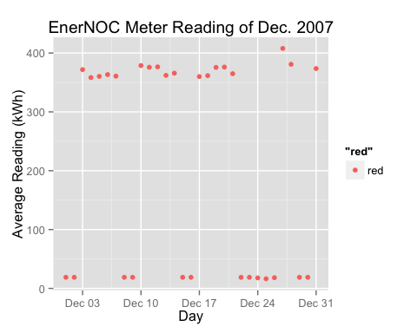

* This is the table of average reading for each day according to **weekdays**.

week_ave_data

## day ave.reading  
## 1 Sat 18.83796  
## 2 Sun 18.83796  
## 3 Mon 371.74884  
## 4 Tue 358.33953  
## 5 Wed 360.36111  
## 6 Thu 363.37500  
## 7 Fri 360.73023  
## 8 Sat 18.83796  
## 9 Sun 18.83796  
## 10 Mon 378.72222  
## 11 Tue 375.82326  
## 12 Wed 376.48611  
## 13 Thu 362.05556  
## 14 Fri 365.77570  
## 15 Sat 18.83796  
## 16 Sun 18.83796  
## 17 Mon 360.01389  
## 18 Tue 361.56944  
## 19 Wed 375.54167  
## 20 Thu 376.15278  
## 21 Fri 364.88889  
## 22 Sat 18.83796  
## 23 Sun 18.83796  
## 24 Mon 17.84722  
## 25 Tue 16.36574  
## 26 Wed 18.20833  
## 27 Thu 407.84259  
## 28 Fri 380.86111  
## 29 Sat 18.83796  
## 30 Sun 18.83796  
## 31 Mon 373.62500

* This is the point plot of average reading for each day according to **weekdays** of Dec. 2007

