Client - > where UI application will live

Server -> contains Python flask server

Model -> contains the notebook and the artifacts(model and the columns name)

**IN SERVER:::**

Server.py is the main server file where I imported a flask module and created an app using

“app = Flask(__name__)” and in main I call “app.run()”. It will run application on a specific port.

Created a routine for getting location names, return all the locations using jsonify method. Returning a response which contains all the locations. For locations creating a new file called util which will contain all the core routines whereas the server will do the routing of request and response.

**In util file::**

Has 3 global variable (model,column names,locations) .

1. Has routine as get_location_names where we return the location as list.
2. Has routine as load_saved_artifacts where we save the locations and model in the respective global variables.

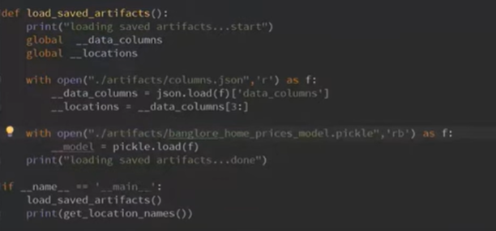

1. Has routine as get_estimated_price which takes some arguments and return the predicted price

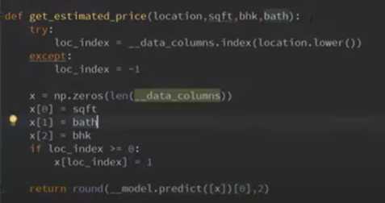

Back in server.py created a routine predict_home_price()

