- HTIA snapshots are created by Data protection software (CyberSense) and users want to restore from clean immutable snapshot to its original location through Ansible playbook.
- Follow the Readme file to use Ansible.
- Run the playbook snapshot_restore.yml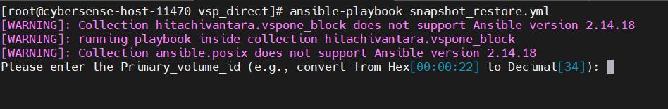
- Prompt will appear to put the user input
- User needs to put the primary volume id to get all snapshot pair details.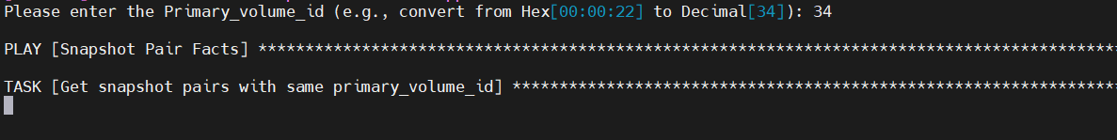

- User is asked to check the snapshot pairs and get the mirror_unit_id to do point-in-time Snapshot restore.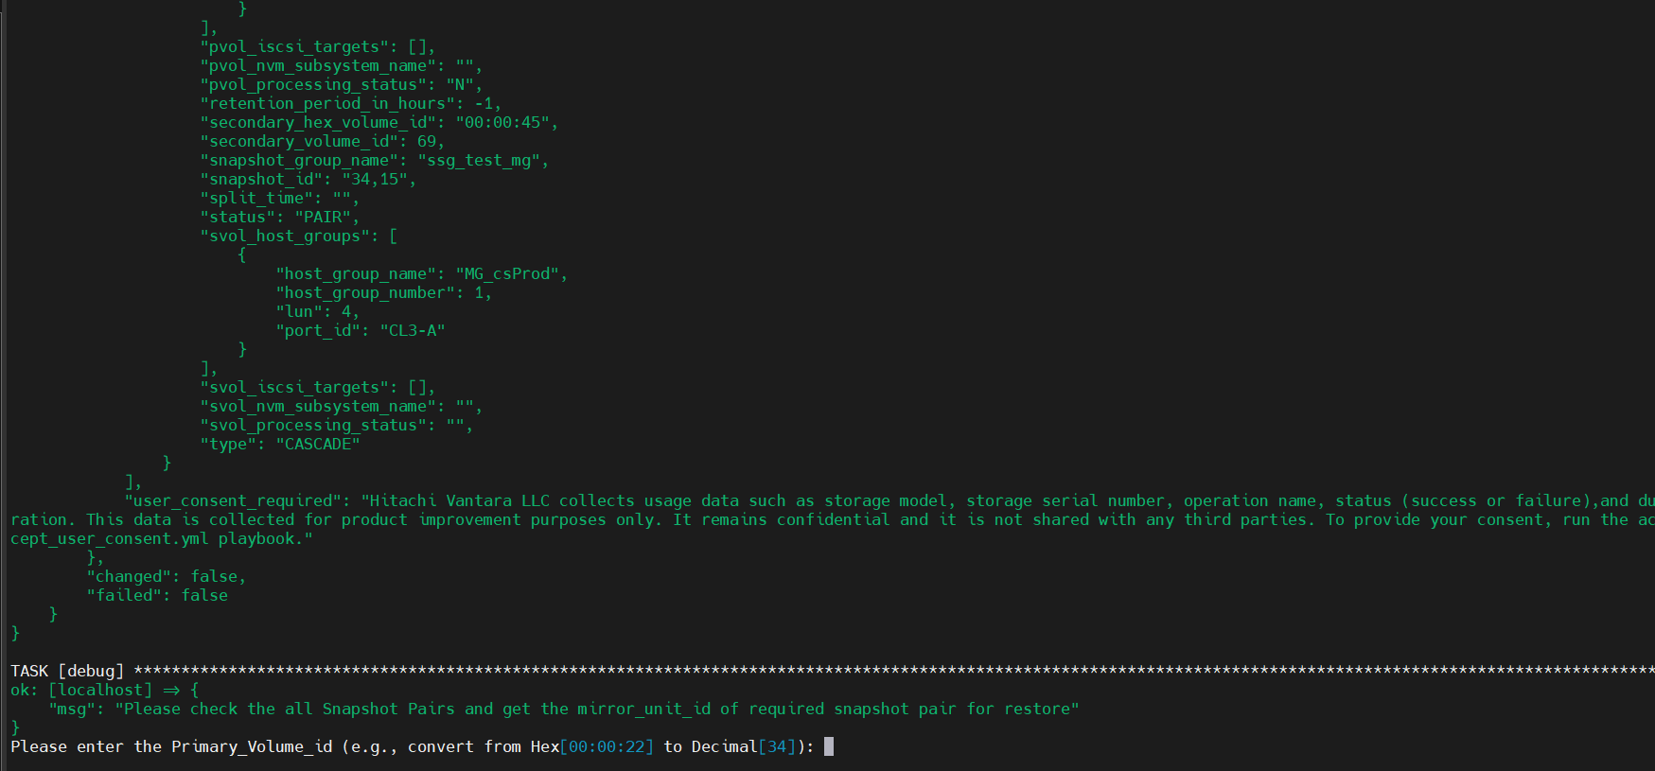

- Get the details from all snapshots by scrolling up the tab.

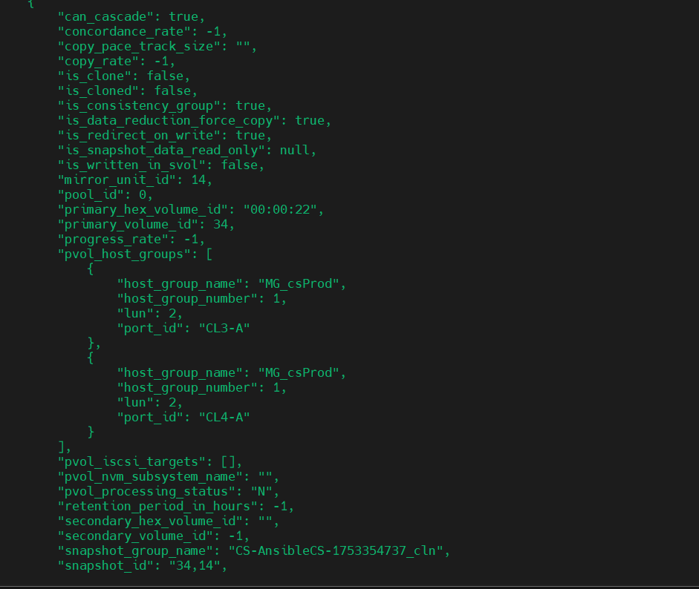

- Again, prompt is appeared to put the required details for restore.
- User needs to provide Primary_volume_id and mirror_unit_id to continue the restoration task.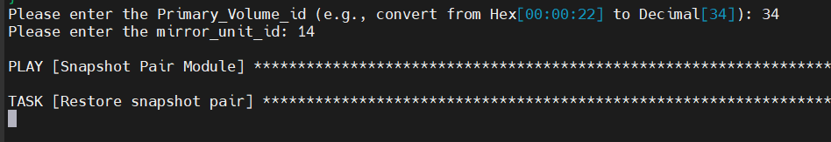

- Restoration is completed and data is recovered to its original location and remount the directory is needed to view the recovered data.

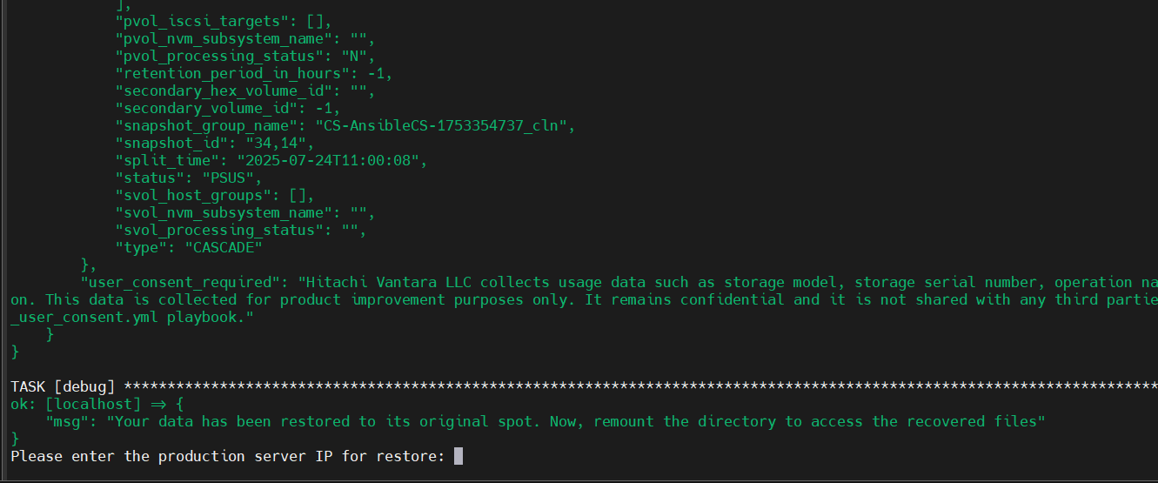

- Now, another prompt appeared for remount task.
- Users need to provide production server IP, mount path and device path.
- Unmount task, then filesystem repair task and mount task are performed.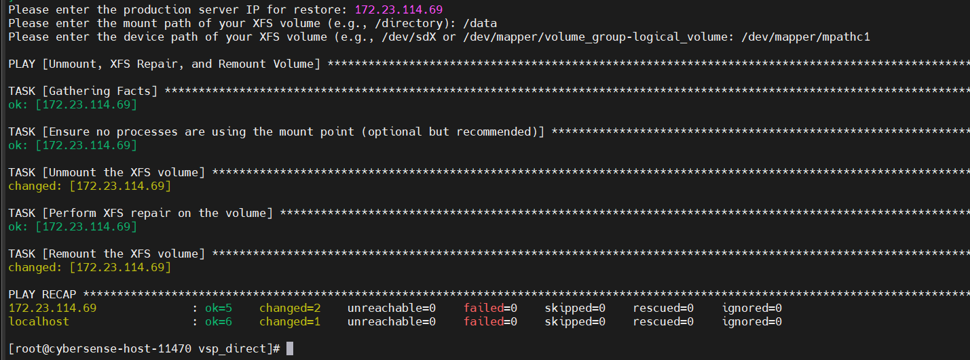

- Data are visible from production host.
