## Installation/Setup:

* Place the theme in the themes folder, or upload through the Admin.
* Setup the resources by running **gulp**, or **gulp --production** for deployment.

Note: How to install gulp? Click here <https://roots.io/sage/docs/theme-development/>

## Custom Templates:

There are 2 templates for the homepage and car frontpage:

* Homepage (front-page.php)
* Car Frontpage (front-page-car.php)

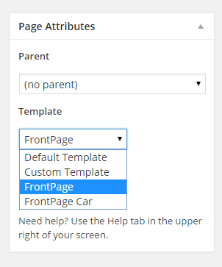

Use the appropriate template to set up page as homepage.

## Utilities:

### Section

Full length page section that can be used in any page.

Click on the section icon on the visual tab of rich text editor which opens a section tag:

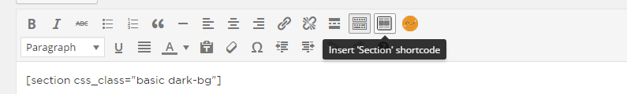

Enter additional css classes. Either of the following can be used in this context:

1. dark-bg :best for section used over an image or dark background 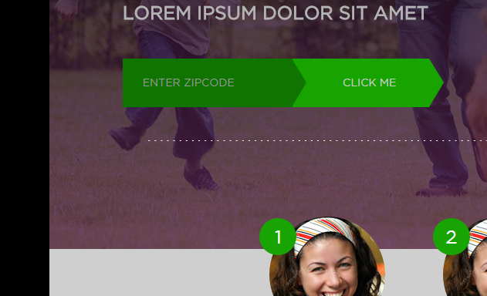
2. textured-bg :section with a dark textured background. 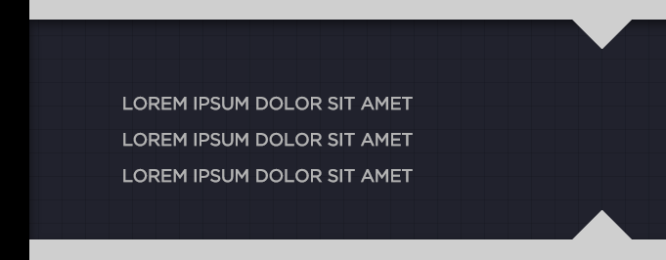

Enter content and click on the section button again to close the tag.

Eg:

[section css_class="basic dark-bg"]

LOREM IPSUM DOLOR SIT AMET

LOREM IPSUM DOLOR SIT AMET

LOREM IPSUM DOLOR SIT AMET

LOREM IPSUM DOLOR SIT AMET

[/section]

### Steps:

Click on the Steps form icon on the visual tab of rich text editor.



It creates the following shortcode:

[steps css_class=""]

[step step_number="1" image_file="http://example.com/image.png" caption="This is a step 1" /]

[step step_number="2" image_file="http://example.com/image.png" caption="This is a step 2" /]

[step step_number="3" image_file="http://example.com/image.png" caption="This is a step 3" /]

[/steps]

Note: Replace steps number, image file and caption to appropriate values. Currently limited to 3 steps only

### Conversion Button:

Use the following shortcode to create the conversion form.

[conversion_button textbox_placeholder="Optional text" button_text="Optional Button Text"]

Default Output:

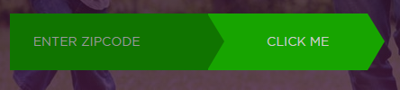

## Splash Page

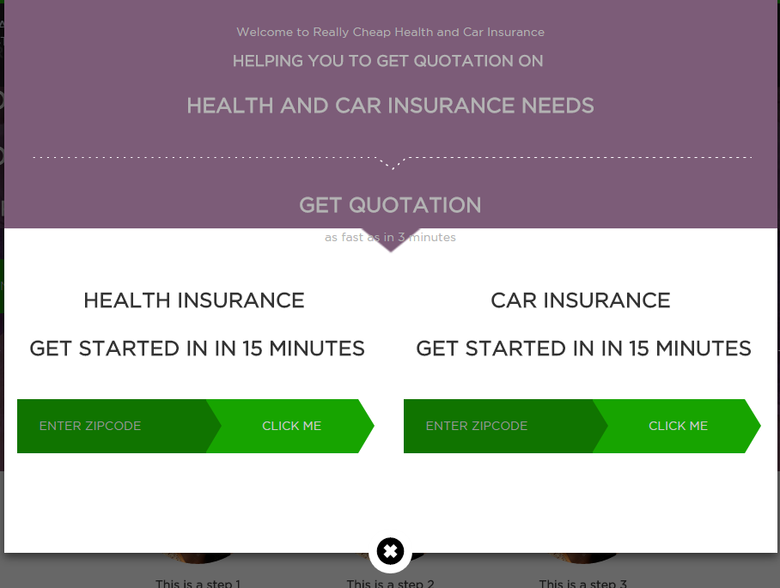

The splash page only show in the home page and divided into 3 sections: Splash Page Text Top, Splash Page Text Left and Splash Page Text Right. The content can be added, when editing the homepage. Note that conversion button shortcode also works here.

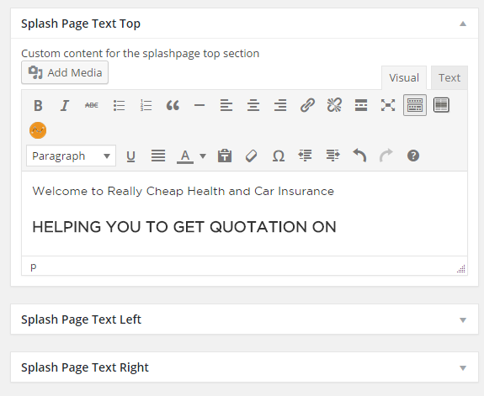

## Additional setup options for theme:

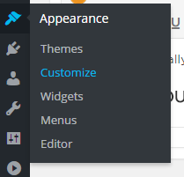

Go to Appearance 🡪Customize 🡪 Additional Settings:

|  |  |
| --- | --- |
|  | * Change the color of the splash page header |
| * Put a custom header banner for the home page |
| * Put a custom header banner for the car home page. |
| * Customize Floating box. Supports conversion button shortcode. |

## Other settings:

Please set the static page and blog page options in order to view the home page.

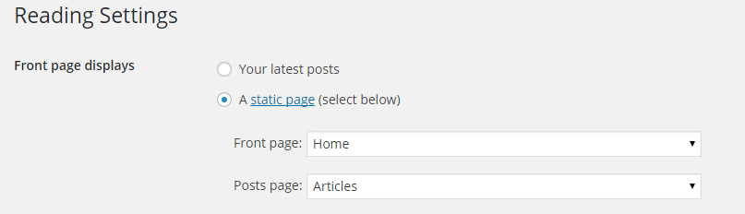

Also set blog pages show at most to **12**.

Yet Another Related Posts Plugin is supported through a custom template. Select Simple (yarpp-template-example.php) from the options.

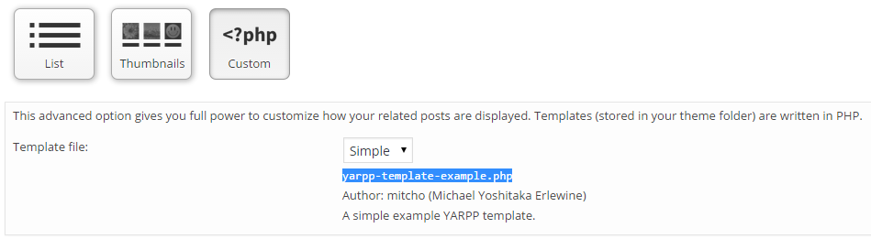

Also set Maximum number of related posts to **6**