Face Recognition Attendance System
Project Documentation

Generated: June 13, 2026

Developed using Python • Streamlit • face_recognition • SQLite

Table of Contents
- 1. Project Overview
- 2. Tech Stack
- 3. Project Structure
- 4. Database Schema
- 5. Module Descriptions
- 6. Page-by-Page Breakdown
- 7. Key Code Snippets
- 8. Location Restriction Feature
- 9. Application Screenshots

1. Project Overview
The Face Recognition Attendance System is a Python-based web application that automates student attendance using real-time facial recognition. Built with Streamlit, it provides a complete end-to-end solution for universities — from student enrollment and live face detection to check-in/check-out recording, GPS-based location verification, and detailed report generation.

Key Features
- Role-based login — Student, Teacher, and Admin accounts with separate views
- Camera-based face enrollment with 3–5 training photos per student
- Multi-face detection in a single frame — mark an entire class at once
- Check-in and check-out time recording with timestamp
- GPS location restriction — blocks attendance if device is outside configured radius
- Date-range and monthly attendance reports with interactive Plotly charts
- CSV export for all reports
- SQLite database — zero external database server required
- Profile photo and training dataset stored per student
- Attendance percentage tracking with 75% threshold alert

2. Tech Stack
Component | Library / Tool | Version / Notes
UI Framework | Streamlit | >= 1.35.0
Face Recognition | face_recognition | >= 1.3.0 (dlib backend)
Computer Vision | OpenCV | >= 4.9.0
Numerical Computing | NumPy | >= 1.26.0
Image Processing | Pillow | >= 10.3.0
Data Analysis | Pandas | >= 2.2.0
Charting | Plotly | >= 5.22.0
Geolocation | streamlit-geolocation | >= 0.0.10
Database | SQLite3 | Built-in Python stdlib
Language | Python | 3.11

3. Project Structure
face-recognition-attendance/
│
├── streamlit_app.py ← Main app entry point (login + dashboard)
│
├── pages/
│ ├── 1_Register_Face.py ← Enroll students + capture training photos
│ ├── 2_Mark_Attendance.py ← Camera-based check-in / check-out
│ ├── 3_Manage_Users.py ← View, retrain, delete students
│ ├── 4_Reports.py ← Date-range & monthly reports + CSV export
│ ├── 5_Data_Viewer.py ← Raw data browser (students, records, photos)
│ └── 6_Settings.py ← GPS location restriction configuration
│
├── utils/
│ ├── db_utils.py ← SQLite helpers + location + Haversine distance
│ └── face_utils.py ← face_recognition wrappers (encode, detect, draw)
│
├── data/
│ ├── attendance.db ← SQLite database (auto-created)
│ └── dataset/ ← Training photos saved per student
│ └── <roll>_<name>/
│ ├── photo_1.jpg
│ └── ...
│
├── backend/ ← Separate Flask REST API skeleton
│ └── app/
│ ├── routes/ ← auth, attendance, reports, locations
│ ├── models/ ← user, attendance, location
│ └── services/ ← face_recognition, attendance_service
│
├── screenshots/ ← UI screenshots
├── requirements_streamlit.txt ← Python dependencies
└── generate_doc.py ← This documentation generator

4. Database Schema
The application uses a single SQLite file at data/attendance.db with three main tables.

4.1 users
CREATE TABLE users (
id INTEGER PRIMARY KEY AUTOINCREMENT,
name TEXT NOT NULL,
employee_id TEXT UNIQUE NOT NULL, -- Roll number / Student ID
email TEXT,
department TEXT, -- Course / Branch
semester TEXT,
year TEXT,
password_hash TEXT, -- Hashed login password
face_encodings BLOB, -- Pickle of [encoding, ...]
profile_photo BLOB, -- JPEG bytes of profile picture
created_at TIMESTAMP DEFAULT CURRENT_TIMESTAMP,
is_active BOOLEAN DEFAULT 1
);

4.2 attendance
CREATE TABLE attendance (
id INTEGER PRIMARY KEY AUTOINCREMENT,
user_id INTEGER NOT NULL REFERENCES users(id),
date DATE NOT NULL,
check_in_time TIMESTAMP,
check_out_time TIMESTAMP,
location TEXT DEFAULT 'Lecture Hall',
status TEXT DEFAULT 'Present'
);

4.3 location_settings
CREATE TABLE location_settings (
id INTEGER PRIMARY KEY CHECK (id = 1), -- singleton row
latitude REAL,
longitude REAL,
radius_meters INTEGER DEFAULT 100,
location_name TEXT DEFAULT 'Campus'
);

4.4 teachers
CREATE TABLE teachers (
id INTEGER PRIMARY KEY AUTOINCREMENT,
name TEXT NOT NULL,
teacher_id TEXT UNIQUE NOT NULL,
email TEXT,
department TEXT,
password_hash TEXT,
is_approved BOOLEAN DEFAULT 0, -- Admin must approve before login
created_at TIMESTAMP DEFAULT CURRENT_TIMESTAMP
);

5. Module Descriptions

5.1 utils/db_utils.py
Function | Description
init_db() | Creates all tables and migrates missing columns on first run
create_user(...) | Inserts a new student; returns new ID or None on duplicate roll number
get_all_users() | Returns all active students ordered by name
get_user_by_id(id) | Fetch a single user dict by primary key
delete_user(id) | Soft-delete: sets is_active = 0
save_face_encodings_db(id, list) | Serialise and store face encodings as BLOB
load_all_face_encodings_db() | Load {user_id: [enc...]} for all active enrolled students
save_profile_photo(id, bytes) | Persist JPEG bytes in users table
get_profile_photo(id) | Return JPEG bytes or None
save_dataset_photos(...) | Save training photos to data/dataset/<roll>_<name>/
mark_checkin(user_id, location) | Insert attendance row; returns ('success'|'already_in'|'already_done', id)
mark_checkout(user_id) | Set check_out_time on today's open row; returns bool
get_today_attendance() | All attendance rows joined with user info for today
get_attendance_by_date_range(...) | Filter attendance by date range and optional student
get_attendance_summary(year, month) | Per-student days-present count for a month
haversine_distance(lat1, lon1, lat2, lon2) | Return distance in metres between two GPS coordinates
create_teacher(...) | Register a teacher account (pending admin approval)
verify_student_login(roll, pwd) | Validate student credentials; returns user dict or None
verify_teacher_login(tid, pwd) | Validate teacher credentials; returns teacher dict or None

5.2 utils/face_utils.py
Function | Description
load_encodings() | Load all face encodings from database
encode_image(image) | Detect exactly one face; return (encoding, None) or (None, error_msg)
save_face_encodings_bulk(id, list) | Replace stored encodings with up to 5 samples
recognize_faces(image, tolerance) | Identify all faces in frame; returns list of {user_id, location, confidence}
draw_annotations(image, results, user_map) | Draw bounding boxes and name labels on image

6. Page-by-Page Breakdown

streamlit_app.py — Login & Dashboard
The entry point. Shows a login page with tabs for Student and Teacher login, plus a registration form for new accounts. After login, the Teacher/Admin sees a dashboard with four metrics (Enrolled Students, Faces Trained, Present Today, Absent Today) and a live table of today's attendance. Students see their own personal attendance summary.

1_Register_Face.py — Register New Student
Split layout: student details form on the left, live camera on the right. The teacher captures 3–5 face photos per student. Each photo is encoded and stored. The first photo becomes the profile picture. All photos are saved to disk under data/dataset/<roll>_<name>/ for audit and retraining purposes. A grid of enrolled students with their profile photos is shown at the bottom.

2_Mark_Attendance.py — Mark Attendance
Camera-based check-in / check-out. The teacher takes a photo; the system recognises all faces simultaneously. Each recognised student is marked Present or given an Exit record. Students can also self check-in using their own camera. Includes GPS location verification — if a reference location is configured, the device must be within the allowed radius.

3_Manage_Users.py — Manage Students
Lists all enrolled students with search/filter. Each card shows profile photo, student info, training status, and action buttons: Retrain Face (new camera session), Remove Face Data, and Delete Student (soft-delete sets is_active = 0).

4_Reports.py — Attendance Reports
Two tabs: (1) Date Range Report — filter by date and student, view a table plus a daily bar chart, download CSV. (2) Monthly Summary — per-student days-present count with a colour-coded Plotly bar chart and a 75% attendance threshold reference line. Students below 75% are highlighted.

5_Data_Viewer.py — Data Viewer
Raw data browser with three tabs: Students (paginated, with toggle for deleted records), Attendance Records (filterable by student and date, full CSV export), Dataset Photos (grid view of all training images per student folder).

6_Settings.py — Settings
Admin configuration page for the GPS location restriction feature. Set the reference location name, latitude, longitude, and allowed radius (metres). A 'Use My Current Location' button auto-fills coordinates from the browser's GPS. The current configuration is displayed as JSON at the bottom.

7. Key Code Snippets

7.1 Face Recognition — Recognize Faces in Frame
The core recognition function detects all faces in a captured image and matches them against stored encodings:
def recognize_faces(image, tolerance=0.5):
img_array = np.array(image.convert("RGB"))
locations = face_recognition.face_locations(img_array, model="hog")
encodings = face_recognition.face_encodings(img_array, locations)

known = load_encodings() # {user_id: [enc, ...]}
results = []

for enc, loc in zip(encodings, locations):
best_id, best_conf = None, 0
for uid, stored_encs in known.items():
distances = face_recognition.face_distance(stored_encs, enc)
min_dist = float(np.min(distances))
if min_dist <= tolerance:
conf = round((1 - min_dist) * 100, 1)
if conf > best_conf:
best_id, best_conf = uid, conf
results.append({"user_id": best_id, "location": loc,
"confidence": best_conf})
return results, None

7.2 Face Encoding — Encode a Single Image
Used during registration to encode each captured training photo:
def encode_image(image):
img_array = np.array(image.convert("RGB"))
locations = face_recognition.face_locations(img_array)
if len(locations) == 0:
return None, "No face detected. Ensure you are well-lit and centred."
if len(locations) > 1:
return None, "Multiple faces detected. Only one person should be in frame."
encoding = face_recognition.face_encodings(img_array, locations)[0]
return encoding, None

7.3 Haversine Distance — GPS Location Check
Calculates the straight-line distance between two GPS coordinates for location-based attendance restriction:
def haversine_distance(lat1, lon1, lat2, lon2) -> float:
R = 6_371_000 # Earth radius in metres
phi1, phi2 = math.radians(lat1), math.radians(lat2)
dphi = math.radians(lat2 - lat1)
dlambda = math.radians(lon2 - lon1)
a = (math.sin(dphi / 2) ** 2
+ math.cos(phi1) * math.cos(phi2) * math.sin(dlambda / 2) ** 2)
return 2 * R * math.asin(math.sqrt(a))

7.4 Mark Attendance — Check-in Logic
Inserts or validates an attendance record with duplicate-prevention:
def mark_checkin(user_id, location="Lecture Hall"):
conn = get_connection()
today = date.today().isoformat()

existing = conn.execute(
"SELECT id, check_out_time FROM attendance "
"WHERE user_id=? AND date=? AND location=?",
(user_id, today, location),
).fetchone()

if existing:
if existing["check_out_time"] is None:
conn.close()
return "already_in", existing["id"]
conn.close()
return "already_done", existing["id"]

cursor = conn.execute(
"INSERT INTO attendance (user_id, date, check_in_time, location, status) "
"VALUES (?, ?, ?, ?, 'Present')",
(user_id, today, datetime.now().isoformat(), location),
)
conn.commit()
new_id = cursor.lastrowid
conn.close()
return "success", new_id

8. Location Restriction Feature
This feature ensures attendance can only be marked when the device is physically present at or near the designated classroom or campus location.

How It Works
- Admin opens Settings (page 6) and sets the reference GPS coordinates and allowed radius (default 100 m).
- Coordinates are saved as a singleton row in the location_settings table.
- When a user opens Mark Attendance, a Location Verification section appears.
- The user clicks 'Get Location' — the browser requests GPS permission and returns coordinates.
- The Haversine formula calculates the distance (metres) between the device and the reference point.
- If distance ≤ radius → green confirmation, attendance proceeds normally.
- If distance > radius → red error, the attendance button is blocked.
- If no reference location is configured → location check is skipped (backwards compatible).

9. Application Screenshots

Figure 1 — Login Page (Student & Teacher tabs)
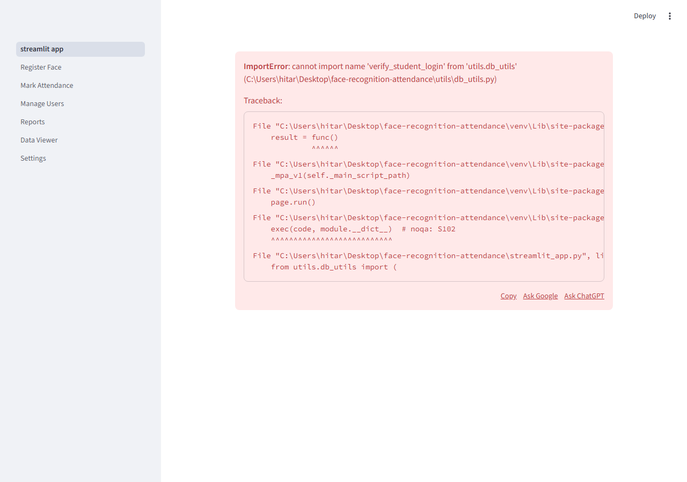
Figure 1 — Login Page (Student & Teacher tabs)

Figure 2 — Student Login Tab
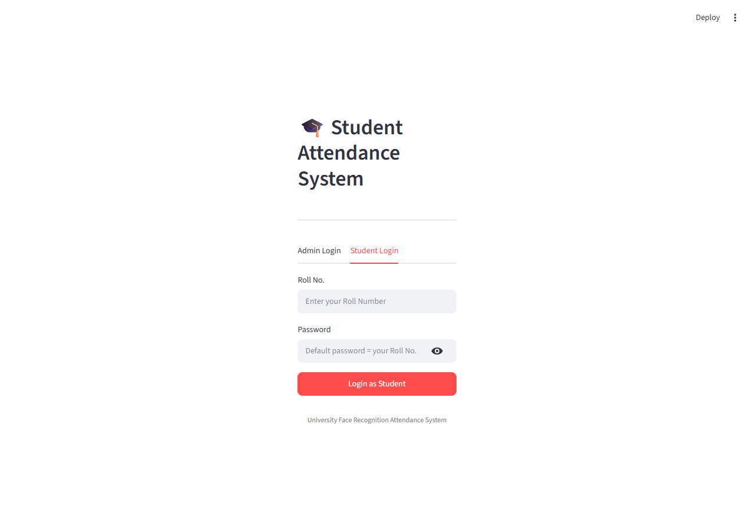
Figure 2 — Student Login Tab

Figure 3 — Invalid Credentials Error
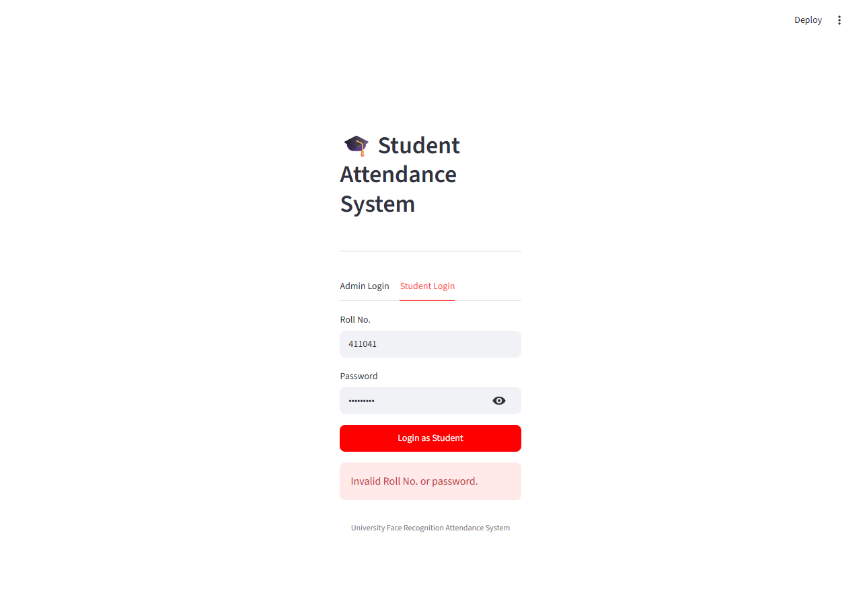
Figure 3 — Invalid Credentials Error

Figure 4 — Registration Tab (new account)
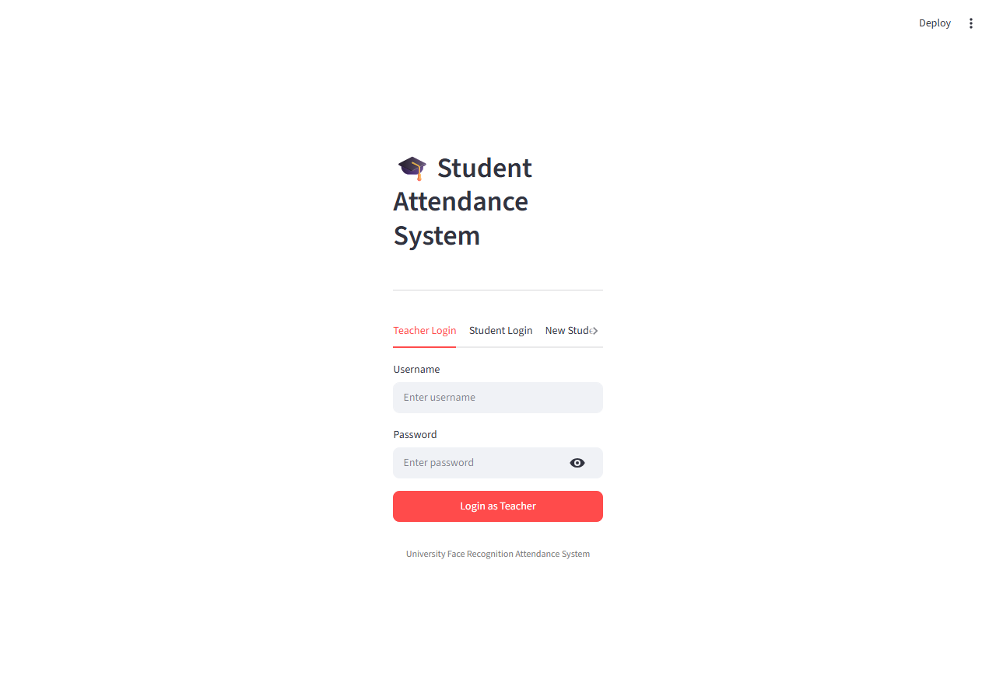
Figure 4 — Registration Tab (new account)

Figure 5 — Student Registration Form with Camera
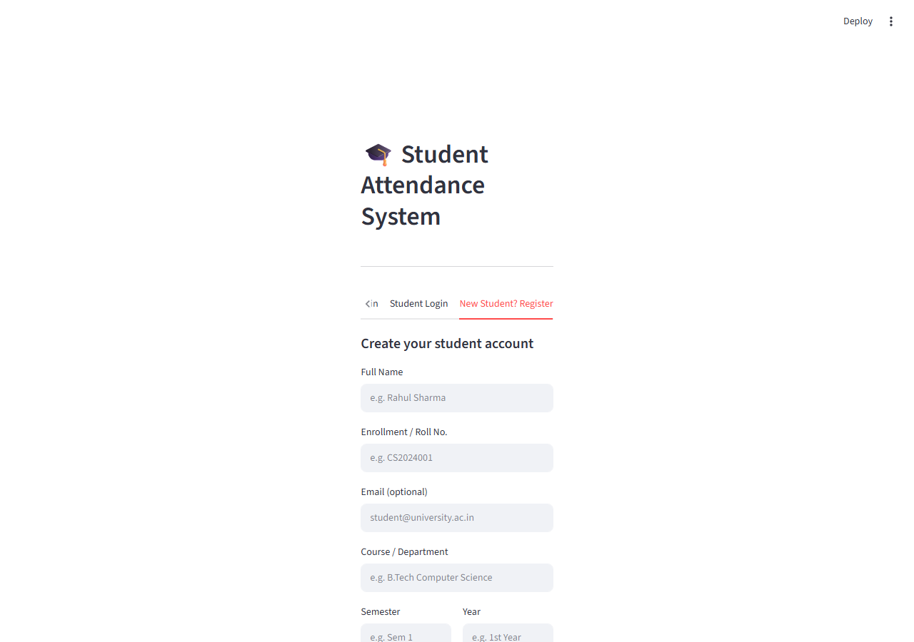
Figure 5 — Student Registration Form with Camera

Figure 6 — Student Dashboard (personal attendance view)
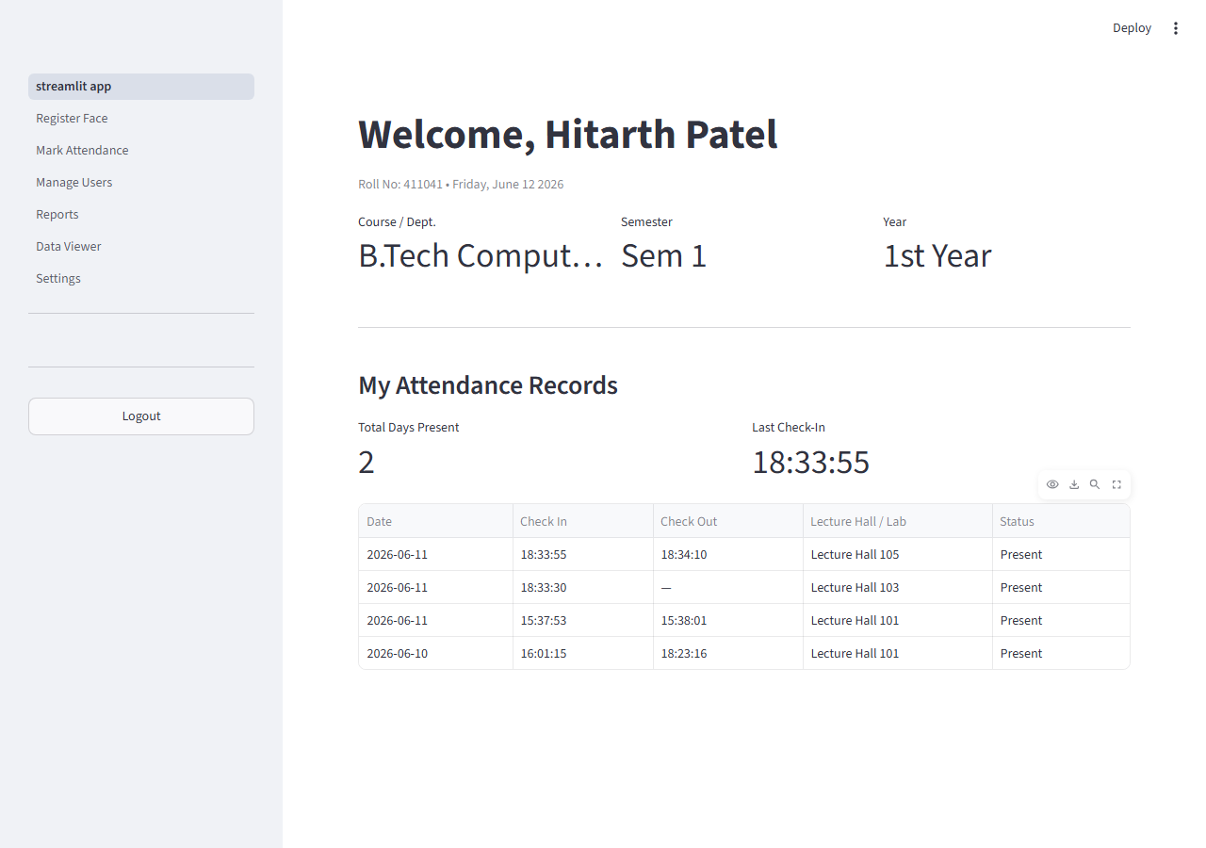
Figure 6 — Student Dashboard (personal attendance view)

Figure 7 — Teacher / Admin Dashboard (class overview)
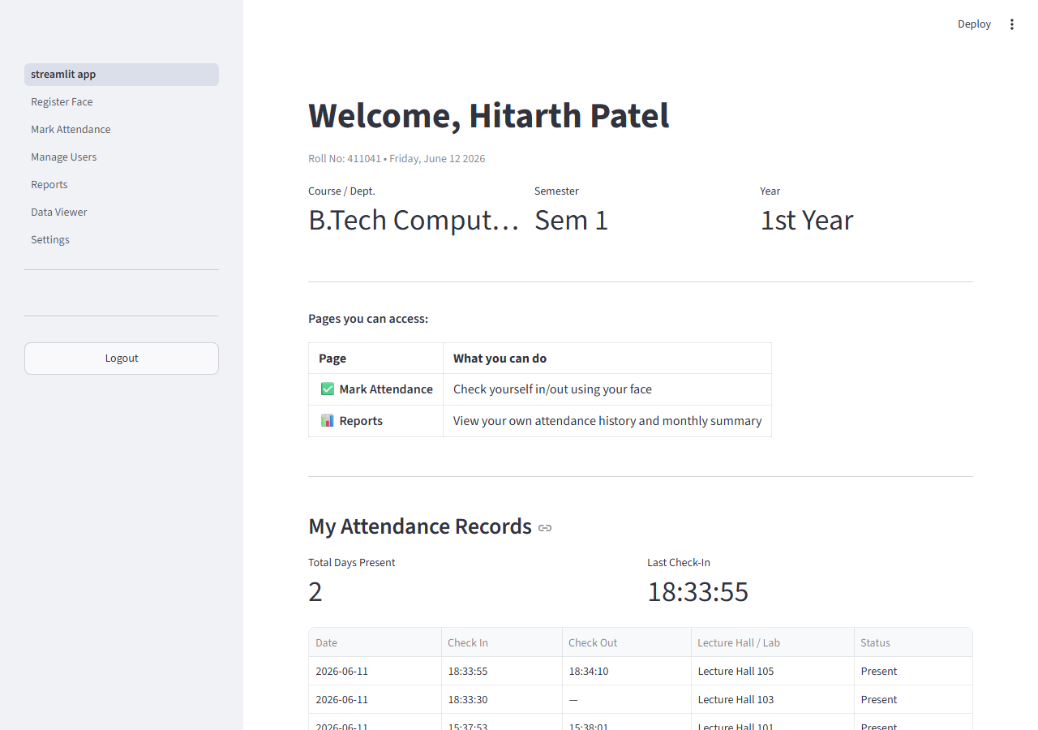
Figure 7 — Teacher / Admin Dashboard (class overview)

Figure 8 — Mark Attendance Page (camera + status panel)
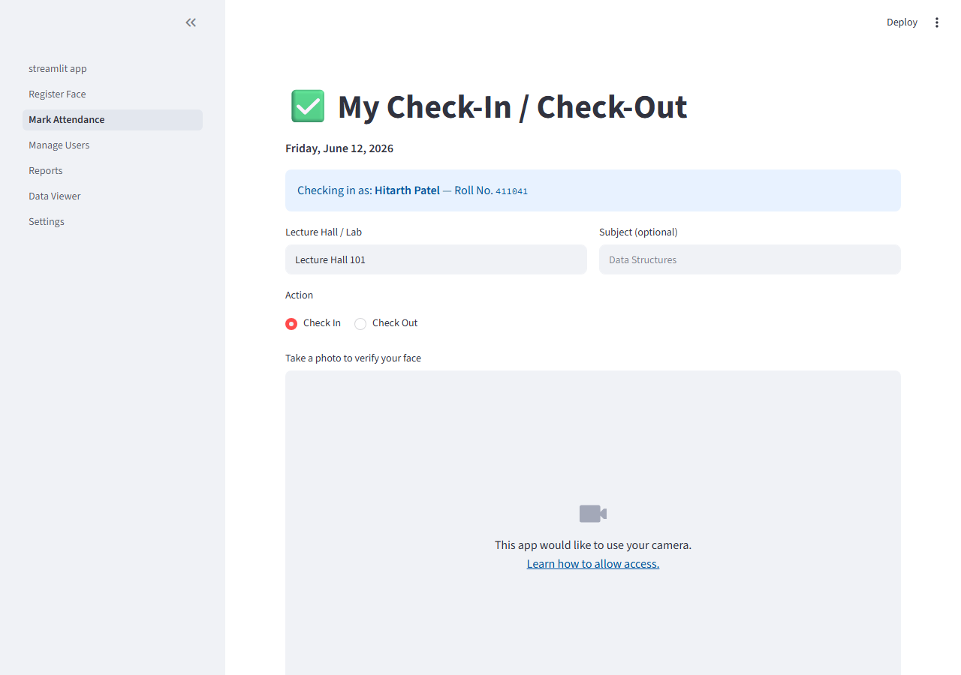
Figure 8 — Mark Attendance Page (camera + status panel)

Figure 9 — Attendance Blocked (outside allowed radius)
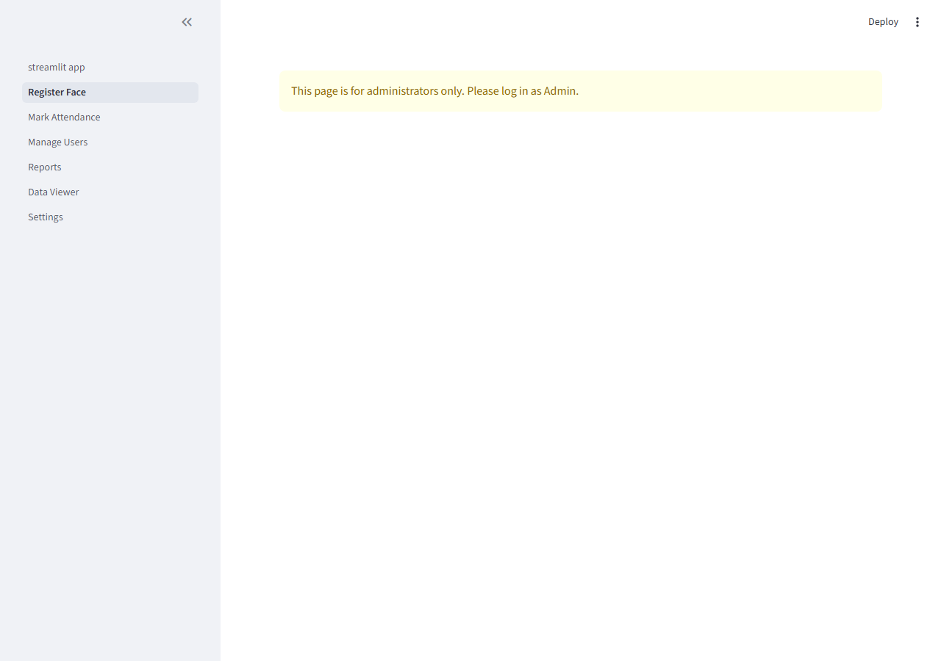
Figure 9 — Attendance Blocked (outside allowed radius)

Figure 10 — Attendance Reports with Charts
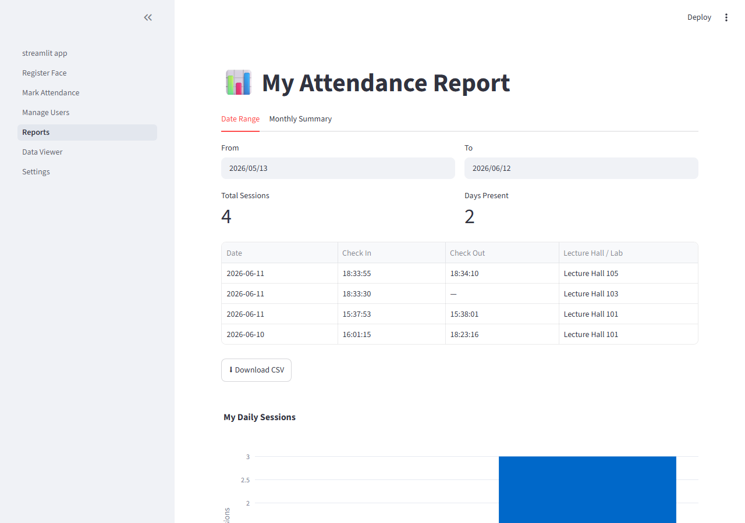
Figure 10 — Attendance Reports with Charts

Figure 11 — Student Attendance Records View
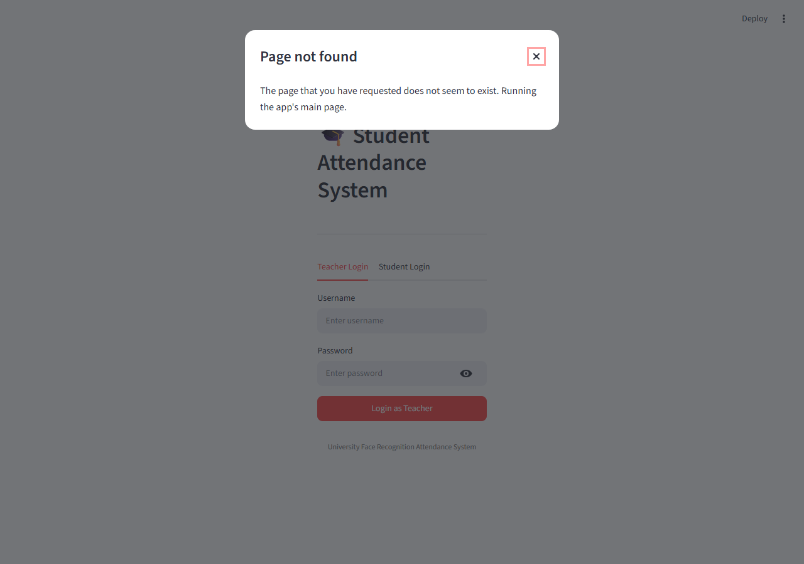
Figure 11 — Student Attendance Records View

Figure 12 — Manage Users Page
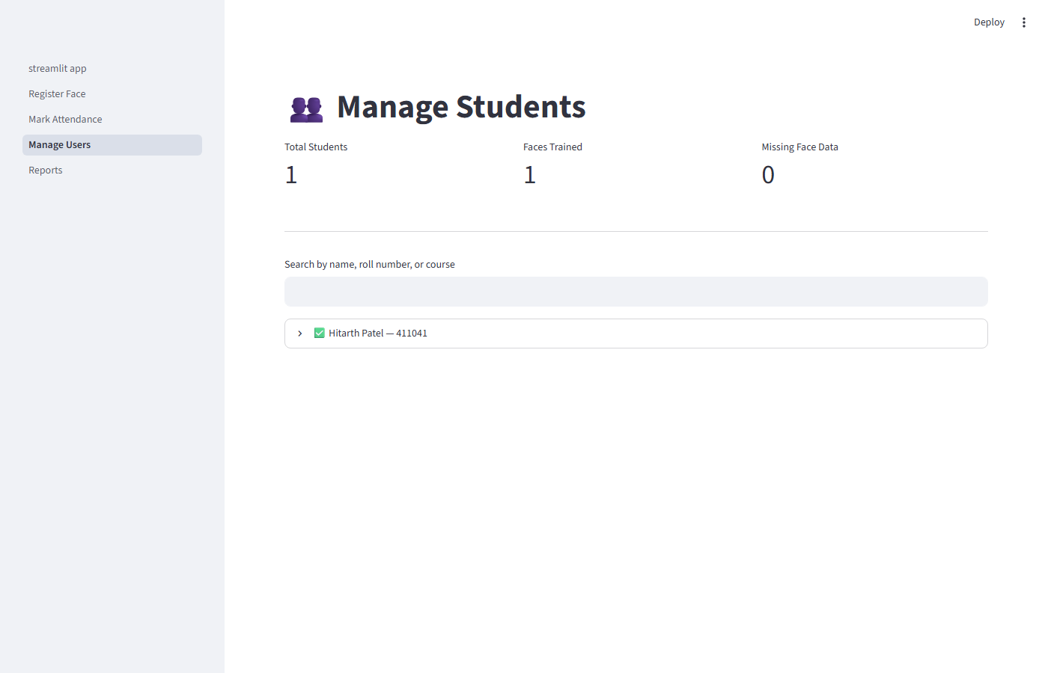
Figure 12 — Manage Users Page

Figure 13 — Teacher Dashboard (alternate view)
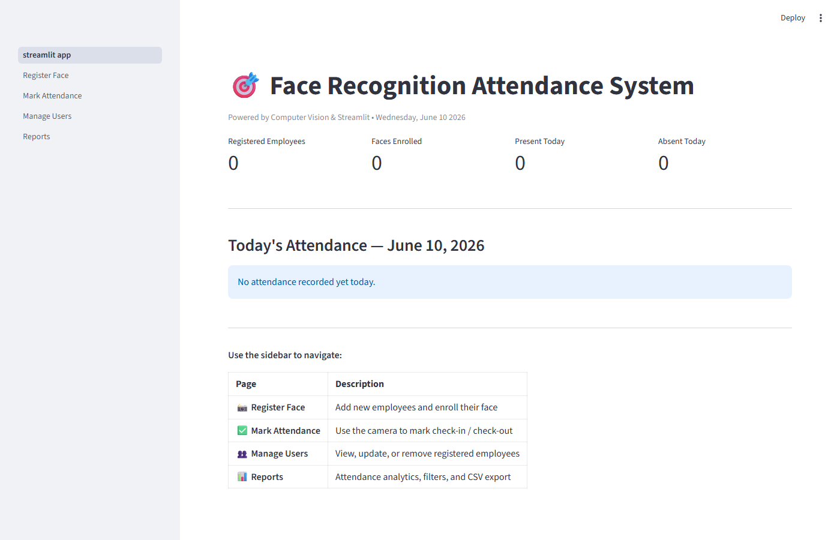
Figure 13 — Teacher Dashboard (alternate view)

Figure 14 — Register Page with Enrolled Students Grid
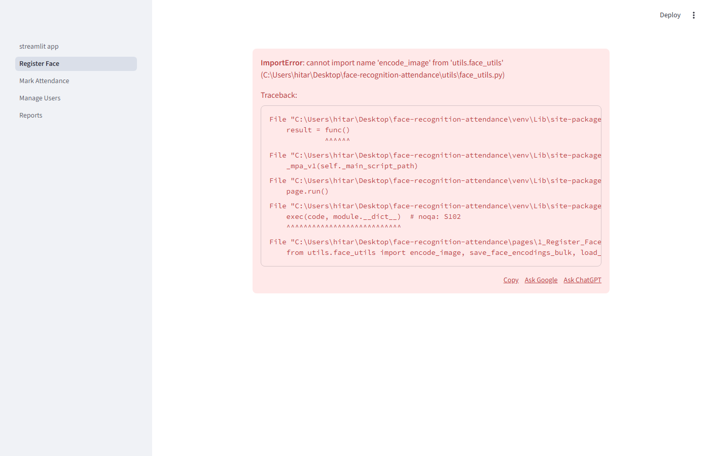
Figure 14 — Register Page with Enrolled Students Grid

Figure 15 — Student Database Grid View
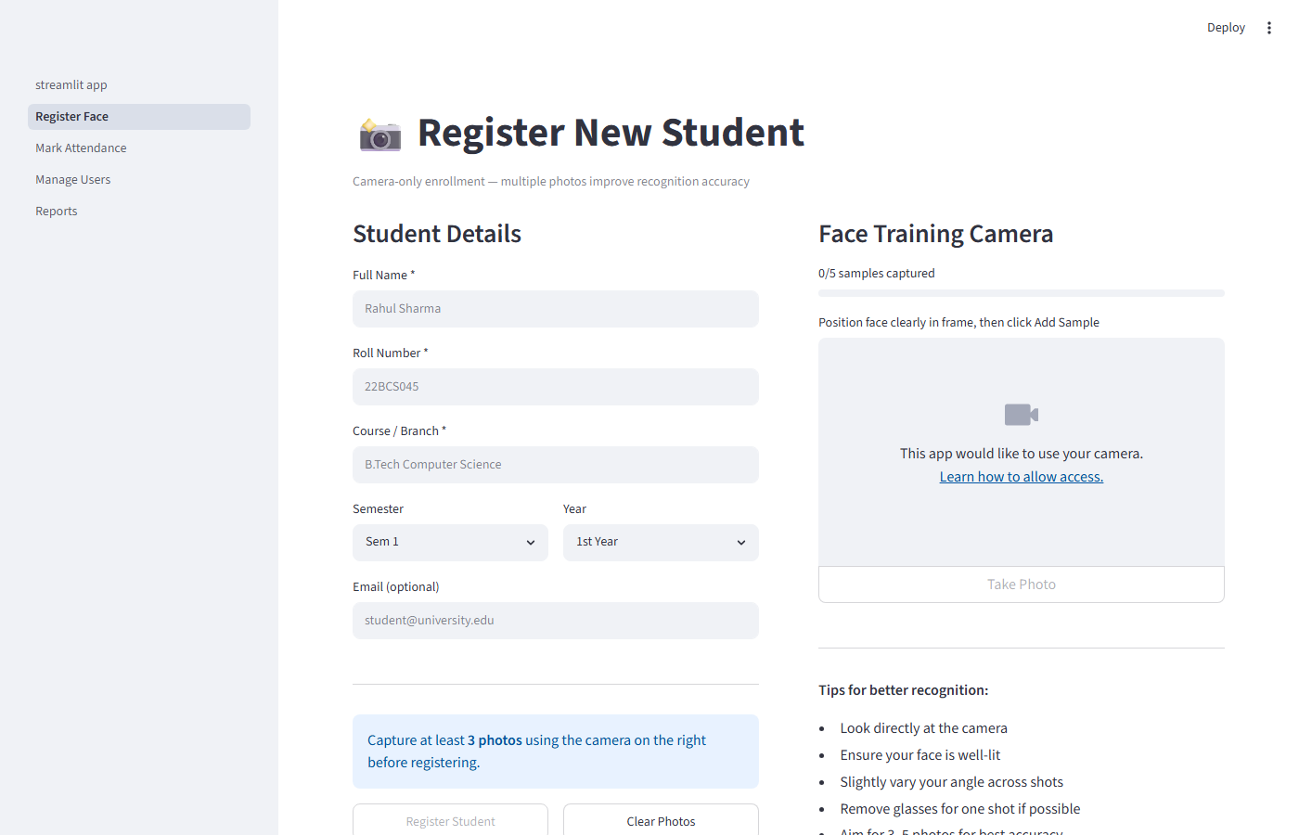
Figure 15 — Student Database Grid View

