

ASSESSMENT GUIDE

Brain Cloud
Specification and Design

Student names
- Team leader
- Member 2
- Member 3
- Member 4
- Member 5

Document Acceptance and Release Notice
This document is authorised for release once all signatures have been obtained.

PREPARED: |  | Date: |  | / |  | /
(for acceptance) | <Name>  Project Manager, Student Group
ACCEPTED: |  | Date: |  | / |  | /
(for release) | Project Sponsor, VIT

Referencing guides
You must reference all the sources of information you have used in your assessments. Please use the IEEE referencing style in your assessments in this unit. Refer to the library’s reference guides for more information.
- https://elearning.vit.edu.au/pluginfile.php/473840/block_html/content/VIT%20Library%20Refer encing%20-%20IEEE%20-%2007042020.pdf

Academic misconduct
VIT ensures that the integrity of its students’ academic studies follows an acceptable level of excellence. VIT will adhere to its VIT Policies, Procedures and Forms, which explain the importance of staﬀ and student honesty about academic work. It outlines the behaviours that are "academic misconduct", including plagiarism.

Late submissions
In cases where there are no accepted mitigating circumstances as determined through VIT Policies, Procedures and Forms, late submission of assessments will lead automatically to the imposition of a penalty. Penalties will be applied as soon as the deadline is reached.

Short extensions and special consideration
Special Consideration is a request for:
  - Extensions of the due date for an assessment, other than an examination (e.g. assignment extension).
  - Special Consideration (Special Consideration in relation to a Completed assessment, including an end-of-unit Examination).
Students wishing to request Special Consideration in relation to an assessment the due date of which has not yet passed must engage in written emails to the teaching team to Request for Special Consideration as early as possible and prior to start time of the assessment due date, along with any accompanying documents, such as medical certificates.
For more information, visit VIT Policies, Procedures and Forms.

Inclusive and equitable assessment
Reasonable adjustment in assessment methods will be made to accommodate students with a documented disability or impairment. Contact the unit teaching team for more information.

Contract Cheating
Contract cheating usually involves the purchase of an assignment or piece of research from another party. This may be facilitated by a fellow student, friend or purchased on a website. Other forms of contract cheating include paying another person to sit an exam in the student's place.

Contract cheating warning:
  - By paying someone else to complete your academic work, you don’t learn as much as you could have if you did the work yourself.
  - You are not prepared for the demands of your future employment.
  - You could be found guilty of academic misconduct.
  - Many of for pay contract cheating companies recycle assignments despite guarantees of “original, plagiarism-free work” so similarity is easily detected by TurnitIn.
  - Penalties for academic misconduct include suspension and exclusion.
  - Students in some disciplines are required to disclose any findings of guilt for academic misconduct before being accepted into certain professions (e.g., law).
  - You might disclose your personal and financial information in an unsafe way, leaving yourself open to many risks including possible identity theft.
  - You also leave yourself open to blackmail - if you pay someone else to do an assignment for you, they know you have engaged in fraudulent behaviour and can always blackmail you.

Grades
We determine your grades to the following Grading Scheme:
Grade | Percentage
A | 80% – 100%
B | 70% – 79%
C | 60% – 69%
D | 50% – 59%
N | 0% – 49%

Table of Contents
1. Executive Summary 1
2. Specification 1
2.1 System Description 1
2.2 Feasibility Analysis 1
2.2.1 Technical Feasibility 1
2.2.2 Economic Feasibility 1
2.2.3 Organizational Feasibility 1
2.3 Requirements Specification 1
2.3.1 Functional 1
2.3.2 Non-functional 1
2.4 Use Cases 1
2.4.1 Use Case Diagrams 2
2.4.2 Use Case Descriptions 2
2.5 Context Model 2
3. Design 2
3.1 Architectural Design 2
3.2 Hardware Specifications 2
3.3 Database Structure 2
3.4 Interface Design 2
3.5 Sequence Diagrams 2
3.6 State Diagrams 2
4. References 3

List of Figures
Figure 1: Use Case Diagram — Brain Cloud
Figure 2: Context Model — Level 0 Data Flow Diagram
Figure 3: Layered Architecture
Figure 4: Entity-Relationship Diagram
Figure 5: Login Page — Wireframe
Figure 6: Admin Dashboard — Wireframe
Figure 7: Sequence Diagram — Login
Figure 8: Sequence Diagram — Create & Assign Task
Figure 9: State Diagram — Task Status Lifecycle

List of Tables
Table 1: User Roles Summary
Table 2: Functional Requirements
Table 3: Non-Functional Requirements
Table 4: Hardware & Software Environment
Table 5: Database Indexes

Glossary
MERN -- The MongoDB, Express.js, React, Node.js stack used to build Brain Cloud.
RBAC -- Role-Based Access Control -- restricting actions based on a user's assigned role (Admin, Staff, or User).
JWT -- JSON Web Token -- a signed, stateless token used to authenticate every protected API request.
bcrypt -- A password-hashing algorithm used to store passwords irreversibly instead of in plain text.
Mongoose -- An Object Data Modelling (ODM) library that defines schemas and validation for MongoDB documents.
Zod -- A schema-validation library used to validate request bodies on the backend and form input on the frontend.
Middleware -- A function that runs before a route's controller, such as authenticate or authorize, used to guard access to an endpoint.
Endpoint -- A single URL + HTTP method combination exposed by the REST API, e.g. POST /api/tasks.

UI | User Interface

Executive Summary
Brain Cloud is a role-based user and task management system developed as a college-level MERN stack (MongoDB, Express.js, React, Node.js) project. It demonstrates a complete, production-style full-stack web application — authentication, role-based access control (RBAC), CRUD operations, dashboards, and a polished SaaS-style user interface — while remaining simple enough to explain end-to-end in a viva and to extend further if required.
Small teams and organisations often need a lightweight way to manage user accounts with different levels of access, assign and track work items between team members, and give each person visibility only into what is relevant to their own role. Brain Cloud addresses this with a three-tier role system — Admin, Staff, and User — layered over a simple, auditable task-management workflow, with every permission enforced on the backend API itself rather than hidden only in the user interface.
The system supports JWT-based authentication with bcrypt password hashing, staff and user account management, task creation and assignment, an organisation-wide announcement feed, role-specific dashboards with live statistics, and self-service profile and password management. The frontend is built with React, TypeScript, Tailwind CSS, React Router, Redux Toolkit, and Axios; the backend is built with Node.js, Express.js, TypeScript, MongoDB, and Mongoose. The architecture is deliberately kept simple — a single REST API and a single database, with no microservices, message queues, or container orchestration — so that the project stays easy to build, run, and defend.
This document specifies the requirements, use cases, and context of the Brain Cloud system, and presents its architectural, database, interface, and behavioural design.

Specification
This section specifies what Brain Cloud must do: the problem it solves, its feasibility, its functional and non-functional requirements, the use cases supported for each role, and the system's context within its environment.

System Description
Brain Cloud is a web-based application that lets an organisation manage staff and user accounts and assign and track tasks between them, with every permission enforced on the backend API rather than only hidden in the UI. The system is built around three account roles that share a single authentication mechanism but see very different views and capabilities:
Role | Summary
ADMIN | Full access — manages Staff and User accounts, views all tasks, and sees system-wide statistics.
STAFF | Manages User accounts and tasks (create, assign, track); cannot manage Staff or Admin accounts.
USER | Views and updates only the tasks assigned to them, views announcements, and manages their own profile.

Table 1: User Roles Summary

Core capabilities include JWT-based authentication, three-tier role-based access control, staff and user account management (create, edit, deactivate, reset password), task management with priority and due dates, an organisation-wide announcement feed, role-specific dashboards, and self-service profile management. Tasks can only ever be assigned to accounts with the USER role — never to Staff or Admin — which is enforced in the backend controller layer, not only in the UI.

Feasibility Analysis
Brain Cloud was evaluated for feasibility along three dimensions before implementation began: whether the team had the technical means to build it, whether it was affordable to build and run, and whether it fits the way a small organisation actually operates.

Technical Feasibility
The entire stack — React, TypeScript, Tailwind CSS, Node.js, Express.js, and MongoDB — is free, open-source, well-documented, and widely taught, so the team already had (or could quickly acquire) the skills needed to build the system. The architecture deliberately avoids heavyweight infrastructure: no Docker, no Kubernetes, no Redis, no message queues, and no microservices. A developer only needs Node.js and a MongoDB instance (local or a free MongoDB Atlas cluster) to run the entire application. JWT authentication, bcrypt hashing, and Zod validation are mature, battle-tested libraries, which keeps technical risk low.

Economic Feasibility
Every technology used is free and open-source, so there are no licensing costs. MongoDB Atlas offers a free-tier cluster suitable for a project of this size, and the frontend/backend can both be deployed on free or low-cost tiers of common hosting platforms (e.g. Vercel/Netlify for the client, Render/Railway for the API) for demonstration purposes. The only real cost is development time, which is bounded by the deliberately simple, non-over-engineered architecture described in Section 3.1.

Organizational Feasibility
The three-role model (Admin, Staff, User) maps directly onto how small teams and organisations are already structured, so no retraining is required beyond learning a conventional, SaaS-style web interface. Because authorization is enforced on the backend, the system remains organisationally safe even if a user shares a link or inspects network requests — a Staff member genuinely cannot perform an Admin-only action, regardless of what the UI shows them. The scope was also bounded with explicit account limits (up to 100 User accounts and 15 Staff accounts), keeping the system aligned with the size of organisation it targets.

Requirements Specification
Requirements are grouped into functional requirements (what the system does) and non-functional requirements (the qualities the system must have while doing it).

Functional
Table 2 lists the functional requirements, each enforced on the backend API regardless of which role's client sends the request.
ID | Requirement | Role(s)
FR-01 | A user shall be able to log in with an email and password and receive a signed JWT. | All
FR-02 | The system shall force a password change on first login for any account created or reset by an Admin/Staff member. | All
FR-03 | A user shall be able to change their own password and update their own profile. | All
FR-04 | An Admin shall be able to create, edit, deactivate, and reset the password of Staff accounts. | Admin
FR-05 | An Admin or Staff member shall be able to create, edit, deactivate, and reset the password of User accounts. | Admin, Staff
FR-06 | An Admin or Staff member shall be able to create a task with a title, description, priority, and due date, and assign it to a User account. | Admin, Staff
FR-07 | The system shall reject any attempt to assign a task to an account that is not a User-role account. | Admin, Staff
FR-08 | A User shall be able to view only the tasks assigned to them and update their status (TODO -> IN_PROGRESS -> COMPLETED/CANCELLED). | User
FR-09 | An Admin or Staff member shall be able to view, update, and delete any task they are permitted to see. | Admin, Staff
FR-10 | An Admin or Staff member shall be able to post an announcement visible to every authenticated role. | Admin, Staff
FR-11 | All authenticated roles shall be able to view the announcement feed. | All
FR-12 | An Admin shall be able to view system-wide dashboard statistics (user/staff/task counts). | Admin
FR-13 | A Staff member shall be able to view a dashboard scoped to tasks and users they manage. | Staff
FR-14 | A User shall be able to view a dashboard scoped to their own assigned tasks. | User

Table 2: Functional Requirements

Non-functional
Table 3 lists the non-functional requirements that shape how the system is built, not just what it does.
Category | Requirement
Security | Passwords are hashed with bcrypt (never stored or returned in plain text); all protected routes require a valid JWT; every permission check is duplicated on the backend regardless of what the frontend hides.
Performance | Dashboard aggregation queries run in parallel (Promise.all) so each dashboard loads with a single round trip; list endpoints are paginated to avoid returning unbounded result sets.
Usability | A responsive, Tailwind CSS-based SaaS-style interface with consistent loading, empty, and error states, and toast feedback on every action.
Maintainability | A layered backend (routes -> middleware -> controllers -> models) and a typed frontend (TypeScript + Zod) keep the codebase simple enough to explain end-to-end and safe to extend.
Scalability | Account creation is capped (100 Users, 15 Staff) to keep the system within its intended scale as a departmental tool, not an enterprise-wide platform.
Reliability | A centralised error handler normalises every error response, and a small automated RBAC test suite guards the core permission rules against regressions.
Availability | The stateless JWT design means any server instance can serve any authenticated request without shared session state.

Table 3: Non-Functional Requirements

Use Cases
Figure 1 shows the use cases supported by Brain Cloud for each of the three roles. Shared use cases (shown once, linked to more than one actor) avoid duplicating behaviour that Admin and Staff, or Staff and User, perform in the same way.

Use Case Diagrams
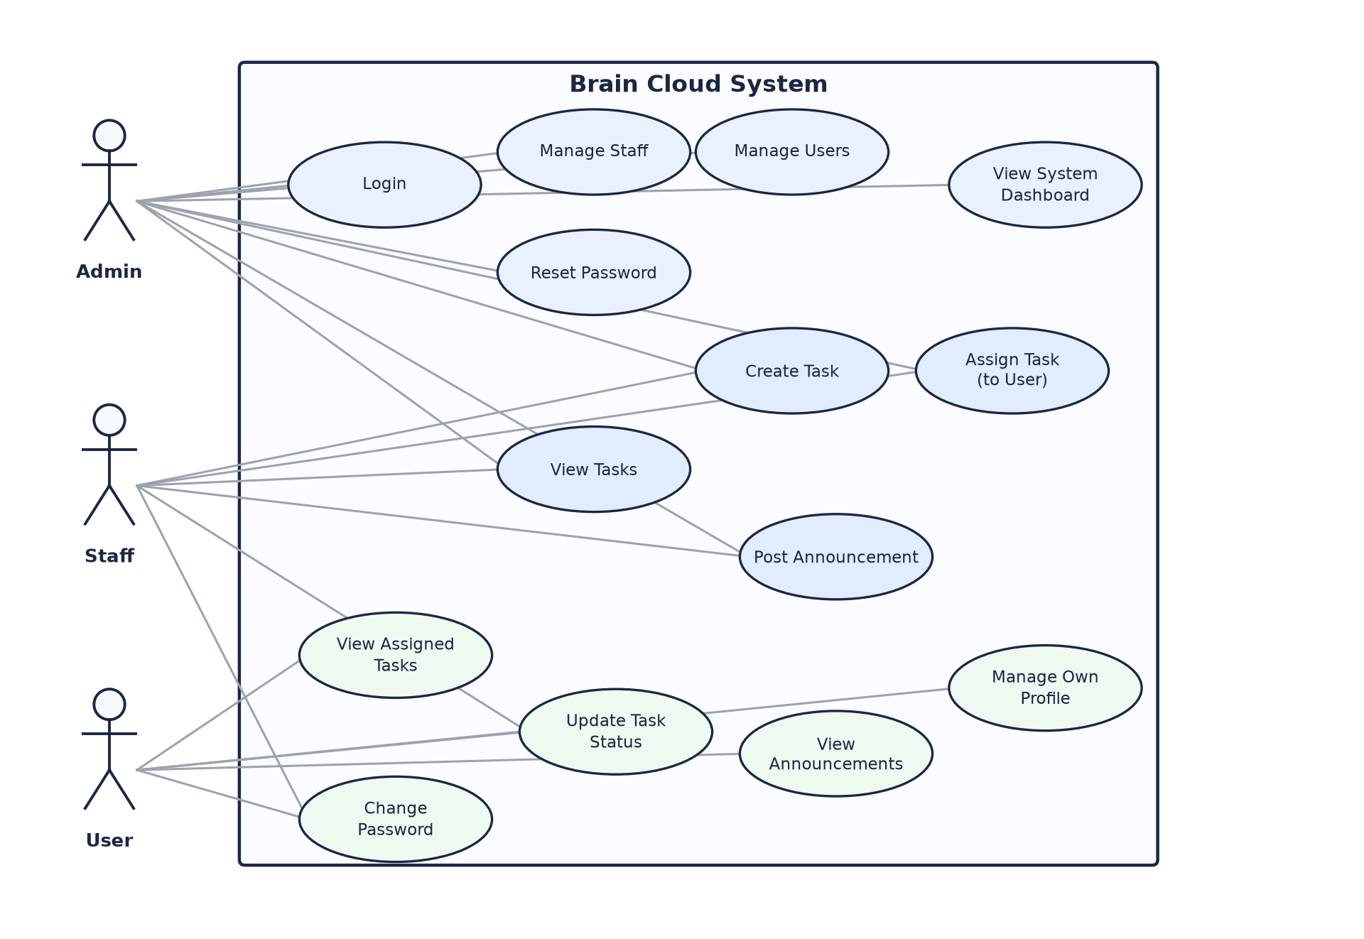
Figure 1: Use Case Diagram — Brain Cloud

Use Case Descriptions
Three representative use cases are described in detail below: logging in (shared by every role), creating and assigning a task (Admin/Staff), and updating a task's status (every role, scoped to their own permissions).
Use Case ID | UC-01
Name | Login
Actor(s) | Admin, Staff, User
Description | An actor authenticates with an email and password and is redirected to the dashboard that matches their role.
Preconditions | The actor has an active (non-deactivated) account.
Main Flow | 1. Actor submits email and password on the Login page.  2. The system looks up the account by email.  3. The system verifies the password against the stored bcrypt hash.  4. The system signs a JWT containing the user's id and role.  5. The system returns the token and profile; the client stores both and redirects to the actor's role-specific dashboard.
Alternate / Exception Flow | If the password is incorrect, a 401 error is returned. If the account is deactivated, a 403 error is returned. If mustChangePassword is set on the account, the actor is redirected to the forced password-reset page instead of the dashboard.
Postconditions | The actor holds a valid JWT and is logged into their role-specific dashboard.

Use Case ID | UC-02
Name | Create and Assign Task
Actor(s) | Admin, Staff
Description | An Admin or Staff member creates a task and assigns it to a User account.
Preconditions | The actor is authenticated as Admin or Staff, and at least one active User account exists to assign the task to.
Main Flow | 1. Actor opens the task creation form and enters a title, description, priority, and due date.  2. Actor selects a User account to assign the task to.  3. Actor submits the form; the client calls POST /api/tasks.  4. The system verifies the actor's role (ADMIN or STAFF) and that the selected assignee is an account with role USER.  5. The system creates the task and returns it to the client.  6. The task appears on the assigned User's dashboard and task list.
Alternate / Exception Flow | If the assignee is not a USER-role account, the request is rejected with a 400 error, even if sent directly to the API. If the actor is a plain User, the request is rejected with a 403 error.
Postconditions | A new task exists in the TODO state, visible to its assignee, creator, and any Admin.

Use Case ID | UC-03
Name | Update Task Status
Actor(s) | Admin, Staff, User
Description | An actor moves a task through its status lifecycle.
Preconditions | The task exists, and the actor is either the task's assignee or an Admin/Staff member.
Main Flow | 1. Actor opens a task they are permitted to see.  2. Actor selects a new status (e.g. IN_PROGRESS, COMPLETED, or CANCELLED).  3. The client calls PATCH /api/tasks/:id/status.  4. If the actor is a USER, the system verifies the task is assigned to them.  5. The system updates the task's status and returns the updated task.
Alternate / Exception Flow | If a User attempts to update a task not assigned to them, the system rejects the request with a 403 error, even if the task id is guessed or supplied directly.
Postconditions | The task reflects its new status on every dashboard and list view that shows it.

Context Model
Figure 2 is a Level 0 data flow diagram showing Brain Cloud as a single process, its external entities (the three human roles plus the MongoDB data store it depends on), and the data that flows between them. No entity communicates directly with another — every flow passes through the Brain Cloud system, which is what lets it enforce role-based access on every request.
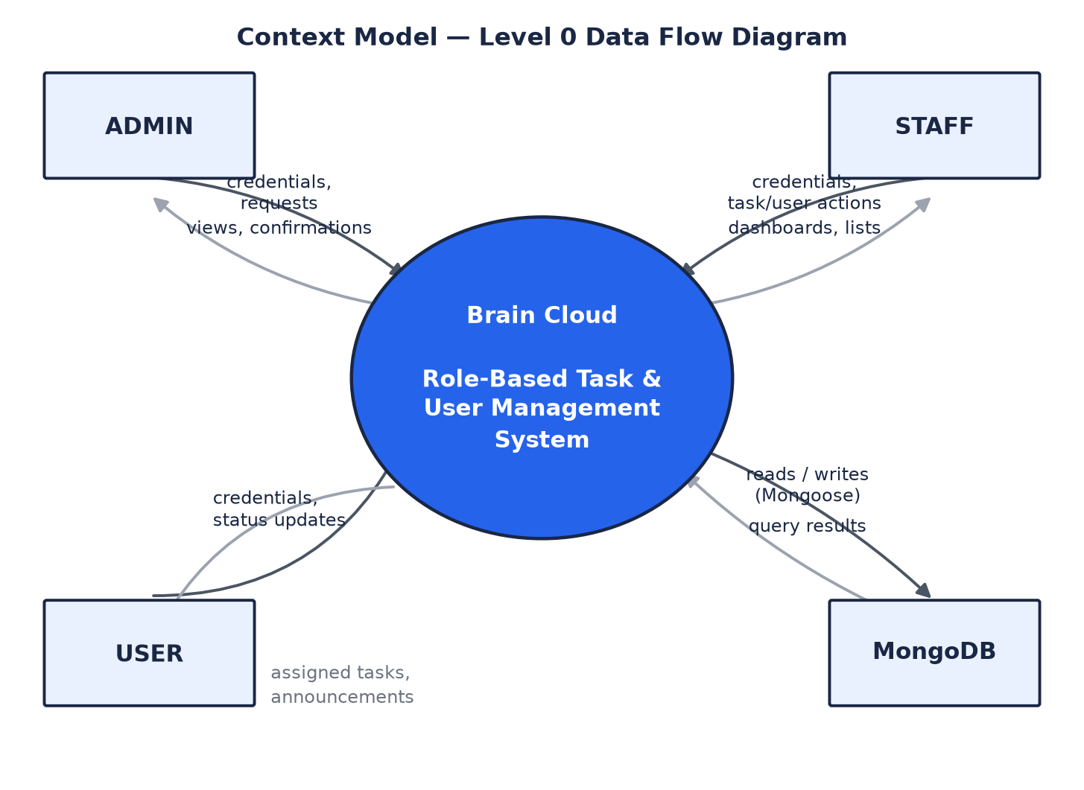
Figure 2: Context Model — Level 0 Data Flow Diagram

Admin and Staff send credentials and management requests (create/edit/deactivate accounts, create and assign tasks, post announcements) and receive dashboards, lists, and confirmations in return. Users send credentials and status updates for their own tasks, and receive their assigned tasks and the announcement feed. MongoDB is the single persistent data store underlying all three collections — User, Task, and Announcement — accessed exclusively through the Mongoose models in the backend.

Design
This section presents how Brain Cloud is built to meet the requirements in Section 2: its layered architecture, the hardware/software environment it runs on, its database structure, its interface design, and the sequence and state behaviour of its two central workflows — authentication and task management.

Architectural Design
Brain Cloud follows a straightforward layered architecture (Figure 3) with no microservices, message queues, or caching layers — a React single-page application talking to a single Express REST API backed by one MongoDB database.
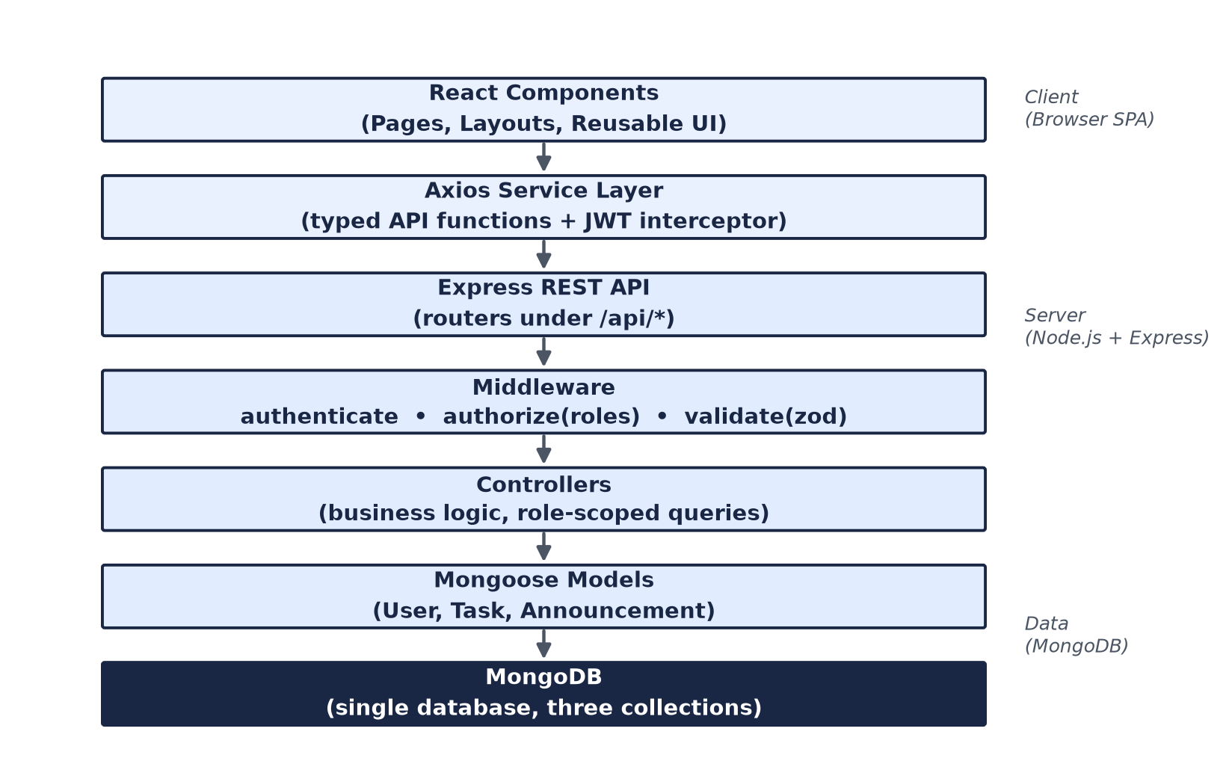
Figure 3: Layered Architecture

Each layer has exactly one responsibility, so a request can be traced from click to database in under a minute:
• React Components render pages and call functions from the services layer — they never call axios or fetch directly.
• The Axios Service Layer wraps every API endpoint in a typed function and attaches the JWT via a request interceptor.
• The Express REST API receives the request and routes it to the matching router.
• Middleware runs first: authenticate verifies the JWT and loads the user, authorize(...roles) checks the user's role, and validate(schema) checks the request body with Zod.
• Controllers contain the business logic, e.g. "only return tasks assigned to this user if they are a USER".
• Mongoose Models define schemas, validation, and hooks such as hashing a password before save.
• MongoDB persists the data.
Authorization is enforced only on the backend. The frontend also hides buttons and routes a role should not see, but this is a UX convenience — the API independently rejects any unauthorized request with 403 Forbidden, even if the request bypasses the UI entirely. This structure was chosen deliberately over more "enterprise" patterns (repository pattern, CQRS, dependency-injection containers) because it maps directly onto how Express and Mongoose are taught and documented, and because there is no infrastructure to run beyond Node.js and MongoDB.

Hardware Specifications
Brain Cloud has no special hardware requirements — it runs anywhere Node.js and MongoDB run. Table 4 summarises the development and deployment environment.
Component | Minimum | Recommended
Development machine | 4 GB RAM, dual-core CPU, 5 GB free disk | 8+ GB RAM, quad-core CPU, SSD storage
Node.js runtime | Node.js 18 LTS | Node.js 20 LTS
Database | MongoDB 6 (local, single node) | MongoDB Atlas free-tier shared cluster
Server / hosting (deployment) | 1 vCPU, 512 MB RAM (e.g. a free-tier PaaS dyno) | 1+ vCPU, 1 GB+ RAM for steadier response times under load
Client device | Any device with a modern evergreen browser (Chrome, Edge, Firefox, Safari) | Same — the UI is responsive down to mobile widths
Network | A standard broadband/mobile connection | Same — the API is lightweight JSON over HTTPS

Table 4: Hardware & Software Environment

Database Structure
Brain Cloud uses MongoDB with three collections, managed through Mongoose schemas: User, Task, and Announcement. Figure 4 shows their fields and relationships.
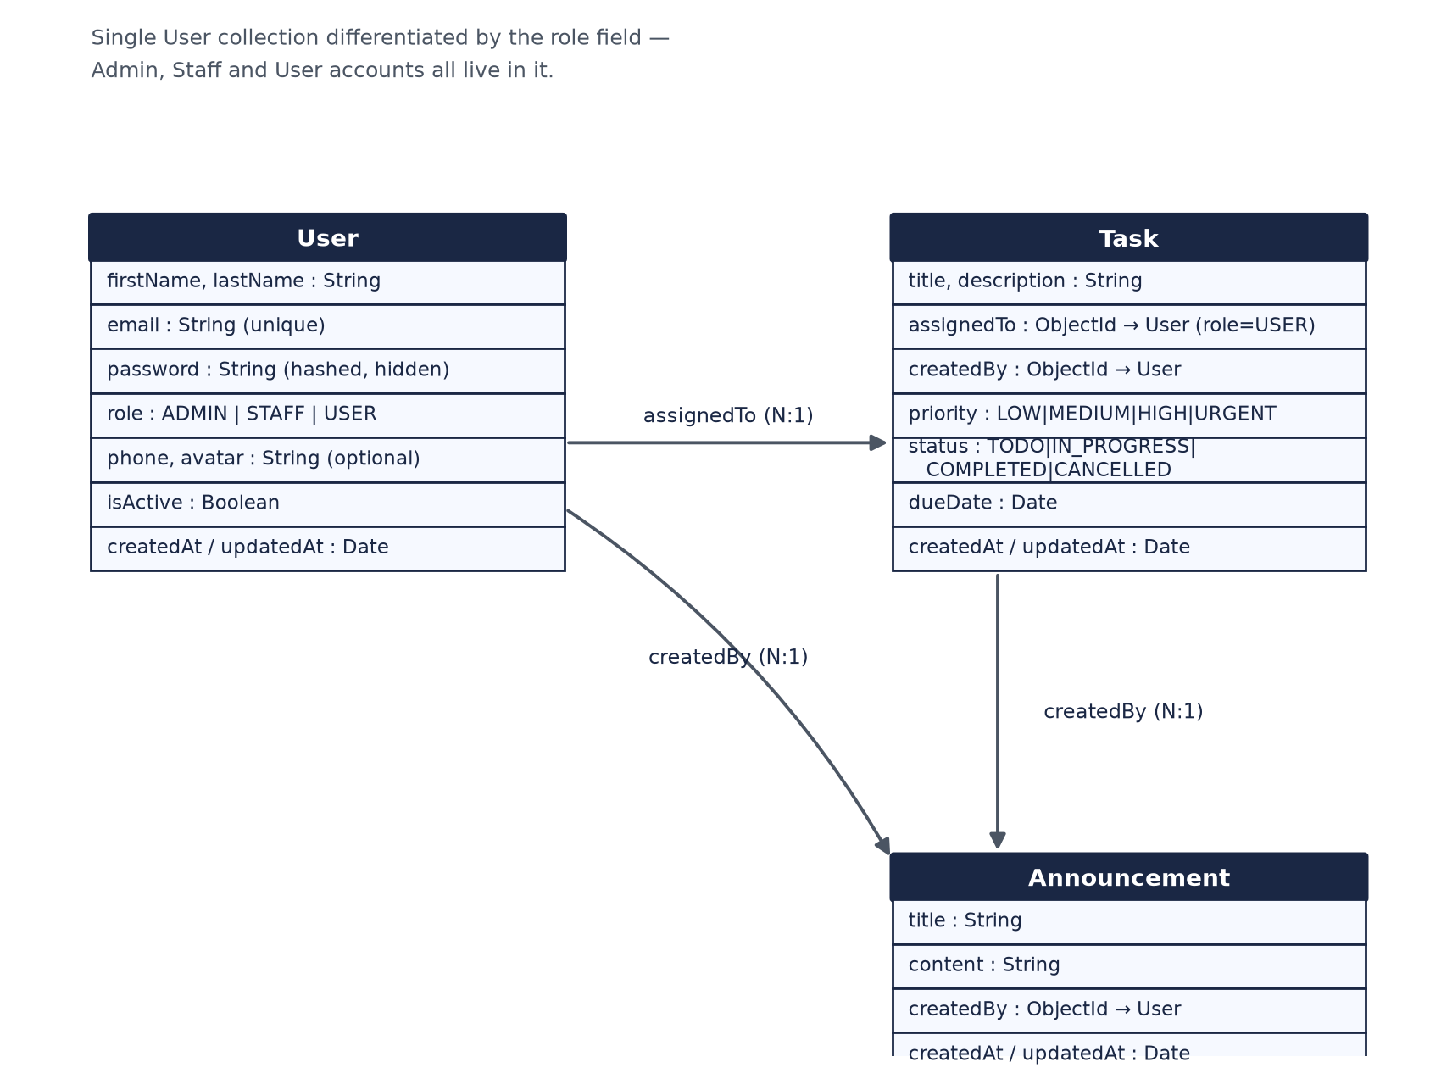
Figure 4: Entity-Relationship Diagram

A separate Staff or Admin collection was deliberately avoided — Admin, Staff, and User accounts are all stored in the single User collection, differentiated only by the role field. This avoids duplicating near-identical schemas for what is conceptually the same entity (a person who can log in) and keeps the authentication logic simple, since there is only ever one collection to check on login.
Task.assignedTo must reference a User document with role: "USER" — this is not expressible as a plain Mongoose schema-level constraint, so it is checked explicitly in the task controller before every create/update. Task.assignedTo and Task.createdBy are populated with the referenced user's name and email whenever a task is fetched, so the frontend never needs a separate lookup.
Index | Purpose
User.email (unique) | Enforces no duplicate accounts; used on every login.
Task.{assignedTo, status} (compound) | Supports the most common query pattern — "show this user's tasks filtered by status" — used by the User dashboard and task list.

Table 5: Database Indexes

Interface Design
The frontend is a Vite-powered React and TypeScript single-page application, styled entirely with Tailwind CSS in a clean, modern SaaS style. Figures 5 and 6 show wireframes of the two pages every role passes through most often — the login page and a role dashboard.
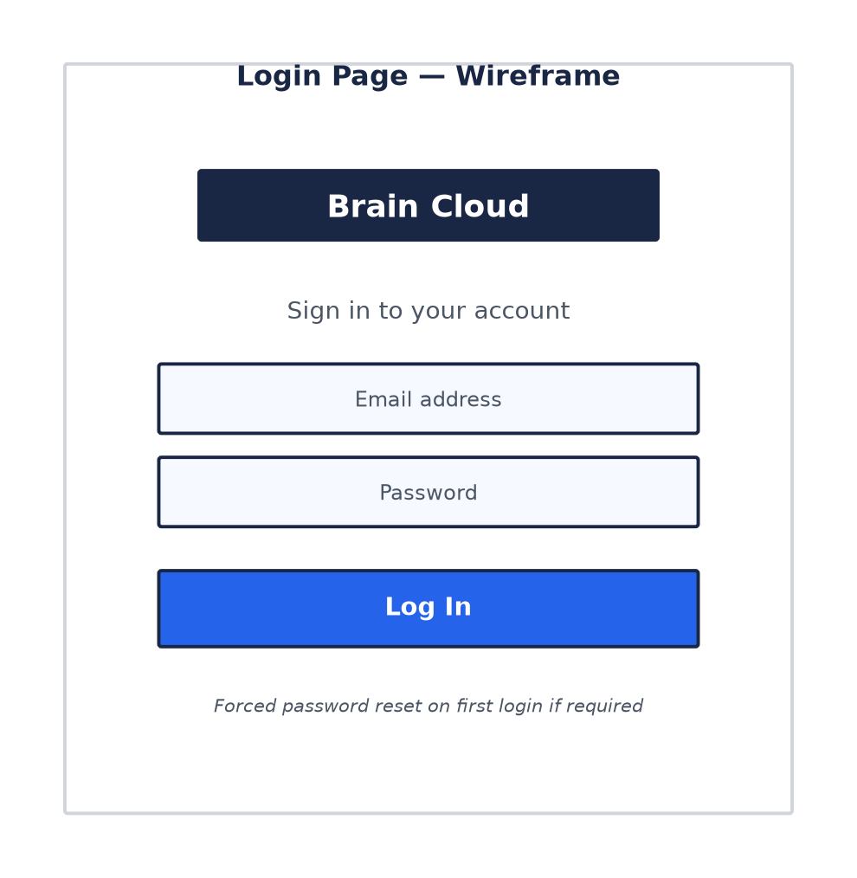
Figure 5: Login Page — Wireframe

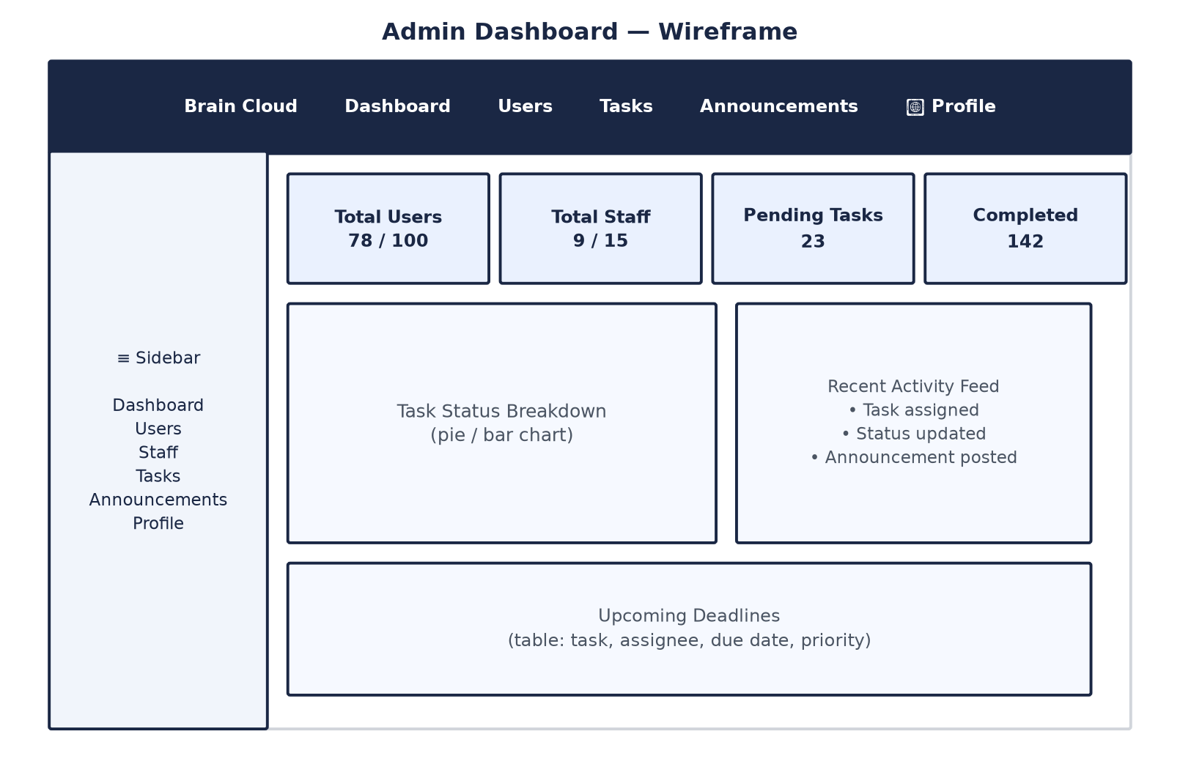
Figure 6: Admin Dashboard — Wireframe

Every role's dashboard follows the same layout — a fixed sidebar for navigation, stat cards summarising the numbers that matter to that role, a task-status chart, and recent activity/upcoming-deadline panels — but is populated with data scoped to what that role is allowed to see.
A small set of reusable components is shared across every page, instead of building one-off UI per screen:
• Button, FormInput, Card, Modal, ConfirmDialog — generic UI primitives.
• Badge (with role / status / priority colour helpers) — consistent coloured labels.
• StatCard — the icon + number + label cards used on every dashboard.
• Pagination, LoadingSpinner, EmptyState — shared list-page states.
Rather than building separate list/form pages per role, a few pages are parameterised and reused: UserManagementPage and UserFormPage render both the Staff and User management screens by taking a service and basePath as props, and TaskManagementPage/TaskDetailPage are shared across Admin, Staff, and User task views via canCreate/canManage flags. Forms use plain controlled state with Zod schemas mirroring the backend validators, so a failed client-side validation never reaches the API.

Sequence Diagrams
Figures 7 and 8 trace the two most important interactions in the system: authenticating, and creating/assigning a task.
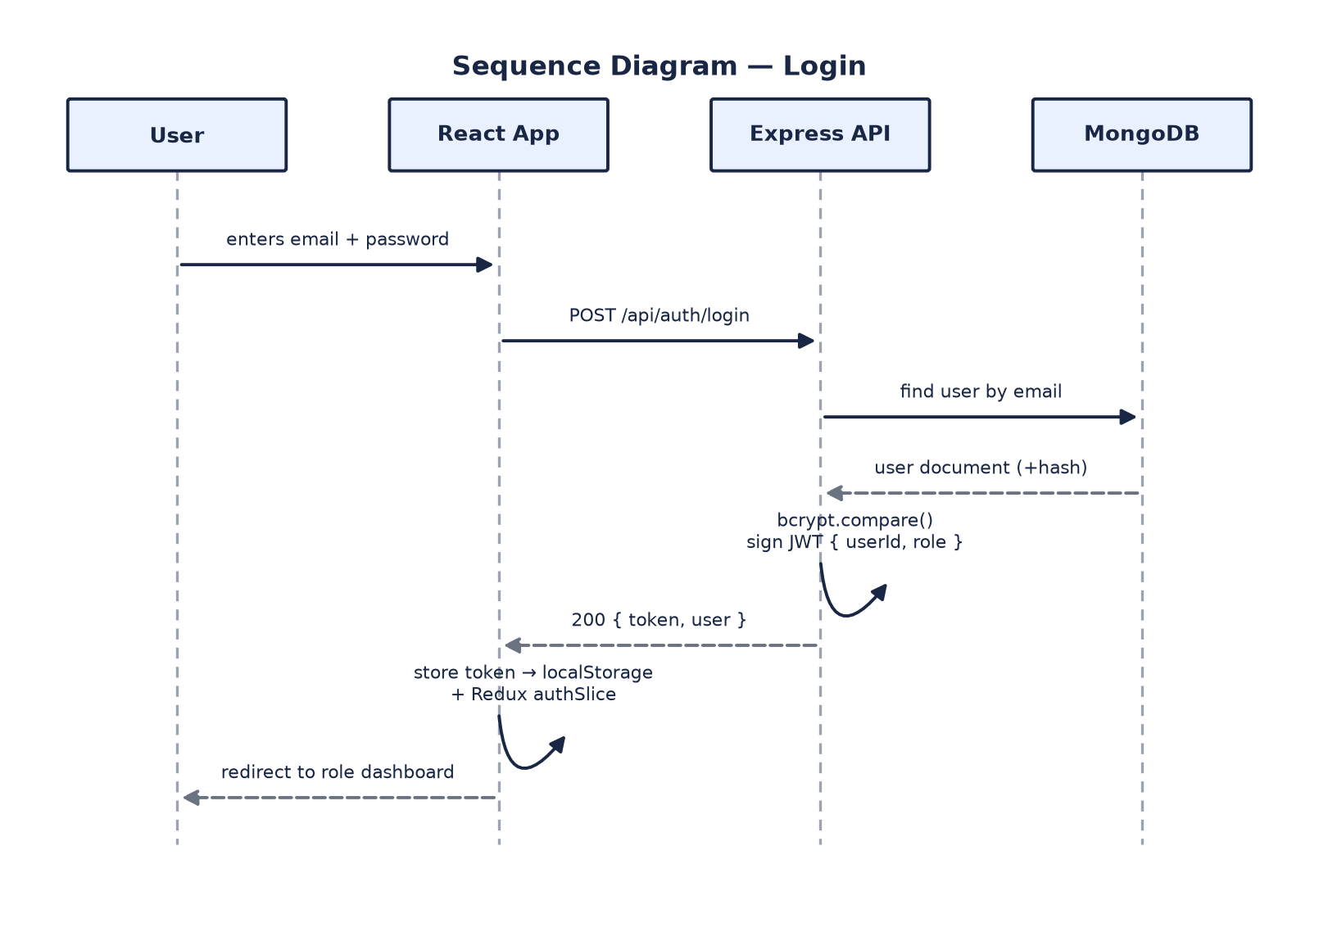
Figure 7: Sequence Diagram — Login

On login, the password is never compared or stored as plain text — bcrypt.compare runs against the stored hash, and the resulting JWT (containing only the user's id and role) is the sole piece of state the client holds afterwards.

Figure 8 shows task creation and assignment, including the row-level checks that run before the write is allowed.
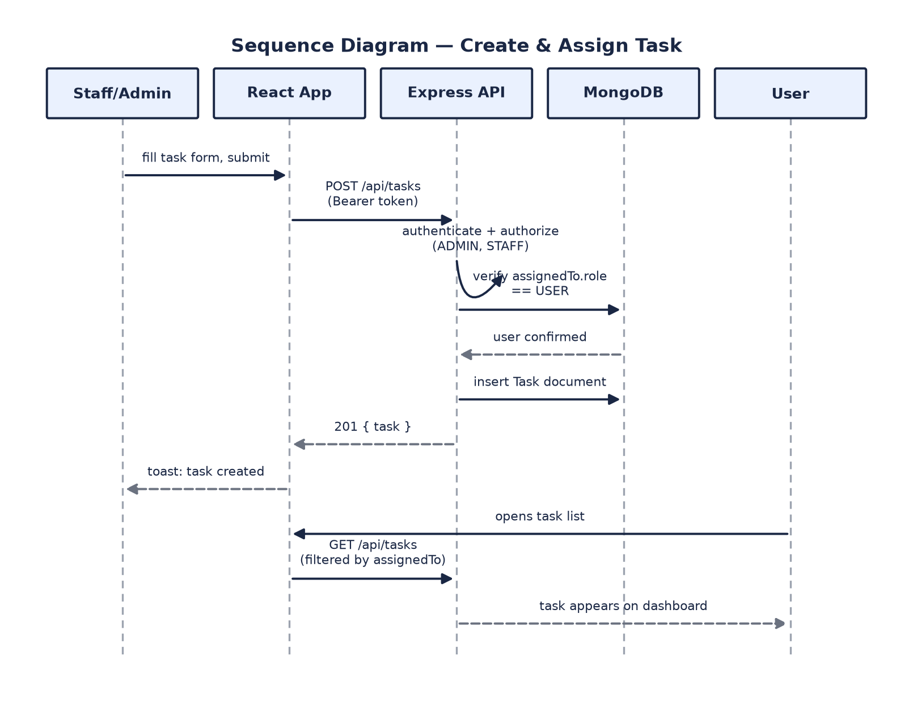
Figure 8: Sequence Diagram — Create & Assign Task

Two checks happen before any task is persisted: authorize("ADMIN", "STAFF") rejects a plain User outright, and the controller separately verifies that the chosen assignee is a USER-role account — a task can never be assigned to a Staff or Admin account, even by a client that calls the API directly. Once created, the task is immediately visible to its assignee because every task list query for a USER is forced to assignedTo = <their own id>.

State Diagrams
A task's status is the one entity in the system with a meaningful state machine. Figure 9 shows its lifecycle.
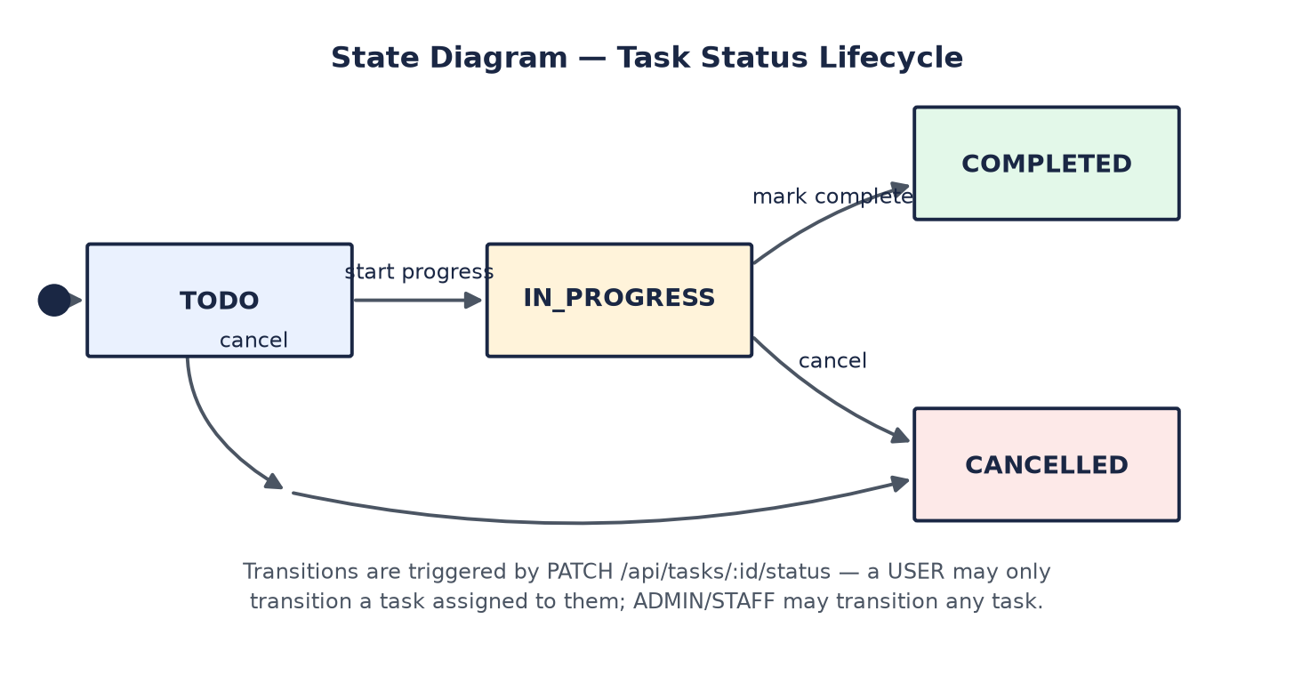
Figure 9: State Diagram — Task Status Lifecycle

Every transition is triggered by PATCH /api/tasks/:id/status and is subject to the same row-level rule used everywhere else in the system: a User may only transition a task assigned to them, while an Admin or Staff member may transition any task. There is no transition back into TODO once a task has moved to IN_PROGRESS — cancellation is the only way out of an in-progress task besides completing it.

References
[1] Meta Platforms, Inc., "React -- The library for web and native user interfaces," react.dev. [Online]. Available: https://react.dev/
[2] Microsoft, "TypeScript -- JavaScript with syntax for types," typescriptlang.org. [Online]. Available: https://www.typescriptlang.org/
[3] Tailwind Labs Inc., "Tailwind CSS -- Rapidly build modern websites," tailwindcss.com. [Online]. Available: https://tailwindcss.com/
[4] Remix Software, Inc., "React Router," reactrouter.com. [Online]. Available: https://reactrouter.com/
[5] Redux Toolkit maintainers, "Redux Toolkit -- The official, opinionated, batteries-included toolset for efficient Redux development," redux-toolkit.js.org. [Online]. Available: https://redux-toolkit.js.org/
[6] Axios contributors, "Axios -- Promise based HTTP client for the browser and node.js," axios-http.com. [Online]. Available: https://axios-http.com/
[7] Colin McDonnell, "Zod -- TypeScript-first schema validation with static type inference," zod.dev. [Online]. Available: https://zod.dev/
[8] OpenJS Foundation, "Node.js," nodejs.org. [Online]. Available: https://nodejs.org/
[9] OpenJS Foundation, "Express -- Fast, unopinionated, minimalist web framework for Node.js," expressjs.com. [Online]. Available: https://expressjs.com/
[10] MongoDB, Inc., "MongoDB Documentation," mongodb.com. [Online]. Available: https://www.mongodb.com/docs/
[11] Automattic, "Mongoose -- Elegant MongoDB object modeling for Node.js," mongoosejs.com. [Online]. Available: https://mongoosejs.com/
[12] Auth0, Inc., "jsonwebtoken -- An implementation of JSON Web Tokens," GitHub. [Online]. Available: https://github.com/auth0/node-jsonwebtoken
[13] D. Wijaya et al., "bcryptjs," npmjs.com. [Online]. Available: https://www.npmjs.com/package/bcryptjs
[14] Recharts Group, "Recharts -- A composable charting library built on React components," recharts.org. [Online]. Available: https://recharts.org/
[15] Node.js contributors, "Test runner," Node.js API documentation. [Online]. Available: https://nodejs.org/api/test.html

Marking Guide:
Criteria (used as a guide only) | Exceeds  Expectations  (100% - 80%) | Meets  Expectations  (80% -70%) | Approaches  Expectations  (70% - 50%) | Does Not Meet  Expectations  (50%- 0%)
Other Evaluation
Executive Summary
Document format
Connectedness between Sections
Completness
Specification
System Description
Feasibility Analysis
Requirements Specification
Use Cases
Context Model
Misc elements
Design
Architectural Design
Hardware Specifications
Database Structure
Interface Design
Sequence Diagrams
State Diagrams
Misc elements
Grammar
Spelling is satisfactory
Grammatical expression is satisfactory

