

CHAROTAR UNIVERSITY OF SCIENCE AND TECHNOLOGY

FACULTY OF TECHNOLOGY AND ENGINEERING

B. TECH (IT/CE/CSE/AIML)

Subject: Advanced Web Development Frameworks (ITUE301) | Semester: 5th

Practical Statement: Asynchronous Processing with Event-Driven Architecture.

Screenshots (Supplementary Problems are also implemented):
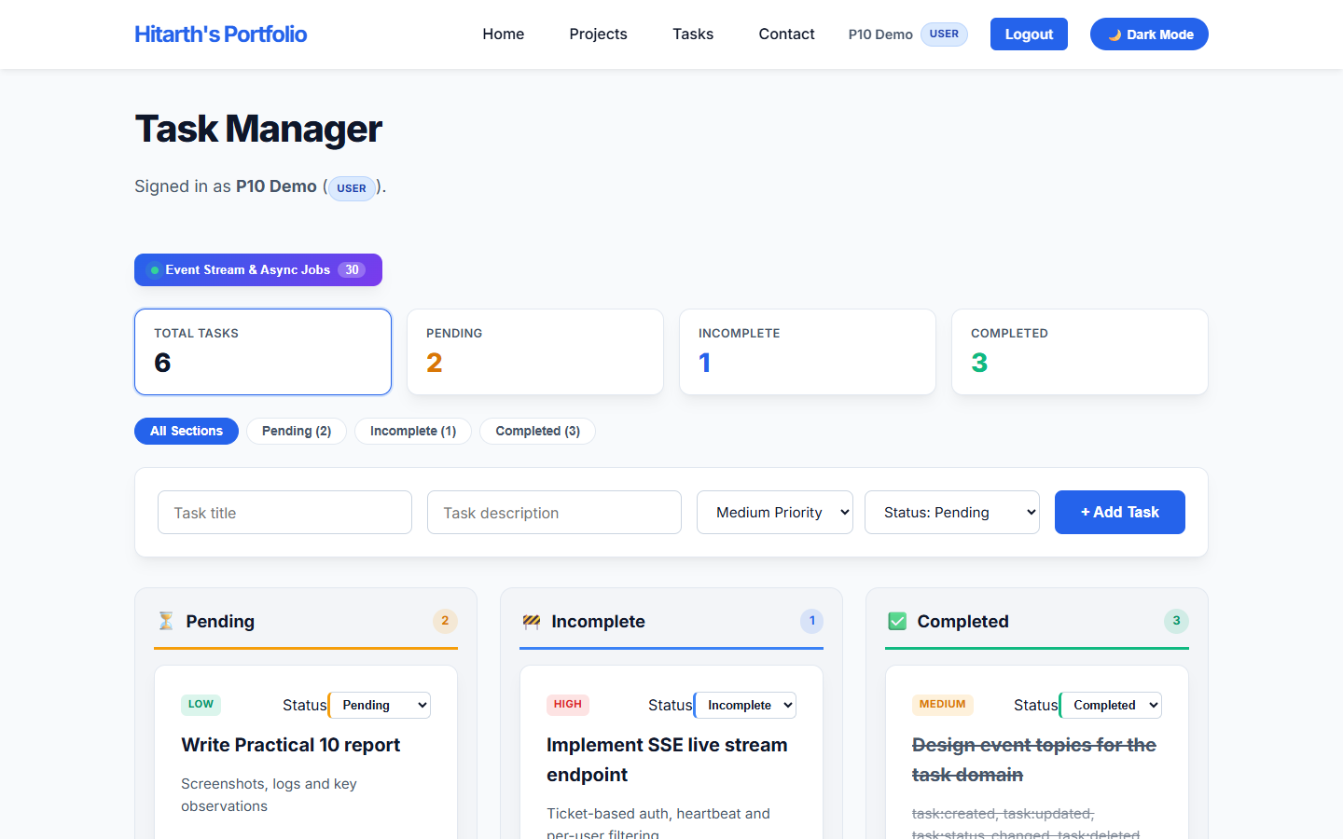
Figure 1: Tasks page connected to the Node.js + MongoDB backend, with the new "Event Stream & Async Jobs" button (live event counter) that opens the event-driven architecture panel.

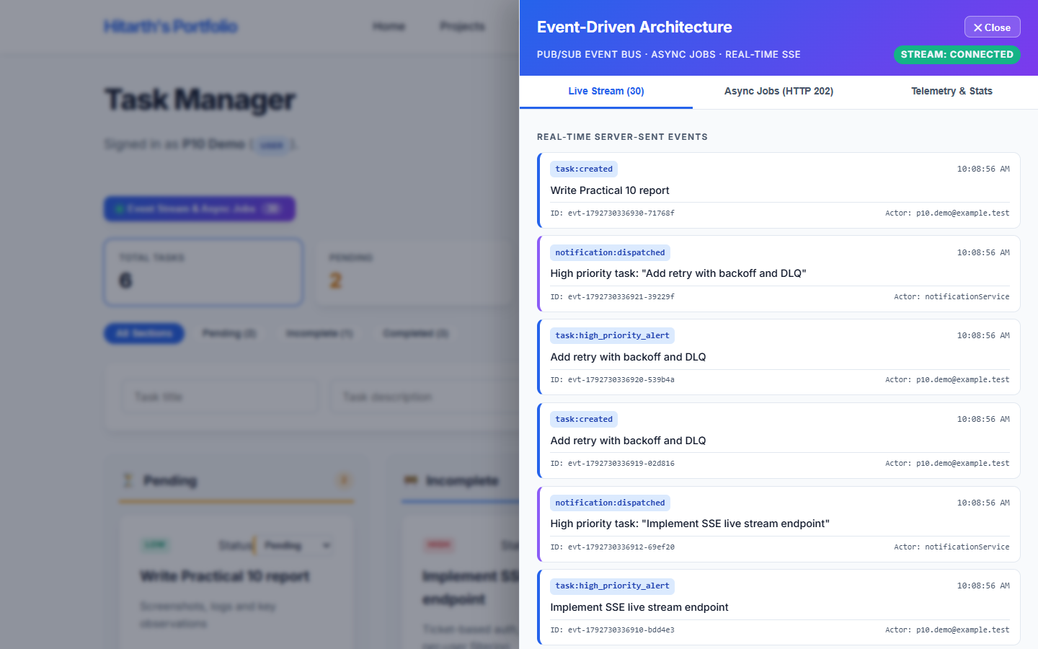
Figure 2: Event-Driven Architecture drawer on the Live Stream tab. The SSE stream is CONNECTED (opened with a single-use ticket, so the JWT never appears in the URL) and recent events are loaded from history.

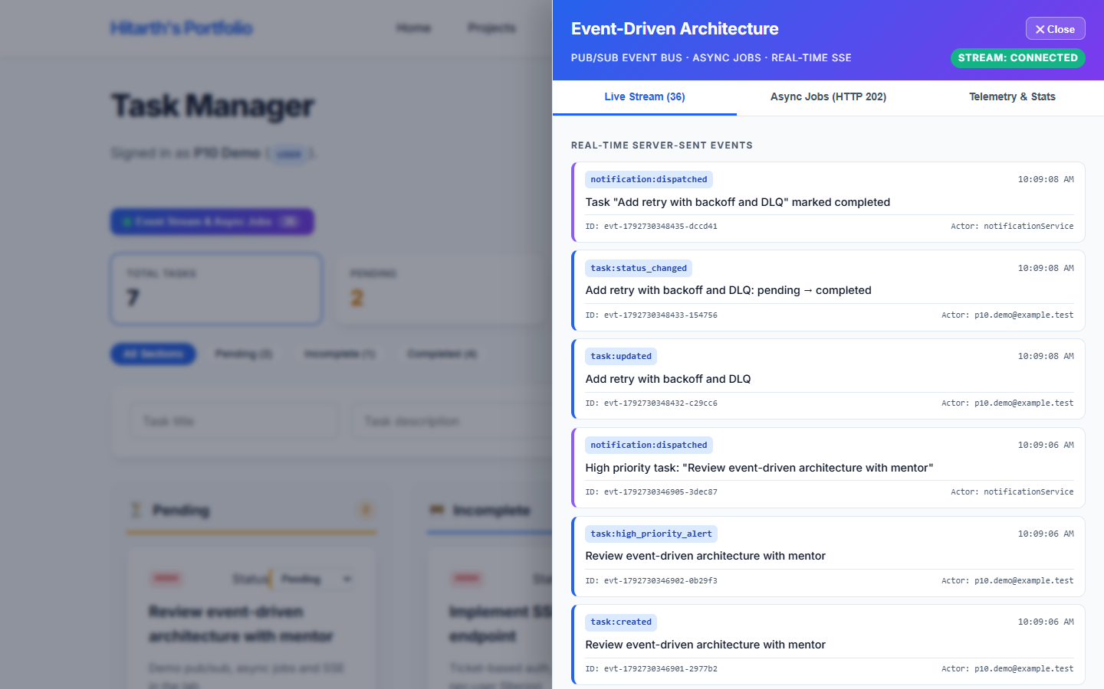
Figure 3: Creating a high-priority task and completing another from the dashboard publishes task:created, task:high_priority_alert, task:updated and task:status_changed; the notification subscriber reacts with notification:dispatched, all pushed to the browser in real time.

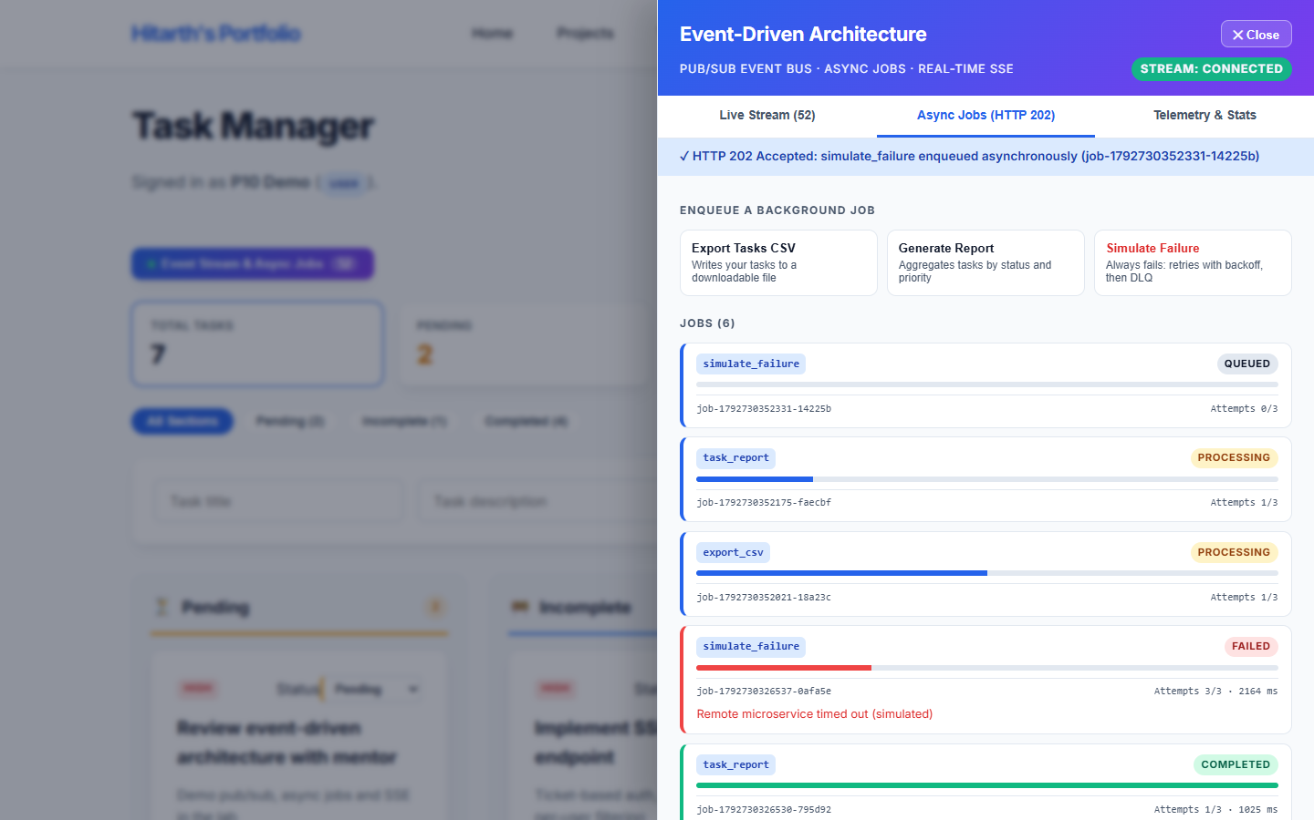
Figure 4: Async Jobs tab: each job request returns HTTP 202 Accepted immediately and is processed by background workers (concurrency 2), with live progress bars driven by job:progress events.

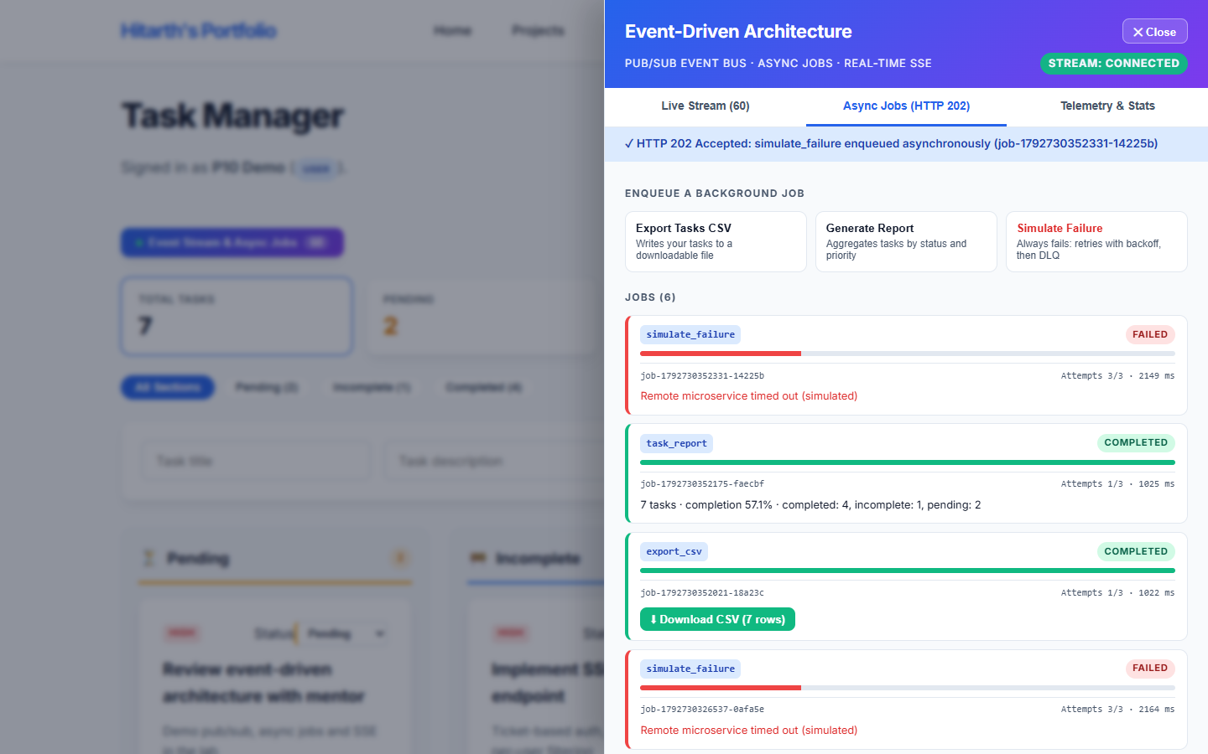
Figure 5: Completed jobs: export_csv produced a downloadable CSV, task_report returned an aggregate summary, and simulate_failure FAILED after 3/3 attempts (exponential backoff) and was moved to the Dead Letter Queue.

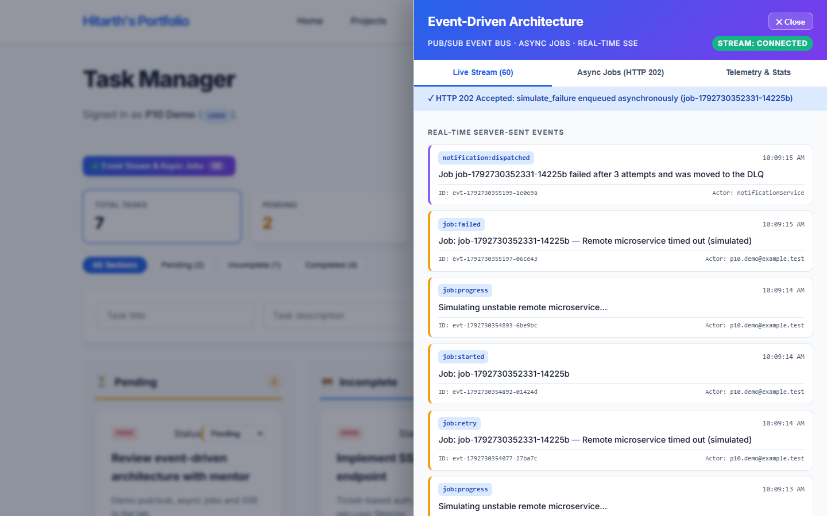
Figure 6: Live Stream showing the job lifecycle events (job:enqueued, job:started, job:progress, job:retry, job:completed, job:failed) with event IDs, timestamps and actors.

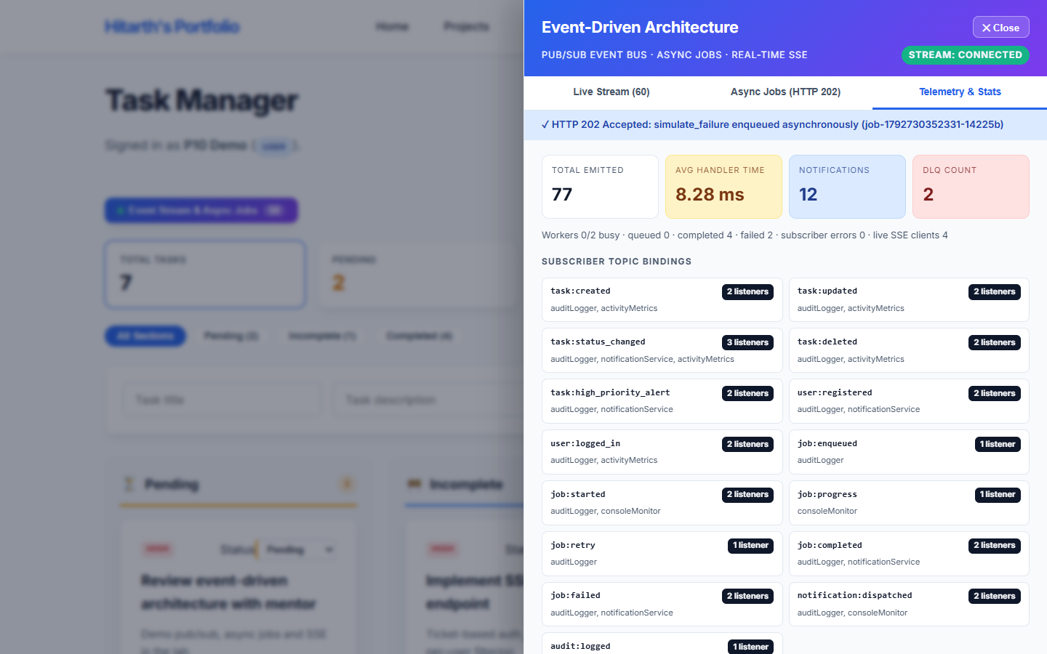
Figure 7: Telemetry & Stats tab: total events emitted, average subscriber handler time, notifications sent, DLQ count, worker/queue status, and the subscribers bound to each event topic.

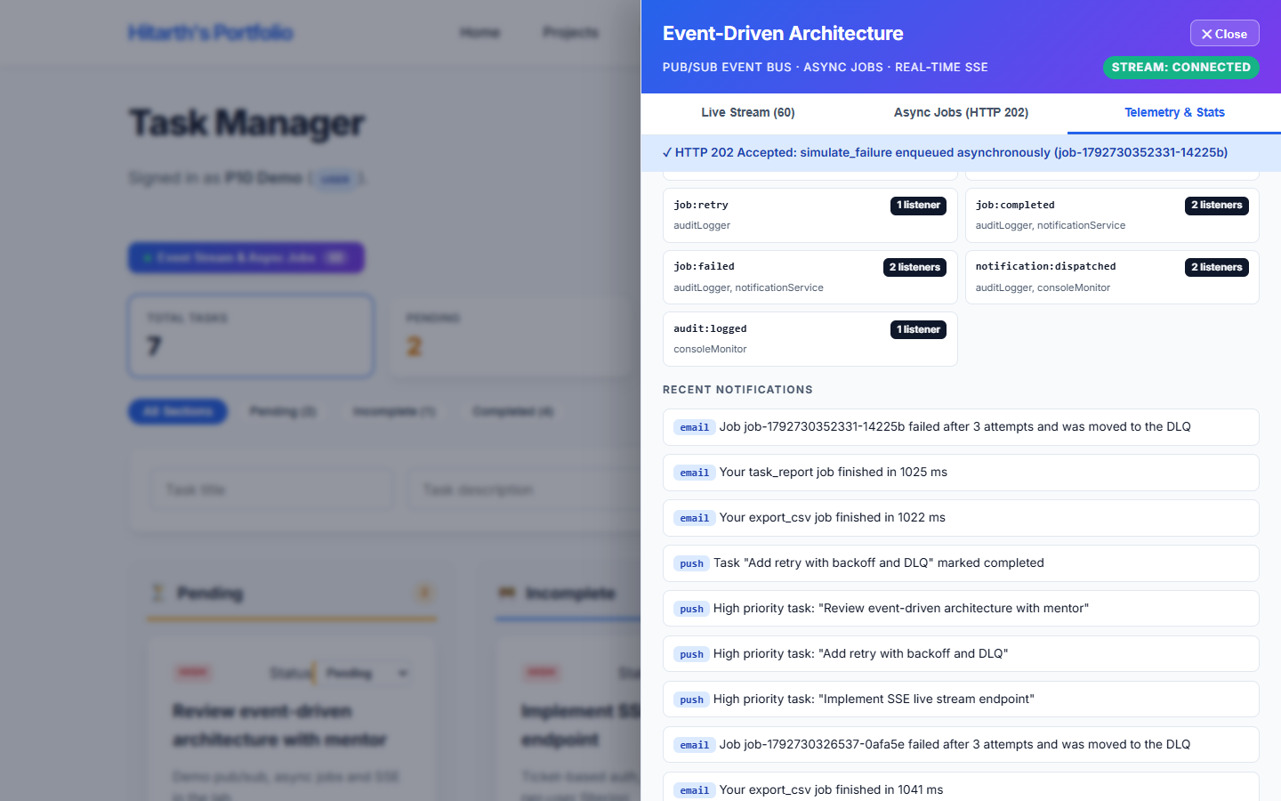
Figure 8: Telemetry tab scrolled: remaining topic bindings and the recent notifications produced by the notification subscriber (job finished, job failed / moved to DLQ, high-priority alerts).

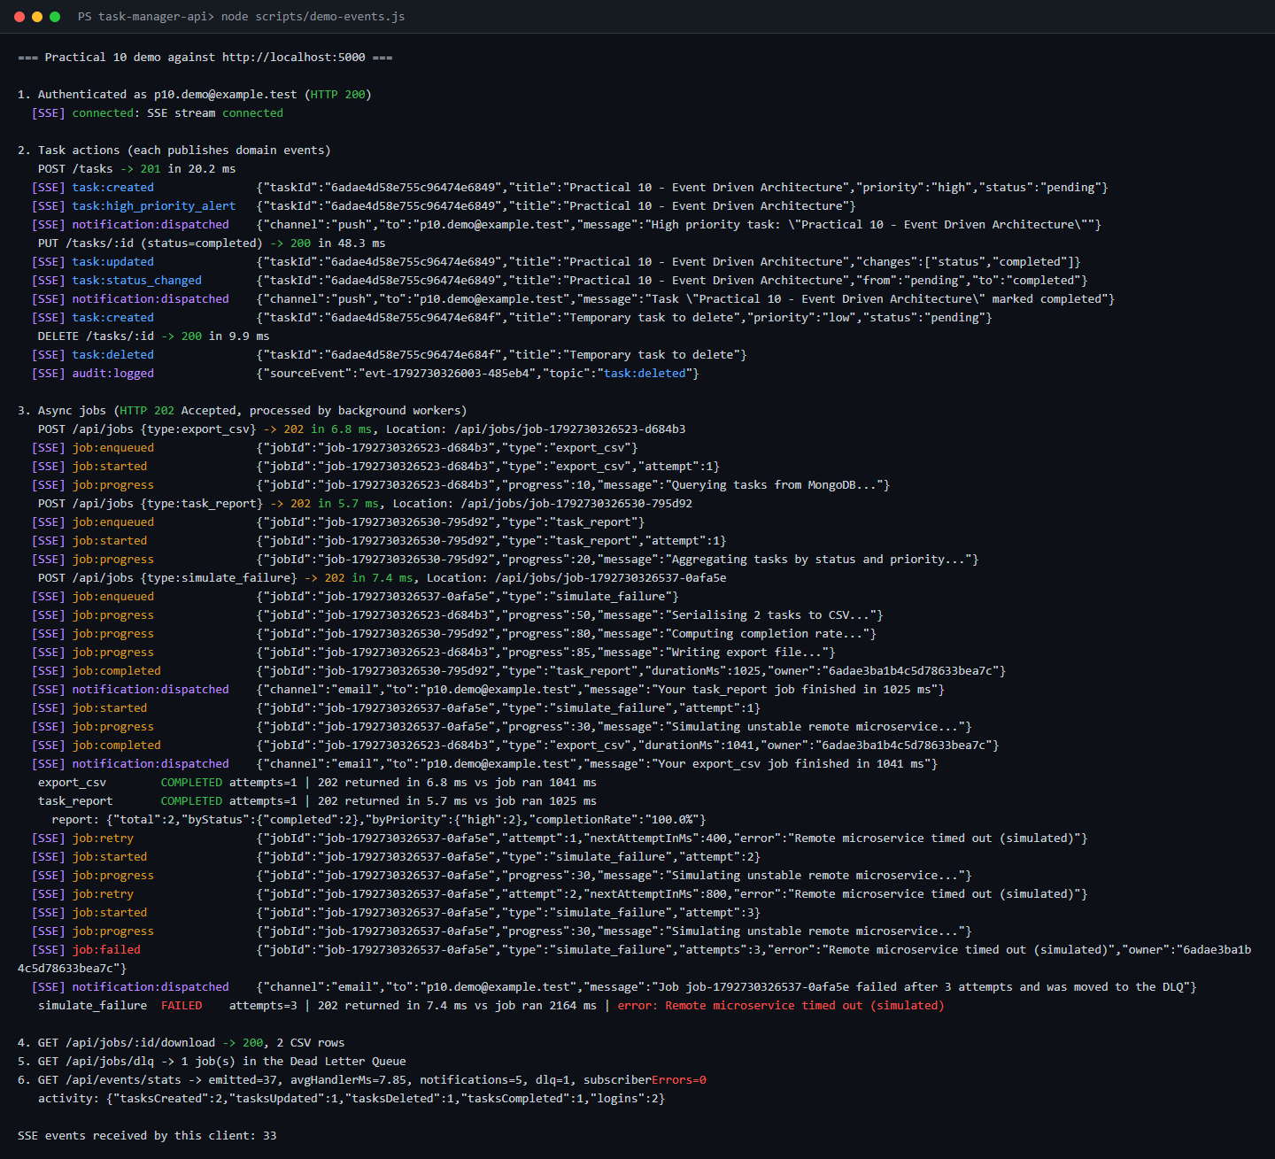
Figure 9: Terminal log of scripts/demo-events.js: the client receives every event over SSE; POST /api/jobs answers 202 in ~5-7 ms while the jobs themselves run ~1-2 s, proving the request is non-blocking.

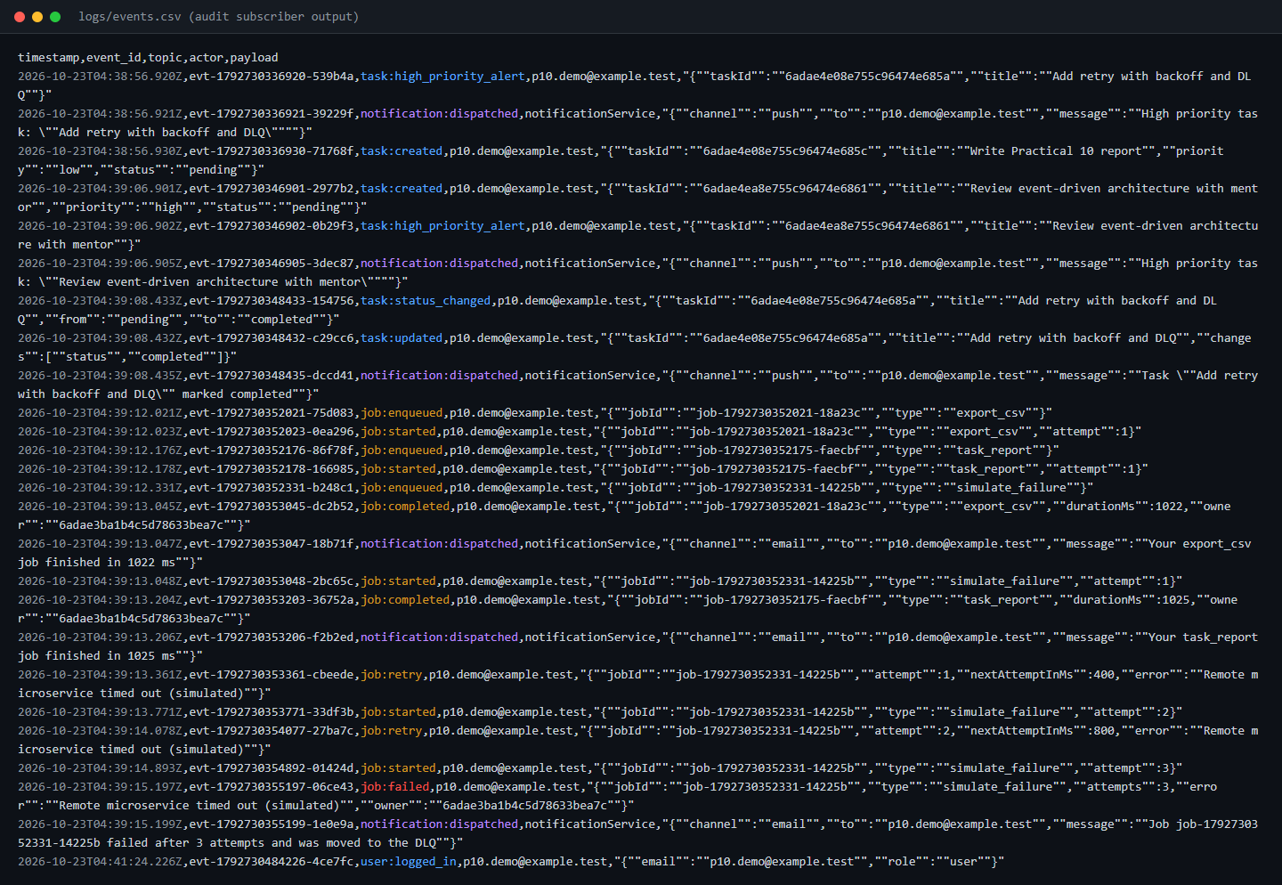
Figure 10: logs/events.csv written by the audit-logger subscriber: one row per domain event with timestamp, event ID, topic, actor and JSON payload.

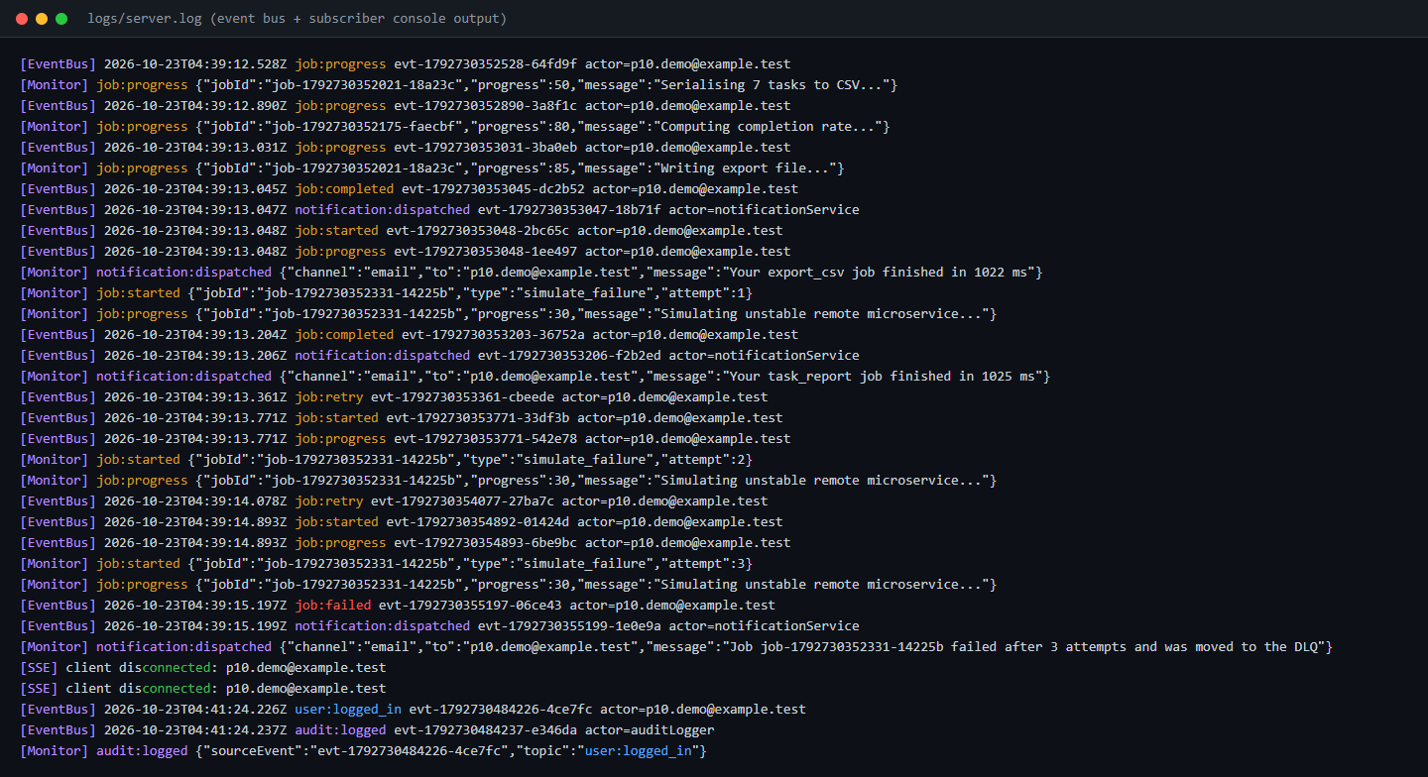
Figure 11: logs/server.log: [EventBus] publish lines and [Monitor] subscriber output, showing the retry with backoff and the final job:failed event followed by the failure notification.

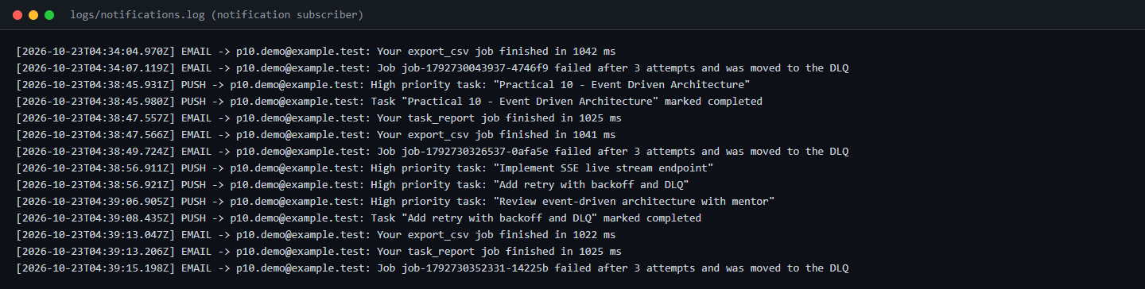
Figure 12: logs/notifications.log written by the notification subscriber (simulated email / push channels), fully decoupled from the controllers that produced the events.

Github Repo Link: https://github.com/hitarth1812/Student-Portfolio

