Library Management System

1. Requirement of system:  
   Book Information: Stores information about books, including title, author, publication date, and genre.

Member Information: Stores information about library members, including registration details and borrowing history.

Transaction Data: Stores data about book borrowing and returning, including due dates and fines.

2) Entities:  
 Books information  
 Student information  
 Fine Details  
 Librarian Information  
 Issue Detail

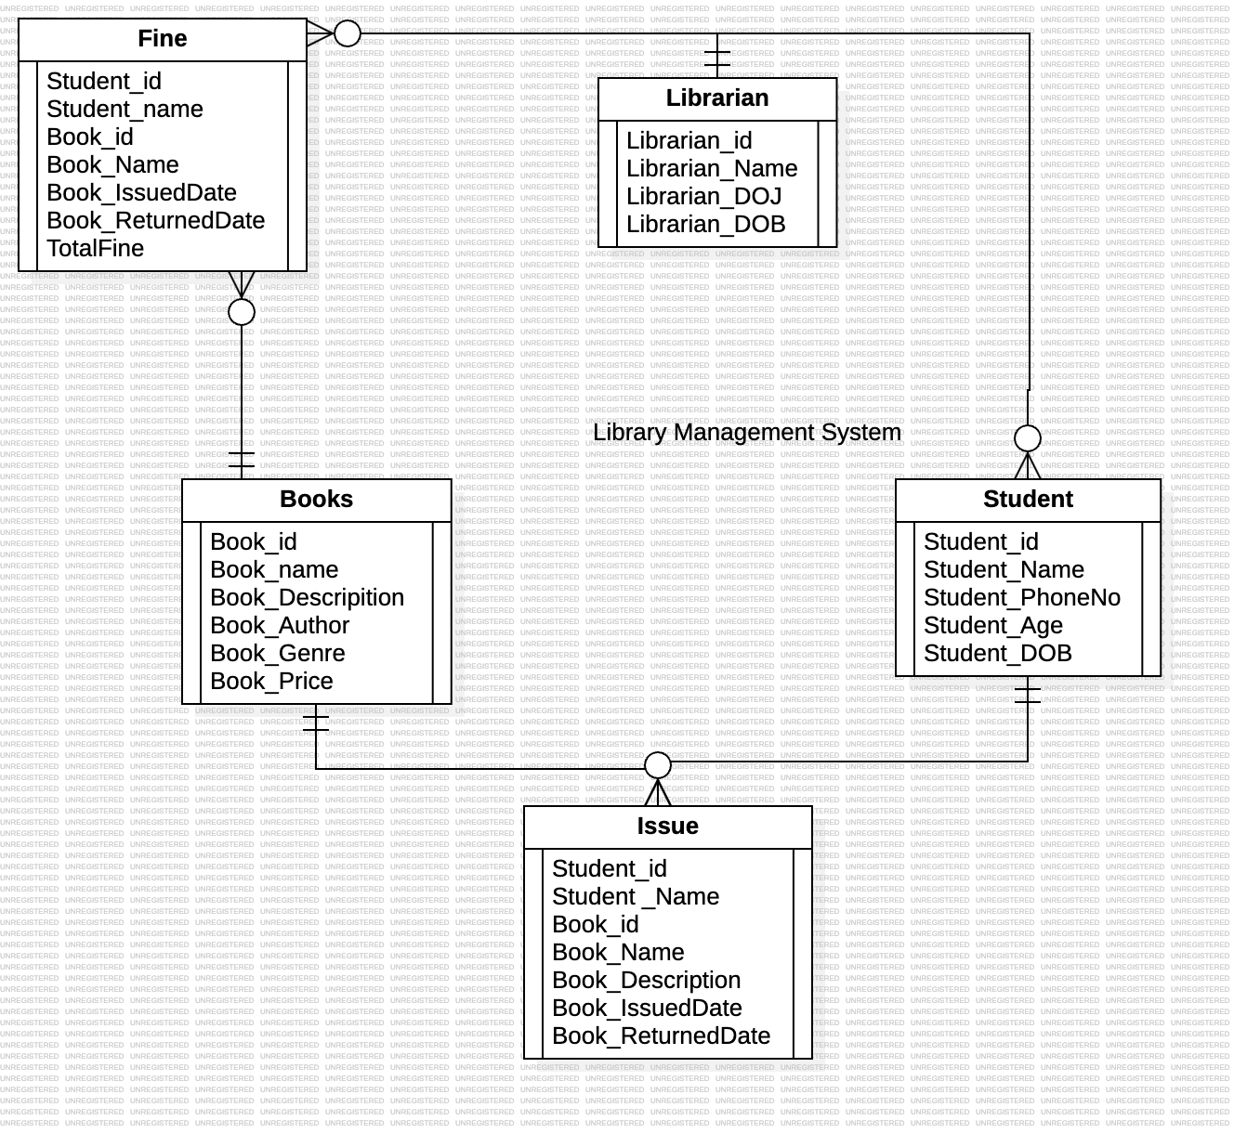3)Entities Relationship Diagram by Using StarUML

4) Entities Relationship Diagram by Using MS Word

Name

ID

DOB

Librarian

DOJ

M

Name

ID

Student

M

M

Phone_no

Age

1

1

DOB

Price

Name

Library  
Management  
System

M

1

M

Total Fine

Book _   
 Returned

Book_  
Issue

Book_Name

Student_  
Name

Book_ID

Student_ID

Book _   
 Returned

Book_  
Issue

Book_  
Description

Book_Name

Student_  
Name

Genre

Author

Description

Fine

Issue

Book

Book_ID

Student_ID

ID