DBMS

Hitarth Patel

150096724046

Jensen Huang

4 March 2025

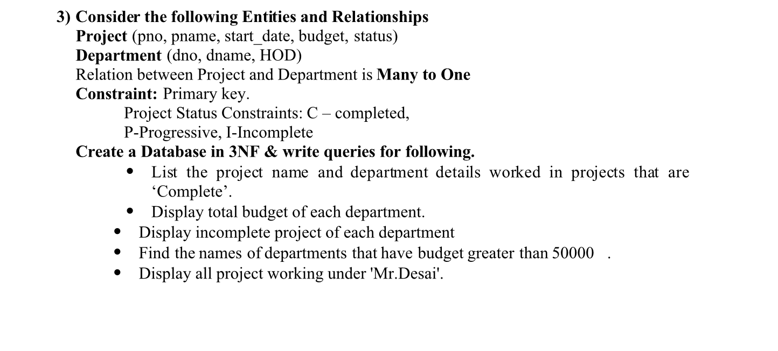

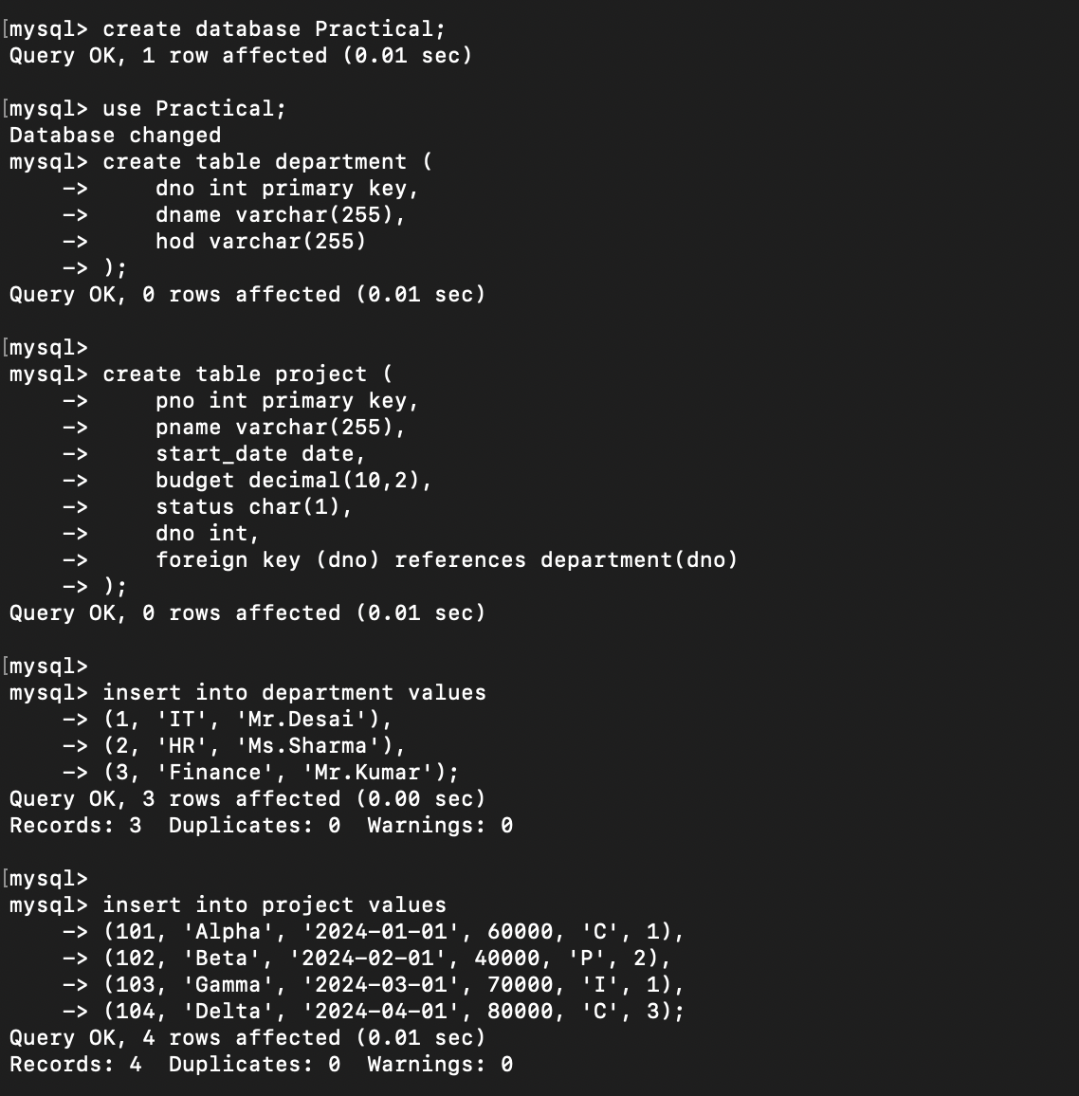

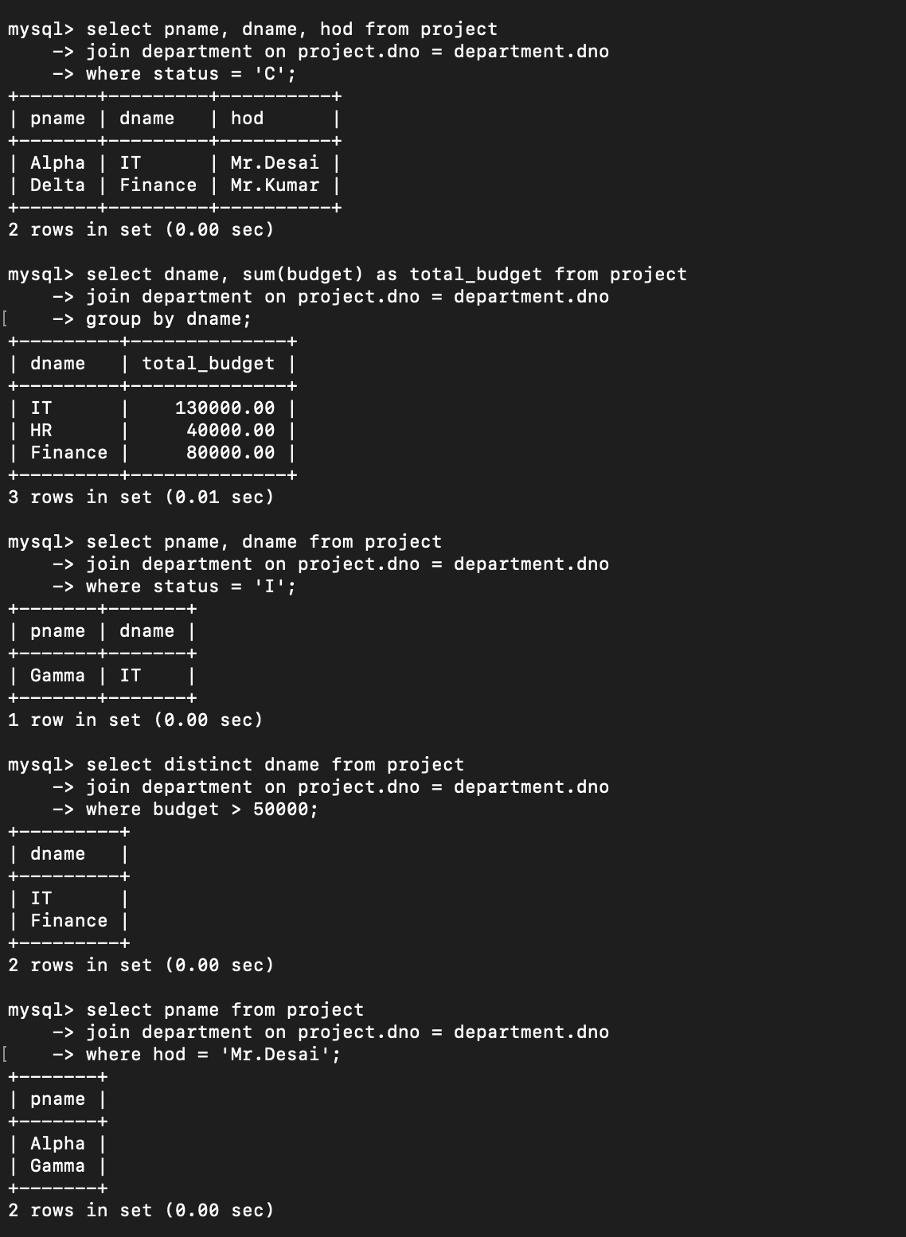

**DBMS Practical List (Based on User, Indexing, Role, Trigger, and Stored Procedure)**

This practical list covers key **database management concepts** related to **users, indexing, roles, triggers, and stored procedures**.

**1. User Management in DBMS**

**Practical 1: Create and Manage Users**

**Objective:** Create different database users (User1 and User2)with specific privileges.

* Create a new database user.
* Grant and revoke privileges (SELECT, INSERT, DELETE, UPDATE).
* Display user privileges.s



**2. Indexing in DBMS**

**Practical 2: Implement Indexing on a Project Table**

**Objective:** Improve query performance using indexing.

* Create Project table with a primary key.
* Insert multiple user records.
* Create an index on the Budget column.
* Display index.
* Remove an index and analyze the impact.
* **Composite Indexing** – Create an index on dame and HOD and analyze query performance.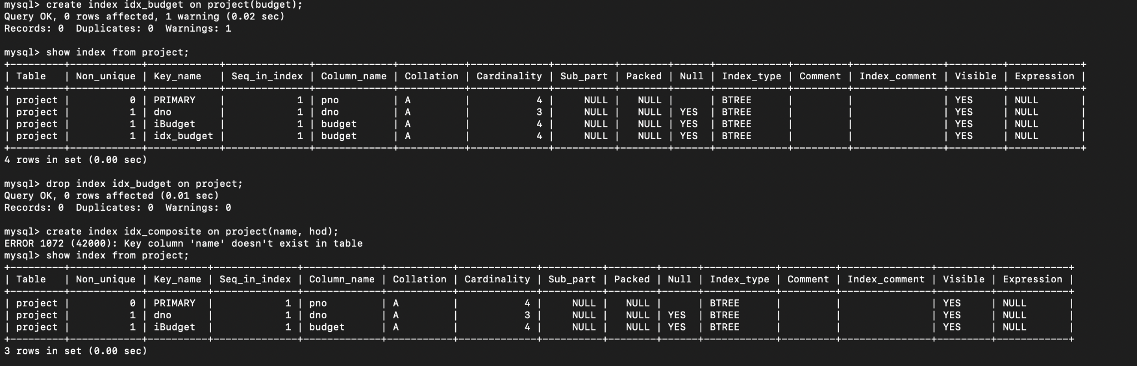

**3. Role Management in DBMS**

**Practical 3: Create and Assign Roles**

**Objective:** Manage user roles and permissions efficiently.

* Create different roles (Admin, Editor, Viewer).
* Assign privileges to roles.(select,insert,update privileges)
* Assign roles to users and test access levels.



**4. Triggers in DBMS**

**Create a Trigger to Prevent Invalid Salary Updates**



**5. Stored Procedure in DBMS**

**Create a Stored Procedure to Insert a New Employee**

