**Halil İbrahim Taşkömür**

**Mail :** [**taskomurhalilibrahim@gmail.com**](mailto:taskomurhalilibrahim@gmail.com)[**linkedin.com/in/hitaskomur**](https://linkedin.com/in/hitaskomur)

**Phone number : +90 544 410 67 71** [**github.com/hitaskomur**](https://github.com/hitaskomur)

**Introduction :**

* **Purpose of Project**
* **Dataset**
* **Deep Leraning Model**
* **Improvements**
* **Conclusions**

**Purpose of Project:**

-Detecting differences between satellite images taken at two different times.

**Dataset:**

-[Used LEVIR_CD Dataset](https://www.kaggle.com/datasets/mdrifaturrahman33/levir-cd/data).

- LEVIR-CD consists of 637 very high-resolution (VHR, 0.5m/pixel) Google Earth (GE) image patch pairs with a size of 1024 × 1024 pixels. These bitemporal images with time span of 5 to 14 years have significant land-use changes, especially the construction growth. LEVIR-CD covers various types of buildings, such as villa residences, tall apartments, small garages and large warehouses.

**Dataset Samples**

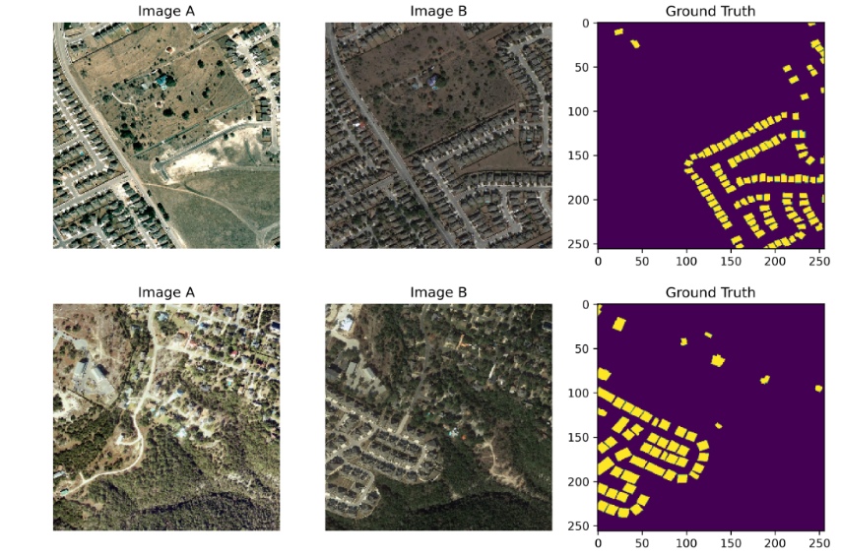

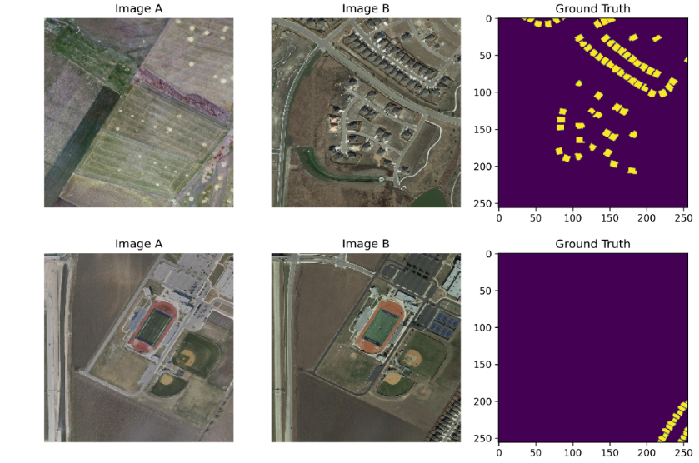

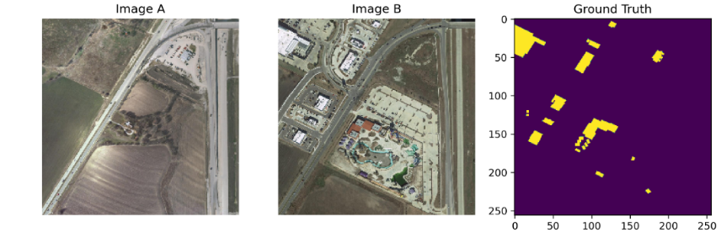

**Deep Learning Model:**

A fully connected neural network algorithm was used. It comprises input, encoder, decoder, and output layers. The train dataset was used for model training, the validation dataset for validation, and the test dataset for testing. Although various techniques and parameters were tested, this model was selected as the most cost-effective (U-Net, Siamese-U-Net, augmentation data, etc.).

**Model Parameters Results**

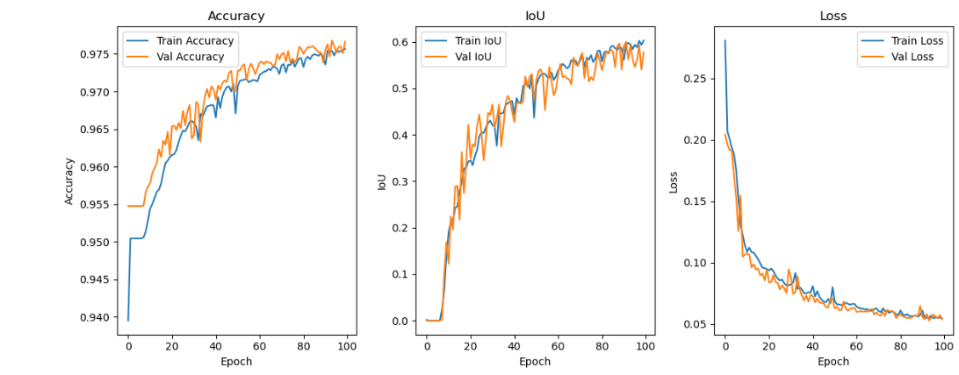

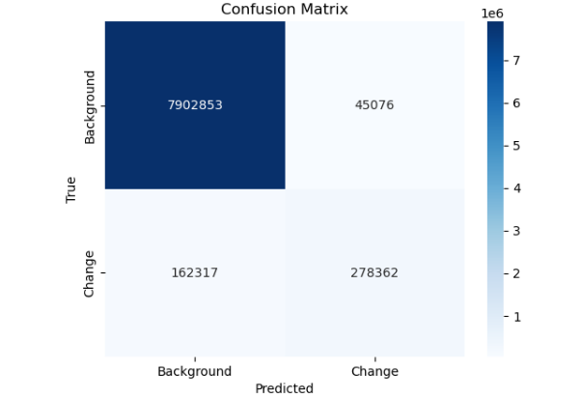

**Visualizing Test Samples**

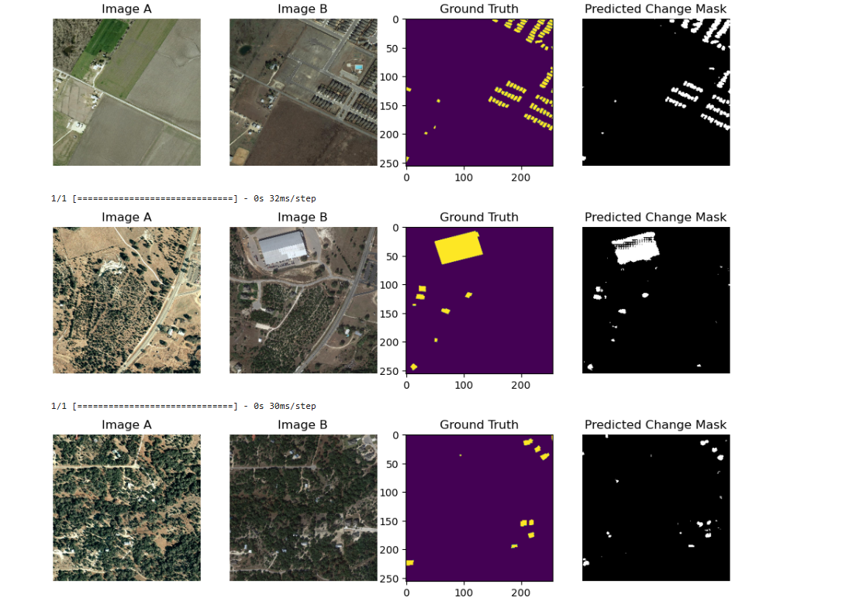

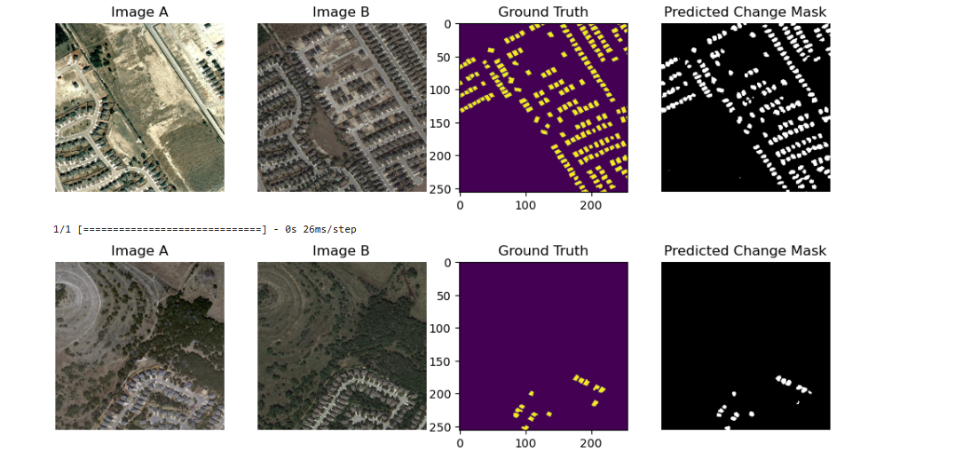

**Test Evaluation Scores**

-Test Loss: 0.0573, -Test Accuracy: 0.9733, -Test IoU: 0.6190

-Precision: 0.8413579301898346, -Recall: 0.6983813614898826,

-F1 Score: 0.7632314119168575

**Improvements:**

- Created UI web page with streamlit

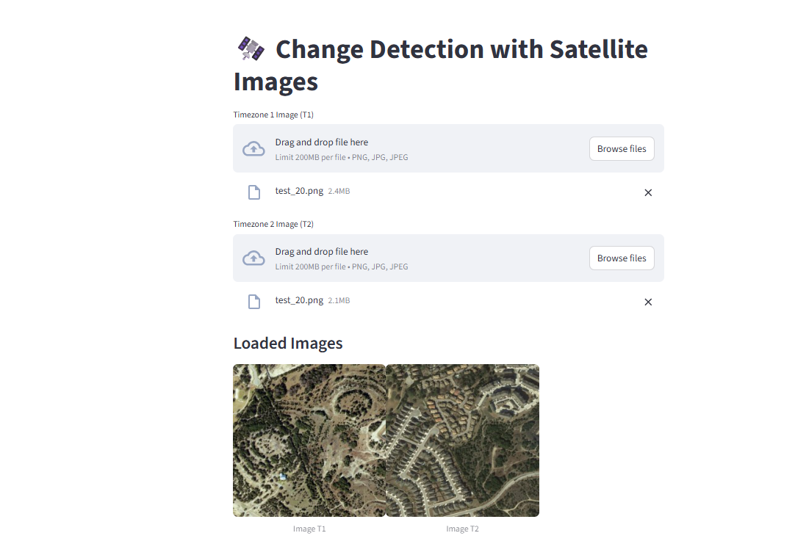

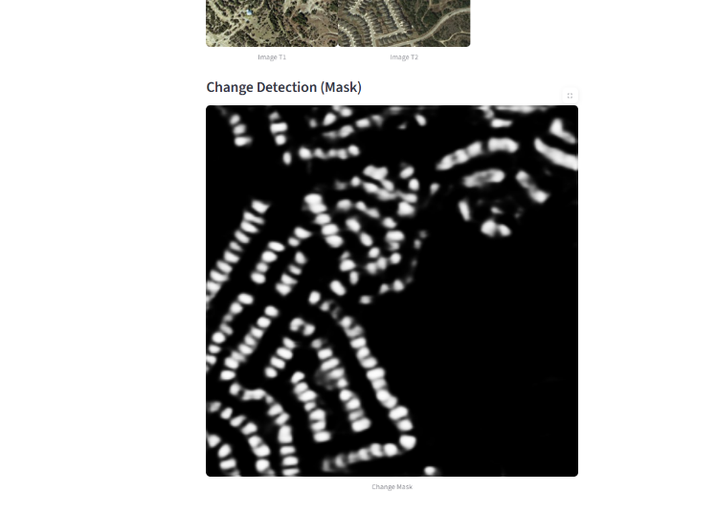

-Created Api by fastapi.

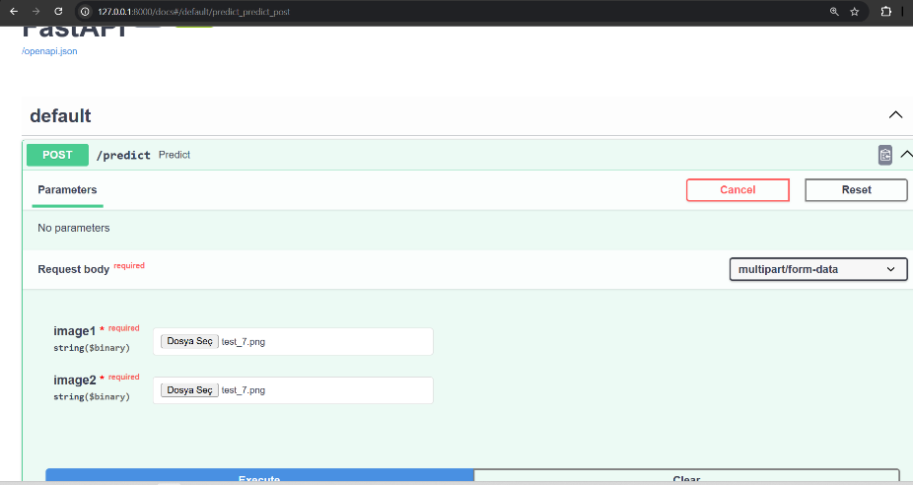

**-** Quantization (Size reduction has been made so that it can be used on hardware with low resources (mobile, embedded systems, etc.)

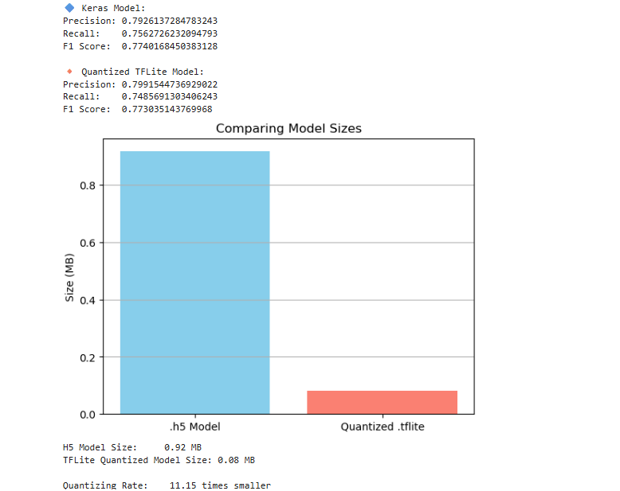

**Conclusions:**

-More detailed fine-tuning can be done for specific areas or structures in the model.

-Model results can be re-evaluated with data augmentation.

-Improvements can be made based on the area to be used.