ITS553 – Secure Java Programming
Lab 5 – Server and Client Execution Result
Instructor: Dr. Tu
Author: Steve Jia
Date: 7/16/17
Job sample size used for these screenshots are less than 20 to demonstrate threads terminations.
Server Printout:
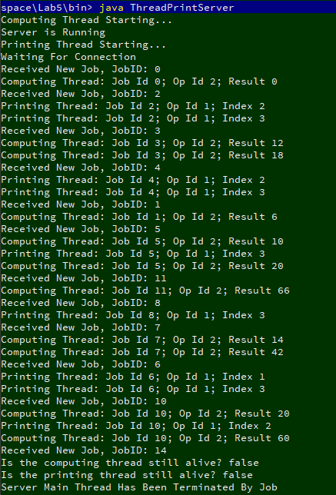
Client Printout:
