ITS553 – Secure Java Programming
Lab 6 – Final Project – Server and Client Execution Results
Instructor: Dr. Tu
Author: Steve Jia
Date: 07/30/17
Server and Client at Initial Connection:
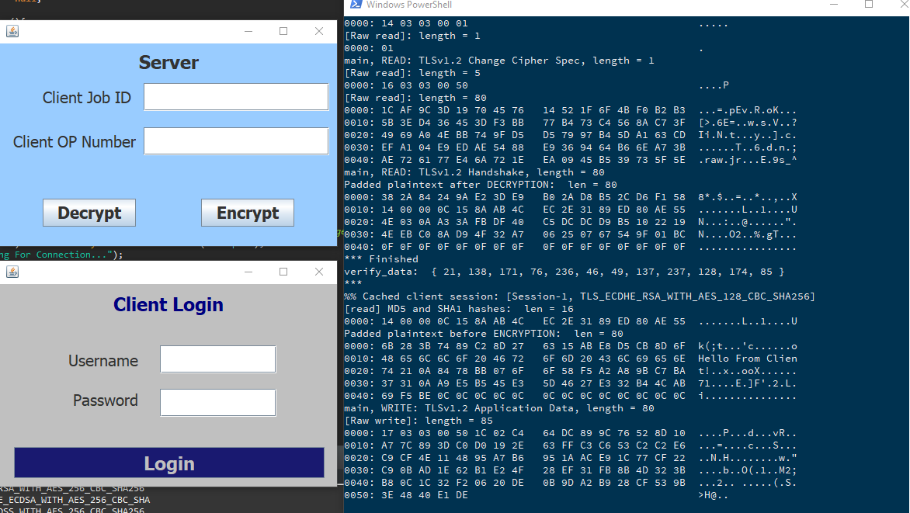
Database Table sslusers.userinfo at Initial Connection:
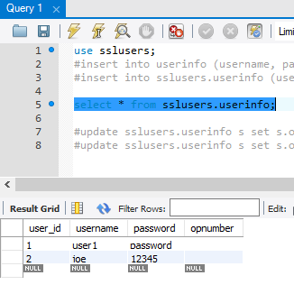
Client – Bad/Incorrect Login:
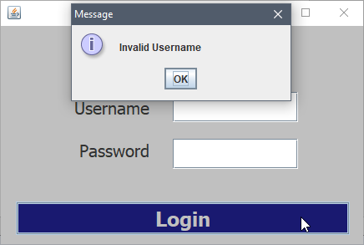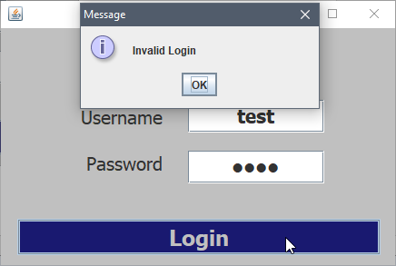
Client – After Successful Login; Notice the username is on the JFrame
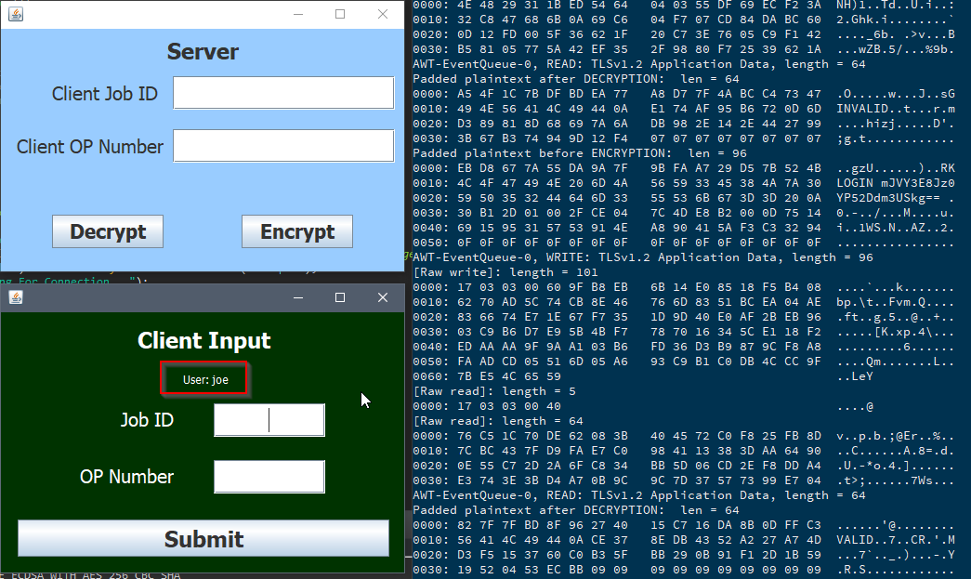
Server & Client – After Client Has Submitted A Job ID and OP Number, Notice On the Server Side the OP Number is encrypted
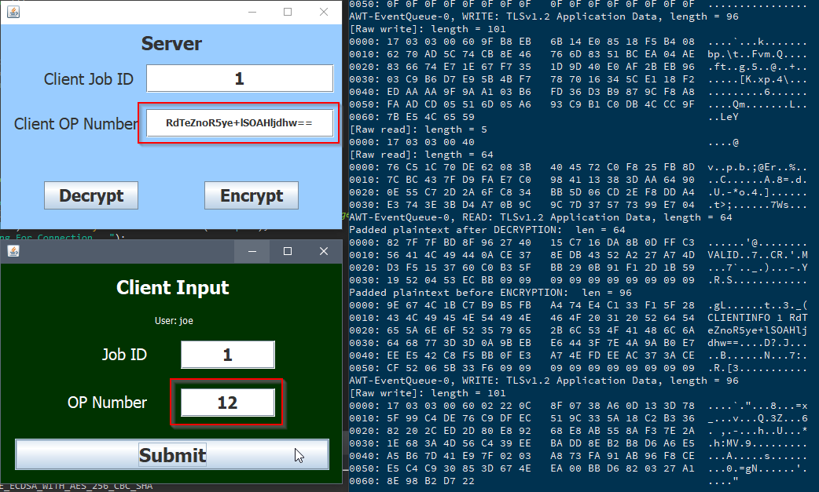
Database Table – Client’s OP Number is stored as encrypted
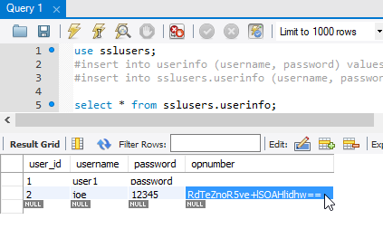
Server Can Decrypt The OP Number
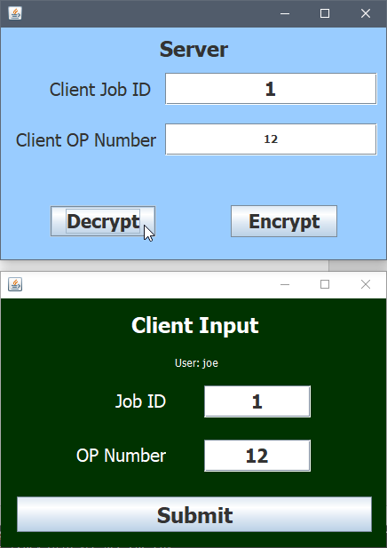
Server can also encrypt/re-encrypt
