Output of The Burger Surfer

# 1)Command Line:

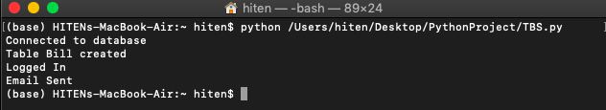

# 2)Home Page

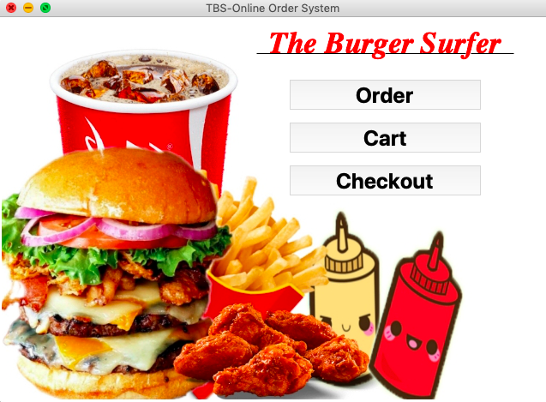

# 3)Order Page

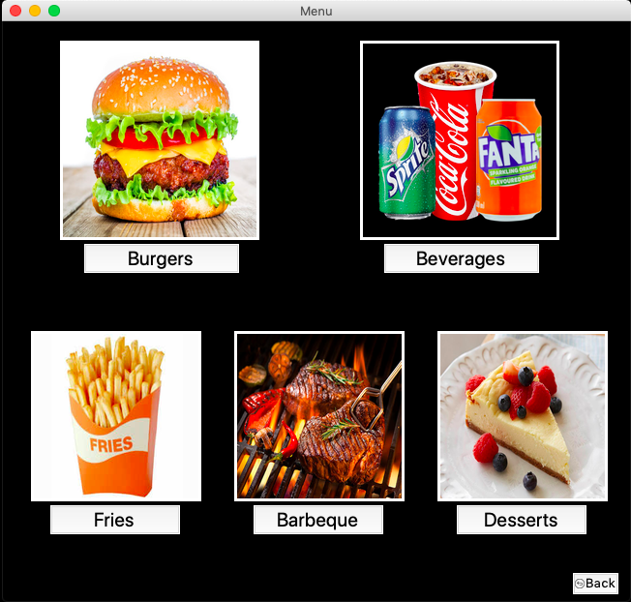

# 4)Burgers Menu

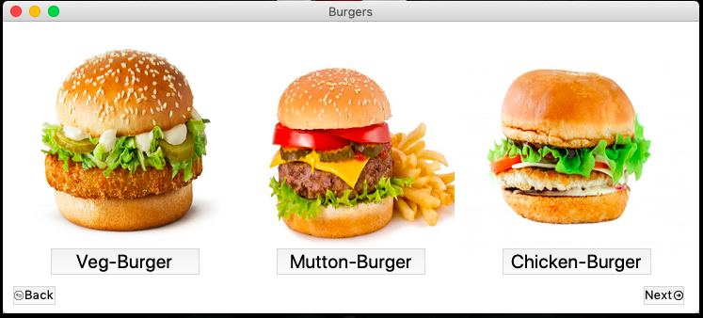

# 5)Fries Menu

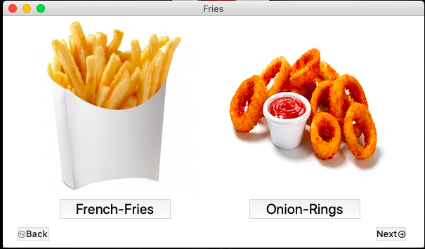

# 6)Barbeque Menu

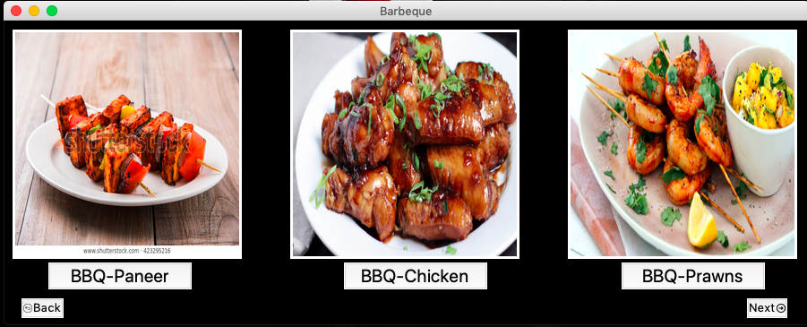

# 7)Beverages Menu

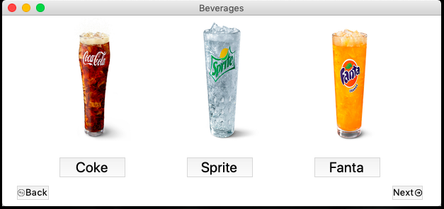

# 8)Desserts Menu

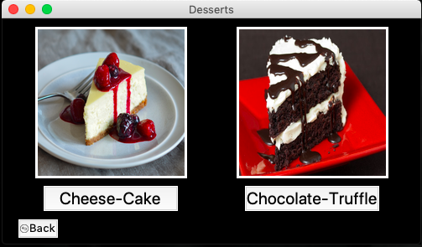

# 

# 9)Cart Empty Message (If no items are selected)

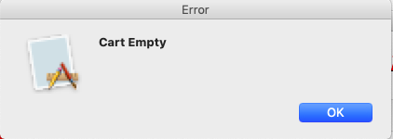

# 10)Cart Page (If Items are selected)

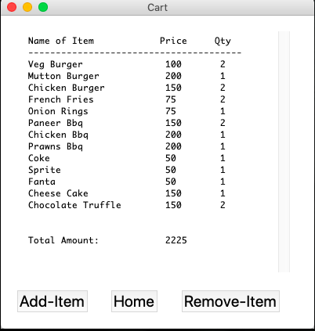

# 11)Checkout Page asking Login Details

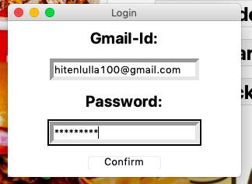

# 12)Order Confirmation Message

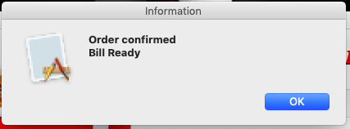

# 13)Bill Saved in Folder

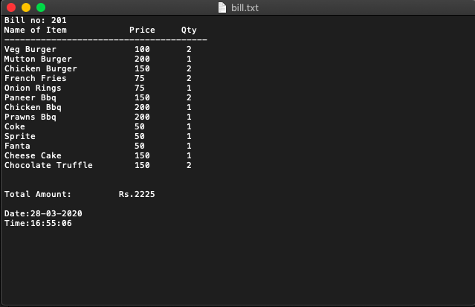

# 14) Mail received to [theburgersurfer@gmail.com](mailto:theburgersurfer@gmail.com)

