deVinci Camera Calibration Report

1. Problem Formulation
deVinci Camera Calibration is to find the several quantities internal to camera which will affect the imaging process, and the intrinsic unknowns which should be found are listed below:
1. Uc: central pixel in u direction of image plane, Vc: central pixel in v direction of image plane
2. Base line
3. focal length
4. the position of camera frame origin w/rt (with respect to) world frame
5. the orientation of camera frame w/rt world frame (known aligned with world frame)
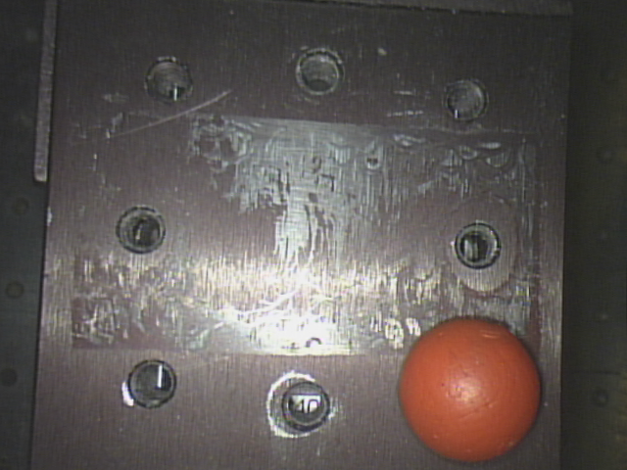
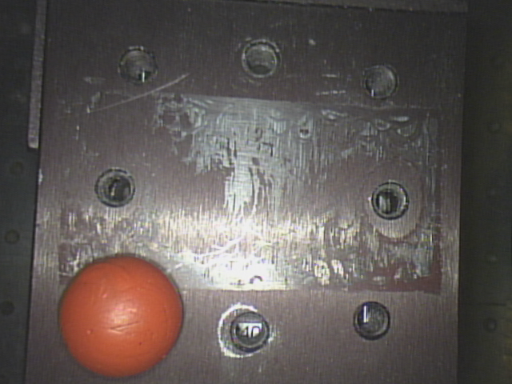
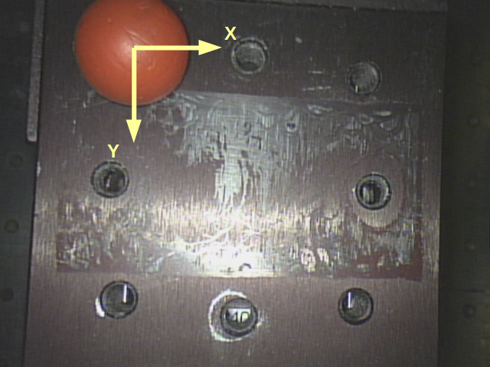
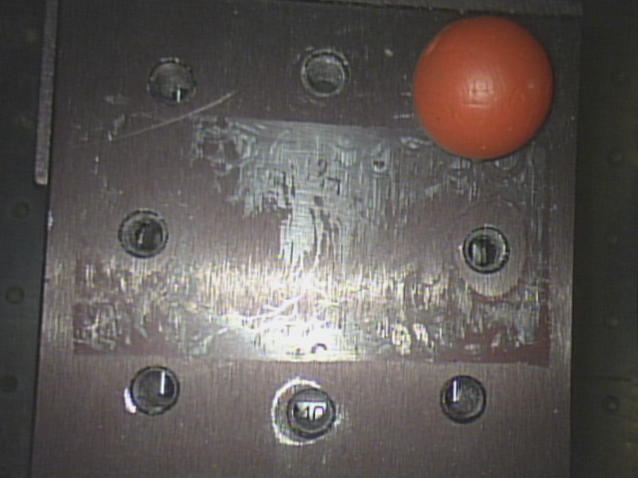
By taking 24 snapshots of four fiducials in 5 elevations, each elevation height = 0.005m starting from 0 to 0.025m, both left and right cameras captured 24 pixels of fiducials centroid, as listed in Table 1.1. Also, a world coordinate frame was built on the height of 0.0025 as shown in figure 1.1 and 1/2. The sequence of taking snapshots was from position 1 to position 4 in each elevation. Based on the built world frame, the fiducials centroid coordinates with respect to (w/rt) world frame are knowns and listed in Table 1.2. The orientation of camera frame was assumed to be aligned with world frame.
Figure 1.1 Fiducials positions and world coordinate frame
Position: 2
Position: 3
Position: 4
Position: 1
(0,0)
(1'', 0)
(1'', 1'')
(0, 1'')
Table 1.1 24 points pixels in left and right cameras
Table 1.2 24 points coordinates w/rt world frame
The geometric relationship between world frame and two camera frames are shown in figure 1.2.
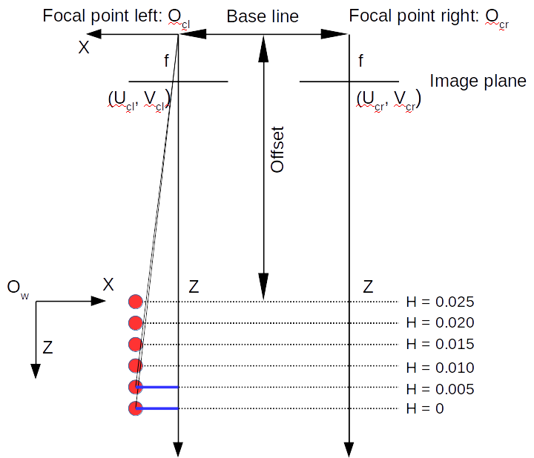
Figure 1.2 Geometric relationship between unknowns

2. Equations to solve focal length, offset and delta theta
Since each points Z coordinate in world frame are knowns, so that each point Z coordinate in camera frame can be found by relationship as shown in Eqn 2.1.
(Eqn 2.1)
In Eqn 2.1
i: number of layers
j: number of points on each layer
From there each point coordinates in world frame have the following relationship with coordinates in camera frame.
(Eqn 2.2)
In Eqn 2.2
O_{c/w}: Origin of camer frame expressed in world frame
^{w}R_{c}: Rotaion matrix from camera frame to world frame
Since in each layer the z coordinate of each point either in camera frame of world frame is same, in each layer using position 1 and 2 coordinates (pixels) minus position 4 and 3 coordinates (pixels), respectively, consequently two delta_x and two delta_u values were obtained. In the same way, using position 2 and 3 coordinates (pixels) minus position 1 and 4 coordinates (pixels), respectively, two delta_y and two delta_v values were also obtained. By now, Eqn 2.2 evolved to following format.
(Eqn 2.3)
In Eqn 2.3
i: number of layers
j: number of points coordinates (pixels) difference
By assuming camera frame is aligned with respect to world frame, the rotation matrix is identity, so by expanding Eqn 2.3, the unknowns offset and f is able to be found.

3. Results
For the first case, the focal length is set to two different values between left and right side cameras, one is fx and the other is fy. Also, the delta theta was assumed to be zero at first, thus 48 linear equations were found to solve 3 unknowns, fx, fy and offset. The result is list in Table 2.1
Table 2.1 Focal length and offset
Fx (unit: pixel) | Fy (unit: pixel) | Offset (unit: mm)
 | 877 | 68.3

Base on the found Fx, Fy, and offset, putting those values back to Eqn 2.3, four delta theta was obtained, corresponding to left camera X/Y and right camera X/Y. Using RMS(root mean square) method, .
Another way to have delta theta estimation was to use , so that there will be 12 such ratios for each camera, and the best fit delta theta for left camera is and for right camera. Because of is so small, so that. Again, using this estimated to recalculate focal length and offset, and the estimated values were found as list in Table 2.2.
Table 2.2 Focal length and offset, when
Fx (unit: pixel) | Fy (unit: pixel) | Offset (unit: mm)
837 | 920 | 68.3

Compared with the value list Table 2.1, large difference was found except offset. In same way, focal length and offset values in Table 2.2 were again replaced in Eqn 2.3 and this time, rotation matrix was replaced as, and the unknowns became to be and.
(Eqn 3.1)
The result was listed in Table 2.3.
Table 2.3values
 | Left Camera | Right Camera
 | 0.9986 | 0.0522
 | 0.9988 | 0.0486
Average | 0.9987 | 0.0504

Thus the system is self consistent. Further, the assumption that camera frame is aligned with world frame is acceptable.

4. Solving central pixels
Finding central pixels is basically to solve geometric relationships found by similar triangles, as shown in figure 4.1
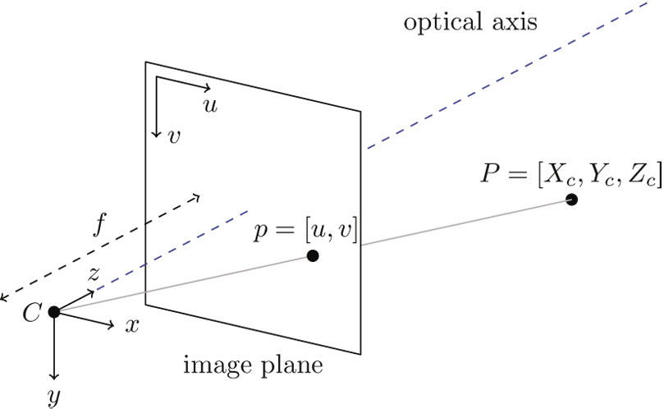
Figure 4.1 Geometric relationship of similar triangle

Based on figure 4.1, and figure 1.1 and 1.2, the following relationship can be deduced as expressed by Eqn 4.1
(Eqn 4.1)
In Eqn 4.1, the approximation is that and for each elevation, also and , thus 24 linear equations were built, two unknowns need to be found, and . Same method applied to Y and V direction, Eqn 4.2 were built.
(Eqn 4.2)
In Eqn 4.1, the approximation is that and for each elevation, also and , thus 24 linear equations were built, two unknowns need to be found, and . After applying these to equations to left and right camera, central pixels and and were found. According to and , the origin of left camera frame and right camera frame w/rt world frame can also be determined. The results in Table 4.1 was based on results from Table 2.1. Another set of results was also listed in Table 4.2 which is based on focal length and offset from Table 2.2.
Table 4.1 Central pixels and point coordinates
 | Left Camera | Right Camera
Uc | 321 | 321
Vc | 333 | 330
 | 0.013 | 0.0186
 | -0.0204 | -0.0203
Origin's X coordinate wrt World frame | 0.0124 | 0.0068
Origin's Y coordinate wrt World frame | 0.0204 | 0.0203
Table 4.2 Central pixels and point coordinates
 | Left Camera | Right Camera
Uc | 321 | 321
Vc | 333 | 330
 | 0.013 | 0.0189
 | -0.02 | -0.0199
Origin's X coordinate wrt World frame | 0.0124 | 0.0065
Origin's Y coordinate wrt World frame | 0.02 | 0.0199

According to Table 4.1 and Table 4.2, the results were very close.

5. Solving base line
To get base line, 24 disparities were found in both cameras, so that base line need to fit 24 equations by using least squares method.
(Eqn 5.1)
After solving linear equations, , base on either Table 2.1 or Table 2.2.
To check the validity of baseline, 24 points x coordinates in both left camera frame and right camera frame were obtained, as shown in Table 5.1 and Table 5.2. Then using x coordinates in left camera minus baseline, the estimated x coordinates in right camera were gained. Finally comparing this estimated x coordinates with x coordinates in right camera obtained at first step, the errors was small.
Table 5.1 24 points coordinates w/rt camera frame and error (based on results from Table 2.1 and Table 4.1)

Table 5.3 24 points coordinates w/rt camera frame and error (based on results from Table 2.2 and Table 4.2)

6.Validation
By now, all intrinsic values were got, so that validation was carried out by comparing the transformed points coordinates in camera frame to world frame between points coordinates in world frame as shown in Table 1.2. This comparison was performed between X and Y coordinate. And the results is list below. From the tables below, the errors is acceptable.

Table 6.1 Points coordinates comparison btw left camera frame with world frame based on results from Table 2.1

Table 6.2 Points coordinates comparison btw right camera frame with world frame based on results from Table 2.1

Table 6.3 Points coordinates comparison btw right camera frame with world frame based on results from Table 2.2
Table 64 Points coordinates comparison btw right camera frame with world frame based on results from Table 2.2

7. Conclusion
Based on the errors estimation in chapter 6, the intrinsic properties from Table 2.1 and Table 4.1, also Table 2.2 and Table 4.2 are both acceptable.

