Guidelines to fill visa application from online:
It is requested that all applicants for visa to Taiwan should fill in the application forms on line and print out the filled forms to submit to the visa counter.
The website to fill in the application form is
https://visawebapp.boca.gov.tw
The steps:
On-line visa application form:
How to fill visa application form on-line?
- Please go to the website to fill the form on-line:
https://visawebapp.boca.gov.tw
- Once you go to the website, you will see the main page as below:
→ Click on General Visa Application
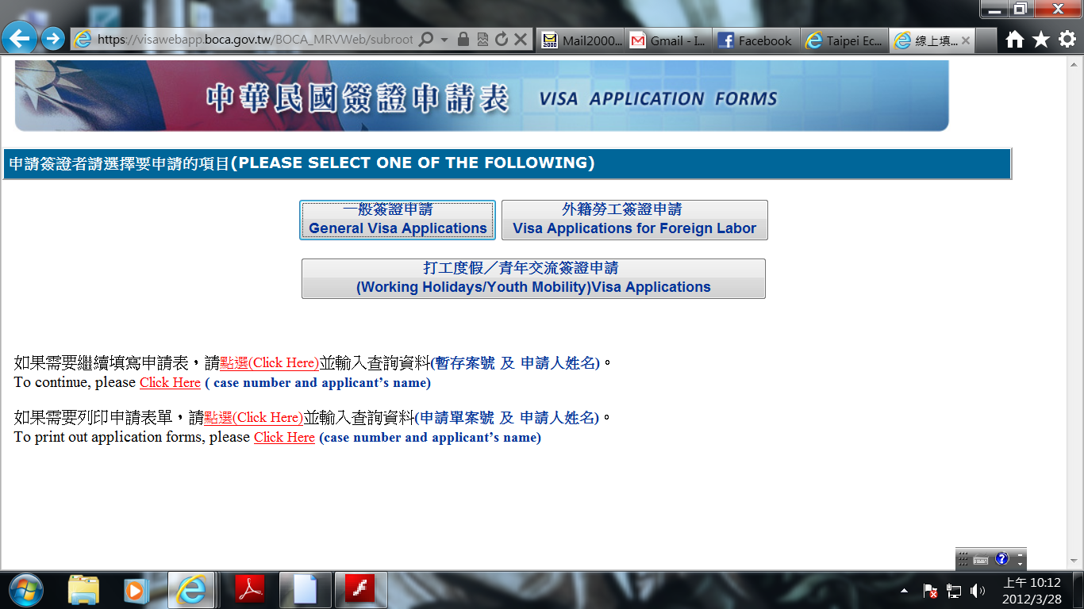

- Start to fill up the form,

→ Please note the location for visa application, choose Taipei Economic and Cultural Center in Chennai
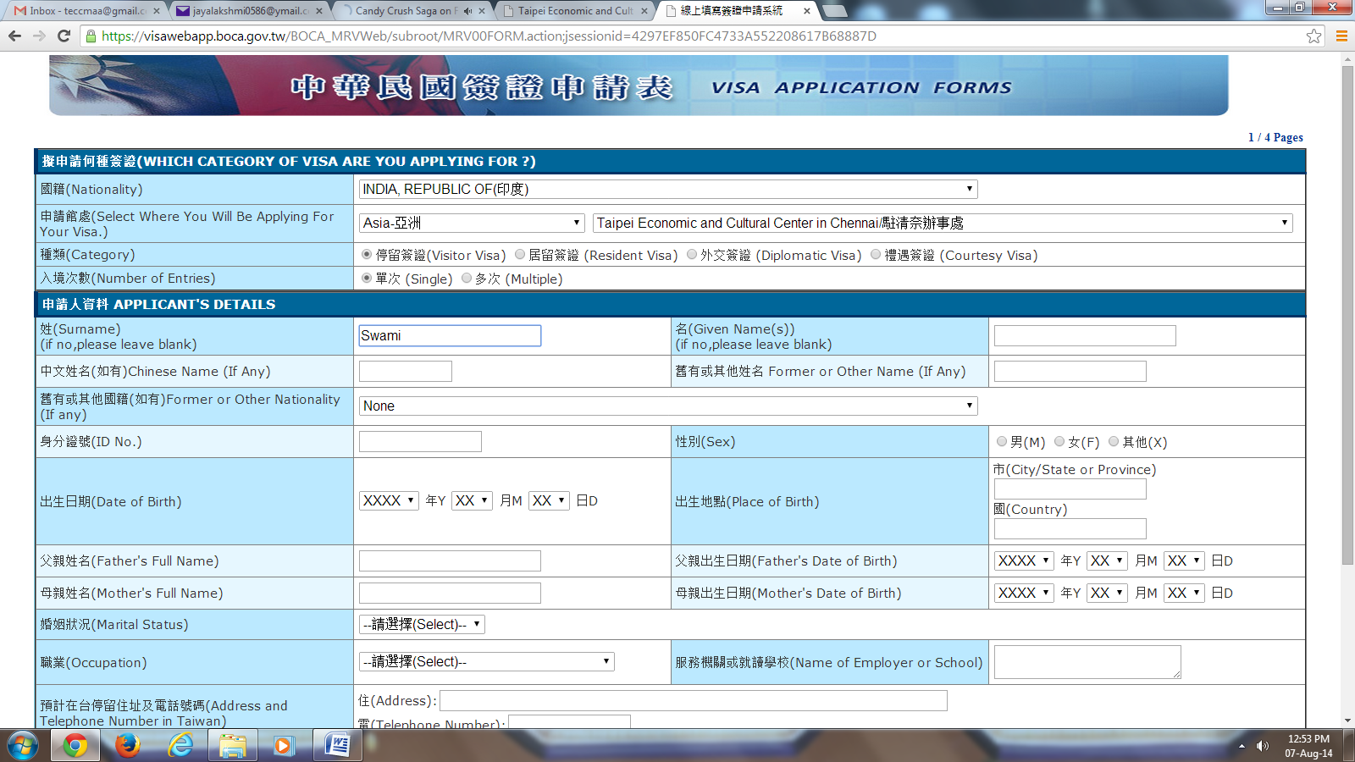
- Once filling up all the details please click on Next
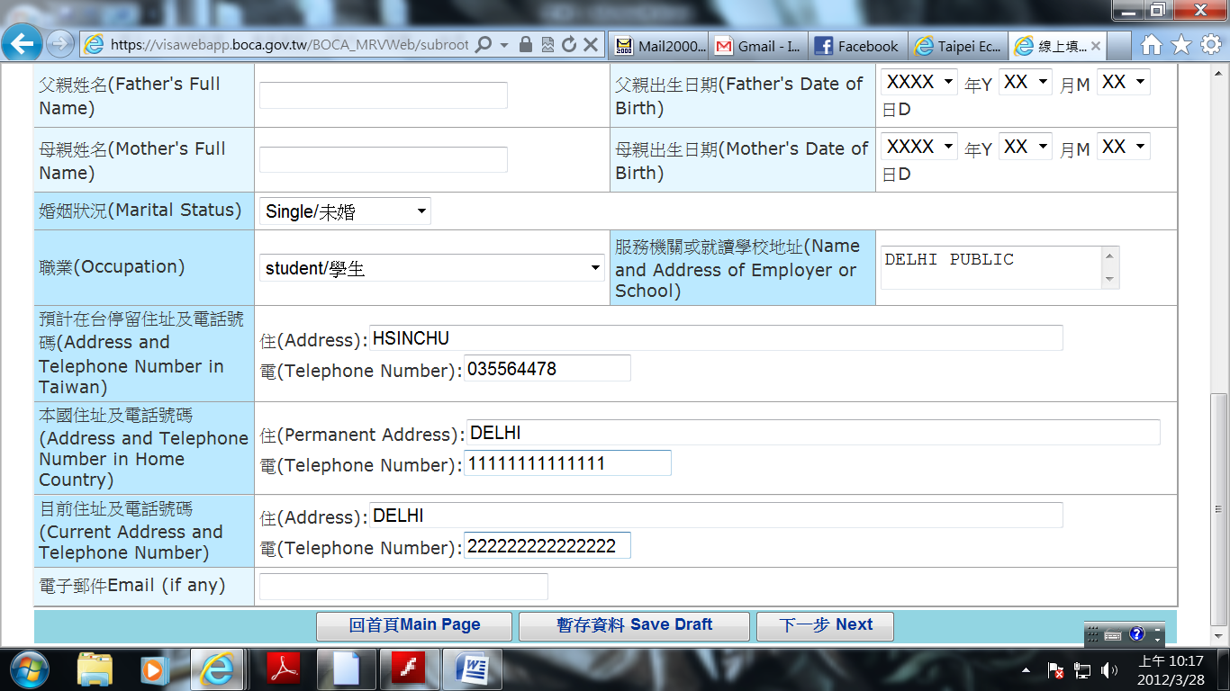

- Go to the following page, fill up the passport details and etc.

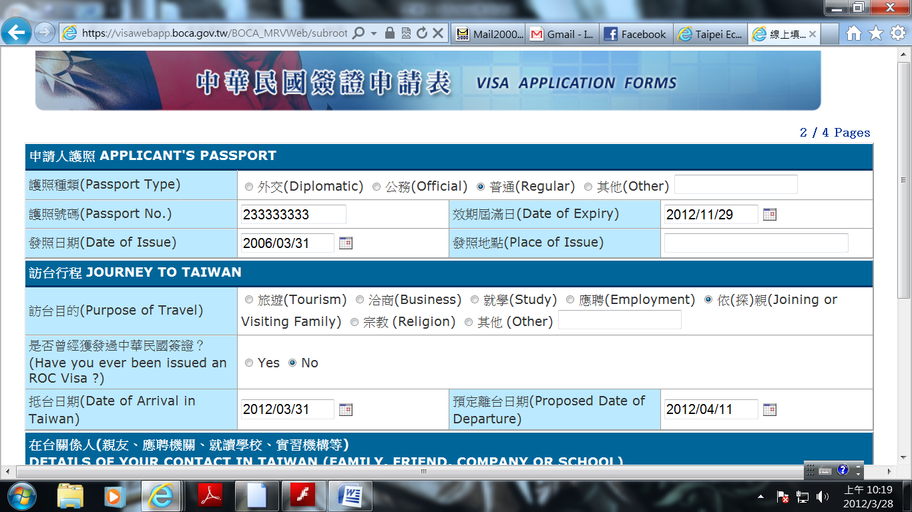

- Once filling up the contact person details please click on Next again,
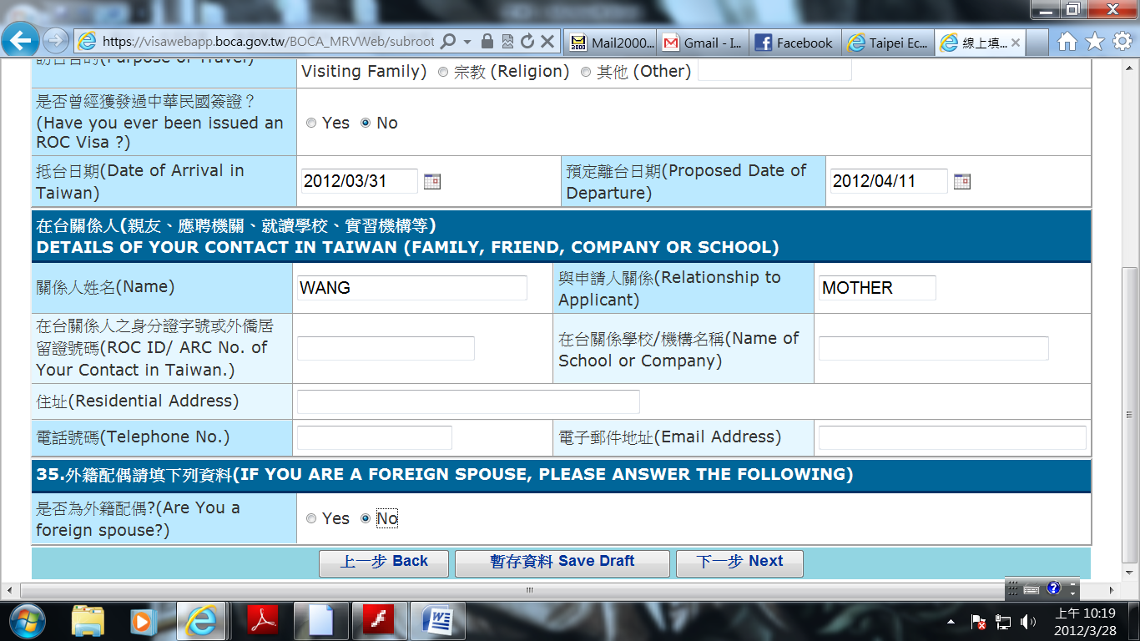
- The next page please choose the options as below, then click on Next,

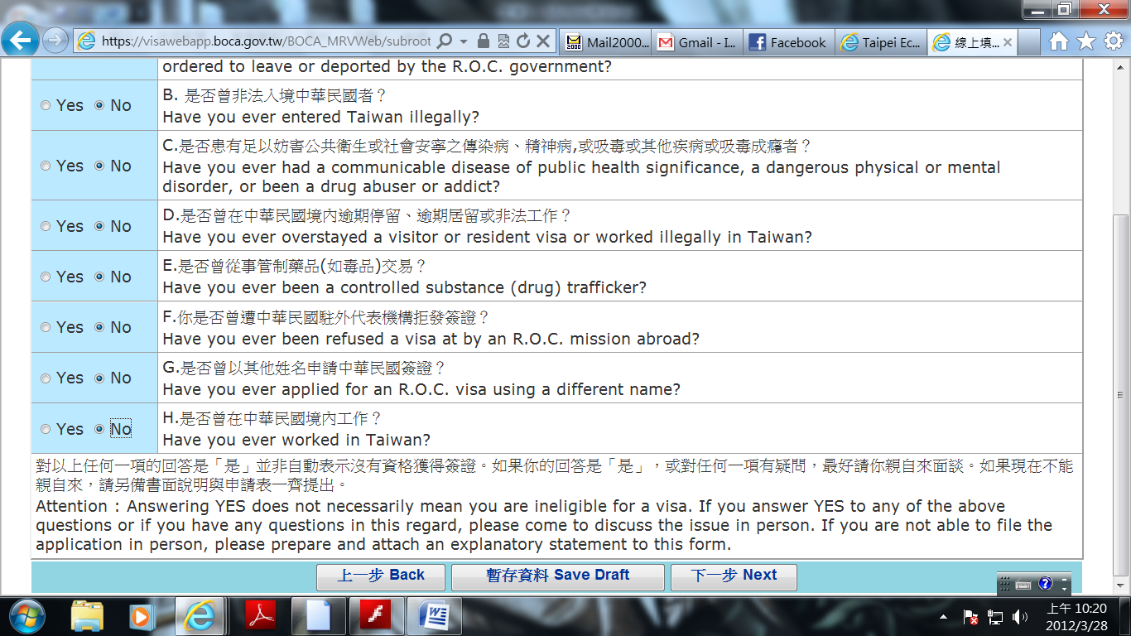

- The next page you will need to fill the application date and the agent’s details, if any,
then click on Submit,

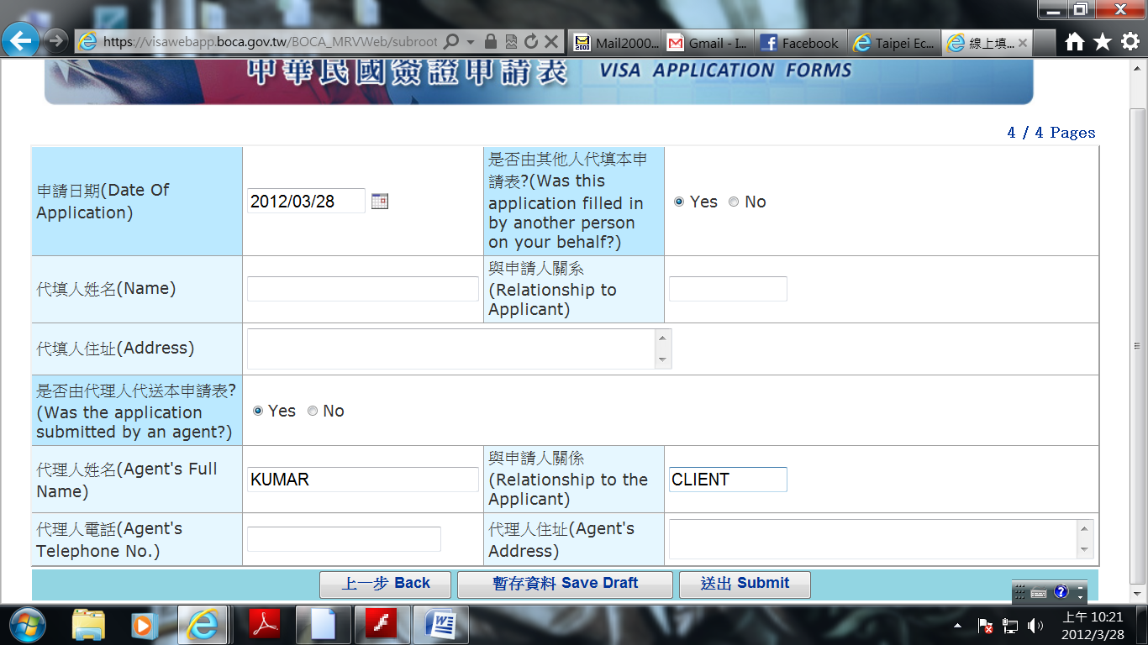

- Once you click on Submit, the page will come out one condition page, please click on
I Agree,
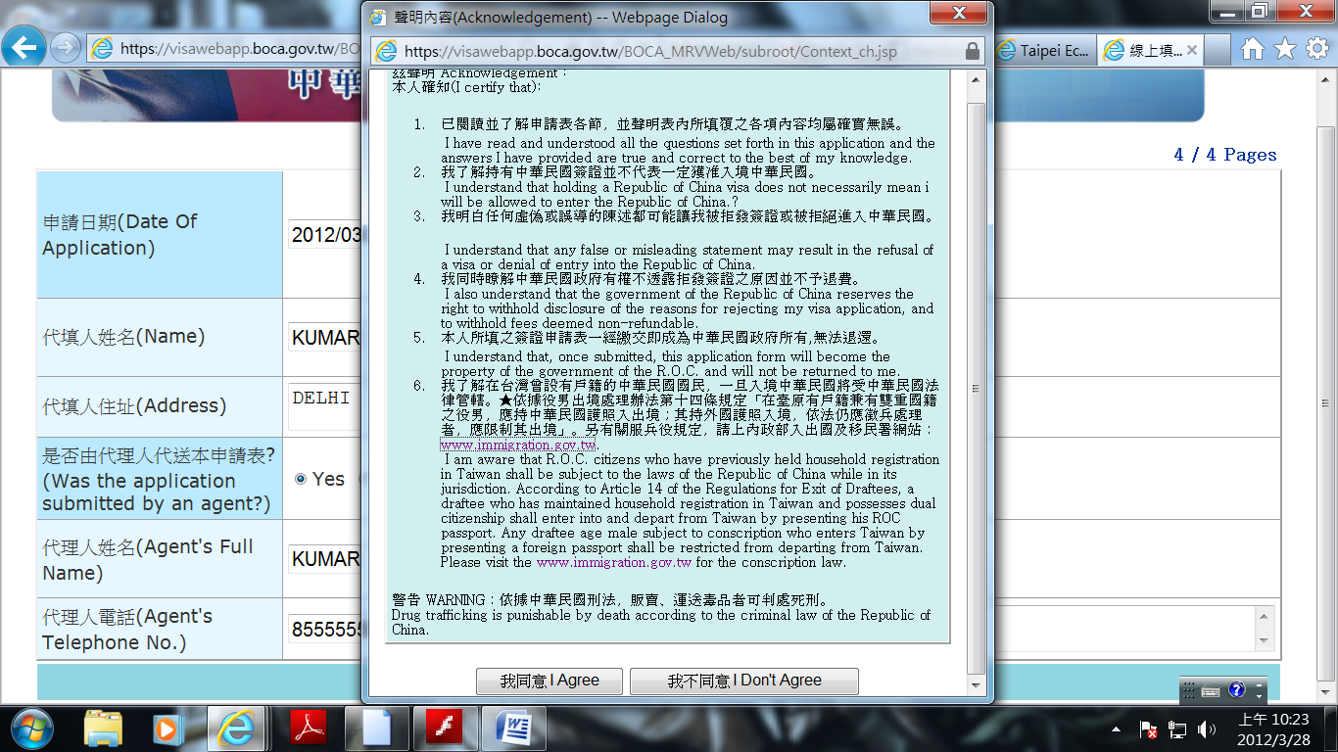

- Congratulations! You have completed the fill-up procedure,

→ You will find your Application No.in the next page, please click on Print Application Form

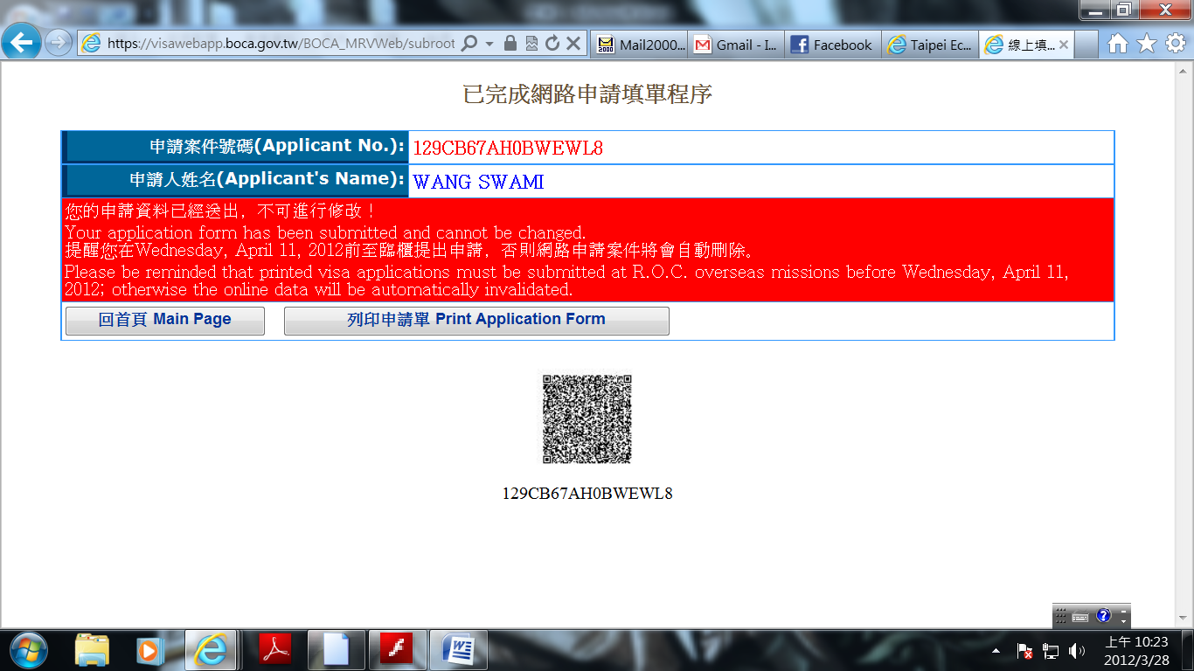

- Once you click on Print Application form, the system will automatically come out the PDF file of application form, just print it out,

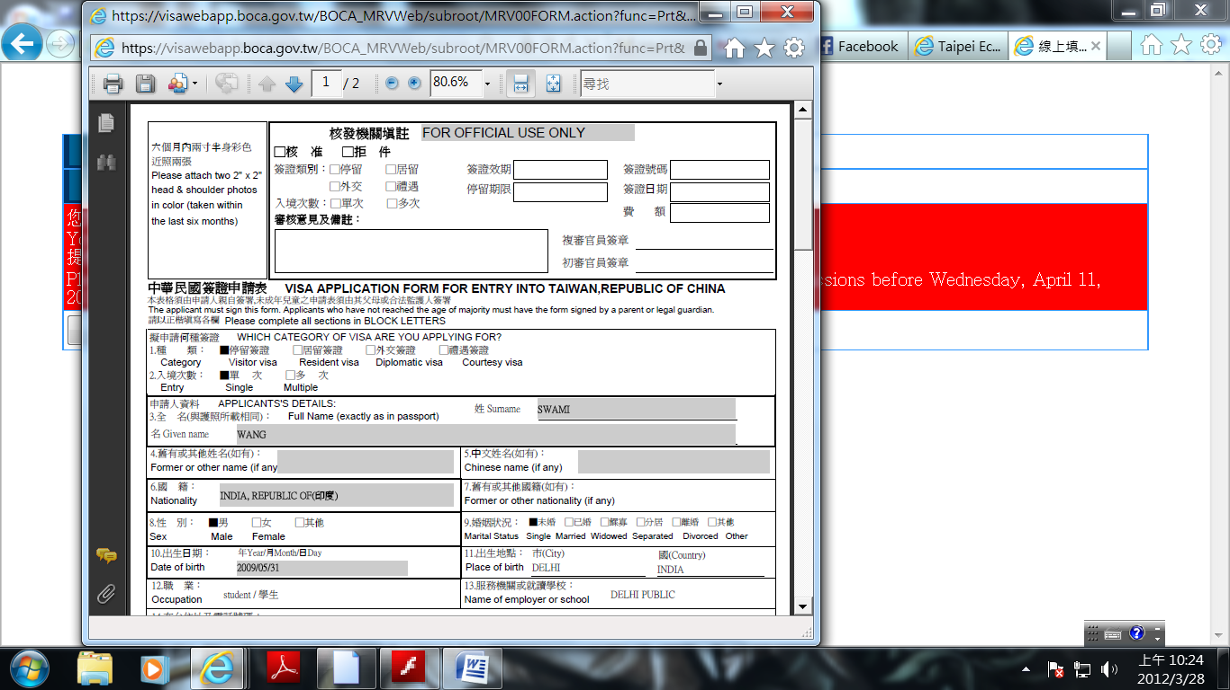
- The following visa application procedure is same as how we practice earlier, please carry this application form along with all the visa requirements when submitting your application.

- Thanks for the cooperation, in case you face any technical problem kindly contact our visa office.

Visa Division
Taipei Economic and Cultural Center in Chennai
No.30, Norton Road, Mandaveli, Chennai-600 028.
Tel: 044 -43024511/43024311/43023011
Email : teccmaa@gmail.com

