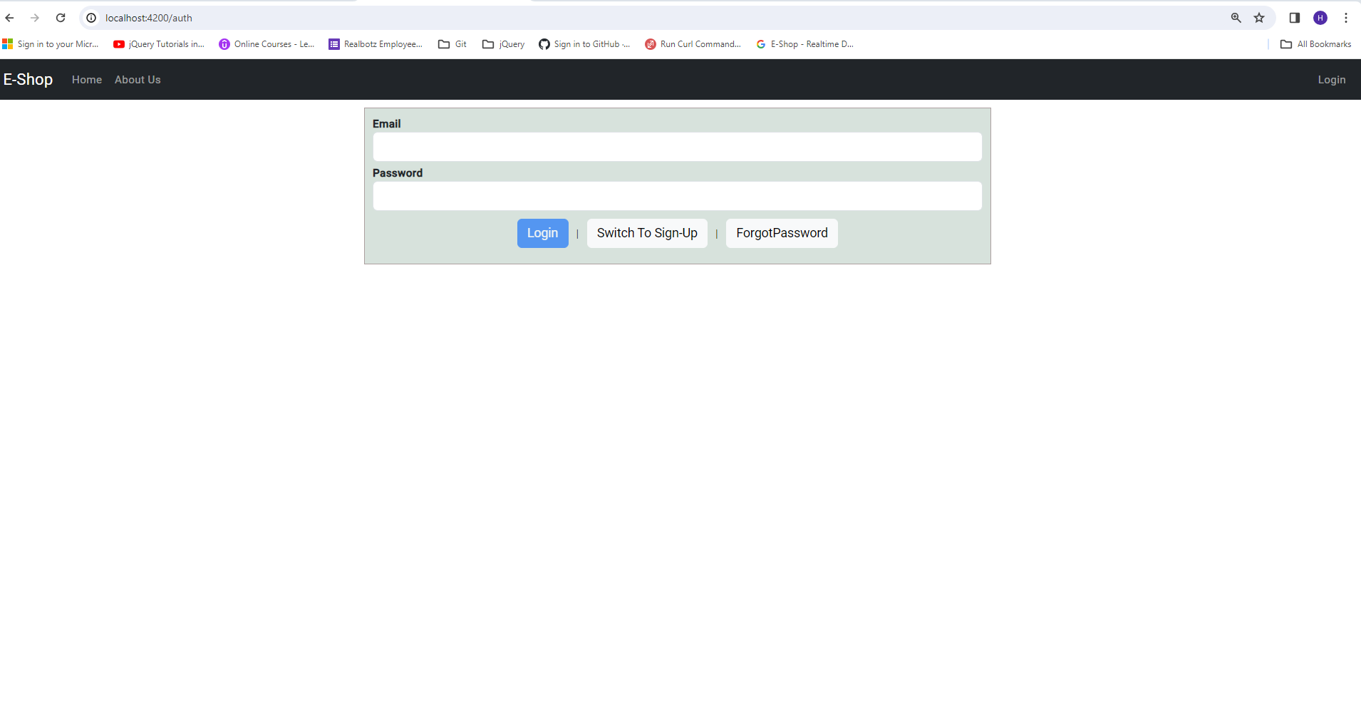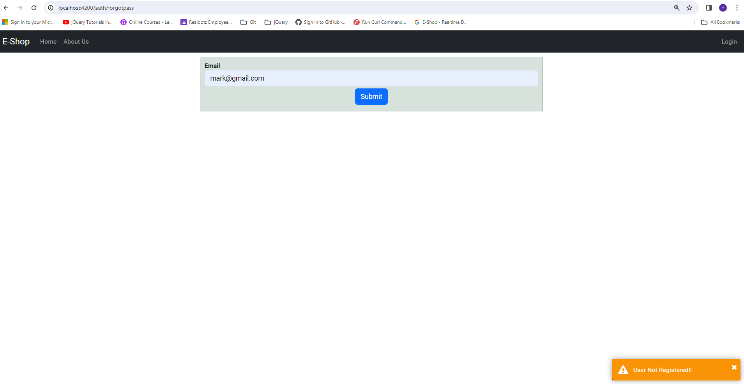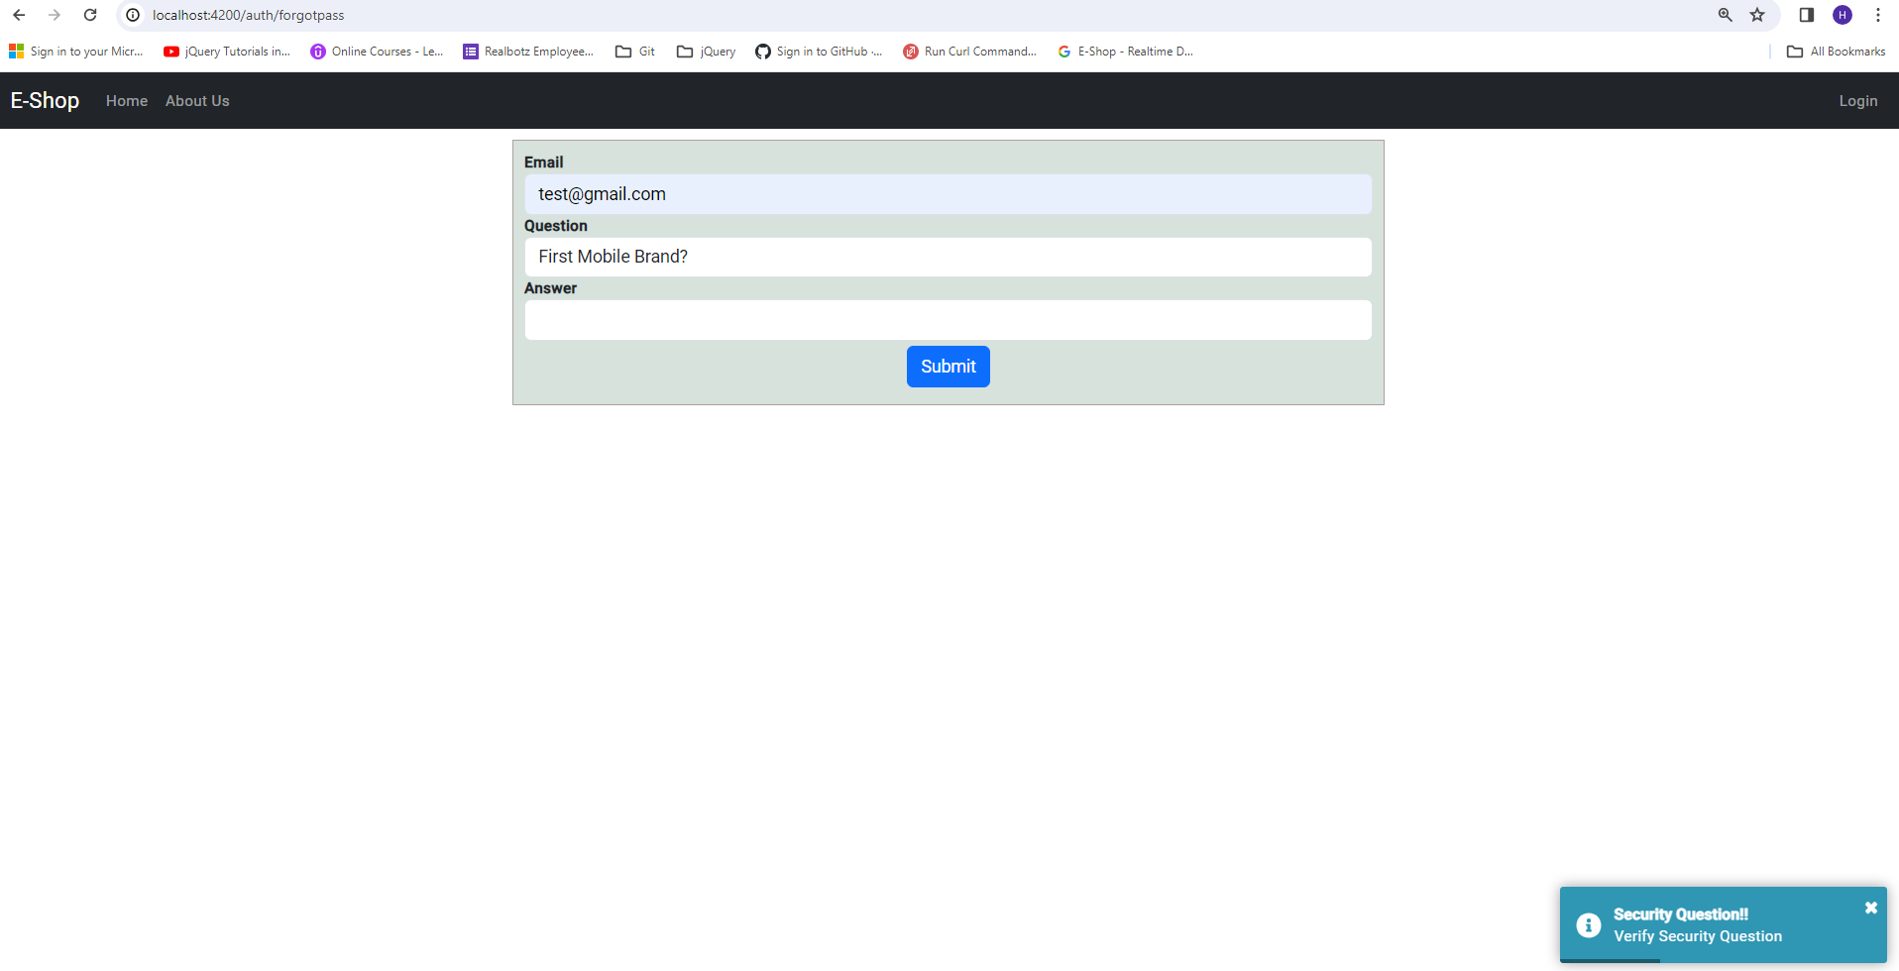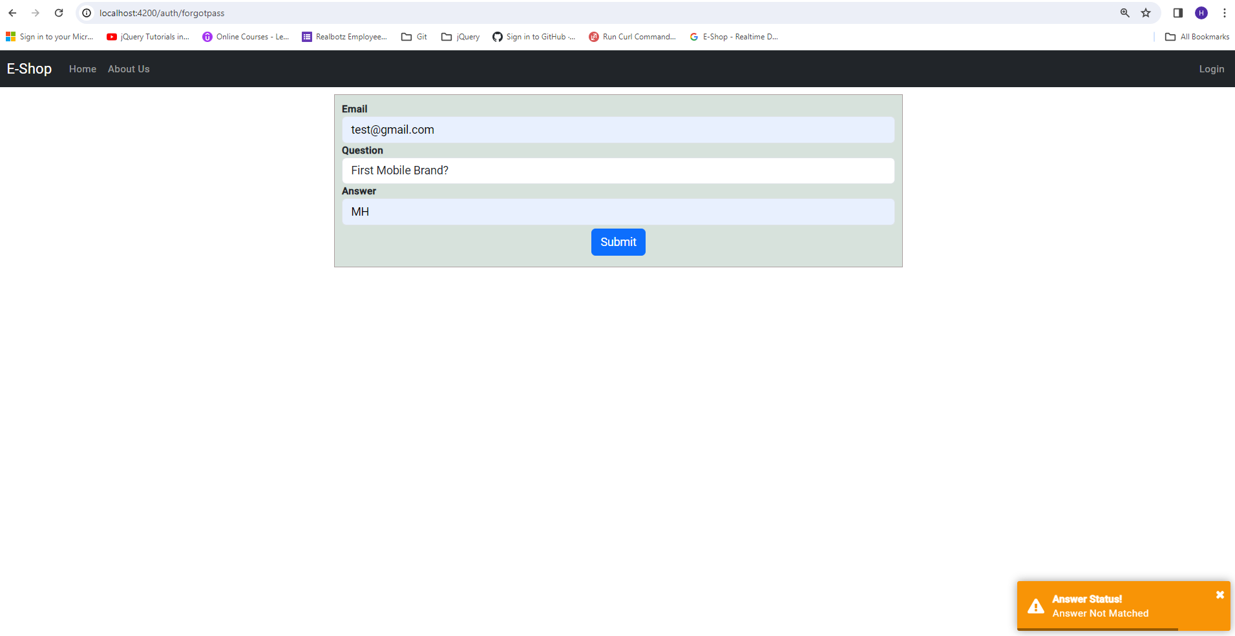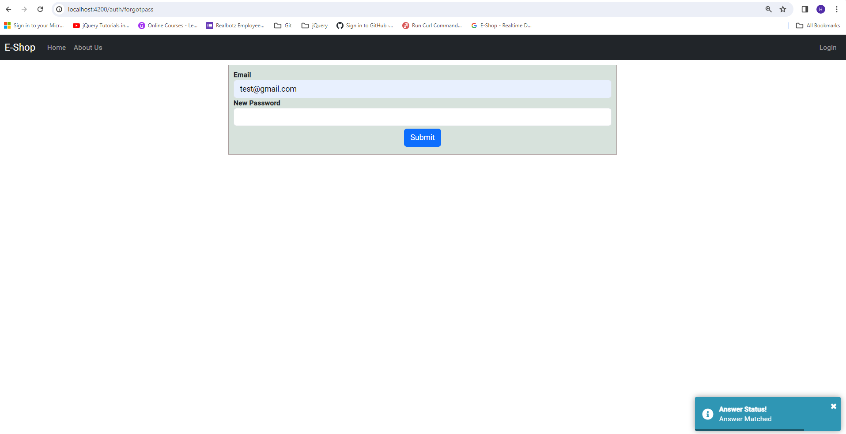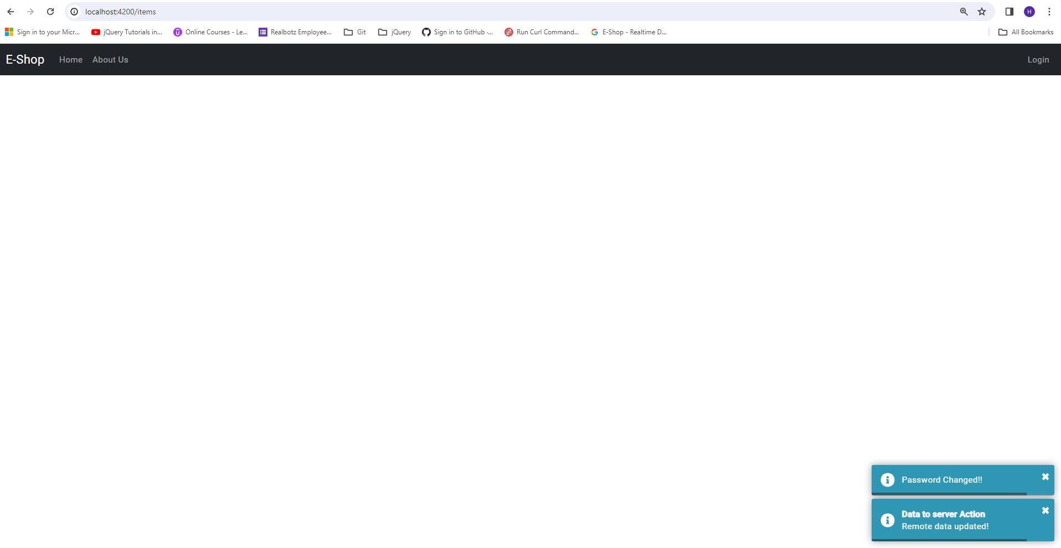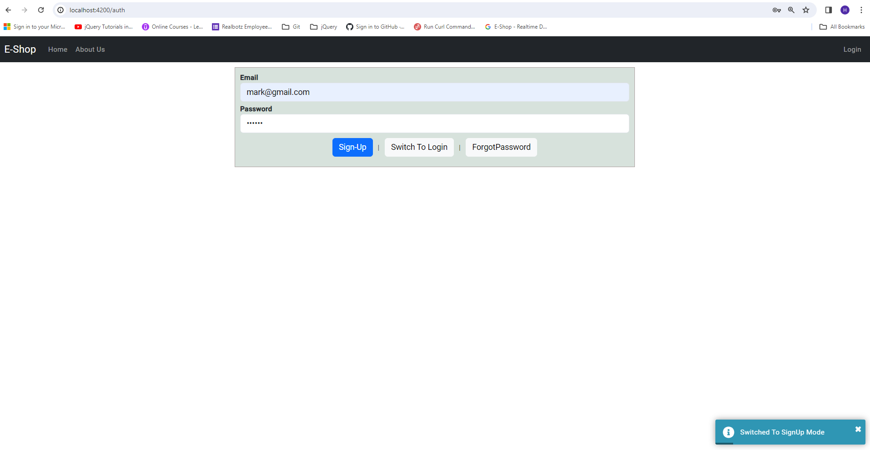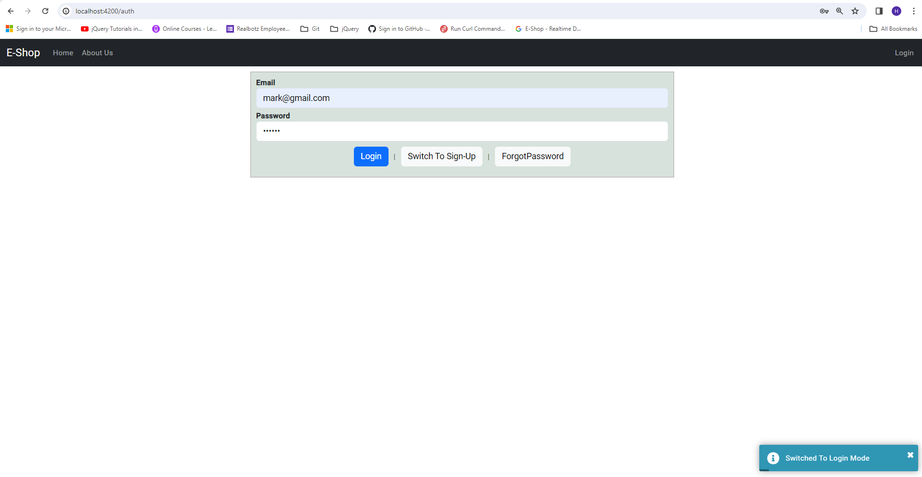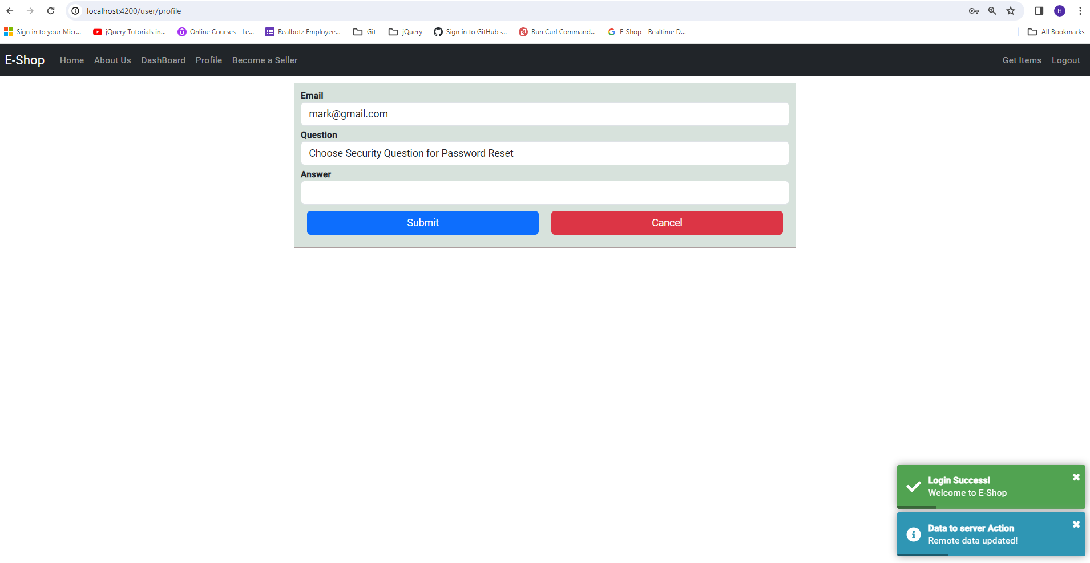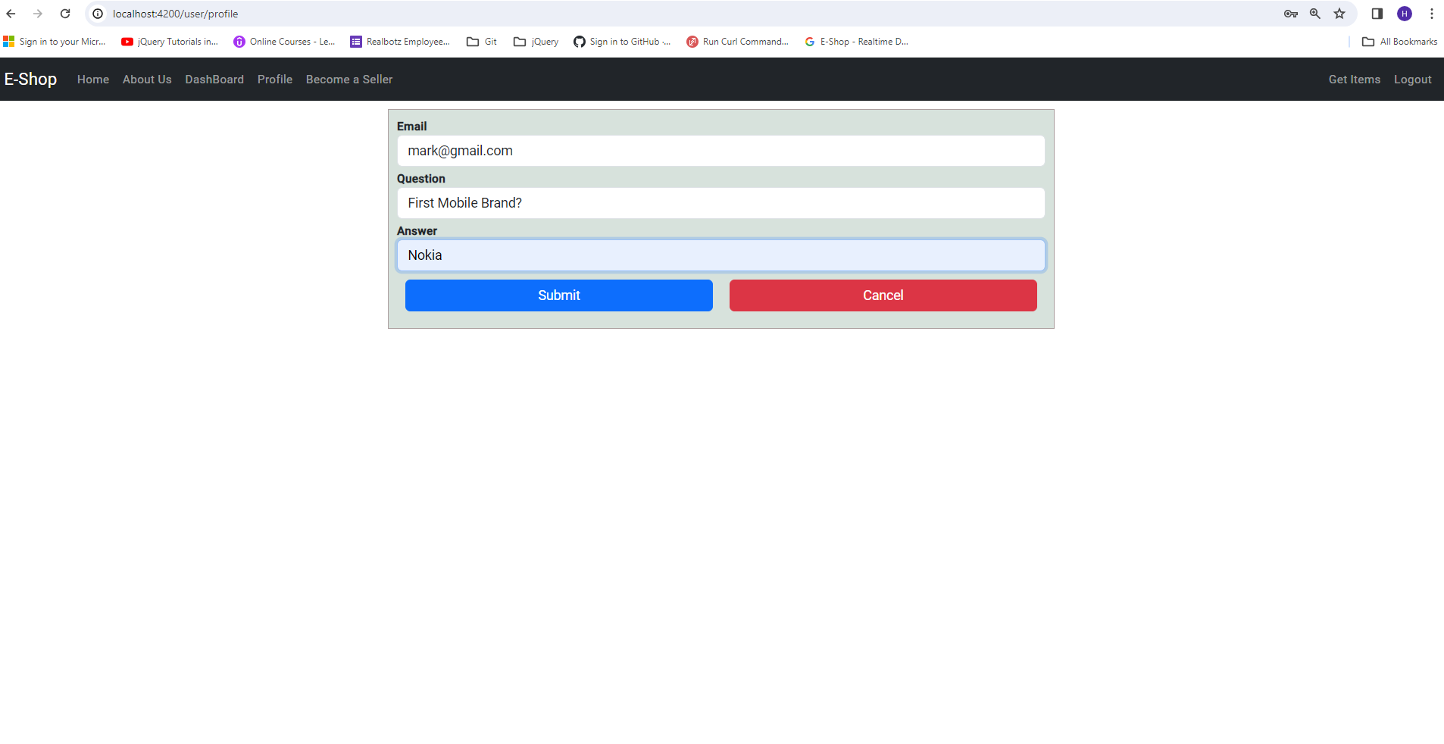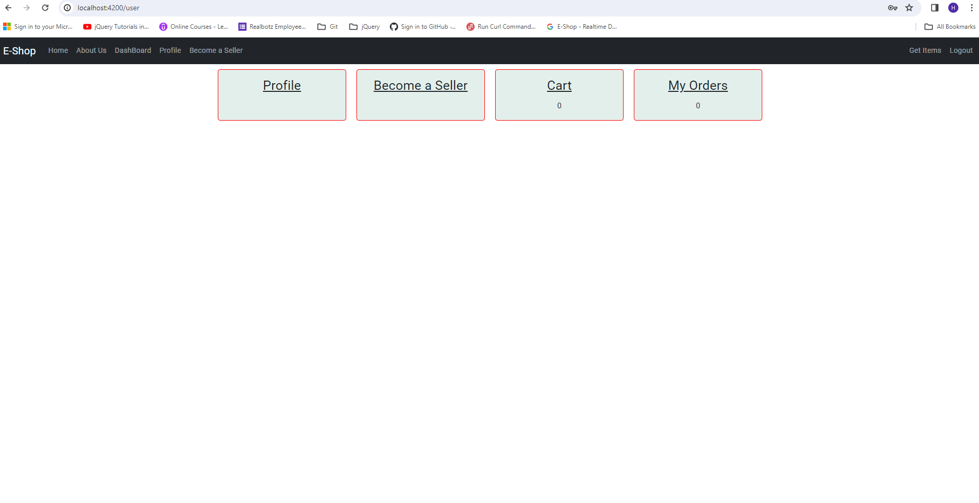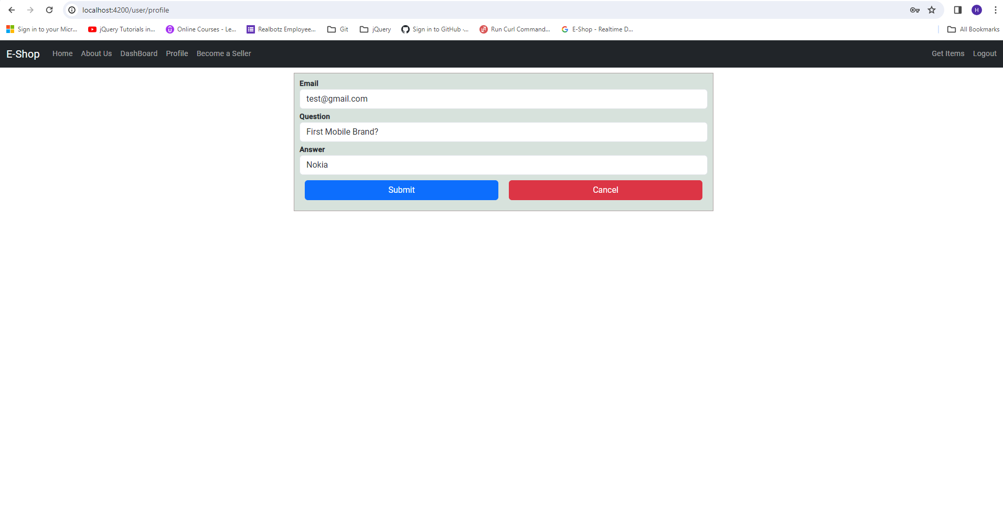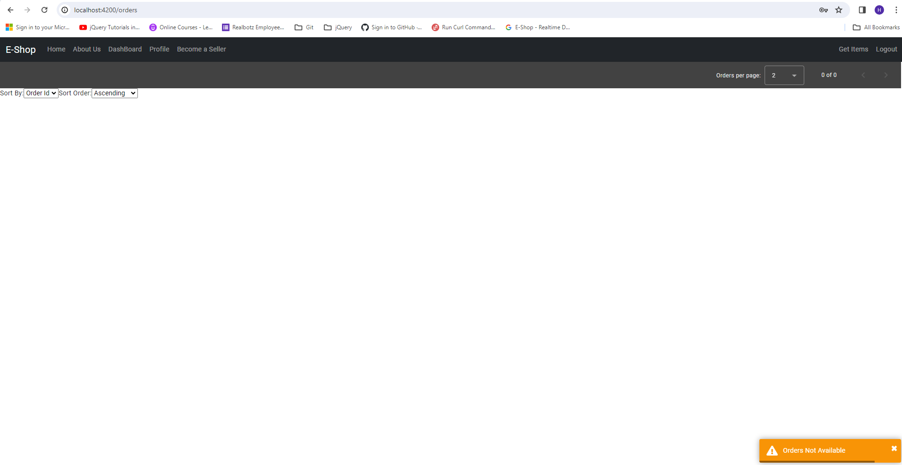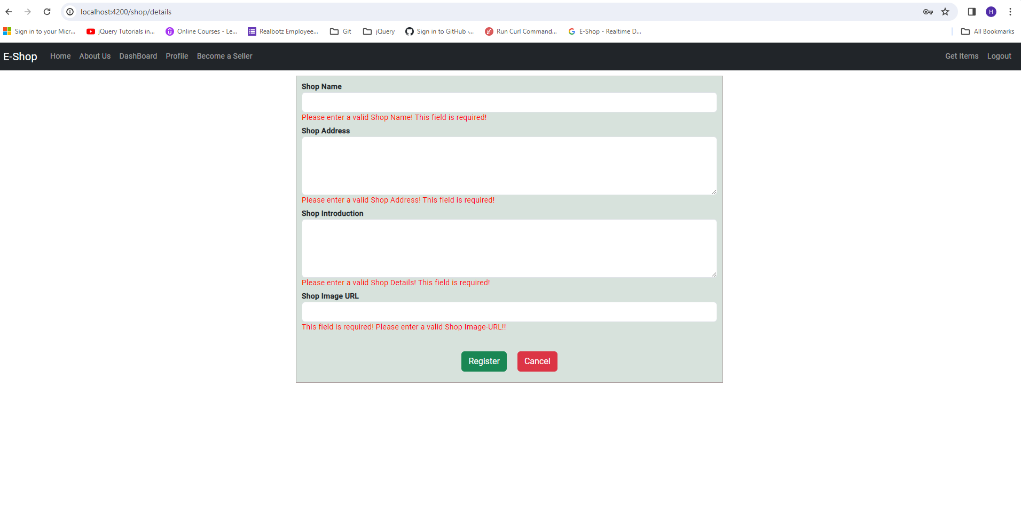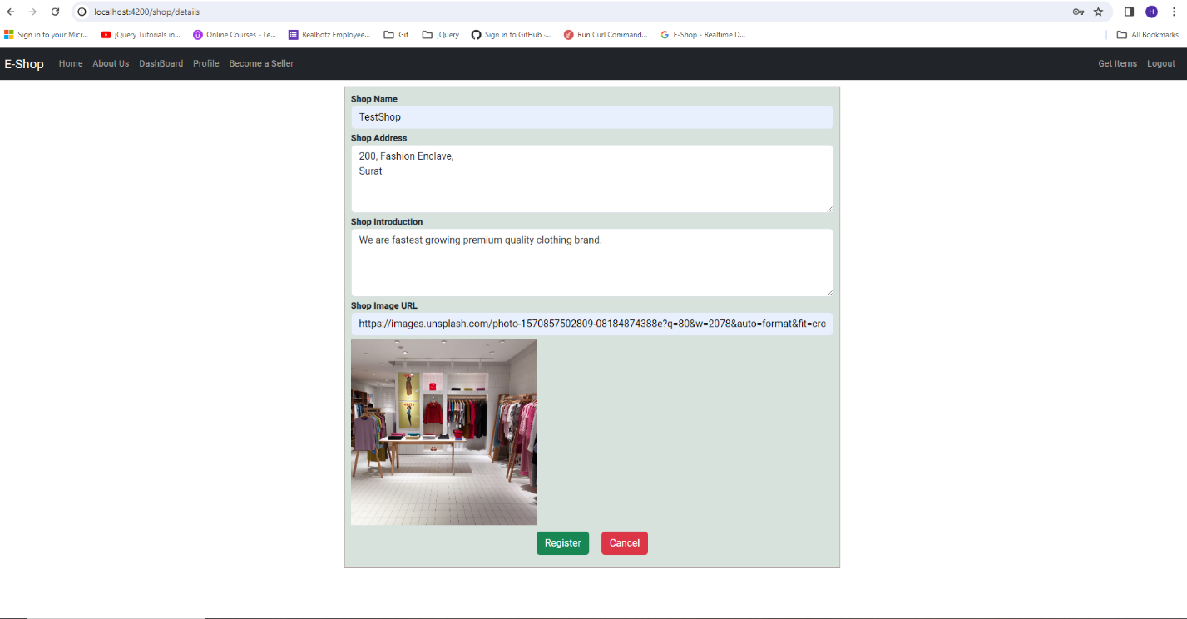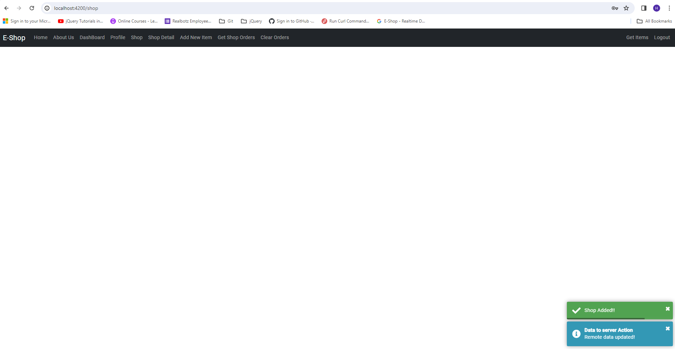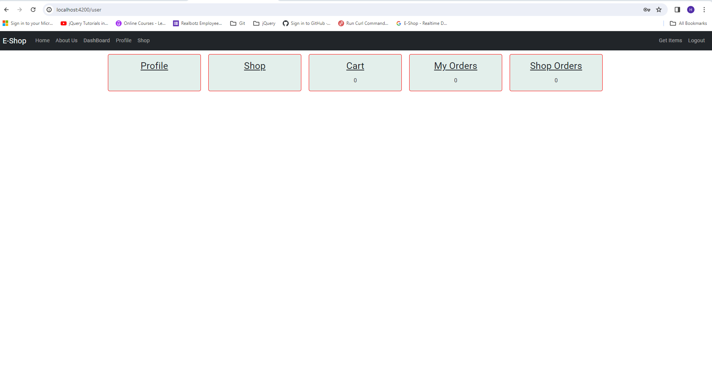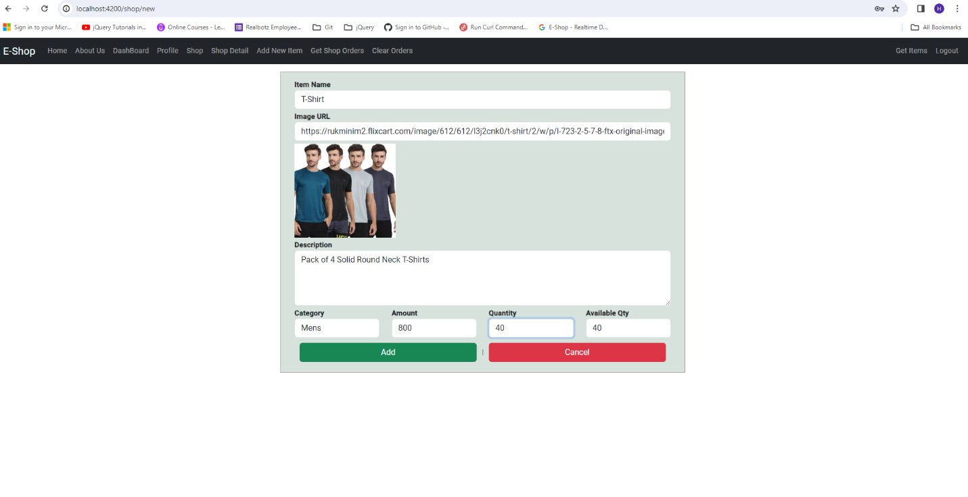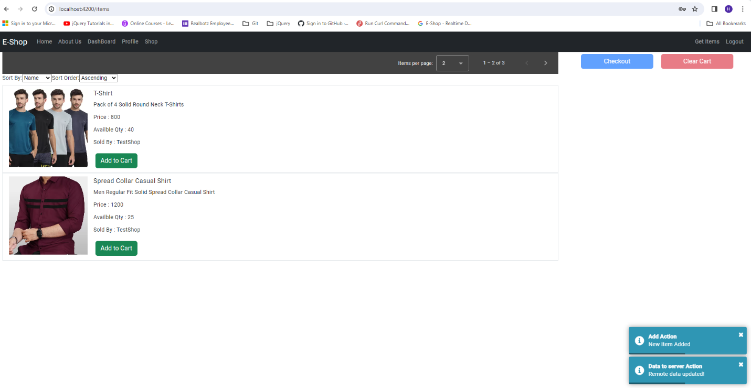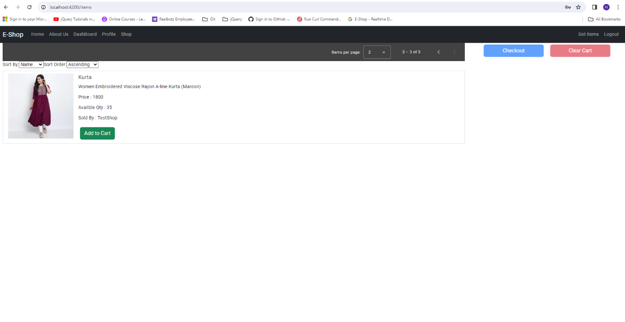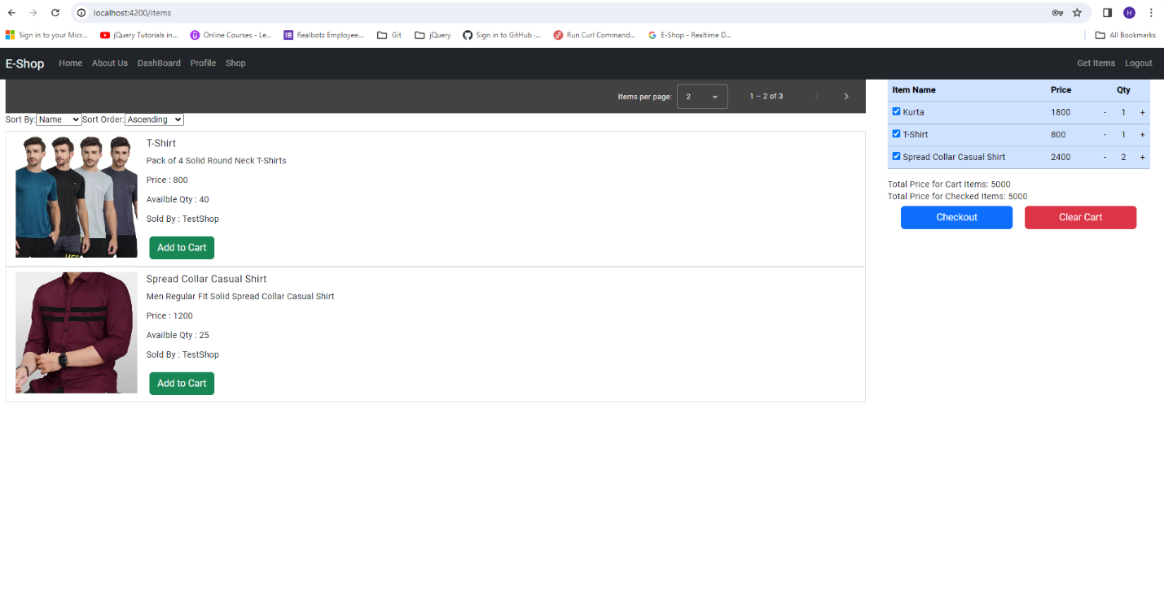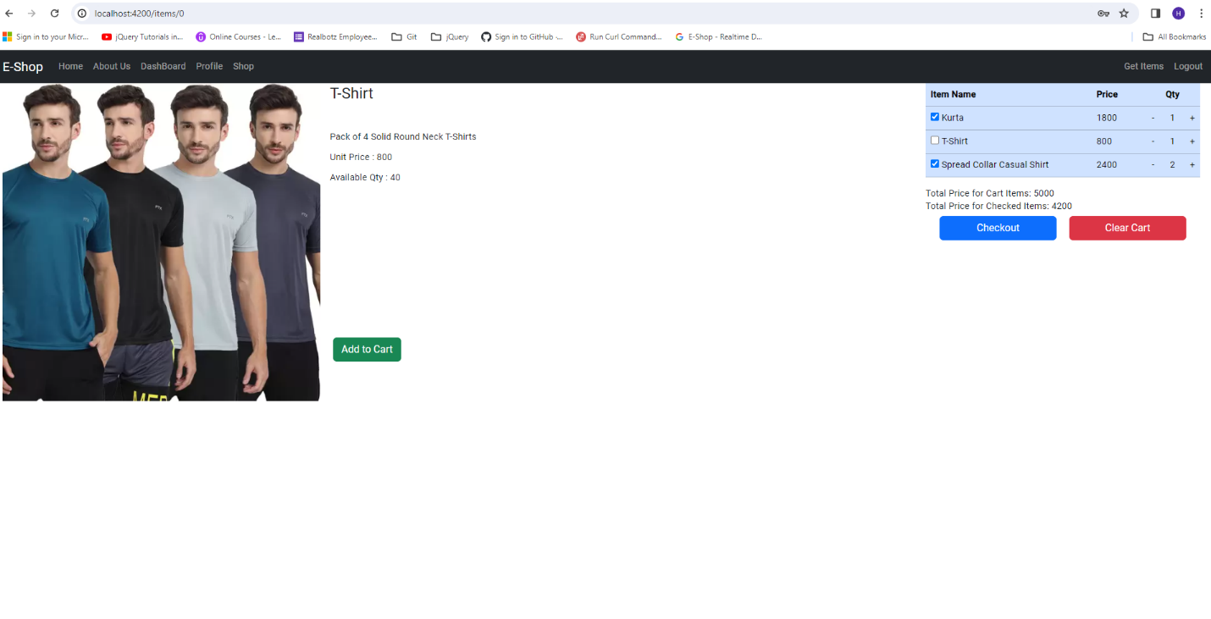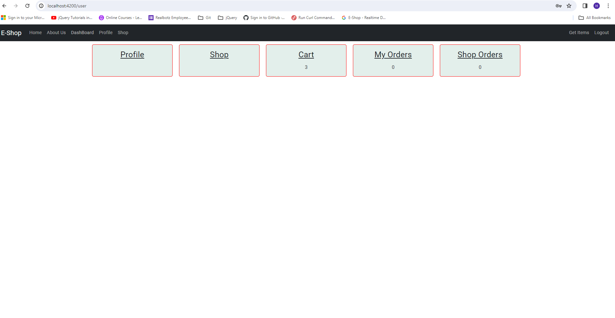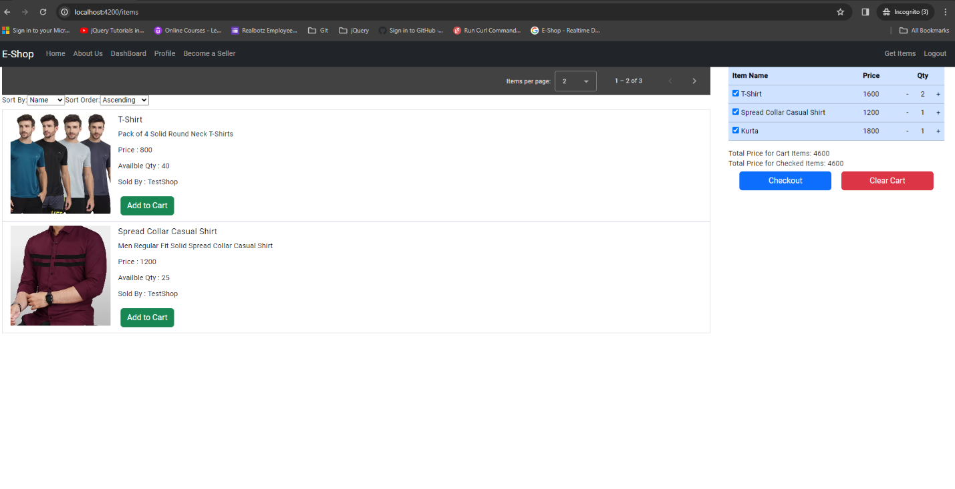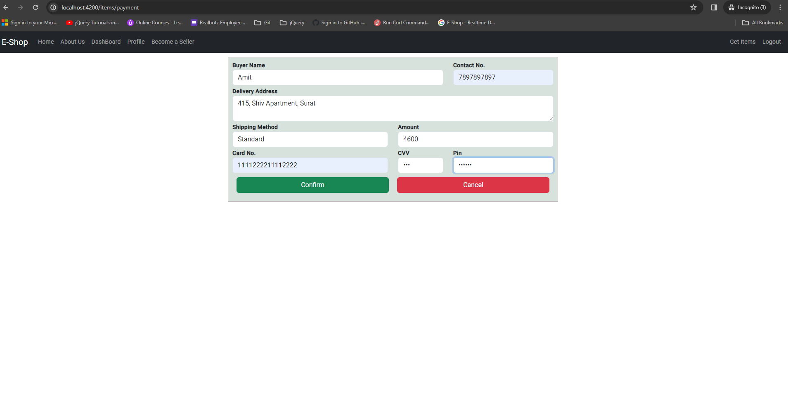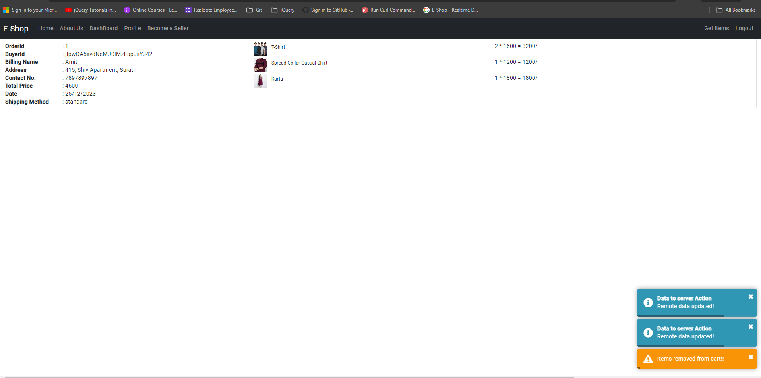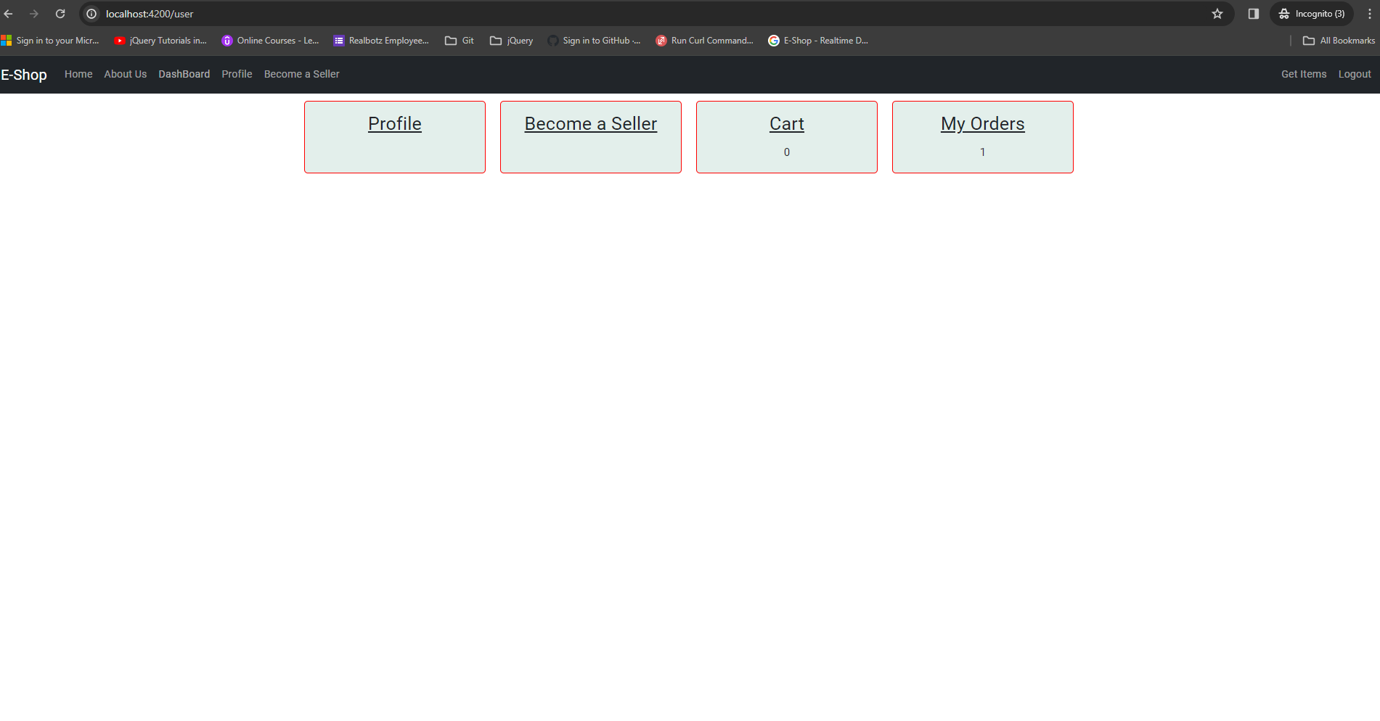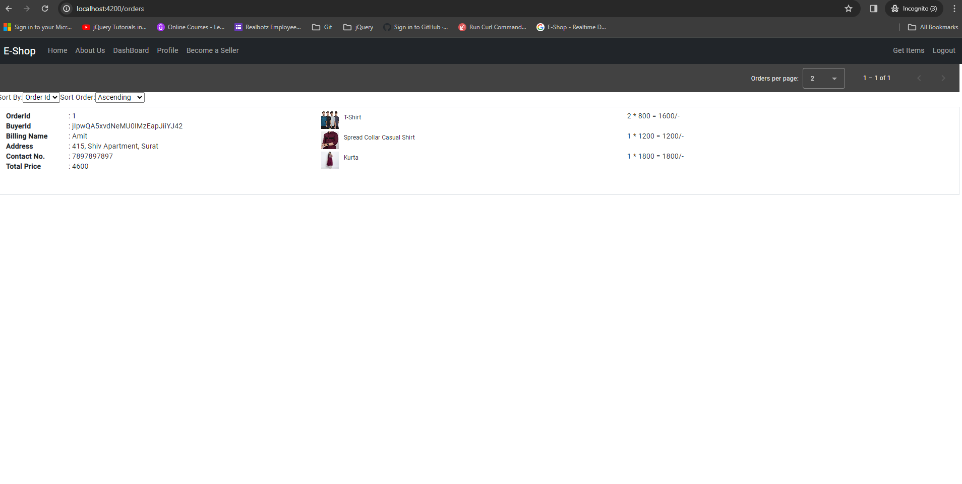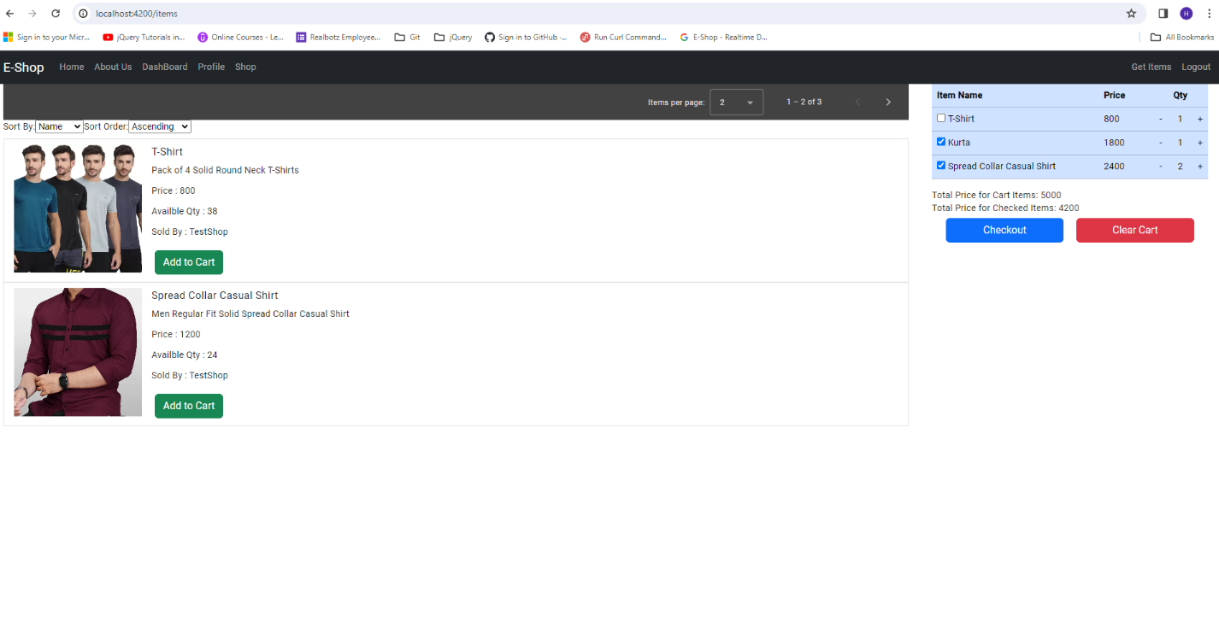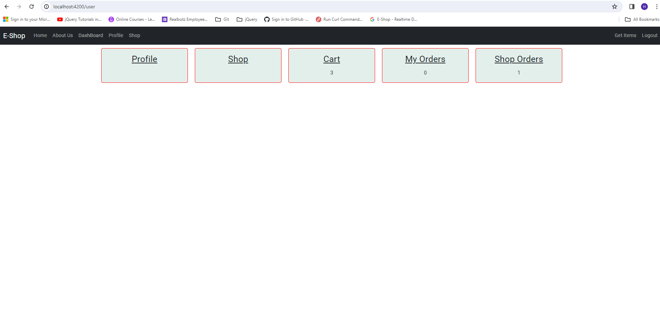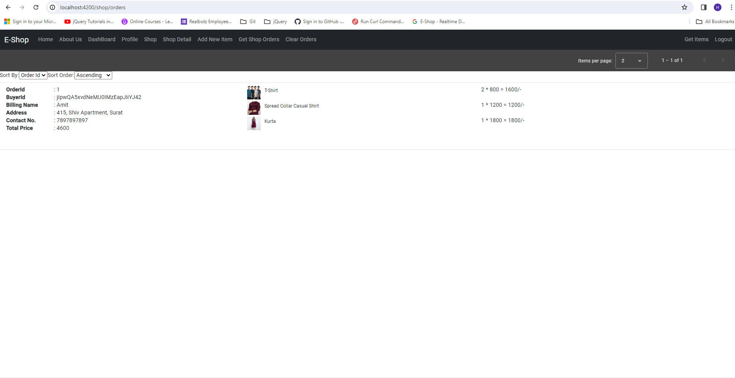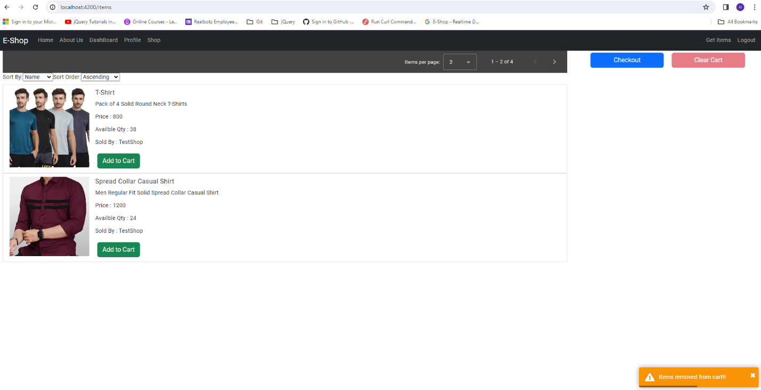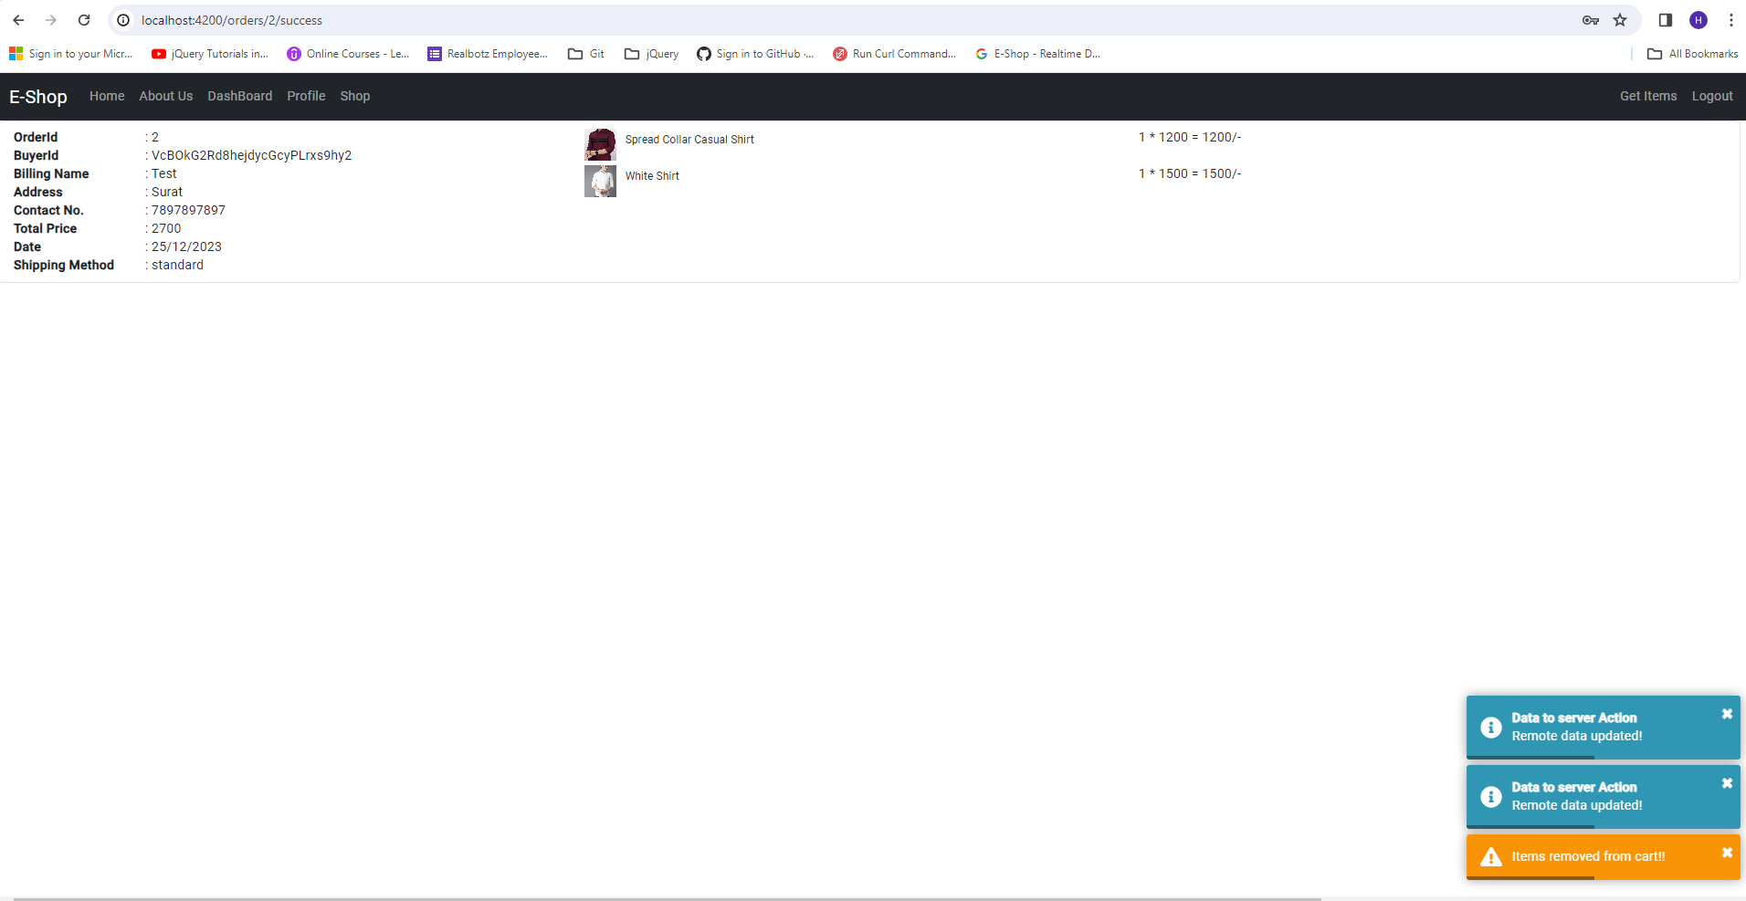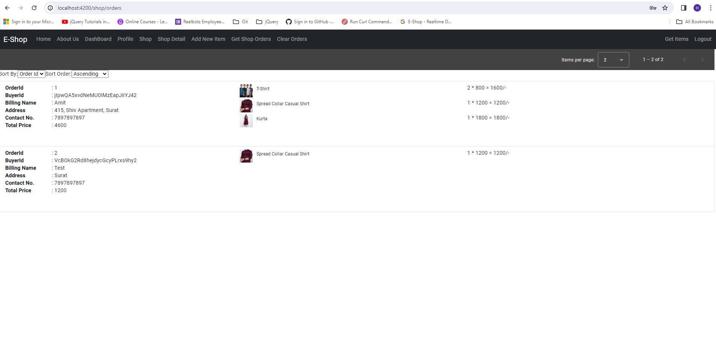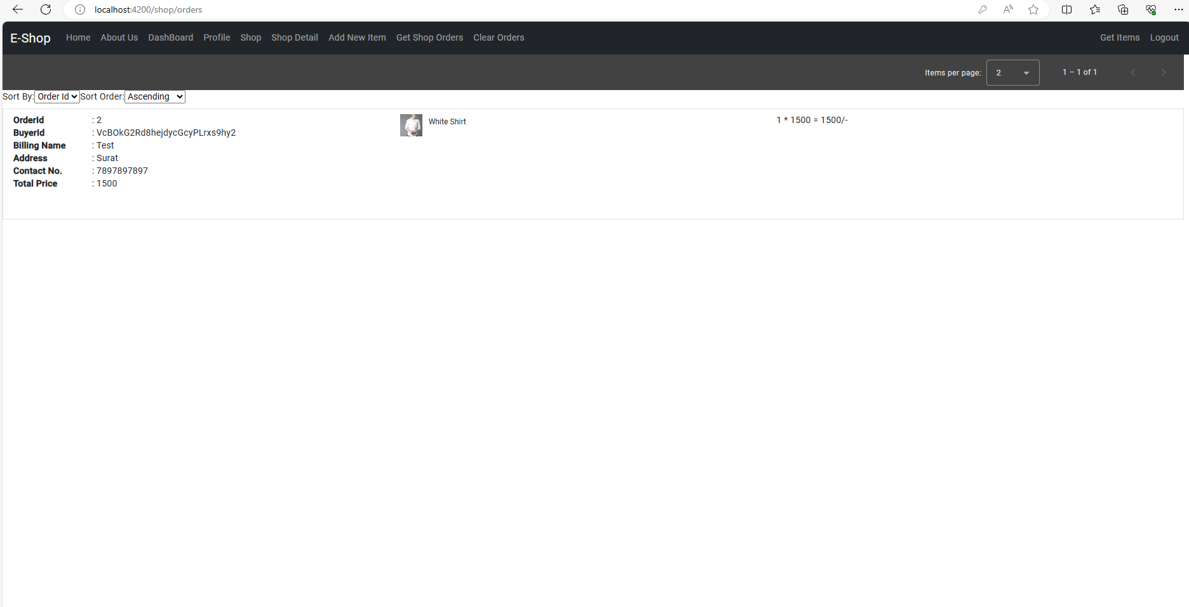

Forgot Password

If user with email id not exists/registered then

* Shows Toast Notification as “User Not Registered”.
* Remains on same page.

Auth Page : Login, Signup & Forgot Password

On Switch To Sign-Up

* Toggles form as Sign-Up form,
* Login Button to Sign-Up,
* Button Role becomes Switch To Login

On ForgotPassword

* Displays Forgot Password form.

Home Page => Item List

About Us => About E-Shop

Forgot Password

If user with email id exists/registered then

* Displays user’s security question.
* Shows Toast Notification as “Verify Security Question”

Forgot Password

If answer to question doesn’t matched then

* Shows Toast Notification as “Answer Not Matched”.

Forgot Password

If answer to question matched then

* Shows Toast Notification as “Answer Matched”.
* User able to enter New Password.

Home Page

On Password Change

* Shows Toast Notification as “Password Changed”.
* Shows Toast Notification as “Remote Data Updated”.
* Shows Item List if available.

Auth Page :

On Switch To Sign-Up

* Toggles form as Sign-Up form,
* Login Button to Sign-Up,
* Button Role becomes Switch To Login,
* Shows Toast Notification as “Switched To SignUp Mode”.

Auth Page :

On Switch To Login

* Toggles form as Login form,
* Sign-Up Button to Login,
* Button Role becomes Switch To Login,
* Shows Toast Notification as “Switched To Login Mode”.

Profile Page :

On SignUp

* Shows User Profile Form where user needs to select Security Question & enter answer,
* Shows Toast Notification as “Welcome to E-Shop”.

Profile Page :

On Submit

* Sets user’s security question & answer.

Home Page => Item List

About Us => About E-Shop

DashBoard => User’s Dashboard Page

Profile => User Profile Page

Become a Sellet => Shop Registration Page

DashBoard Page :

Profile, Become a Seller, Cart with no. of items in cart, MyOrders with no. of orders placed

On Profile

* Shows User Profile.

On Become a Seller

* Shows Shop Registration Form

On Cart

* Shows User Cart

On My Orders

* Shows user’s list of orders

Profile Page :

* Shows User Profile Form with user’s pre-set question and answer.
* User can update question &/ answer.

Orders Page :

* Shows user’s list of orders if available else Shows Toast Notification as “Orders Not Available”.

Shop Registration Page :

* Shop Registration Form with invalid details.

Shop Registration Page :

* Shop Registration Form with valid details.

Shop => list of items added/listed by user as seller if available

Shop Details => Shop Details Page

Add New Item => Add Item Page

Get Shop Orders => list of orders received for items added/listed by user as seller if available

Shop Page

On submission of Shop Registration Form

* Shows Toast Notification as “Shop Added”,
* Shows Toast Notification as “Remote Data Updated”,
* Shows list of items added/listed by user as seller if available,
* “Become a Seller” changes to Shop,
* NavBar changes.

On Shop

* Shows list of items added/listed by user as seller if available.

On Shop Orders

* Shows list of orders received for items added/listed by user as seller if available

On Profile

* Shows User Profile.

On Cart

* Shows User Cart

On My Orders

* Shows user’s list of orders

DashBoard Page :

Profile,

Shop if user registers shop,

Cart with no. of items in cart,

My Orders with no. of orders placed,

Shop Orders with no. of orders received for items added/listed by user as seller if available

Add Item Page :

* Add Item Form with valid details.

Sort By Name/Price/Quantity

Sort Order Acsending / Descending

User can select no. items per page

Cart Section

Home Page

On submission of Add Item Form

* Shows Toast Notification as “New Item Added”,
* Shows Toast Notification as “Remote Data Updated”,
* Shows list of items added/listed by user as seller if available.

User can select no. items per page

On Add to Cart

* Add item to Cart if item not present in Cart Items else increase Cart Item quantity & price.

Cart Section

On Checbox

* Changes Total Price for checked Items.

On Checkout

* Shows Payment Page.

On Clear Cart

* Removes Items in Cart.

On “-” sign

* Decreases Cart Item quantity & price if Cart Item quantity > 1 else removes Item from Cart.

On “+” sign

* Increases Cart Item quantity & price if Cart Item quantity < Item’s Available quantity.

Item’s Detail Page

* Name
* Description
* Unit Price
* Available Quantity
* Image

DashBoard Page :

Profile,

Shop if user registers shop,

Cart with no. of items in cart,

My Orders with no. of orders placed,

Shop Orders with no. of orders received for items added/listed by user as seller if available

Buyer Home Page with Few Items in Cart

Payment Page

On Checkout from Cart Section

* Shows Payment Form with Amount as Total Price for checked Items,

On Confirm

* Place order & removes items from Cart.
* Shows Order Details.
* Shows Toast Notification as “Items removed from Cart”,
* Shows Toast Notification as “Remote Data Updated”.

Order Detail Page

On Confirm from Payment Page

* Shows Order Details.
* Shows Toast Notification as “Items removed from Cart”,
* Shows Toast Notification as “Remote Data Updated”.

DashBoard Page :

On Order Placement

Profile,

Shop if user registers shop,

Cart with no. of items in cart,

My Orders with no. of orders placed.

Orders Page

On My Orders from DashBoard Page

* Shows list of orders.

Seller Home Page with Few Items in Cart

DashBoard Page :

Profile,

Shop if user registers shop,

Cart with no. of items in cart,

My Orders with no. of orders placed,

Shop Orders with no. of orders received for items added/listed by user as seller if available

Shop Orders Page

On Shop Orders from DashBoard Page

* Shows list of orders received for items added/listed by user as seller if available.

Cart Section

On Clear Cart

* Removes Items in Cart,
* Shows Toast Notification as “Items removed from Cart”.

Order Detail Page

On Confirm from Payment Page

* Shows Order Details.
* Shows Toast Notification as “Items removed from Cart”,
* Shows Toast Notification as “Remote Data Updated”.

Order Id : 2 => Ordered Items : 2

Shop Orders Page : Seller-1

On Shop Orders from DashBoard Page

* Shows list of orders received for items added/listed by user as seller if available.

Order Id : 2 => Ordered Items added/listed by user as seller : 1

Shop Orders Page : Seller-2

On Shop Orders from DashBoard Page

* Shows list of orders received for items added/listed by user as seller if available.

Order Id : 2 => Ordered Items added/listed by user as seller: 1

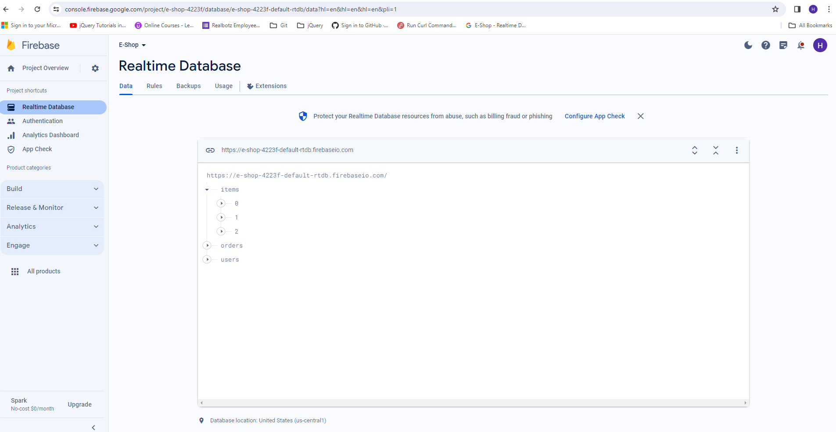

Firebase Realtime Database

* Items
* Orders
* Users