CS669: Pattern Recognition

Programming Assignment 4

Instructor: Dileep A.D.

By-

Group 12

Ayush Garg (B13111)

Himanshu Singal (B13312)

Hitesh Tarani (B13139)

**Introduction:**

**Datasets:**

**Dataset 1:** 2-dimensional artificial data of 3 or 4 classes:

(a) Linearly separable dataset

(b) Nonlinearly separable data set **(Only for SVM)**

**Dataset 2:** Real world data set:

(a) Two dimensional speech dataset (used in Assignment 1)

(b) Image dataset

**Classifiers to be built:**

1. Bayes classifier using unimodal Gaussian distribution on Dataset-1(a) and Dataset-2.

2. Bayes classifier using GMM on Dataset-2. GMM is built using the K-means clustering to initialize the parameters.

3. Build Bayes classifier using unimodal Gaussian distribution on the 1-dimensional representation of Dataset-1(a) and Dataset-2(a) obtained using PCA.

4. Build Bayes classifier using unimodal Gaussian distribution and GMM on the reduced dimensional representations of Dataset-2 obtaind using PCA.

5. Fisher linear discriminant analysis (FDA) based classifier on Dataset-1 and Dataset-2. Use both Bayes classifier using unomodal Gaussian and GMM.

6. Perceptron-based classifier on Dataset-1.

7. SVM-based classifier using (a) linear kernel, (b) polynomial kernel and (c) Gaussian/RBF kernel on Dataset-1 and Dataset-2

8. SVM-based classifier using (a) linear kernel, (b) polynomial kernel and (c) Gaussian/RBF kernel on the reduced dimensional representations of Dataset-2 obtained using PCA.

**Perform the experiments on different values of *K* in GMM for different reduced dimensions. Also perform experiments on different values of SVM and kernel parameters for different reduced dimensions.**

**Note: Concatenate the local feature vectors in each image to form a super vector. Now each image will become a vector with 36*23-dimension.**

**1. Bayes classifier using Unimodal Gaussian distribution on Dataset-1(a) and Dataset-2.**

**a. Dataset-1(a): Linearly Separable**

1. **Classification Accuracy** = 100%
2. **Confusion Matrix based on performance for test data.**

$$\left[\begin{matrix}125 & 0 & 0 \\ 0 & 125 & 2 \\ 0 & 0 & 125\end{matrix}\right]$$

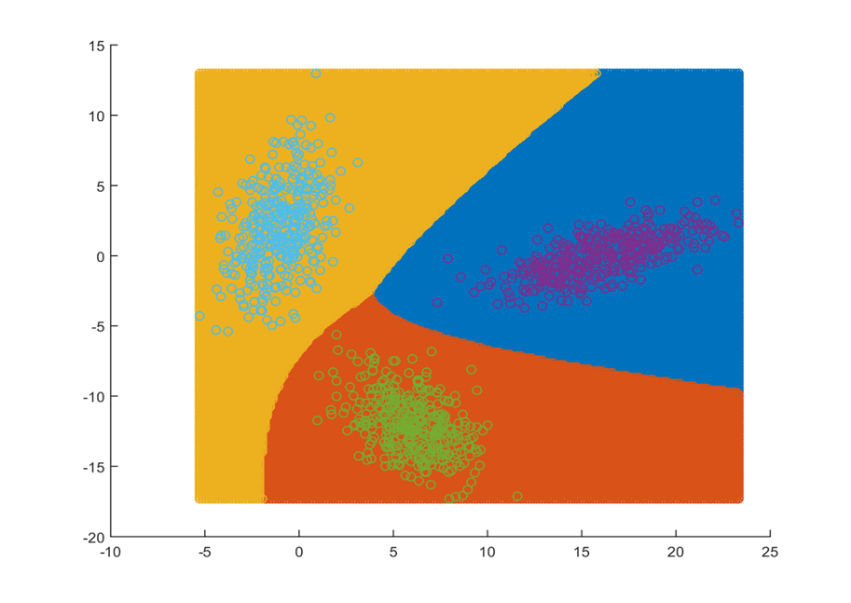

**b. Dataset-2**

Two dimensional speech dataset (used in Assignment 1)

**Classification Accuracy: - 82.698%**

**Confusion Matrix**

|  |  |  |  |
| --- | --- | --- | --- |
|  | Class1 | Class2 | Class3 |
| Class1 | 411 | 203 | 0 |
| Class2 | 91 | 531 | 0 |
| Class3 | 11 | 8 | 554 |

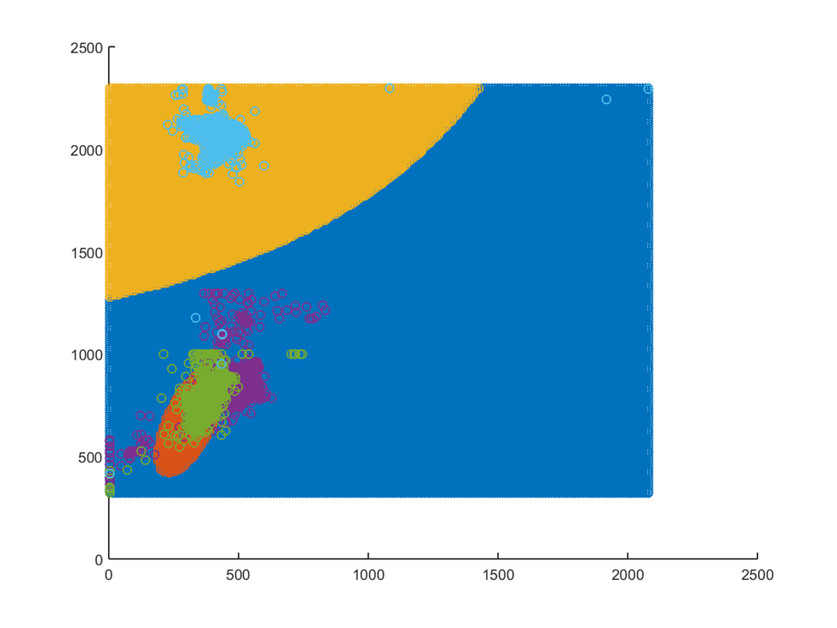

**2. Bayes classifier using GMM on Dataset-2. GMM is built using the K-means clustering to initialize the parameters.**

|  |  |  |
| --- | --- | --- |
| **Dataset** | **Confusion Matrix** | **Accuracy** |
| Two dimensional speech dataset | **K = 8,8,4 $$\left[\begin{matrix} 404 & 214 & 4 \\ 45 & 573 & 4 \\ 7 & 13 & 552\end{matrix}\right]$$** | 84% |
| Image dataset | **K= 16 $$\left[\begin{matrix}80 & 3 & 7 \\ 2 & 80 & 0 \\ 3 & 2 & 72\end{matrix}\right]$$** | 93.173% |

**3. Build Bayes classifier using unimodal Gaussian distribution on the 1- dimensional representation of Dataset-1(a) and Dataset-2(a) obtained using PCA.**

|  |  |  |
| --- | --- | --- |
| **Dataset** | **Confusion Matrix** | **Accuracy** |
| Linearly Separable | $$\left[\begin{matrix} 123 & 2 & 0 \\ 4 & 120 & 1 \\ 0 & 0 & 125\end{matrix}\right]$$ | 98.133 % |
| Two dimensional speech dataset | $$\left[\begin{matrix}312 & 302 & 0 \\ 73 & 549 & 0 \\ 13 & 7 & 553\end{matrix}\right]$$ | 78.165% |

**4. Build Bayes classifier using unimodal Gaussian distribution and GMM on the reduced dimensional representations of Dataset-2 obtained using PCA.**

1. Two dimensional speech dataset

GMM

|  |  |  |  |
| --- | --- | --- | --- |
| **L** | **No. of Clusters** | **Confusion Matrix** | **Accuracy** |
| 1 | **3** | $$\left[\begin{matrix} 499 & 115 & 0 \\ 98 & 524 & 0 \\ 16 & 10 & 547\end{matrix}\right]$$ | 86.78% |

1. Image dataset

Univariate

|  |  |  |
| --- | --- | --- |
| **L** | **Confusion Matrix** | **Accuracy** |
| 1 | $$\left[\begin{matrix} 26 & 34 & 30 \\ 12 & 70 & 0 \\ 21 & 2 & 54\end{matrix}\right]$$ | 60.24% |
| 2 | $$\left[\begin{matrix} 26 & 37 & 27 \\ 9 & 70 & 3 \\ 9 & 3 & 65\end{matrix}\right]$$ | 64.659% |
| 4 | $$\left[\begin{matrix} 59 & 15 & 16 \\ 5 & 73 & 4 \\ 9 & 3 & 65\end{matrix}\right]$$ | 79% |
| 8 | $$\left[\begin{matrix} 73 & 8 & 9 \\ 11 & 68 & 3 \\ 6 & 4 & 67\end{matrix}\right]$$ | 83.53% |
| 16 | $$\left[\begin{matrix} 77 & 4 & 9 \\ 6 & 68 & 8 \\ 8 & 3 & 66\end{matrix}\right]$$ | 84.73% |

Multivariate

|  |  |  |  |
| --- | --- | --- | --- |
| **L** | **No. of Clusters** | **Confusion Matrix** | **Accuracy** |
| 1 | 3 | $$\left[\begin{matrix} 39 & 21 & 30 \\ 15 & 66 & 1 \\ 22 & 0 & 55\end{matrix}\right]$$ | 64.25% |
| 4 | 3 | $$\left[\begin{matrix} 67 & 9 & 14 \\ 11 & 66 & 5 \\ 6 & 2 & 69\end{matrix}\right]$$ | 81.124% |
| 8 | 3 | $$\left[\begin{matrix} 77 & 6 & 7 \\ 13 & 65 & 4 \\ 7 & 3 & 67\end{matrix}\right]$$ | 83.93% |

**5. Fisher linear discriminant analysis (FDA) based classifier on Dataset-1 and Dataset-2. Use both Bayes classifier using unimodal Gaussian and GMM.**

**Dataset-1: Linearly Separable**

|  |  |  |
| --- | --- | --- |
| **Model** | **Confusion Matrix** | **Accuracy** |
| Unimodal | $$\left[\begin{matrix} 125 & 0 & 0 \\ 0 & 125 & 0 \\ 0 & 0 & 125\end{matrix}\right]$$ | 100% |
| GMM | $$\left[\begin{matrix}125 & 0 & 0 \\ 0 & 125 & 0 \\ 0 & 0 & 125\end{matrix}\right]$$ | 100% |

**Dataset-2: Speech Dataset**

|  |  |  |
| --- | --- | --- |
| **Model** | **Confusion Matrix** | **Accuracy** |
| Unimodal | $$\left[\begin{matrix} 476 & 138 & 0 \\ 83 & 539 & 0 \\ 13 & 8 & 552\end{matrix}\right]$$ | 86.62% |
| GMM | $$\left[\begin{matrix}452 & 162 & 0 \\ 58 & 564 & 0 \\ 13 & 8 & 552\end{matrix}\right]$$ | 86.67% |

**Dataset-2: Image Dataset**

Matrix was coming out to be singular.

**7. SVM-based classifier using (a) linear kernel, (b) Gaussian/RBF kernel on Dataset-1 and Dataset-2.**

**Dataset-1(a): Linearly Separable**

|  |  |  |
| --- | --- | --- |
| **Kernel** | **Confusion Matrix** | **Accuracy** |
| Linear | $$\left[\begin{matrix} 125 & 0 & 0 \\ 0 & 125 & 0 \\ 0 & 0 & 125\end{matrix}\right]$$ | 100% |
| RBF/Gaussian | $$\left[\begin{matrix}125 & 0 & 0 \\ 0 & 125 & 0 \\ 0 & 0 & 125\end{matrix}\right]$$ | 100% |

**Dataset-1(b): Non-Linearly Separable**

**Ring**

|  |  |  |
| --- | --- | --- |
| **Kernel** | **Confusion Matrix** | **Accuracy** |
| Linear | $$\left[\begin{matrix}0 & 75 \\ 0 & 300\end{matrix}\right]$$ | 80% |
| RBF/Gaussian | $$\left[\begin{matrix}75 & 0 \\ 0 & 300\end{matrix}\right]$$ | 100% |

**Spiral**

|  |  |  |
| --- | --- | --- |
| **Kernel** | **Confusion Matrix** | **Accuracy** |
| Linear | $$\left[\begin{matrix}175 & 151 \\ 151 & 175\end{matrix}\right]$$ | 53.68% |
| RBF/Gaussian | $$\left[\begin{matrix}296 & 30 \\ 30 & 296\end{matrix}\right]$$ | 90.798% |

**Interlock**

|  |  |  |
| --- | --- | --- |
| **Kernel** | **Confusion Matrix** | **Accuracy** |
| Linear | $$\left[\begin{matrix}118 & 7 \\ 1 & 124\end{matrix}\right]$$ | 96.8% |
| RBF/Gaussian | $$\left[\begin{matrix}125 & 0 \\ 0 & 125\end{matrix}\right]$$ | 100 % |

**Dataset-2(a): Two dimensional Speech**

|  |  |  |
| --- | --- | --- |
| **Kernel** | **Confusion Matrix** | **Accuracy** |
| Linear | $$\left[\begin{matrix} 415 & 199 & 0 \\ 20 & 602 & 0 \\ 0 & 15 & 558\end{matrix}\right]$$ | 87.065% |
| RBF/Gaussian | $$\left[\begin{matrix}402 & 211 & 1 \\ 40 & 580 & 2 \\ 3 & 12 & 558\end{matrix}\right]$$ | 85.13% |

**Dataset-2(b): Image Dataset**

|  |  |  |
| --- | --- | --- |
| **Kernel** | **Confusion Matrix** | **Accuracy** |
| Linear | $$\left[\begin{matrix} 86 & 2 & 2 \\ 1 & 81 & 0 \\ 4 & 2 & 71\end{matrix}\right]$$ | 95.582% |
| RBF/Gaussian | $$\left[\begin{matrix}90 & 0 & 0 \\ 82 & 0 & 0 \\ 77 & 0 & 0\end{matrix}\right]$$ | 36.145% |

**8. SVM-based classifier using (a) linear kernel, (b) polynomial kernel and (c) Gaussian/RBF kernel on the reduced dimensional representations of Dataset-2 obtained using PCA.**

**Dataset-2(a): Speech Data**

|  |  |  |  |
| --- | --- | --- | --- |
| **Kernel** | **L** | **Confusion Matrix** | **Accuracy** |
| Linear | 1 | $$\left[\begin{matrix} 430 & 184 & 0 \\ 65 & 557 & 0 \\ 6 & 12 & 555\end{matrix}\right]$$ | 85.24% |
| RBF/Gaussian | 1 | $$\left[\begin{matrix}468 & 146 & 0 \\ 48 & 574 & 0 \\ 10 & 11 & 552\end{matrix}\right]$$ | 88.115% |

**Dataset-2(b): Image Data**

|  |  |  |  |
| --- | --- | --- | --- |
| **Kernel** | **L** | **Confusion Matrix** | **Accuracy** |
| Linear | 1 | $$\left[\begin{matrix} 54 & 26 & 10 \\ 14 & 68 & 0 \\ 33 & 2 & 42\end{matrix}\right]$$ | 65.863% |
| RBF/Gaussian | 1 | $$\left[\begin{matrix}44 & 25 & 21 \\ 14 & 68 & 0 \\ 30 & 0 & 47\end{matrix}\right]$$ | 63.855% |
| Linear | 16 | $$\left[\begin{matrix} 66 & 12 & 12 \\ 5 & 75 & 2 \\ 7 & 3 & 67\end{matrix}\right]$$ | 83.534% |
| RBF/Gaussian | 16 | $$\left[\begin{matrix}44 & 4 & 42 \\ 10 & 34 & 38 \\ 2 & 1 & 74\end{matrix}\right]$$ | 61.044% |