**Docker implementation of cloud custodian with azure**

Dockerfile :

FROM ubuntu:18.04

######INSTALL PYTHON3.7##########

RUN apt update -y \

&& apt install build-essential zlib1g-dev libncurses5-dev libgdbm-dev libnss3-dev libssl-dev libsqlite3-dev libreadline-dev libffi-dev wget tar curl make nano -y \

&& wget https://www.python.org/ftp/python/3.7.4/Python-3.7.4.tgz \

&& tar -xf Python-3.7.4.tgz \

&& cd Python-3.7.4 \

&& ./configure --enable-optimizations \

&& make -j 8 \

&& make altinstall \

&& cp -R /usr/local/bin/python3.7 /usr/bin \

&& mv /usr/bin/python3.7 /usr/bin/python \

&& echo "PATH=$PATH:/usr/bin/python" > ~/.bashrc \

&& . ~/.bashrc \

&& python --version

###########INSTALL CLOUD CUSTODIAN FOR AZURE##########

RUN python -m venv custodian \

&& /bin/bash -c "source /custodian/bin/activate" \

&& python -m pip install c7n_azure \

&& python -m pip install azure-cli

Step1: Run docker image using below command

$ docker run -it --name <name_of_container> -h <hostname> <image_name/id> /bin/bash

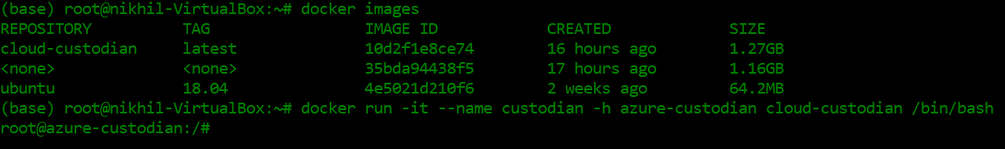

Step2: Login to azure using azure cli

$ az login

**Note: Once you fire this command it will give you one URL and code. Open that URL in browser and paste the code and login to your appropriate account. Once you done this you will get below output.**

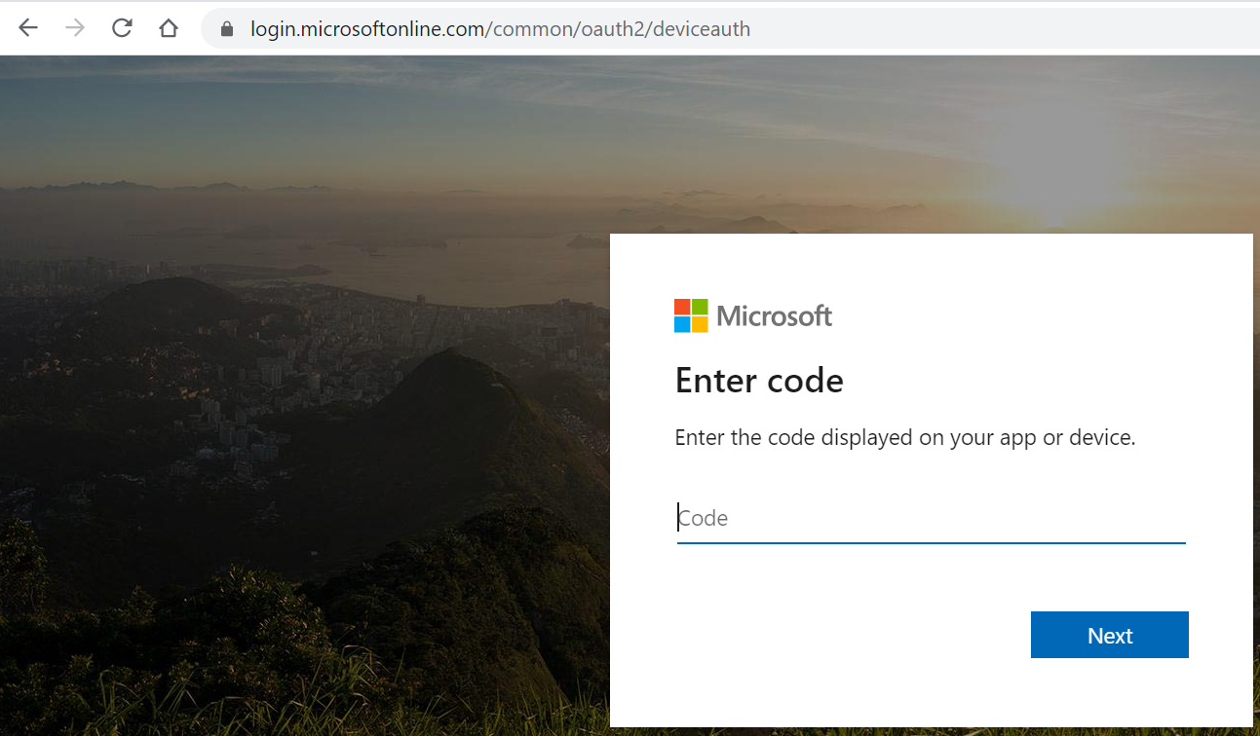

* After pasting code click “**Next**”
* Select your account to login

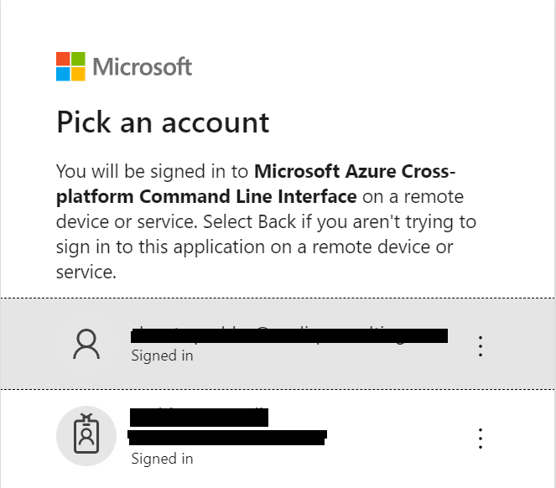

* Once you select the account you will get below screen on command prompt

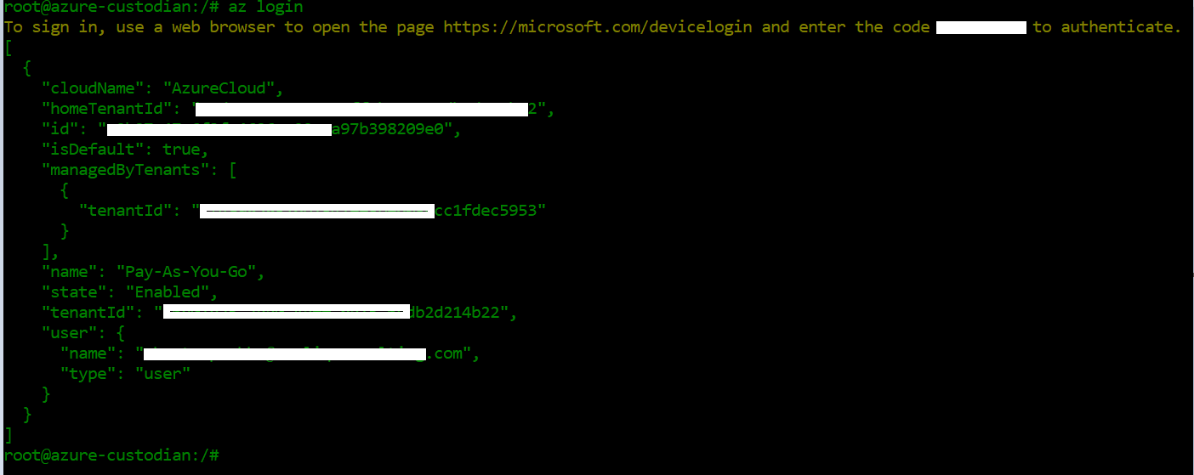

**Step3**: Create YML file to make a changes in resources.

Example –

policies:

- name: my-first-policy

description: |

Adds a tag to a virtual machines

resource: azure.vm

filters:

- type: value

key: name

value: confjumpbox

actions:

- type: tag

tag: Hello

value: World

**Step4**: Run this file using custodian command

$ custodian run --output-dir=. custodian.yml

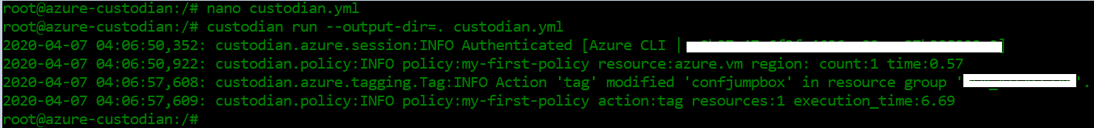

* You can see the tag changes in console also.

