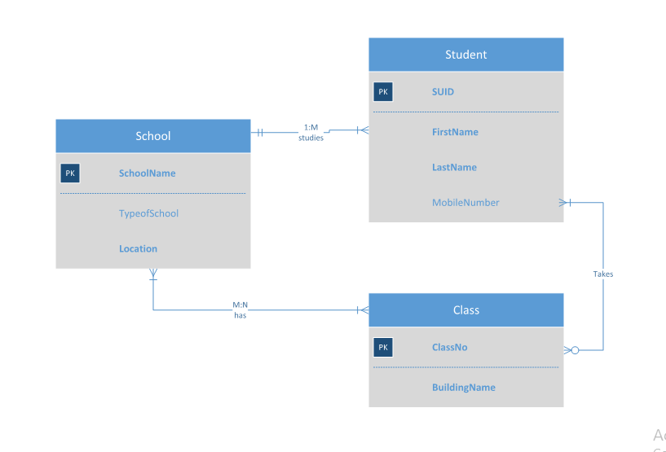

**ERD Diagram**

**BUSINESS RULES:**

* School has 1 or many students.
* A single student can attend only and only 1 school.
* Each school has 1 or many classes.
* A class is taken at at least 1 or many different schools.
* A student can or can’t attend several classes. (Assumption several classes being considered many so optional many)
* Every class needs at least 1 or more students.

**Relationships between the entities:**

* Relationship between a student and a school is 1:M as a single student can attend only 1 school and a school can have 1 or many students studying in it.
* Relationship between School and Classes is M:N as each school can have 1 or many classes and a class can be hosted by 1 or many schools.
* Relationship between a student and class is optional many as a student may attend or may not attend classes and each class has 1 or more students. (May or may not take many classes plural optional many)

**Question 2: One to Many Relationship**

**Relationship for 1 to many** :

Manager and Employee have one-to-many relationship. An employee has 1 manager assigned to him and a manager has 1 or more employees working under him.

**Business Rules:**

1. Manager manages 1 or more employees.
2. An employee has only 1 manager**.**

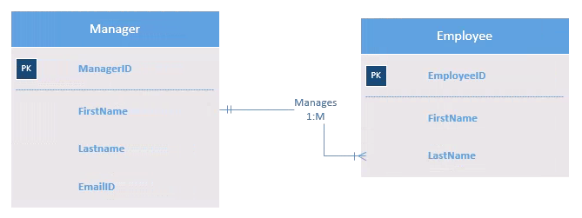

**ERD Diagram**