**Question 1: ONLINE WEBSITE DESIGN**

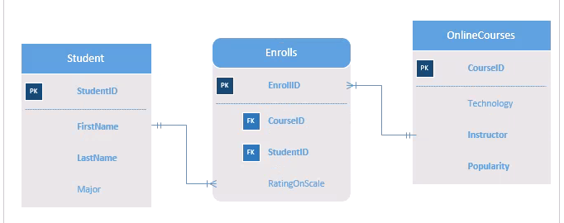

ERD Diagram for Online Website

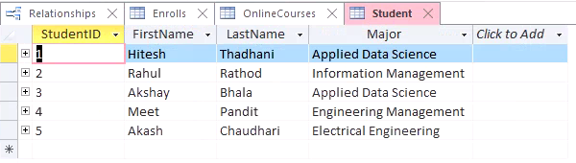

MS Access for Student Table

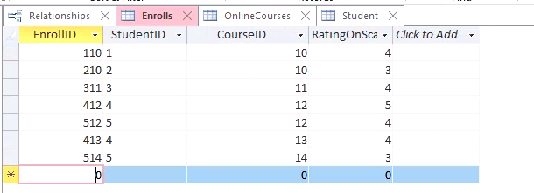

MS Access for Enrolls Table

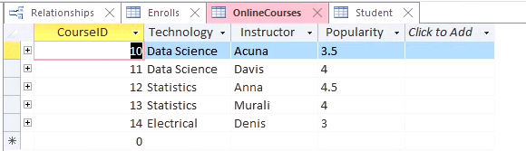

MS Access for Online Courses Table

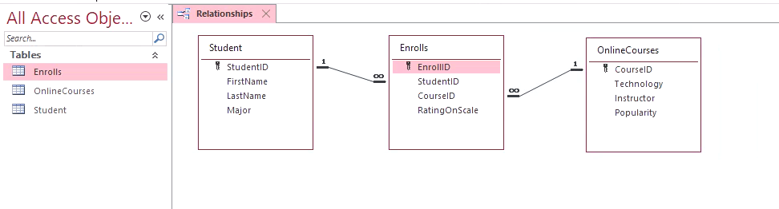

Relationship between the 3 Entities in MS Access

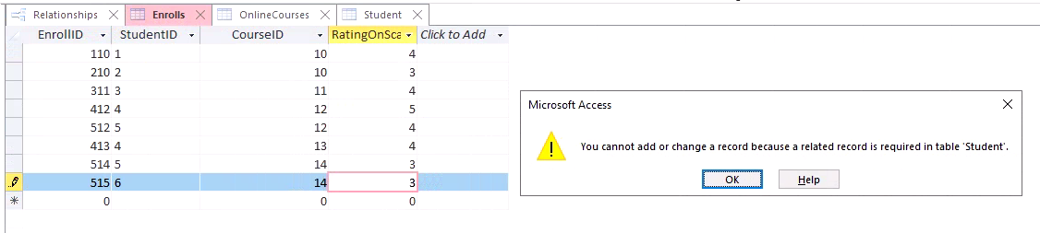

MS Access Referential Integrity Constraint Enforced

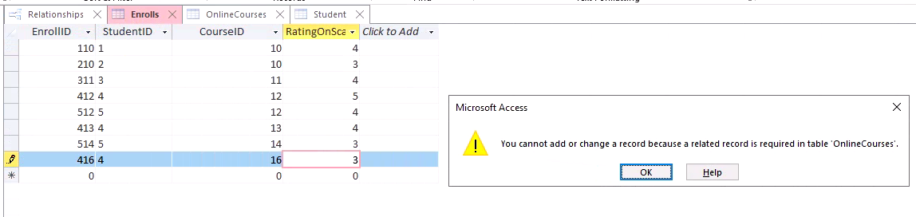

MS Access Referential Integrity Constraint Enforced

**Business Rules:**

* A Student can take 1 or more Online Courses.
* An Online Course can be taken by 1 or more Students.
* Ratings are included in Associative Entity with attribute name as RatingOnScale.
* Popularity for each course is defined in Online Courses.

**Relationships:**

The relationship between Student & Skills is M:N as a student can take 1 or more Online Courses and an Online Course can be taken by 1 or more Students. Associative Entity is used to break the M:N to 2 1:M relationships.

**Question No 2: TERNARY RELATIONSHIP EXAMPLE**

**Ternary Relationship Example where Employees use Skills to work on a Project**

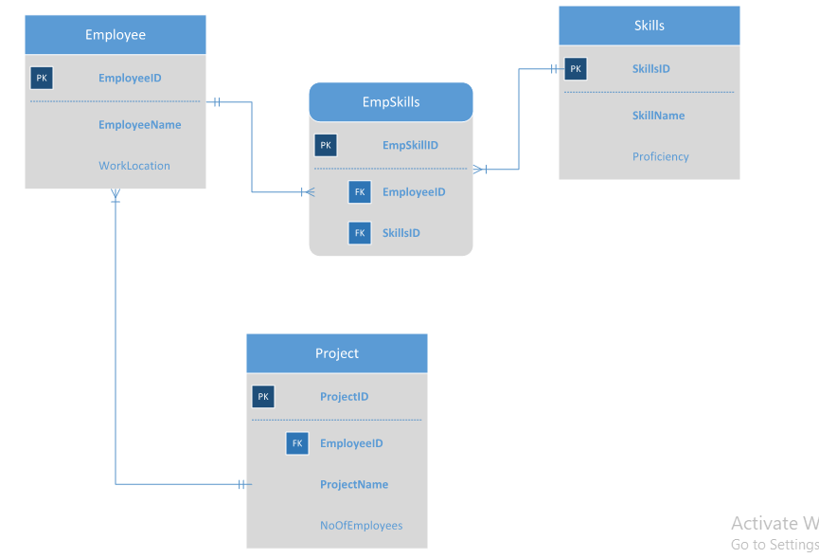

ERD Diagram for Organization depicting ternary relationship

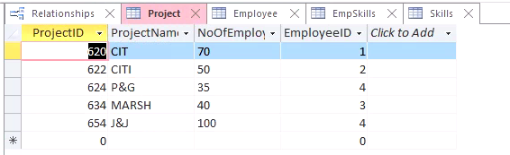

MS Access for Project Table

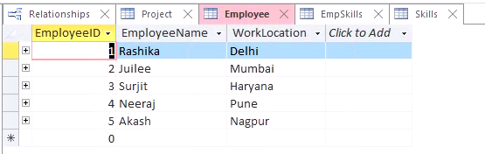

MS Access for Employee Table

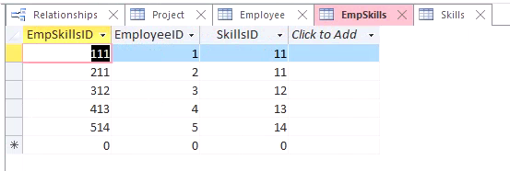

MS Access for EmpSkills Tables

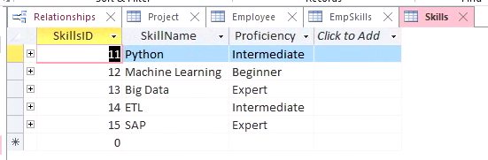

MS Access for Skills Table

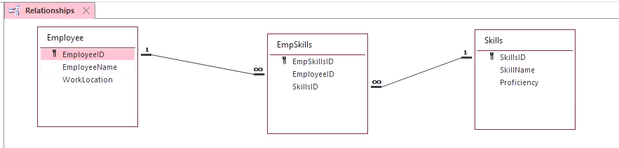

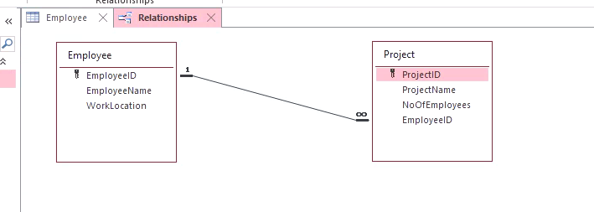

Relationship between the Entities in Ternary Relationship (Second relation is still giving error for 1:M)

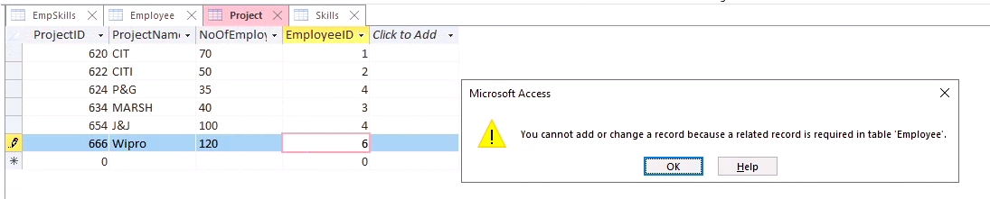

MS Access Referential Integrity Constraint

**Business Rules:**

* An Employee can have 1 or many skills.
* A Skill can be acquired by 1 or many employees.
* An Employee can belong to only 1 Project.
* A Project can have 1 or many Employees.

**Relationships:**

An Employee works in 1 project only whereas 1 or more employees can work in a single project making it 1:M relationship between Employees & Project.

An Employee can have 1 or more skills and a skill can be acquired by 1 or more employees making it M:N relationship between Employee & Skills. Many-to-Many relationships have to be broken into 2 1:M relationships using Associative Entity whose Primary key is called Surrogate key with attributes from both Employee & Skills Entity.