**Question 1: Caller Log Records**

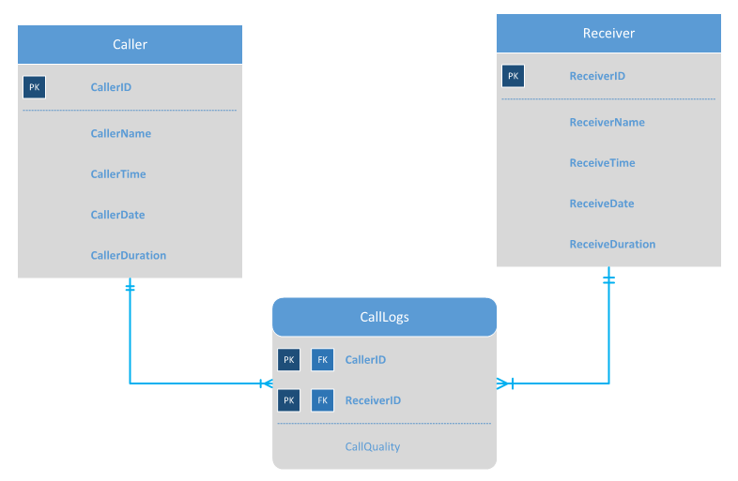

ERD Diagram with Composite Keys

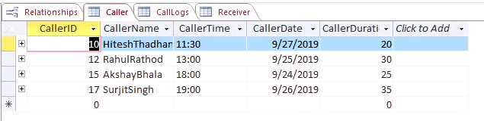

Caller Table

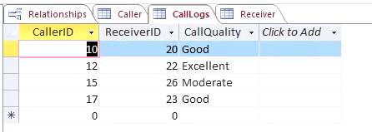

CallLogs Table

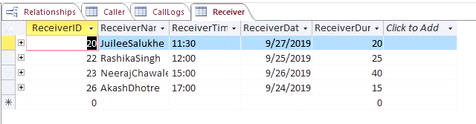

Receiver Table

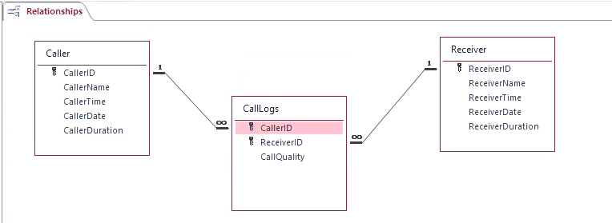

Relationship between the entities in MS Access

**Business Rules:**

A caller can call 1 or more AT&T Customers.

A receiver can receive call from 1 or more AT&T Customers.

A caller cannot call itself.

A receiver cannot receive call from itself.

**Relationship:**

The Relationship between Caller & Receiver is M:N as there are 1 or more callers calling others and 1 or more receivers receiving calls from others.

Here Composite Key Identifying Relationship is used as the values cannot be NULL for the Associative Entity Foreign Keys.

**Question 2: Many-to-Many Relationships Example**

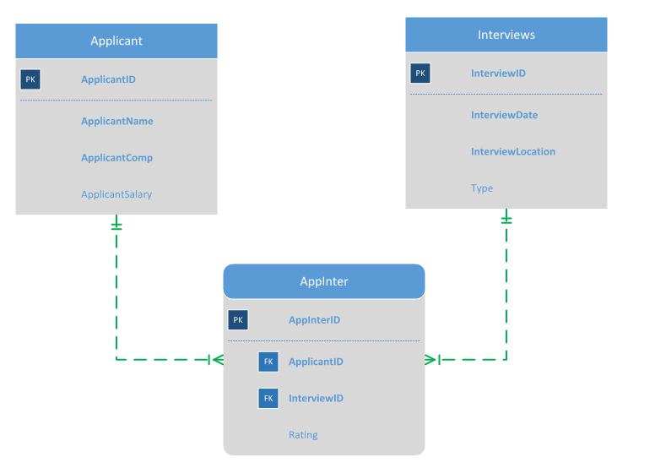

ERD Diagram using Surrogate Keys

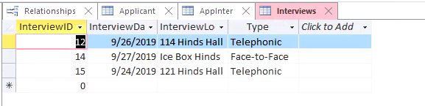

Interviews Table



AppInter Table

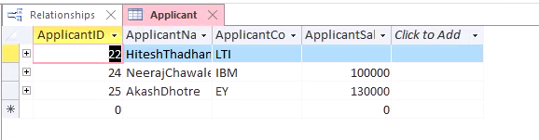

Applicant Table

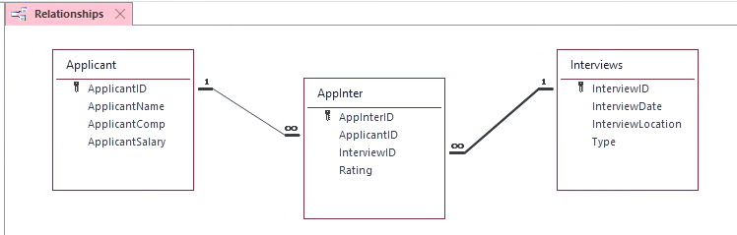

Relationship in MS Access

**Business Rules:**

An applicant can apply to 1 or more interviews.

An Interview can have 1 or more applicants scheduled.

**Relationship:**

The Relationship between Applicant & Receiver is M:N as there is 1 or more applicant for an interview and an applicant can give 1 or more interview.

Surrogate Key Non-Identifying relationship is used in this Many-to-Many relationship to break it into 2 1:M relationships using Associative Entity as we can have NULL Values for the ApplicantID and InterviewID with Surrogate Key uniquely identifying the row and the other foreign keys can be NULL.