**PART 1:**

**SQL Statements for Table Creation, Table Data Insertion and Table Data Output as requested with screenshots**

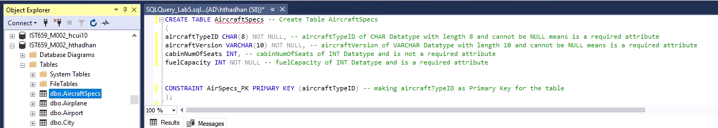

AircraftSpecs Table Creation

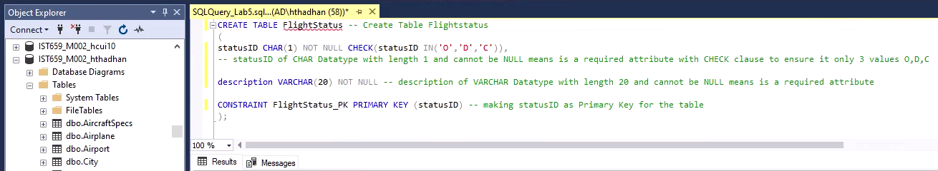

FlightStatus Table Creation

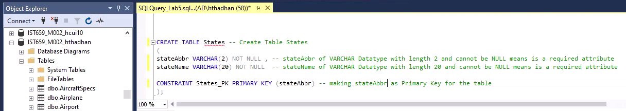

States Table Creation

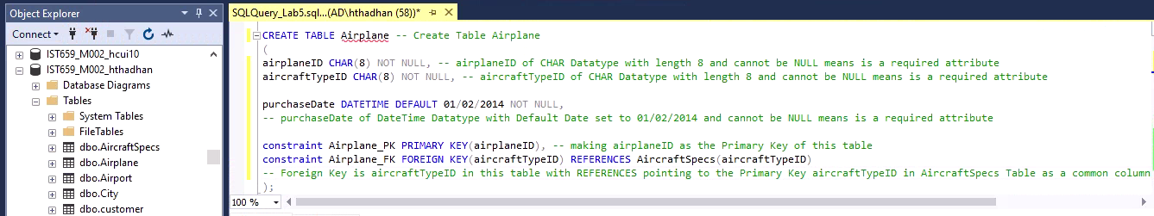

Airplane Table Creation

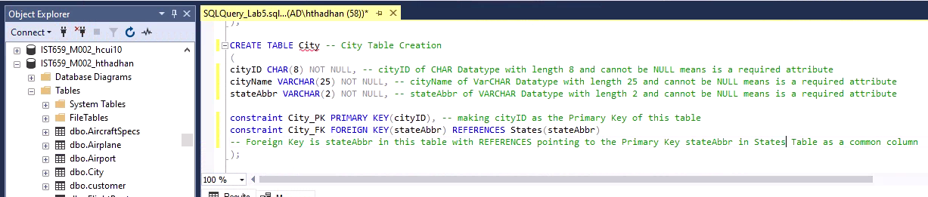

City Table Creation

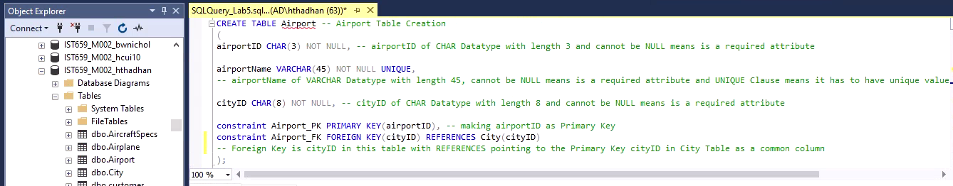

Airport Table Creation

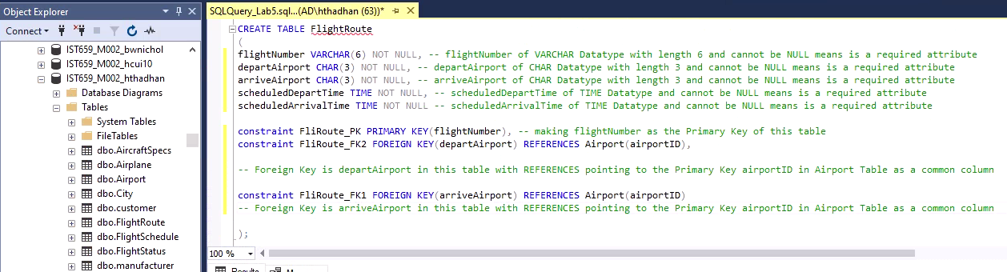

FlightRoute Table Creation

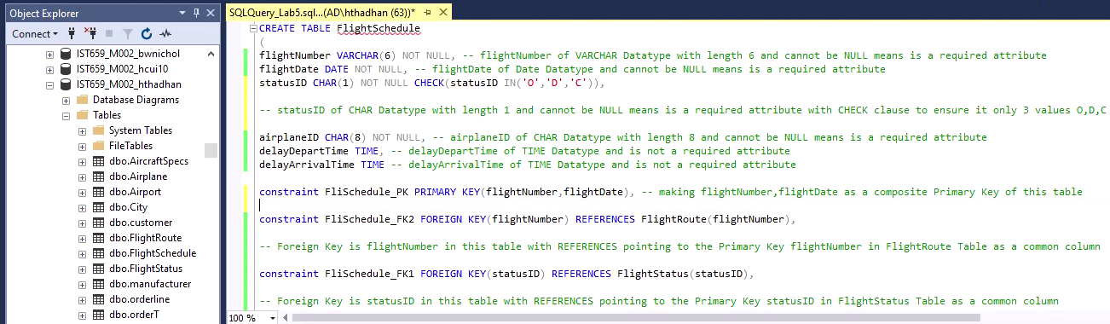

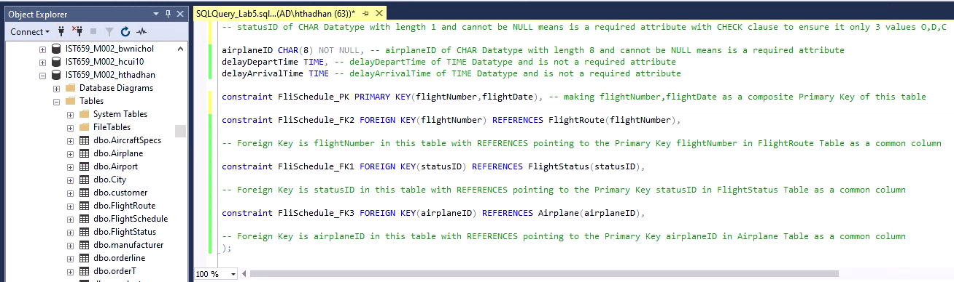

FlightSchedule Table Creation

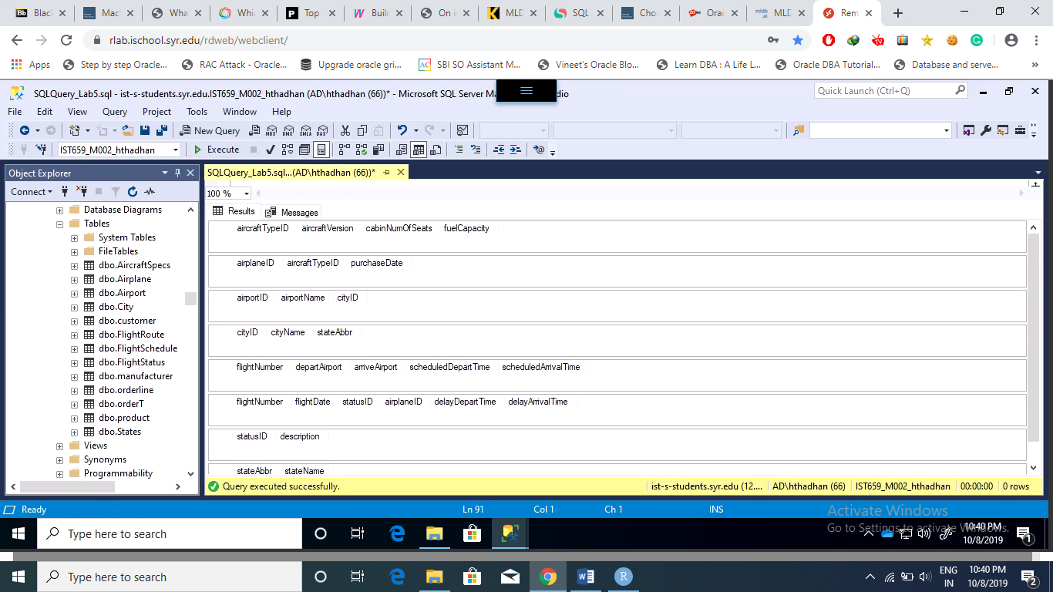

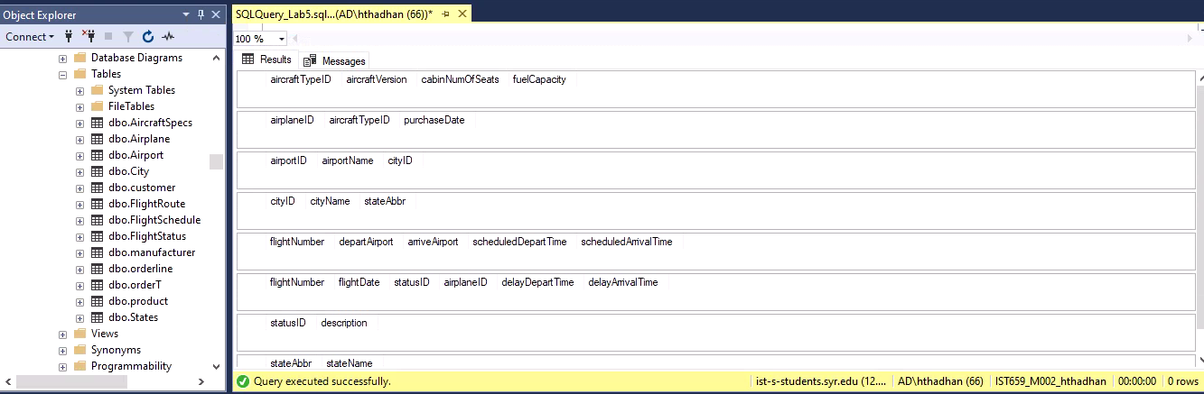

Blank Tables Attributes before Inserting the data

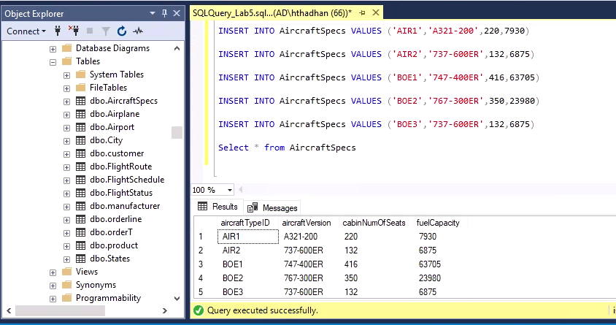

AircraftSpecs Table

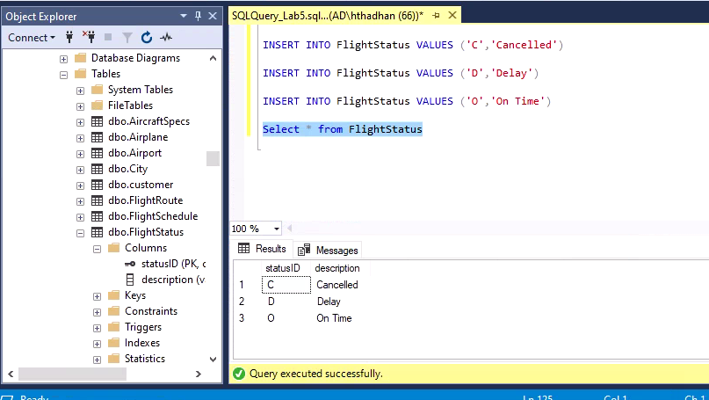

FlightStatus Table

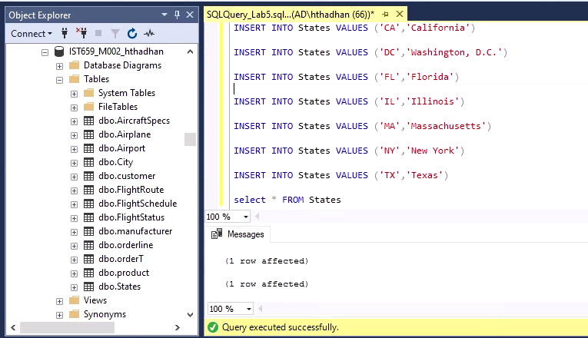

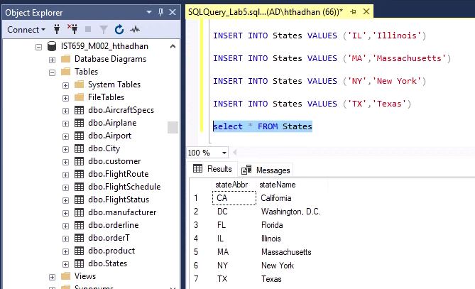

States Table

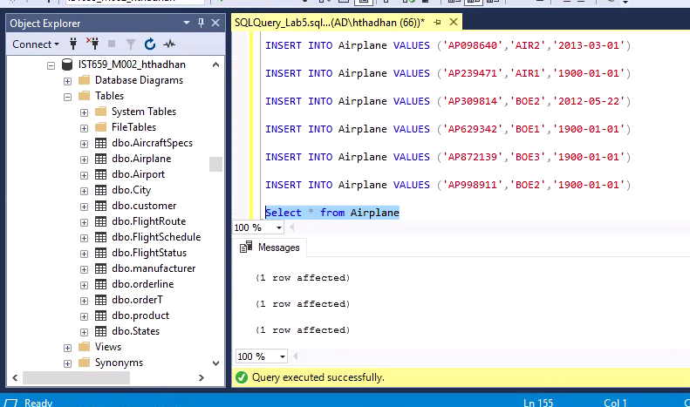

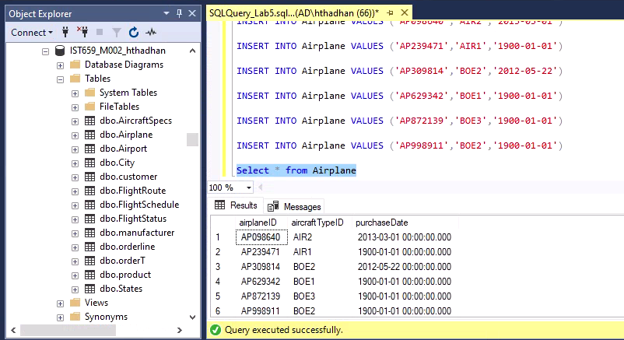

Airplane Table

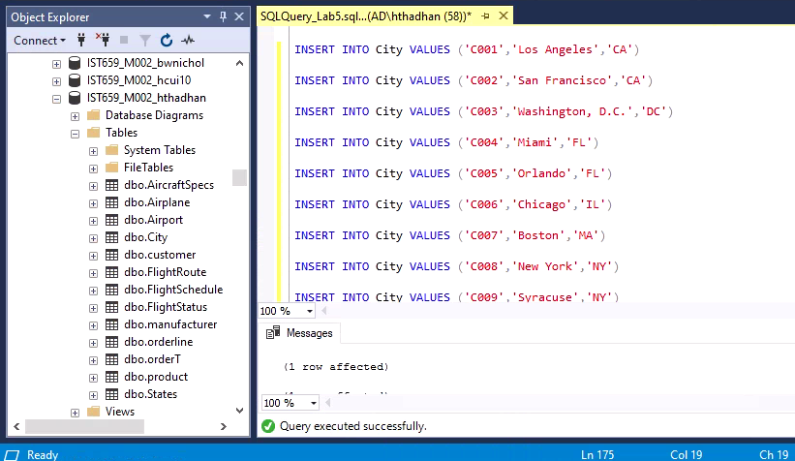

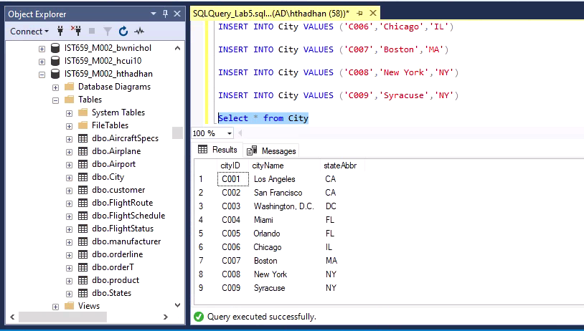

City Table

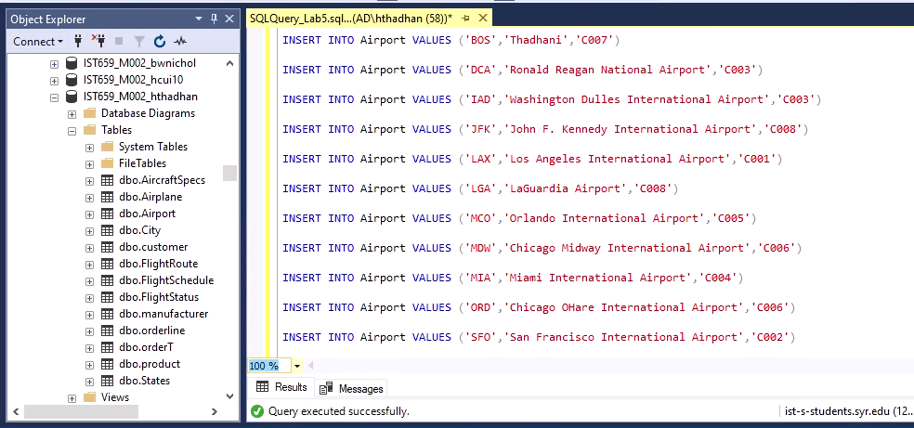

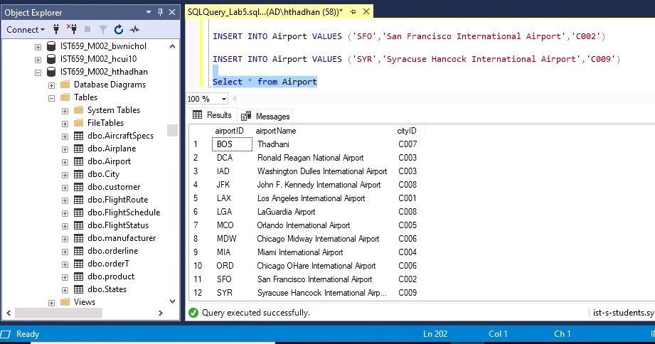

Airport Table

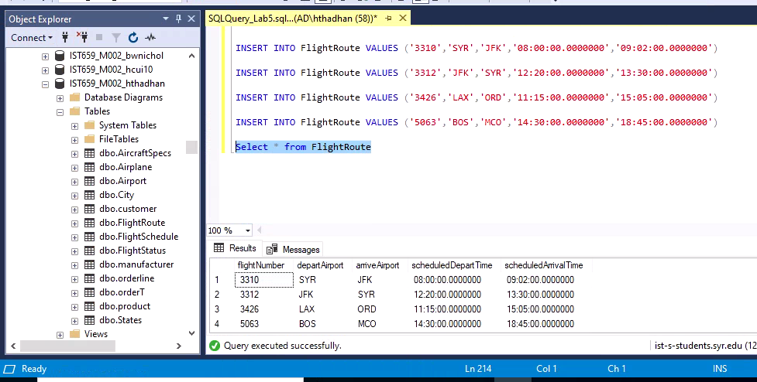

FlightRoute Table

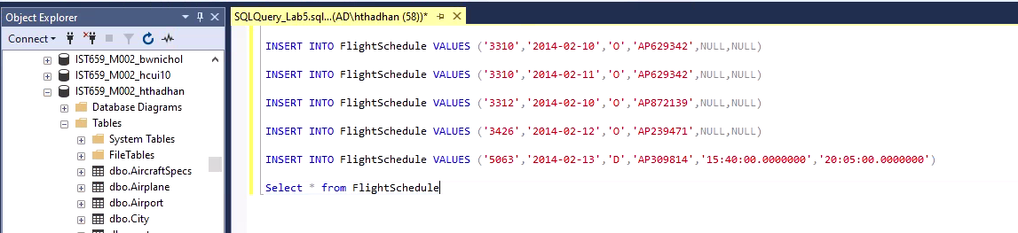

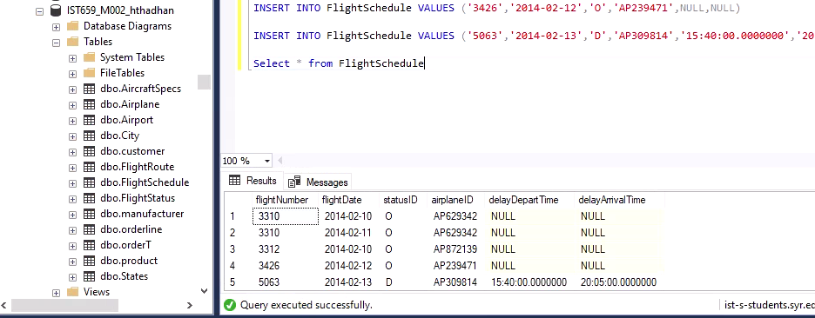

FlightSchedule Table

**PART 2:**

**Query Output:**

1. Find all aircrafts whose fuel capacity is less than 63705. Show aircraft id, cabin number of seats and fuel capacity.

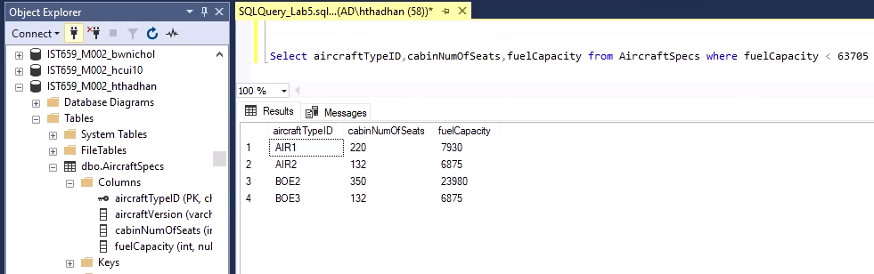

1. Find all airplanes which were on time or delayed. Show only airplane ID, flight date and statusID.

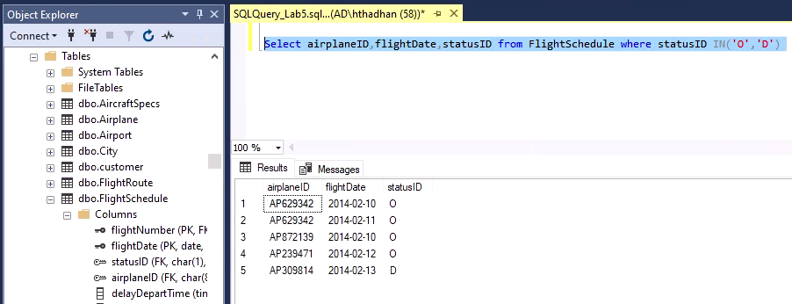

1. Find all the airplanes that have been purchased before the year 2013-02-10. Show airplane id and the purchase Date.

