**Insertion Output Before & After New Data Insertion:**

**Airplane Table Data Updation:**

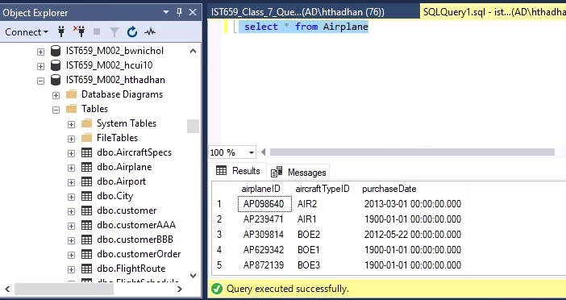

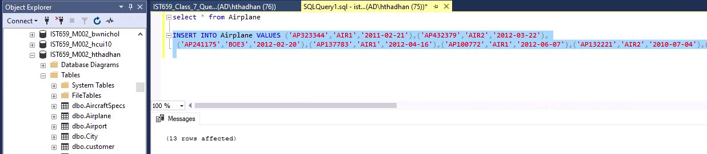

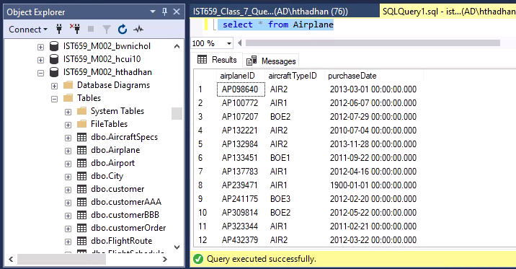

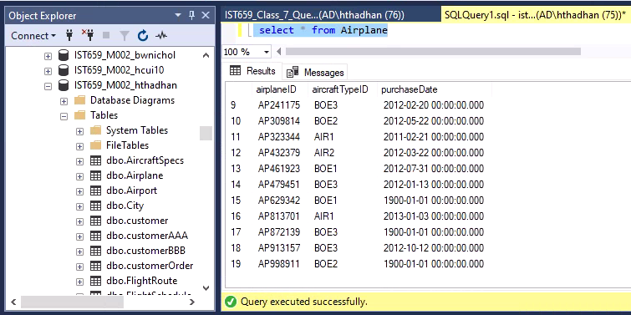

**FlightRoute Table Data Insertion:**

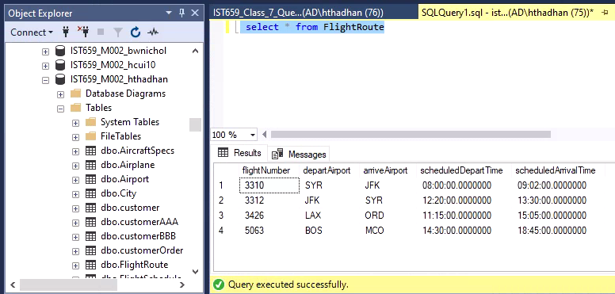

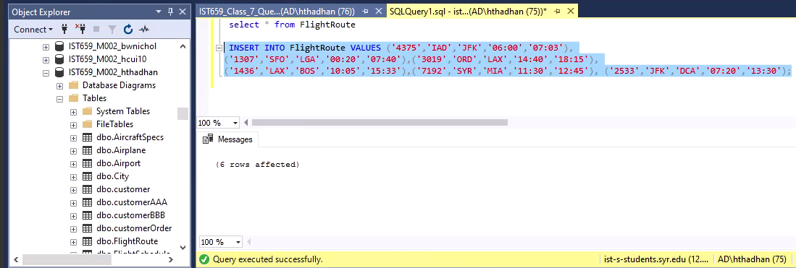

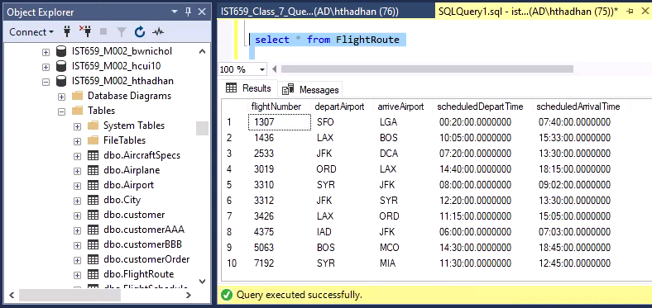

**Flight Schedule Table data insertion:**

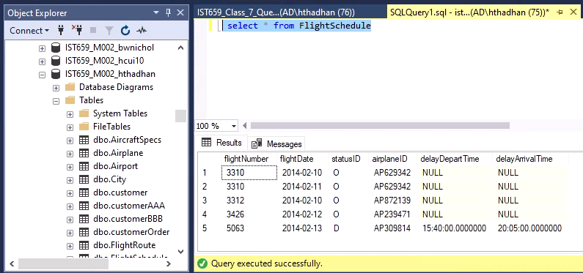

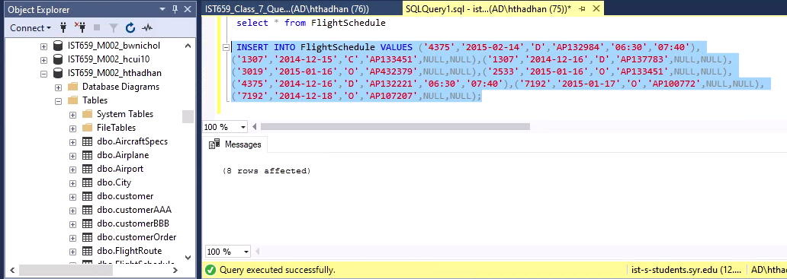

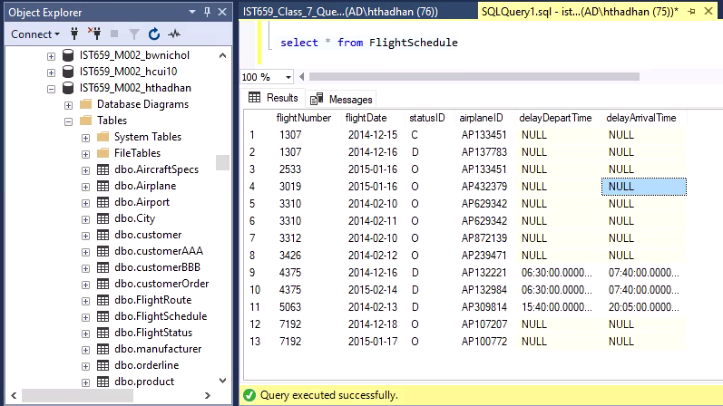

**Output of the queries:**

1. Find out all flight schedule information of flight “3310” and “3312”. Make sure to show all the fields.

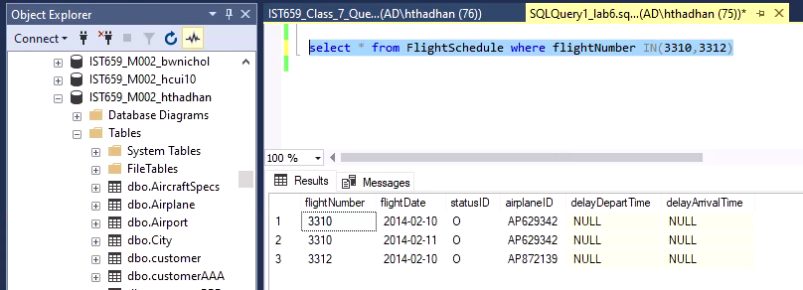

1. Find all flights departing from airports that start with ‘S’. Show flight number, depart airport, arrival airport, and depart time.

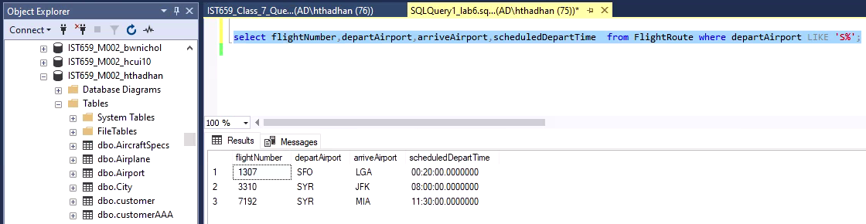

1. Find 4 most recently purchased planes. Show airplane ID and purchase date only.

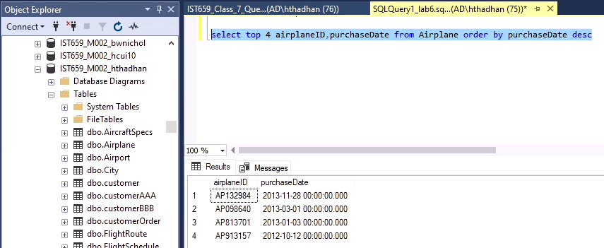

1. Count the number of flights departing each day. Show the date and the number of flights.

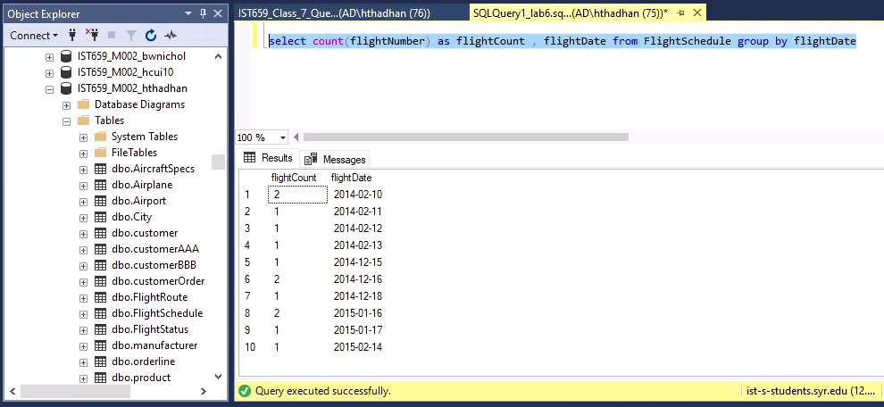

1. Sort the AircraftSpecs table by fuel capacity in descending order. Show the result with aircraft version and fuel capacity.

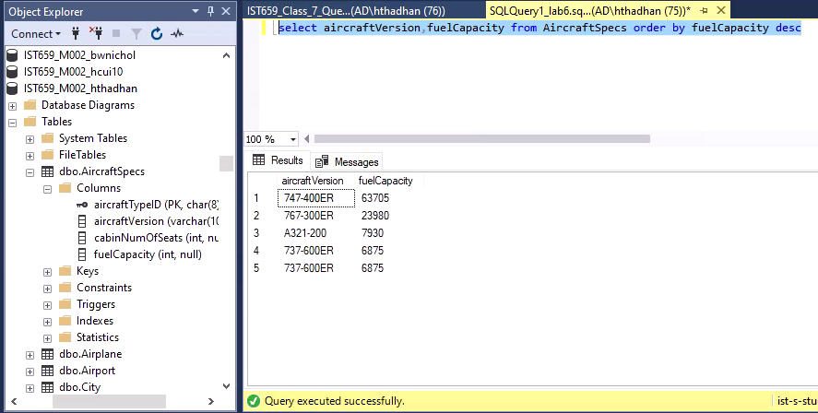

1. Find all airplanes which flew in the first half of Feb 2014 (From Feb 1- to Feb 14) and the flight status was “on time”. Show airplane ID, purchase date, flight number, and status ID.

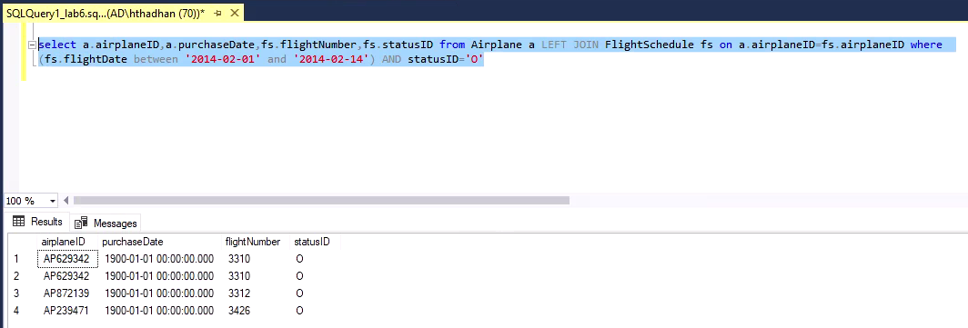

1. Find all flights which depart from “BOS” after noon. Show flight number, flight date, depart airport and scheduled depart time.

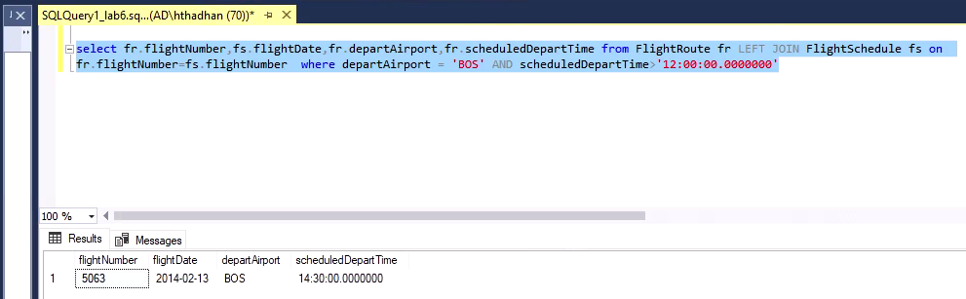

1. Find all airplanes which were delayed or cancelled. Show only airplane ID, flight date and status description.

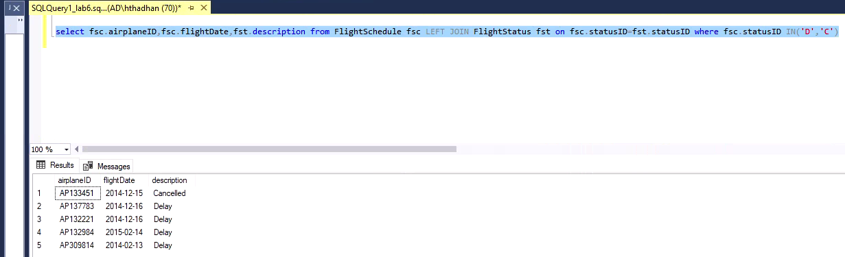

1. Find the flight(s) which are “on time”, display the Flight number and departure airport.

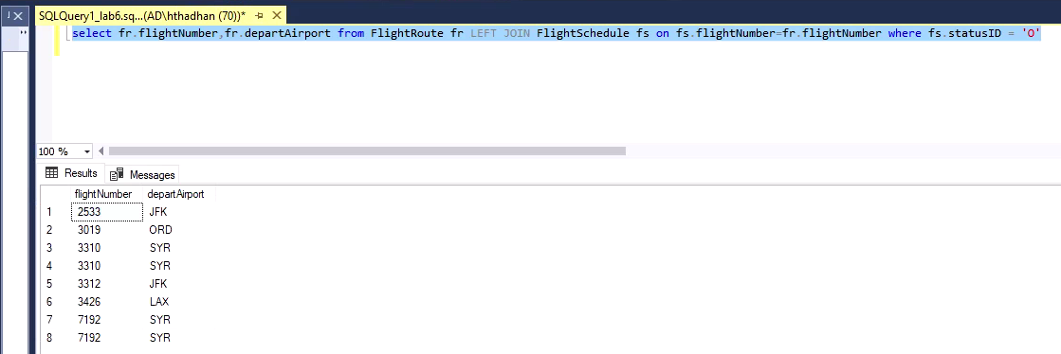

1. Find all the airplanes that have not been scheduled to fly.(You can use Left Join)

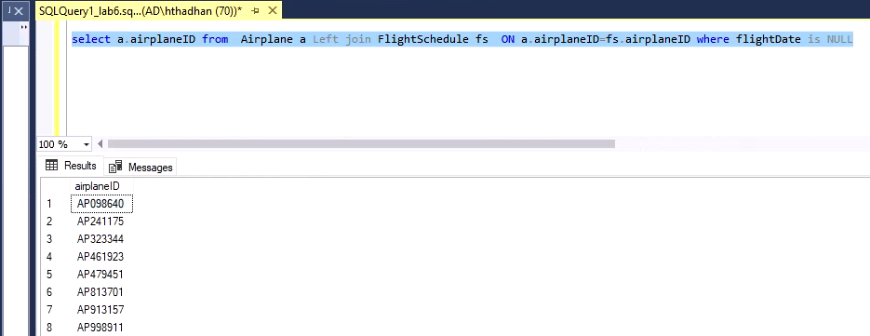

1. Find all only airplanes that have been scheduled to fly and delayed. Display Airplane ID of the flight *(Use Right Join)*

