**Table Creation:**

Employee Table Creation:

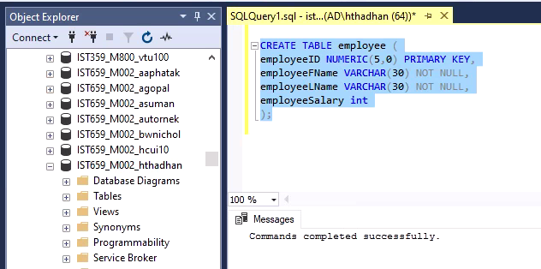

Project Table Creation:

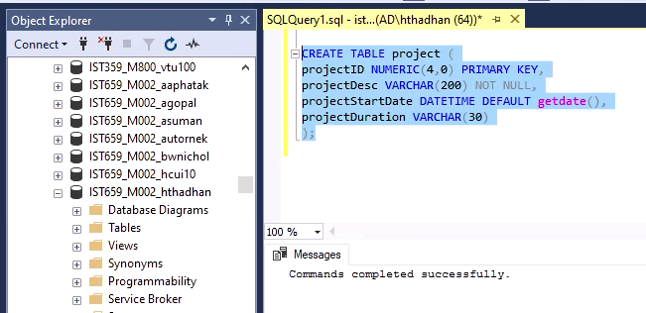

projectAssignment Table Creation:

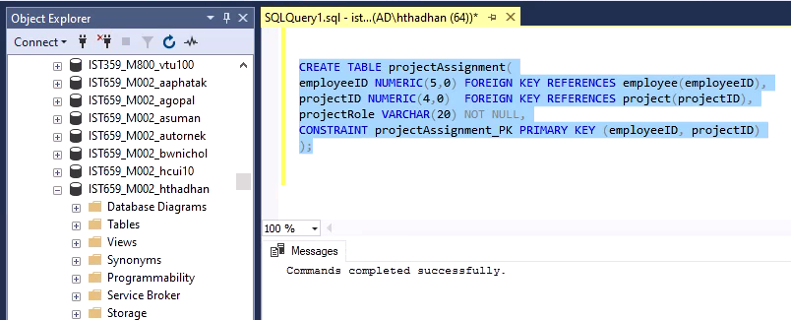

**Values Insertion into 3 tables:**

Inserting values into Project Table:

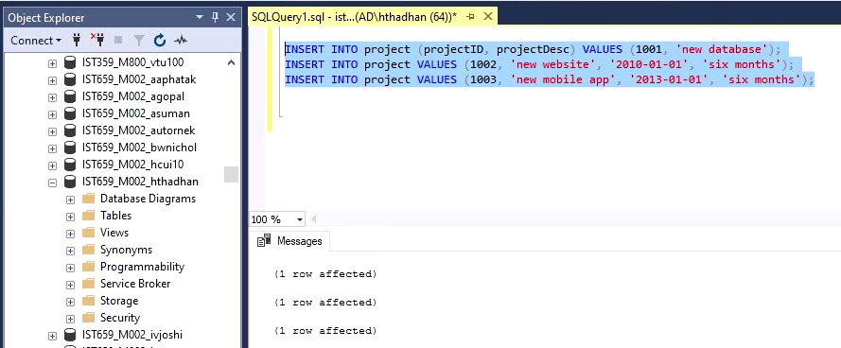

Inserting values into employeeTable:

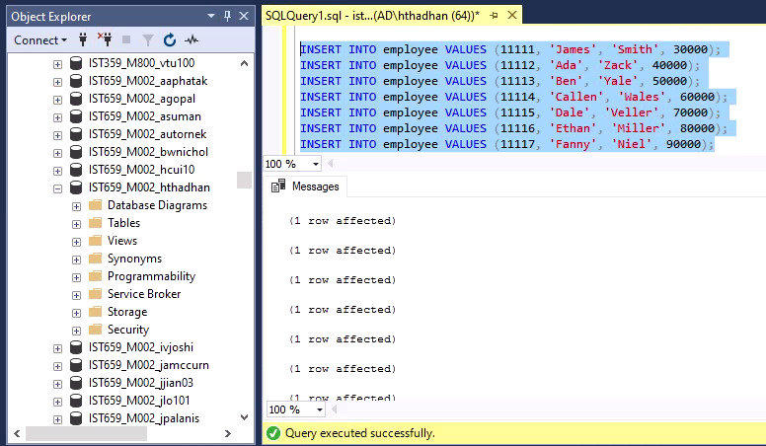

Inserting values into projectAssignment Table:

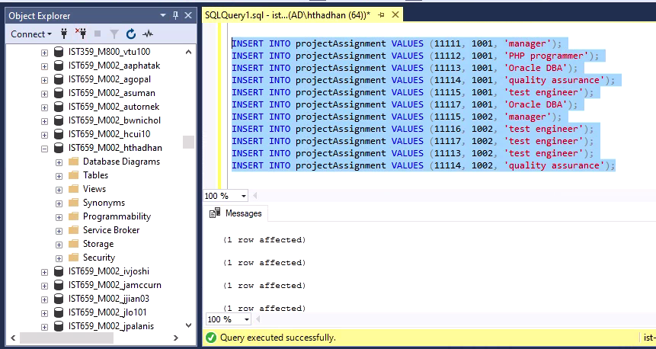

**Data Validation after Insertion and before starting any operation on Tables:**

Employee Table:

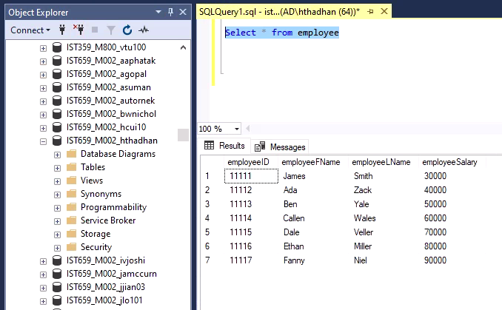

Project Table:

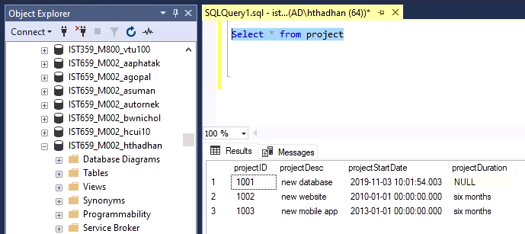

projectAssignment Table:

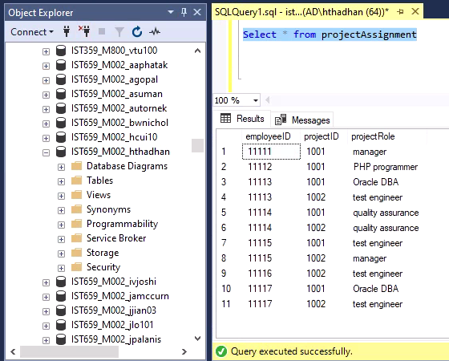

ANSWER THE FOLLOWING QUESTIONS:

1. Add an employee using your own name and create a project assignment for yourself using an existing project id.

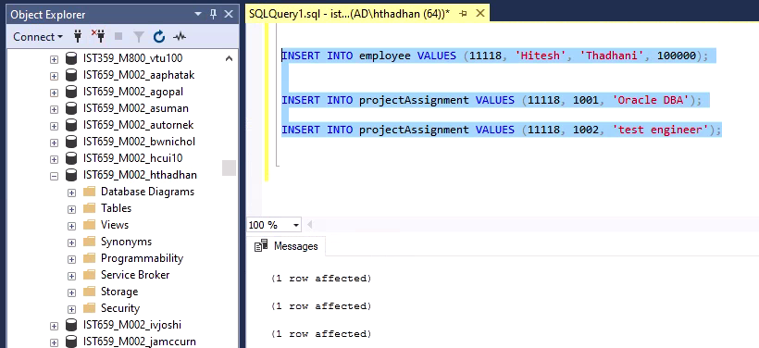

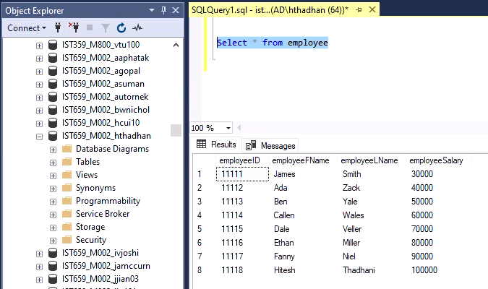

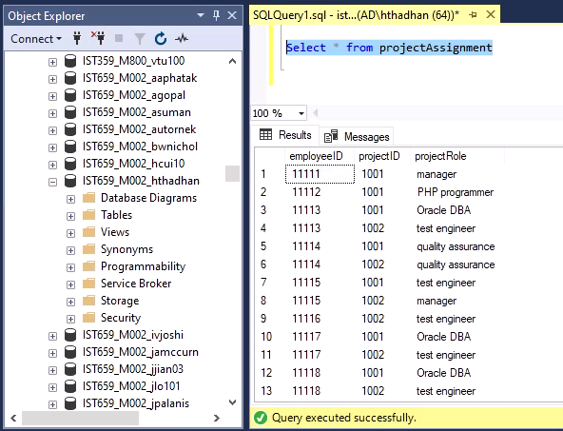

1. Write a scalar-valued function that returns the average salary of the Employees.

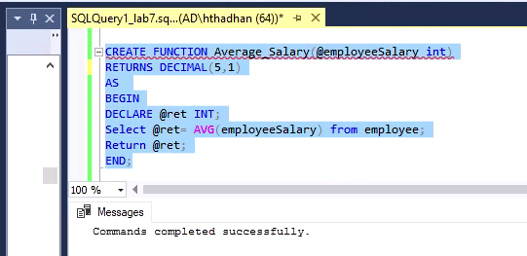

Execution of scalar valued function:

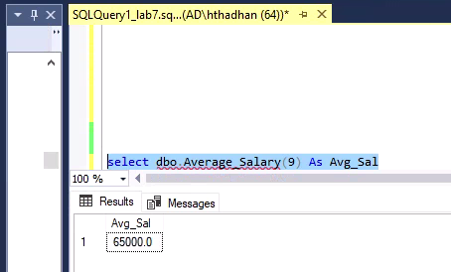

1. Write a table-valued function that returns the Projects given an EmployeeID as a parameter and
   1. Show the function creation log
   2. Return the results for your own project (from question 1)

A Creating the table valued function

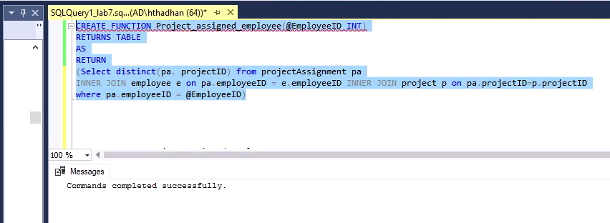

B Returns the projectID for my employee id

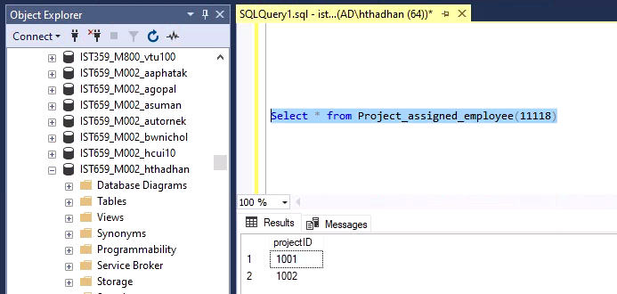

Returns projectID for employeeID 11112 who is assigned only 1 project with projectID 1001

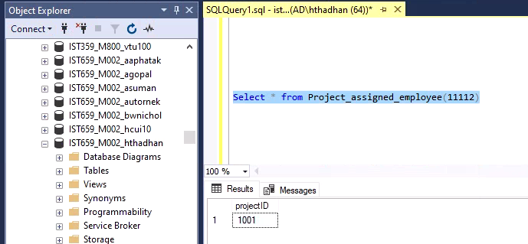

1. Alter the Employee table to add a new column called *‘Number_of_Projects’* as **INTEGER** data type. Write a procedure that updates employee table with the total projects assigned to each employee (to the newly created column)

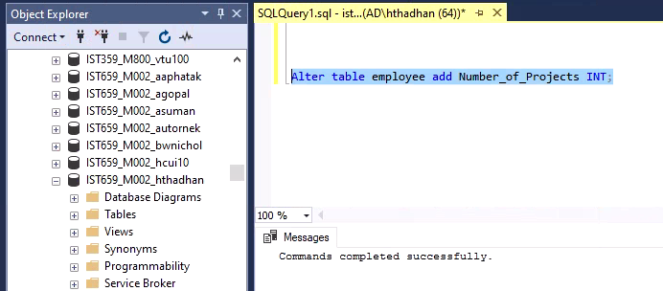

Before updating the number of projects in the new column created all values are shown NULL.

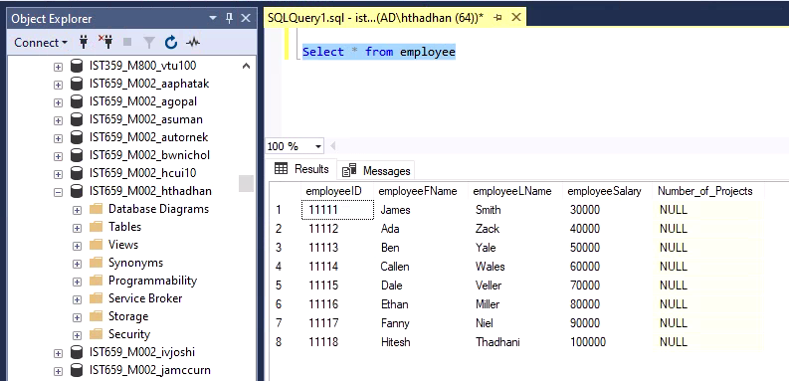

Stored Procedure updates the project count for an employee

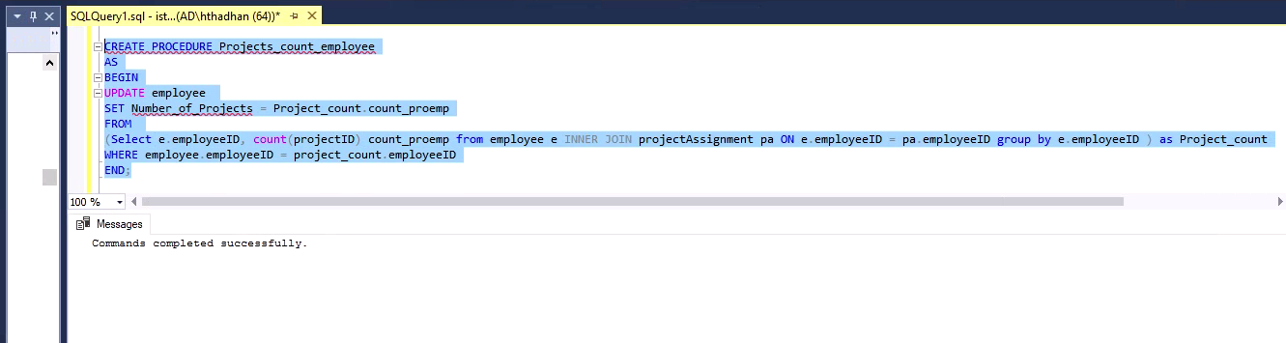

Execution of stored procedure:

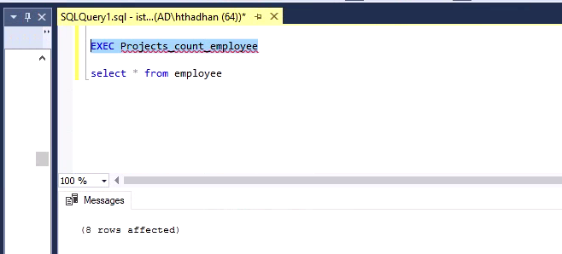

Output at the end of execution of stored procedure validating count of projects for all the employees

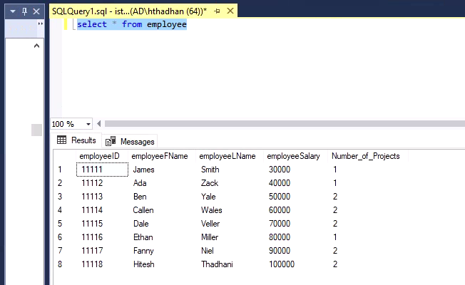

1. Create a trigger that can update the *‘Number_of_Projects’* column whenever a new project is assigned to an employee.

Trigger Creation on projectAssignment Table:

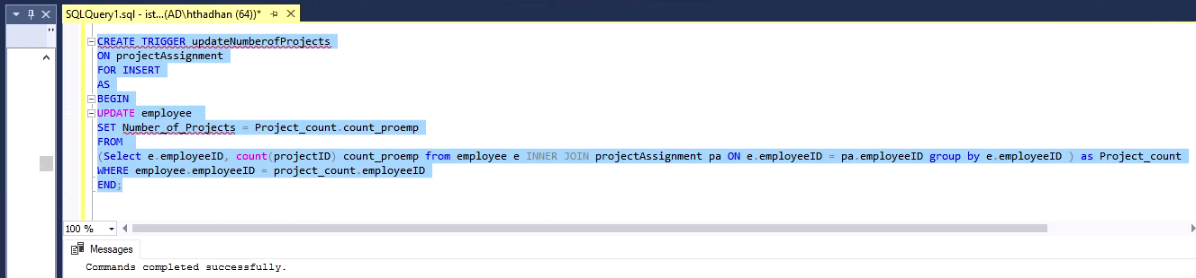

* 1. Test the trigger with the below insert:

INSERT INTO projectAssignment VALUES (11114, 1003, ‘quality assurance');

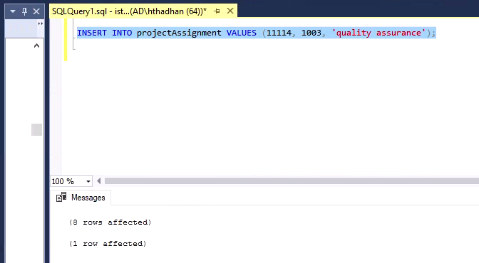

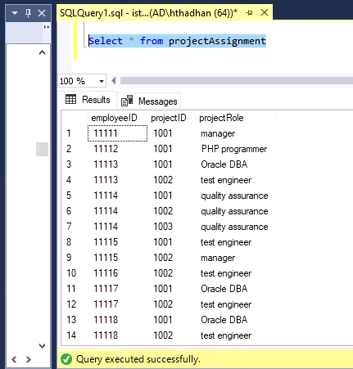

Count of Number_of_Projects in employee table updated automatically to 3 for employeeID 11114 which was 2 before running the insert operation.

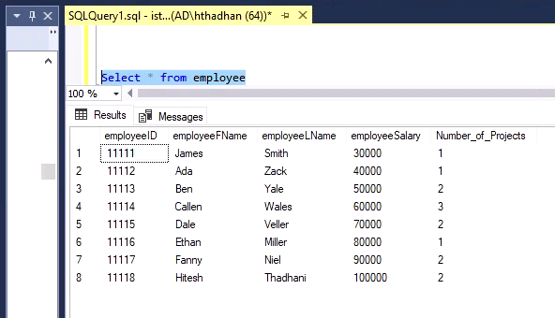

INSERT INTO projectAssignment VALUES (11115, 1003,'test engineer');

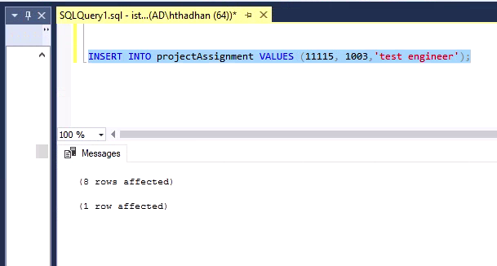

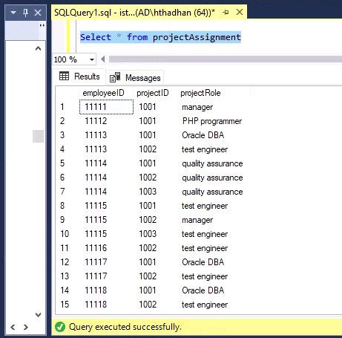

Count of number_of_projects in employee table updated automatically to 3 for employeeID 11115 which was 2 as in the previous insert screenshot for employeeID 11114.

