**Before doing Transactions:**

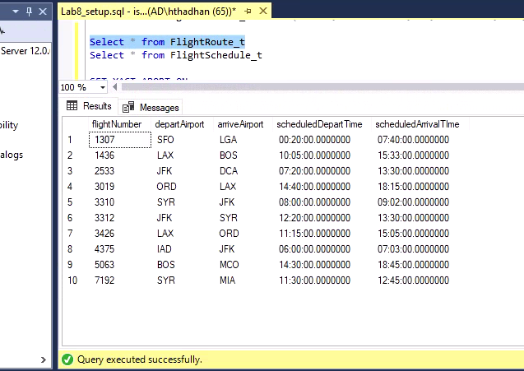

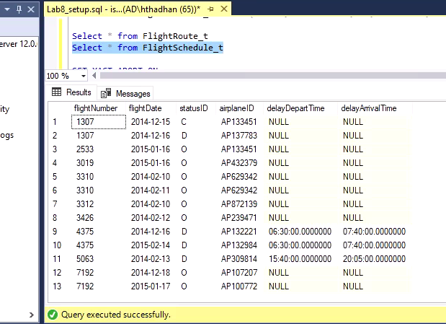

**TRANSACTIONS:**

1) Two new flights are scheduled to leave from BOS to ORD airports.

• The first flight (flightId 1111) will be on airplane AP098640 departing on-time at 2018-11-05 12:00:00 and arriving on-time at 2018-11-05 14:30:00.

• The second flight (flightId 1112) will be on airplane AP432379 departing on-time at 2018-11-05 22:00:00 and arriving on-time at 2018-11-06 00:30:00.

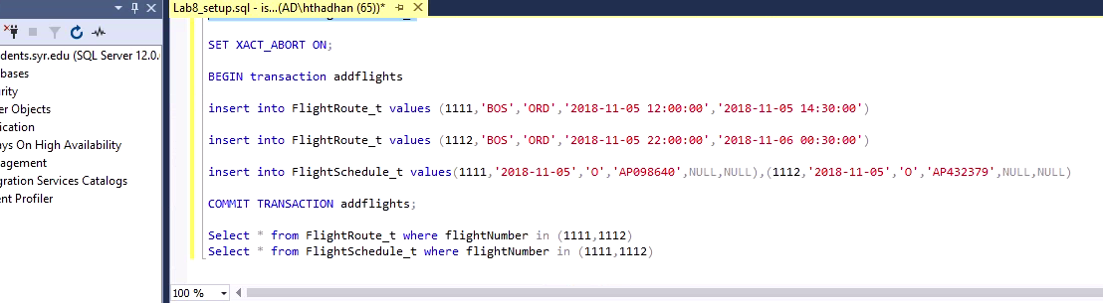

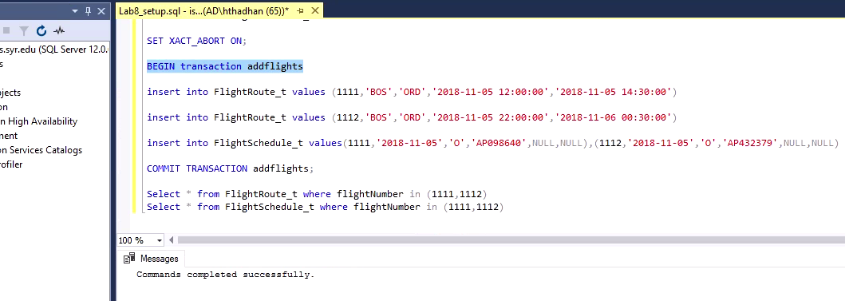

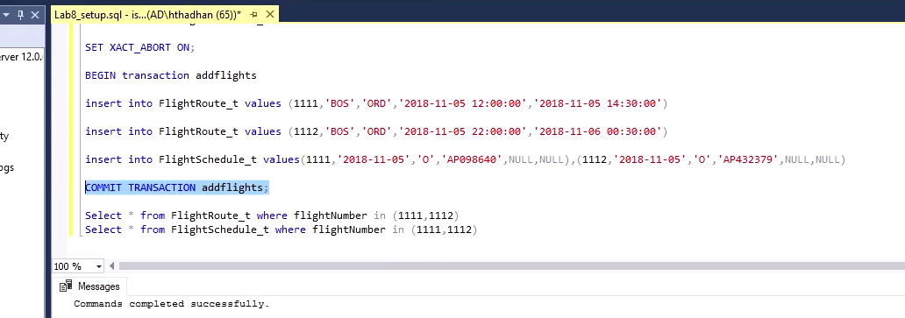

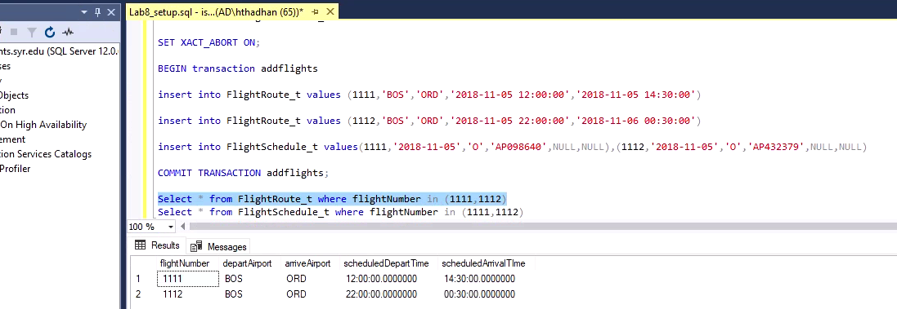

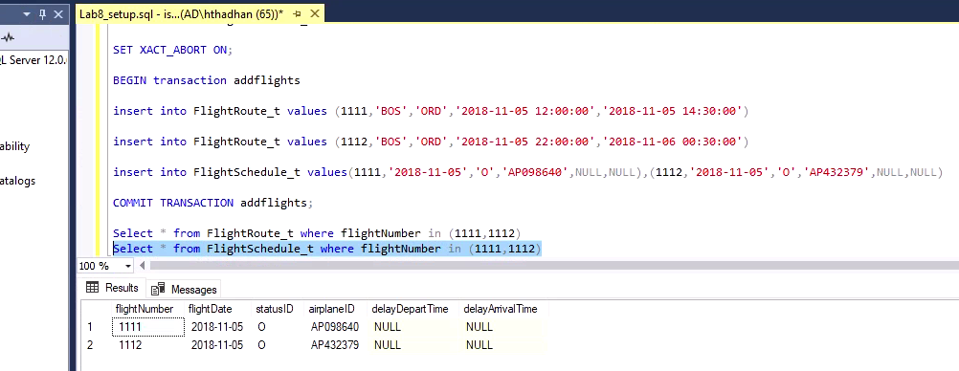

2) Due to forecasted inclement weather, the new flights’ statuses have changed.

• The earlier new flight from BOS to ORD (flightId 1111) has been delayed by 10 hours.

• The later new flight from BOS to ORD (flightId 1112) has been canceled.

• NOTE: DO NOT commit this transaction (i.e. COMMIT TRANSACTION …;)

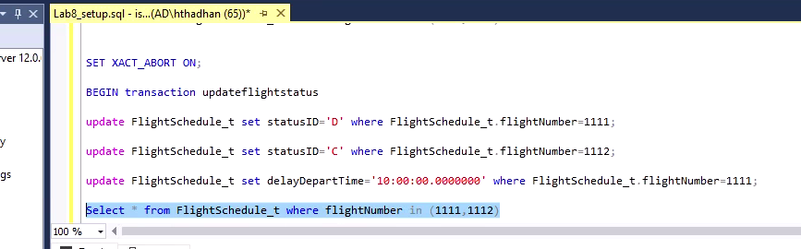

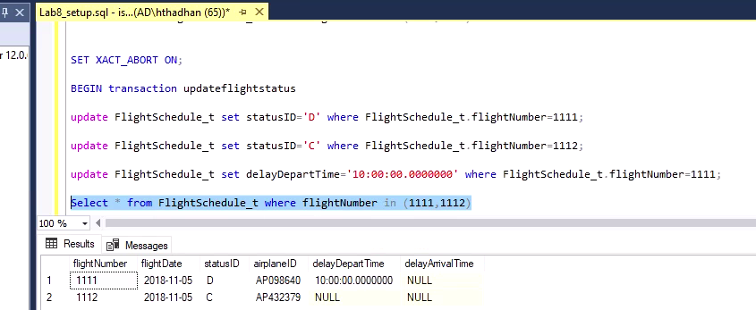

3) The weather has improved and the two flight are back to the original statuses (question 1).

• ROLLBACK the last transaction (2)

• NOTE: If you committed the transaction in (2), you’ll be unable to Rollback. Revert instead using a new transaction with update statements.

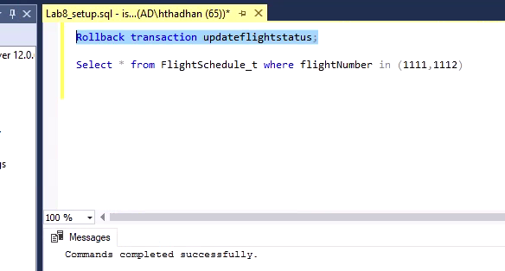

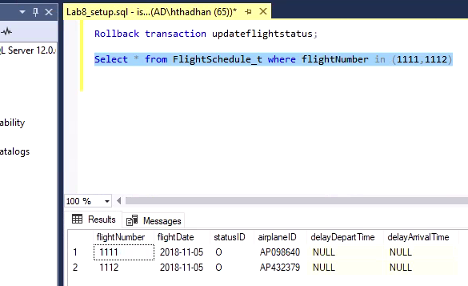

4) There is a new flightRoute between Portland, OR (cityID C010) and Seattle, WA (cityID C011).

• The Portland airport is airportId PDX and is named Portland International Airport.

• The Seattle airport is airportId SEA and is named Seattle–Tacoma International Airport.

• The flight from PDX to SEA (flightID 1003) is scheduled to depart at 08:00:00 and arrive at 09:15:00.

• The flight from SEA to PDX (flightID 1004) is scheduled to depart at 14:00:00 and arrive at 15:15:00.

• NOTE: No flights have been scheduled yet for this flightRoute.

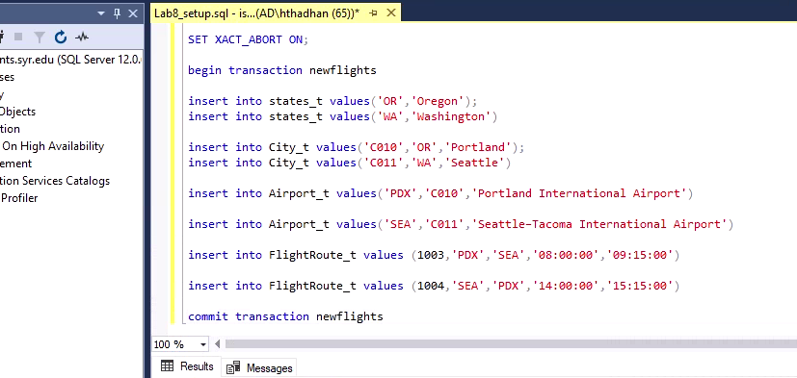

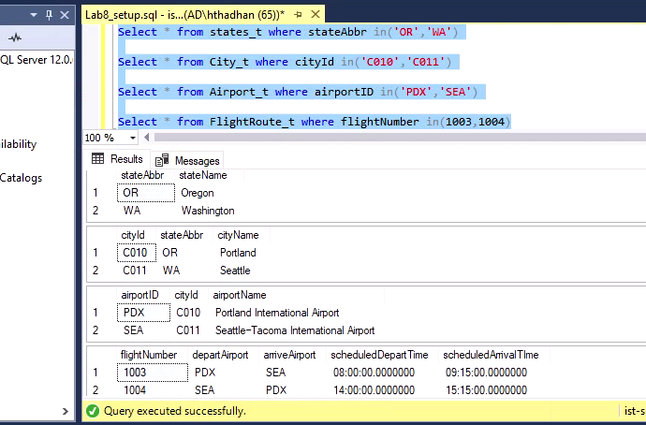

5. An operations analyst is interested in understanding flight capacity at each airport. In order to do so, they need to continually monitor how many departing and arriving flights occur at each airport.

To assist the analyst, create a VIEW called Airport_Capacity with the following columns:

• airportId, airportName, cityId, cityName, stateAbbr, StateName

• View contains the total number of departing and arriving flights for each airport

• The view excludes airports which have no departing and arriving flights

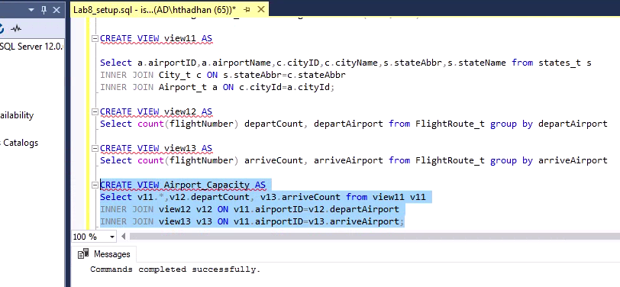

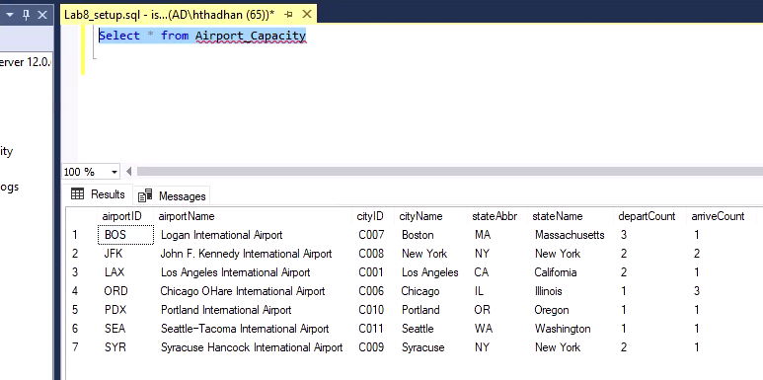

6) Query the *Airport_Capacity* view and return the distinct states (*DISTINCT stateAbbr*) where the number of departures is greater than or equal to the number of arrivals.

