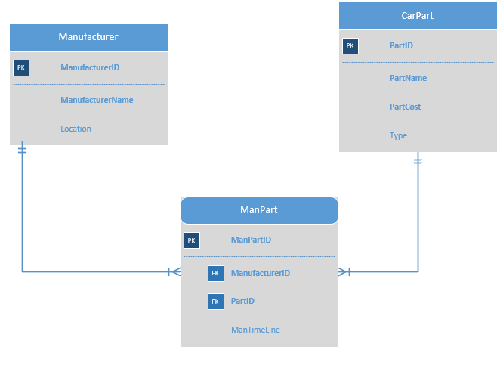

ERD Diagram with Surrogate Keys

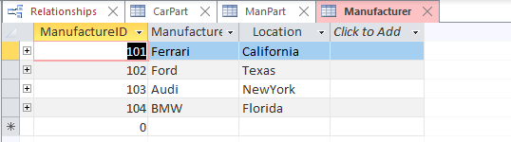

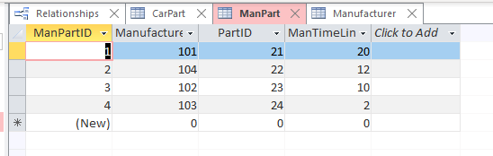

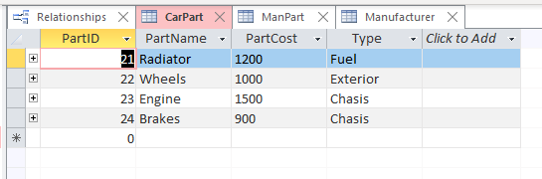

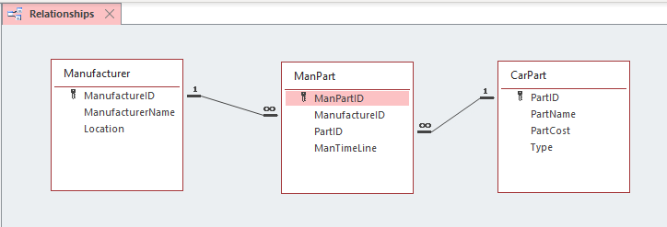

Relationship in MS Access

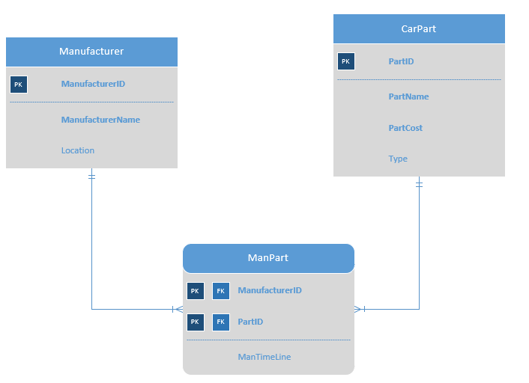

ERD Using Composite Keys

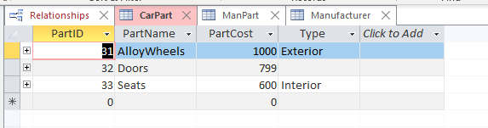

CarPart Table

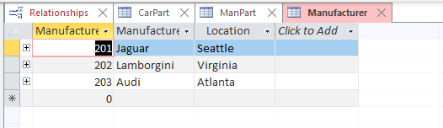

Manufacturer Table

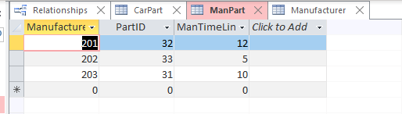

ManPart Table

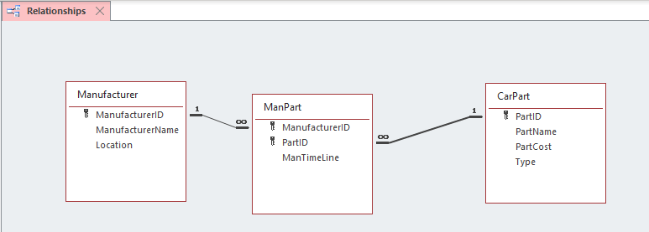

Relationship in MS Access