Perquisites –

* NPM is required on the system to run the apps
* Back End to run on – ‘localhost:3030’ else please update the FrontEnd/ToDo/App.js with appropriate endpoint
* For database I have used SqlLite and the file is at the location – src/Backend/to_do_app.sqlite

Table Structure –

Task Table – CREATE TABLE `task` (

`id` INTEGER PRIMARY KEY AUTOINCREMENT,

`Text` TEXT,

`bucket_id` integer,

`status` TEXT,

`is_active` boolean,

`createdAt` datetime,

`updatedAt` datetime,

FOREIGN KEY (bucket_id) REFERENCES bucket(id) )

Bucket Table - CREATE TABLE `bucket` (

`id` INTEGER PRIMARY KEY AUTOINCREMENT,

`text` VARCHAR(255) NOT NULL,

`createdAt` DATETIME NOT NULL,

`updatedAt` DATETIME NOT NULL,

is_active boolean)

Following is the screens are there interpretation –

1. Home – All the task that are In Progress and To Do as show on this dashboard 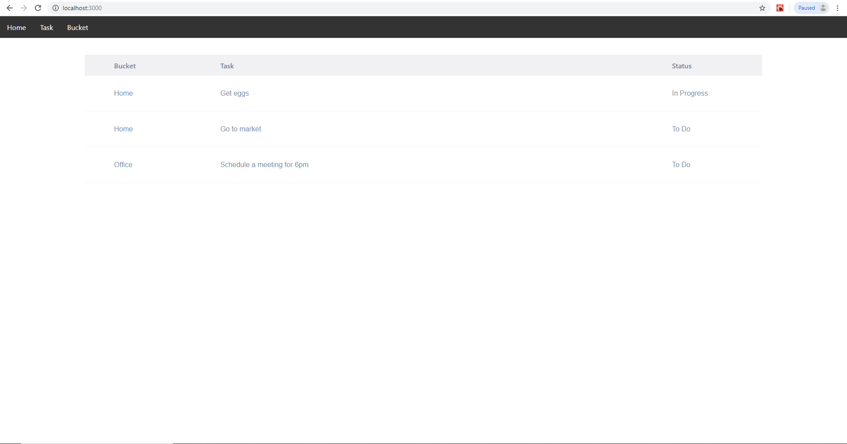
2. Task – This dashboard shows all the task that are in In Progress, To Do or Done marked. 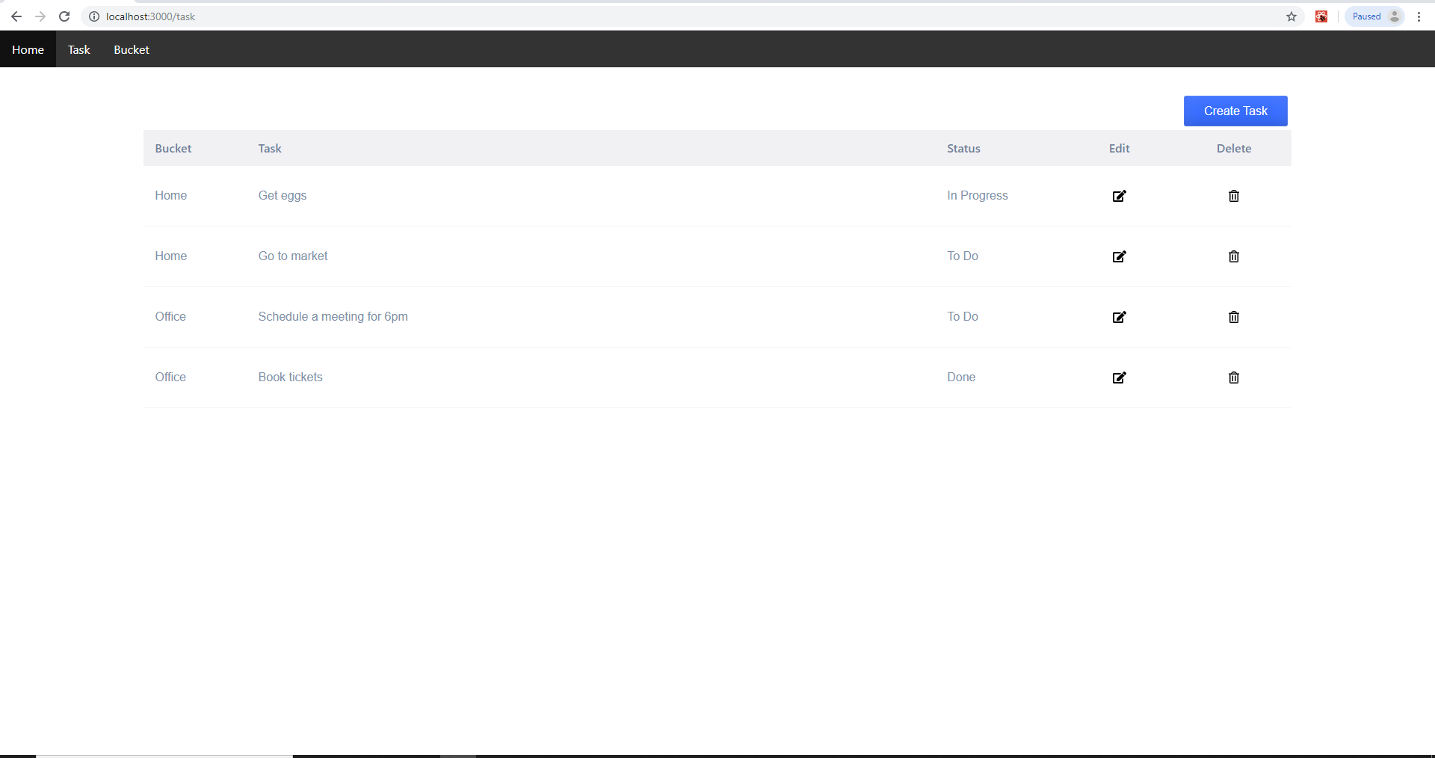
   1. Create Task button– To create new task by selecting (Note: No validations check are in place)
      1. A bucket from the drop down
      2. Test box to input the task 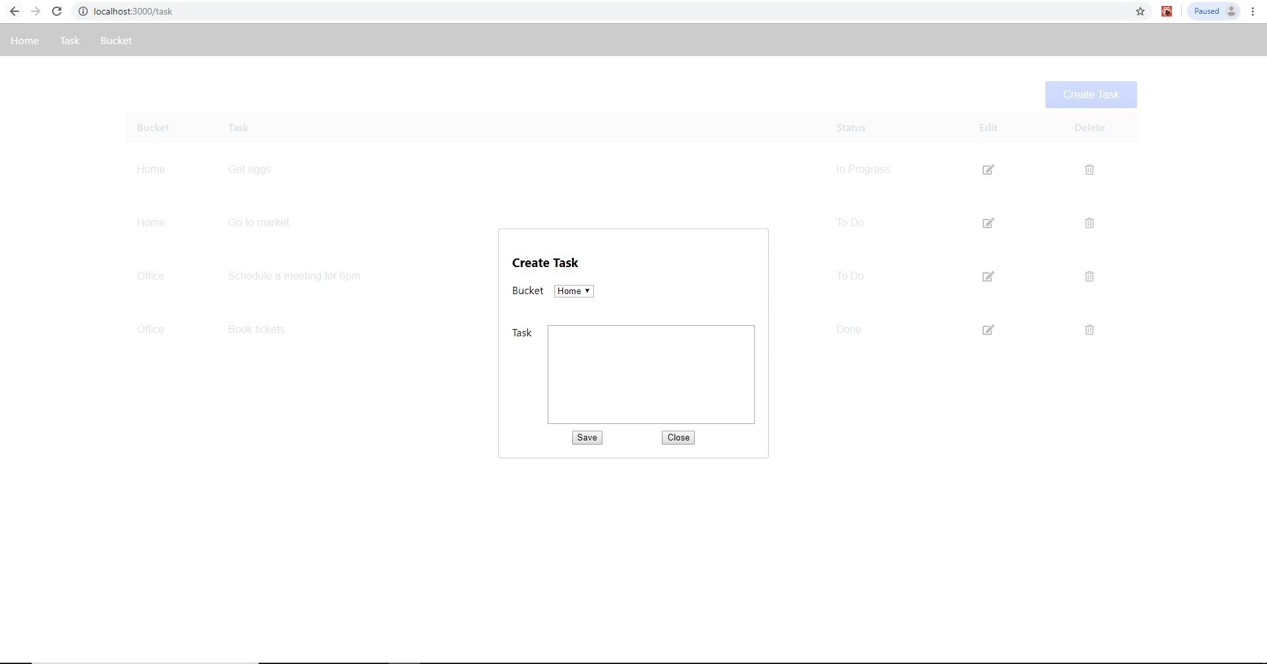
   2. Edit button – To edit any information previous entered 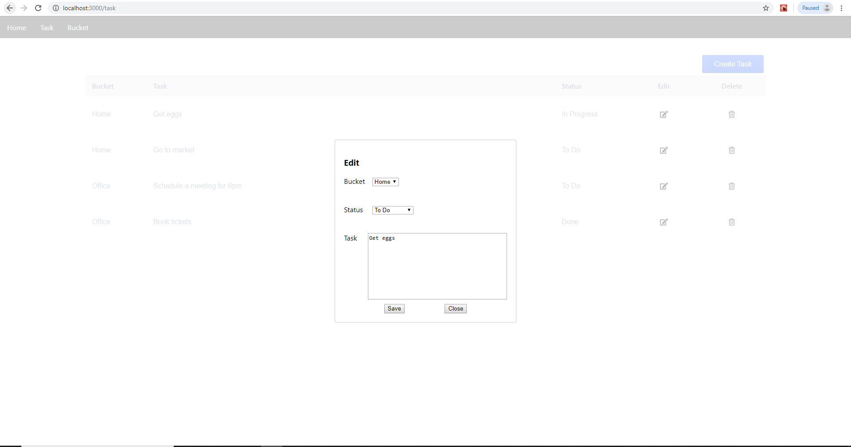
   3. Delete button – To delete the task from the system. 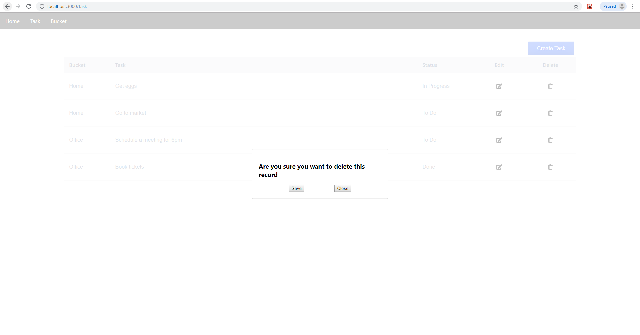
3. Bucket – This dashboard shows all the buckets created in the system 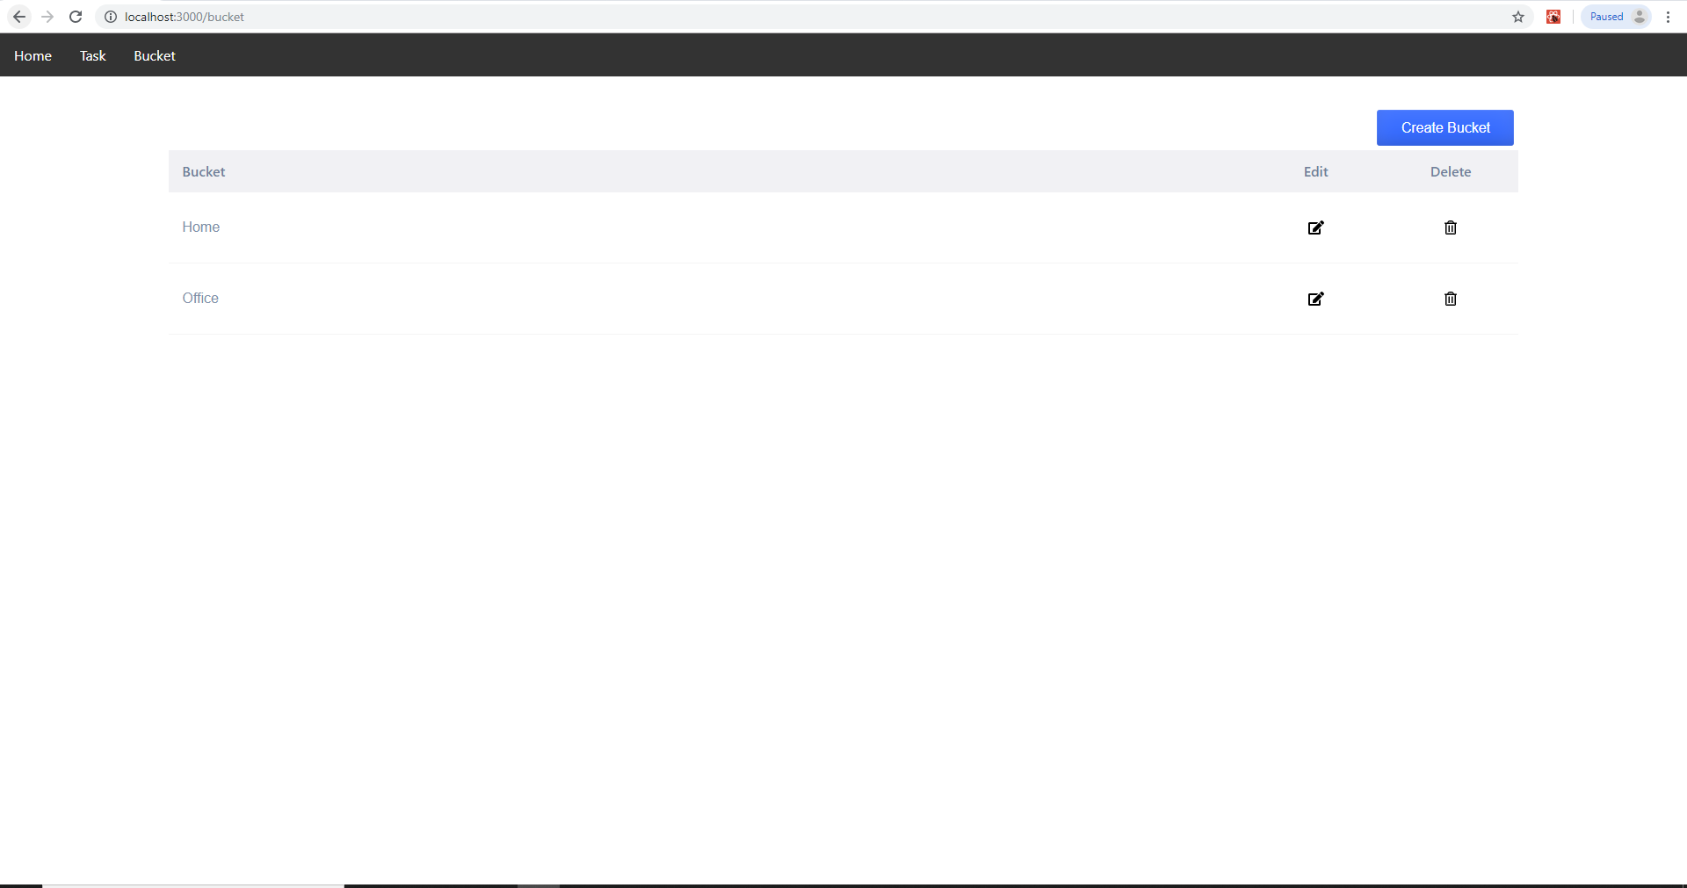
   1. Create Bucket button – To create a new bucket
      1. Bucket Name – Enter a bucket name not present in the drop down(Note: No validations check are in place) 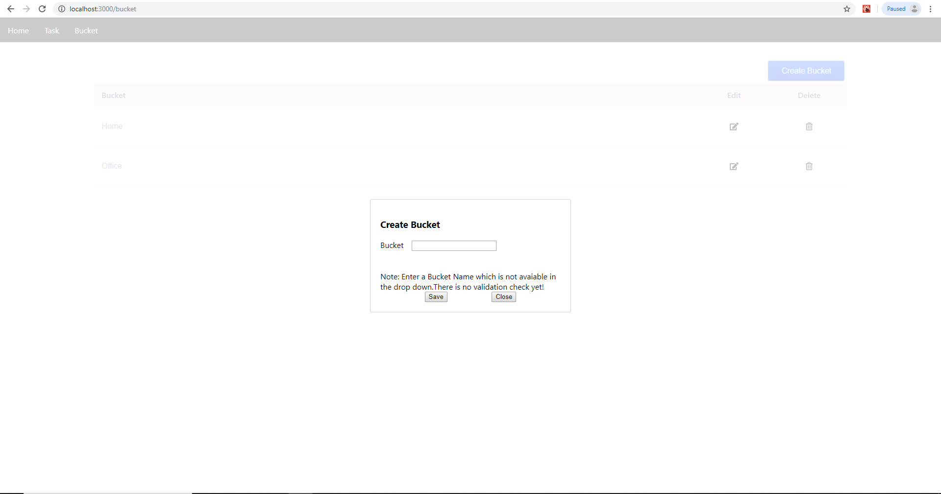
   2. Edit Button - To edit any information previous entered 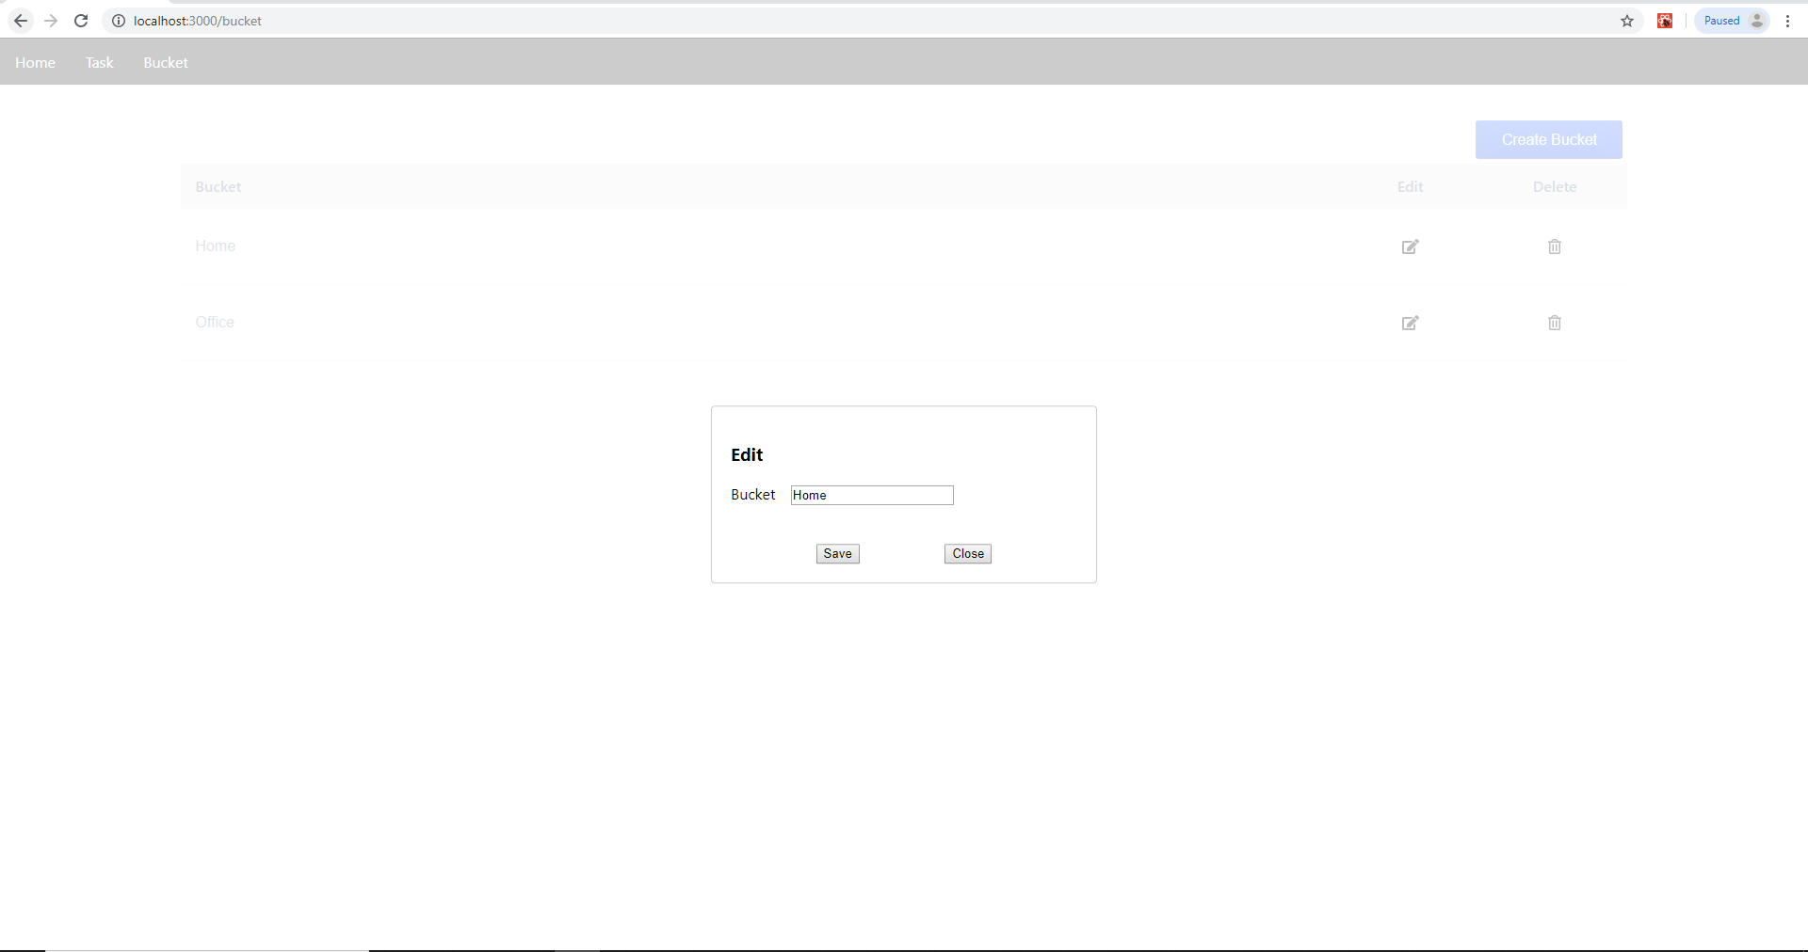
   3. Delete button – To delete the bucket from the system. 