OPERATIONAL RESEARCH

PRACTICAL

SUBMITTED BY –

NAME – HITESH YADAV  
CLASS - BSC 3  
ROLL NO - 16517

Q1. *TO SOLVE THE LINEAR PROGRAMMING PROBLEM USING GRAPHICAL METHOD INCORPORATING:*

*A) UNIQUE SOLUTION*

*B) INFEASIBLE SOLUTION*

*C) MULTIPLE SOLUTION*

*D) REDUNDENT CONSTRAINT*

*INTERPRET THE SOLUTION*

SOLUTION

A)

EQUATION THAT GIVES OUPUT AS UNIQUE SOLUTION IS:

MAX Z=2X1+3X2

S.T.

X1+3X2<=12

3X1+2X2<=12

X1,X2>=0

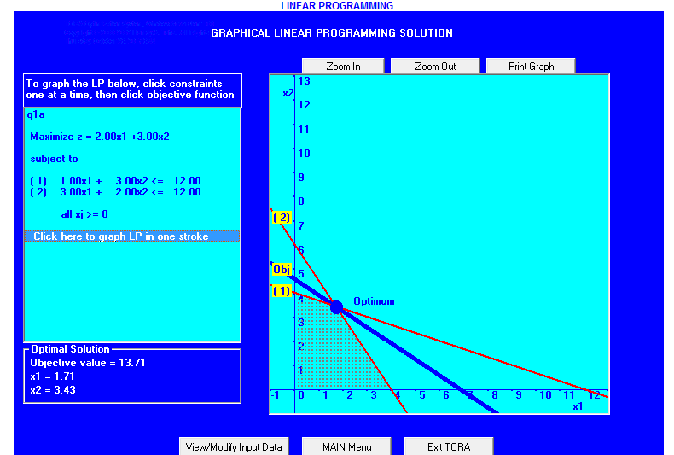

INTERPRETATION:

BOTH EQUATION ARE PLOTTED SEPRATELY ON THE GRAPH AND THEN A FEASIBLE REASON IS MARKED THEN AT ALL POSSIBLE EXTREME POINTS THE MAX Z IS EVALUATED.THE EXTREME POINT WHERE THE VALUE IS MAXIMUM IS OPTIMAL POINT AND THAT VALUE IS CALLED OPTIMAL VALUE.

HERE IN THE ABOVE CASE OPTIMAL POINT SAY D(1.71,3.43) GIVES THE MAX VALUE OF Z.THEREFORE THIS IS THE CASE OF UNIQUE SOLUTION

B)

EQUATION THAT HAS INFEASIBLE SOLUTIONS IS:

MAX Z=2X1+3X2

S.T.

4X1+5X2<=12

5X1+7X2>=20

X1,X2>=0

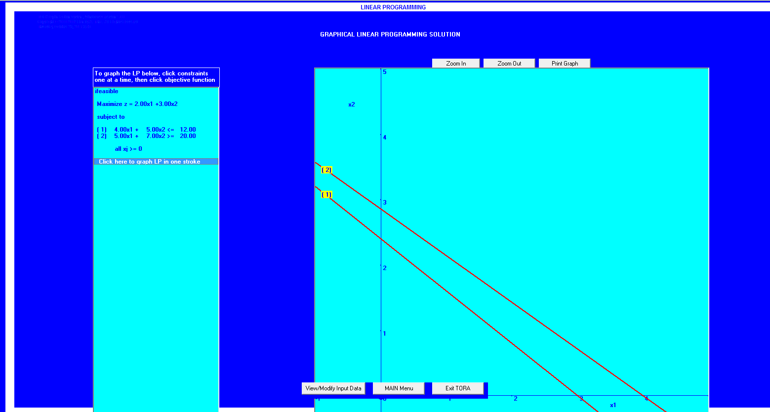

INTERPRETATION:

IN THE ABOVE CASE WE PLOTTED THE GRAPH.WE HAVE NO FEASIBLE SOLUTION SPACE AND WE DID NOT GET ANY OF THE EXTREME POINTS.THEREFORE THE SOLUTION IS INFEASIBLE

C)

EQUATION CORROSPONDING TO MULTIPLE SOLUTIONS IS:

MAX Z=2X1+4X2

S.T.

X1+2X2<=5

X1+X2<=4

X1,X2>=0

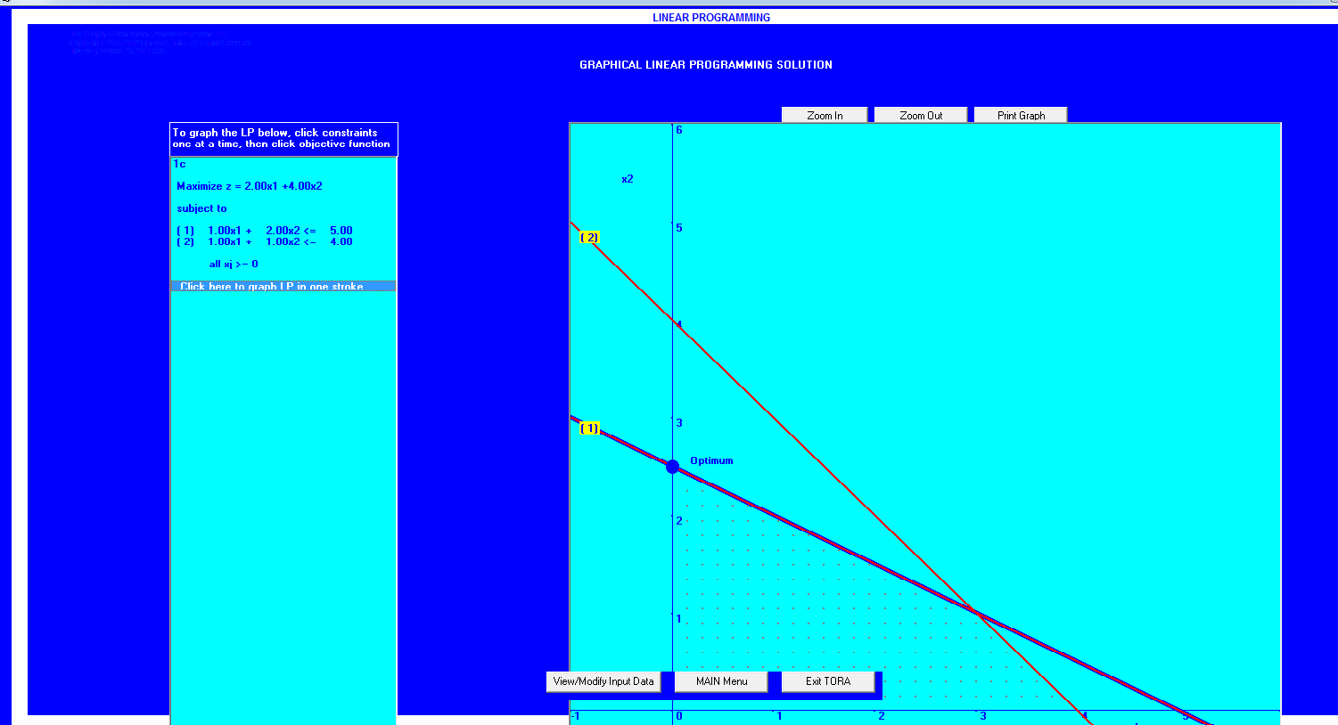

INTERPRETATION:

IN THE ABOVE EXAMPLE WE GET MORE THEN ONE POINT WHERE THE VALUE OF Z IS SAME AND WHICH IS MAXIMUM ALSO. HERE OPTIMUM SOLUTION IS ON THE LINE OF EQUATION 1 WHICH DENOTES THAT THIS IS THE CASE OF MULTIPLE SOLUTION

D)

EXAMPLE CORRESPONDING TO REDUNDENT SOLUTION IS:

MAX Z=5X1+3X2

S.T.

2X1+3X2<=10

4X1+6X2<=12

X1,X2>=0

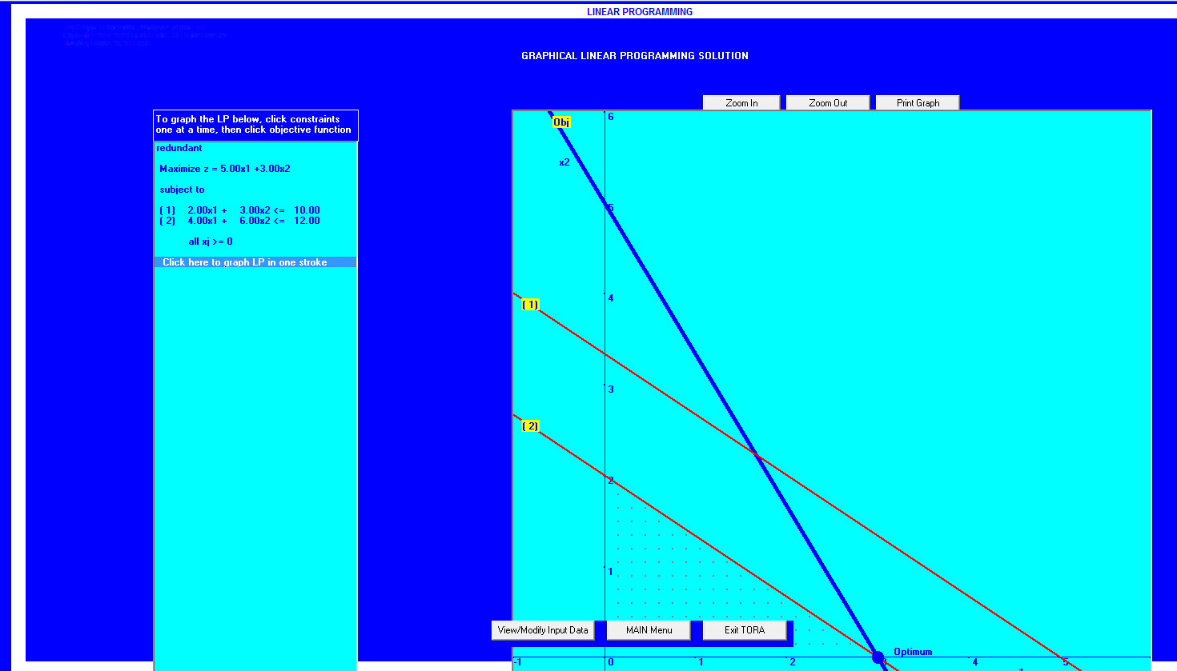

INTERPRETATION:

FEASIBLE SOLUTION SPACE IS SAME AS THAT OF EQUATION2.ALSO,OPTMUM POINT IS AT THAT LINE SO WE COCLUDED THAT EQUATION1 HAS NO IMPORTANCE AND THAT WHY IT IS A REDUNDANT CONSTRAINT.

Q2*. TO SOLVE THE LP PROBLEM USING SIMPLEX METHOD INCORPORATING*

*A) UNIQUE SOLUTION*

*B) INFEASIBLE SOLUTION*

*C) MULTIPLE SOLUTION*

*D) REDUNDANT CONSTRAINT*

*E) DEGENERACY SOLUTION*

*F) UNBOUNDED SOLUTION*

*INTERPRET THE SOLUTION*

SOLUTION

A)

EQUATION THAT HAS UNIQUE SOLUTION:

MAX Z=2X+3Y

S.T.

4X+5Y<=10

2X+7Y<=14

X,Y>=0

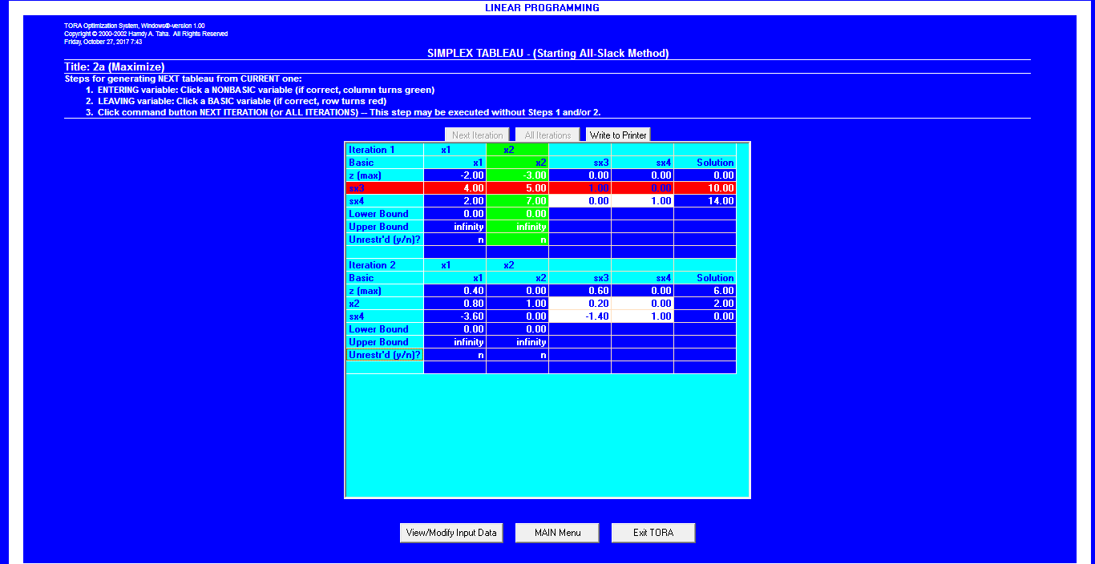

INTERPRETATION:

MOST NEGATIVE Z CAN IMPROVE THE SOLUTION IN CASE OF MAXIMIZATION.HERE,-3 IS MOST NEGATIVE AND CORRESPONDING MIN RATIO IS CALCULATED.

IN ITERATION 2 sX3 LEAVES AND X2 ENTERS.OPTIMAL SOLUTION IS OBTAINED IN ITERATION 2 WITH VALUE X1=0,sX4=0,X2=2,X3=0,X4=0 AND MAX Z=6

B)

EQUATION HAVING INFEASIBLE SOLUTION IS:

MIN Z=3X+4Y

S.T.

2X+Y<=2

3X+4Y>=12

X,Y>=0

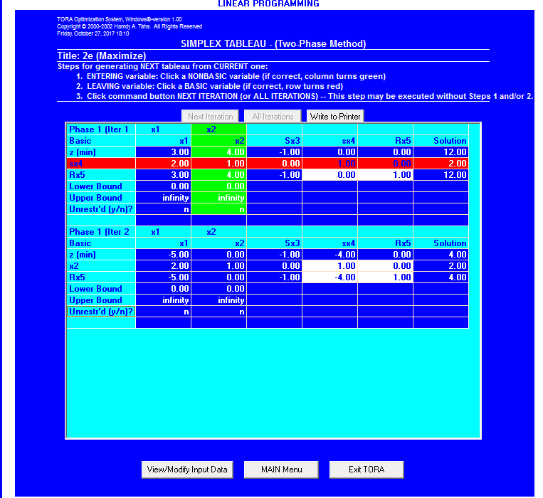

INTERPRETATION:

THIS IS CLEAR FROM THE EQUATIONS THAT THERE WILL BE NO FEASIBLE SOLUTION SPACE.HERE,IN ITERATION 1 Rx5 IS NON ZERO THEREFORE THE SOLUTION IS INFEASIBLE (R IS ARTIFICIAL VARIABLE).

C)

EQUATION CORRESPONDING TO MULTIPLE SOLUTION IS:

MAX Z=2X+4Y

S.T.

X+2Y<=5

X+Y<=4

X,Y<=0

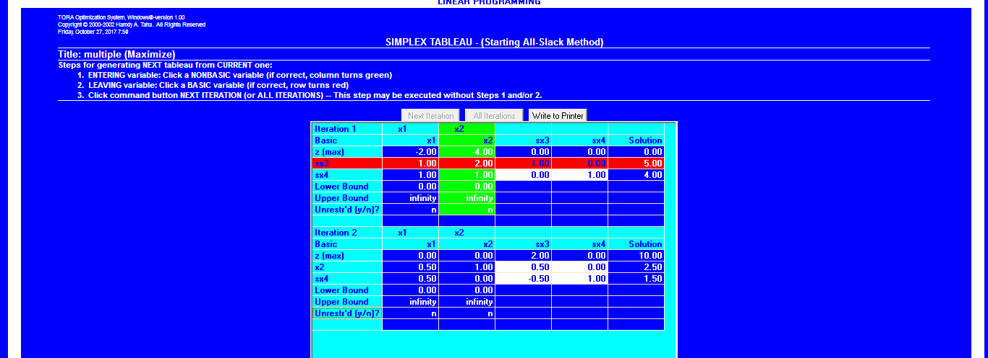

INTERPRETATION:

IN THE ABOVE CASE X2,Sx4 ARE BASIC VARIABLE.ALSO NOTE THAT IN ITERATION 2 X1 IS ALSO ZERO WHICH INDICATES THAT X1 CAN BE MADE BASIC,ALTERING THE VALUE OF THE BASIC VARIABLES WITHOUT CHANGING THE VALUE OF Z.SO THIS IS THE CASE OF ALTERNATIVE OPTIMA.

D)

EQUATION REPRESENTING REDUNDANT CONSTRAINTS:

MAX Z=3X+9Y

S.T.

X+4Y<=8

X+2Y<=4

X,Y>=0

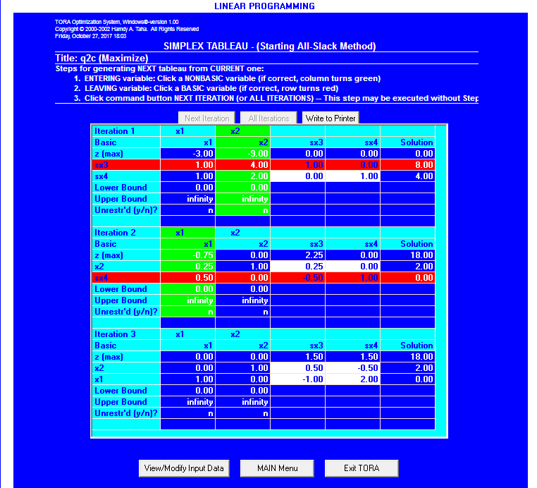

INTERPRETATION:

BY SEEING THE EQUATION IT IS CLEAR THAT IN FEASIBLE REGION CONTRIBUTION IS ONLY FROM EQUATION1.THEREFORE EQUATION 2 IS REDUNDANT AND HAS NO SIGNIFICANCE.BY USING SIMPLEX METHOD THE VALUE OF BASIC VARIABLE COMES OUT TO BE ZERO AND THEREFORE REDUNDANT CONSTRAINT EXISTS IN THE SOLTION

E)

EQUATION REPRESENTING DEGENERATED OPTIMAL SOLUTION:

MAX Z=3X+9Y

S.T.

X+4Y<=8

X+2Y<=4

X,Y>=0



INTERPRETATION:

BY USING SIMPLEX METHOD THE VALUE OF BASIC VARIABLE COMES OUT TO BE ZERO AND THEREFORE DEGENERATED SOLUTION EXISTS.

F)

EQUATION REPRESENTING UNBOUNDED SOLUTION IS:

MAX Z=2X1+X2

S.T.

X1-X2<=10

2X1<=40

X1,X2>=0

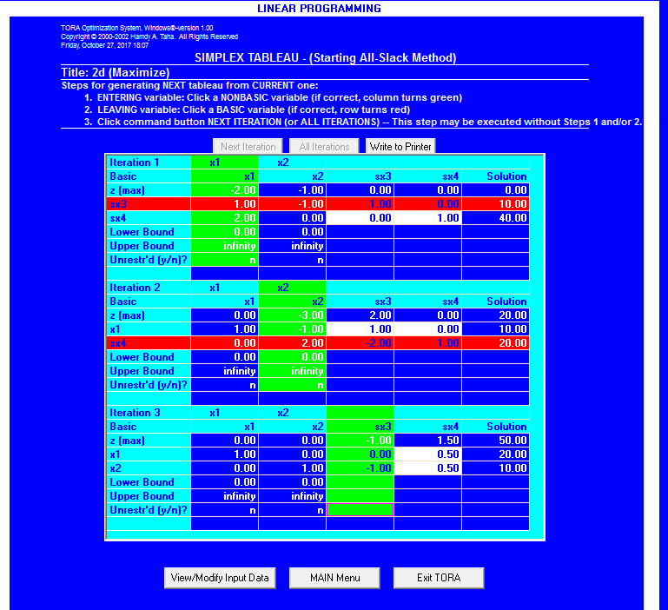

INTERPRETATION:

IN THE STARTING TABLE BOTH X1 AND X2 HAVE NEGATIVE Z-EQUATION COEFFICIANTS,WHICH MEANS INCREASE IN THEIR VALUE WILL INCREASE THE OBJECTIVE CONSTRAINT.HERE X2 IS NEGATIVE MEANING THAT X2 CAN BE INCREASED INDEFINITELY WITHOUT VIOLATING THE CONSTRAINTS.

Q3.*TO SOLVE THE LP PROBLEM USING BIG M METHOD INCORPORATING*

*A) UNIQUE SOLUTION*

*B) INFEASIBLE SOLUTION*

*C) MULTIPLE SOLUTION*

*D) REDUNDANT CONSTRAINT*

*E) DEGENERACY SOLUTION*

*F) UNBOUNDED SOLUTION*

*INTERPRET THE SOLUTION*

SOLUTIONS

A)

EQUATION CORROSPONDING TO UNIQUE SOLUTION:

MAX Z=20X1+10X2

S.T.

X1+X2>=150

X1<=40

X2=20

X1,X2>=0

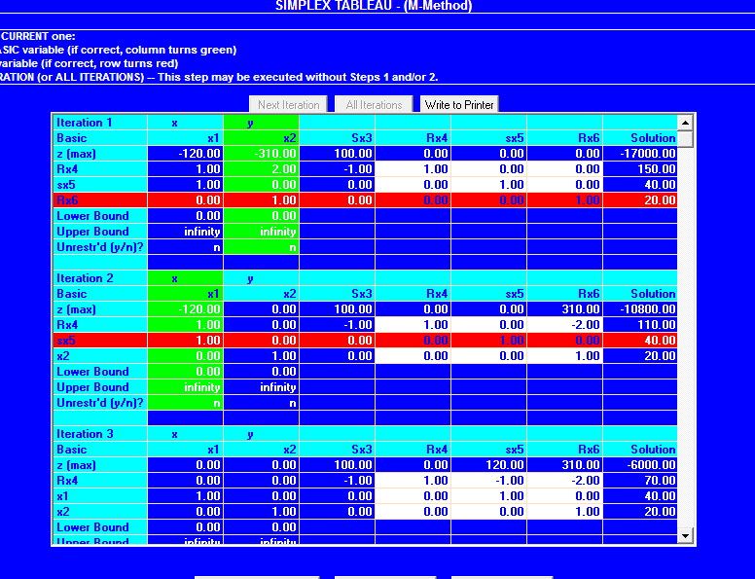

INTERPRETATION:

ARTIFICIAL VARIABLES ARE INTRODUCED AND THEN EQUATIONS IS SOLVED USING ITERATION METHOD.ITERATION 4 GIVES OPTIMAL SOLUTION AND THEREFORE ABOVE EXAMPLE IS CASE OF UNIQUE SOLUTION

B)

EQUATION CORRESPONDING TO MULTIPLE SOLUTION IS:

MAX Z=2X+4Y

S.T.

X+2Y=5

X+Y<=4

X,Y>=0

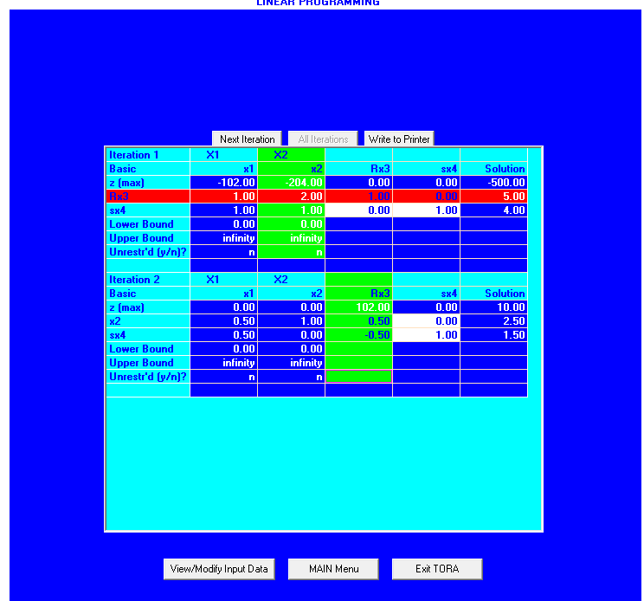

INTERPRETATION:

IN ITERATION 2 X1 IS ALSO ZERO WHICH INDICATES THAT X1 CAN BE MADE BASIC, ALTRING THE VALUE OF THE BASIC VARIABLES WITHOUT CHANGING THE VALUE OF Z.SO THIS IS THE CASE OF ALTERNATIVE OPTIMA.

C)

EQUATION REPRESENTING REDUNDANTCONSTRAINTS:

MAX Z=3X+9Y

S.T.

X+4Y=8

X+2Y=4

X,Y>=0

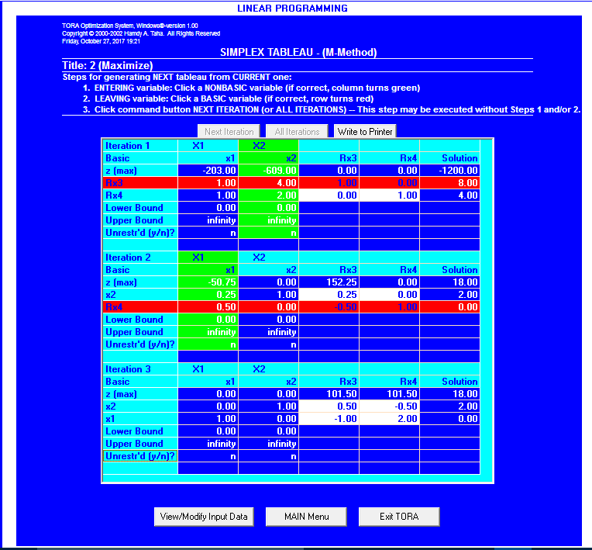

INTERPRETATION:

BY SEEING THE EQUATION IT IS CLEAR THAT IN FEASIBLE REGION CONTRIBUTION IS ONLY FROM EQUATION1.THEREFORE EQUATION 2 IS REDUNDANT AND HAS NO SIGNIFICANCE.BY USING BIG M METHOD THE VALUE OF BASIC VARIABLE COMES OUT TO BE ZERO AND THEREFORE REDUNDANT CONSTRAINT EXISTS IN THE SOLTION

D)

EQUATION REPRESENTING DEGENERATED SOUTION:

MAX Z=3X+9Y

S.T.

X+4Y=8

X+2Y=4

X,Y>=0



INTERPRETATION:

BY USING BIG M METHOD THE VALUE OF BASIC VARIABLE COMES OUT TO BE ZERO AND THEREFORE DEGENERACY EXISTS IN THE SOLUTION.

E)

EQUATION REPRESENTING UNBOUNDED SOLUTION IS:

MAX Z=2X1+X2

S.T.

X1-X2<=10

2X1>=40

X1,X2>=0

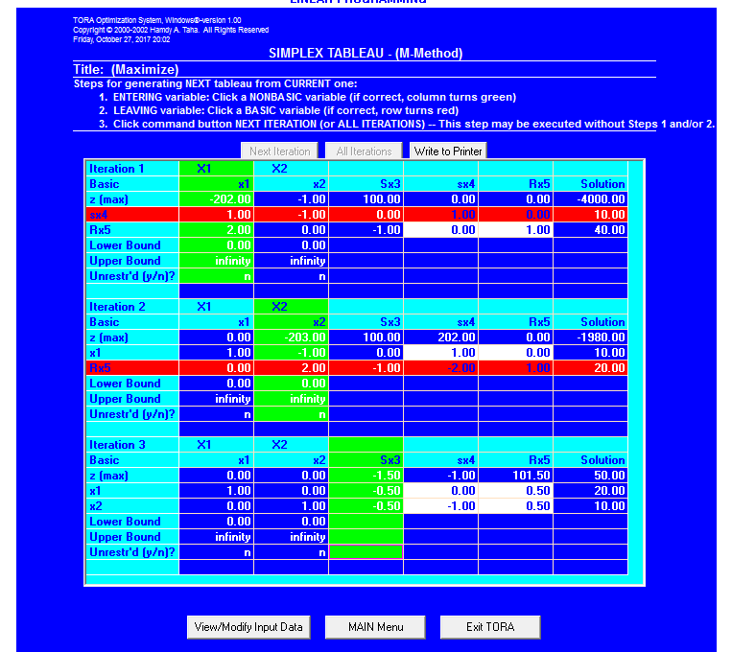

INTERPRETATION:

SINCE X2 IS NEGATIVE THEN INCREASE IN ITS VALUE CAN INCREASE THE OBJECTIVE CONSTRAINT SO IT IS A CASE OF UNBOUNDED CONSTRAINTS

F)

EQUATION REPRESENTING THE INFEASIBLE SOLUTION IS:

MIN Z=3X+4Y

S.T.

2X+Y<=2

3X+4Y>=12

X,Y>=0

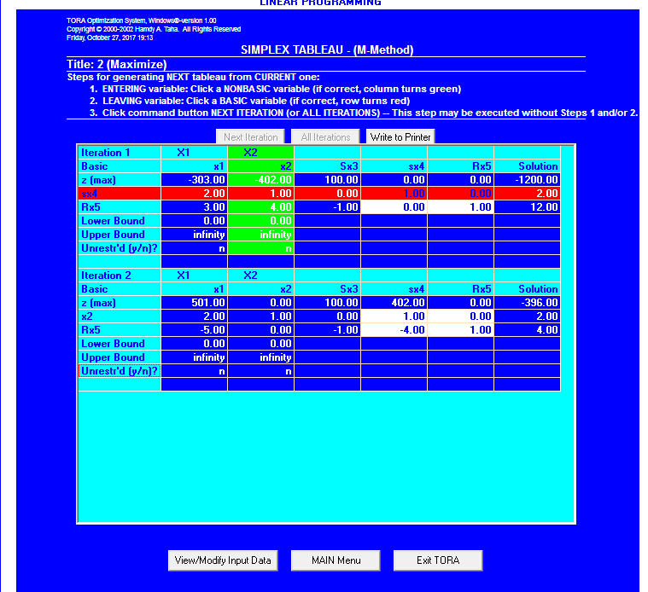

INTERPRETATION:

HERE IN OPTIMAL ITERATION, VALUE OF ARTIFICIAL VARIABLE Rx5 IS NON ZERO SO IT IS AN INFEASIBLE SOLUTION.

Q4.*TO SOLVE THE LP PROBLEM USING TWO PHASE METHOD INCORPORATING*

*A) UNIQUE SOLUTION*

*B) INFEASIBLE SOLUTION*

*C) MULTIPLE SOLUTION*

*D) REDUNDANT CONSTRAINT*

*E) DEGENERACY SOLUTION*

*F) UNBOUNDED SOLUTION*

*INTERPRET THE SOLUTION*

SOLUTIONS

A)

EQUATION CORROSPONDING TO UNIQUE SOLUTION:

MAX Z=20X1+10X2

S.T.

X1+2X2=150

X1<=40

X2>=20

X1,X2>=0

**Phase 1** 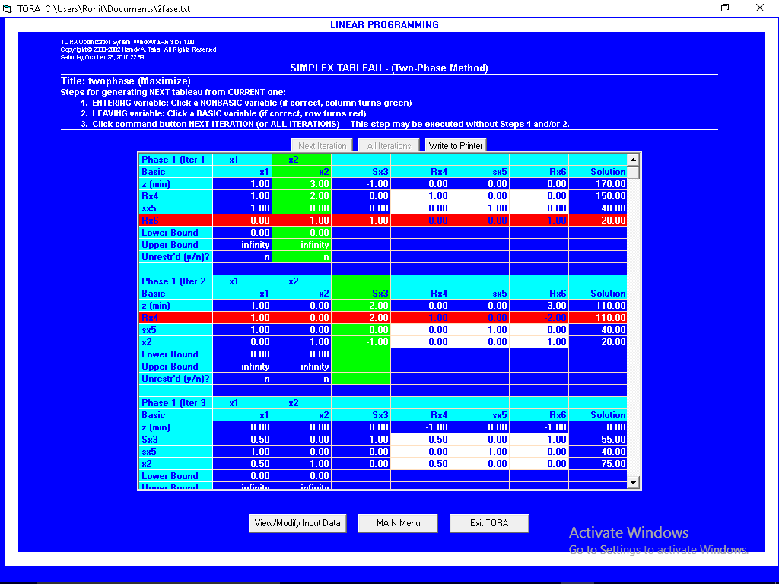

**Phase 2**

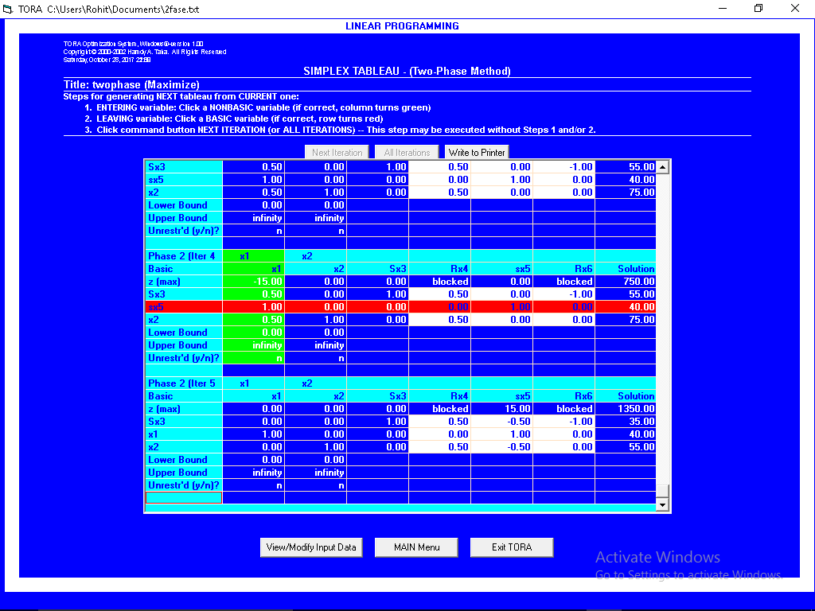

INTERPRETATION:

ARTIFICIAL VARIABLES ARE INTRODUCED AND THEN EQUATIONS IS SOLVED USING ITERATION (TWO PHASE) METHOD.WHERE THE PHASE ONE IS MINIMIZED WITH THE Z=RX4+RX6+SX5. AFTER THAT PHASE TWO HAS ORIGINAL MAXIMIZATION EQUATION. ITERATION 5 GIVES OPTIMAL SOLUTION AND THEREFORE ABOVE EXAMPLE IS CASE OF UNIQUE SOLUTION

B)

EQUATION REPRESENTING THE INFEASIBLE SOLUTION IS:

MIN Z=3X+4Y

S.T.

2X+Y<=2

3X+4Y>=12

X,Y>=0

**PHASE 1**

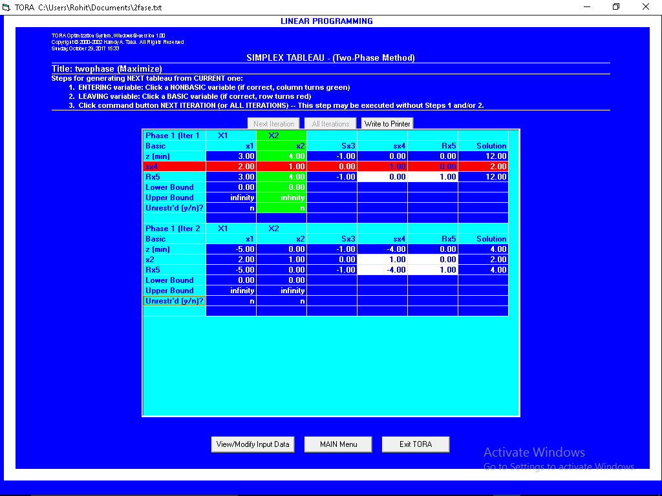

INTERPRETATION:

HERE IN OPTIMAL ITERATION VALUE OF ARTIFICIAL VARIABLE Rx5 IS NON ZERO IN PHASE 1 SO IT IS INFEASIBLE SOLUTION SO WE DON’T PERFORM PHASE 2.

C)

EQUATION CORRESPONDING TO MULTIPLE SOLUTION IS:

MAX Z=2X+4Y

S.T.

X+2Y=5

X+Y>=4

X,Y>=0

**PHASE 1** 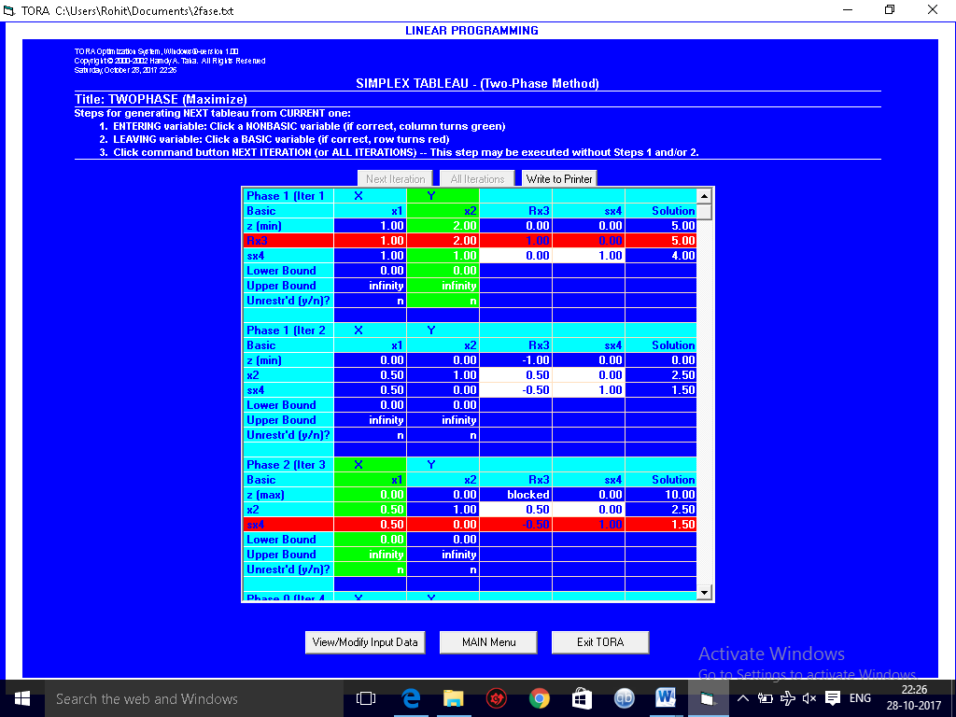

**PHASE 2**

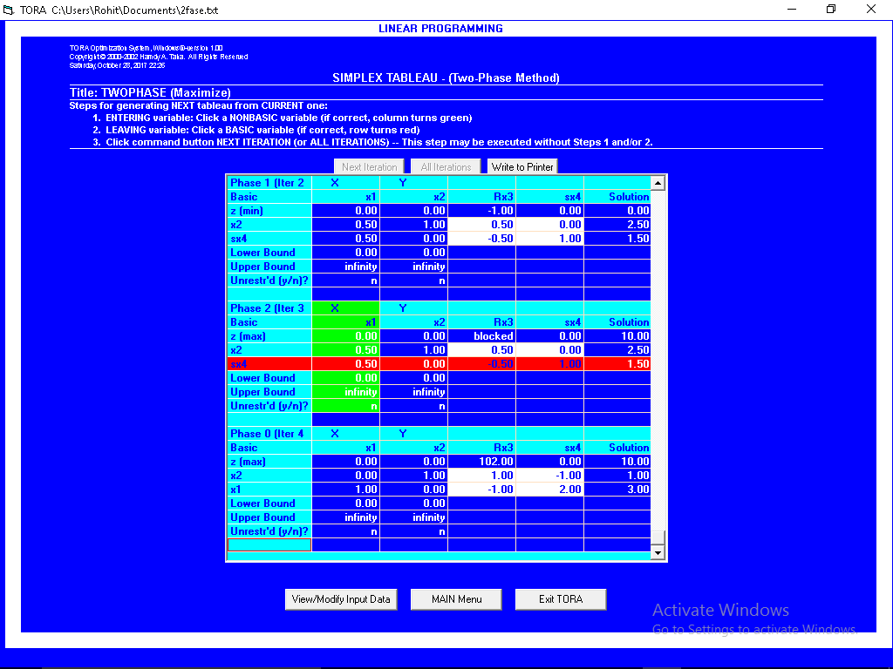

INTERPRETATION:

IN ITERATION 3 WE CAN SEE THAT THERE IS A NON BASIC VARIABLE (X1) WITH ZERO VALUE IN Z-ROW WHICH INDICATES AN ALTERNATE OPTIMA AS SHOWN IN ITERATION 4, ALTERING THE VALUE OF THE BASIC VARIABLES WITHOUT CHANGING THE VALUE OF Z.SO THIS IS THE CASE OF ALTERNATIVE OPTIMA.

D)

EQUATION REPRESENTING REDUNDANT CONSTRAINTS:

MAX Z=3X+9Y

S.T.

X+4Y=8

X+2Y=4

X,Y>=0

**PHASE 1**

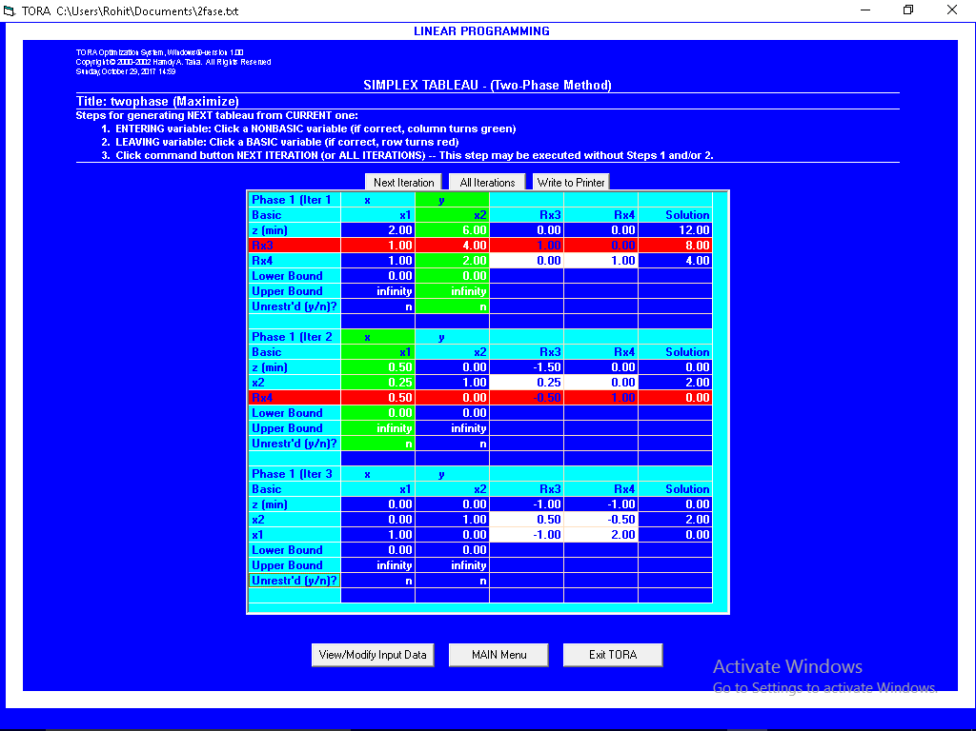

**PHASE 2**

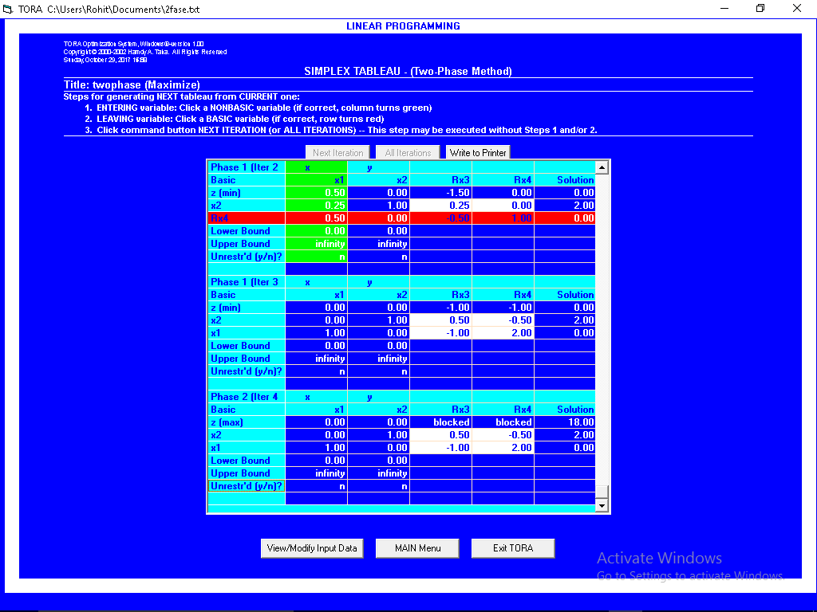

INTERPRETATION:

BY SEEING THE EQUATION IT IS CLEAR THAT IN FEASIBLE REGION CONTRIBUTION IS ONLY FROM EQUATION1.THEREFORE EQUATION 2 IS REDUNDANT AND HAS NO SIGNIFICANCE.BY USING TWO PHASE METHOD THE VALUE OF BASIC VARIABLE COMES OUT TO BE ZERO I.E. DEGENERACY WHICH ALSO MEAN THAT THERE IS A REDUNDANT CONSTRAINT IN THE EQUATION.

E)

EQUATION REPRESENTING DEGENERACY CONSTRAINTS:

MAX Z=3X+9Y

S.T.

X+4Y=8

X+2Y=4

X,Y>=0

**PHASE 1**



**PHASE 2**



INTERPRETATION:

BY USING TWO PHASE METHOD THE VALUE OF BASIC VARIABLE COMES OUT TO BE ZERO AND THEREFORE DEGENERACY EXISTS IN THE SOLTION

**F.**

EQUATION REPRESENTING UNBOUNDED SOLUTION IS:

MAX Z=2X1+X2

S.T.

X1-X2<=10

2X1>=40

X1,X2>=0

**PHASE 1**

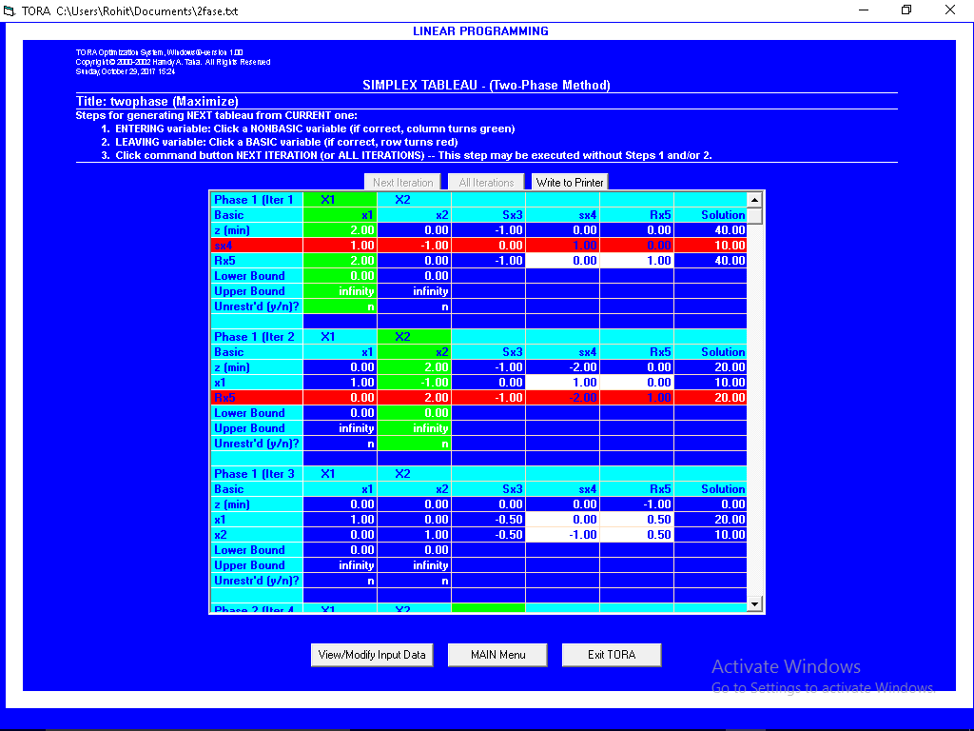

**PHASE 2**

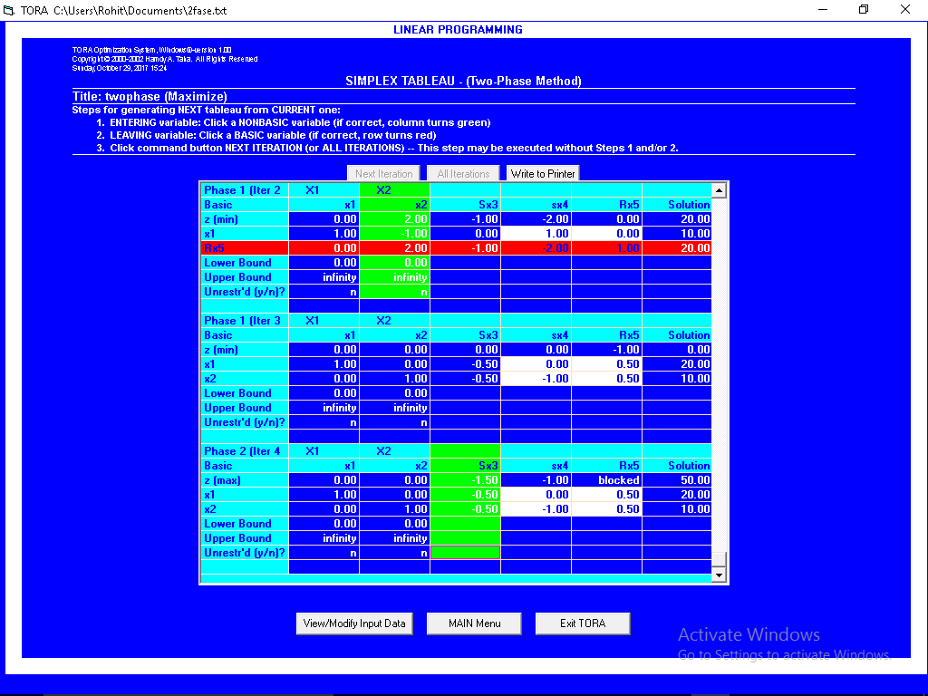

INTERPRETATION:

SINCE SX3 HAS HIGHEST NEGATIVE VALUE IN Z-ROW IN ITERATION 4 BUT SX3 HAS NON-POSITIVE COLUMN SO IT CANNOT ENTER THE BASIC SOLUTION WHICH SHOWS THAT THE SOLUTION IS UNBOUNDED.

*Q5. TO CHECK THE IMPACT OF INTERCHANGING CONSTRAINT IN SIMPLEX METHOD.*

OUR EQUATION IS:-

Maximize z= 3x1 + 2x2

Subject to

4x1 - x2 <=4

4x1+3x2<=6

4x1 + x2 <=4

X1,x2>=0

**FINDING OPTIMAL SOLUTION**

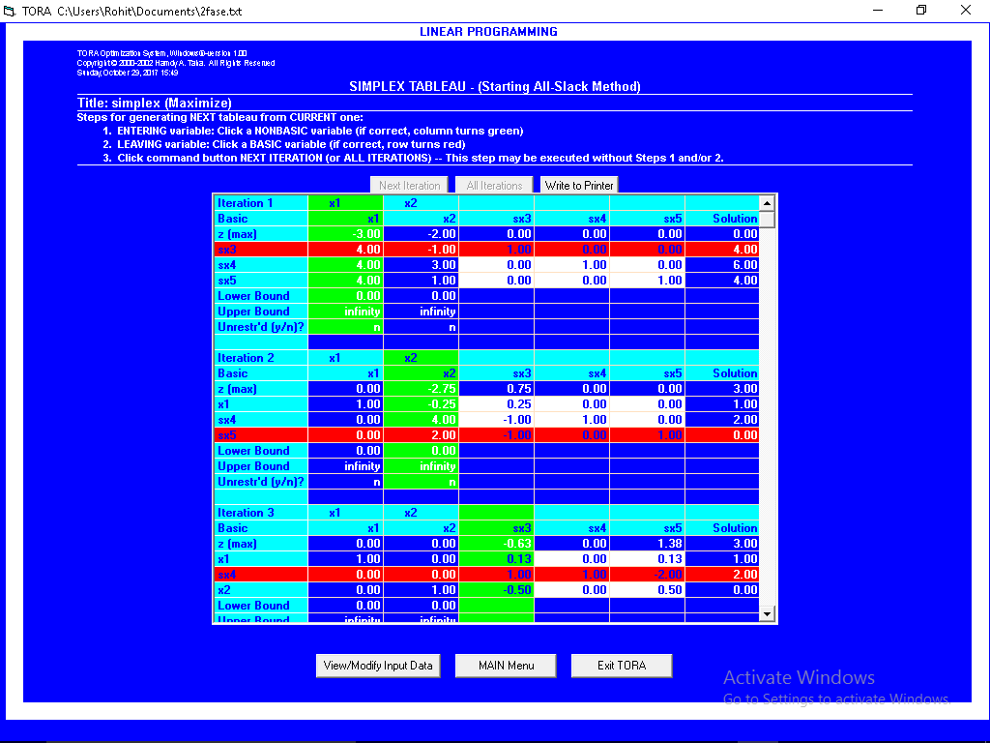

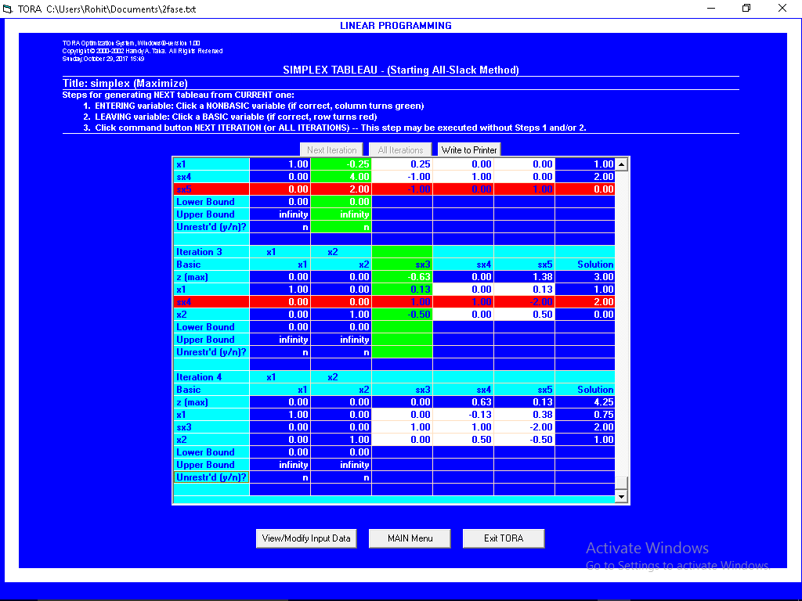

INTERPERTATION:

OUR OPTIMAL SOLUTION IS AT x1=0.75 AND x2=1 WHICH IS 4.25 AND IT TAKES 4 ITERATIONS TO REACH TO OPTIMAL SOLUTION.

**INTERCHANGING CONSTRAINT 1 AND 3**

NOW OUR EQUATION IS:-

Maximize z= 3x1 + 2x2

Subject to

4x1 +x2 <=4

4x1+3x2<=6

4x1 - x2 <=4

X1,x2>=0

**FINDING OPTIMAL SOLUTION**

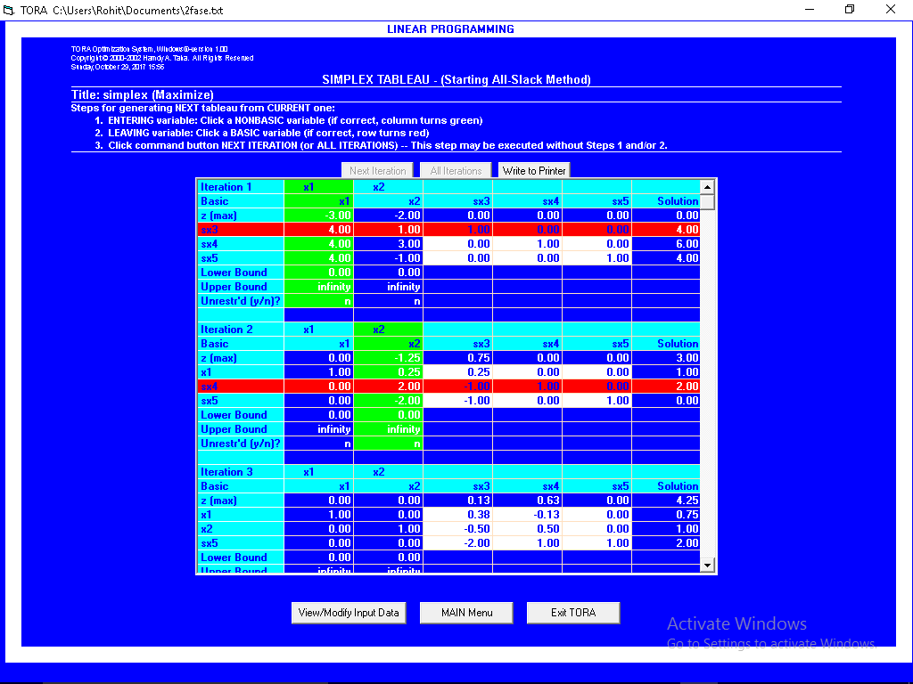

INTERPERTATION:

AFTER INTERCHANGING THE CONSTRAINTS WE HAVE OPTIMAL SOLUTION AT X1=0.75 AND X2=1 WHICH IS 4.75 AND IT TAKES 3 ITERATIONS TO REACH OPTIMAL.

SO,

WITH THIS WE KNOW THAT THE SOLUTION DOES NOT DIFFER FROM PREVIOUS EVEN AFTER INTERCHANGING THE CONSTRAINT. ONLY THE NUMBER OF ITERATION CHANGE AND THAT IS BECAUSE IF WE PLOT IT ON A GRAPH THE SHORTEST PATH TO OPTIMAL WILL BE THROUGH CONSTRAINT 4X1+X2<=4. BUT SINCE THERE IS A TIE WE DON’T KNOW IN SIMPLEX METHOD WHICH ROUTE IS FASTER AND *TORA* BREAKS TIE OF FIRST COME FIRST SERVE BASIS SO THERE WAS MORE ITERATION IN FIRST TIME THEN IN SECOND.

Q7. *SOLVE THE TRANSPORTATION PROBLEM USINF EACH OF THE INITIAL BASIC FEASIBLE TECHNIQUE*

**Method 1: Northwest – Corner Rule**

1 2 3 4 Supply

|  |  |  |  |
| --- | --- | --- | --- |
| 10 | 2 | 20 | 11 |
| 12 | 7 | 9 | 20 |
| 4 | 14 | 16 | 18 |

1 15

2 25

3 10

Demand 5 15 15 15

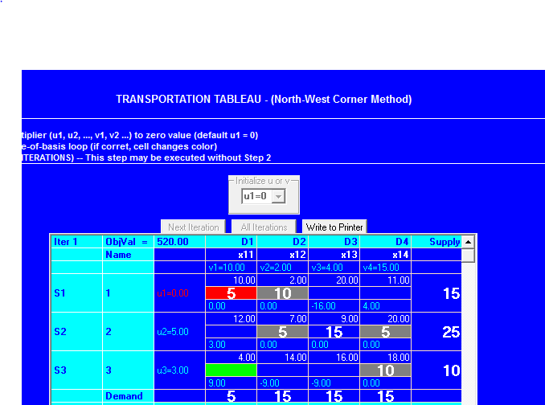

INTERPRETATION:

Since the starting basic solution ( consisting of 6 basic variable ) is

X11 = 5, x12 = 10, x22 = 5, x23 = 15, x24=5, x34=10

The associated cost of the schedule is

Z = 5X10 + 10X2 + 5X7 + 15X9 + 5X20 + 10X18 = $520

**Method 2: Least Cost Stating Solution**

1 2 3 4 Supply

|  |  |  |  |
| --- | --- | --- | --- |
| 10 | 2 | 20 | 11 |
| 12 | 7 | 9 | 20 |
| 4 | 14 | 16 | 18 |

1 15

2 25

3 10

Demand 5 15 15 15

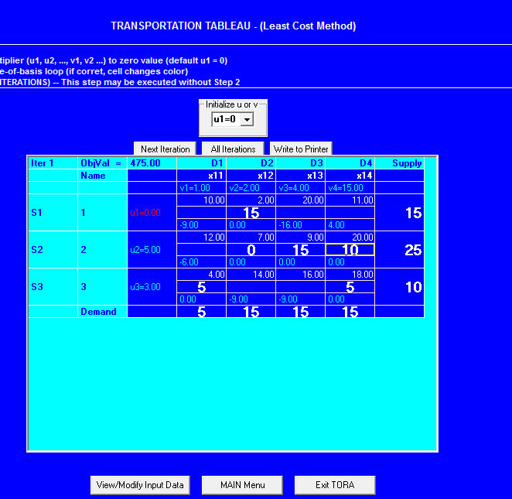

INTERPRETATION:

Since the starting solution (consisting of 6 basic variable)

X12 =15, x14 = 0, x23 = 15, x24 = 10, x31 = 5, x34 = 5

The associated cost of the schedule is

Z = 15X2 + 0X11 + 15X9 + 10X20 + 5X4 + 5X18 = $475

Least Cost starting method happens to be better than the northwest – corner solution

**Method 3: Vogel approximation method (VAM)**

1 2 3 4 Supply

|  |  |  |  |
| --- | --- | --- | --- |
| 10 | 2 | 20 | 11 |
| 12 | 7 | 9 | 20 |
| 4 | 14 | 16 | 18 |

1 15

2 25

3 10

Demand 5 15 15 15

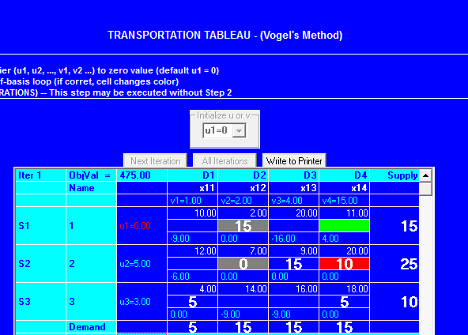

INTERPRETATION:

Since the starting solution ( consisting of 6 basic variable ) is

X12 = 15, x14 = 0, x23 = 15, x24 = 10, x31 = 5, x34 = 5

The associated cost of the schedule is

Z = 15X2 + 0X11 + 15X9 + 10X20 + 5X4 + 5X18 = $475

This happens to have the same cost as in the least-cost method. VAM is an improved version of the least-cost method, but not always, produces better starting solution.