Software Requirement Specification
Of
Network Management System


Prepared by : Kisan Chaurasiya(12ESKIT039)
Jatin Patni(12ESKIT035)
Hitesh jaisinghani(12ESKIT032)
Mentor : Sunil Dhankar Sir August 10 ,2015
Maintained by: NIMDA TEAM MEMBERS

Names Mail-Id

KISAN CHAURASIYA chaurasiyakishan@gmail.com

JATIN PATNI jatin.patni.619@gmail.com

HITESH JAISINGHANI hiteshjaisinghani11@gmail.com

ABSTRACT

This document describes the functional and non-functional requirements and preliminary analysis of network management system. It is aimed to provide a brief description of the project and to provide as a reference for both the Client and The Neptune Team.

Software requirement specification (SRS)

A document describing the requirements of a software system from the user's point of view.

An SRS document specifies:

- The required behavior of a system in terms of input data, required processing, output data, operational scenarios and interfaces and

- The attributes of a system including performance, security, maintainability, reliability, availability and safety requirements and design constraints.

Alias: user requirement specification, functional specification

Contents

1 Introduction | 4
4
- Introduction ...................................................................................................... 4

- Document’s Purpose .......................................................................................... 4

Document’s Scope ............................................................................................. 5

Definitions ........................................................................................................ 5

- References ......................................................................................................... 5

2 Overall Description | 5

Overview of Current System .............................................................................. 6

- Product Perspective ............................................................................................ 6

Project Scope ..................................................................................................... 7

Product Functions .............................................................................................. 7

User Interface ..................................................................................................... 10

- Constraints ........................................................................................................ 10

3 User Interface Requirement | 11
3.1 User panel ………………………………………………………................................. | 11
3.2 User Config panel ………………………………………………………..................... | 12
3.3 Physical panel …………………………………………………………...................... | 13
3.4 Ip Config panel……………………………………………………………………...... | 14

PC command prompt ………………………………………………………….......... 15

Interface of mail server………………………………………………………………. 16

Firewall panel ………………………………………………………………….......... 17

4 System features | 18
4.1 Packet Tracer Workspace ………………………………………….............................. | 18

4.2 Packet Tracer Modes ………………………………………………………................. | 18

5 Other Non-functional Requirements | 20
5.1 Performance Requirements…………………………………………………………..... | 20
5.2 Safety Requirements ………………………………………………………………....... | 20
5.3 Business Rule.. .………………………………………………………………............... | 20
Appendix A

1 Introduction:

This section gives a detailed introduction of network management system and a brief description of document purpose and document’s scope

1.1 Introduction

Network Management System helps utilities transform their operations (like smart metering, distribution automation, and substations) for the smart grid with unified network management. With this system, utility operations share a converged IP-based communications network, and thus manage millions of grid endpoint devices
Network Management System is a software platform that helps to enable a clear separation between communications network management and utility operational applications. These include Distribution Management System (DMS), Outage Management System (OMS), and Meter Data Management (MDM).

1.2 Document’s Purpose

This document is intended for understanding the definition of requirements that are necessary for the development of the network system.

This document act as basis for:

- Fault Management—Detect, isolate, notify, and correct faults encountered in the network.
- Configuration Management—Configuration aspects of network devices such as configuration file management, inventory management, and software management.
- Performance Management—Monitor and measure various aspects of performance so that overall performance can be maintained at an acceptable level.
- Security Management—Provide access to network devices and corporate resources to authorized individuals.
- Accounting Management—Usage information of network resources.

1.3 Document’s Scope

Document management system success relies on proper planning for the scope and needs of your organization -- not only today, but in the future, says consultant Steve Weissman.

1.4 Definitions

A network management system (NMS) is a set of hardware and/or software tools that allow an IT professional to supervise the individual components of a network within a larger network management framework.
Network management system components assist with:
- Network device discovery - identifying what devices are present on a network.
- Network device monitoring - monitoring at the device level to determine the health of network components and the extent to which their performance matches capacity plans and intra-enterprise service-level agreements (SLAs).
- Network performance analysis - tracking performance indicators such as bandwidth utilization, packet loss, latency, availability and uptime of routers, switches and other Simple Network Management Protocol (SNMP) -enabled devices.
- Intelligent notifications - configurable alerts that will respond to specific network scenarios by paging, emailing, calling or texting a ne

1.5 References

1. O'Brien, J., Rodden, T., Rouncefield, M.,Hughes, J. (1999) At home with the technology: an ethnographic study of a set-top-box trial. ACM Trans. Comput.-Hum. Interact., 6 (3).282-308.
2. http://totallyfreedownload.net/cisco-packet- tracer-5-3-3-download
3. Janitor, J., and K. Kniewald. 2010. Visual learning tools for teaching/learning computer networks. ICNS’10 Proceedings of the 2010 6th International Conference on Networking and Services, Cancun, Mexico.
4. Laurillard, D. 2002. Rethinking University Teaching: a framework for the effective use of educational technology, 2nd ed. London: Routledge Falmer, 154.
5. Prieto-Bla´zquez, J. et al. 2008. An integrated structure for a virtual networking laboratory. IEEE transactions on Industrial Electronics 55, no. 6: 2334_42.
6. Wang, M. 2008. Packet Tracer 5.0, Packet Tracer Messaging Protocol (PTMP), Specifications Document: Cisco Systems.
7. Jianping Pan. Teaching computer networks in a real network: the teachnical perspectives. SIGCSE '10 Proceddings of the 41 st ACM technical symposium on computer science education.

2 Overall Description:

This section gives overview of network systems deployed in the industry and the detailed perspective of the management system into an industry.

2.1 Overview of Current System

A network management system (NMS) is a set of hardware and/or software tools that allow an IT professional to supervise the individual components of a network within a larger network management framework.

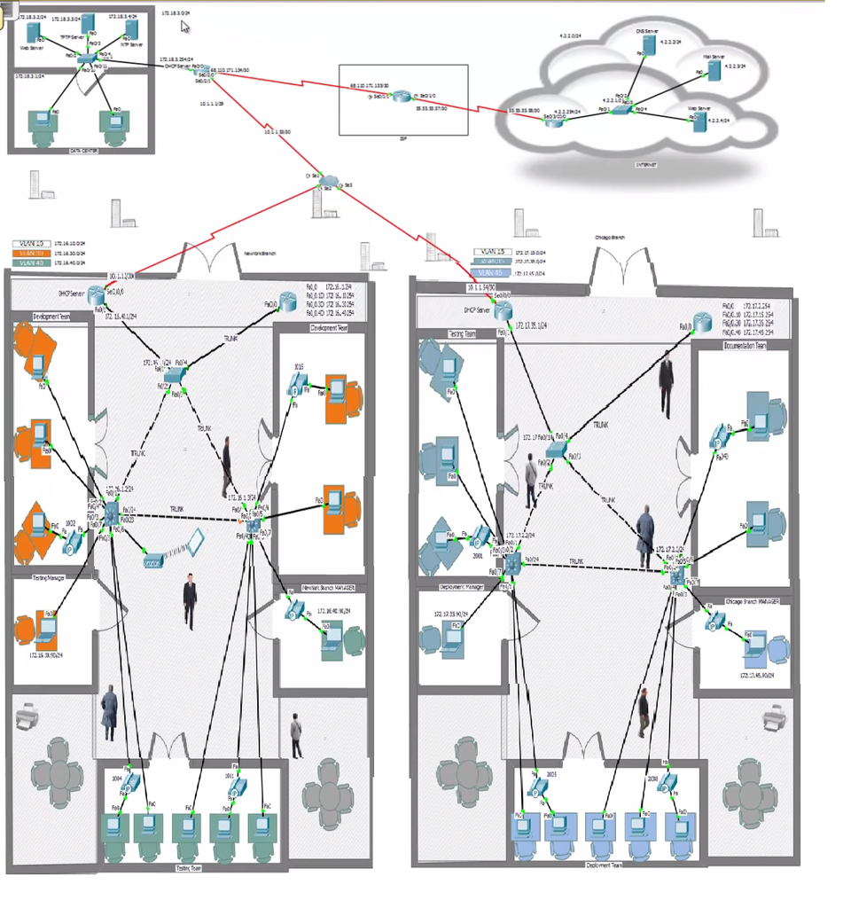

2.2 Product Perspective

This product is aimed at employees, students and every type of users. Whenever there is network created in an IT firm, network engineers can consider this project as utility to create the network and manage it properly. The project’s purpose is to manage a huge network of a company which has different clusters according to company's demand. At the end of the project, the system will have its configurations and functionalities reviewed, network management system and user interface improved.

2.3 Project Scope

The project will mainly focus on the network management system of big firm. It shows an enterprise network design and its functionality.
2.4 Project Functions

Network management system

Enterprise network managament system can be broadly classified into 4 different parts

2.4.1 ISP (Internet Service Provider)

An Internet service provider (ISP) is an organization that provides services for accessing, using, or participating in the Internet. Internet service providers may be organized in various forms, such as commercial, community-owned, non-profit, or otherwise privately owned.

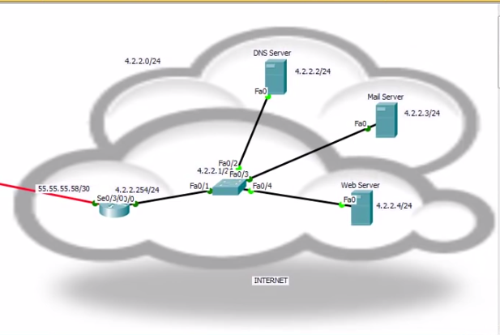

2.4.2 DATA Center

A data center (sometimes spelled datacenter) is a centralized repository, either physical or virtual, for the storage, management, and dissemination of data and information organized around a particular body of knowledge or pertaining to a particular business.

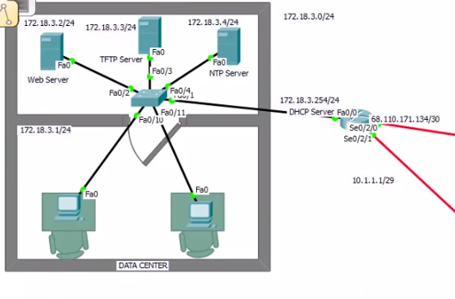
2.4.3 Network Branch

The main network is managed by this branch. All the configuration are done on routers ,swirches and firewall .

.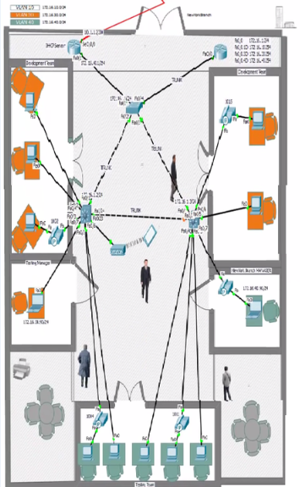
2.5 User Characteristics

A user can access the CLI-Mode of a router either by using a terminal software, for first time configuration, when a PC is connected to a Router, using a console cable or by using telnet/ssh/putty etc, when it is connected using a cross-over cable. Following basic commands can be typed on any router to assign an IP address on an Ethernet and serial interface.
Users, who spend more time, doing practice on a packet tracer, become more confident to work with real equipment. Students are very much interested in learning various concepts of networking using packet tracer. They are very much interested in creating their own scenarios and always keep on asking what if questions. There is better understanding of connecting proper devices, using appropriate cables and assigning proper IP address to various networking devices. There is also clear understanding about the difference in working of various networking devices and their appropriate use in connecting various hosts together. The multi-user functionality of a packet tracer helps the students to collaborate and compete with each other to increase and enhance the learning of different concepts.

2.6 Constraints

2.6.1 Hardware Constraints

Minimum hardware requirements for Cisco Packet Tracer to function properly are the following

1. Processor: Intel based 166 MHz

  - RAM: 128 MB

  - Hard-disk space: 4 Gb

  - Networking: Ethernet 10/100.

  - GUI support needed.

3.User Interface Reuireqment

This section describes some of the major user interface in the user interface of packet tracer. A further detail of the UI of the system such as the configurations and layout will be described in the SDD.

3.1 User Panel

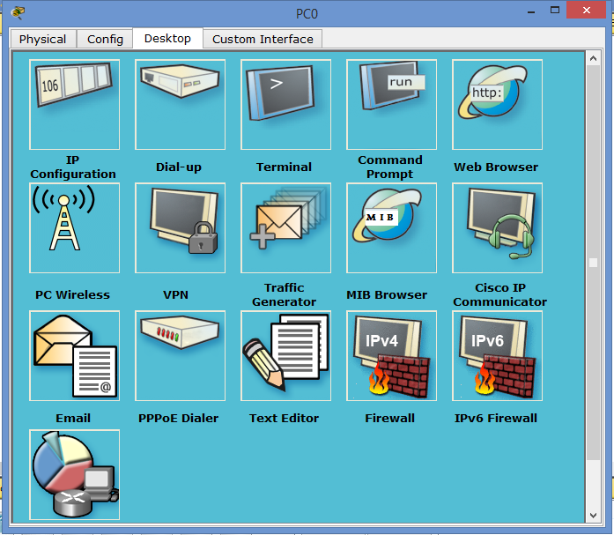

3.2 User config panel

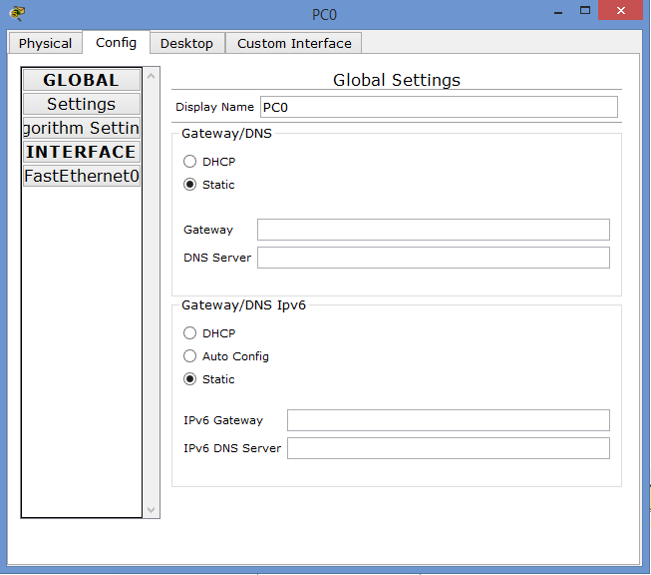
3.3 Physical Panel

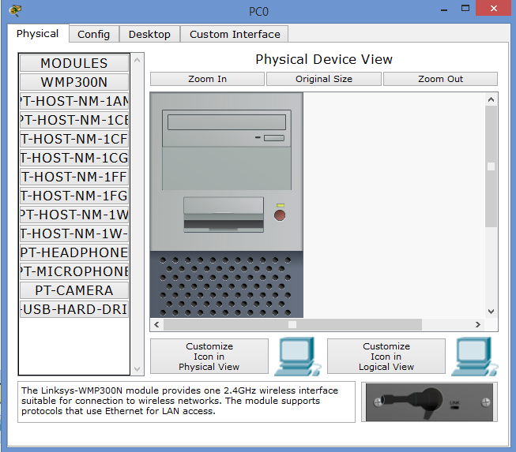

3.4 IP Config Panel

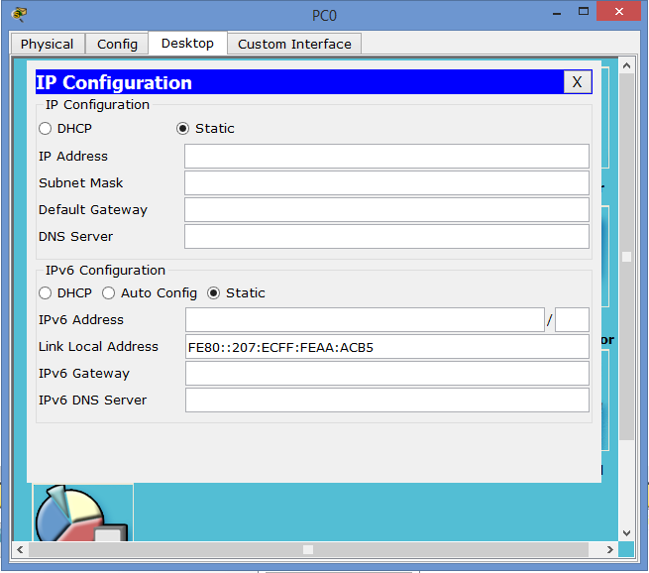
3.5 PC command prompt

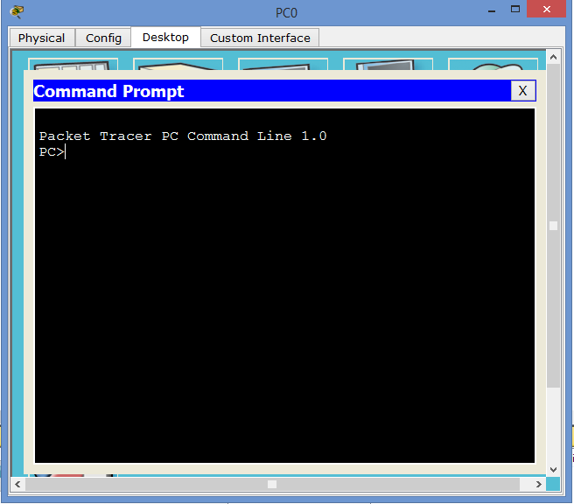
3.6 Interface of Mail Server

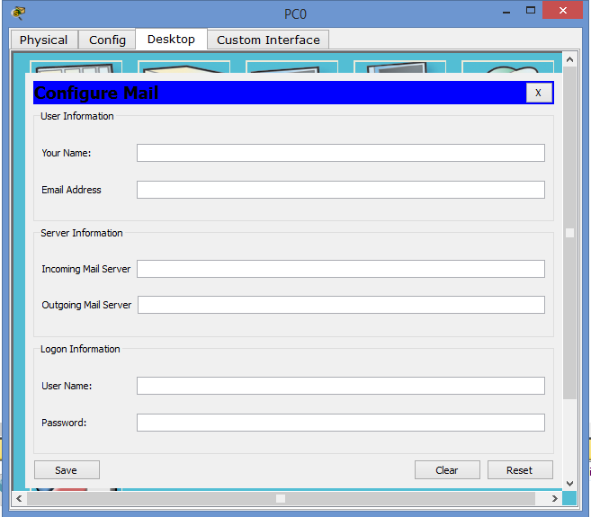
3.7 Firewall Panel

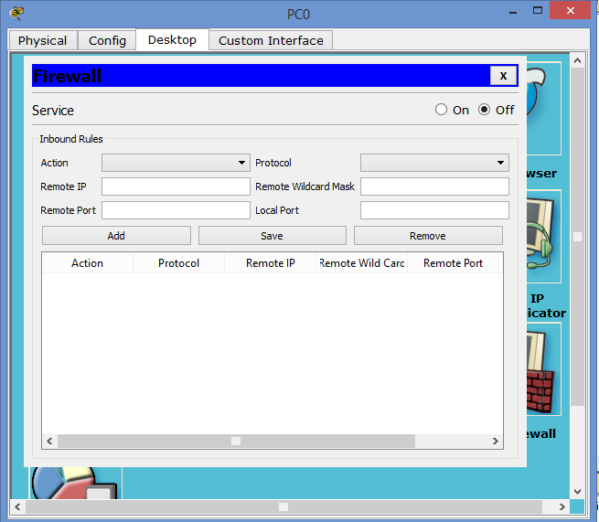
4.System Features

Cisco Packet Tracer is a network simulation program that allows students to experiment with network behavior and ask “what if” questions. As an integral part of the Networking Academy comprehensive learning experience, Packet Tracer provides simulation, visualization, authoring, assessment, and collaboration capabilities and facilitates the teaching and learning of complex technology concepts.

4.1 Packet Tracer Workspaces:

Cisco Packet Tracer has two workspaces—logical and physical. The logical workspace allows users to build logical network topologies by placing, connecting, and clustering virtual network devices. The physical workspace provides a graphical physical dimension of the logical network, giving a sense of scale and placement in how network devices such as routers, switches, and hosts would look in a real environment. The physical view also provides geographic representations of networks, including multiple cities, buildings, and wiring closets.

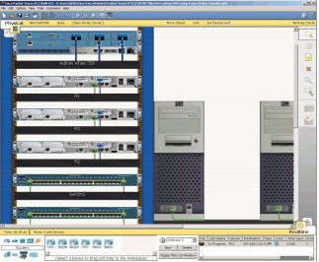
Fig: The physical workspace provides a graphical view of the logical network

4.2 Packet Tracer Modes
Cisco Packet Tracer provides two operating modes to visualize the behavior of a network—real-time mode and simulation mode. In real-time mode the network behaves as real devices do, with immediate real-time response for all network activities. The real-time mode gives students a viable alternative to real equipment and allows them to gain configuration practice before working with real equipment. In simulation mode the user can see and control time intervals, the inner workings of data transfer, and the propagation of data across a network. This helps students understand the fundamental concepts behind network operations. A solid understanding of network fundamentals can help accelerate learning about related concepts.

Protocols: Cisco Packet Tracer supports the following protocols

Layer | Cisco Packet Tracer Supported Protocols
Application | • FTP , SMTP, POP3, HTTP, TFTP, Telnet, SSH, DNS, DHCP, NTP, SNMP, AAA, ISR VOIP, SCCP config and calls ISR command support, Call Manager Express
Transport | • TCP and UDP, TCP Nagle Algorithm & IP Fragmentation, RTP
Network | • BGP, IPv4, ICMP, ARP, IPv6, ICMPv6, IPSec, RIPv1/ v2/ng, Multi-Area OSPF, EIGRP, Static Routing, Route Redistribution, Multilayer Switching, L3 QoS, NAT, CBAL , Zone-based policy firewall and Intrusion Protection System on the ISR, GRE VPN, IPSec VPN
Network Access/ Interface | • Ethernet (802.3), 802.11, HDLC, Frame Relay, PPP, PPPoE, STP, RSTP, VTP, DTP, CDP, 802.1q, PAgP, L2 QoS, SLARP, Simple WEP, WPA, EAP

Modular Devices:

Graphical representations visually simulate hardware and offer the ability to insert interface cards into modular routers and switches, which then become part of the simulation.

Multiuser Functionality:

Cisco Packet Tracer is a network-capable application, with a multiuser peer-to-peer mode that allows collaborative construction of virtual networks over a real network. The multiuser feature enables exciting collaborative and competitive interactions, providing the option to progress from individual to social learning and features opportunities for collaboration, competition, remote instructorstudent interactions, social networking, and gaming.
5.Other Non-Functional Requirements

5.1 Performance requirements

Numbers are given with 64 byte packet size, IP only, and are only an indication of raw switching performance. These are testing numbers, usually with FE to FE, Gig E to Gig E or POS to POS, no services enabled. As you add ACL's, encryption, compression, etc - performance will decline significantly from the given numbers, unless it is a hardware-assisted platform, such as the ASR 1000, 7600 or 12000, which process QoS, ACL's, and other features in hardware (or when a hardware assist is installed, for instance an AIM-VPN in a 3745 will offload the encryption from the CPU). Every situation is different - please simulate the true environment to get applicable performance values.

Knowing the performance for a specific router platform is not a good indication of how well a specific feature will perform. If a feature is supported in the CEF path, for instance, and we know the feature-free CEF throughput in a specific configuration, then we only know the platform's "never-to-exceed" performance but we do not know the actual performance of any given feature, which will always be less.

5.2 Safety Requirements

•Always disconnect all power cords and interface cables before moving the appliance.
•Never assume that power is disconnected from a circuit; always check.
•Keep the appliance chassis area clear and dust-free before and after installation.
•Keep tools and assembly components away from walk areas where you or others could trip over them.
•Do not work alone if potentially hazardous conditions exist.
•Do not perform any action that creates a potential hazard to people or makes the equipment unsafe.
•Do not wear loose clothing that may get caught in the appliance chassis.
•Wear safety glasses when working under conditions that may be hazardous to your eyes.

5.3 Business Rules

Cisco Packet Tracer provides multiple opportunities for instructors to demonstrate networking concepts. Although Packet Tracer is not a substitute for real equipment, it allows students to practice using a command-line interface. This “e-doing” capability is a fundamental component of learning how to configure routers and switches.

Packet Tracer’s simulation mode enables instructors to demonstrate processes that were formerly hidden to students. These simulation capabilities can help simplify the learning process by providing tables, diagrams, and other visual representations of internal functions such as dynamic data transfers and packet content expansion. The simulation mode also decreases instructor presentation time by replacing whiteboards and static slides with real-time visuals.

Appendix A: Glossary

FTP | File transfer protocol
SMTP | Simple mail transfer protocol
HTTP | Hyper text transfer protocol
TFTP | Trivial file transfer protocol
SSH | Secure shell
DNS | Domain name server
DHCP | Dynamic host control protocol
NTP | Network time protocol
SNMP | Simple network management protocol
AAA | Authentication, authorization & accounting
Pop3 | Post office protocol version 3
BGP | Border gateway protocol
Tcp | Transport control protocol
Udp | User datagram protocol
ARP | Address resolution protocol
IPv6 | Internet protocol version 6
IPv4 | Internet protocol version 4
OSPF | Open shortest path first
EIGRP | Enhanced Interior Gateway Routing Protocol
ICMP | Internet Control Message Protocol
STP | Spanning tree protocol
IPsec | Internet protocol security
GRE | Generic Routing Encapsulation for tunneling
WEP | Wired Equivalent Privacy
WPA | Wi-Fi Protected Access
SLARP | Serial Line Address Resolution Protocol
QoS | Quality of service
L2 | Layer 2
PAgP | Port aggregation protocol
VTP | Vlan trunking protocol

