**Introduction**

**Abstract**

All the facilities, functions, activities, associated with flow and transformations of goods and services from raw materials to customer, as well as the associated information flow. Managing flow of information through supply chain in order to attain the level of synchronization that will make it more responsive to customer needs while lowering costs. Supply chain management is the streamlining of a business' supply-side activities to maximize customer value and to gain a [competitive advantage](http://www.investopedia.com/terms/c/competitive_advantage.asp) in the marketplace. Supply chain management (SCM) represents an effort by suppliers to develop and implement supply chains that are as efficient and economical as possible. Supply chains cover everything from production, to product development, to the information systems needed to direct these undertakings. It includes the movement and storage of raw materials, work in progress inventory and finished goods from point of origin to point of consumption. To ensure that the supply chain is operating as efficient as possible and generating the highest level of customer satisfaction at the lowest cost, companies have adopted Supply Chain Management processes and associated technology. Supply Chain Management has three levels of activities that different parts of the company will focus on: strategic; tactical.

* [**Strategic**](http://logistics.about.com/od/strategicsupplychain/a/strategic.htm): At this level, company management will be looking to high level strategic decisions concerning the whole organization, such as the size and location of manufacturing sites, partnerships with suppliers, products to be manufactured and sales markets.
* [**Tactical**](http://logistics.about.com/od/tacticalsupplychain/a/tactical.htm): Tactical decisions focus on adopting measures that will produce cost benefits such as using industry best practices, developing a purchasing strategy with favored suppliers, working with logistics companies to develop cost effect transportation and developing warehouse strategies to reduce the cost of storing inventory.

**Basic introduction about technologies:**

**2.1 Tools and technologies Used**

* Languages used- HTML, CSS, PHP
* Database used- MYSQL
* BROWSER-GOOGLE CHROME
* OS-Windows 8

**2.2 HTML,CSS and PHP**

HTML is a **markup** language for **describing** web documents (web pages).

* HTML stands for **H**yper **T**ext **M**arkup **L**anguage
* A markup language is a set of **markup tags**
* HTML documents are described by **HTML tags**
* Each HTML tag **describes** different document content

CSS is a stylesheet language that describes the presentation of an HTML (or XML) document

* CSS describes how elements must be rendered on screen, on paper, or in other media.
* **CSS** stands for **C**ascading **S**tyle **S**heets
* CSS describes **how HTML elements are to be displayed on screen, paper, or in other media**
* CSS **saves a lot of work**. It can control the layout of multiple Web pages all at once
* External Style Sheets are stored in **CSS files**

PHP is a server scripting language, and a powerful tool for making dynamic and interactive Web pages.

* PHP is a widely-used, free, and efficient alternative to competitors such as Microsoft's ASP.

**2.3 MySQL**

* MySQL is the most popular Open Source Relational SQL database management system.
* MySQL is a very powerful program in its own right. It handles a large subset of the functionality of the most expensive and powerful database packages.
* MySQL is customizable.The open-source GPL license allows programmers to modify the MySQL software to fit their own specific environments.

**2.4 Wamp server**

* Wamp is a Windows OS based program that installs and configures Apache web server, MySQL database server, PHP scripting language, phpMyAdmin (to manage MySQL database’s), and SQLiteManager (to manage SQLite database’s).
* Wamp is designed to offer an easy way to install Apache, PHP and MySQL package with an easy to use installation program instead of having to install and configure everything yourself.
* Wamp is so easy because once it is installed it is ready to go. You don’t have to do any additional configuring or tweaking of any configuration files to get it running.

**System requirements**

**Hardware requirements:**

|  |  |
| --- | --- |
| **Component** | **Description** |
| **Processor** | Intel / AMD Dual Core and above |
| **Memory (Internal)** | 512 MB DDR3 – SD-RAM minimum |
| **Memory (External)** | Hard Disk Drive (HDD) – 80 GB Minimum, 5400 RPM and above  OR  Solid State Drive (SSD) – 64 GB Minimum |
| **Screensize** | Widescreen monitor with 16:9 dimensions, 1366 x 768 Resolution |
| **Input Devices** | QWERTY Keyboard (U.S.)  Double button USB / PC2 mouse |

**Software requirements:**

|  |  |
| --- | --- |
| **Number** | **Description** |
| 1 | Wamp Server |
| 2 | MySQL |
| 3 | Windows 2008 |

**Project description**

All facilities, functions, activities, associated with flow and transformation

of goods and services from raw materials to customer as well as the

associated information flows. Managing flow of information through supply

chain in order to attain the level of synchronization that will make it more

responsive to customer needs while lowering costs. It includes the

movement and storage of raw materials, work in progress inventory and

finished goods from point of origin to point of consumption.

|  |
| --- |
| **ADVANTAGES** |
|  |

* **Reduced Costs**

Supply chain management involves identifying those processes that increase cost without increasing the value of the final product. These processes are wasteful and do not add value, and should be eliminated whenever possible.

* **Increased Efficiency**

Resource wastage is a common source of increase production costs. Often this is due to improper planning. A company that employs supply chain management is able to achieve efficiency of its operations since only those value adding activities are encouraged. This ensures that the organization’s processes flow smoothly and output keeps inline with the company's needs.

**DISADVANTAGES**

* Price fluctuations
* Incomplete orders
* Late delivery

**System Analysis**

Before we begin a new system it is important to study the present system that will be improved or replaced. We need to analyze how this system uses hardware, software etc. In this present age of competition our website need to be prepared and updated according to the changing requirements of industry.

**Disadvantages of Present System**

* Inability of modification of data
* Provides fixed format of supply
* Lack of immediate retrieval

**Characteristics of Proposed system**

* Easy to edit and update the database
* Easy to check the dealers and customer’s name and their order details
* Wide range of products
* Expert guidance at every step of product selection and their company’s name

**System Design**

**Design Goals:**

The following goals should be kept in mind while designing the system:

**Make system more secure:** This is necessary to make system more secure so that system could act as catalyst to achieve objectives.

**Make system user friendly:** This is necessary so that system works efficiently and more friendly.

**Make system compatible:** This is necessary so that system should fit in the integrated system. To integrate other modules into itself.

**Data Flow Diagram:**

A **data flow diagram** (**DFD**) is a graphical representation of the "flow" of data through an information system, modelling its process aspects. A**DFD** is often used as a preliminary step to create an overview of the system, which can later be elaborated.

## Data Flow Diagrams Notations

There are essentially two different types of notations for data flow diagrams (Yourdon & Coad or Gane & Sarson) defining different visual representations for processes, data stores, data flow and external entities.

Yourdon and Coad type data flow diagrams are usually used for system analysis and design, while Gane and Sarson type DFDs are more common for visualizing information systems.

Visually, the biggest difference between the two ways of drawing data flow diagrams is how processes look. In the Yourdon and Coad way, processes are depicted as circles, while in the Gane and Sarson diagram the processes are squares with rounded corners.

**Process Notations.** A process transforms incoming data flow into outgoing data flow.

**Datastore Notations.** Datastores are repositories of data in the system. They are sometimes also referred to as files.

**Dataflow Notations.** Dataflows are pipelines through which packets of information flow. Label the arrows with the name of the data that moves through it.

**External Entity Notations.** External entities are objects outside the system, with which the system communicates. External entities are sources and destinations of the system's inputs and outputs.

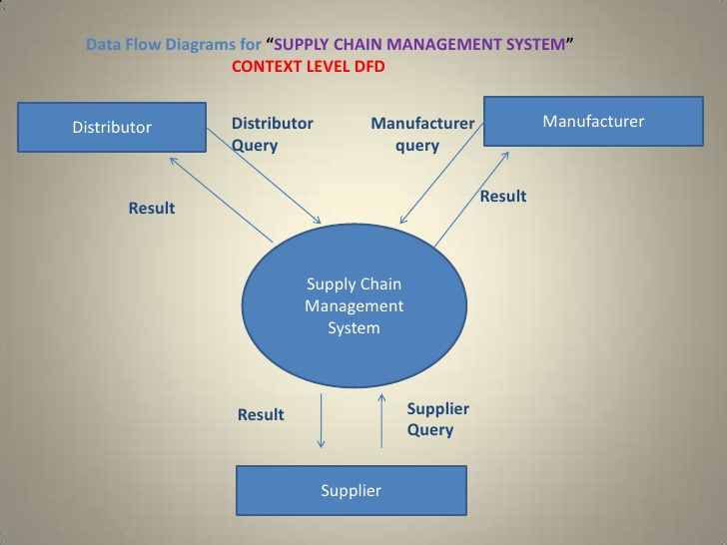

Fig. 1

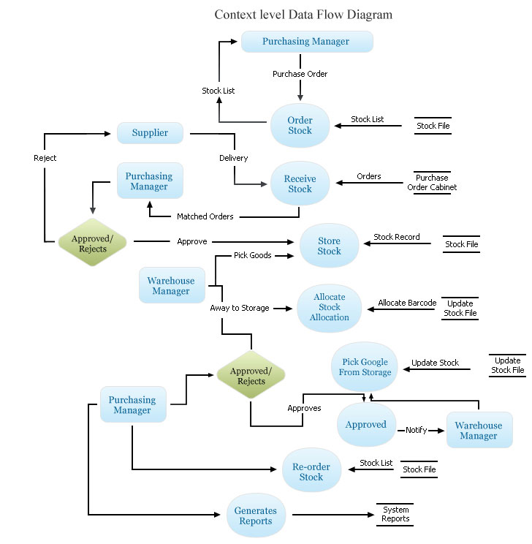

Fig. 2

**Use case diagram:**

A **use case diagram** at its simplest is a representation of a user's interaction with the system that shows the relationship between the user and the different use cases in which the user is involved. A use case diagram can identify the different types of users of a system and the different use cases and will often be accompanied by other types of diagrams as well.

### Actor

You can picture an actor as a user of the IT system, for example Mr. Steel or Mrs. Smith from check-in. Because individual persons are irrelevant for the model, they are abstracted. So the actors are called "check-in employee" or "passenger":

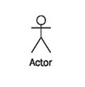

Actors represent roles that users take on when they use the IT system, e.g., the role of a check-in employee. One person can act in more than one role toward the IT system. It is important for the IT system in which role a person is acting. Therefore, it is necessary to log on to many IT systems in a certain role, for instance, as a normal user or as an administrator. In each case access to the appropriate functionalities (use cases) is granted.

Actors themselves are not part of the IT system. However, as employees they can be part of the business system (see Figure 4.5).

### Use Case

Use cases describe the interactions that take place between actors and IT systems during the execution of business processes:

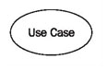

A use case represents a part of the functionality of the IT system and enables the user (modeled as an actor) to access this functionality.

Anything that users would like to do with the IT system has to be made available as a use case (or part of a use case). Functionalities that exist in the IT system, but that are not accessed by means of use cases, are *not* available to users.

Even though the idea behind use cases is to describe interactions, flows of batch processing, which generally do not include interactions, can also be described as use cases. The actor of such a batch use case is then the one who initiates batch processing.

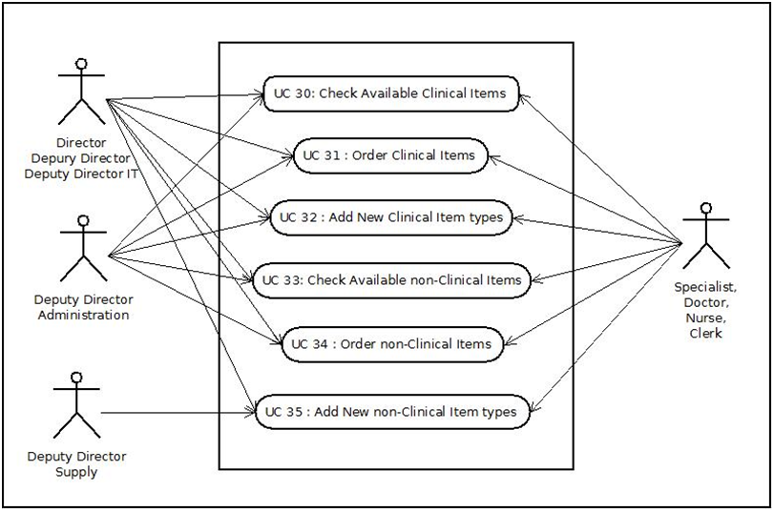

Fig. 3

**ER diagram:**

An **entity–relationship model** (**ER model**) is a data model for describing the data or information aspects of a business domain or its process requirements, in an abstract way that lends itself to ultimately being implemented in a database such as a relational database. The main components of ER models are entities (things) and the relationships that can exist among them.

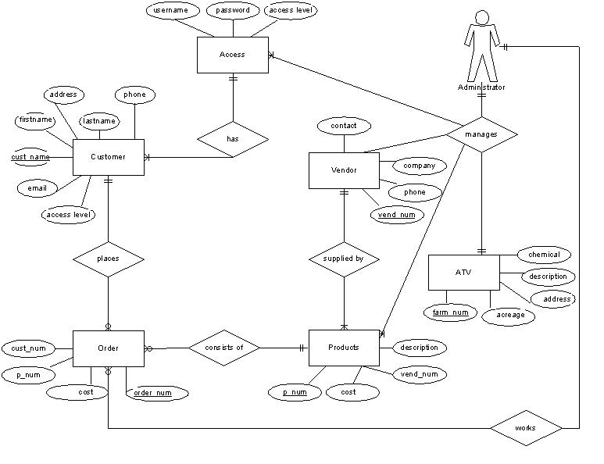

Fig. 4

**Snapshots**

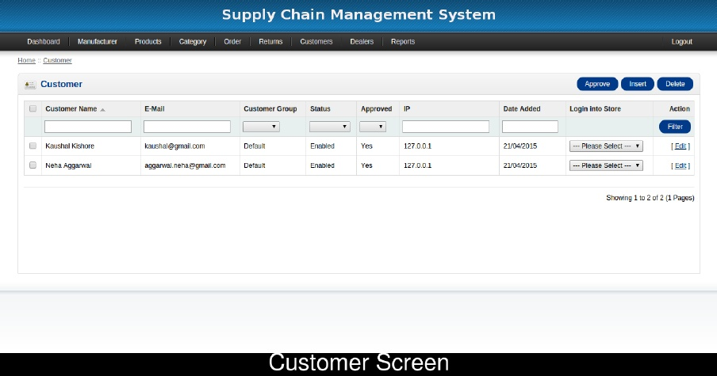

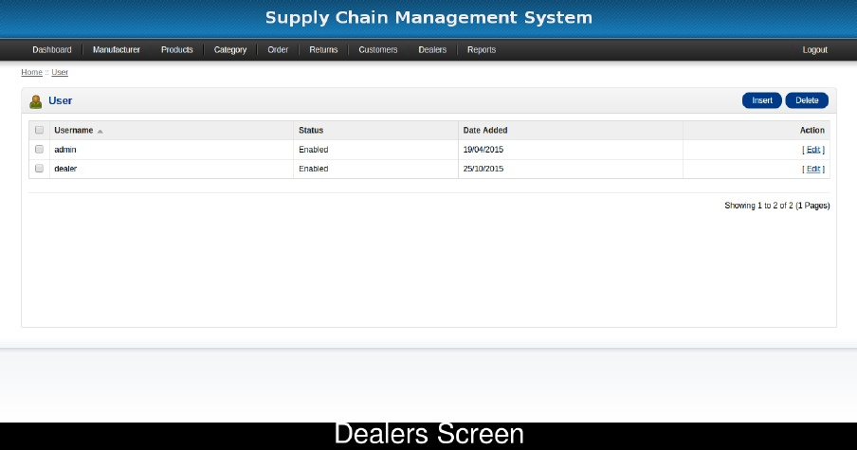

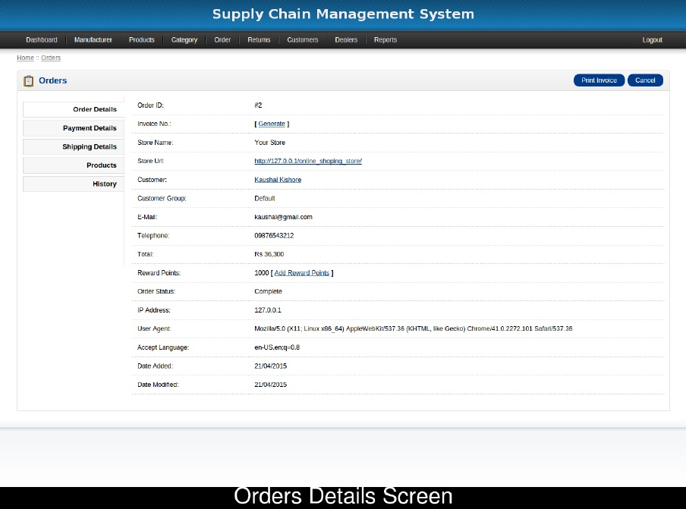

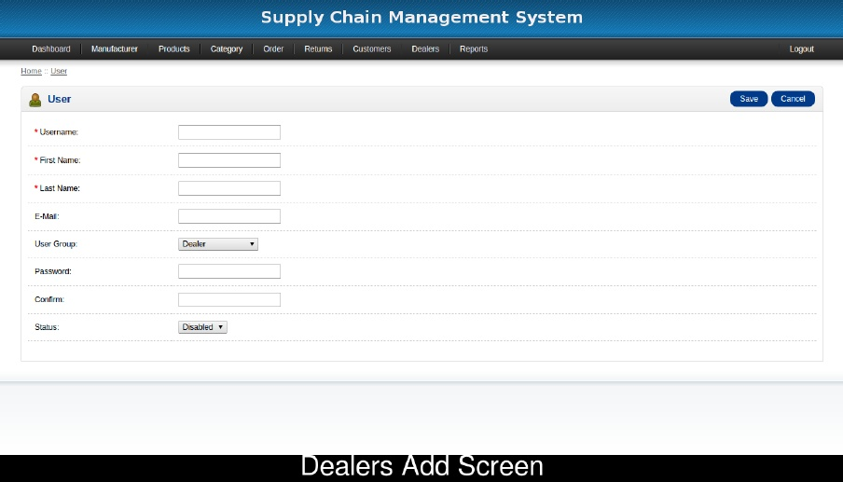

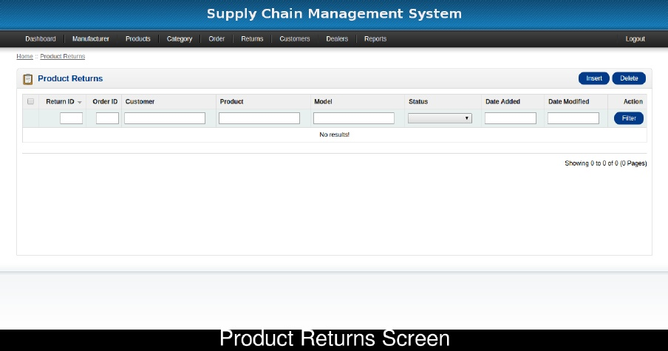

**Bibliography and references**

1. <http://www.github.com>/
2. <http://www.w3schools.com/html/>
3. <http://www.w3schools.com/css/>
4. <http://www.w3schools.com/js/>
5. <http://www.w3schools.com/php/>
6. <http://www.w3schools.com/sql/>
7. Database design: Silberschatz Korth