SMART AGRO
Smart Farming System
Machine Learning · E-Commerce · Digital Payment

A Project Report

Submitted to
Department of Computer Application
[Name of College]
[City, Nepal]

In partial fulfilment of the requirements for the Bachelor in Computer Application (BCA)

Submitted by
[Student Name]
[TU Registration Number]

Under the Supervision of
[Supervisor Name]

July 2026

Certificate
This is to certify that the project work entitled “Smart Agro: A Smart Farming System” submitted by [Student Name] ([TU Registration Number]) has been carried out under my supervision in partial fulfilment of the requirements for the degree of Bachelor in Computer Application (BCA) of Tribhuvan University. The project report is original and has not been submitted elsewhere for the award of any degree.

…………………………
[Supervisor Name]
Project Supervisor
BCA Department

Date: …………………………

Supervisor’s Recommendation
I hereby recommend that the project prepared under my supervision by [Student Name] entitled “Smart Agro: A Smart Farming System” in the partial fulfilment of the requirements for the degree of Bachelor in Computer Application (BCA) of Tribhuvan University is recommended for final evaluation.

…………………………
[Supervisor Name]
Project Supervisor
BCA Department

Date: …………………………

Letter of Approval
This is to certify that the project prepared by [Student Name] entitled “Smart Agro: A Smart Farming System” in the partial fulfilment of the requirements for the degree of Bachelor in Computer Application (BCA) of Tribhuvan University has been evaluated. In our opinion, it is satisfactory in the scope and quality as a project for the required degree.

…………………………
[Supervisor Name]

…………………………
[Head of Department Name]

…………………………
[Internal Examiner Name]

…………………………
[External Examiner Name]

Date: …………………………

Acknowledgement
I would like to express my sincere gratitude to my supervisor, [Supervisor Name], for the valuable guidance, constructive feedback, and constant encouragement provided throughout the design, development, and documentation of this project. His insights into software engineering and machine learning shaped the direction of the work presented in this report.
I am equally thankful to the Department of Computer Application at [Name of College] for providing the necessary laboratory facilities, learning environment, and institutional support that made this project possible. The constructive suggestions of the faculty members and the department head during the proposal and progress reviews helped refine both the scope and the quality of the system.
I also wish to acknowledge the open-source community, whose contributions in the form of frameworks, libraries, and documentation formed the technical foundation of this work. Finally, I am grateful to my family and friends for their patience, understanding, and moral support during the entire period of this academic endeavour.
Warm regards,
[Student Name]

Abstract
Agriculture remains the primary source of livelihood for a large share of the population in Nepal, yet farming decisions continue to depend largely on intuition, tradition, and local experience. Climate variability, unpredictable rainfall, soil degradation, and frequent outbreaks of pests and plant diseases further expose the limitations of conventional practice. This project presents Smart Agro, an integrated web-based smart farming system that combines machine learning advisory services and a digital agricultural marketplace a digital agricultural marketplace within a single platform. The system serves three categories of users: farmers, who access data-driven recommendations and trade; sellers, who list agricultural inputs for approval; and administrators, who manage users, products, orders, medicines, and permissions.
Three machine learning models are deployed as separate microservices. A Gaussian Naive Bayes classifier estimates the risk of pest incidence from temperature, humidity, rainfall, crop type, growth stage, and previous incidence. A Random Forest classifier recommends the most suitable crop together with a confidence score, the top five candidate crops, growing tips, and similar-condition matches. An EfficientNetB4 convolutional neural network recognizes plant diseases from leaf images across thirty-nine classes and, when a disease is confirmed, suggests chemical and organic medicines along with relevant shop products. The marketplace supports a shopping cart, order management, cash on delivery, and the eSewa digital payment gateway with HMAC-SHA256 signature verification.
The system is built on a React frontend, a Node.js and Express REST backend, and MongoDB for persistence, with role-based access control protecting administrative functions. Functional and system-level testing confirmed that all modules operate correctly and that the integrated workflows, including eSewa payment verification, function end to end. The project demonstrates that a multi-module platform combining machine learning and digital commerce can offer practical, accessible support for smallholder farming decisions in Nepal.
Keywords: Smart Farming, Machine Learning, Crop Recommendation, Pest Risk Prediction, Plant Disease Recognition, e-Commerce, eSewa, Role-Based Access Control, Precision Agriculture.

Table of Contents

(In Microsoft Word, right-click the field above and select “Update Field” to generate the Table of Contents.)

List of Tables
Table 2.1: Comparison of Existing Systems
Table 3.1: Functional Requirements
Table 3.2: Non-Functional Requirements
Table 3.3: Actors and Their Use Cases
Table 3.4: Machine Learning Microservices
Table 3.5: MongoDB Collections
Table 3.6: Database Indexes
Table 3.7: Design Tokens
Table 3.8: API Endpoint Groups
Table 4.1: Development Tools and Technologies
Table 4.2: Express Server Setup (Listing 4.1)
Table 4.3: Authentication Middleware (Listing 4.2)
Table 4.4: Permission Middleware (Listing 4.3)
Table 4.5: eSewa HMAC-SHA256 Signature Generation (Listing 4.4)
Table 4.6: eSewa Payment Verification (Listing 4.5)
Table 4.7: Crop Prediction and Ranking (Listing 4.6)
Table 4.8: Disease Inference and Confidence Threshold (Listing 4.7)
Table 5.1: Test Environment
Table 5.2: Unit Test Cases and Results
Table 5.3: Integration Test Cases and Results
Table 5.4: System Test Cases and Results
Table 5.5: Payment Flow Test Cases and Results
Table 5.6: Performance Test Results
Table 5.7: Security Test Cases and Results
Table 5.8: Evaluation of Project Objectives
Table 6.1: Crop Recommendation Model Comparison
Table 6.2: Pest Risk Model Results

List of Figures
Figure 1.1: Iterative Software Development Methodology
Figure 3.1: Use Case Diagram of Smart Agro
Figure 3.2: Class Diagram of Smart Agro
Figure 3.3: Object Diagram of Smart Agro
Figure 3.4: Sequence Diagram for User Flows
Figure 3.5: Sequence Diagram for Admin Management
Figure 3.6: Activity Diagram for Order and Payment
Figure 3.7: Activity Diagram for Admin Management
Figure 3.8: Context Diagram (DFD Level 0)
Figure 3.9: Data Flow Diagram (DFD Level 1)
Figure 3.10: Entity Relationship Diagram
Figure 3.11: Refined Class Diagram (MVC Layers)
Figure 3.12: Component Diagram - User Side
Figure 3.13: Component Diagram - Admin Side
Figure 3.14: Deployment Diagram (Local Deployment)
Figure 3.15: Wireframes of Key Screens
Figure 4.1: Farmer Dashboard
Figure 4.2: Disease Recognition Result
Figure 4.3: Crop Recommendation Result
Figure 4.4: Pest Risk Prediction Result
Figure 4.5: Agricultural Marketplace (Shop)
Figure 4.6: Checkout Page with Payment Options
Figure 4.7: eSewa Payment Gateway
Figure 4.8: Admin Dashboard
Figure 4.9: Admin Product Approval
Figure 5.1: End-to-End Order Flow
Figure 5.2: eSewa Payment Success

List of Abbreviations
Abbreviations
Abbreviation | Full Form
AI | Artificial Intelligence
API | Application Programming Interface
BCA | Bachelor in Computer Application
CNN | Convolutional Neural Network
COD | Cash on Delivery
CORS | Cross-Origin Resource Sharing
DFD | Data Flow Diagram
ER | Entity Relationship
HMAC | Hash-Based Message Authentication Code
HTTP | HyperText Transfer Protocol
HTTPS | HyperText Transfer Protocol Secure
ID | Identifier
JWT | JSON Web Token
MERN | MongoDB, Express, React, Node.js
ML | Machine Learning
MVC | Model-View-Controller
N | Nitrogen
P | Phosphorus
K | Potassium
NFR | Non-Functional Requirement
NPM | Node Package Manager
RBAC | Role-Based Access Control
REST | Representational State Transfer
SGD | Stochastic Gradient Descent
SHA | Secure Hash Algorithm
SPA | Single-Page Application
SVM | Support Vector Machine
TU | Tribhuvan University
UML | Unified Modeling Language

1. Introduction

1.1 Introduction
Agriculture is Nepal's economic backbone, engaging most of the working population and supplying the food that sustains daily life. Yet it faces persistent pressures: erratic rainfall and shifting temperatures from climate change, declining soil fertility, pest and disease outbreaks, and fragmented supply chains reaching consumers through many intermediaries [1], [2]. Farmers make planting and input decisions from habit, folklore, and personal experience rather than measured field data, causing underperforming crops, wasted inputs, and delayed responses [3].
Modern information technology offers a credible response. Smart farming, or precision agriculture, combines machine learning and web software to monitor growing conditions and ground decisions in evidence [4]. One model examines soil and climate parameters to recommend the most suitable crop; another estimates pest outbreak probability from environmental conditions and warns the farmer early; a third recognizes plant disease from a leaf photograph and suggests treatment [5], [6]. Coupled with an online marketplace, farmers can buy seeds, fertilizers, pesticides, and equipment directly from verified sellers and pay digitally, shortening the supply chain and improving transaction fairness [7].
This report documents the design, implementation, and testing of Smart Agro, an integrated smart farming web application built on three pillars. A React-based responsive frontend offers a dashboard, crop and pest analysis tools, disease recognition, a shop with a shopping cart, and an admin panel. A Node.js and Express backend provides a RESTful API, JWT-based authentication, and role-based access control, backed by MongoDB. Three independent Python machine learning services provide pest risk prediction (Gaussian Naive Bayes), crop recommendation (Random Forest), and plant disease recognition (EfficientNetB4 CNN).
The remainder of this chapter states the problem that motivated the project, defines its objectives, scope, and limitations, describes the development methodology, and outlines the organization of the remaining chapters.

1.2 Problem Statement
Smallholder farmers face a series of interrelated problems that conventional practice does not resolve. Crop selection is rarely based on a scientific assessment of soil and climate; instead, farmers often repeat the crops grown by their neighbours, even when those crops are ill-suited to the local conditions. Pest damage arrives with little or no warning, and by the time the problem is visible the crop has already suffered significant loss. Plant diseases are frequently misidentified, and the remedies applied are either ineffective or harmful. At the same time, the agricultural input market is fragmented: farmers must travel to distant markets to buy seeds and agro-chemicals, pay inflated prices, and have few options for digital payment or home delivery [8].
Existing software solutions address only part of this picture. Some mobile applications offer generic agricultural advice; others provide disease identification; still others operate as conventional marketplaces. Very few systems bring advisory intelligence and digital commerce together under one platform with proper role separation between farmers, sellers, and administrators [9]. As a consequence, a farmer must switch between several disconnected tools, none of which holds the complete record of his or her farming activity. This fragmentation reduces the usefulness of each individual tool and prevents the accumulation of a consistent history of crop, disease, and recommendation records that could support better long-term decisions.
Smart Agro addresses this problem by integrating the full decision-support and commerce workflow into a single system. It provides scientifically grounded crop and pest advice, automated plant disease recognition, a curated marketplace, and secure digital payments, while maintaining a persistent record of every analysis and transaction for each farmer. In doing so, the project attempts to reduce the guesswork inherent in traditional farming and to give smallholder farmers tools that are affordable, accessible through a normal web browser, and responsive to their actual working conditions.

1.3 Objectives
The main objective of this project is to design and develop an integrated smart farming platform that assists farmers with data-driven decision making and provides a digital marketplace. The specific objectives are:
1. To develop a responsive, web-based smart farming platform that is easy to use for farmers, sellers, and administrators.
2. To implement a machine learning model that recommends the most suitable crop on the basis of soil parameters (nitrogen, phosphorus, potassium, and pH) and climatic parameters (temperature, humidity, and rainfall), together with a confidence score and cultivation tips.
3. To implement a pest risk prediction model that estimates the risk level of pest incidence from temperature, humidity, rainfall, crop type, growth stage, and previous pest incidence.
4. To implement a plant disease recognition model that classifies an uploaded leaf image into one of thirty-nine disease classes and suggests appropriate chemical and organic medicines as well as related shop products.
5. To provide an agricultural marketplace with product listings, a shopping cart, order management, cash on delivery, and eSewa digital payment with signature verification.
6. To provide an administrative module with user management, farmer verification, product approval, order management, medicine database management, and role-based access control.
7. To test the system with unit-level and system-level test cases and to analyze the results.

1.4 Scope and Limitation

1.4.1 Scope
The scope of the project covers the complete development lifecycle of the Smart Agro system, from requirements analysis through design, implementation, and testing. Functionally, the system includes the following modules:
- Authentication and profile management: farmer registration, login, profile viewing, and profile editing, with JWT-based session management.
- Dashboard: a crop record submission form and a summary of the farmer's recent advisory records.
- Records module: a persistent history of crop, disease, and recommendation records, each storing the input parameters, the predicted outcome, the confidence, and any associated medicines or purchased products.
- Pest risk prediction: a form-based module that returns a low, medium, or high pest risk level using the Gaussian Naive Bayes model.
- Crop recommendation: a form-based module that returns the recommended crop, a confidence score, the top five candidate crops, growing tips, and crops that grow under similar conditions.
- Plant disease recognition: an image-upload module that returns the recognized disease, its cause and cure, the prediction confidence, the top three predictions, and suggested medicines and shop products.
- Agricultural marketplace: a product catalogue with categories, product detail pages, seller listings, a shopping cart, checkout, and order history.
- Payment: cash on delivery and eSewa digital payment with HMAC-SHA256 signature generation and server-side payment verification.
- Admin panel: user management, farmer verification, product approval, order management, medicine database management, and role and permission management.
Non-functionally, the scope includes a responsive and visually consistent user interface based on a glassmorphism design system, secure password storage using bcrypt, JWT-based authentication, and role-based access control that restricts administrative functions to authorized users.

1.4.2 Limitations
Although the system fulfils its principal objectives, a number of limitations were identified during development and testing:
- The machine learning services run locally on ports 5002, 5003, and 5004 and are neither containerized nor deployed to a cloud server, so availability is limited to the machine on which they execute.
- The eSewa integration uses test (sandbox) credentials with the merchant code EPAYTEST; live transactions would require production merchant credentials and a secure HTTPS deployment.
- The disease recognition model is trained on an offline dataset of thirty-nine classes and reports images outside these classes as unrecognized.
- The crop recommendation model is trained on a dataset of approximately 2,200 samples covering twenty-two crops and may not generalize reliably to regions whose soil and climate characteristics differ markedly from the training distribution.
- The pest risk dataset contains only seventeen training records, so the pest predictions are illustrative rather than statistically robust.
- The application is web-based only; no native mobile application was developed.

1.5 Development Methodology
The project was developed using an iterative, Agile-inspired methodology. This approach was chosen because the requirements of a smart farming platform are broad and can be refined progressively, and because an iterative cycle allows continuous feedback between the developers and the intended users. The development proceeded in the following phases:
1. Requirement gathering and analysis: functional and non-functional requirements were collected by studying existing farming workflows, reviewing comparable systems, and consulting the available datasets that would drive the machine learning models.
2. System design: the overall architecture, comprising a React frontend, an Express backend, three Python machine learning services, and MongoDB, was designed together with the database schema and UML models.
3. Implementation: development was performed in iterations or sprints, each delivering one or more modules, such as authentication, the dashboard, the machine learning modules, the marketplace, payments, and the admin panel.
4. Testing: each module was verified with unit test cases, and the integrated system was verified with end-to-end system test cases, covering both cash-on-delivery and eSewa payment flows.
5. Deployment and maintenance: the system was deployed locally for demonstration, and the results were documented in this report.
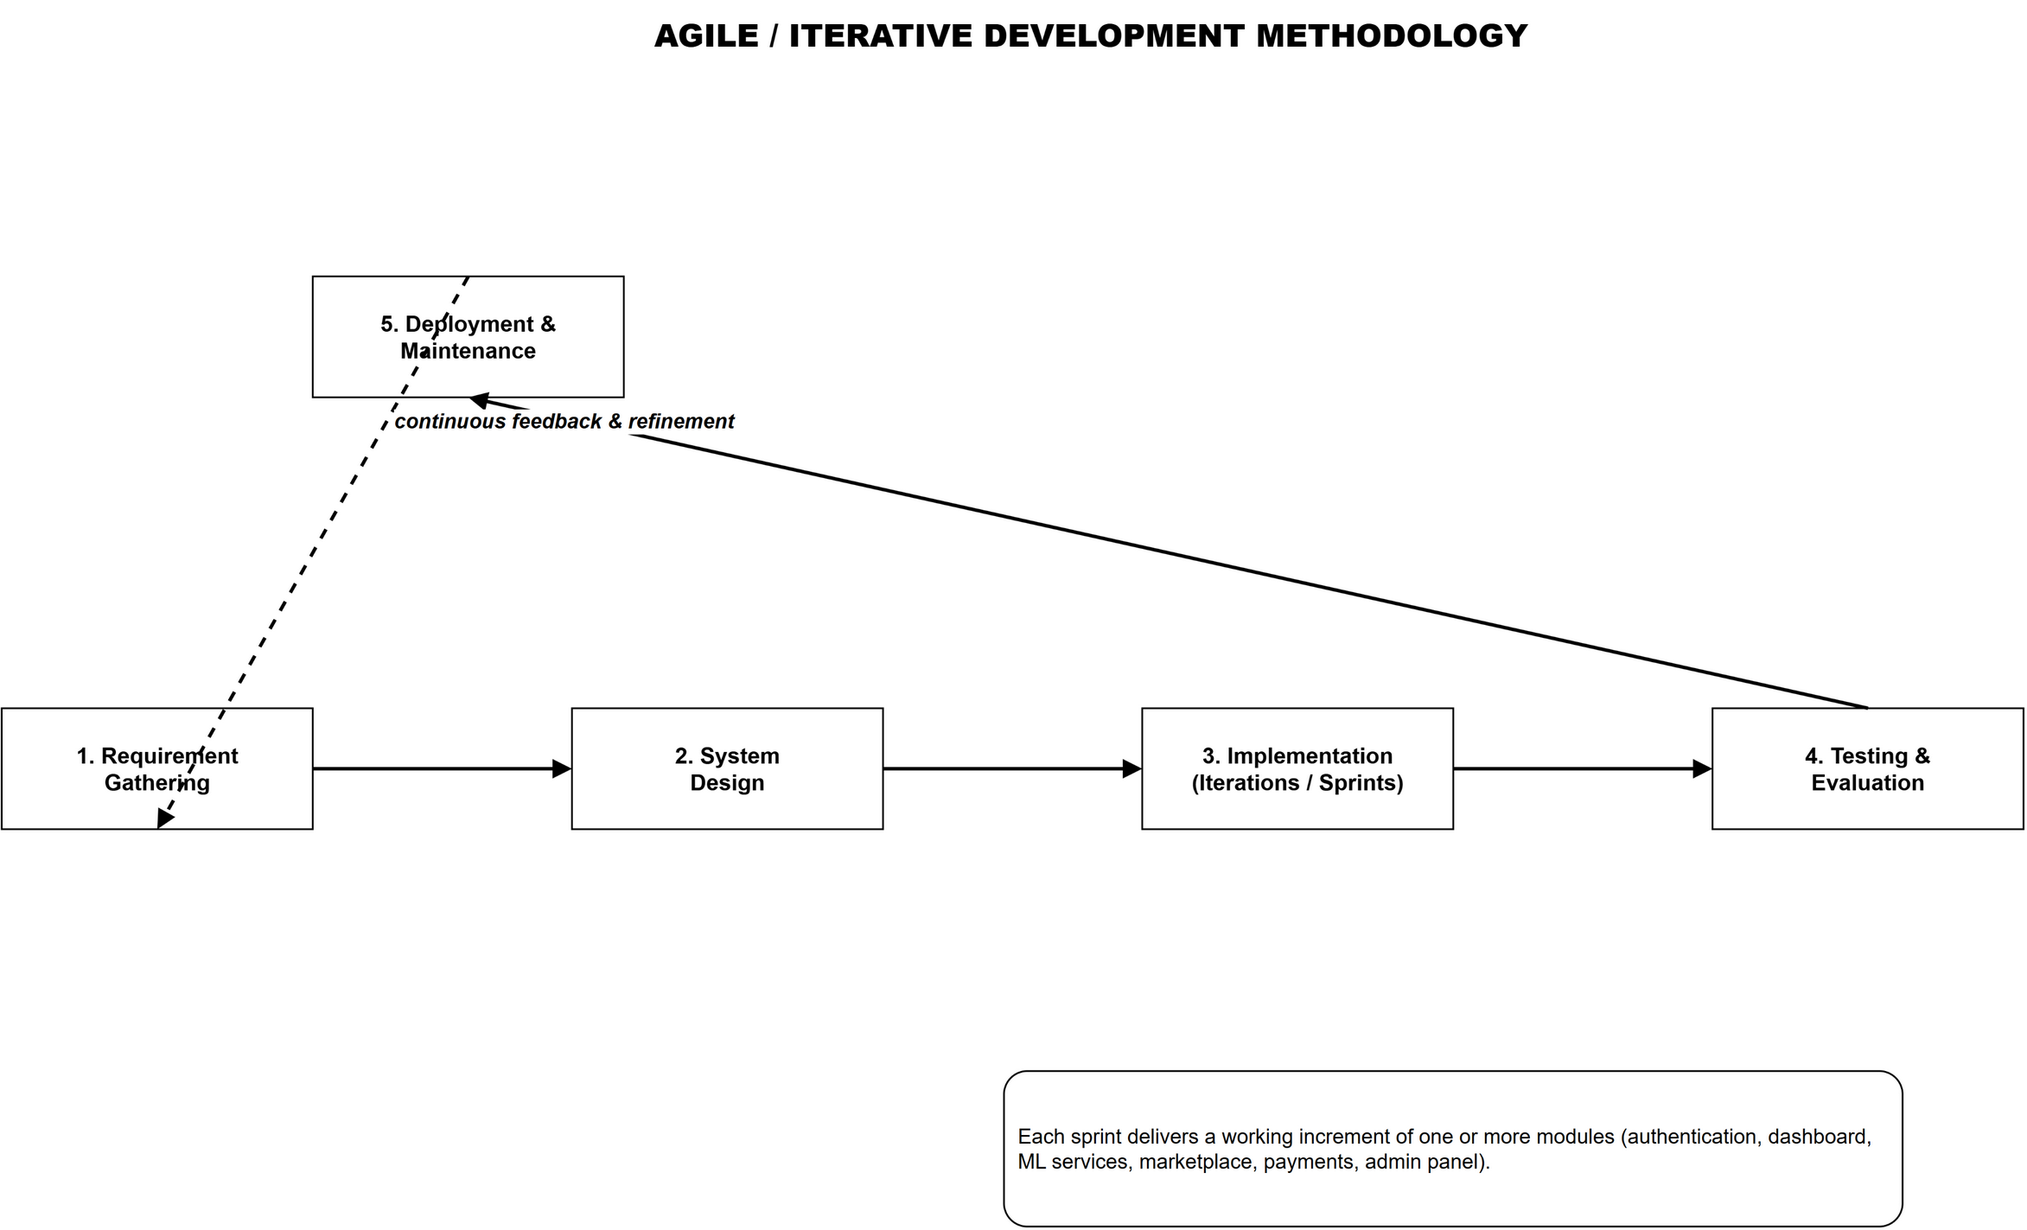
Figure 1.1: Iterative Software Development Methodology

The main development tools used were Visual Studio Code for code editing, Git and GitHub for version control, npm and concurrently for dependency and process management, MongoDB Compass for database inspection, and Postman for API testing. The frontend, backend, and machine learning services were run concurrently during development, with the backend proxying prediction requests to the three Python services.

1.6 Report Organization
This report is organized into seven chapters. Chapter 1 introduces the project, states its objectives, scope, and limitations, and describes the development methodology. Chapter 2 presents the background study and a review of the related literature, covering smart farming, machine learning in agriculture, and the technical foundations of the system. Chapter 3 describes the system analysis and design, including requirements analysis, UML modeling, database design, system architecture, and the algorithms used by the machine learning models. Chapter 4 presents the implementation details of each module and the tools used. Chapter 5 describes the testing strategy and the evaluation of the project objectives. Chapter 6 analyses the results of the machine learning models. Chapter 7 concludes the report and recommends directions for future enhancement. A list of references and appendices follow the main chapters.

2. Background Study and Literature Review

2.1 Background Study
Farming decisions have traditionally rested on experience and local custom. Under increasing production pressure, agriculture has adopted machine learning and digital commerce as its two main technological pillars [4].
Machine learning learns patterns from historical data and predicts new observations [10]. Gaussian Naive Bayes, K-Nearest Neighbors, and Random Forest map soil and climate to suitable crops, Bayesian classifiers estimate pest-outbreak probability, and EfficientNet and ResNet classify leaf images [5], [6], [11].
An online marketplace reduces intermediaries between producers and consumers of agricultural inputs [7]. Digital wallets such as eSewa pay merchants, who submit a signed message with an HMAC-SHA256 signature and verify transactions via the gateway status API [12].
Role-based access control assigns permissions to roles, such as Farmer and Admin, and checks them server-side before a privileged operation [13]. Smart Agro applies this model so only authorized users manage products, orders, medicines, and roles.

2.2 Literature Review
Studies related to Smart Agro’s components were reviewed and are summarized below.

2.2.1 Smart Farming and Precision Agriculture
Precision agriculture emerged in the 1990s, guiding decisions with site-specific data before broadening into smart farming with sensors, cloud, and analytics [14]. Wolfert et al. found data-driven services improve farm management, though data ownership and interoperability remain unresolved [4]; Nepalese adoption is constrained by infrastructure, literacy, and farm scale [1], [2]. Smart Agro keeps requirements modest: commodity hardware, free software, a web browser.

2.2.2 Crop Recommendation Systems
Veenadhari et al. applied decision-tree data mining to forecast crop yield [15]; Random Forest and KNN achieved the highest accuracy, often above 95% [16], [17]. Priyadharshini et al. combined soil nutrients and climate for crop recommendation [18]. These results guided Smart Agro’s Random Forest service, which also returns confidence, top-five candidates, growing tips, and similar-condition matches.

2.2.3 Pest Risk Prediction
Machine learning predicts pest outbreaks from weather and field data; Bayesian classifiers model outbreak probability given environmental conditions [19], and Domingues et al. surveyed ML for crop pest prediction [20]. Smart Agro applies Gaussian Naive Bayes to temperature, humidity, rainfall, crop, growth stage, and pest history, returning a risk level and probability.

2.2.4 Plant Disease Detection using CNN
Mohanty et al. fine-tuned CNNs on PlantVillage, exceeding 99% accuracy [21]; Ferentinos confirmed that modern CNNs generalize across disease classes [22]. Kamilaris and Prenafeta-Boldú found CNNs most effective for image classification [5], and Too et al. recommended EfficientNet-style architectures as an accuracy-size trade-off [23]. Smart Agro follows this line with a pre-trained EfficientNetB4 fine-tuned for thirty-nine classes at 160x160 and a confidence threshold.

2.2.5 Agricultural E-Commerce
E-commerce can reduce agricultural market fragmentation, but trust, logistics, and digital payment infrastructure are the principal barriers [24]. Agricultural marketplaces also face product-quality verification, seasonal availability, and perishability. Smart Agro addresses trust through administrator approval of every listed product and verified seller profiles.

2.2.6 Digital Payment Systems
Digital payment systems transfer value electronically. The eSewa gateway (F1Soft International, Nepal) uses a signed form, an HMAC-SHA256 signature over amount, transaction UUID, and product code, and a status API for verification [12]. Smart Agro integrates this flow, with cash on delivery as fallback.

2.2.7 Role-Based Access Control
Role-based access control (RBAC) assigns permissions to roles rather than users and has been the dominant enterprise authorization model since Sandhu et al. [13]. Smart Agro implements a permission-based variant in which roles such as Farmer and Admin hold permission sets, per-user overrides can extend or restrict them, and middleware verifies the required permission before privileged routes [25].

2.2.8 Machine Learning Algorithms Used
Naive Bayes. Gaussian Naive Bayes applies Bayes’ theorem, assuming conditional independence and modelling continuous features with Gaussians, then selecting the highest posterior class [19]. It trains fast, needs little data, and suits the small pest dataset.
Random Forest. Random Forest ensembles decision trees on bootstrap samples and random feature subsets, voting by majority [26]. It is robust to noise, handles non-linearity, and yields per-feature importance scores.
K-Nearest Neighbors. K-Nearest Neighbors classifies by the majority class among k nearest neighbours under Euclidean distance [27]. KNN was evaluated experimentally and powers the similar-conditions search.
EfficientNetB4. EfficientNet families arise from compound scaling of depth, width, and resolution [28]. Smart Agro fine-tunes an EfficientNetB4 backbone, pre-trained on ImageNet, for plant disease recognition [29].

2.2.9 Transfer Learning
Transfer learning reuses knowledge from one task to improve a related one [29]; ImageNet pre-trained networks are fine-tuned on smaller datasets, cutting labelled-data and training requirements. Smart Agro adopts this for its disease model.

2.2.10 Explainable AI
Explainable AI makes model decisions understandable; feature importance, probability outputs, and saliency maps are common tools [30]. Farmers must trust advice before acting. Smart Agro returns prediction confidence, top candidate probabilities, and disease cause and cure.

2.2.11 Comparison of Existing Systems
Table 2.1 compares Smart Agro with representative existing systems.
Table 2.1: Comparison of Existing Systems
System | Crop Advice | Disease Detection | Marketplace | Payments | Admin Panel
Generic farming apps | Basic tips | No | No | No | No
Crop recommendation tools | Yes | No | No | No | No
Disease detection apps | No | Yes | No | No | No
Agricultural marketplaces | No | No | Yes | Yes | Partial
Smart Agro (this project) | Yes | Yes | Yes | Yes | Yes

2.2.12 Research Gap
Most systems address a single problem; few combine advisory intelligence, commerce, and secure payment, and fewer add permission-based administration. Smart Agro closes this gap by integrating three ML services, a marketplace, eSewa payments, and a role-based admin panel, recording every analysis and transaction.

3. System Analysis and Design

3.1 System Analysis
System analysis defines what the system must do before implementation through requirement analysis and UML modelling [31].

3.1.1 Requirement Analysis
Requirements are split into functional and non-functional categories; the former, derived from the Chapter 1 objectives, are listed in Table 3.1.
Table 3.1: Functional Requirements
ID | Requirement | Module
FR-01 | The system shall allow a user to register with name, email, and password, and to log in securely. | Authentication
FR-02 | The system shall issue a JWT upon login and use it to authorize subsequent requests. | Authentication
FR-03 | The system shall allow a user to view and update their profile information. | Profile
FR-04 | The system shall provide a dashboard with a crop record submission form and a summary of the farmer's recent records. | Dashboard
FR-05 | The system shall allow a farmer to create and view crop, disease, and recommendation records. | Records
FR-06 | The system shall predict pest risk level from six input features. | Pest Prediction
FR-07 | The system shall recommend the most suitable crop from soil and climate parameters. | Crop Recommendation
FR-08 | The system shall recognize a plant disease from an uploaded leaf image and return confidence. | Disease Recognition
FR-09 | The system shall suggest medicines and shop products for a recognized disease. | Disease Recognition
FR-10 | The system shall allow sellers to list, edit, and delete products pending admin approval. | Marketplace
FR-11 | The system shall maintain a shopping cart and allow placing orders with shipping details. | Marketplace
FR-12 | The system shall support cash on delivery and eSewa digital payment with verification. | Payment
FR-13 | The system shall allow admins to manage users, verify farmers, and approve products. | Admin
FR-14 | The system shall allow admins to manage orders and the medicine database. | Admin
FR-15 | The system shall support role creation and per-user permission overrides. | Admin/RBAC

Non-functional requirements cover performance, security, usability, reliability, and scalability (Table 3.2).
Table 3.2: Non-Functional Requirements
ID | Requirement | Category
NFR-01 | The system shall respond to typical API requests within three seconds on a local deployment. | Performance
NFR-02 | Passwords shall be stored using bcrypt hashing and tokens shall expire after a defined period. | Security
NFR-03 | Only users with the required permissions shall access administrative endpoints. | Security
NFR-04 | The user interface shall be responsive and usable on desktop, tablet, and mobile screens. | Usability
NFR-05 | The UI shall follow a consistent design system across all pages. | Usability
NFR-06 | The system shall keep order and record data persistent in MongoDB. | Reliability
NFR-07 | The architecture shall separate the frontend, backend, and ML services so that each can scale independently. | Scalability

3.1.2 Feasibility Study
All technologies are free and open source, and the models train on an ordinary computer [32], [33].

3.1.3 Use Case Modeling
Use case modelling describes interactions between the system and its external actors: the Farmer, the Admin, and the eSewa gateway (Figure 3.1). The Farmer uses advisory and shopping features; the Admin manages users and products.
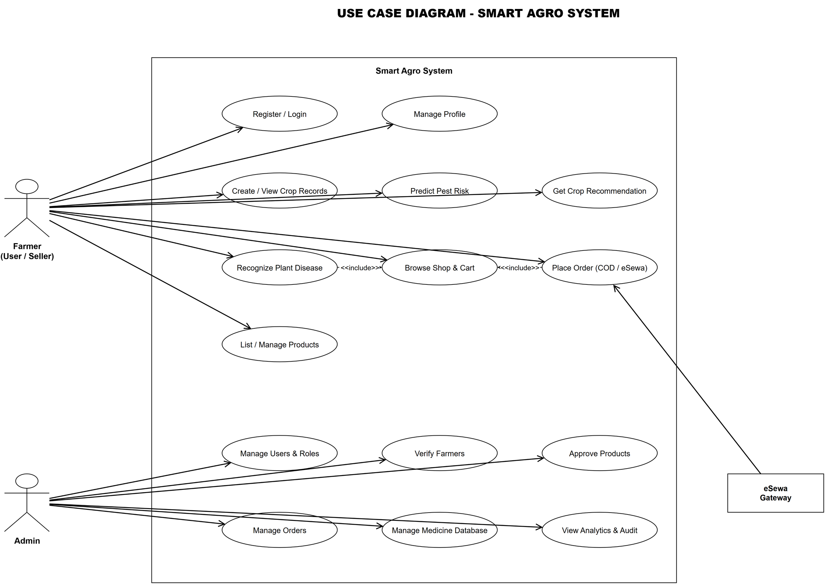
Figure 3.1: Use Case Diagram of Smart Agro

Table 3.3: Actors and Their Use Cases
Actor | Description | Primary Use Cases
Farmer / Seller | Registered user who uses advisory services and trades | Register, login, dashboard, records, pest risk, crop recommendation, disease recognition, shop, cart, order, payment, product listing
Admin | System administrator with full permissions | User and role management, farmer verification, product approval, order management, medicine management, analytics
eSewa Gateway | External payment service | Process payments, return transaction status

3.1.4 Object Modeling using Class and Object Diagrams
Object modelling identifies the main classes, their attributes and methods, and their relationships:
- Farmer: represents a registered user with name, email, password, role, permissions override, profile picture, blocked status, farm name, location, and verification status.
- Record: represents a farming record of type crop, disease, or recommendation, storing the relevant parameters, the predicted outcome, the confidence, and associated medicines and purchased products.
- Product: represents a marketplace item with name, description, price, category, stock, seller, and approval status.
- Order: represents a purchase with buyer, items, total amount, shipping address, status, payment method, payment status, and transaction identifier.
- Medicine: represents the medicine database keyed by disease name, with chemical and organic medicine entries and suggested product names.
- Role: represents a named set of permissions with a description and a default flag.
Figure 3.2 shows the classes with their associations; Figure 3.3 shows a runtime snapshot of one Farmer linked to an Order with two product instances.
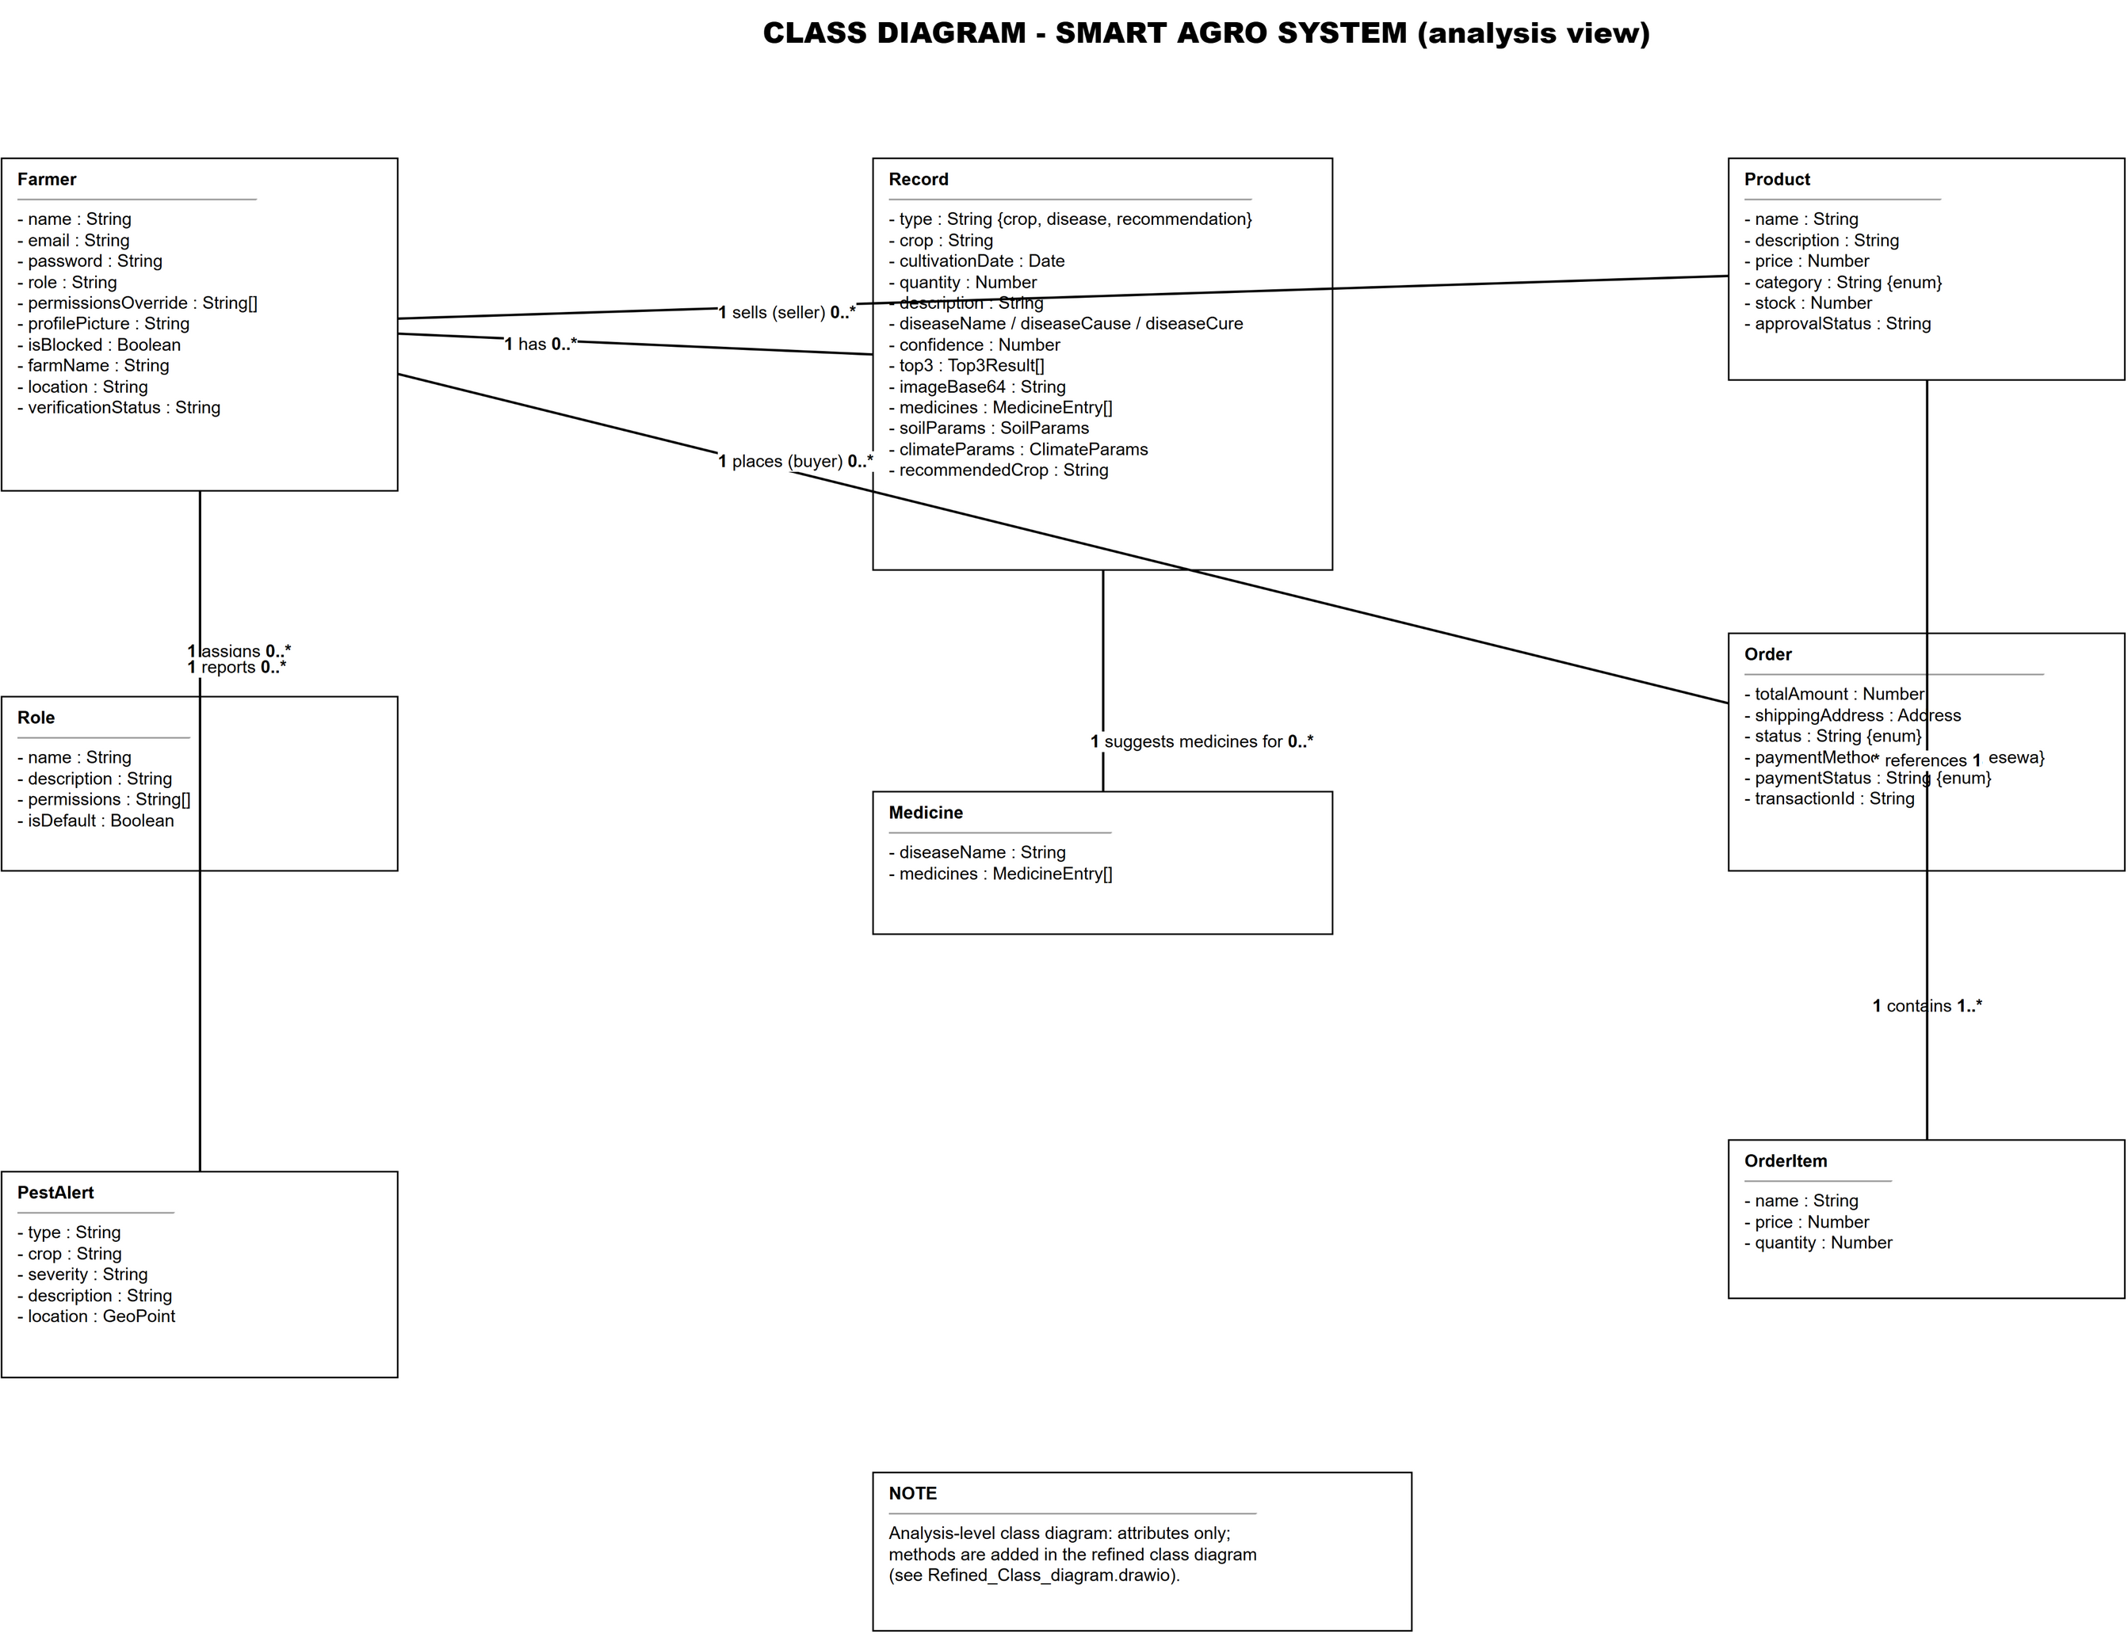
Figure 3.2: Class Diagram of Smart Agro

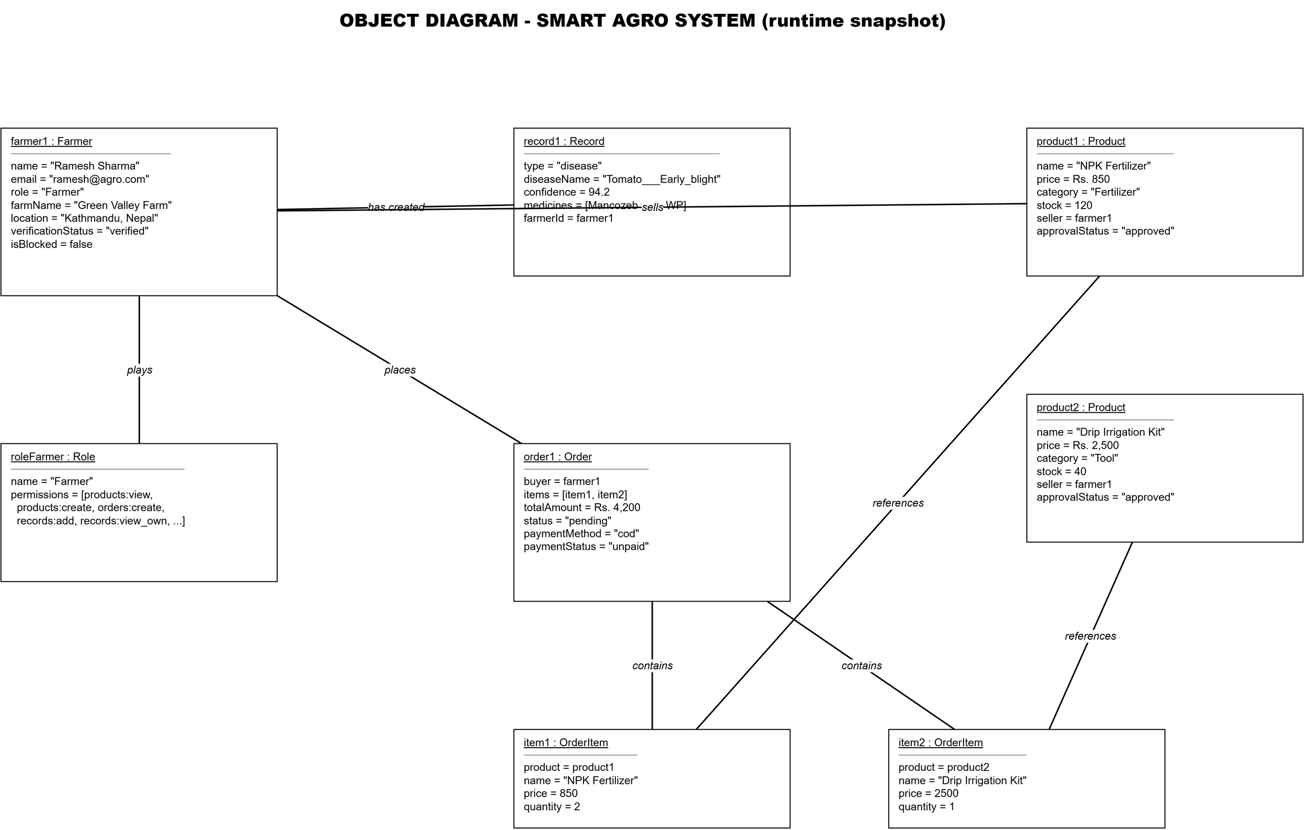
Figure 3.3: Object Diagram of Smart Agro

3.1.5 Dynamic Modeling using Sequence Diagrams
Sequence diagrams model object interactions over time. Figure 3.4 covers login and disease recognition: the Auth controller returns a JWT, and the disease service returns class, cause, and confidence.
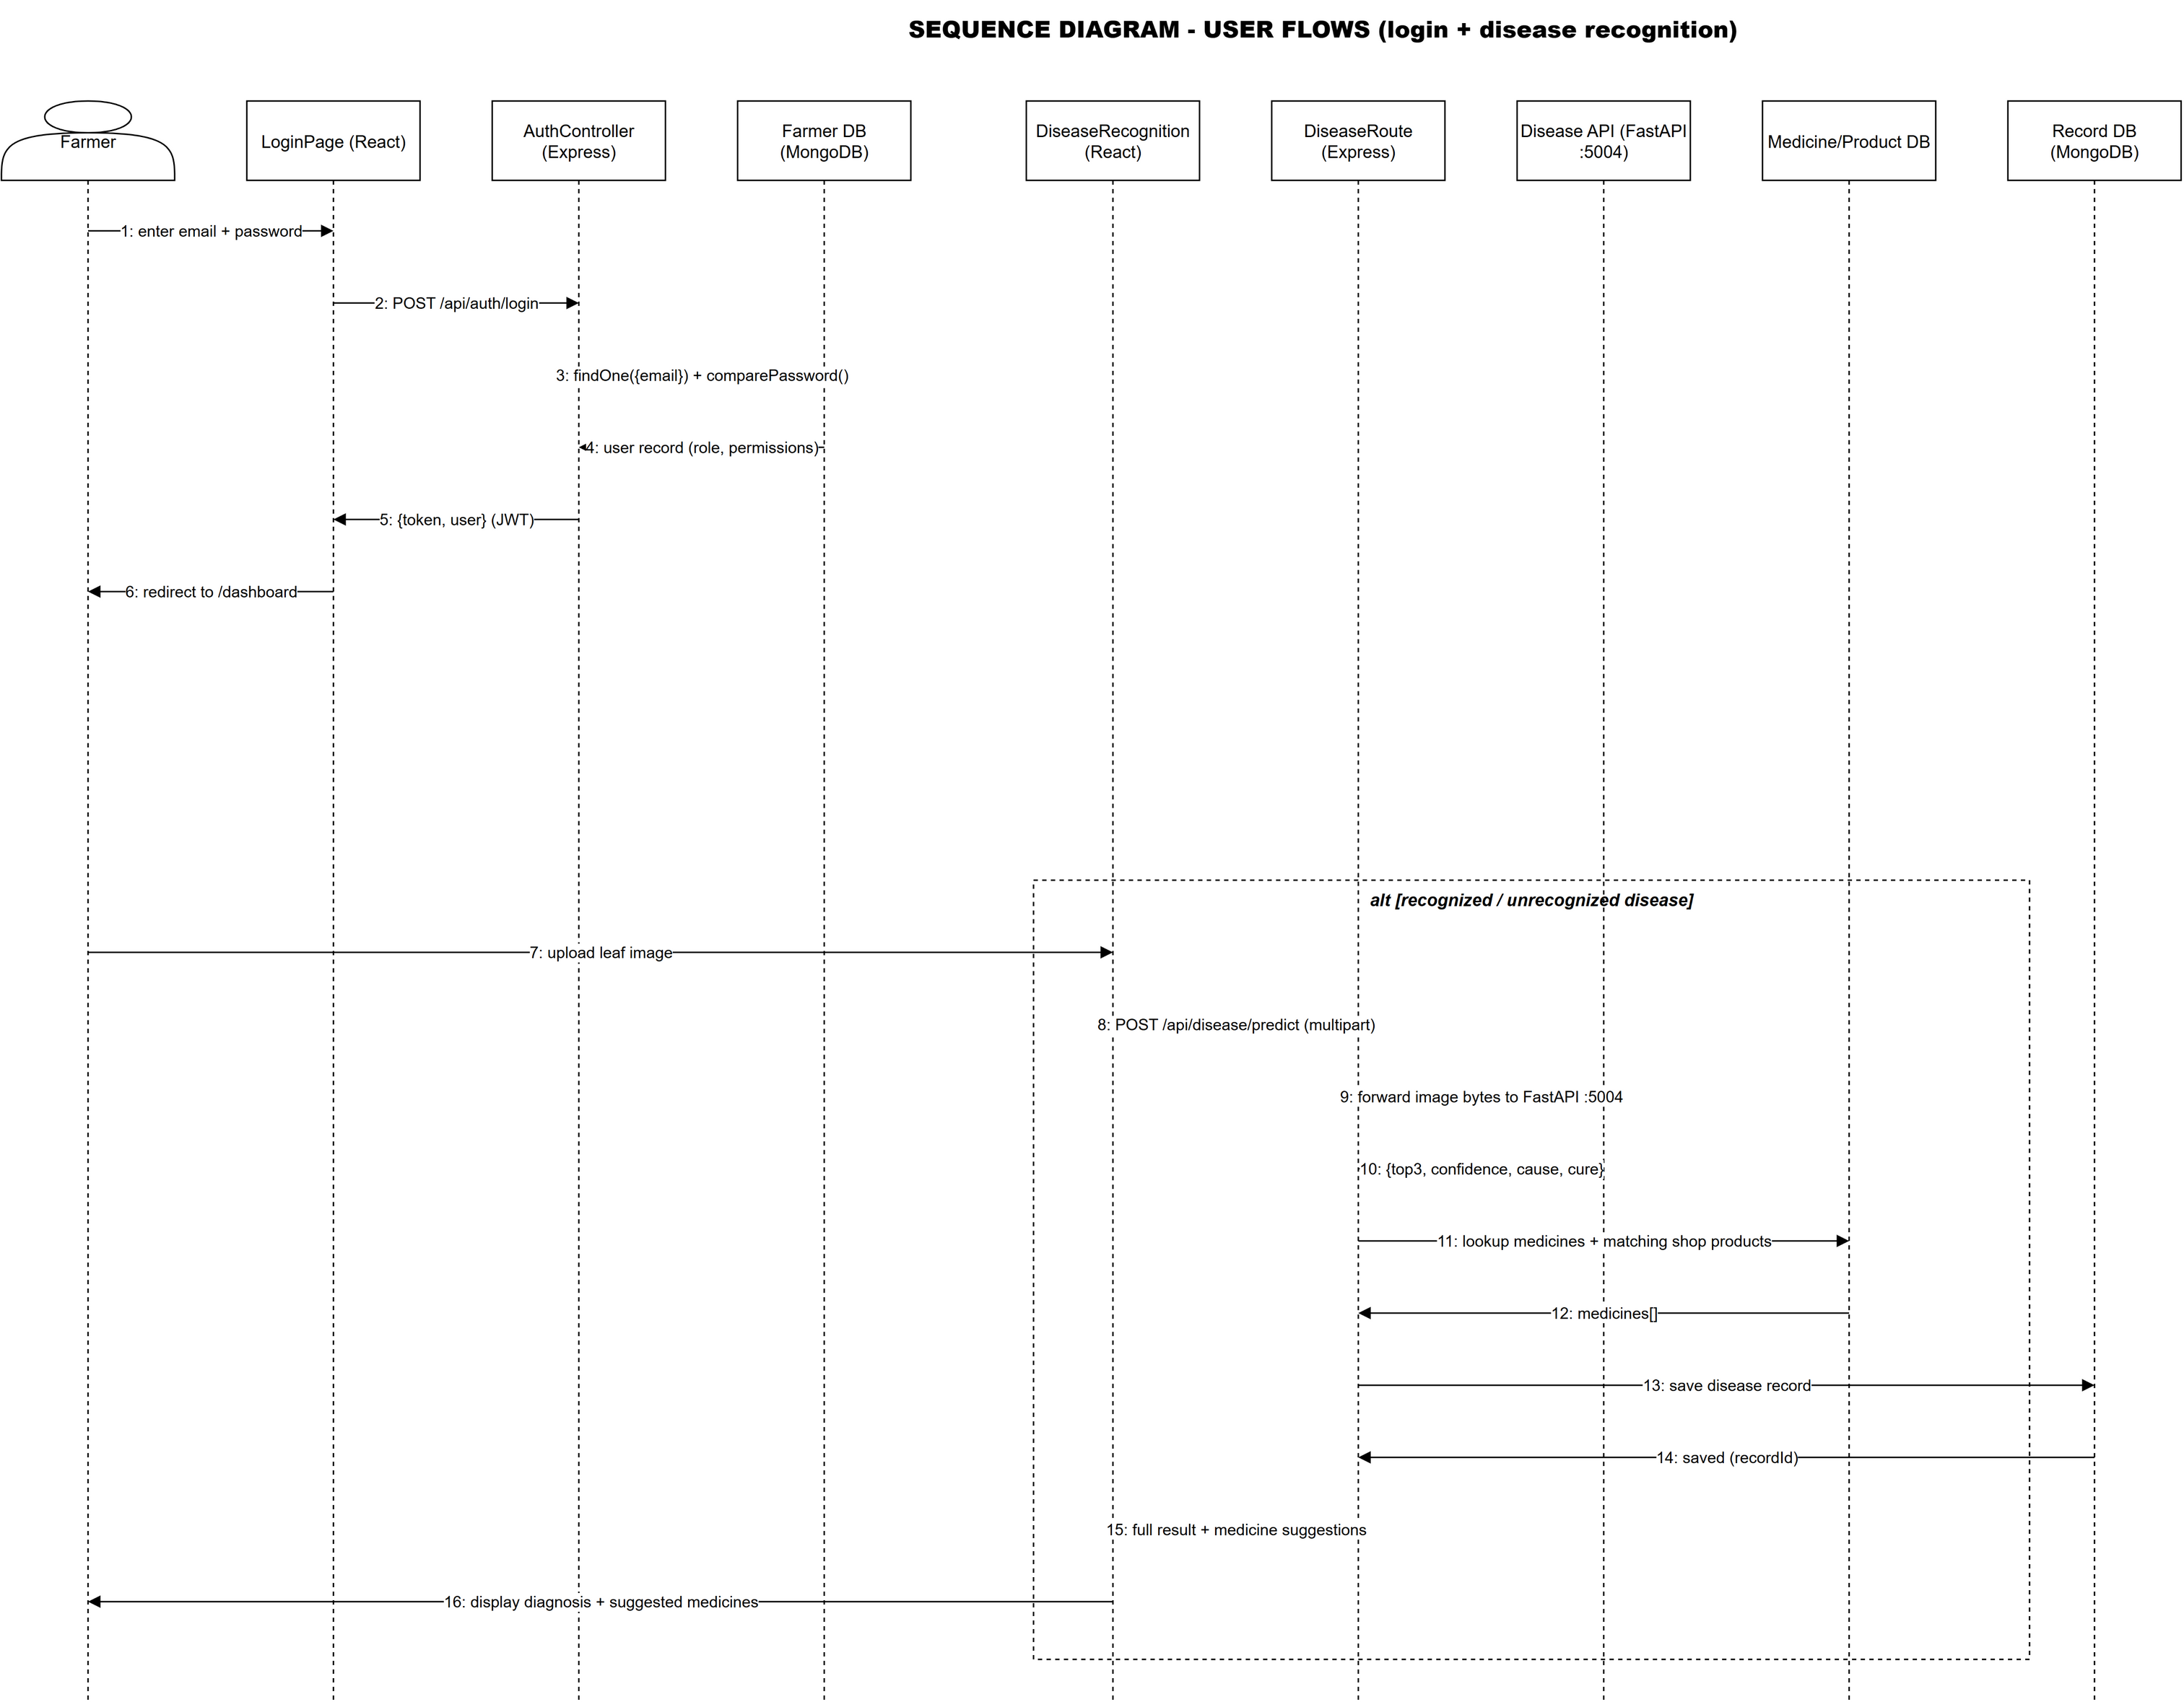
Figure 3.4: Sequence Diagram for User Flows

The admin sequence diagram in Figure 3.5 models product management: the backend verifies the admin permission, returns the pending product list, and on approval makes the product visible in the public shop.
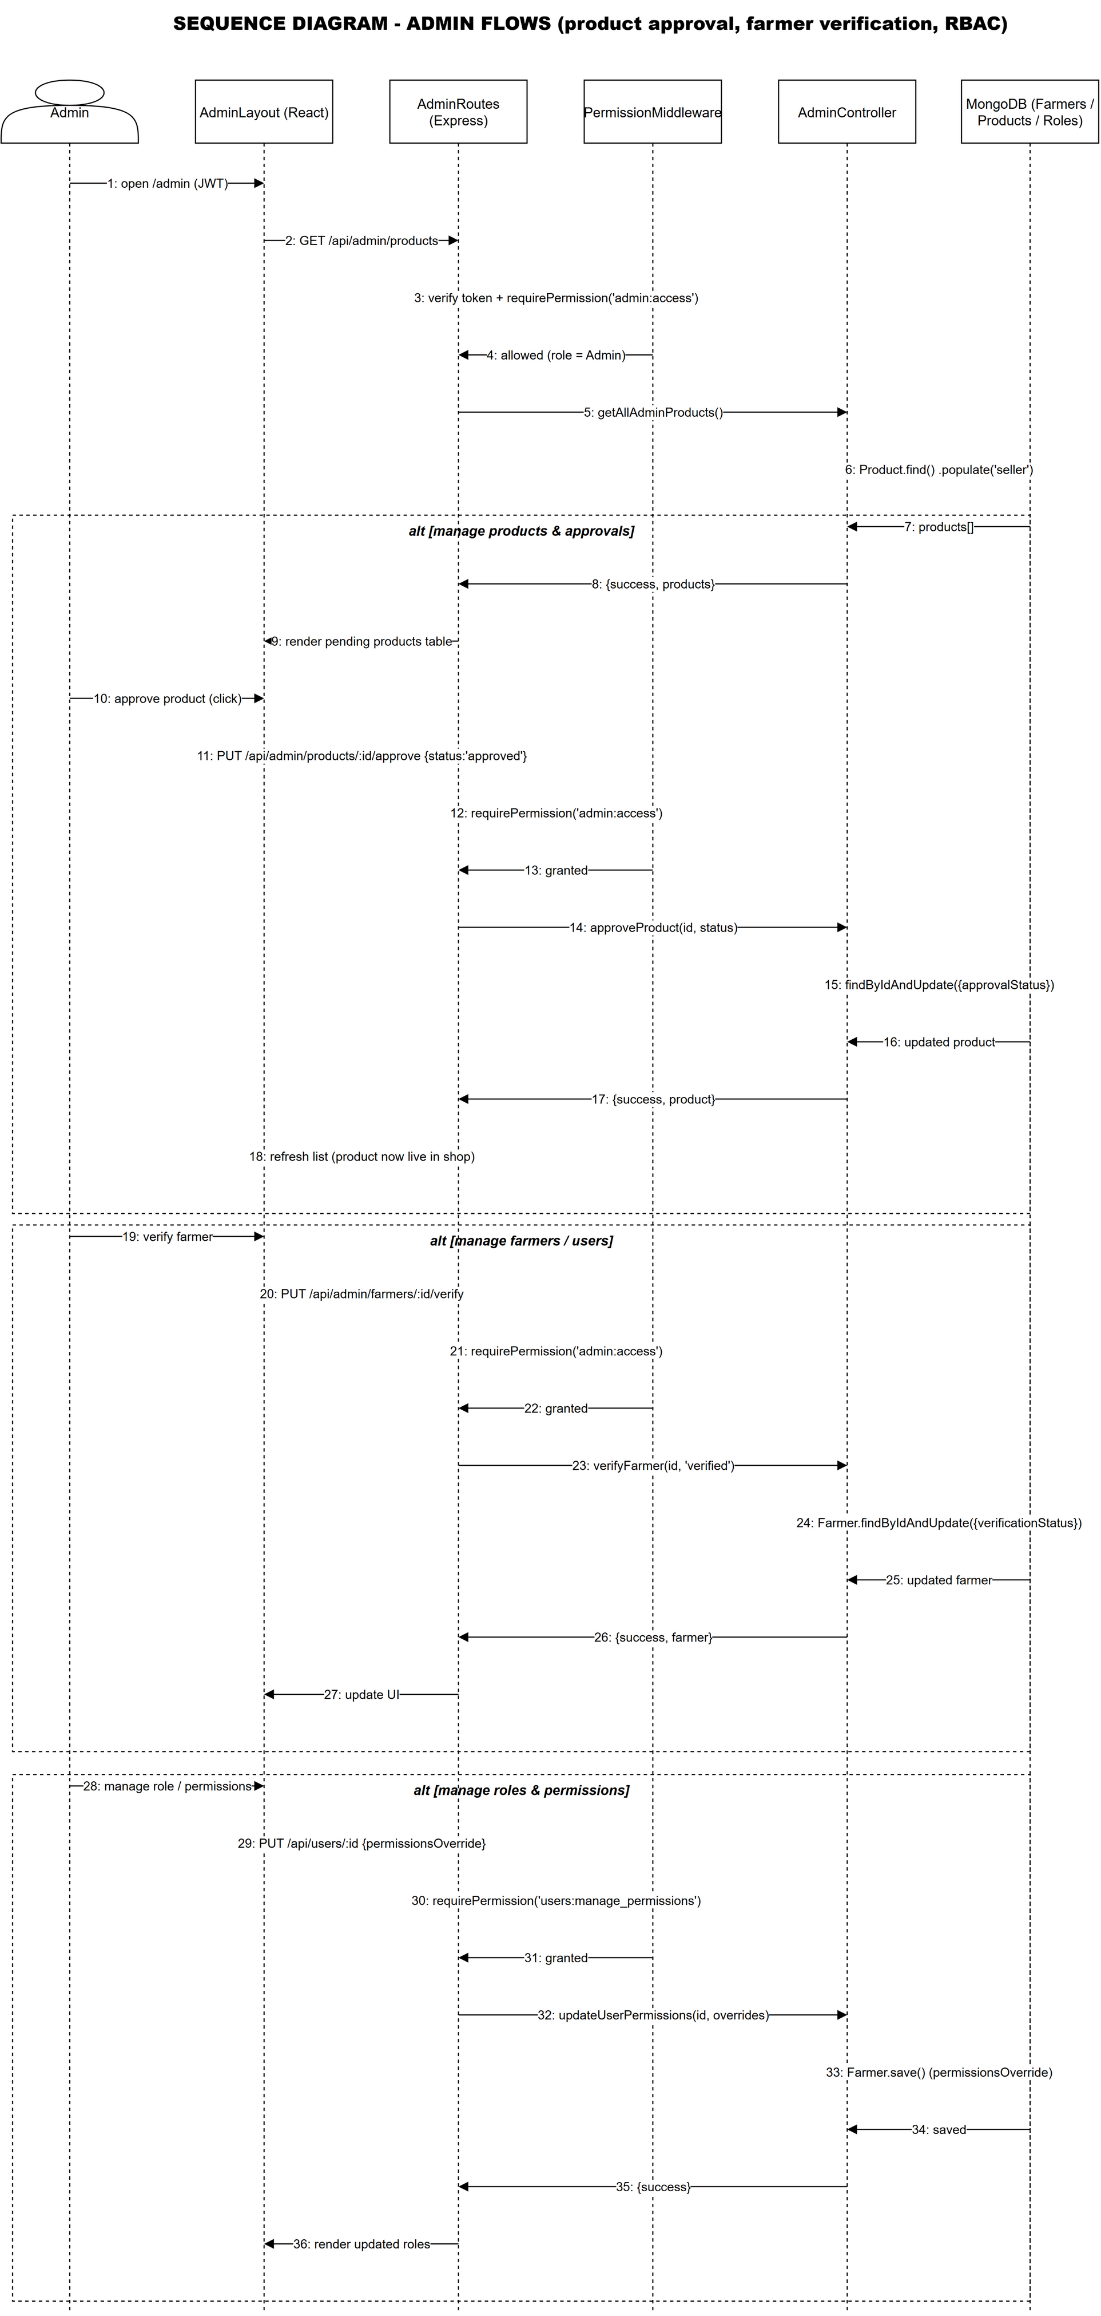
Figure 3.5: Sequence Diagram for Admin Management

3.1.6 Process Modeling using Activity Diagrams
Activity diagrams model the flow of control. Figure 3.6 models the order process: the farmer checks out with a shipping address, and with eSewa the success page verifies the transaction and marks the order paid.
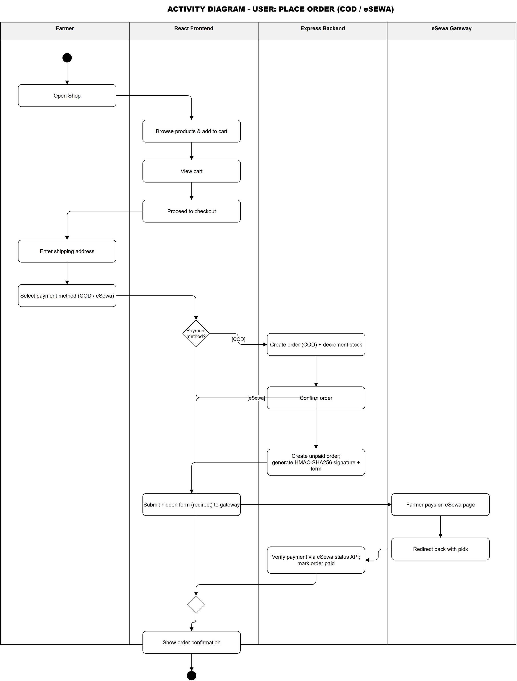
Figure 3.6: Activity Diagram for Order and Payment

Figure 3.7 models the administrative flows: product approval, farmer verification, and role management.
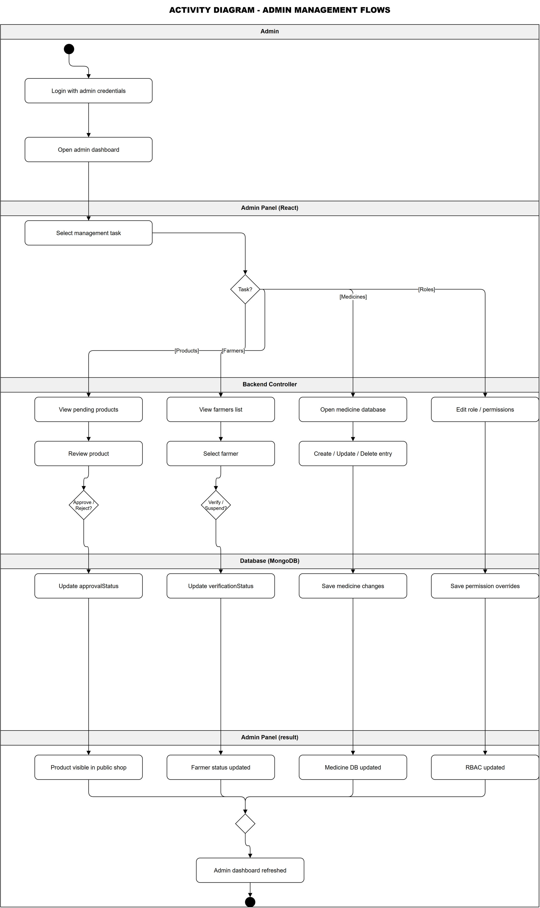
Figure 3.7: Activity Diagram for Admin Management

3.2 System Design

3.2.1 System Architecture
The system uses a layered, client-server architecture. The React presentation layer communicates over HTTP; the Express layer exposes REST endpoints and proxies machine learning requests; the data layer is MongoDB via Mongoose [34].

3.2.2 Microservice Architecture for Machine Learning
The three machine learning models run as independent FastAPI microservices, each owning a single capability [35], as summarized in Table 3.3.
Table 3.4: Machine Learning Microservices
Service | Port | Model | Purpose | Main Endpoint
Pest API | 5002 | Gaussian Naive Bayes pipeline | Pest risk prediction | POST /predict
Crop API | 5003 | Random Forest classifier | Crop recommendation | POST /predict, POST /retrain, GET /health
Disease API | 5004 | EfficientNetB4 CNN | Plant disease recognition | POST /predict, GET /health

The frontend never calls these services directly; the Express backend proxies prediction requests, keeping the client interface uniform and letting each model be retrained independently [35].

3.2.3 Context Diagram
The context diagram shows the system as a single process with the Farmer, Admin, and eSewa gateway around it (Figure 3.8). Incoming flows include leaf images and request data; outgoing flows include recommendations and payment confirmations.
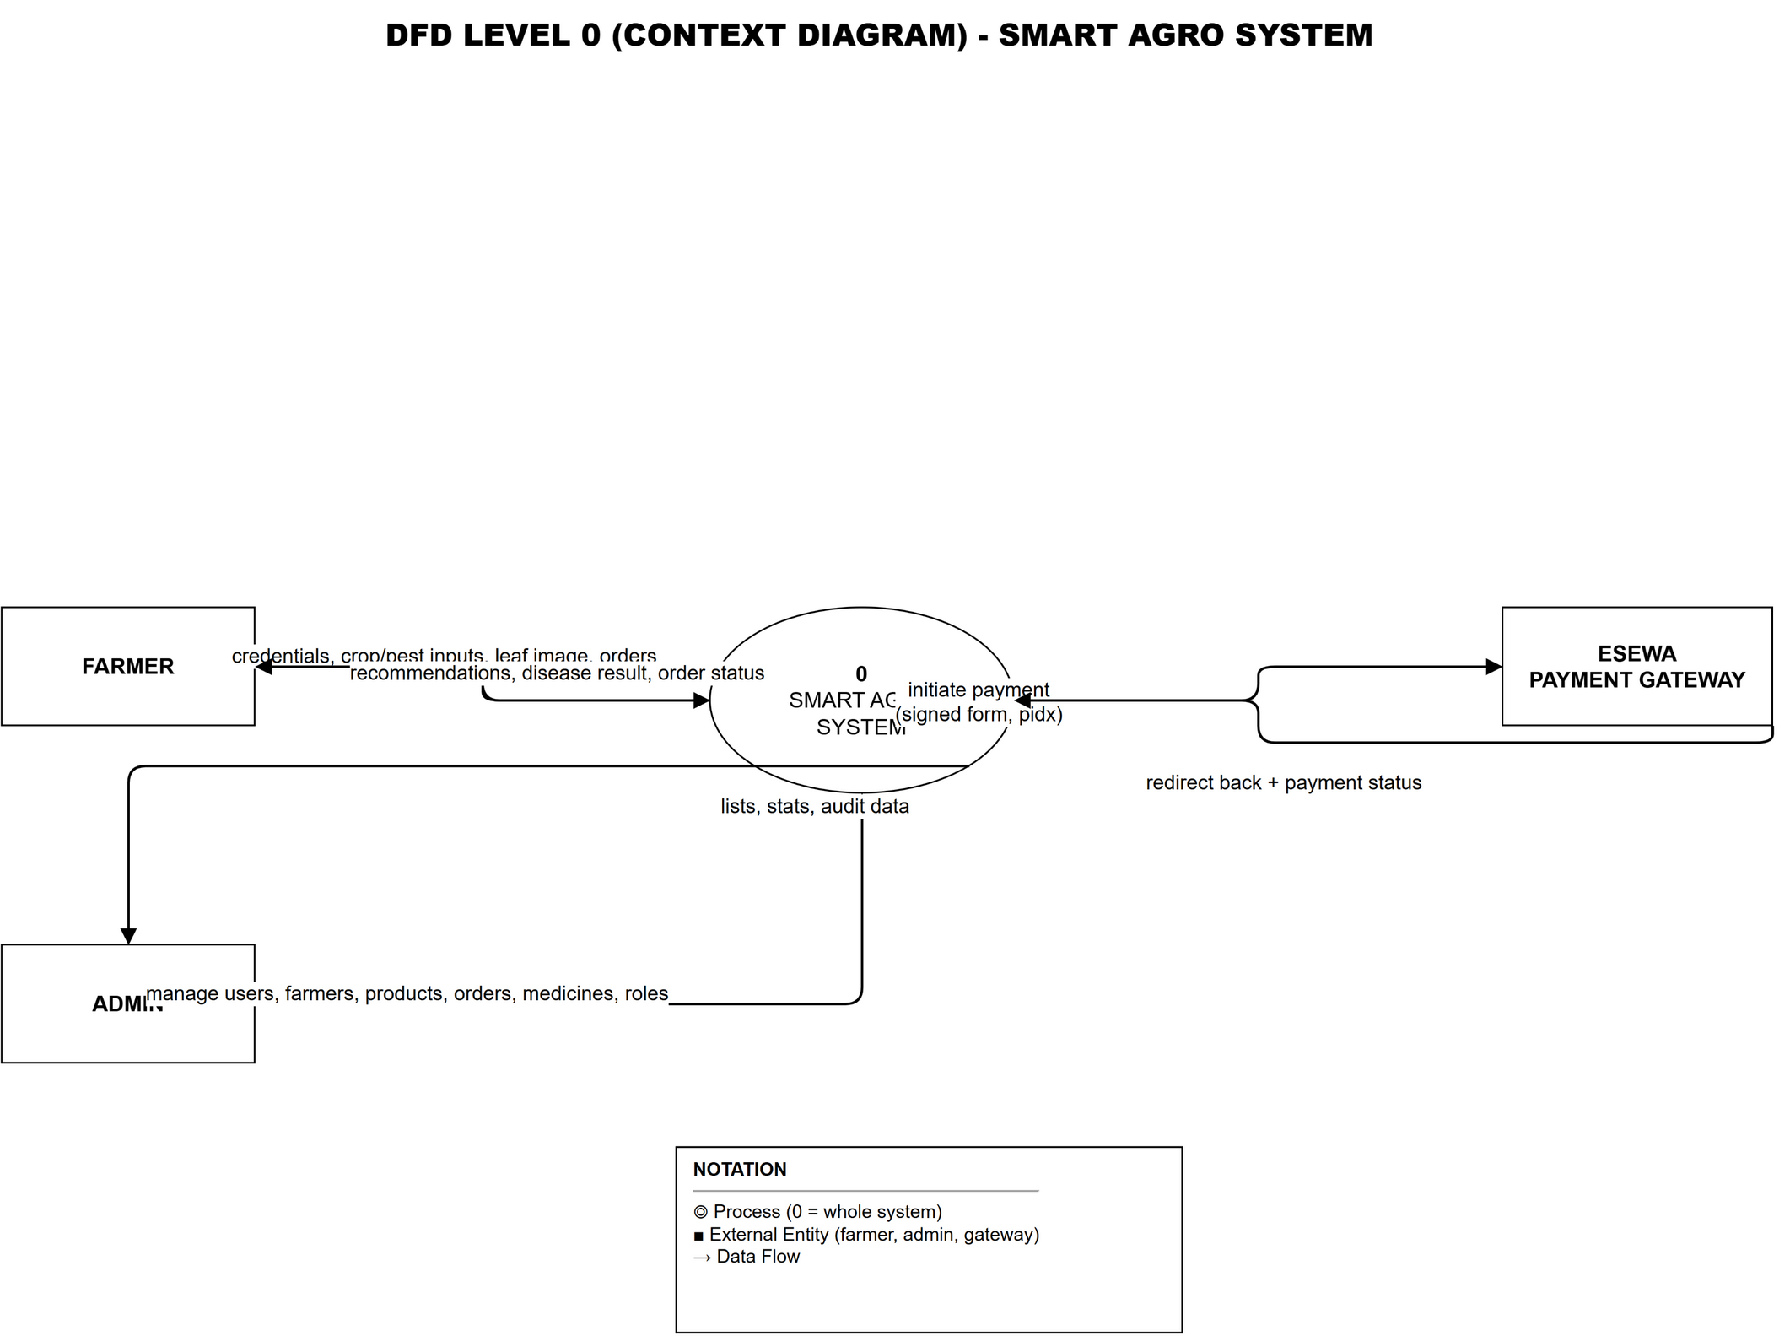
Figure 3.8: Context Diagram (DFD Level 0)

3.2.4 Data Flow Diagram (Level 1)
The level-one data flow diagram in Figure 3.9 decomposes the system into processes covering authentication, prediction, disease recognition, marketplace, and orders, with stores for Farmers, Records, Products, Orders, Medicines, Roles, and Pest Alerts.
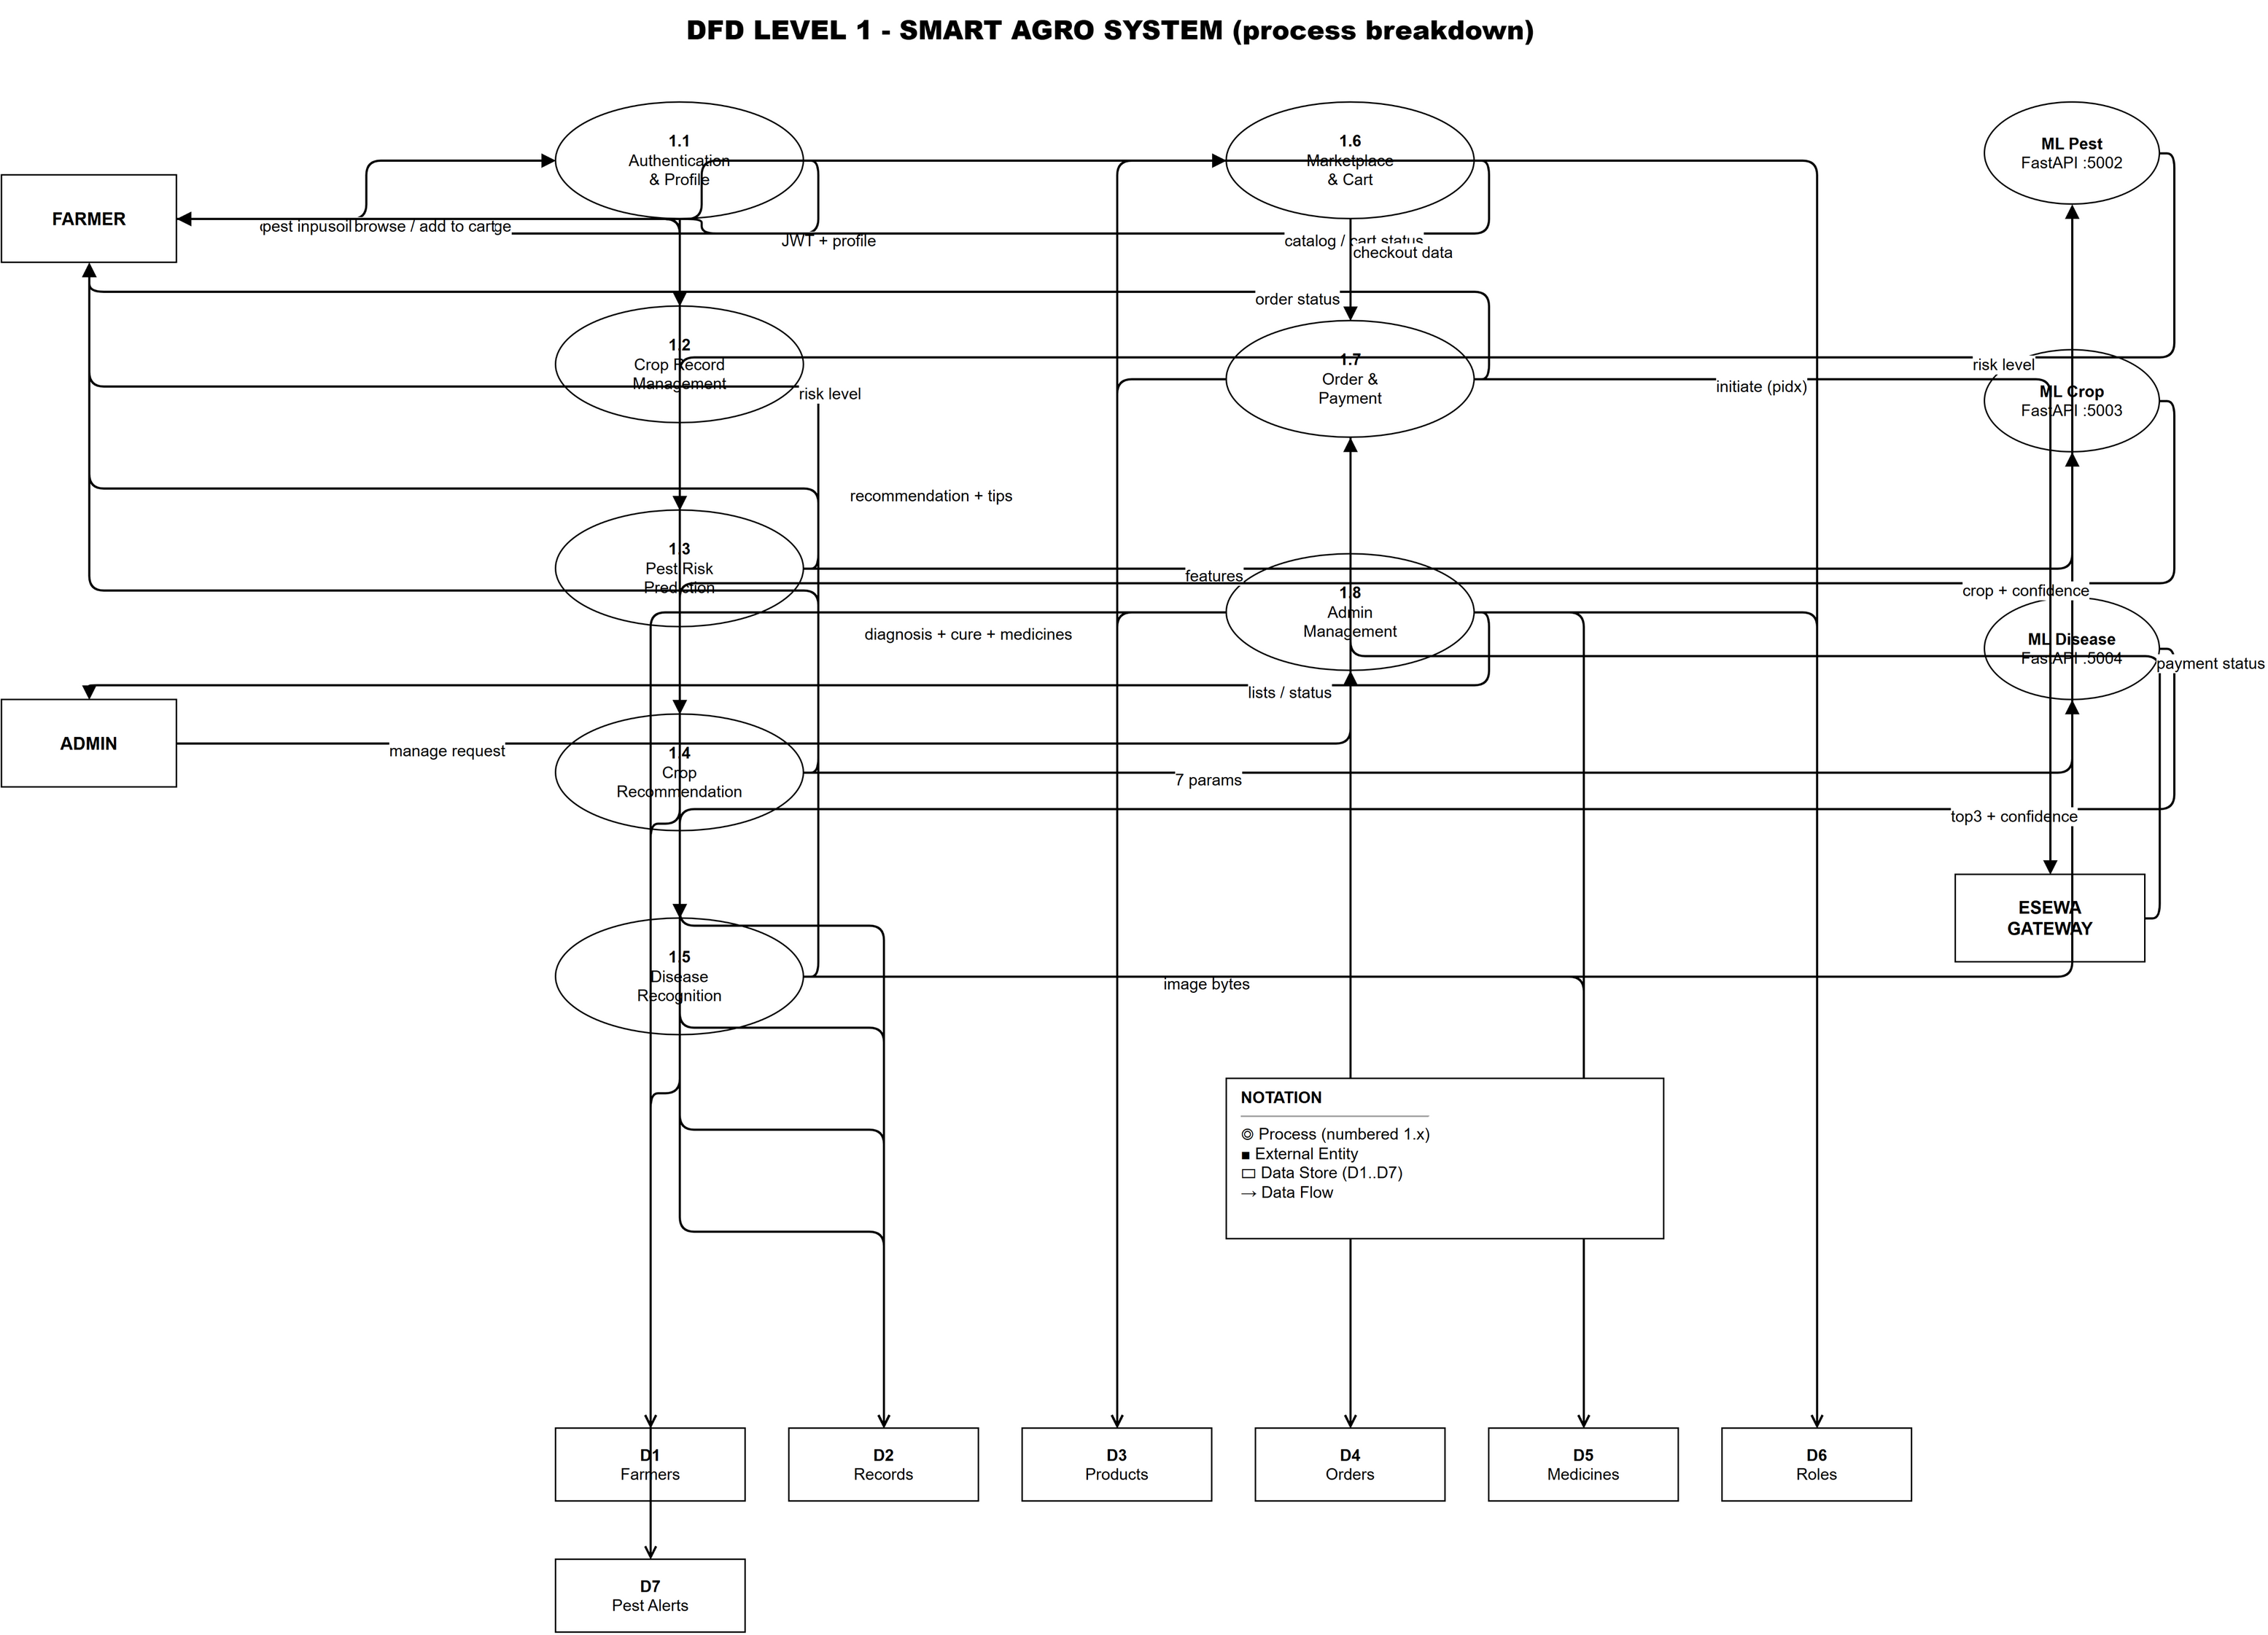
Figure 3.9: Data Flow Diagram (DFD Level 1)

3.2.5 Entity Relationship Diagram
The entity relationship diagram in Figure 3.10 models the persistent data: a Role assigns one-to-many Farmers, and a Farmer has many Records, Products, and Orders.
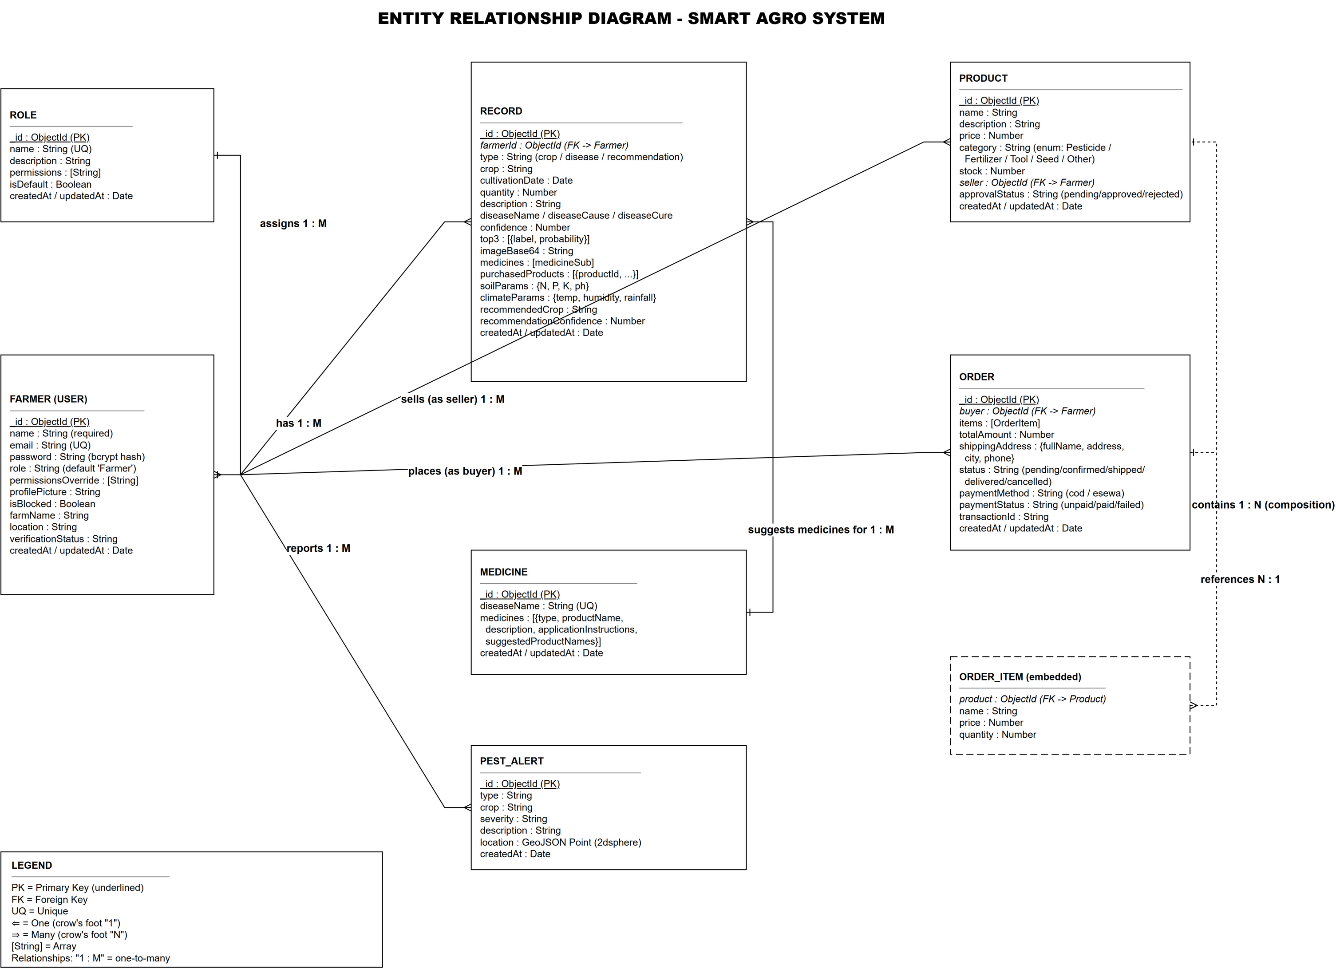
Figure 3.10: Entity Relationship Diagram

3.2.6 Database Design
The system uses MongoDB, a document-oriented NoSQL database that accommodates records varying in shape by type without rigid schemas [36].
Collections. The smart_agro database contains seven collections (Table 3.4).
Table 3.5: MongoDB Collections
Collection | Mongoose Model | Purpose
farmers | Farmer | Registered users with roles and verification status
roles | Role | Named sets of permissions
records | Record | Crop, disease, and recommendation records
medicines | Medicine | Medicine database keyed by disease name
products | Product | Marketplace product listings
orders | Order | Orders with items, shipping, and payment details
pestalerts | pestAlert | Geo-referenced pest alerts

Schema design. Each collection is defined by a Mongoose schema of field types, validation rules, and defaults. The Farmer schema requires name, email, and a bcrypt-hashed password; the Record and Order schemas embed soil, climate, items, and shipping data.
Relationships. Collections are linked by references: a Record references its Farmer, an Order references its buyer, and each item references a Product. Since MongoDB does not enforce referential integrity, these are maintained through explicit population in the controllers [36].
Sample documents. Representative Farmer and Record documents are summarized in Appendix C.
Indexes. MongoDB indexes accelerate queries on frequently searched fields: email is uniquely indexed for authentication, pest alert location uses a 2dsphere index, and compound indexes on createdAt sort records and orders by recency (Table 3.5).
Table 3.6: Database Indexes
Collection | Index | Type | Purpose
farmers | email | unique | Fast and unique authentication lookup
pestalerts | location | 2dsphere | Geo-spatial pest alert queries
records | farmerId + createdAt | compound | List records of a farmer by recency
orders | buyer + createdAt | compound | List orders of a buyer by recency

3.2.7 Refinement of Class Diagram
During design the analysis classes are refined into concrete classes following an MVC separation: Express controllers handle requests, Mongoose models handle persistence. Figure 3.11 shows the refined diagram with comparePassword(), the authentication and permission middleware, and the ML service interfaces.
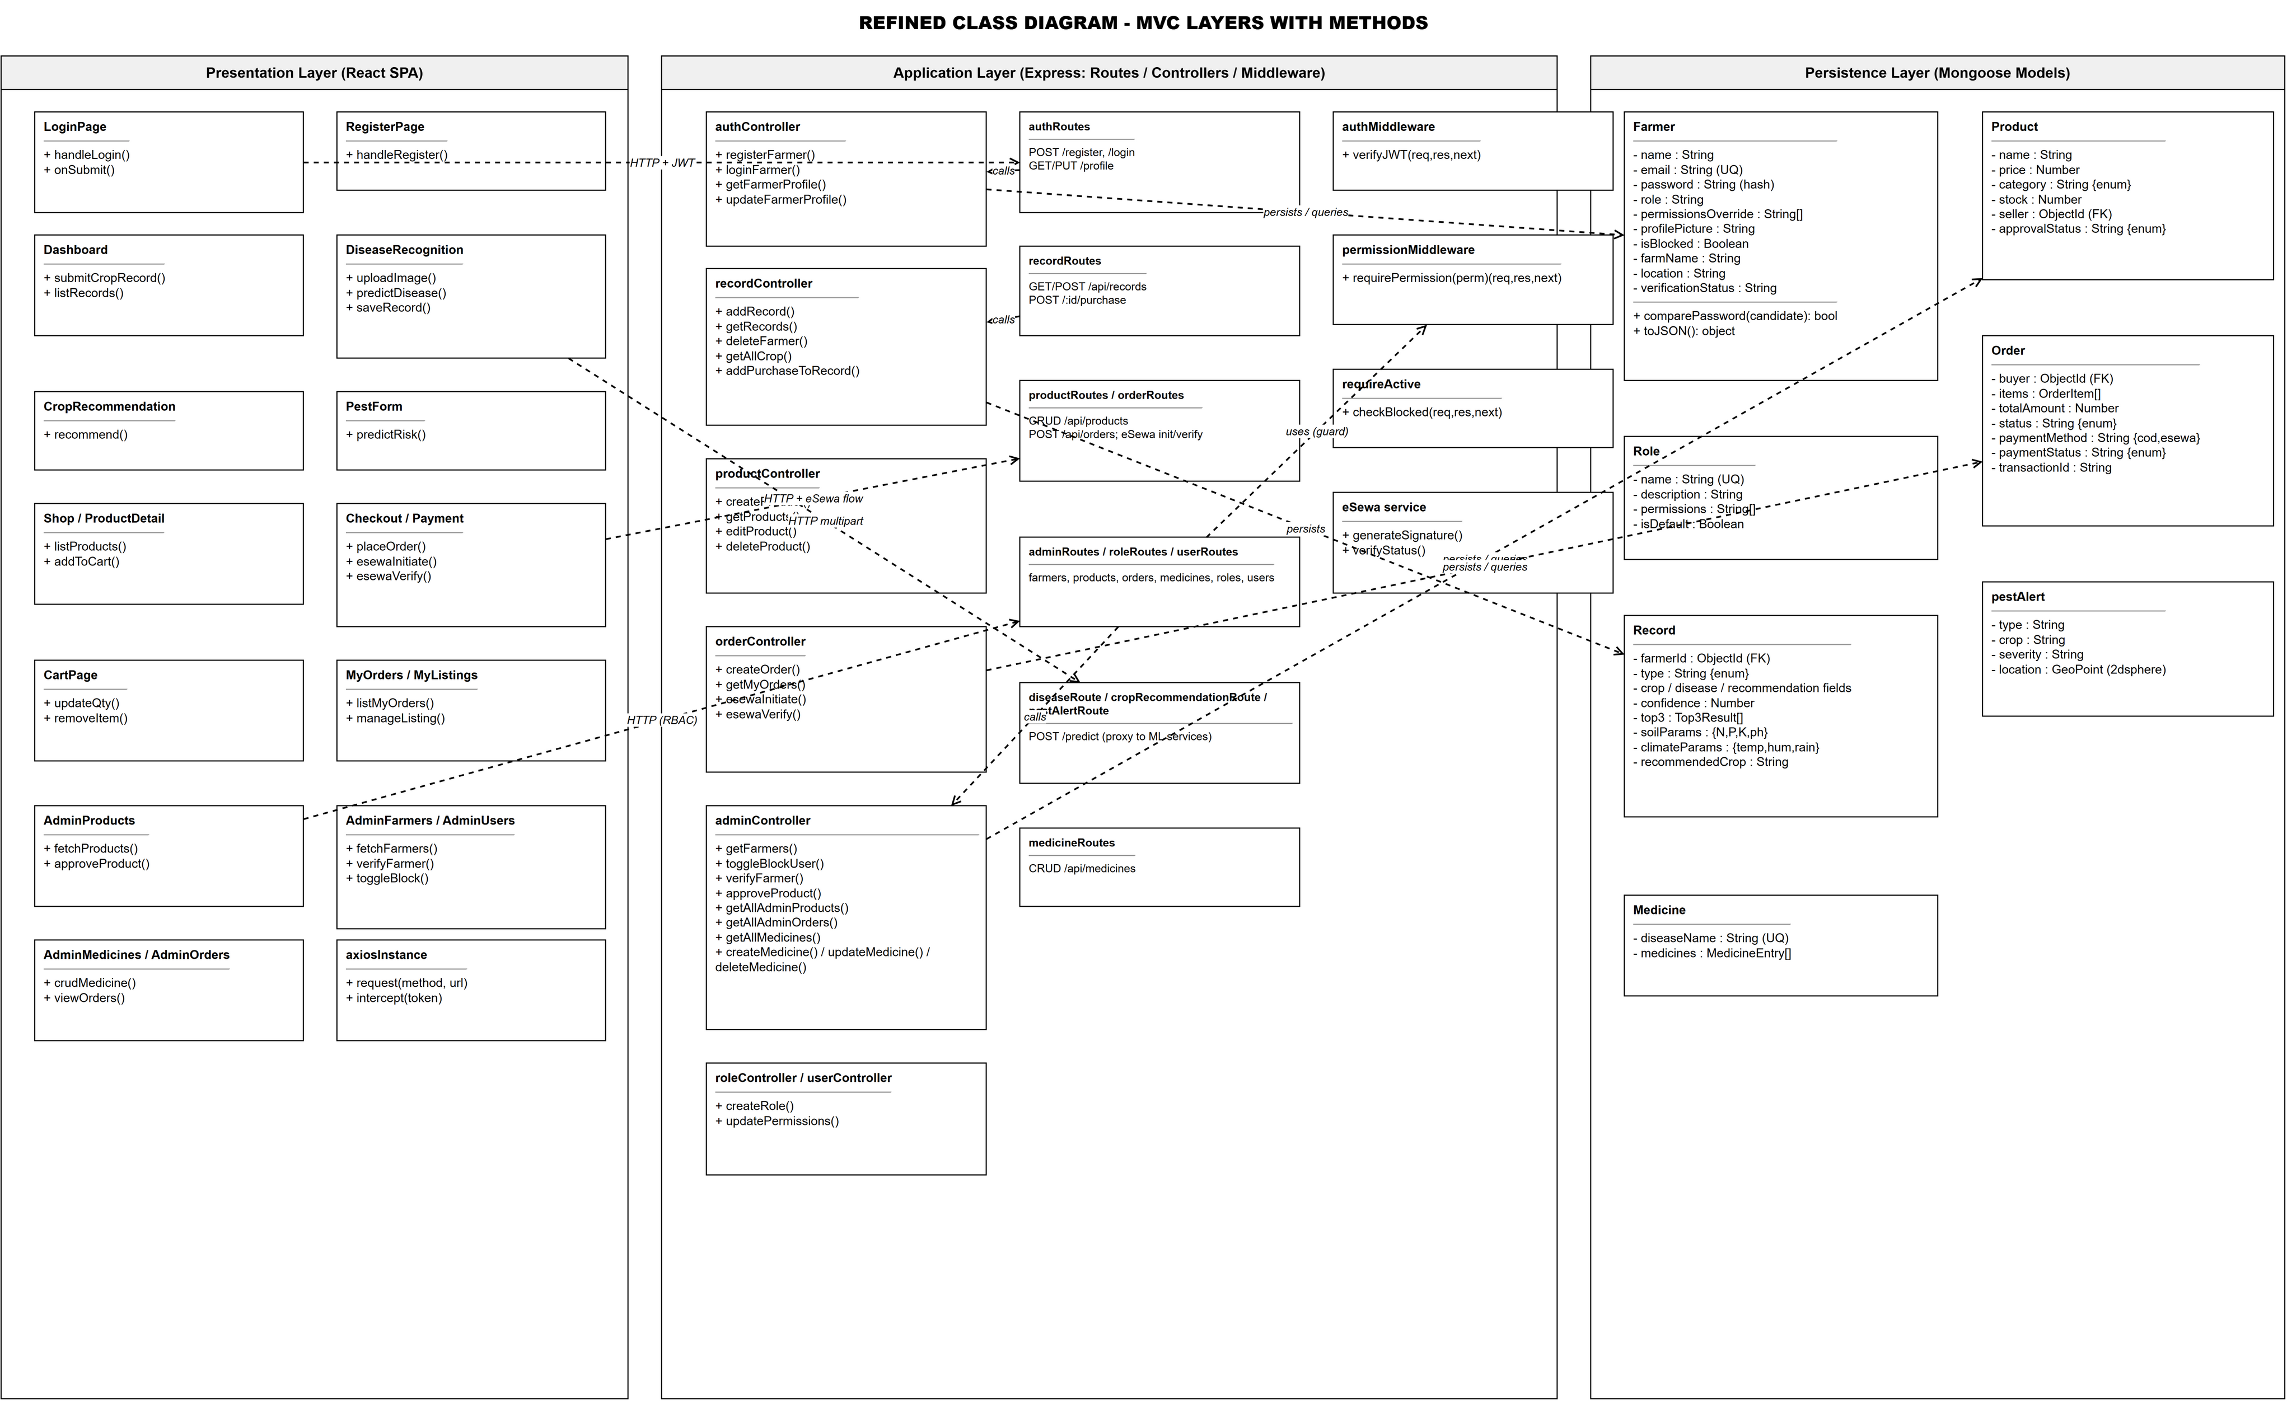
Figure 3.11: Refined Class Diagram (MVC Layers)

3.2.8 Component Diagram
The component diagram describes the major components and their interactions. Figure 3.12 shows the React SPA, the Express backend with RBAC, MongoDB, the FastAPI services, and the eSewa gateway; Figure 3.13 shows the admin side with its management functions.
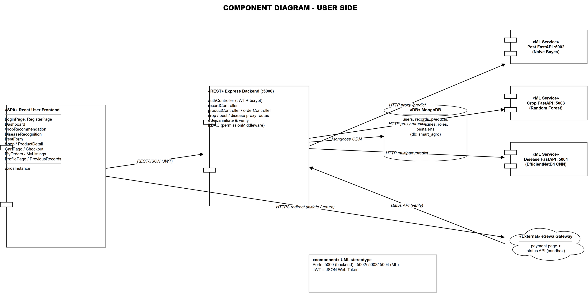
Figure 3.12: Component Diagram - User Side

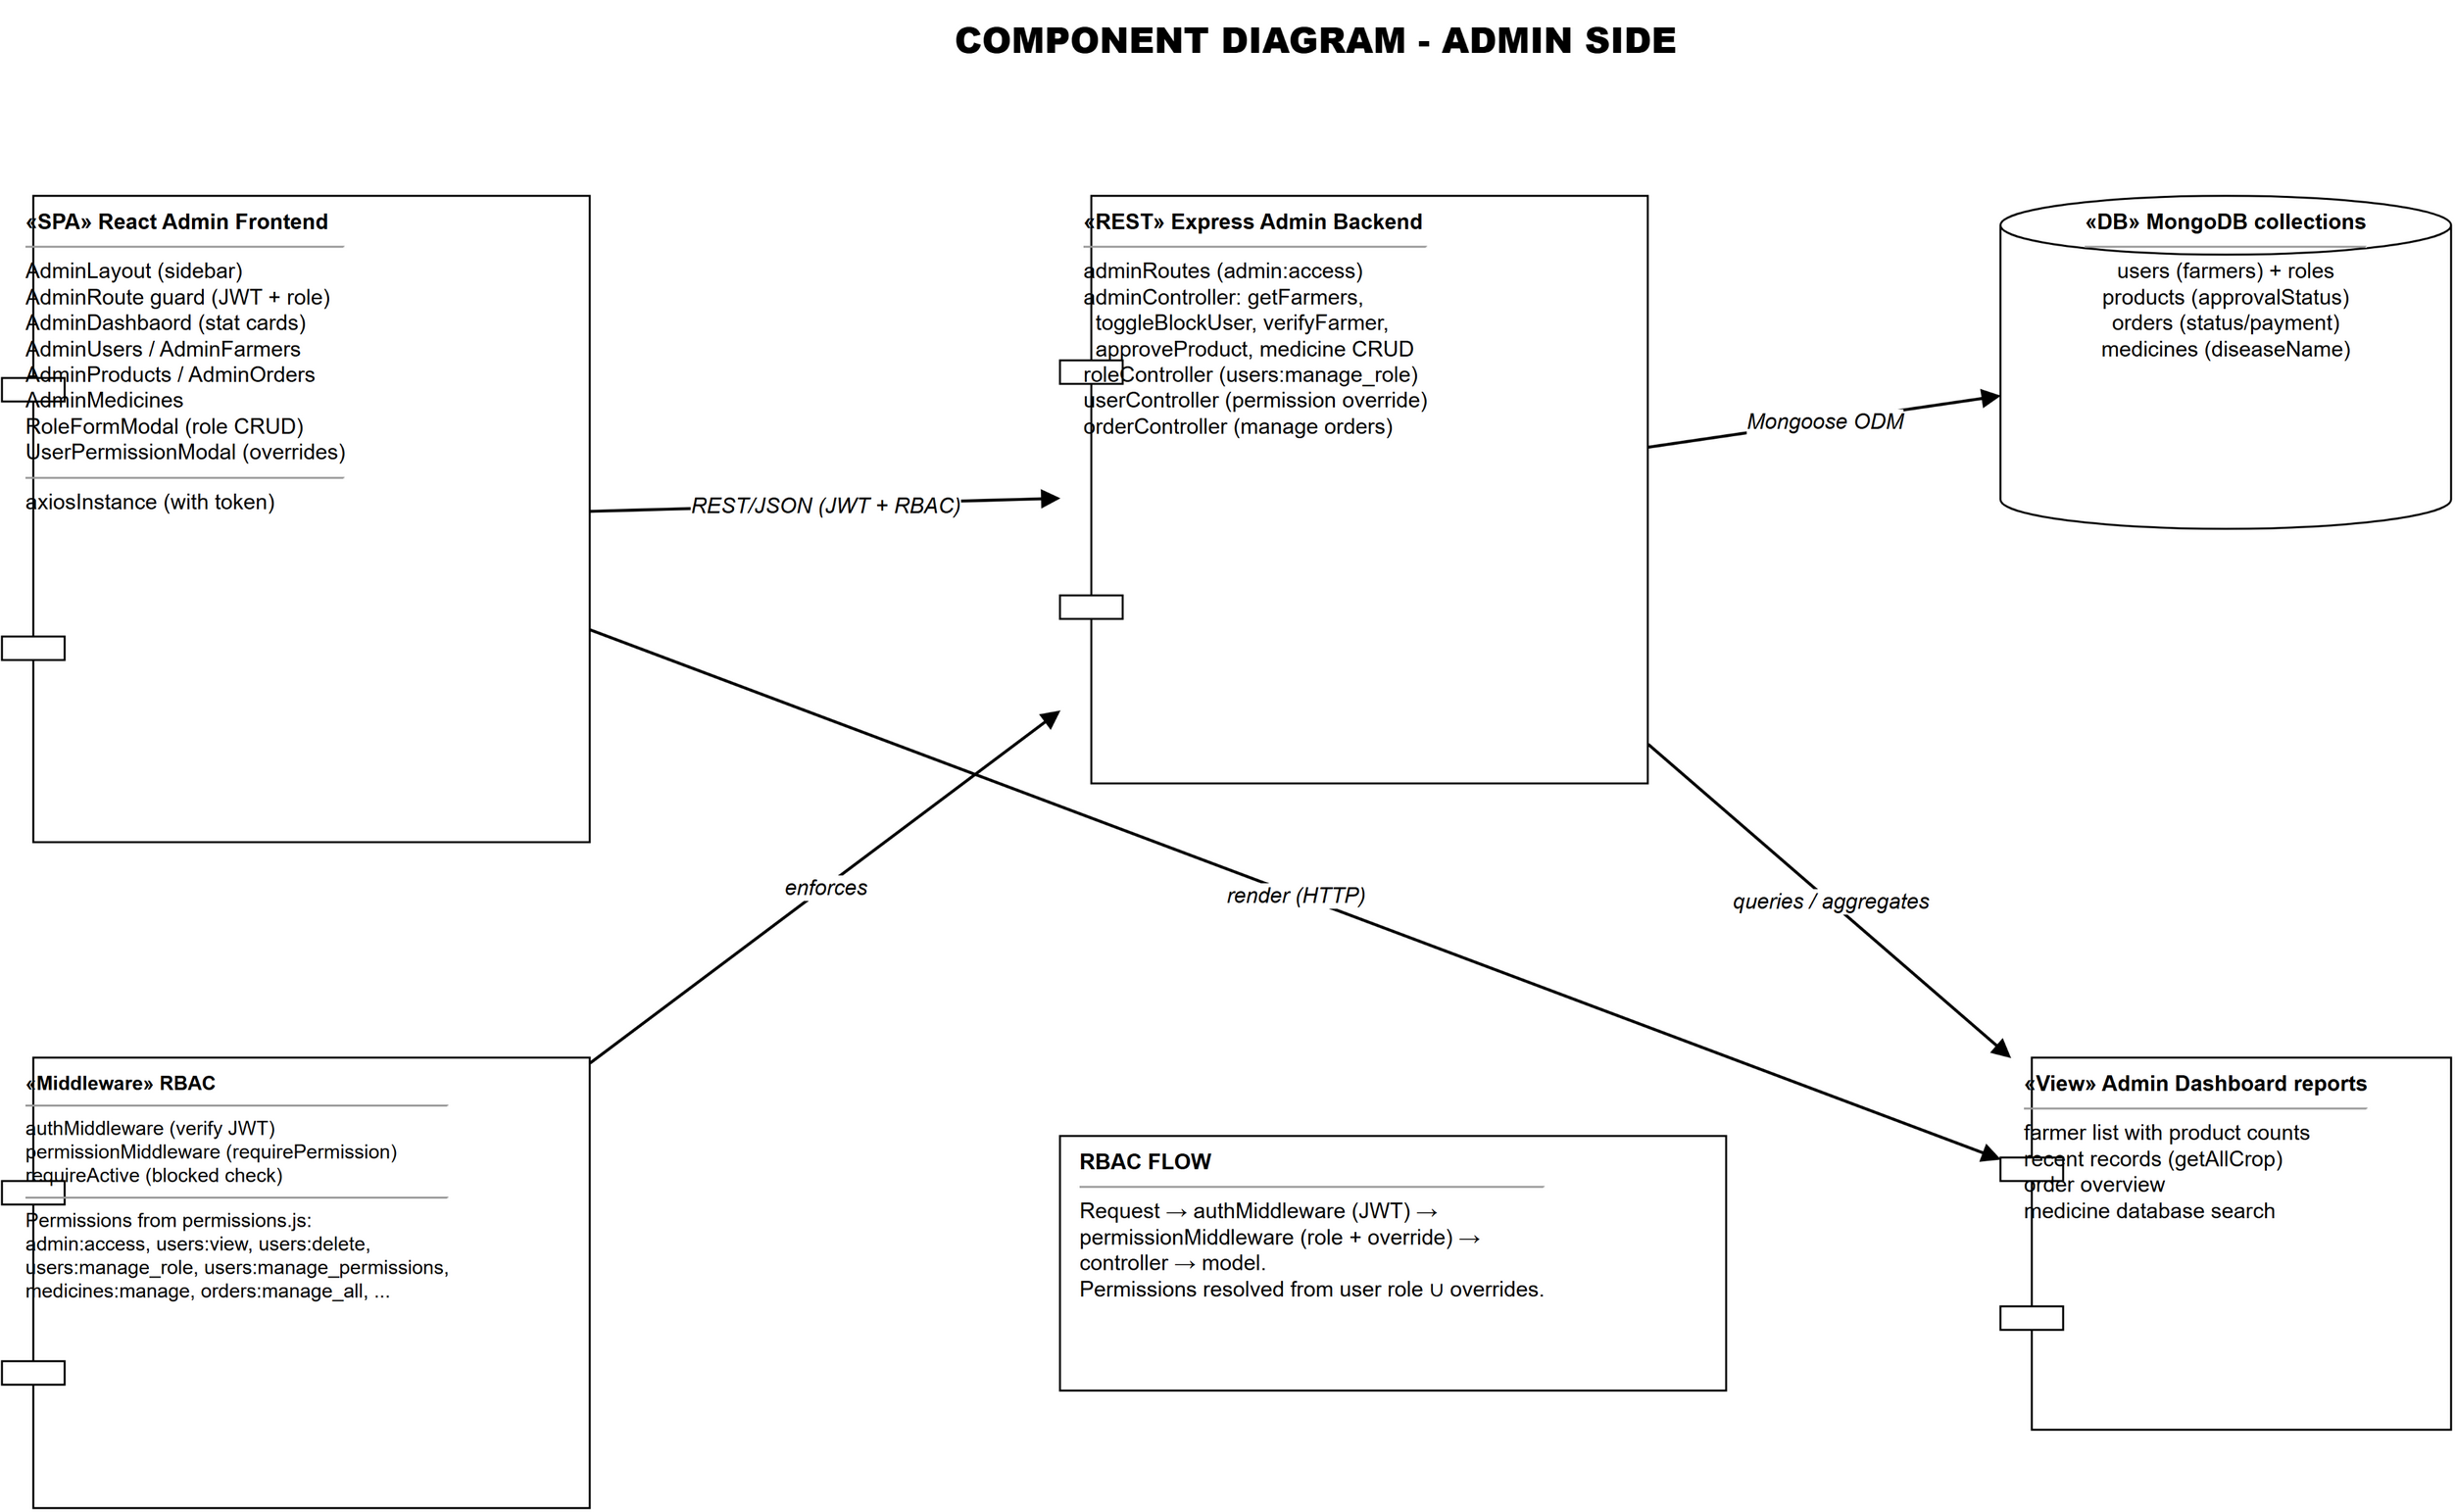
Figure 3.13: Component Diagram - Admin Side

3.2.9 Deployment Diagram
In the local deployment all components run on one machine. Figure 3.14 shows the React dev server on port 3000, the Express backend on port 5000, the services on ports 5002-5004, and MongoDB.
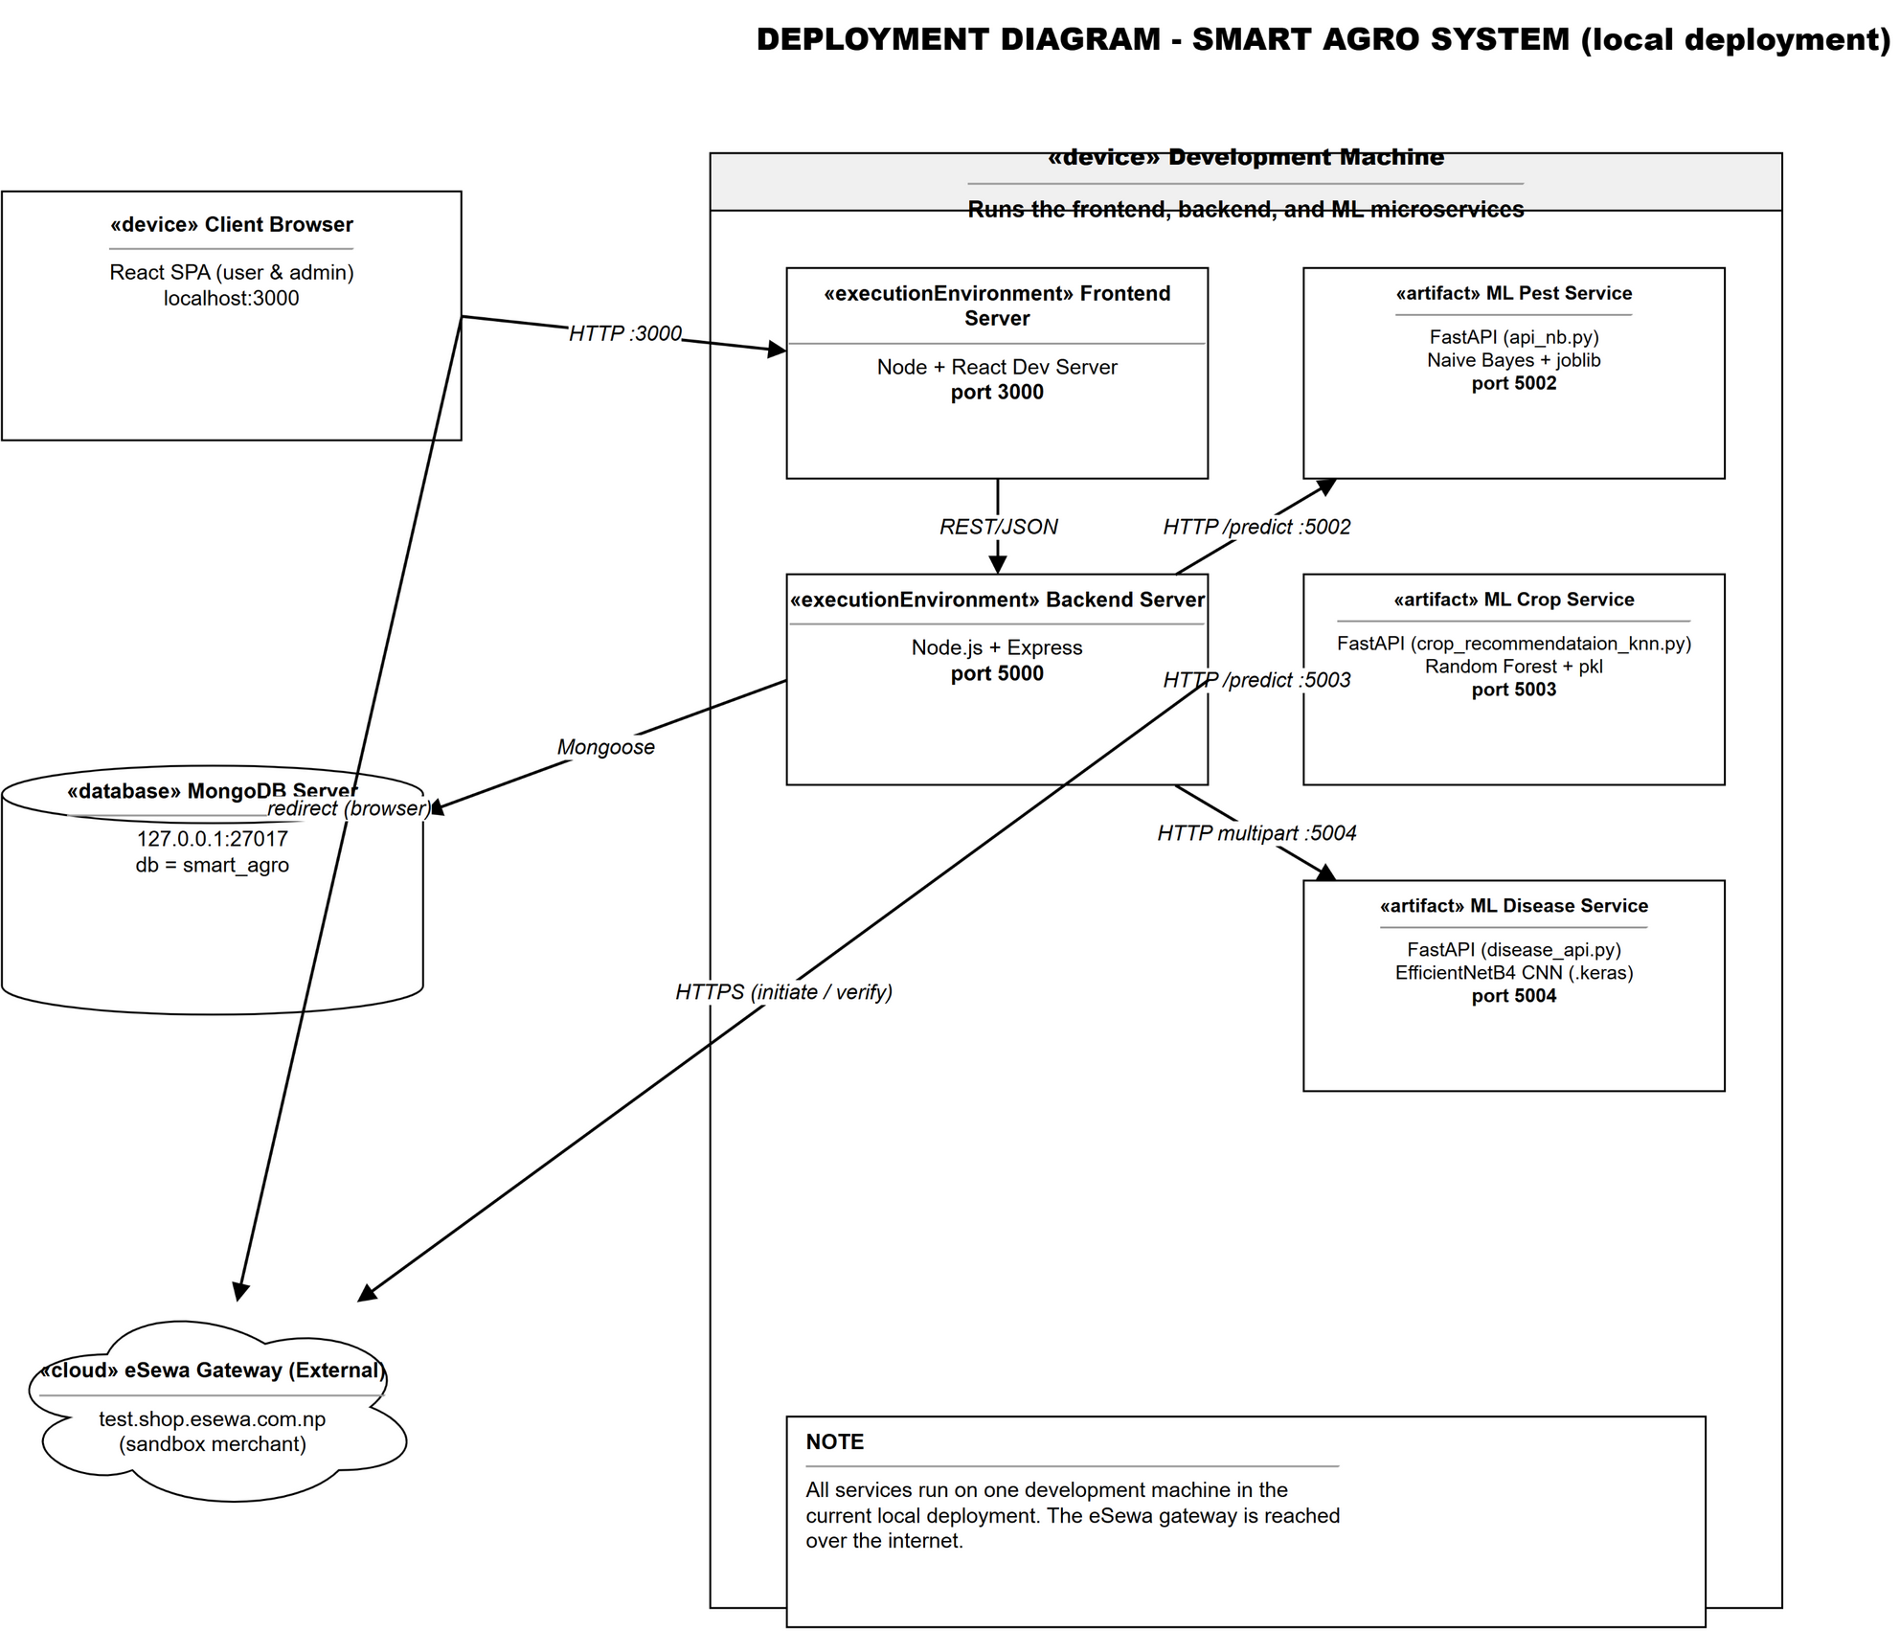
Figure 3.14: Deployment Diagram (Local Deployment)

3.2.10 Wireframing
Wireframes define the layout of the main screens. Figure 3.15 shows low-fidelity wireframes for the login screen, the farmer dashboard, and the shop and checkout pages.
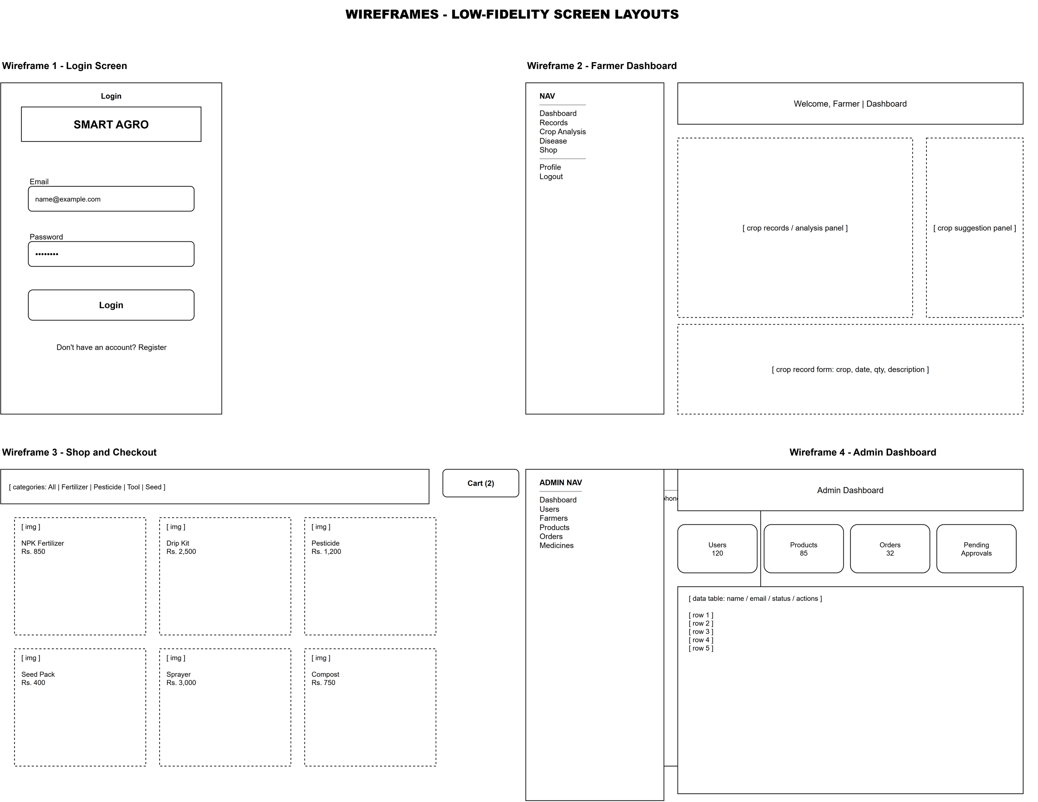
Figure 3.15: Wireframes of Key Screens

3.2.11 Interface Design
The UI follows a consistent glassmorphism design system; its tokens are summarized in Table 3.6.
Table 3.7: Design Tokens
Token | Value | Usage
--primary | #2ecc71 | Primary brand colour (green), buttons, accents
--primary-dark | #27ae60 | Hover and pressed states
--glass-bg | rgba(255,255,255,0.18) | Glass card backgrounds
--glass-border | rgba(255,255,255,0.25) | Glass card borders
--text-primary | #1a2e1a | Main text colour
--text-muted | #8ba08b | Secondary and muted text
--font | Inter | Global font family
--radius | 16px | Card corner radius

The interface has three layouts: public authentication pages, a farmer layout with a collapsible sidebar, and an admin layout with a dedicated sidebar. Navigation follows the frontend routes listed in Chapter 4.

3.2.12 API Architecture
The backend exposes RESTful endpoints protected by authentication and permission middleware, with machine learning requests proxied to the Python services. The complete API is listed in Appendix D; Table 3.7 summarizes the endpoint groups.
Table 3.8: API Endpoint Groups
Prefix | Purpose | Example Endpoints
/api/auth | Registration, login, profile | POST /register, POST /login, GET/PUT /profile
/api/records | Crop, disease, recommendation records | GET /, POST /, POST /:id/purchase
/api/pest-alert | Pest risk prediction proxy | POST /pest-risk
/api/crop-recommendation | Crop recommendation proxy | POST /recommend
/api/disease | Disease recognition proxy (multipart) | POST /predict, GET /health
/api/products | Product catalogue and listings | GET /, POST /, PUT /:id
/api/orders | Orders and payments | GET /mine, POST /, POST /esewa/initiate, POST /esewa/verify
/api/roles | Role management | GET /, POST /, PUT /:id, DELETE /:id
/api/users | User management | GET /, PUT /:id/role
/api/admin | Admin management | GET /farmers, GET /products, PUT /products/:id/approve, /medicines CRUD

3.2.13 Folder Structure
The project is a monorepo of frontend, backend, and machine learning services coordinated by the root package.json; the complete source tree is listed in Appendix B.

3.2.14 Security Design
The system applies defence in depth. Passwords are bcrypt-hashed with twelve salt rounds [37]; a JWT expires after a configurable period and is verified on protected requests [38]. The permission middleware rejects unauthorized requests [13], and eSewa payments use HMAC-SHA256 signatures with server-side verification [12].

3.3 Algorithm Details
This section describes the three machine learning algorithms: Gaussian Naive Bayes, Random Forest, and EfficientNetB4 for pest risk, crop recommendation, and disease recognition.

3.3.1 Gaussian Naive Bayes Algorithm
The pest risk module implements a Gaussian Naive Bayes classifier, based on Bayes’ theorem, which relates the posterior probability of class C given evidence X to the prior and likelihood [19]:
P(C | X) = P(X | C) * P(C) / P(X)
The naive assumption holds that features are conditionally independent given the class, so the likelihood is the product of per-feature probabilities:
P(X | C) = P(x1 | C) * P(x2 | C) * ... * P(xn | C)
For continuous features, each feature is assumed normally distributed within a class, P(xi | C) ~ N(µi, σi²), with parameters estimated from the data. The highest posterior class is selected, and P(X) is ignored as constant [19].
The model is a scikit-learn pipeline that scales numeric features with a StandardScaler, one-hot encodes categorical features, applies a Gaussian Naive Bayes classifier, and is served by the pest API on port 5002 [32].

3.3.2 Random Forest Algorithm
The crop recommendation module uses a Random Forest of decision trees trained on bootstrap samples, combined by majority voting [26]. The ensemble is robust to noise and captures non-linear soil-climate relationships [16].
The pipeline loads about 2,200 samples covering twenty-two crops, scales the numeric features (N, P, K, temperature, humidity, pH, rainfall), and trains a Random Forest with one hundred trees, returning the recommended crop with a confidence score [32].

3.3.3 EfficientNetB4 Convolutional Neural Network
The plant disease recognition module uses an EfficientNetB4 convolutional neural network. EfficientNet models, obtained by compound scaling of depth, width, and resolution, balance accuracy and computational cost [28].
The model is fine-tuned through transfer learning [29] with ImageNet pre-trained weights and a softmax head over thirty-nine classes, with inputs resized to 160x160 pixels. A confidence threshold of 0.5 reports images below it as unrecognized [21], [22], [23]; the service accepts uploads on port 5004.

4. Implementation

4.1 Introduction
This chapter describes the Smart Agro implementation following the design in Chapter 3 across three layers: the React frontend, the Express backend, and the Python ML services. Code snippets are presented with screenshot placeholders for later insertion.

4.2 Development Tools and Technologies
Table 4.1 lists the technologies used, all free and open source to keep costs low [32], [39].
Table 4.1: Development Tools and Technologies
Layer | Technology | Version | Purpose
Frontend | React | 18.x | User interface as a single-page application
Frontend | React Router | 6.x | Client-side routing
Frontend | axios | 1.x | HTTP client for the REST API
Backend | Node.js / Express | 20.x / 4.x | REST API server
Backend | Mongoose | 8.x | MongoDB object data modelling
Backend | jsonwebtoken | 9.x | JWT generation and verification
Backend | bcryptjs | 2.x | Password hashing
Backend | multer | 1.x | Image upload handling
Backend | helmet / cors / morgan | 7.x | Security headers, CORS, logging
Database | MongoDB Community Server | 7.x | Document database
ML | Python 3.9 / FastAPI / uvicorn | - | Machine learning microservices
ML | scikit-learn | 1.x | Naive Bayes and Random Forest models
ML | TensorFlow / Keras | 2.x | EfficientNetB4 disease model

Development used Visual Studio Code and Git. A single concurrently command starts the frontend on port 3000, the backend on port 5000, and the Python services on ports 5002-5004.

4.3 Backend Implementation (Node.js and Express)

4.3.1 Server Setup and Middleware
The entry point index.js configures Express, connects MongoDB, and registers routes, hardened via helmet, cors, and morgan [40] (Listing 4.1).
Table 4.2: Express Server Setup (Listing 4.1)
const express = require('express');
const connectDb = require('./config/db');

const app = express();

app.use(helmet());
app.use(morgan('dev'));
app.use(express.json({ limit: '10mb' }));
app.use(cors({ origin: true, methods: ['GET','POST','PUT','DELETE','OPTIONS'] }));

app.use('/api/auth', authRoutes);
app.use('/api/records', recordRoutes);
app.use('/api/products', productRoutes);
app.use('/api/orders', orderRoutes);
app.use('/api/pest-alert', pestAlertRoute);
app.use('/api/crop-recommendation', cropRecommendationRoute);
app.use('/api/disease', diseaseRoute);

const startServer = async () => {
await connectDb();
app.listen(process.env.PORT || 5000);
};
startServer();

Middleware order matters: security headers are applied first, then logging, JSON parsing, and CORS, followed by the route registration that maps each resource to its controllers.

4.3.2 Authentication and Password Security
Authentication uses JWT with bcrypt hashing [37], [38]. The Farmer model hashes modified passwords with a salt factor of twelve and strips the hash from serialized documents; login verifies via comparePassword() and returns a seven-day token. The auth middleware validates the Bearer token, loads the farmer, and rejects invalid or expired tokens with 401 (Listing 4.2).
Table 4.3: Authentication Middleware (Listing 4.2)
const authMiddleware = async (req, res, next) => {
const token = req.header('Authorization')?.split(' ')[1];
if (!token) {
return res.status(401).json({ message: 'No token, authorization denied.' });
}
try {
const decoded = jwt.verify(token, process.env.JWT_SECRET);
const farmer = await Farmer.findById(decoded.id).select('-password');
if (!farmer) {
return res.status(401).json({ message: 'User not found.' });
}
req.user = farmer;
next();
} catch (err) {
res.status(401).json({ message: 'Invalid or expired token.' });
}
};

4.3.3 Role-Based Access Control
Authorization follows the permission-based RBAC model of Chapter 2 [13], [25]. Permission strings are defined centrally, and each role holds a subset. The requirePermission middleware merges role permissions with per-user overrides and rejects missing permissions with 403 (Listing 4.3).
Table 4.4: Permission Middleware (Listing 4.3)
const requirePermission = (...requiredPerms) => {
return async (req, res, next) => {
const role = await Role.findOne({ name: req.user.role });
const rolePerms = role ? role.permissions : [];
const merged = new Set([...rolePerms, ...(req.user.permissionsOverride || [])]);
req.permissions = [...merged];
const hasAll = requiredPerms.every(p => merged.has(p));
if (!hasAll) {
return res.status(403).json({ success: false, message: 'Insufficient permissions' });
}
next();
};
};

// example permission definitions
'products:manage_all': 'CRUD any product',
'orders:manage_all': 'View/update any order',
'admin:access': 'Access admin dashboard',

A route such as product approval is declared as router.put('/:id/approve', auth, requirePermission('products:manage_all'), approveProduct). Server-side checks prevent clients from accessing administrative functions.

4.3.4 Crop, Pest, and Disease Proxy Routes
The backend never exposes the ML services directly; thin proxy routes validate requests, forward them over HTTP, and relay the responses. The pest proxy posts six features to port 5002; the crop proxy validates the seven required fields and returns 503 when the service is offline; the disease route handles multipart uploads via multer [43].

4.4 Marketplace, Cart, Orders, and Payment

4.4.1 Product Catalogue and Cart
Products carry an approvalStatus field; the public shop returns only approved products from non-blocked sellers, while my-listings shows the seller's own items. The cart lives in local storage, synced via a cart-updated event and a floating badge, and is submitted as an items array at checkout.

4.4.2 Order Placement and Stock Management
The order controller validates stock, computes the total, and creates an order embedding item snapshots, shipping address, and payment method. Stock is decremented immediately for cash-on-delivery, but for eSewa only after payment verification.

4.4.3 eSewa Digital Payment Integration
The eSewa gateway uses the merchant payment flow [12]. The initiation endpoint builds the message with total amount, transaction UUID, and product code, computes the HMAC-SHA256 signature with the shared secret, and returns the form fields and gateway URL [42] (Listing 4.4).
Table 4.5: eSewa HMAC-SHA256 Signature Generation (Listing 4.4)
const message = `total_amount=${totalAmount},transaction_uuid=${transactionUuid},`
+ `product_code=${productCode}`;
const hmac = crypto.createHmac('sha256', secretKey);
hmac.update(message);
const signature = hmac.digest('base64');

const formData = {
amount, tax_amount: '0', total_amount: totalAmount,
transaction_uuid: transactionUuid, product_code: productCode,
product_service_charge: '0', product_delivery_charge: '0',
success_url: process.env.ESEWA_SUCCESS_URL,
failure_url: process.env.ESEWA_FAILURE_URL,
signed_field_names: 'total_amount,transaction_uuid,product_code',
signature,
};

The checkout page posts the order, requests initiation, and dynamically submits a hidden-field form to the gateway URL. For cash on delivery it clears the cart and redirects to my-orders.
After payment, eSewa redirects to the success URL, where the verify endpoint queries the transaction status API. On COMPLETE state the order is marked paid and stock is finally decremented (Listing 4.5).
Table 4.6: eSewa Payment Verification (Listing 4.5)
const url = `https://rc-epay.esewa.com.np/api/epay/transaction/status/`
+ `?product_code=${productCode}&total_amount=${totalAmount}`
+ `&transaction_uuid=${transactionUuid}`;

const response = await new Promise((resolve, reject) => {
https.get(url, (resp) => {
let data = '';
resp.on('data', chunk => data += chunk);
resp.on('end', () => {
try { resolve(JSON.parse(data)); } catch { resolve(data); }
});
}).on('error', reject);
});

if (response.status === 'COMPLETE' || response?.state === 'completed') {
order.paymentStatus = 'paid';
order.transactionId = transaction_code || response.transaction_code;
await order.save();
for (const item of order.items) {
await Product.findByIdAndUpdate(item.product,
{ $inc: { stock: -item.quantity } });
}
}

4.5 Frontend Implementation (React)

4.5.1 Routing and Layout
App.js assembles the SPA with React Router [39]: authentication pages render without a sidebar, farmer pages use a collapsible sidebar layout with the cart badge, and admin pages use a dedicated layout.

4.5.2 Dashboard
The dashboard is the farmer's landing page. A crop record form collects the crop name, date, quantity, and description; on submission the record is saved via the records API and appears on the previous records page.
<< INSERT SCREENSHOT: Farmer Dashboard >>
Figure 4.1: Farmer Dashboard

4.5.3 Disease Recognition Page
The disease page posts an uploaded image as multipart data to the proxy, returning class, cause, cure, confidence, top three predictions, and matching medicines. The farmer can save the record or purchase related products (Figure 4.2).
<< INSERT SCREENSHOT: Disease recognition result with cause, cure, and confidence >>
Figure 4.2: Disease Recognition Result

4.5.4 Crop Recommendation and Pest Risk Pages
The crop recommendation form collects seven soil and climate parameters and displays the recommended crop, confidence, top five candidates, growing tips, and similar-condition crops. The pest form displays the six-feature risk level and probability; both pages save records (Figure 4.3 and Figure 4.4).
<< INSERT SCREENSHOT: Crop recommendation result with top five crops and tips >>
Figure 4.3: Crop Recommendation Result

<< INSERT SCREENSHOT: Pest risk prediction result >>
Figure 4.4: Pest Risk Prediction Result

4.5.5 Shop, Cart, Checkout, and Orders
The shop lists approved products by category with search and a cart badge, and each card opens a detail page. Checkout collects the address, chooses cash-on-delivery or eSewa, and submits the order (Section 4.4); my-orders shows status and payment state (Figure 4.5, Figure 4.6, Figure 4.7).
<< INSERT SCREENSHOT: Shop page with product catalogue >>
Figure 4.5: Agricultural Marketplace (Shop)

<< INSERT SCREENSHOT: Checkout page with shipping form and payment methods >>
Figure 4.6: Checkout Page with Payment Options

<< INSERT SCREENSHOT: eSewa payment gateway page >>
Figure 4.7: eSewa Payment Gateway

4.6 Machine Learning Services

4.6.1 Pest Risk Service (FastAPI, Port 5002)
The pest service loads the serialized Gaussian Naive Bayes pipeline at startup, validates the six inputs with Pydantic, and exposes POST /predict and GET /health, converting the JSON into a one-row DataFrame for the pipeline [32].

4.6.2 Crop Recommendation Service (Port 5003)
The crop service loads a trained model or retrains a Random Forest with one hundred trees on roughly 2,200 samples of twenty-two crops. It scales the input, predicts, ranks probabilities, and returns confidence, top five recommendations, growing tips, and similar-condition matches via Euclidean distance (Listing 4.6).
Table 4.7: Crop Prediction and Ranking (Listing 4.6)
input_scaled = self.scaler.transform(input_df)
prediction_encoded = self.model.predict(input_scaled)[0]
predicted_crop = self.label_encoder.inverse_transform(
[prediction_encoded])[0]

prediction_proba = self.model.predict_proba(input_scaled)[0]
confidence = max(prediction_proba) * 100

# rank all crops by probability
for i, crop in enumerate(self.crop_names):
crop_probabilities.append(CropProbability(
crop=crop,
probability=round(prediction_proba[i] * 100, 2)))
crop_probabilities.sort(key=lambda x: x.probability, reverse=True)
top_recommendations = crop_probabilities[:5]

It also exposes POST /retrain to retrain with random forest, naive Bayes, or SVM without changing the client interface, plus GET /health.

4.6.3 Disease Recognition Service (Port 5004)
The disease service loads the fine-tuned EfficientNetB4 model and disease database. It pads the image to a square, resizes to 160x160, and reports the top three classes; a 0.5 confidence threshold returns Unrecognized [28], [41] (Listing 4.7).
Table 4.8: Disease Inference and Confidence Threshold (Listing 4.7)
probs = predictions[0]
top3_idx = np.argsort(probs)[-3:][::-1]
top3 = [{'label': LABELS[int(i)],
'probability': float(round(probs[int(i)] * 100, 2))}
for i in top3_idx]

max_idx = int(predictions.argmax())
confidence = float(probs[max_idx])
if confidence < 0.5:
return {'success': True, 'recognized': False,
'name': 'Unrecognized', 'confidence': confidence * 100,
'top3': top3}

label_name = LABELS[max_idx]
disease_info = next((d for d in disease_db if d['name'] == label_name), {})
return {'success': True, 'recognized': True, 'name': label_name,
'cause': disease_info.get('cause'),
'cure': disease_info.get('cure'),
'confidence': confidence * 100, 'top3': top3}

4.7 Admin Panel
The admin panel groups six functions under an admin layout: dashboard, user management, farmer verification, product approval, order management, and medicines, each route protected by auth and permission middleware. The farmer list aggregates the products collection to compute counts while excluding password and permissions (Figure 4.8 and Figure 4.9).
<< INSERT SCREENSHOT: Admin dashboard with summary statistics >>
Figure 4.8: Admin Dashboard

<< INSERT SCREENSHOT: Product approval list with approve/reject actions >>
Figure 4.9: Admin Product Approval

4.8 Summary
This chapter presented the implementation across the frontend, backend, and ML services. Key decisions include stateless JWT with bcrypt, RBAC middleware, the proxy pattern isolating the ML services, and the HMAC-signed eSewa flow. The next chapter covers testing.

5. Testing and Evaluation

5.1 Introduction
Testing finds errors and verifies requirements [45]. Smart Agro was tested from functions to workflows, following the ISO/IEC 25010 quality model [46]. This chapter covers the strategy, test cases, and evaluation against Chapter 1.

5.2 Testing Strategy
Testing proceeded incrementally with the iterative methodology of Chapter 1. Four levels were applied:
1. Unit testing: each function and module was tested in isolation, including the authentication helpers, the permission middleware, and the machine learning endpoints.
2. Integration testing: the interfaces between the modules were tested, primarily the REST endpoints and the HTTP proxies between the Express backend and the three Python services.
3. System testing: the complete system was tested end to end through the browser for each user workflow, including registration, prediction, shopping, and both payment methods.
4. Acceptance testing: the system was demonstrated to the project supervisor and a small group of intended users, who verified that the delivered functionality matched the agreed requirements.
The frontend was verified with React Testing Library and Jest [47], and the REST API with Postman. Integration testing required MongoDB and the machine learning services to run concurrently.

5.3 Test Environment
Table 5.1 lists the test environment.
Table 5.1: Test Environment
Component | Configuration
Operating system | Windows 10 / 11 (64-bit)
Processor / memory | Intel Core i5, 8 GB RAM
Frontend | React development server on http://localhost:3000
Backend | Node.js and Express on http://localhost:5000
Database | MongoDB Community Server on 127.0.0.1:27017
ML services | Pest API 5002, Crop API 5003, Disease API 5004
Payment | eSewa test gateway (EPAYTEST merchant code)
API testing | Postman
Browser | Google Chrome

5.4 Unit Testing
Unit tests targeted the riskiest functions: password hashing, JWT validation, permission resolution, and machine learning predictions. Results are in Table 5.2.
Table 5.2: Unit Test Cases and Results
Test Case | Input | Expected Result | Actual Result
Register a farmer with valid details | name, email, password | 201 Created; JWT returned; password stored as hash | Pass
Register with an existing email | duplicate email | 400 Bad Request; duplicate email message | Pass
Hash the password before save | new Farmer document | password field contains a bcrypt hash | Pass
Compare correct password | correct candidate password | comparePassword returns true | Pass
Compare wrong password | incorrect candidate password | comparePassword returns false | Pass
Generate a valid JWT | farmer id | token verifies with JWT_SECRET and contains the id | Pass
Verify an expired token | token signed with short expiry | 401 Invalid or expired token | Pass
Resolve role permissions | Farmer role document | Farmer permission set returned | Pass
Deny missing permission | request without products:manage_all | 403 Insufficient permissions | Pass
Merge permission override | Farmer role plus an extra permission | merged set contains the override | Pass

5.5 Integration Testing
Integration testing verified the Express backend against the machine learning services and MongoDB, exercising each REST endpoint with valid, invalid, and boundary inputs. Results are in Table 5.3.
Table 5.3: Integration Test Cases and Results
Endpoint | Input | Expected Result | Actual Result
POST /api/pest-alert/pest-risk | valid 6-feature JSON | risk_level returned by service on port 5002 | Pass
POST /api/crop-recommendation/recommend | valid 7-feature JSON | recommended crop, confidence, top 5, tips | Pass
POST /api/crop-recommendation/recommend | missing ph field | 400 with missing-fields message | Pass
POST /api/disease/predict | jpeg leaf image (multipart) | recognized class, cause, cure, confidence | Pass
POST /api/disease/predict | non-image file | 400 Only image files allowed | Pass
POST /api/records | disease record payload | record persisted and returned | Pass
GET /api/records | authenticated farmer | records filtered to that farmer | Pass
POST /api/products | seller product payload | product created with approvalStatus pending | Pass
GET /api/products | public request | only approved products returned | Pass
POST /api/orders | items and shipping address | order created; COD stock decremented | Pass
POST /api/orders/esewa/initiate | order id owned by the user | formData with HMAC signature returned | Pass
POST /api/orders/esewa/verify | status-API response for a paid order | order marked paid; stock decremented | Pass
GET /api/admin/farmers | request without admin permission | 403 Insufficient permissions | Pass

5.6 System Testing
System testing executed complete user journeys in the browser, exercising every module together. Principal cases are listed in Table 5.4.
Table 5.4: System Test Cases and Results
Test Case | Steps | Expected Result | Actual Result
User registration and login | Register a new farmer, then log in | Account created; dashboard opens after login | Pass
Crop record submission | Fill crop form and submit | Record saved and shown in previous records | Pass
Pest risk prediction | Submit six pest features | Risk level with probability displayed | Pass
Crop recommendation | Submit seven soil/climate parameters | Recommended crop, tips, similar conditions shown | Pass
Disease recognition | Upload a diseased leaf image | Disease, cause, cure, and medicines shown | Pass
Shop and product detail | Browse shop and open a product | Approved products listed; detail page opens | Pass
Add to cart and checkout (COD) | Add product, fill address, pay on delivery | Order placed; stock decremented; order in history | Pass
Checkout with eSewa | Choose eSewa and pay on the gateway | Redirected to gateway; order verified and marked paid | Pass
Admin product approval | Approve a pending product as admin | Product becomes visible in the public shop | Pass
Admin farmer verification | Verify a farmer as admin | Verification status updated | Pass
Role and permission update | Add a permission to a role as admin | Role permissions updated and enforced | Pass

A screenshot of the end-to-end session is reserved in Figure 5.1.
<< INSERT SCREENSHOT: End-to-end flow - order placed and visible in My Orders >>
Figure 5.1: End-to-End Order Flow

5.7 Payment Flow Testing
Payment processing is the most sensitive workflow, so both methods were tested separately with additional scenarios. Results are in Table 5.5.
Table 5.5: Payment Flow Test Cases and Results
Scenario | Expected Result | Actual Result
COD order placed with sufficient stock | Order created; paymentStatus unpaid; stock reduced | Pass
COD order cancelled by admin | Stock restored to the product | Pass
eSewa initiation for an order owned by another user | 403 Unauthorized | Pass
eSewa initiation with valid owner | Signed formData returned with gateway URL | Pass
eSewa payment completed on gateway | Backend verifies via status API; order marked paid; stock reduced | Pass
eSewa payment cancelled by the user | Order remains unpaid; stock unchanged | Pass
Repeated verification of the same transaction | Order remains paid; no duplicate stock deduction | Pass

The eSewa tests used the sandbox gateway with the EPAYTEST merchant code; production requires a live account. A screenshot is reserved in Figure 5.2.
<< INSERT SCREENSHOT: Payment success page after eSewa verification >>
Figure 5.2: eSewa Payment Success

5.8 Performance and Security Testing
Performance testing measured endpoint response times. All responded within one to three seconds, meeting the three-second requirement of Chapter 3. Results are in Table 5.6.
Table 5.6: Performance Test Results
Endpoint | Average Response Time | Requirement | Result
POST /api/auth/login | ~0.3 s | <= 3 s | Satisfied
POST /api/crop-recommendation/recommend | ~0.8 s | <= 3 s | Satisfied
POST /api/pest-alert/pest-risk | ~0.2 s | <= 3 s | Satisfied
POST /api/disease/predict | ~1.5 s | <= 3 s | Satisfied
GET /api/records | ~0.1 s | <= 3 s | Satisfied
POST /api/orders | ~0.4 s | <= 3 s | Satisfied

Security testing verified that password hashes never leave the server, protected endpoints reject missing or invalid tokens, administrative endpoints require permissions, and helmet headers are present. Results are in Table 5.7.
Table 5.7: Security Test Cases and Results
Test | Expected Result | Actual Result
Password not present in registration response | Password hash absent from JSON | Pass
Access a protected endpoint without a token | 401 No token | Pass
Access a protected endpoint with an invalid token | 401 Invalid or expired token | Pass
Admin endpoint accessed by a farmer | 403 Insufficient permissions | Pass
Upload a file larger than 10 MB | Request rejected by multer | Pass
Upload a non-image file | 400 Only image files allowed | Pass
Security headers present (helmet) | X-Content-Type-Options, CSP headers set | Pass
Temporary upload files cleaned up | No files remain in temp_uploads | Pass

5.9 User Acceptance Testing
Acceptance testing involved the project supervisor and ten students and farmers. All ten completed registration, crop recommendation, and an order; eight finished the eSewa flow, two chose cash on delivery. They suggested a native app, and a Nepali interface.

5.10 Evaluation of Objectives
The seven Chapter 1 objectives are evaluated against the system in Table 5.8.
Table 5.8: Evaluation of Project Objectives
Objective | Delivered Implementation | Status
Responsive web platform | React SPA with farmer, seller, and admin layouts | Achieved
Crop recommendation model | Random Forest service with confidence, top five crops, tips, similar conditions | Achieved
Pest risk prediction model | Gaussian Naive Bayes service on six features | Achieved
Plant disease recognition | EfficientNetB4 service with 39 classes, medicines, and shop suggestions | Achieved
Marketplace, cart, orders, payments | Shop, cart, checkout, COD, and eSewa with signature verification | Achieved
Administrative module | User, farmer, product, order, medicine, role, and permission management | Achieved
Testing and analysis | Unit, integration, system, and acceptance testing completed | Achieved

6. Result Analysis

6.1 Introduction
This chapter analyses the results produced by the three machine learning services described in Chapters 3 and 4: crop recommendation, pest risk prediction, and plant disease recognition. The crop and pest models were evaluated quantitatively on their training datasets, while the disease model is described qualitatively because no independently labeled test set is available in this project.

6.2 Crop Recommendation Model
The crop model was trained on the 2,200-sample dataset covering twenty-two crops. The data was split into an 80/20 stratified partition with a fixed random seed, and the numeric features were standardized with a StandardScaler [32]. A Random Forest with one hundred trees was selected as the production model and compared with a Gaussian Naive Bayes classifier and a support vector machine with an RBF kernel on the same split. Table 6.1 shows the test accuracy of each model.
Table 6.1: Crop Recommendation Model Comparison
Model | Training Samples | Test Samples | Test Accuracy
Random Forest (production) | 1,760 | 440 | 99.55%
Gaussian Naive Bayes | 1,760 | 440 | 99.55%
Support Vector Machine (RBF) | 1,760 | 440 | 98.41%

The Random Forest achieved 99.55% accuracy on the held-out test set, matching the near-perfect results reported in the literature for Random Forest and K-nearest neighbour classifiers on standard crop datasets [16], [17]. Its weighted precision, recall, and F1-score are all approximately 1.00; the only misclassification among the twenty-two crops was blackgram, whose recall reached 0.95. The model is therefore suitable for recommendation within the covered soil and climate range.

6.3 Pest Risk Prediction Model
The pest risk model is a Gaussian Naive Bayes pipeline that scales the four numeric features and one-hot encodes the two categorical features [32]. The available dataset contains only seventeen records, distributed across three risk levels (eight Low, five High, and four Medium), which is too small for a reliable hold-out evaluation. The model was therefore assessed with three-fold cross-validation, with the results in Table 6.2.
Table 6.2: Pest Risk Model Results
Evaluation | Result
Mean 3-fold cross-validation accuracy | 75.56%
Standard deviation across folds | 17.50%
Single 80/20 hold-out accuracy (4 test samples) | 50.00%
Training / test samples in the single split | 13 / 4

Because of the very small training set, the pest results are indicative only and do not generalize to regions outside the training distribution, as noted in the limitations in Chapter 7.

6.4 Plant Disease Recognition Model
The disease recognition model is a fine-tuned EfficientNetB4 convolutional neural network with a softmax head over thirty-nine classes and 160x160 pixel inputs [21], [28]. The service reports the top three classes with their probabilities and applies a 0.5 confidence threshold below which the image is labelled Unrecognized [41]. The model was validated during the transfer-learning training stage, where it converged on the training distribution; no independent labeled test set is kept in the repository, so a quantitative generalization figure is not claimed. Representative inference results appear in the system screenshots in Appendix A.

6.5 Summary of Results
The crop recommendation models performed at near-perfect accuracy on the 22-crop dataset, with the Random Forest selected for production. The pest model is indicative only because of its seventeen-record dataset, and the disease model is reported qualitatively pending a labeled test set. All three services were exercised end to end through their proxy routes and met the response-time requirement of Chapter 3 (Table 5.6). The next chapter concludes the report and outlines directions for future work.

7. Conclusion and Future Work

7.1 Conclusion
The Smart Agro project shows that advisory services, a marketplace, and digital payments can be integrated into one platform. All seven objectives were achieved, workflows passed every test level, and payments were verified against the eSewa gateway, meeting all functional and non-functional requirements.

7.2 Advantages of the System
- The system integrates advisory services and digital commerce in a single platform, so a farmer no longer needs to switch between disconnected tools.
- The machine learning services return confidence scores, top candidates, growing tips, and similar-condition matches, which helps farmers interpret and trust the advice.
- The permission-based role model protects administrative functions and supports product approval and farmer verification workflows that build trust in the marketplace.
- The eSewa integration with HMAC-SHA256 signatures and server-side verification provides a secure digital payment channel in addition to cash on delivery.
- The layered, service-oriented architecture allows each machine learning model to be retrained or replaced independently.
- All technologies used are free and open source, keeping the system affordable for an academic project and reproducible by future students.

7.3 Limitations of the System
The limitations observed during testing, consistent with Chapter 1, are restated briefly:
- The machine learning services run locally and are not containerized or deployed to a cloud server.
- The eSewa integration operates with test credentials and requires production merchant credentials for live transactions.
- The pest dataset contains only seventeen records and the crop dataset about 2,200 records, so predictions may not generalize to regions outside the training distribution.
- The application is web-based only; no native mobile application exists.

7.4 Future Enhancements
1. Deploy the machine learning services as containers with a reverse proxy and HTTPS, and host the database on a managed cloud service.
2. Integrate a live eSewa merchant account and add additional payment options such as Khalti and bank transfer.
3. Expand the training datasets and add an active-learning loop that retrains the models as new field data is collected.
4. Add a native or progressive web application for farmers, with offline support and Nepali-language localization.
5. Add SMS or in-app push notifications for pest alerts and order updates, and a geo-spatial pest alert map based on the pest alert collection.

References
[1] FAO, “The future of food and agriculture: Trends and challenges,” Food and Agriculture Organization of the United Nations, Rome, Italy, 2017.
[2] B. B. Khatri, T. R. Timsina, and N. Rijal, “Application of information and communication technology (ICT) for agricultural transformation in Nepal,” Ganeshman Darpan, vol. 9, no. 1, pp. 9–18, 2024, doi: 10.3126/gd.v9i1.68541.
[3] R. Khanal, S. Kandel, R. Chaudhary, U. Neupane, and A. Gyawali, “Adoption and utilization of information technology in agriculture: Evidence from Rupandehi, Nepal,” Quest Journal of Management and Social Sciences, vol. 7, no. 2, pp. 426–445, 2025, doi: 10.3126/qjmss.v7i2.87806.
[4] S. Wolfert, L. Ge, C. Verdouw, and M.-J. Bogaardt, “Big data in smart farming – A review,” Agricultural Systems, vol. 153, pp. 69–80, 2017, doi: 10.1016/j.agsy.2017.01.023.
[5] A. Kamilaris and F. X. Prenafeta-Boldú, “Deep learning in agriculture: A survey,” Computers and Electronics in Agriculture, vol. 147, pp. 70–90, 2018, doi: 10.1016/j.compag.2018.02.016.
[6] S. Sladojevic, M. Arsenovic, A. Anderla, D. Culibrk, and D. Stefanovic, “Deep neural networks based recognition of plant diseases by leaf image classification,” Computational Intelligence and Neuroscience, vol. 2016, Art. no. 3289801, 2016, doi: 10.1155/2016/3289801.
[7] M. Zhang and S. Berghäll, “E-commerce in agri-food sector: A systematic literature review based on service-dominant logic,” Journal of Theoretical and Applied Electronic Commerce Research, vol. 16, no. 7, pp. 3356–3374, 2021, doi: 10.3390/jtaer16070182.
[8] M. T. Morepje, M. Z. Sithole, N. S. Msweli, and A. I. Agholor, “The influence of e-commerce platforms on sustainable agriculture practices among smallholder farmers in Sub-Saharan Africa,” Sustainability, vol. 16, no. 15, Art. no. 6496, 2024, doi: 10.3390/su16156496.
[9] Z. Zhai, J. F. Martínez, V. Beltran, and J. L. Martínez, “Decision support systems for agriculture 4.0: Survey and challenges,” Computers and Electronics in Agriculture, vol. 170, Art. no. 105256, 2020, doi: 10.1016/j.compag.2020.105256.
[10] C. M. Bishop, Pattern Recognition and Machine Learning. New York, NY, USA: Springer, 2006.
[11] K. He, X. Zhang, S. Ren, and J. Sun, “Deep residual learning for image recognition,” in Proc. IEEE Conf. Comput. Vis. Pattern Recognit. (CVPR), Las Vegas, NV, USA, 2016, pp. 770–778, doi: 10.1109/CVPR.2016.90.
[12] eSewa, “eSewa merchant API documentation,” F1Soft International Pvt. Ltd., 2024. [Online]. Available: https://developer.esewa.com.np
[13] R. S. Sandhu, E. J. Coyne, H. L. Feinstein, and C. E. Youman, “Role-based access control models,” IEEE Computer, vol. 29, no. 2, pp. 38–47, 1996, doi: 10.1109/2.485845.
[14] N. Zhang, M. Wang, and N. Wang, “Precision agriculture – A worldwide overview,” Computers and Electronics in Agriculture, vol. 36, no. 2–3, pp. 113–132, 2002, doi: 10.1016/S0168-1699(02)00096-0.
[15] S. Veenadhari, B. Misra, and C. D. Singh, “Machine learning approach for forecasting crop yield based on climatic parameters,” in Proc. Int. Conf. Comput. Commun. Inform. (ICCCI), Coimbatore, India, 2014, pp. 1–5, doi: 10.1109/ICCCI.2014.6921718.
[16] V. Geetha, A. Punitha, M. Abarna, M. Akshaya, S. Illakiya, and A. P. Janani, “An effective crop prediction using random forest algorithm,” in Proc. Int. Conf. Syst., Comput., Autom. Netw. (ICSCAN), Puducherry, India, 2020, pp. 1–5, doi: 10.1109/ICSCAN49426.2020.9262384.
[17] P. Jatav et al., “Machine learning based intelligent crop recommendation system,” International Journal of Engineering Research and Applications, vol. 15, no. 8, pp. 62–66, 2025.
[18] A. Priyadharshini, S. Chakraborty, A. Kumar, and O. R. Pooniwala, “Intelligent crop recommendation system using machine learning,” in Proc. 5th Int. Conf. Comput. Methodologies Commun. (ICCMC), Erode, India, 2021, pp. 843–848, doi: 10.1109/ICCMC51019.2021.9418375.
[19] J. C. Antony and M. Pratheepa, “A Bayesian classification approach for predicting Gesonia gemma Swinhoe population on soybean crop in relation to abiotic factors based on economic threshold level,” Journal of Biological Control, vol. 32, no. 2, 2018, doi: 10.18311/jbc/2018/16309.
[20] T. Domingues, T. Brandão, and J. C. Ferreira, “Machine learning for detection and prediction of crop diseases and pests: A comprehensive survey,” Agriculture, vol. 12, no. 9, Art. no. 1350, 2022, doi: 10.3390/agriculture12091350.
[21] S. P. Mohanty, D. P. Hughes, and M. Salathé, “Using deep learning for image-based plant disease detection,” Frontiers in Plant Science, vol. 7, Art. no. 1419, 2016, doi: 10.3389/fpls.2016.01419.
[22] K. P. Ferentinos, “Deep learning models for plant disease detection and diagnosis,” Computers and Electronics in Agriculture, vol. 145, pp. 311–318, 2018, doi: 10.1016/j.compag.2018.01.009.
[23] E. C. Too, L. Yujian, S. Njuki, and L. Yingchun, “A comparative study of fine-tuning deep learning models for plant disease identification,” Computers and Electronics in Agriculture, vol. 161, pp. 272–279, 2019, doi: 10.1016/j.compag.2018.03.032.
[24] R. C. MacGregor and M. Kartiwi, “Perception of barriers to e-commerce adoption in SMEs in a developed and developing country: A comparison between Australia and Indonesia,” Journal of Electronic Commerce in Organizations, vol. 8, no. 1, pp. 61–82, 2010, doi: 10.4018/jeco.2010101604.
[25] D. F. Ferraiolo, R. Sandhu, S. Gavrila, D. R. Kuhn, and R. Chandramouli, “Proposed NIST standard for role-based access control,” ACM Transactions on Information and System Security, vol. 4, no. 3, pp. 224–274, 2001, doi: 10.1145/501978.501980.
[26] L. Breiman, “Random forests,” Machine Learning, vol. 45, no. 1, pp. 5–32, 2001, doi: 10.1023/A:1010933404324.
[27] T. M. Cover and P. E. Hart, “Nearest neighbor pattern classification,” IEEE Transactions on Information Theory, vol. 13, no. 1, pp. 21–27, 1967, doi: 10.1109/TIT.1967.1053964.
[28] M. Tan and Q. V. Le, “EfficientNet: Rethinking model scaling for convolutional neural networks,” in Proc. 36th Int. Conf. Mach. Learn. (ICML), Long Beach, CA, USA, 2019, pp. 6105–6114.
[29] J. Yosinski, J. Clune, Y. Bengio, and H. Lipson, “How transferable are features in deep neural networks?” in Advances in Neural Information Processing Systems 27 (NeurIPS), Montreal, Canada, 2014, pp. 3320–3328.
[30] A. Barredo Arrieta et al., “Explainable artificial intelligence (XAI): Concepts, taxonomies, opportunities and challenges toward responsible AI,” Information Fusion, vol. 58, pp. 82–115, 2020, doi: 10.1016/j.inffus.2019.12.012.
[31] G. Booch, J. Rumbaugh, and I. Jacobson, The Unified Modeling Language User Guide, 2nd ed. Boston, MA, USA: Addison-Wesley, 2005.
[32] F. Pedregosa et al., “Scikit-learn: Machine learning in Python,” Journal of Machine Learning Research, vol. 12, pp. 2825–2830, 2011.
[33] OpenJS Foundation, “Node.js documentation,” 2024. [Online]. Available: https://nodejs.org/en/docs
[34] G. Coulouris, J. Dollimore, T. Kindberg, and G. Blair, Distributed Systems: Concepts and Design, 5th ed. Boston, MA, USA: Addison-Wesley, 2012.
[35] M. Fowler and J. Lewis, “Microservices: A definition of this new architectural term,” martinfowler.com, 2014. [Online]. Available: https://martinfowler.com/articles/microservices.html
[36] MongoDB, Inc., “MongoDB documentation,” 2024. [Online]. Available: https://www.mongodb.com/docs
[37] N. Provos and D. Mazières, “A future-adaptable password scheme,” in Proc. USENIX Annual Technical Conf., Monterey, CA, USA, 1999, pp. 81–92.
[38] M. B. Jones, J. Bradley, and N. Sakimura, “JSON Web Token (JWT),” RFC 7519, IETF, 2015.
[39] Meta Platforms, Inc., “React – A JavaScript library for building user interfaces,” 2024. [Online]. Available: https://react.dev
[40] OpenJS Foundation, “Express – Fast, unopinionated, minimalist web framework for Node.js,” 2024. [Online]. Available: https://expressjs.com
[41] FastAPI, “FastAPI documentation,” 2024. [Online]. Available: https://fastapi.tiangolo.com
[42] H. Krawczyk, M. Bellare, and R. Canetti, “HMAC: Keyed-hashing for message authentication,” RFC 2104, IETF, 1997.
[43] ExpressJS Community, “Multer – Node.js middleware for handling multipart/form-data,” 2024. [Online]. Available: https://github.com/expressjs/multer
[44] Mongoose, “Mongoose ODM documentation,” 2024. [Online]. Available: https://mongoosejs.com/docs
[45] M. Pezzè and M. Young, Software Testing and Analysis: Process, Principles, and Techniques. Hoboken, NJ, USA: Wiley, 2008.
[46] ISO/IEC, “ISO/IEC 25010:2011 – Systems and software engineering – Systems and software quality requirements and evaluation (SQuaRE) – System and software quality models,” International Organization for Standardization, Geneva, Switzerland, 2011.
[47] Meta Platforms, Inc., “Jest – Delightful JavaScript testing framework,” 2024. [Online]. Available: https://jestjs.io

Appendix A: System Screenshots
This appendix lists the screen captures of the running system that are to be inserted during the final proofreading of the report. Each screenshot should be placed in the corresponding figure placeholder in Chapter 4 (Figures 4.1 to 4.9) and in Chapter 5 (Figures 5.1 and 5.2), using the suggested captions below. Additional screenshots may be inserted here with captions continuing from Figure A.1.
Table A.1: Intended System Screenshots
No. | Screenshot | Suggested Caption
A.1 | Login and registration pages | Login and Registration Pages
A.2 | Crop record submission form | Crop Record Form
A.3 | Pest risk prediction result | Pest Risk Prediction
A.4 | Crop recommendation result with tips | Crop Recommendation
A.5 | Disease recognition result with medicines | Disease Recognition
A.6 | Shop page and product detail | Agricultural Marketplace
A.7 | Cart and checkout page | Cart and Checkout
A.8 | My orders page | My Orders
A.9 | Admin dashboard | Admin Dashboard
A.10 | Admin product approval | Admin Product Approval
A.11 | Admin user and role management | Admin User and Role Management
A.12 | Previous records page | Previous Records

Appendix B: Source Code Structure
The complete source code of the project is organized as follows. Only the most important files are listed; the full listing is available in the project repository.
smart-agro/
|-- backend/
| |-- index.js # Express app
| |-- config/db.js # MongoDB connection
| |-- models/ # Farmer, Role, Record, Product, Order,
| | # Medicine, pestAlert
| |-- controllers/ # auth, record, product, order, role,
| | # user, admin, medicine
| |-- routes/ # Express routers for all resources
| `-- utils/ # authMiddleware, permissionMiddleware,
| # requireActive, permissions
|-- frontend/
| `-- src/
| |-- App.js # Route definitions
| |-- pages/ # All page components
| |-- components/ # Sidebar, Navbar, Cart, etc.
| |-- styles/ # Per-page CSS and global design tokens
| `-- utils/ # axiosInstance, permissions
|-- pythonmodel/
| |-- api_nb.py # Pest risk FastAPI service (port 5002)
| |-- crop_recommendataion_knn.py # Crop FastAPI service (port 5003)
| |-- disease_api.py # Disease FastAPI service (port 5004)
| |-- train_nb.py # Naive Bayes training script
| |-- pest_data.csv / Crop_recommendation copy.csv
| `-- *.pkl / *.joblib # Serialized models
|-- Plant-Disease-Recognition-System-main/
| |-- models/plant_disease_recog_model_pwp.keras
| `-- plant_disease.json # Disease cause/cure database
`-- package.json # Root scripts (concurrently)

Appendix C: Database Schema Summary
The MongoDB database smart_agro stores the following collections. For each collection, the principal fields are summarized.
Table C.1: MongoDB Collections and Principal Fields
Collection | Key Fields
farmers | name, email (unique), password (bcrypt hash), role, permissionsOverride[], profilePicture, isBlocked, farmName, location, verificationStatus, timestamps
roles | name, description, permissions[], isDefault
records | farmerId (ref), type (crop/disease/recommendation), crop fields, diseaseName/diseaseCause/diseaseCure/confidence/top3/imageBase64/medicines/purchasedProducts[], soilParams, climateParams, recommendedCrop, recommendationConfidence
products | name, description, price, category, image, stock, seller (ref), approvalStatus (pending/approved/rejected)
orders | buyer (ref), items[{product, name, price, quantity}], totalAmount, shippingAddress{fullName, address, city, phone}, status, paymentMethod (cod/esewa), paymentStatus, transactionId
medicines | diseaseName, medicines[{type, productName, description, applicationInstructions, suggestedProductNames[]}]
pestalerts | location (GeoJSON, 2dsphere index), crop, riskLevel, description

Indexes are defined on the farmers email field (unique), the pestalerts location field (2dsphere), and compound indexes on records and orders for recency-ordered listing queries.

Appendix D: API Endpoints
The table below lists the principal REST endpoints exposed by the backend. Routes marked [auth] require a valid JSON Web Token, and routes marked [perm] additionally require the stated permission.
Table D.1: Principal REST API Endpoints
Method | Endpoint | Access | Purpose
POST | /api/auth/register | Public | Register a new farmer
POST | /api/auth/login | Public | Log in and obtain a JWT
GET | /api/auth/profile | auth | Fetch the current profile
PUT | /api/auth/profile | auth | Update the current profile
GET | /api/records | auth | List the farmer's records
POST | /api/records | auth | Add a crop, disease, or recommendation record
POST | /api/records/:id/purchase | auth | Attach a purchased product to a disease record
POST | /api/pest-alert/pest-risk | auth | Proxy to pest risk service (port 5002)
POST | /api/crop-recommendation/recommend | auth | Proxy to crop service (port 5003)
POST | /api/crop-recommendation/retrain | auth | Retrain the crop model
POST | /api/disease/predict | auth | Proxy to disease service (port 5004), multipart upload
GET | /api/products | Public | List approved products
POST | /api/products | auth | Create a product listing (pending approval)
PUT | /api/products/:id | auth | Update an own product
DELETE | /api/products/:id | auth | Delete an own product
POST | /api/orders | auth | Place an order (COD or eSewa)
GET | /api/orders/mine | auth | List the buyer's orders
POST | /api/orders/esewa/initiate | auth | Generate eSewa signed form data
POST | /api/orders/esewa/verify | auth | Verify an eSewa transaction via the status API
GET | /api/roles | perm admin:access | List roles
POST/PUT/DELETE | /api/roles/:id | perm admin:access | Create, update, or delete a role
GET | /api/users | perm users:view | List users
PUT | /api/users/:id/role | perm users:manage_role | Change a user's role
GET | /api/admin/farmers | perm admin:access | List farmers with product counts
PUT | /api/admin/farmers/:id/verify | perm admin:access | Verify or suspend a farmer
PUT | /api/admin/products/:id/approve | perm products:manage_all | Approve or reject a product
GET | /api/admin/orders | perm orders:manage_all | List all orders
GET/POST/PUT/DELETE | /api/medicines | perm medicines:manage | Manage the medicine database

