**1. Write Java programs to create a class rectangle  and calculate area of rectangle**

class Rectangle

{

private int l, b;

void getData(int l, int b)

{

this.l = l;

this.b = b;

}

int setData()

{

return l*b;

}

}

class RectangleDetail

{

public static void main(String args[])

{

Rectangle obj = new Rectangle();

obj.getData(2,4);

System.out.println("Area Of Rectangle = " + obj.setData());

}

}

**Output:**

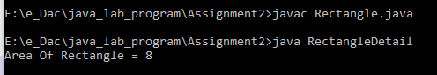

**2. Write Java programs to Calculate area and circumference of circle using multiple classes**

class Area

{

private double pi=3.14, r;

void getRadius(double r)

{

this.r = r;

}

void Area()

{

System.out.println("Area of Circle = "+ pi*r*r);

}

}

class Circumference

{

private double pi=3.14, r;

void getRadius(double r)

{

this.r = r;

}

void Circumference()

{

System.out.println("Circumference of Circle = "+ 2*pi*r);

}

}

class CircleDetails

{

public static void main(String args[])

{

Area objArea = new Area();

Circumference objCir = new Circumference();

objArea.getRadius(2.5);

objArea.Area();

objCir.getRadius(2.6);

objCir.Circumference();

}

}

**output:**

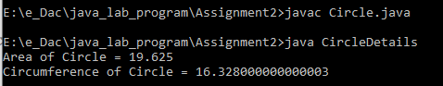

**3. Write Java programs to to find ASCII value of a character**

class Ascii

{

private char a;

void getData(char a)

{

this.a = a;

}

void getValue()

{

int b = a;

System.out.println("Ascii Value Of " + a + " is " + b);

}

}

class AsciiVal

{

public static void main(String args[])

{

Ascii obj = new Ascii();

obj.getData('b');

obj.getValue();

}

}

**Output:**

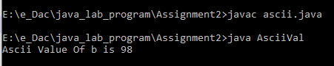

**4 Write a program to design a class to represent a bank account. Include the following   
members.**Date members   
• Name of depositor    
• Account Number    
 • Type of account    
• Balance account in the account    
**Methods:** **-**   
• To assign initial values    
• To deposit an account    
• To withdraw an account after checking balance.    
• To display the name and balance

class BankDetails

{

private String Name, AccountType ;

private int AccountNo;

double Balance;

void setData(String Name, int AccountNo, String AccountType, double Balance)

{

this.Name = Name;

this.AccountNo = AccountNo;

this.AccountType = AccountType;

this.Balance = Balance;

}

void Deposit(double amt)

{

Balance += amt;

System.out.println("Deposited Amount = "+ Balance);

}

void Withdraw(double amt)

{

System.out.println("Amount = "+ Balance);

Balance -= amt;

System.out.println("Amount After Withdrawl = "+ Balance);

}

void NameBalance()

{

System.out.println("Name = " + Name +"\n"+"Amount = " + Balance+" Rs/-");

}

}

class sbi

{

public static void main(String args[])

{

BankDetails obj = new BankDetails();

obj.setData("Hitesh Dayal", 342134774, "Saving", 56343);

obj.NameBalance();

obj.Deposit(2345);

obj.Withdraw(2345);

}

}

**Output:**

