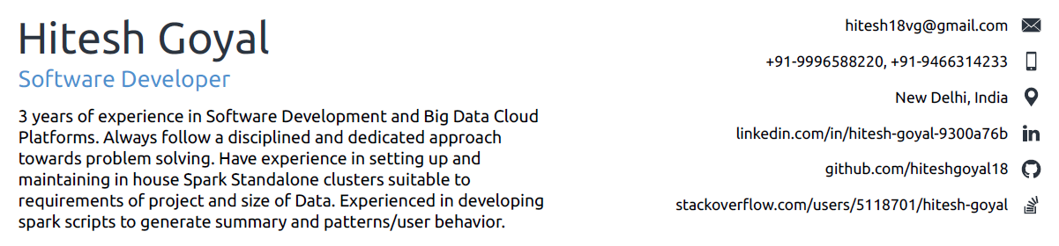



OBJECTIVE



To prove my credentials and worth to your esteemed organization by utilizing my inherent potential and qualification acquired and aspire for a professional career which will provide me an environment with unlimited growth opportunities.

WORK EXPERIENCE



**Q3 Technologies** October 2018 — Present

*Software Developer*

**SAAS - WWTS (World Wide Tech Services)**

Project Description :- WWTS keeps focus on delivering superior IT services, while expanding its people and systems to cover a global presence. We Have converted their WMP portal into a Web Service (<https://wmp.wwts.com>)

Extensively worked on Python, Flask, jQuery.



Built scalable Restful web services with Flask framework.



Integrated celery for background tasks in Flask application.



**ValueCoders Services LLP** March 2018 — October 2018

*Software Developer*

**ChatBot: Telegram Like Application.**

A mobile Chat application (on the top of telegram) using Flask library of python and telethon library for telegram.

Integrated Telethon Library of Python with the Flask Rest Services.



**Case Study: Anomaly Detection (ML).**

Detecting anomalies from a large data set by statistical approach using Gaussian distribution.



**Simpli5d Technologies Pvt Ltd** July 2016 — February 2018

*Software Developer*

**Online Bot Detection.**

Extracted features describing online user behavior using Apache Spark for processing Big Data from amazon S3.



Implemented Decider-Worker model of the product using workflows including Amazon EMR, Amazon SWF and Python Boto3 library.



**In House Spark Cluster.**

Set up an in-house Spark cluster for parallel processing with flexibility for dynamic configuration, removing dependencies on Amazon EMR while retaining full functionalities.



**Ad-Viewability Project.**

Developed Spark Scripts generating key performance indicators for an online advertiser across more than 200 publishers.



**Campaign Management Project.**

Worked on hugely popular libraries like react-native-autotags, react-navigation and created application for managing publisher and Ads targeting.



TECHNICAL SKILLS



**Python (2.x and 3.x).**

Expertise in python Core Concepts including OOP, Data Structures.



2+ years of experience in python including boto3, PySpark, pandas, sqlalchemy, requests libraries. Deep understanding of python frameworks including Flask/Django.



**Apache Spark.**

Extracting, transforming and selecting features from raw data. Aggregation of data sets using Spark Dataframes



Have experience in setting up and maintaining in house **Spark Standalone clusters** suitable to requirements of project and size of Data.



**Amazon Web Services (AWS).**

Keen knowledge of AWS including **Amazon SWF, S3, EMR, EC2, Lambda, Kinesis, Dynamo DB**.



Implemented Amazon **SWF** using python **boto3** library to automate job scheduling with intelligent logics.



**Other Technical skills**

Keen knowledge of Java (core+advanced), MySQL, Postgresql, Android App Development (Developed and Android App to manage attendance). Have good knowledge of Javascript, jQuery, React Native also.



|  |  |
| --- | --- |
| EDUCATION |  |
|  |  |
| **B. Tech in Information Technology** | July 2012 — July 2016 |
| *Guru Jambheshwar University of Science & Technology, Hisar* |  |
| Completed Bachelors with 78.3%. |  |
| **Senior Seconday** | April 2011 — March 2012 |
| *Daffodils Public School* |  |
| Completed with 80.6%. |  |
| **Secondary** | April 2009 — March 2010 |
| *Daffodils Public School* |  |

Completed with 8.2 CGPA

2

STRENGTHS



Punctuality



Good co-ordination



**Very Strong Memory in case of numbers**.



Always ready for emergency situation with utmost dedication.



Understanding a Problem Statement and implementing a Solution.



PERSONAL DETAILS



Father’s Name : Mr. Vijay Goyal



Date of Birth : 23rd Feb, 1994



Nationality : Indian



Passport : N6728712



Marital Status : Unmarried



Language Known : English, Hindi, Punjabi, Haryanvi





DECLARATION



The information I have provided is true to the best of my knowledge and belief.

Date: -

Place: - New Delhi **(Hitesh Goyal)**

Hitesh Goyal 3