Nestlé India Ltd
A Financial Performance & Ratio Analysis, FY2015–FY2026
Business Analytics Project
Prepared by: Hiteshi
July 2026
Tools used: Excel (financial model with cross-sheet formulas & dashboard) · R (statistical analysis & forecasting) · Data source: Screener.in (standalone financials, sourced from Nestlé India audited annual reports)

1. Executive Summary
This report analyses Nestlé India Ltd's standalone financial performance over FY2015–FY2026 using data sourced from Screener.in. The analysis combines an Excel financial model (multi-sheet workbook with cross-sheet ratio formulas and a visual dashboard) with statistical analysis in R (growth rates, correlation analysis, and a linear regression-based forecast).
Nestlé India delivered steady, high-quality growth over the period: revenue grew at an 11.2% CAGR and net profit at a 23.3% CAGR (FY2015–FY2023, the last comparable 12-month years), supported by consistently expanding operating margins (19% to ~24%) and an exceptionally efficient, negative working-capital cycle. The company began a significant capacity expansion (capex) programme from FY2024 onward, which — combined with a one-time change in financial year-end — materially altered the shape of the recent numbers and is the central analytical theme of this report.
Key findings:
- Nestlé India changed its financial year-end from December to March in 2024, creating a 15-month 'stub' reporting period (FY2024) that inflates YoY growth figures and must be excluded from clean trend/CAGR analysis.
- Operating margin has been remarkably stable (22.5% average, SD 1.75 excluding the stub year), reflecting strong pricing power and cost discipline typical of a premium FMCG portfolio.
- ROCE peaked at 169% in the FY2024 stub period and then fell sharply to 84% by FY2026, driven by a capex supercycle — Fixed Assets + CWIP roughly doubled from ₹3,402 Cr (FY23) to ₹6,797 Cr (FY26).
- The capex–ROCE relationship is weak over the full 12-year period (r = 0.14) but strongly negative in the FY23–FY26 subperiod (r = −0.80) — a regime change that a single full-period correlation would have hidden.
- Nestlé runs a structurally negative Cash Conversion Cycle (around −19 to −24 days in most years), meaning suppliers effectively fund its working capital — a hallmark of strong bargaining power in the FMCG value chain.
- Borrowings spiked to ₹1,167 Cr in FY2025 (funding the capex programme) before being paid down to ₹444 Cr in FY2026.

2. Data & Methodology

2.1 Data Source
All figures are standalone (non-consolidated) financials for Nestlé India Ltd, sourced from Screener.in, which compiles data from the company's audited annual reports and BSE/NSE filings. All values are in ₹ Crores unless otherwise stated. Data covers FY2015 through FY2026 (12 reporting periods).

2.2 The FY2024 Transition Period
In 2024, Nestlé India changed its financial year-end from 31 December to 31 March, aligning with the standard Indian statutory fiscal year. This produced a one-time 15-month reporting period (January 2023 – March 2024), labelled 'FY2024 (15M)' throughout this report and the accompanying workbook. Because this period covers 15 months instead of 12, its Sales, Profit, and cash flow figures are not directly comparable to adjacent years, and it is excluded from CAGR and descriptive-statistics calculations to avoid distortion — the same caution that would apply to a corporate restructuring or de-merger event.

2.3 Tools & Techniques
- Excel: A 6-sheet workbook (Read Me, P&L, Balance Sheet, Cash Flow, Ratios, Dashboard) with all ratios computed via live cross-sheet formulas — nothing is hardcoded — plus a 2×2 chart dashboard.
- R (base R, no external packages): year-on-year growth rates, CAGR, descriptive statistics, Pearson correlation analysis, and an OLS linear regression trend/forecast.

3. Revenue & Profitability Trends
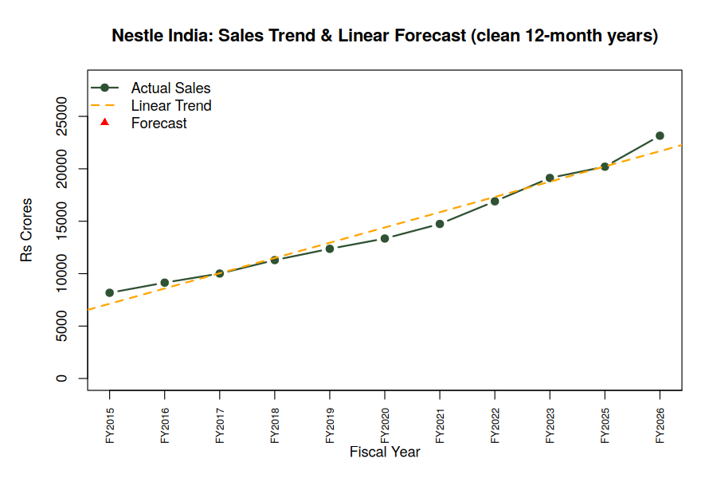
Figure 1: Sales trend (clean 12-month years) with linear regression trend line and 2-year forward projection.
Excluding the FY2024 stub period, Nestlé India's sales grew from ₹8,175 Cr (FY2015) to ₹19,126 Cr (FY2023) — an 11.2% CAGR — before continuing to ₹23,155 Cr by FY2026. A simple OLS linear trend fitted to the 11 clean fiscal years (R² = 0.97) projects sales of roughly ₹23,100–24,600 Cr for the next two comparable years — broadly in line with the FY2026 actual of ₹23,155 Cr, suggesting the business is currently tracking close to its long-run linear trend rather than sharply accelerating or decelerating.
Net profit grew faster than sales over the same period (23.3% CAGR vs. 11.2%), reflecting margin expansion and operating leverage — profit growth has consistently outpaced revenue growth in most years except FY2020–FY2021, when COVID-related cost pressures compressed the gap.
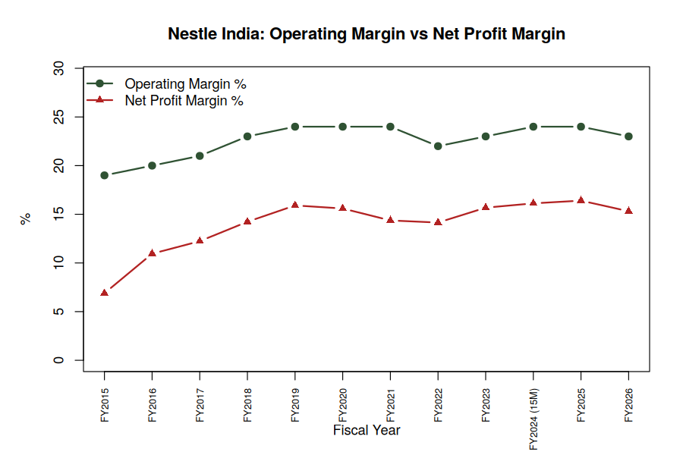
Figure 2: Operating margin vs. net profit margin, FY2015–FY2026.
Operating margin has been stable and gently rising — from 19% in FY2015 to a range of 22–26% in recent years (mean 22.5%, standard deviation of only 1.75 percentage points, excluding the stub year), which is a strong signal of pricing power and disciplined cost management in a business selling largely non-discretionary packaged food and beverage products. Net profit margin is more volatile (mean 13.8%, SD 2.82) since it also reflects swings in other income, interest costs, and tax rate.

4. Returns & the Capex Supercycle
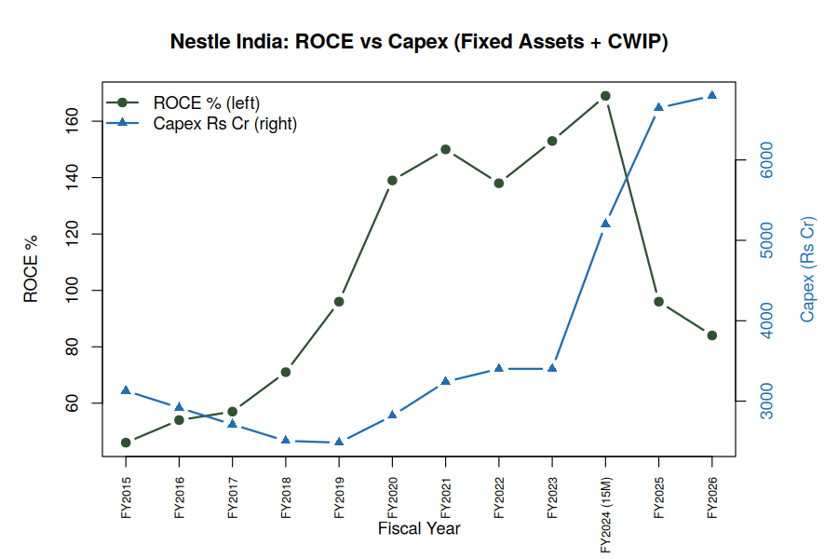
Figure 3: ROCE (%) vs. Capex — Fixed Assets + Capital Work in Progress (₹ Cr).
ROCE climbed steadily from 46% (FY2015) to a peak of 169% in the FY2024 stub period, as the company ran a relatively asset-light model with limited fresh capex through most of the 2015–2023 window. From FY2024 onward, Nestlé India entered a visible capacity expansion phase: Fixed Assets + CWIP roughly doubled from ₹3,402 Cr (FY2023) to ₹6,797 Cr (FY2026), pulling ROCE down to 84% by FY2026 even as absolute profit kept growing.
A useful methodological note: the Pearson correlation between capex and ROCE across the full FY2015–FY2026 period is weak (r = 0.14), because capex actually fell during FY2015–FY2019 while ROCE was rising — an opposite-direction relationship from what we see later. Restricting the correlation to the FY2023–FY2026 capex-supercycle years alone gives r = −0.80, a much stronger and more intuitive relationship. This illustrates a common pitfall in time-series analysis: a single correlation coefficient computed over a long period can mask a genuine regime change partway through — the trend, not just the summary statistic, needs to be inspected.
Borrowings tell a related story: they rose sharply to ₹1,167 Cr in FY2025 — most plausibly to bridge-finance the capex programme — before being paid down to ₹444 Cr in FY2026, consistent with a short-term, self-liquidating financing need rather than a structural increase in leverage. The company remains, per Screener's own assessment, 'almost debt-free' on a longer view.

5. Working Capital Efficiency
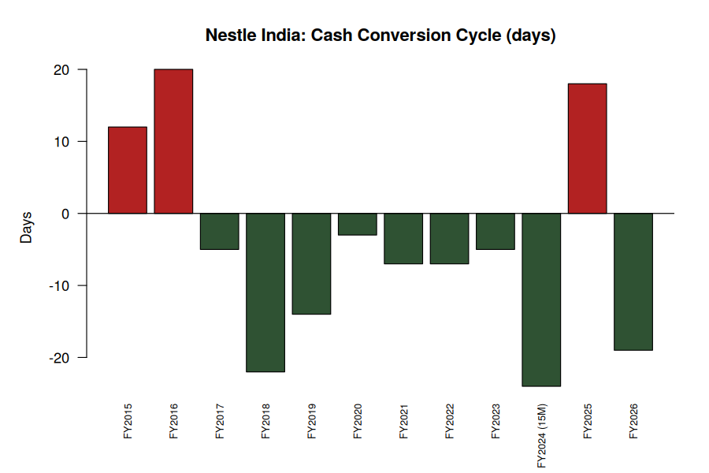
Figure 4: Cash Conversion Cycle (days), FY2015–FY2026.
Nestlé India operates with a structurally negative Cash Conversion Cycle in almost every year of the analysis period (as low as −24 days in FY2026), meaning the company collects cash from customers and sells inventory faster than it pays its own suppliers. This is a hallmark of strong bargaining power in the FMCG value chain — effectively, suppliers help fund Nestlé's working capital rather than the other way round. Debtor days are consistently in the low single digits (3–7 days), underscoring a business that sells largely for cash or very short credit through modern trade and distributor networks.

6. Key Financial Ratios Summary
Metric | FY2015 | FY2020 | FY2023 | FY2026
Sales (₹ Cr) | 8,175 | 13,350 | 19,126 | 23,155
Net Profit (₹ Cr) | 563 | 2,082 | 2,999 | 3,545
Operating Margin % | 19% | 24% | 23% | 23%
Net Profit Margin % | 6.9% | 15.6% | 15.7% | 15.3%
ROCE % | 46% | 139% | 153% | 84%
Debt-to-Equity | 0.01x | 0.07x | 0.11x | 0.08x
Cash Conversion Cycle (days) | 12 | −3 | −5 | −19
Dividend Payout % | 83% | 93% | 56% | 65%

7. Limitations
- Standalone (not consolidated) figures are used throughout, consistent with the historical Screener.in presentation for this company.
- The FY2024 15-month transition period limits like-for-like comparability for that specific year; it is flagged wherever it affects a calculation.
- The R forecast is a simple linear (OLS) trend on 11 data points — a directional indicator only, not a substitute for a bottom-up forecast incorporating volume, pricing, input-cost, and category-level assumptions.
- ROE is computed here using year-end (not average) equity, so it will run slightly higher than Screener's own reported ROE, which uses average equity — both are noted in the workbook.

8. Conclusion
Nestlé India's FY2015–FY2026 track record shows a durable, high-margin FMCG franchise with strong pricing power and an efficient, supplier-funded working capital model. The recent fall in ROCE from a FY2024 peak of 169% to 84% by FY2026 is not a sign of deteriorating profitability — profit growth has continued — but reflects a deliberate capacity expansion programme that is temporarily diluting capital efficiency ratios while new assets ramp up utilisation. Investors and analysts tracking this business going forward should watch capacity utilisation and post-expansion ROCE trajectory as the key indicator of whether this capex cycle pays off as intended.

