|  |  |
| --- | --- |
| Name: Hiteshi Shah (hss7374) | Foundations of Computer Vision  Due: 02/10/2018 |

**HW02**

a. **Overview**

For this assignment, our task was to plot a square wave by adding up sine waves that get smaller and smaller using the following equation:

$$f\left(x\right)= \frac{4}{π} \sum_{k=1, 3, 5…}^{∞}{\frac{1}{k}} sin\left(\frac{kπx}{λ}\right)$$

where $λ$ is the wavelength

b. **Conclusions**

The graph that my program gave out:

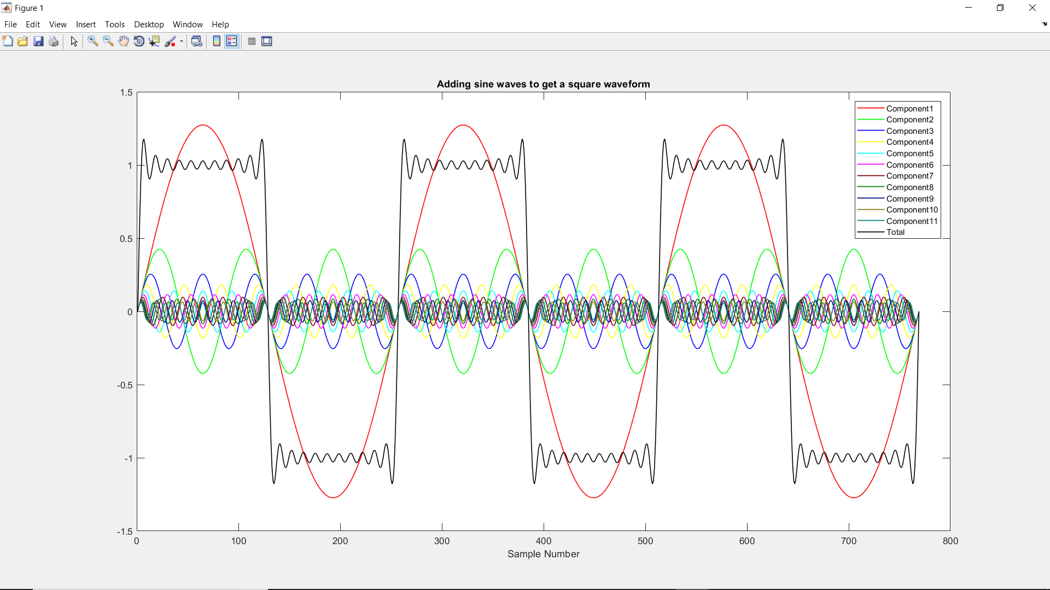

Through this assignment I’ve learned what a square wave is and how it can be achieved by adding sine waves. I had difficulty figuring out how to plot several sine waves in one graph at first but I quickly learned that it can be done using **hold on** in Matlab. I’ve also learned how to display a legend, add a title, and label the axes to a plot in Matlab.