|  |  |
| --- | --- |
| Name: Hiteshi Shah (hss7374) | Foundations of Computer Vision  Due: 02/15/2018 |

**HW04**

a. **Overview**

In this assignment, we’re provided with two images, each of which has exposure or contrast problems. Our task was to try different methods for solving the exposure problem and displaying the final “fixed” image along with a title that includes the name of the method.

b. **Sub-Sections Per Part:**

i. Approach Used

After having passed the filename to the function, I performed different transforms on the given image separately and saved the transform which gave the highest contrast.

ii. Experiment

For each of the images, I chose a particular section of the image to measure the contrast after applying each transform.

For “MG_6373_Integrated_Circuits.jpg”, I chose the bottom right part of the image that has an IC with text written on it:

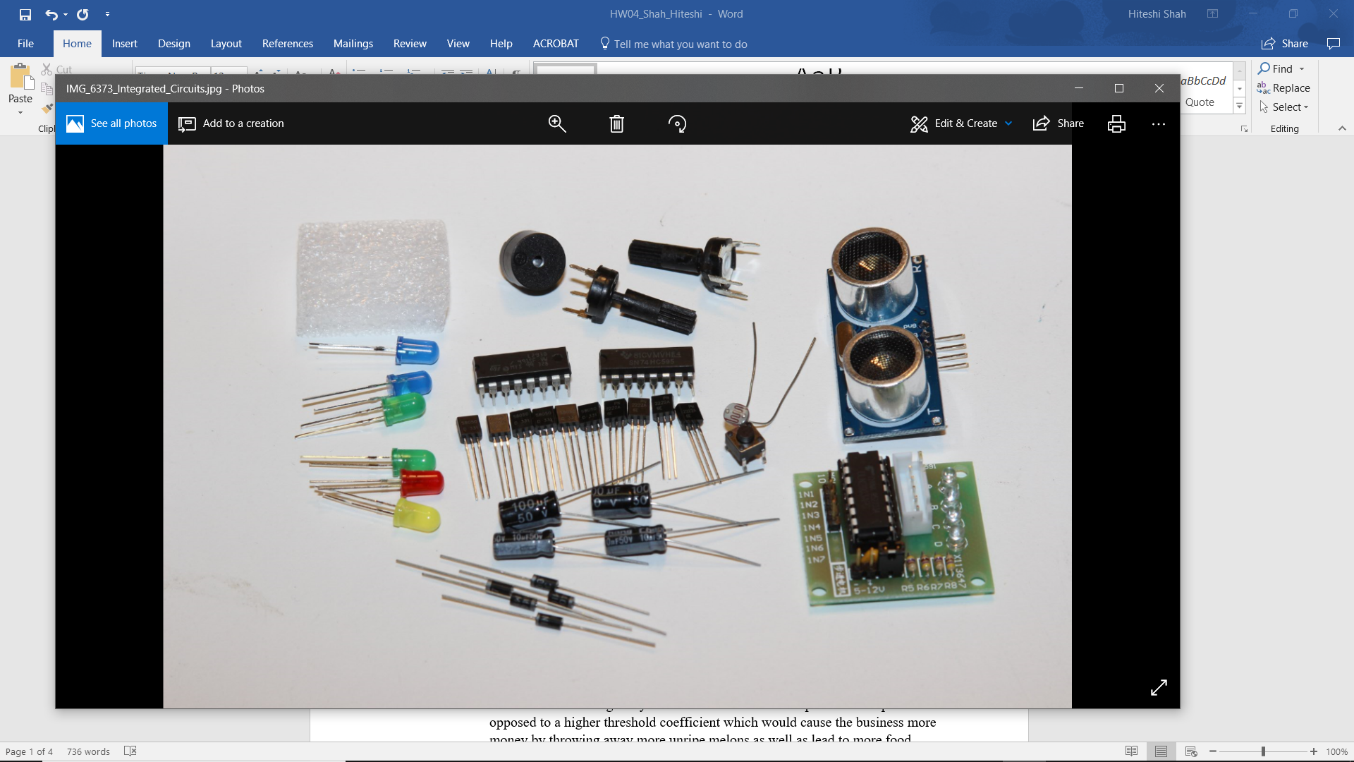

For “Might_Or_Might_NOT.jpg”, I chose the rightmost boat along with the text on its back:

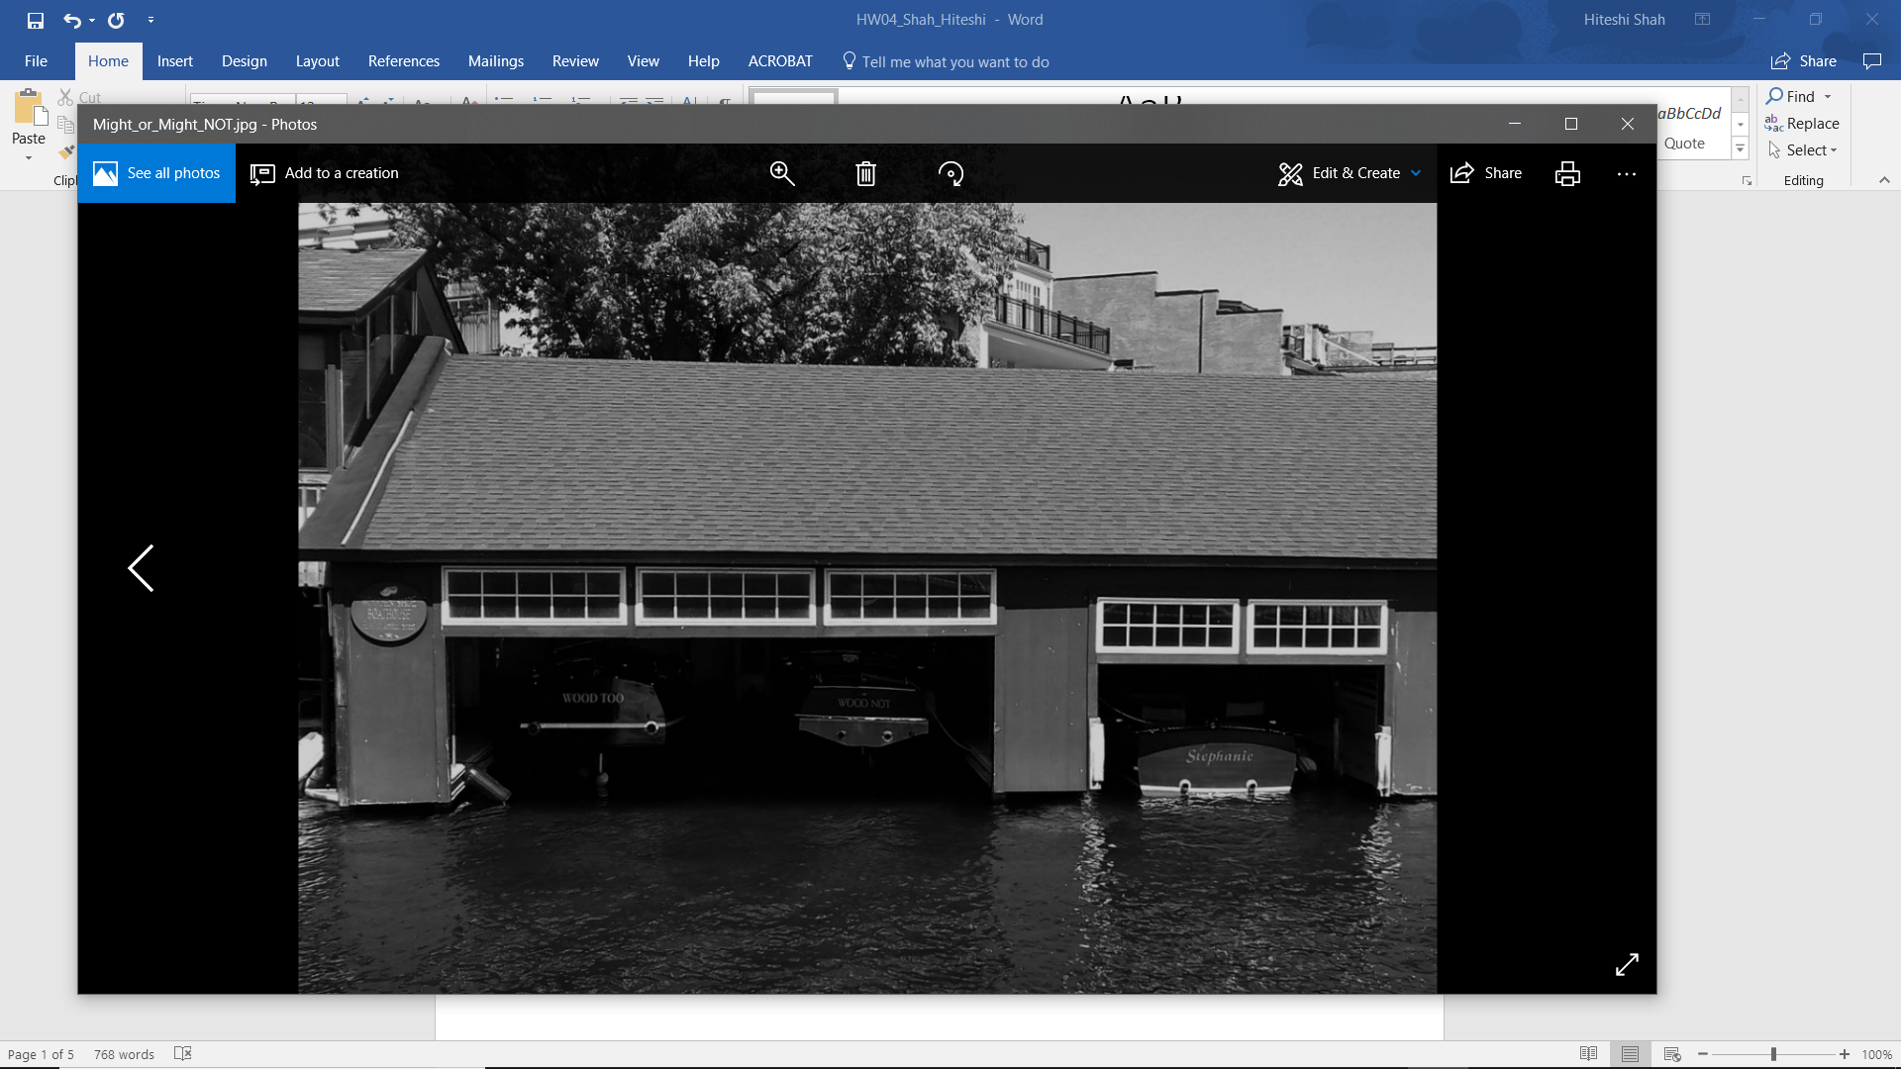

Over these regions of interest, I ran 9 different transforms and calculated the contrast by subtracting the lowest pixel value from the highest. The transforms that I used include: log transform, gamma transform, exponential transform, square-root transform, cube-root transform, square transform, histogram equalization, adaptive histogram equalizing, and contrast stretching. I used a switch statement to which I passed the name of the transform that gave the highest constrast and displayed the final image titled with the transform’s name.

iii. Results

For “MG_6373_Integrated_Circuits.jpg”, the gamma transform provided with the best contrast to be able to read the text on the ICs:

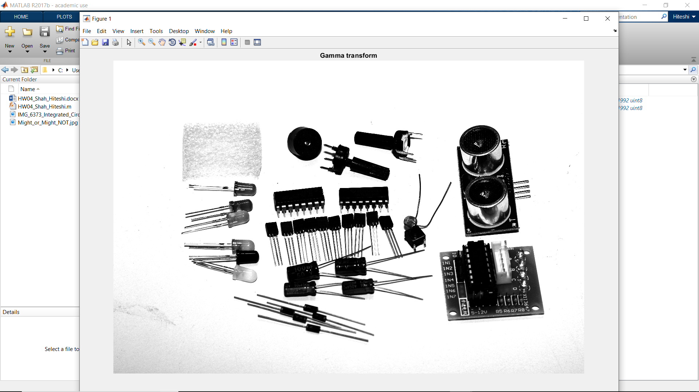

For “Might_or_Might_NOT.jpg”, the logarithm transform provided with the best contrast to be able to read the text on the backs of the boats as well as the sign:

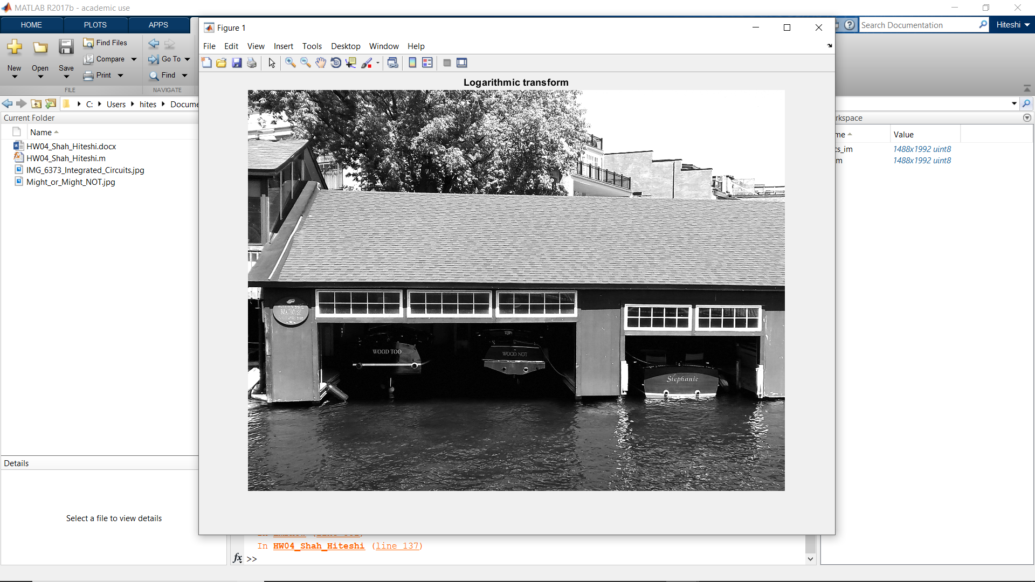

iv. Analysis

The one issue that I faced with this assignment was applying the appropriate transform to the “Might_or_Might_NOT.jpg” image. Even with the logarithmic transform, it’s not very easy to read the text on the sign. I tried using the sign as the region of interest and finding the perfect transform for the entire image which resulted in a very dark image where the text on the backs of the boats were not legible, even though the text on the sign was.

c. **Conclusions**

For the gamma transform of “MG_6373_Integrated_Circuits.jpg”, I used the value of gamma as 3.0 because for values of gamma > 1, the contrast of the high-value regions of the image were enhanced at the expense of the low-value portions.

The logarithmic transform of “Might_or_Might_NOT.jpg” enhances the darker regions of the image without cutting off the lighter regions.