|  |  |
| --- | --- |
| Name: Hiteshi Shah (hss7374) | Foundations of Computer Vision  Due: 03/04/2018 |

**HW08**

1. **Overview**

The goal of this assignment is to write a program which takes in image and counts the number of dice in it, as well as the number of dots on each of the dice.

2. **Approach Used**

For this assignment, I first checked the dimensions of the image being read in to make sure in the image is in landscape mode. If the width of the image was smaller than its height, I rotated it.

Since some dice has red lettering on them, I extracted only the red channel of the image so that the red logo blends into the white body of the dice.

In order to use morphological operations on the image, I converted it from grayscale to binary. Once in binary, I first used the erosion operation on the image to make the white specks in the background go away. I then used the dilation operation to make the black dots on the white dice go away to be able to use the bwlabel() function to count the number of dice in the image.

Now, I used the ‘BoundingBox’ property of the regionprops() function to calculate the smallest rectangle bounding each of the connected components (dice). Then using this information I reduced the original binary image to just the bounding box of the each die and took its complement in order to use the bwlabel() function to count the number of dots on each die. But before using the bwlabel() function, I used the dilation operation to make the black dots on the white dice more prominent.

Finally, I used the bwboundaries() function to plot a red boundary around each die in the image.

3. **Results**

INPUT FILE NAME: img_6858__unk.jpg

Number of dice: 14

Number of 1 's: 3

Number of 2 's: 1

Number of 3 's: 1

Number of 4 's: 6

Number of 5 's: 3

Number of 6 's: 0

Number of unknowns: 0

Total of all dots: 47

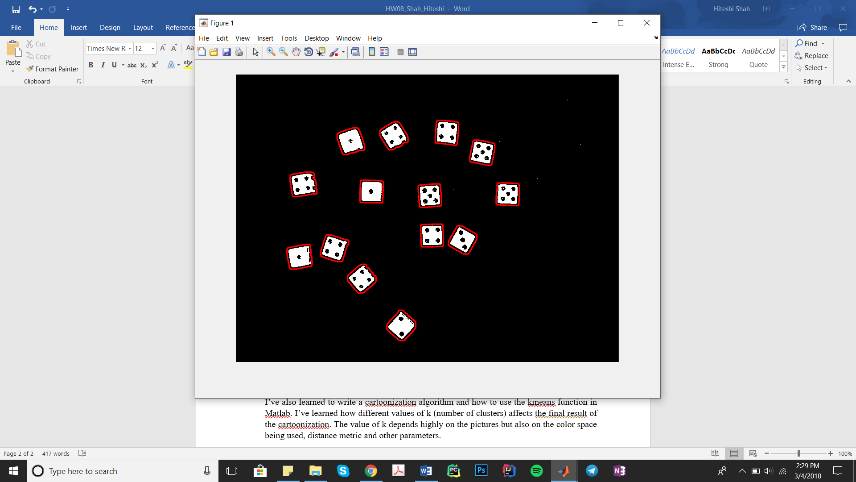

4. **Discussion**

It took a lot of trial and error with the morphological operations to figure out what parameters worked best. Also, figuring out how the regionprops() function worked was challenging.

While the program works fine for most of the input images, it outputs the wrong number of dice when the dice are touching, or the wrong number of dots when the side of the dice are visible.

5. **Conclusions**

In this assignment, how using a particular color channel can be useful to get the information we want. I’ve also learned the importance of using binary images for segmentation.

I’ve also learned various Matlab functions such as bwlabel(), regionprops(), bwconncomp(), bwboundaries() etc., and how each of these can be used for image segmentation.