|  |  |
| --- | --- |
| Name: Hiteshi Shah (hss7374) | Foundations of Computer Vision  Due: 03/25/2018 |

**HW11**

1. **Overview**

The goal of this assignment is to write a program which displays the input image with a magenta circle around each washer, or partial washer, found in the image.

2. **Approach Used**

For this assignment, I first converted the image to binary in order to be able to perform morphological operations on it. I then used the closing operation on the image to make the white specks on the black background go away as well as enhance the white washers. Once I got a cleaner image, I resized the image by scaling it down so that the radii of the washers would be easier to detect. Then using bwlabel(), I got the labelled matrices of the white washers and on each matrix, I used the hough transform to find circles of radii ranging from 30 to 100 pixels. I then displayed the output image with a magenta circle around each washer with a magenta plus sign at the center.

3. **Results**

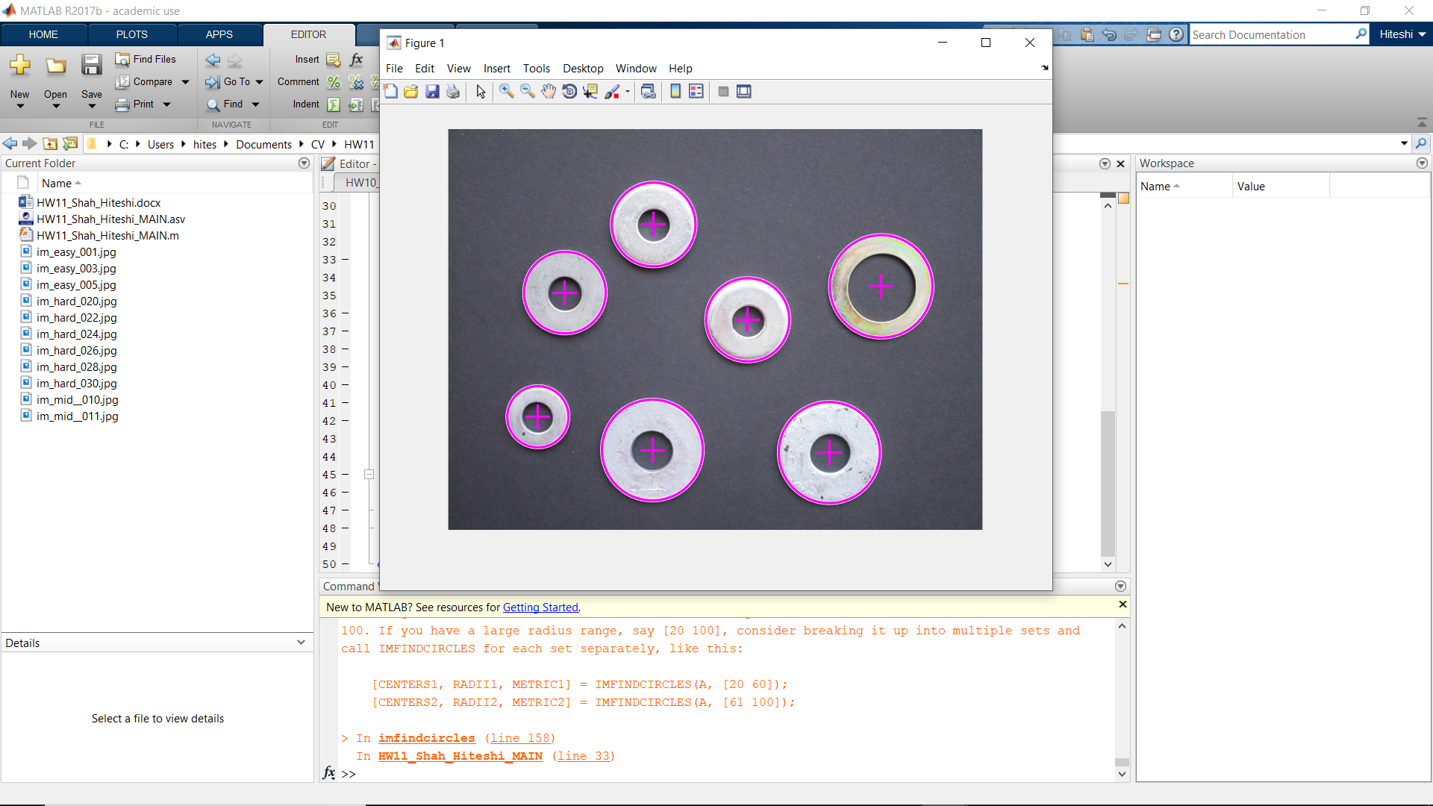

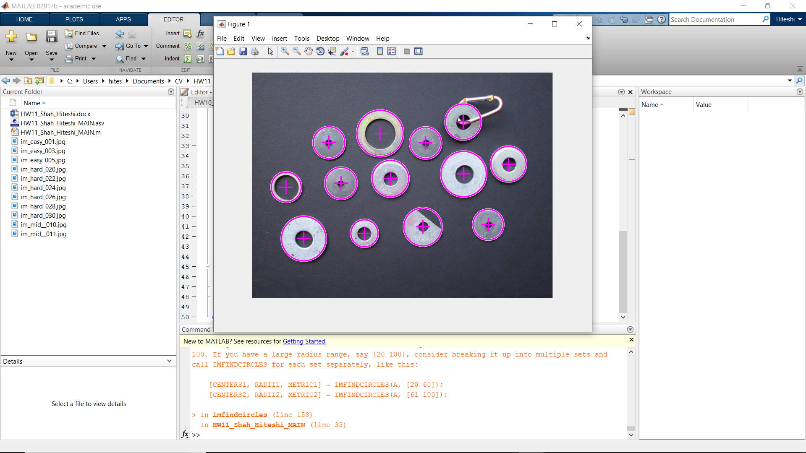

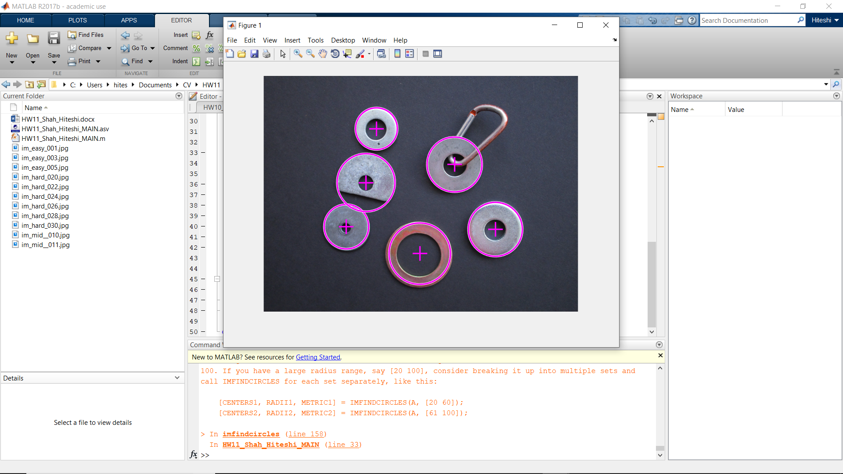

4. **Discussion**

It took a lot of trial and error with the morphological operations to figure out what parameters worked best.

While the program works fine for most of the input images, it sometimes misses a washer or plots a circle around the latch on one of the washers in the hard images.

5. **Conclusions**

In this assignment, I’ve learned the importance of using binary images for segmentation and performing morphological operations.

I’ve also learned how to use the Matlab function imfindcircles() that uses the Hough transform to find circles in the image.