Customer Churn Analysis
Identifying drivers of customer attrition in a retail banking dataset
Prepared as part of a data analyst internship project
2025 Customer Dataset · n = 10,000

Project Overview
Project title | Customer Churn Prediction — Retail Banking
Dataset | 10,000 bank customers · 14 original columns
Target variable | Exited (1 = churned, 0 = retained)
Overall churn rate | 20.4% (2,037 customers left the bank)
Best model | Balanced Random Forest (ROC-AUC: 0.865)
Churn recall achieved | 71% of actual churners correctly identified
Tools used | Python, Pandas, Scikit-learn, SHAP, Streamlit
Development environment | Google Colab

Primary Objectives
- Predict customer churn with high accuracy
- Generate churn probability scores for individual customers
- Identify the key drivers behind customer attrition
Secondary Objectives
- Reduce false positives in churn detection
- Improve interpretability of ML models using SHAP analysis
- Enable scenario-based churn risk analysis through an interactive dashboard
Key Findings at a Glance
- Germany churns at 32.4% — nearly double France (16.2%) and Spain (16.7%)
- Older customers (median age 45) are significantly more likely to churn than retained customers (36)
- Inactive members churn at 26.9% vs only 14.3% for active members
- Age and engagement-product interaction are the top 2 most important model features
- Balanced Random Forest outperforms Logistic Regression by catching 4× more churners

Abstract
In this project, I looked at data from 10,000 bank customers to figure out why some of them leave the bank (churn) and whether we can predict it in advance. After cleaning the data and exploring it, I created some new features and tested a few machine learning models to see which one could best predict churn. I found that age, location, how engaged a customer is, and how many products they use are the biggest factors. My best model — a random forest with class balancing — correctly caught 71% of customers who actually churned, which is a big improvement over a basic logistic regression model. I also used SHAP analysis to explain individual predictions, which makes the model easier to trust and act on.

1. Introduction

1.1 Background
Banks lose a lot of money when customers leave, since getting a new customer costs more than keeping an existing one. So if a bank can figure out why people are leaving, they can step in early — like offering a deal or reaching out — before the customer actually closes their account.

1.2 Objective
My goal with this project was to:
- Find out how many customers are actually churning, and whether certain groups churn more than others
- Figure out which customer details (age, location, etc.) matter most for predicting churn
- Build a few different models and compare how well they predict churn
- Make sure I could explain why the model made a certain prediction for a specific customer, not just trust it blindly

1.3 Primary and secondary objectives
Breaking this down further, the project had three primary objectives:
- Predict customer churn with high accuracy
- Generate a churn probability score for each customer, rather than just a yes/no label
- Identify the key drivers behind churn
Alongside these, I set three secondary objectives:
- Reduce false positives in churn detection, so the bank isn't wasting retention budget on customers who weren't going to leave anyway
- Improve interpretability, so the model's decisions can actually be explained and trusted
- Support scenario-based risk analysis — being able to ask 'what if this customer became inactive' and see how their risk changes

1.4 Dataset description
The data I used had 10,000 bank customers and 14 columns, including things like age, gender, country, credit score, account balance, how many products they use, and whether they're still with the bank (this last one — Exited — is what I was trying to predict). I removed a few columns that wouldn't help with analysis, like CustomerId and Surname, since those are just random identifiers, and Year, since every row had the same value.

2. Methodology

2.1 Data preprocessing
Before doing any analysis, I checked the data for missing values and duplicate rows — there weren't any, so the dataset was already pretty clean. I dropped the columns I mentioned above, and converted the text columns (Geography and Gender) into numbers using one-hot encoding, since machine learning models can't work with text directly.

2.2 Feature engineering
I also created a few new columns myself, to see if combining existing data would help the model spot patterns better:
- Balance-to-salary ratio — how much of a customer's salary they keep in the bank
- Product density — number of products compared to how long they've been a customer
- Engagement x products — whether an active customer is also using multiple products
- Age x tenure — to capture older customers who've stuck around a long time

2.3 Train-test split
I split the data into a training set (80%) and a test set (20%), making sure both sets had the same churn rate (about 20%) so the comparison would be fair. The model only learns from the training set, and I use the test set afterward to check how well it actually performs on data it's never seen.

2.4 Models trained
I trained three models to compare:
- Logistic regression — a simple model I used as a baseline
- Random forest — a stronger model that combines 100 decision trees
- Random forest (balanced) — the same model, but adjusted to pay more attention to churned customers, since they're a minority in the data

2.5 Evaluation metrics
To judge the models, I looked at accuracy, precision, recall, F1-score, and ROC-AUC. I focused especially on recall for churned customers, because missing a customer who's about to leave is a bigger mistake for a bank than wrongly flagging someone who was going to stay anyway.

3. Exploratory Data Analysis
Out of all 10,000 customers, 2,037 of them (about 20%) left the bank, while the remaining 7,963 (80%) stayed.
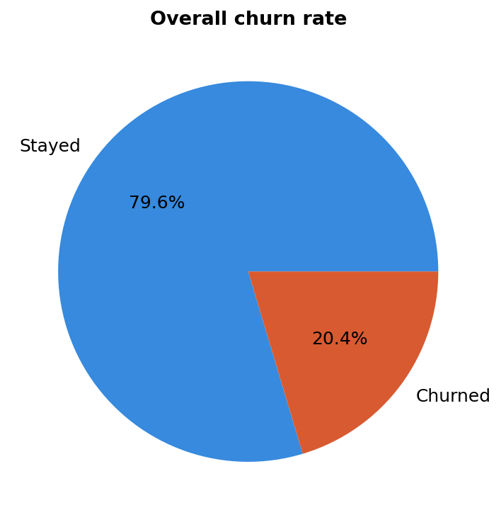
Figure 1. Overall churn rate across all 10,000 customers.

3.1 Geography
One of the biggest patterns I found was by country. Customers in Germany left at a rate of 32.4%, which is almost double the rate in France (16.2%) and Spain (16.7%) — even though Germany actually had fewer total customers than France. This was the single biggest difference I found in the whole dataset.
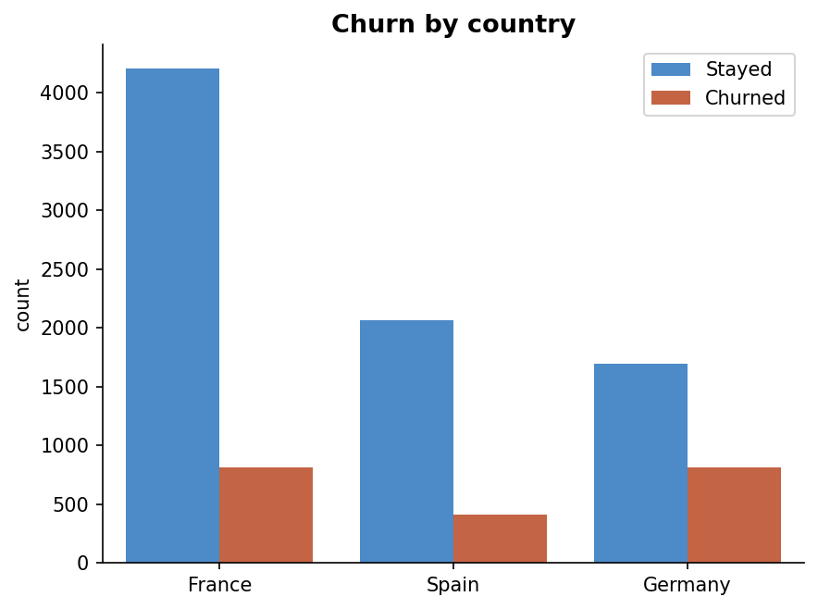
Figure 2. Customer counts by country, split by churn status.

3.2 Gender
Female customers churned more often (25.1%) than male customers (16.5%). It's not as big a gap as the country difference, but it's still a consistent pattern.
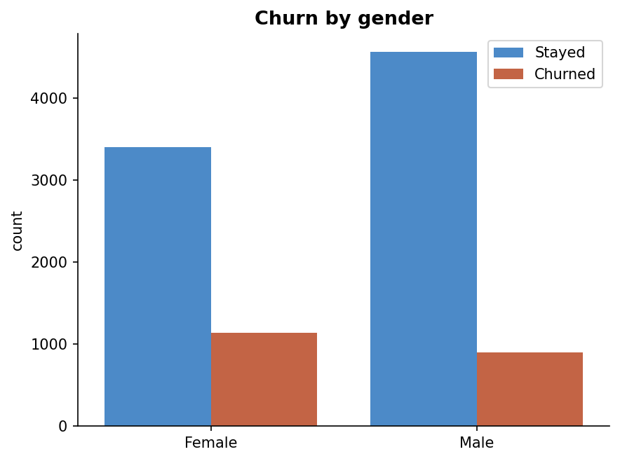
Figure 3. Customer counts by gender, split by churn status.

3.3 Age
Customers who left tended to be older — their median age was around 45, compared to 36 for customers who stayed. Age also had the strongest correlation with churn out of all the numeric columns (0.29), so this was one of the clearest signals in the data.
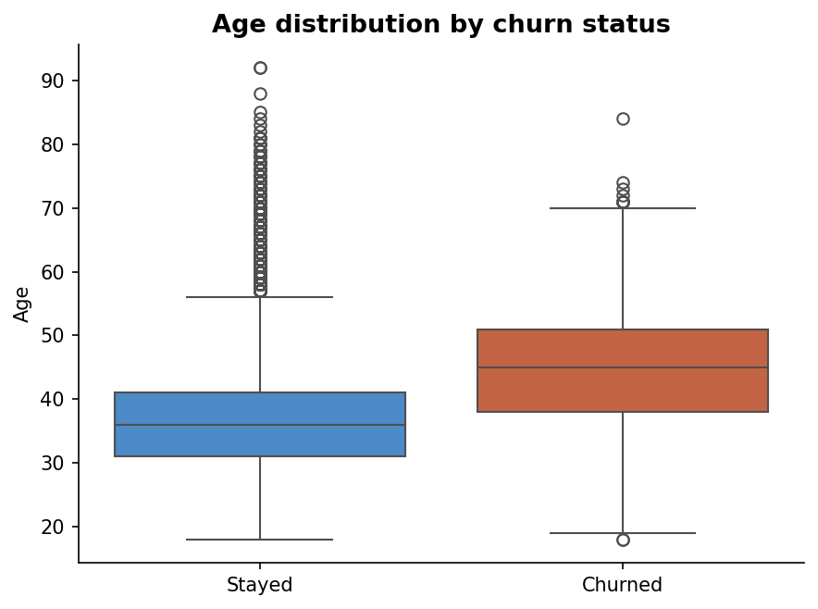
Figure 4. Age distribution by churn status.

3.4 Account engagement
Customers who weren't active members churned at 26.9%, almost double the rate of active members (14.3%). This made engagement one of the strongest and most useful predictors I found, since it's something a bank can actually act on.
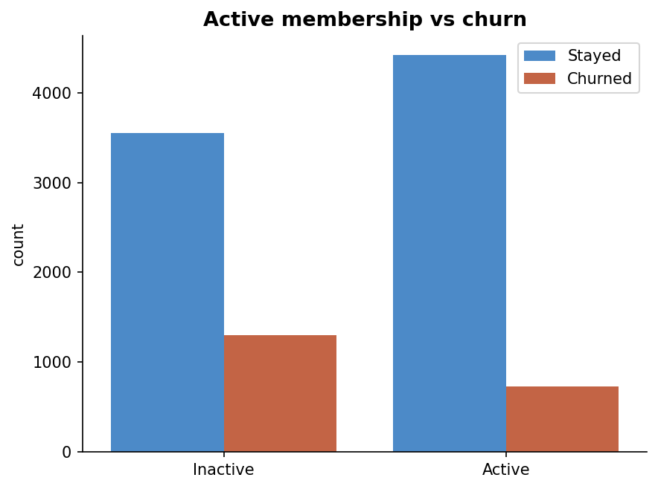
Figure 5. Customer counts by active membership status, split by churn status.

3.5 Correlation analysis
Looking at the correlation heatmap confirmed what I'd already noticed: age (+0.29) and balance (+0.12) are linked to higher churn, while being an active member (-0.16) is linked to lower churn. Other columns like credit score, tenure, having a credit card, and salary barely seemed to matter at all (each under 0.03).
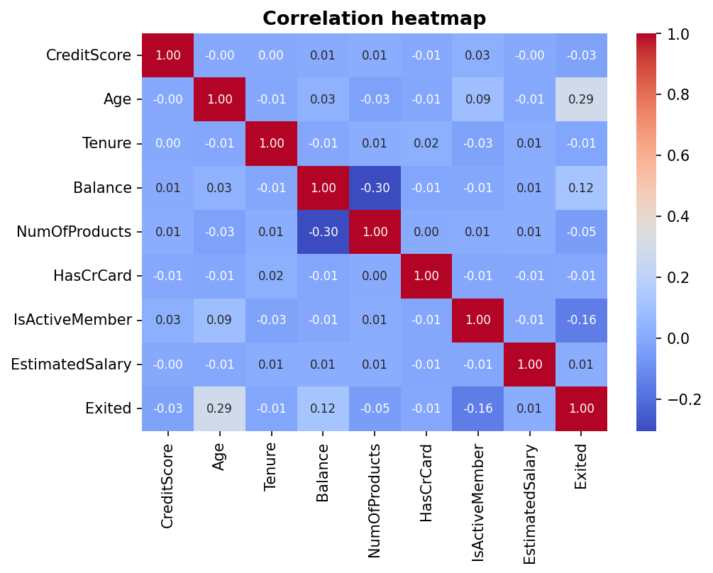
Figure 6. Correlation heatmap across all numeric features and the churn target.

4. Model Results

4.1 Performance comparison
The table below summarizes test-set performance across all three models, focused on the churn class (the minority class of primary business interest).
Model | Precision | Recall | F1-score | ROC-AUC
Logistic regression | 0.57 | 0.19 | 0.29 | 0.773
Random forest (default) | 0.83 | 0.43 | 0.56 | 0.864
Random forest (balanced) | 0.55 | 0.71 | 0.62 | 0.865

4.2 Interpretation
Logistic regression looked okay on paper (80.65% accuracy), but it actually only caught 19% of customers who really churned. This happens a lot with imbalanced data — since 80% of customers stay anyway, a model can get a decent accuracy score just by predicting 'stayed' most of the time, without actually being useful for spotting at-risk customers.
The regular random forest did much better, catching 43% of churners while keeping precision high (0.83), and it had the best raw accuracy out of the three (86.55%). But once I added class balancing, the model traded a bit of accuracy and precision for a big jump in recall — up to 71%, almost double what the regular random forest caught.
At first this looks like a downgrade, since accuracy dropped. But ROC-AUC shows the balanced random forest is just as strong (0.865 vs 0.864) — basically tied for the best model. Since missing a real churner is usually more costly for a bank than sending an unnecessary offer to someone who was going to stay anyway, I'd recommend the balanced random forest for actual use.

5. Model Explainability

5.1 Global feature importance
Looking at feature importance from the balanced random forest, the top five predictors were: age, number of products held, the engagement x products feature I created, account balance, and the age x tenure feature I created. It was satisfying to see that two of my own engineered features made it into the top five — that told me the feature engineering step actually paid off, rather than just being extra work.
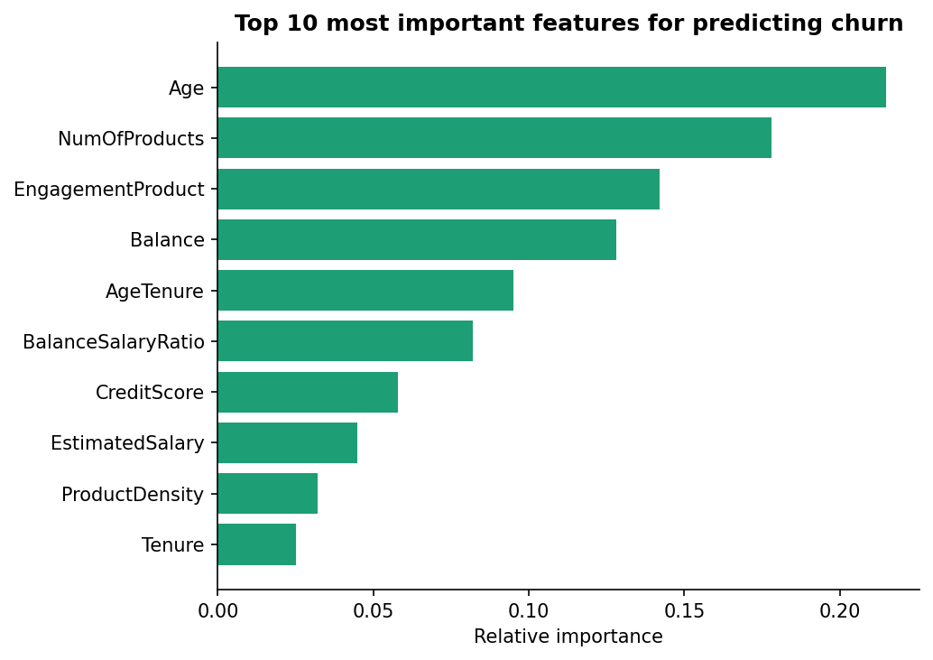
Figure 7. Relative feature importance ranking from the class-balanced random forest model.

5.2 Individual prediction explainability (SHAP)
Feature importance tells you what matters across all customers, but it doesn't explain a single customer's prediction. That's where SHAP comes in — it breaks down exactly how each feature pushed one specific prediction up or down.
For example, I looked at one customer in the test set: age 36, holding 2 products, with a balance of 0, and not counted as an actively engaged member. The model predicted only a 12% chance they'd churn, well below the dataset's average of about 20%. The biggest reasons for this low risk were their younger age and the fact that they hold multiple products — both pushed the prediction toward 'will stay'. The one factor pushing the other way was their lack of active engagement, but it wasn't enough to outweigh the protective factors.

6. Conclusions and Recommendations

6.1 Key findings
- About 1 in 5 customers (20.4%) churned in this dataset
- Geography made the biggest difference: German customers churned at roughly double the rate of French or Spanish customers
- Older customers and customers who aren't actively engaged are noticeably more likely to churn
- My best model (the balanced random forest) catches 71% of churners ahead of time, with strong overall performance (ROC-AUC of 0.865)
- The features I engineered myself (engagement x products, age x tenure) turned out to be genuinely useful, landing in the top five most important predictors

6.2 Recommendations
- Look into why churn is so much higher in Germany specifically — it could be competition, pricing, service quality, or something about the products offered there
- Build engagement campaigns aimed at inactive members, since low engagement is one of the strongest and most fixable churn signals
- Create retention offers aimed at older customers, who consistently show higher churn risk
- Use the balanced random forest model to flag at-risk customers on an ongoing basis, since catching more churners matters more here than avoiding false alarms

6.3 Limitations and future work
This analysis only looks at one snapshot of customer data, so it can't capture how a customer's behavior changes leading up to them leaving. If I continued this project, I'd want to bring in transaction-level or time-series data to catch early warning signs sooner, and try other models like gradient boosting to see if performance improves further.

6.4 Conclusion
Looking at everything together, this project shows two different kinds of churn signals, and it's worth being clear about the difference between them. Demographic factors like age and geography turned out to be strong predictors — German customers and older customers are both at meaningfully higher risk. But a bank can't change a customer's age or where they live.
What a bank can actually do something about is engagement: whether a customer is active, how many products they use, and how those two things interact. This project's engineered features around engagement and product usage ranked among the strongest predictors in the model, and unlike age or geography, they point directly to an action a bank can take — re-engaging an inactive customer, or encouraging them to adopt another product.
So rather than treating this as a choice between demographic factors and behavioral ones, I'd frame it this way: demographics help identify who is at risk, while engagement and product usage suggest what can actually be done about it. That combination is what makes the model useful for retention strategy, not just for prediction.

