How This Problem Can Be Solved
Root-cause intelligence for delivery failures and delays
Logistics operations | Solution design write-up

1. What we are solving
Current logistics systems are good at counting. They can say how many deliveries failed, how many were late, and which city or client looks worse this week. They are weak at explaining why. That gap is the problem.
When a delivery fails, the reason almost never lives in one system. The order file has timestamps and a status. The warehouse file may show a stockout or a slow pack. The fleet log may say the driver could not find the address or sat in congestion. The customer may write “no update from the driver.” Traffic, rain, festivals, and strikes sit in yet another feed. Because these records are not joined, managers investigate by hand. The work is slow, inconsistent, and always after the damage is done.
The business therefore needs a way to turn those silos into one explanation per incident and one pattern per city, client, warehouse, or season—plus a recommended action, not only a chart.

2. Why a dashboard of counts is not enough
A dashboard answers “how many?” Root cause answers “what should we change?” Those are different jobs. If Warehouse B is repeatedly late on dispatch, staffing the last mile will not fix it. If City A fails on address quality and City B fails on rain and traffic, one national playbook will waste money in both places. If a new client wants 20,000 extra orders a month, copying last month’s failure rate onto that volume is a capacity question, not a pie chart.
So the solution must correlate events, not only display them. Correlation means: this late order is the same order that had a warehouse stock delay, a “heavy congestion” GPS note, and a complaint about lateness. Once that link exists, patterns become visible: the same warehouse every August, the same city every festival window, the same client every time the address is incomplete.

3. The solution in one sentence
Build a shipment-centric root-cause layer that joins every domain onto the order, tags likely causes from evidence, writes a short human-readable briefing, and maps the top causes to operational actions.
Figure 1 is that flow.
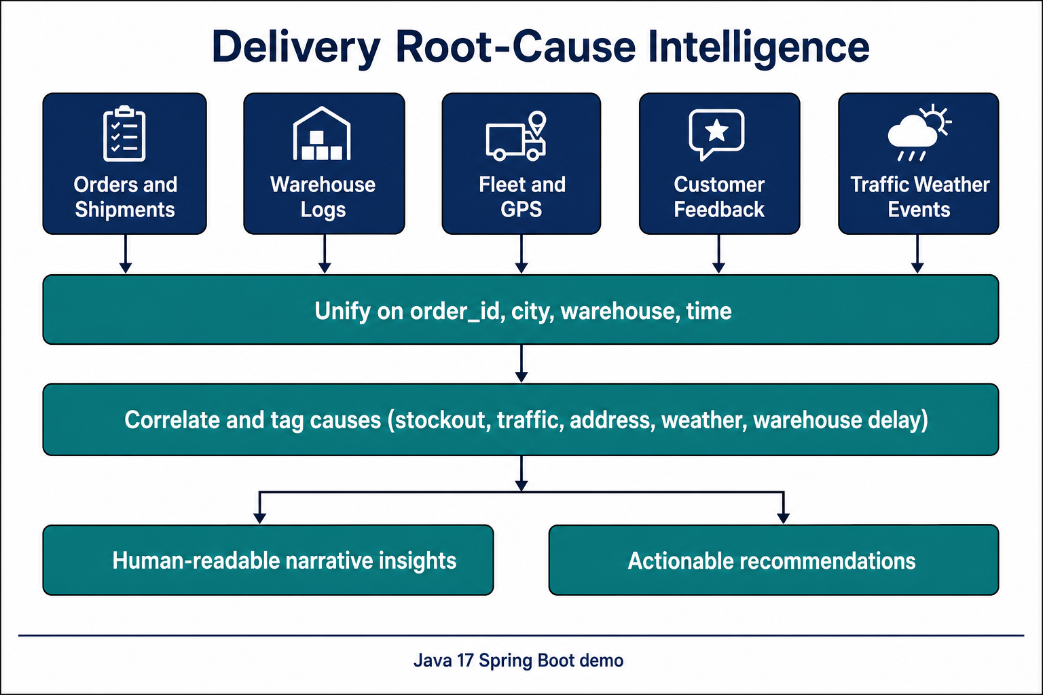
Figure 1. How the problem is solved: bring siloed data together, tag causes, then explain and recommend.

4. Step-by-step approach

Step 1 — Aggregate multi-domain data
Start with the order (or shipment) as the spine. Everything else must attach to it. Typical join keys are order_id, client_id, warehouse_id, driver_id, city, and time (order date, promised delivery, actual delivery, dispatch, GPS departure/arrival).
The domains to bring in are exactly those the business already has, even if they sit in different teams:
Domain | What it tells you | What is usually missing today
Orders & shipments | Promise vs actual, status, stated failure reason | Link to weather, traffic, warehouse dwell
Warehouse | Pick/pack/dispatch time, stock and system notes | Link to downstream late or failed delivery
Fleet & drivers | GPS notes: congestion, breakdown, address not found | Systematic coding of free-text notes
Customer feedback | Late, lost, rude, stock cancel, no update | Aggregation onto the same order
Context | Traffic, rain/fog, festival, holiday, strike | Use in the same report as the order
After the join, each shipment should have a single outcome label: delivered on time, delivered late, failed, returned, or still open after the promise. Without a shared outcome, “delay” means different things in each system.

Step 2 — Correlate events automatically
Do not wait for a large machine-learning project to get value. Define a short cause list that operations already understands, then tag a shipment whenever any source supports that cause.
A practical taxonomy:
- Warehouse: stockout, slow packing, system/WMS issue, late dispatch.
- Network: heavy traffic, weather (rain/fog), festival or holiday load, strike.
- Last mile: incorrect or hard-to-find address, vehicle breakdown.
- Customer / process: return or failed handover, no status update to the customer.
Rules are enough to start, and they are auditable. Examples: failure_reason = Stockout, warehouse note = “Stock delay on item”, and feedback = “cancelled due to stock issue” all raise STOCKOUT. GPS “Address not found” plus failure_reason “Incorrect address” plus a complaint about the wrong address all raise ADDRESS. Heavy traffic in the external feed plus a congestion GPS note raises TRAFFIC.
Important design choice: allow more than one tag on one shipment. Real failures are often stacked (late pack + rain + no customer update). Rank causes by how often they appear in the problem set (failed, delayed, returned, open-late). Attach sample order IDs so a manager can click through and disagree. If evidence is missing, say “insufficient evidence.” Never invent a cause.

Step 3 — Generate human-readable insights
Replace the raw dashboard with a briefing an operations manager can read in a minute. Every answer should contain:
- Scope — which city, client, warehouse, and dates.
- What happened — order count, problem count, problem rate, split of failed vs late vs returned.
- Why — ranked causes with percentages and a one-paragraph story.
- Whether it looks systemic or one-off — for example the same warehouse every week, or a single storm day.
The paragraph should sound like a colleague, not a log file. Example: “In New Delhi on this date, most problem shipments carry weather and stockout tags together. Attack those two first; address quality is also material and will not be fixed by extra riders.” A language model may polish wording later, but it must write from the tagged facts only.

Step 4 — Surface actionable recommendations
Each top cause maps to a playbook line. That mapping is how the system becomes operational, not merely analytical.
If the leading cause is… | Then recommend…
Stockout / inventory gap | Safety stock on high-risk SKUs; do not promise the customer until pick is confirmed
Warehouse delay, slow pack, WMS issue | Earlier cut-offs, extra pack-station staff at peaks, WMS failover checklist
Traffic congestion | Move delivery windows off peak hours; add rider buffer in that city
Weather | Weather-aware ETAs; pause non-critical COD in rain and fog
Address not found | Address and geocode checks at checkout; capture a landmark before dispatch
Vehicle breakdown | Spare vehicles on dense routes; auto-reassign when GPS stalls
Festival / holiday | Surge roster, inventory pre-positioning, freeze aggressive same-day SLAs
Large new client volume | Phase the onboard by city and warehouse; do not dump 20k extra orders onto the current SLA in one wave

5. How this answers the real questions managers ask
The product should be used as questions, because that is how the pain shows up in the business.
Question | What the solution does
Why were deliveries delayed in city X yesterday? | Slice that city and day. Rank tags among problem shipments. Recommend the top two local actions.
Why did Client X’s orders fail last week? | Slice that client and week. Show if the pain is one warehouse, one city, weather, or address quality.
Top reasons linked to Warehouse B in August? | Slice that warehouse and month. Emphasise warehouse-side evidence (dwell, stock, system) plus what happened downstream.
City A vs City B last month? | Same metrics side by side. If the number-one cause differs, do not apply one national fix.
Festival period — likely causes and how to prepare? | Compare festival-tagged work with a baseline week. Staff, inventory, and SLA changes before the peak, not after complaints.
Client Y adds ~20,000 monthly orders — new risks? | Apply current (or similar-client) failure mix to the extra volume. If that is many times today’s monthly load, treat it as a network redesign: caps, dedicated pack lines, extra fleet.

6. How to implement (from simple to production)
You do not need a multi-year platform to prove this. The same logic scales.
- Demonstration: load CSVs into memory, join on order_id, run the cause rules, print or return narratives. A Java 17 Spring Boot service is sufficient. This is what the accompanying program does.
- Near term: schedule a daily job that rebuilds the enriched shipment table in a warehouse. Serve the same questions through an API. Keep rules in version control so operations can review them.
- Later: live traffic and weather, streaming GPS, stronger scoring (official failure reason weighted higher than a weak weather flag), and a thin ops UI on the same API. Machine learning can rank causes once labels are trusted—it should not be the first step.

7. What good looks like
- Reproducible — same data, same explanation.
- Explainable — every cause cites a field, a note, or a count.
- Scoped — changing city, client, warehouse, or dates actually changes the story.
- Honest — empty slices and weak evidence are stated as such.
- Actionable — the last section of every answer is something a manager can assign this week.

8. Conclusion
Delivery failure is not mainly a reporting gap. It is a joining gap. The way to solve it is to put orders, warehouse, fleet, customers, and external conditions on one timeline, tag causes from evidence, and speak in recommendations. That is how the organisation moves from “how many failed?” to “why it failed, and what we will change.”

