How This Problem Can Be Solved
Root-cause intelligence for delivery failures and delays, with an optional AI briefing layer
Java 17 / Spring Boot demonstration | Updated for Cursor Cloud Agents

1. What we are solving
Current logistics systems are good at counting. They can say how many deliveries failed, how many were late, and which city or client looks worse this week. They are weak at explaining why. That gap is the problem.
When a delivery fails, the reason almost never lives in one system. The order file has timestamps and a status. The warehouse file may show a stockout or a slow pack. The fleet log may say the driver could not find the address or sat in congestion. The customer may write “no update from the driver.” Traffic, rain, festivals, and strikes sit in yet another feed. Because these records are not joined, managers investigate by hand. The work is slow, inconsistent, and always after the damage is done.
The business therefore needs a way to turn those silos into one explanation per incident and one pattern per city, client, warehouse, or season—plus a recommended action, not only a chart. Language models can help write that explanation. They must not be allowed to invent a cause that the data did not support.

2. Why a dashboard of counts is not enough
A dashboard answers “how many?” Root cause answers “what should we change?” Those are different jobs. If Warehouse B is repeatedly late on dispatch, staffing the last mile will not fix it. If City A fails on address quality and City B fails on rain and traffic, one national playbook will waste money in both places. If a new client wants 20,000 extra orders a month, copying last month’s failure rate onto that volume is a capacity question, not a pie chart.
So the solution must correlate events, not only display them. Correlation means: this late order is the same order that had a warehouse stock delay, a “heavy congestion” GPS note, and a complaint about lateness. Once that link exists, patterns become visible: the same warehouse every August, the same city every festival window, the same client every time the address is incomplete.

3. The solution in one sentence
Build a shipment-centric root-cause layer that joins every domain onto the order, tags likely causes from evidence, writes a short human-readable briefing (optionally polished by AI from those tags only), and maps the top causes to operational actions.
Figure 1 is the data flow. Figure 2 is where AI sits on top of it.
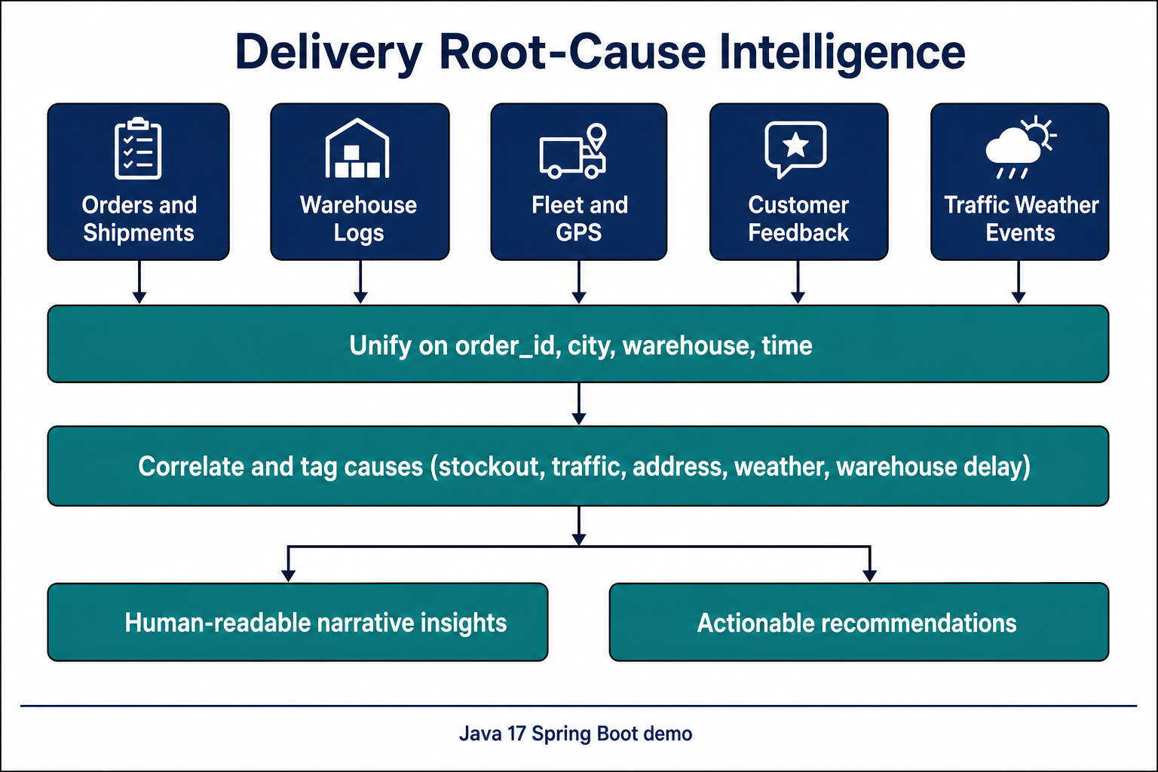
Figure 1. Unify orders, warehouse, fleet, feedback, and context; tag causes; then explain and recommend.

4. Step-by-step approach

Step 1 — Aggregate multi-domain data
Start with the order (or shipment) as the spine. Everything else must attach to it. Typical join keys are order_id, client_id, warehouse_id, driver_id, city, and time (order date, promised delivery, actual delivery, dispatch, GPS departure/arrival).
The domains to bring in are exactly those the business already has:
Domain | What it tells you | What is usually missing today
Orders & shipments | Promise vs actual, status, stated failure reason | Link to weather, traffic, warehouse dwell
Warehouse | Pick/pack/dispatch time, stock and system notes | Link to downstream late or failed delivery
Fleet & drivers | GPS notes: congestion, breakdown, address not found | Systematic coding of free-text notes
Customer feedback | Late, lost, stock cancel, no update | Aggregation onto the same order
Context | Traffic, rain/fog, festival, holiday, strike | Use in the same report as the order
After the join, each shipment has a single outcome label: delivered on time, delivered late, failed, returned, or still open after the promise.

Step 2 — Correlate events automatically (rules first)
Do not wait for a large machine-learning project to get value. Define a short cause list that operations already understands, then tag a shipment whenever any source supports that cause.
- Warehouse: stockout, slow packing, system/WMS issue, late dispatch.
- Network: heavy traffic, weather (rain/fog), festival or holiday load, strike.
- Last mile: incorrect or hard-to-find address, vehicle breakdown.
- Customer / process: return or failed handover, no status update to the customer.
Rules are auditable. Examples: failure_reason = Stockout, warehouse note = “Stock delay on item”, and feedback = “cancelled due to stock issue” all raise STOCKOUT. GPS “Address not found” plus failure_reason “Incorrect address” raise ADDRESS. Heavy traffic plus a congestion GPS note raises TRAFFIC.
Allow more than one tag on one shipment. Rank causes by how often they appear in the problem set. Attach sample order IDs. If evidence is missing, say so. Never invent a cause. This rule engine is the source of truth even after AI is added.

Step 3 — Generate human-readable insights
Replace the raw dashboard with a briefing an operations manager can read in a minute: scope, what happened, ranked why, and whether it looks systemic. A template paragraph is enough to ship. AI is used to rewrite that paragraph in a more natural voice, using only the JSON facts (metrics, tagged causes, sample complaints). The original template is kept as ruleBasedNarrative so an auditor can compare.

Step 4 — Surface actionable recommendations
Each top cause maps to a playbook line. AI may rephrase those lines; it should not introduce a new play (for example “open a new airport hub”) that was not implied by the tags.
If the leading cause is… | Then recommend…
Stockout / inventory gap | Safety stock; do not promise until pick is confirmed
Warehouse delay, slow pack, WMS issue | Earlier cut-offs, extra pack-station staff, WMS failover
Traffic congestion | Move windows off peak; add rider buffer in that city
Weather | Weather-aware ETAs; pause non-critical COD in rain and fog
Address not found | Address and geocode checks at checkout
Festival / holiday | Surge roster, pre-position inventory, freeze aggressive SLAs
Large new client volume | Phase the onboard by city and warehouse

5. How AI is used (and how it is not)
Cursor does not expose a public Chat Completions endpoint comparable to OpenAI. This demonstration therefore calls the official Cursor Cloud Agents API (no-repo agent) with model composer-2.5, authenticated by CURSOR_API_KEY from the Cursor dashboard. The key must live in an environment variable, not in source control.
AI has two jobs only:
- Narrative: after InsightService builds metrics and cause tags, AiNarrativeService sends those facts to Cursor and replaces narrative plus recommendations. Causes, metrics, and sample order IDs stay as the rules computed them.
- Ask: GET or POST /api/insights/ask accepts a sentence such as “Why were deliveries delayed in New Delhi yesterday?” AiQuestionRouter maps it to CITY_DELAYS, CLIENT_FAILURES, WAREHOUSE_FAILURES, CITY_COMPARE, FESTIVAL, or CAPACITY_RISK, then the same InsightService runs. If Cursor is unavailable, a keyword fallback still routes the question.
If rca.ai.enabled is false, the API key is missing, or the Cloud Agent call fails, the API still returns HTTP 200 with the rule-based briefing and aiGenerated = false. Startup DemoRunner does not call Cursor unless rca.ai.on-startup is true, so local boot stays fast.
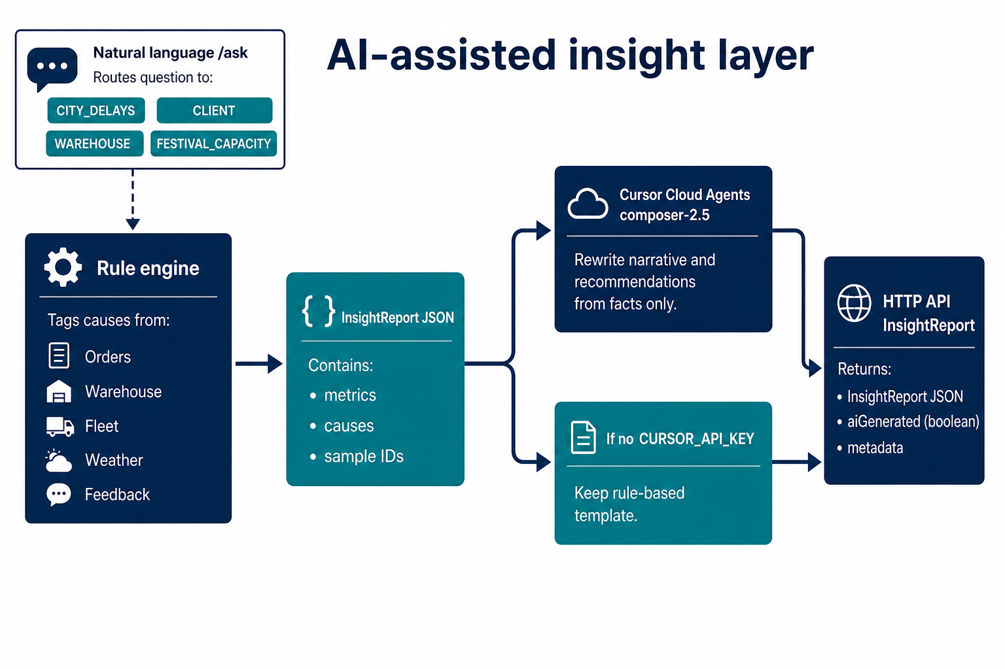
Figure 2. AI sits after the rule engine. Cursor rewrites the briefing from InsightReport facts; it does not retag causes.
Layer | Decides | Technology
Join & outcome | Which orders are late, failed, returned, open-late | Java, in-memory DataStore
Cause tags | Stockout, traffic, address, weather, warehouse, … | CauseEngine rules
Question routing | Which of the six analyses to run | Cursor, with keyword fallback
Briefing prose | How the story is worded for ops | Cursor Cloud Agents (composer-2.5)

6. How this answers the questions managers ask
Question | What the solution does
Why delayed in city X yesterday? | Slice city + date; rank tags; optional AI briefing. Demo: New Delhi, 2025-01-24.
Why did Client X fail last week? | Slice client + week. Demo: client 409, 10–16 Aug 2025.
Warehouse B in August? | Slice warehouse_id 2 (Pune) in 2025-08; emphasise warehouse-side tags.
City A vs City B last month? | Same metrics side by side (New Delhi vs Ahmedabad, Aug 2025).
Festival — causes and how to prepare? | Compare event_type = Festival vs baseline; surge recommendations.
Client Y adds ~20,000 orders/month? | Scale proxy client 118’s problem rate; phase-onboard plan.
Free-text ask | GET /api/insights/ask?q=… or POST {"question":"…"}; same InsightReport inside {question, intent, report}.

7. How to implement
- Demonstration (this repo): load CSVs, join on order_id, run CauseEngine, expose REST on port 8080. Package ai/ is optional and degrades cleanly.
- Configure Cursor: rca.ai.provider=cursor, rca.ai.base-url=https://api.cursor.com, rca.ai.model=composer-2.5, rca.ai.api-key from environment CURSOR_API_KEY.
- Near term: persist the enriched shipment table daily; keep rules in version control.
- Later: live weather/traffic, stronger primary-cause weights, a thin ops UI on the same API. Machine learning to rank causes is a later step, after labels are trusted.

8. What good looks like
- Reproducible — same data, same tags; AI prose may vary slightly.
- Explainable — every cause cites a field or a count; ruleBasedNarrative is retained.
- Scoped — city, client, warehouse, and dates change the story.
- Honest — empty slices and failed AI calls do not invent numbers.
- Actionable — the last section is something a manager can assign this week.

9. Conclusion
Delivery failure is not mainly a reporting gap. It is a joining gap. The way to solve it is to put orders, warehouse, fleet, customers, and external conditions on one timeline, tag causes from evidence, and speak in recommendations. AI is the last mile of that sentence: it writes the briefing in human language. It is not a substitute for joining the data or for an auditable cause taxonomy. That combination is how the organisation moves from “how many failed?” to “why it failed, and what we will change.”

