WEEK 2
TITANIC EXPLORATORY DATA ANALYSISAND VISUALIZATION
Virtual Data Science with Python Trainee InternshipYuvaInternPrepared using the Week 1 cleaned Titanic datasetPython • Pandas • NumPy • Matplotlib • Seaborn

1. Executive Summary
Week 2 focused on Exploratory Data Analysis (EDA) and visualization of the cleaned Titanic dataset produced during Week 1. The Python workflow generated 12 visualizations covering survival counts, gender, passenger class, age, fare, embarkation port, numerical relationships, and correlations. The analysis was executed successfully, with the terminal confirming “WEEK 2 EDA COMPLETED.”
2. Objectives
Understand the structure and descriptive characteristics of the cleaned dataset.
Explore important survival-related features.
Create multiple professional visualizations.
Identify relationships, differences, distributions, and notable patterns.
Interpret the results and summarize key findings.
3. Key Findings from the Completed Analysis
Female survival rate: 0.739726 (approximately 73.97%).
Male survival rate: 0.215321 (approximately 21.53%).
Class 1 survival rate: 0.633333 (63.33%).
Class 2 survival rate: 0.506098 (50.61%).
Class 3 survival rate: 0.259352 (25.94%).
Embarkation C survival rate: 0.580645 (58.06%).
Embarkation Q survival rate: 0.344828 (34.48%).
Embarkation S survival rate: 0.373665 (37.37%).
Average fare by class: Class 1 = 85.675199, Class 2 = 21.889729, Class 3 = 13.588850.
Average age by survival: non-survivors = 30.482418; survivors = 28.299750.
4. Visualization Analysis
4.1 Titanic Survival Count

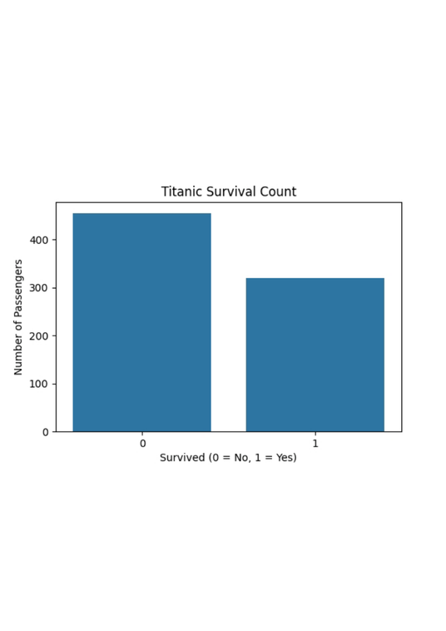

The chart compares passengers who did not survive (0) with those who survived (1). The number of non-survivors is visibly higher than the number of survivors.
4.2 Survival Rate by Gender

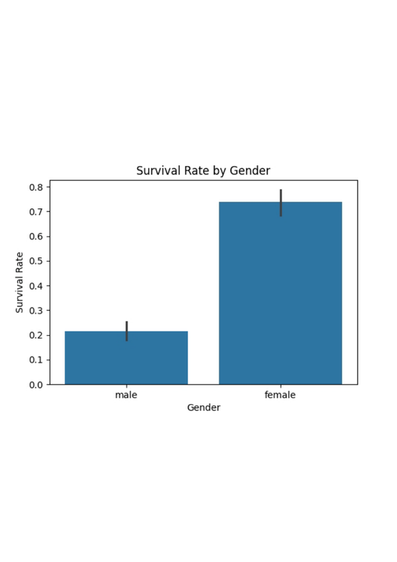

Female passengers have a much higher survival rate than male passengers, indicating a strong gender difference in the cleaned dataset.
4.3 Survival Rate by Passenger Class

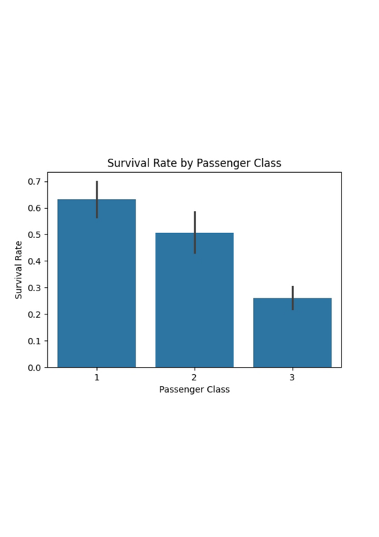

Survival decreases across passenger classes: first class has the highest survival rate, while third class has the lowest.
4.4 Age Distribution of Passengers

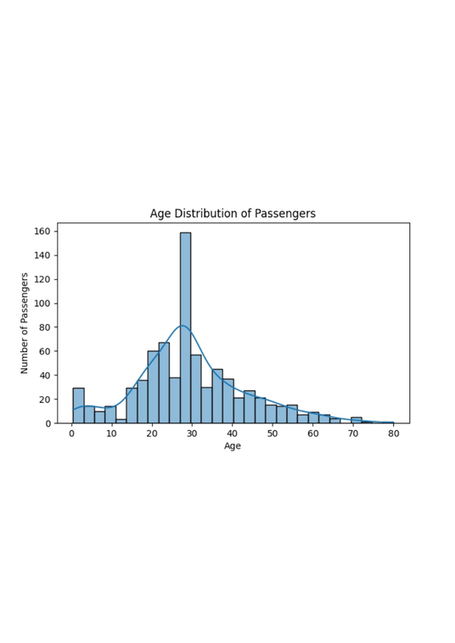

The histogram shows the distribution of passenger ages and the concentration of observations across adult and younger age groups.
4.5 Fare Distribution

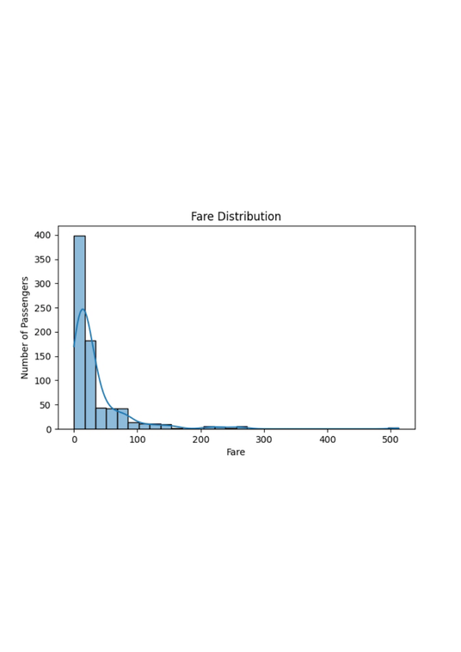

The fare distribution is right-skewed, with most fares concentrated at lower values and a smaller number of high-fare observations.
4.6 Fare Distribution by Passenger Class

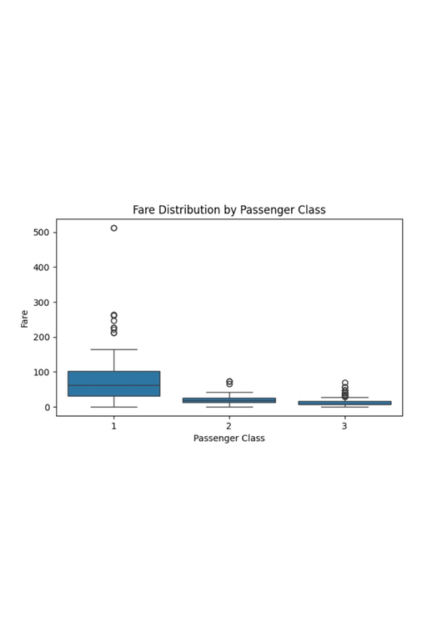

The boxplot shows clear differences in fare levels across classes, with first-class fares generally much higher than second- and third-class fares.
4.7 Age Distribution by Survival

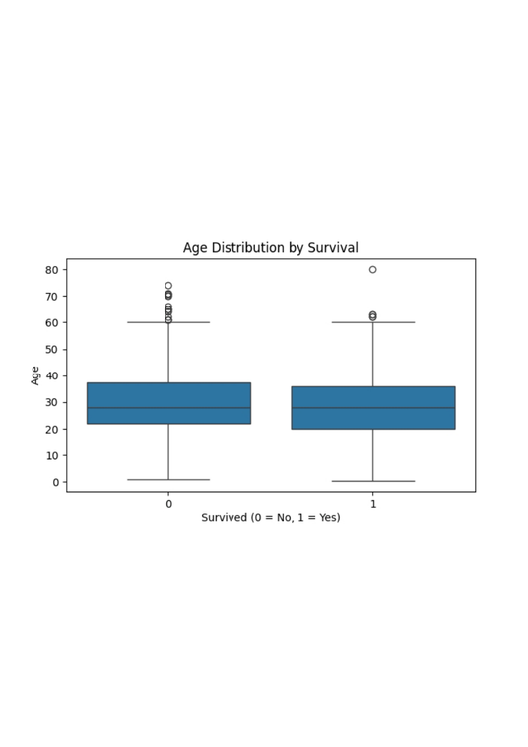

The age distributions of survivors and non-survivors can be compared directly; the terminal analysis shows a slightly lower average age among survivors.
4.8 Survival Rate by Class and Gender

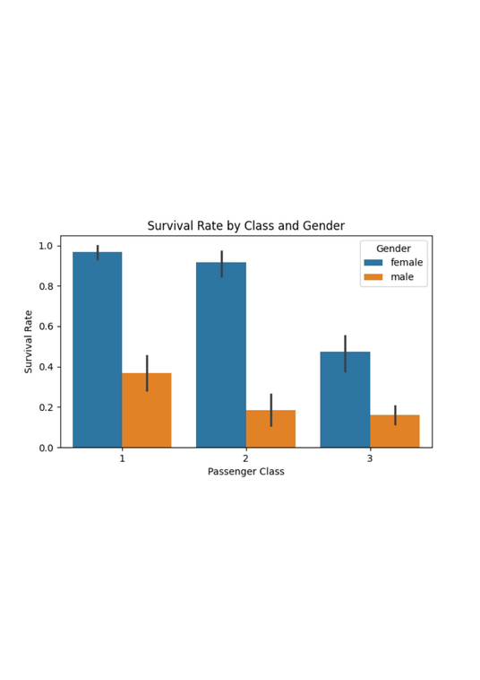

The grouped visualization highlights the combined effect of gender and passenger class on survival, showing substantial differences between groups.
4.9 Correlation Heatmap

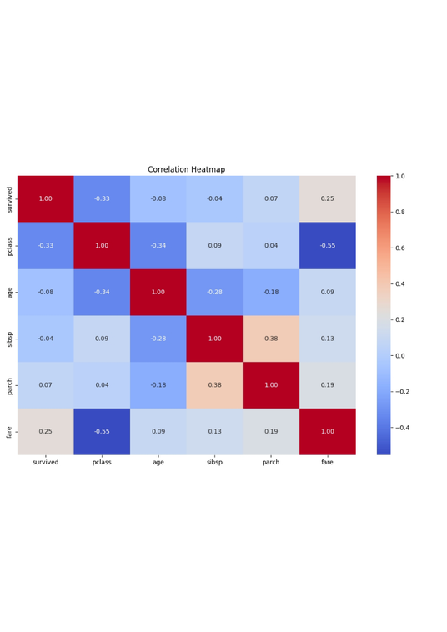

The heatmap summarizes linear relationships among numeric variables and helps identify which variables move together.
4.10 Age vs Fare by Survival

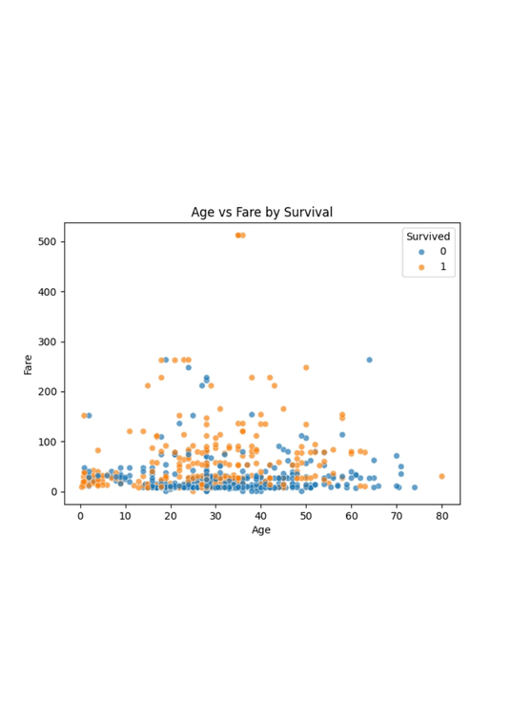

The scatterplot explores the relationship between age and fare while distinguishing passengers by survival status.
4.11 Survival Rate by Embarkation Port

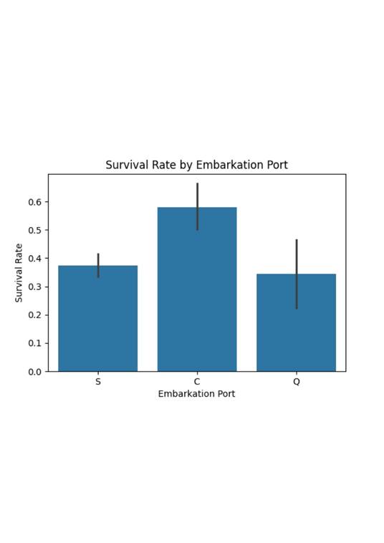

Survival rates differ by embarkation port. Port C has the highest rate in the reported analysis, followed by S and Q.
4.12 Passenger Count by Class

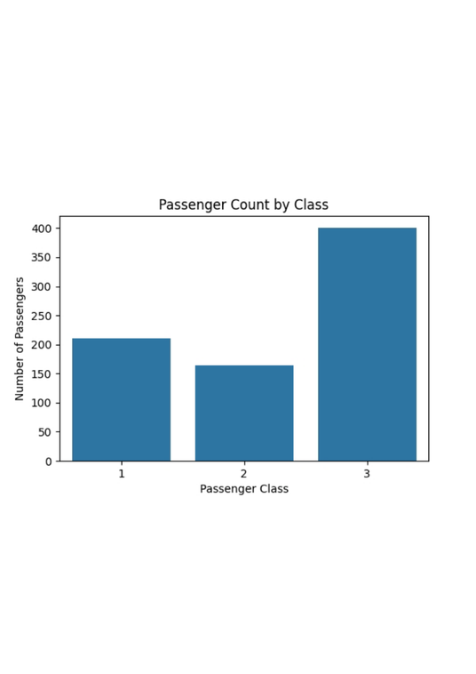

The chart compares the number of passengers in each class and shows the distribution of the dataset across passenger classes.
5. Overall Interpretation
The EDA reveals clear differences in Titanic survival outcomes. Gender and passenger class stand out as especially important features: female passengers had a substantially higher survival rate than male passengers, and first-class passengers had a much higher survival rate than third-class passengers. Fare levels also differed strongly by passenger class. The visualizations provide complementary views of counts, rates, distributions, and numerical relationships.
6. Reproducibility
The analysis was implemented in task2.py using Pandas, NumPy, Matplotlib, and Seaborn. The script loads the Week 1 cleaned CSV, calculates descriptive and grouped statistics, prints key findings, and generates the 12 visualizations.
7. Conclusion
Week 2 EDA and visualization was completed successfully. The analysis converted the cleaned Titanic dataset into a set of interpretable statistics and visual evidence. The results demonstrate meaningful variation in survival by gender, passenger class, and embarkation port and provide a strong foundation for further data analysis.
8. Execution Evidence

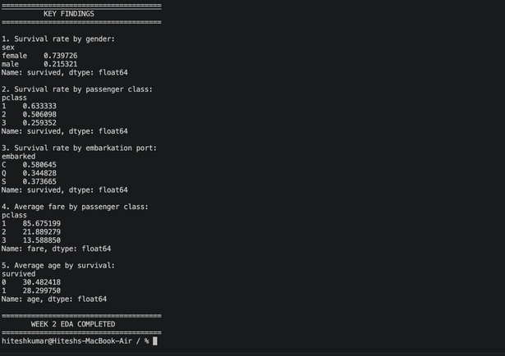

The terminal output confirms the key findings and the successful completion of the Week 2 EDA workflow.

