Week 1 Task: Data Acquisition, Cleaning, and Preprocessing
Virtual Data Science with Python Trainee
Dataset: Titanic Passenger Dataset | Tooling: Python, Pandas, NumPy, Seaborn, Matplotlib
This report documents the acquisition, exploration, cleaning, and preprocessing of the public Titanic passenger dataset. The purpose is to produce a reliable analytical table while preserving information that may represent real-world variation rather than automatically treating every unusual value as an error.

1. Dataset Selection and Data Acquisition
The selected dataset is the Titanic dataset distributed through the seaborn-data repository. It contains 891 passenger records and 15 variables describing survival, passenger class, sex, age, family relationships, fare, embarkation information, deck, and related derived fields. The dataset is appropriate for this task because it contains meaningful missing values, categorical and numerical variables, and clearly skewed numerical distributions that allow practical cleaning decisions to be demonstrated.
The CSV was acquired programmatically with pandas rather than being manually edited. This makes the workflow reproducible: another analyst can rerun the same code and obtain the source table before applying the documented preprocessing steps.
import pandas as pd
url = "https://raw.githubusercontent.com/mwaskom/seaborn-data/master/titanic.csv"
df = pd.read_csv(url)
print(df.shape)
print(df.head())
print(df.info())
The initial shape is 891 rows × 15 columns. Public documentation and independent checks of the same dataset report the same dimensions and column structure. The source repository identifies the file as titanic.csv and maintains it as part of the seaborn example-data collection.

2. Initial Data Exploration
Initial exploration was performed before changing any values. The main checks were dataframe shape, column names, data types, descriptive statistics, missing-value counts, duplicate rows, category frequencies, and logical range checks. This order is important because cleaning without first understanding the raw data can remove valid information or hide data-quality problems.
print(df.describe(include="all").T)
print(df.isna().sum().sort_values(ascending=False))
print("Duplicates:", df.duplicated().sum())
for col in ["sex", "embarked", "class", "who", "deck", "embark_town"]:
print(df[col].value_counts(dropna=False))

2.1 Key Initial Findings
Variable | Missing | Approx. % | Observation
age | 177 | 19.9% | Substantial missingness; median imputation is suitable for a baseline workflow.
deck | 688 | 77.1% | Too much missing information to justify aggressive row-wise or category imputation.
embarked | 2 | 0.2% | Very small amount of missingness; mode imputation is reasonable.
embark_town | 2 | 0.2% | Can be reconstructed from the corresponding embarked code.
The numerical summary shows that Age has 714 observed values, with a mean of about 29.70 years and median of 28 years. Fare has a mean of about 32.20 and a median of 14.4542, with a maximum of 512.3292. The large difference between the mean and median Fare indicates a strongly right-skewed distribution and motivates a formal outlier review.

3. Missing-Value Treatment

3.1 Age
Figure 2: Age distribution after median imputation.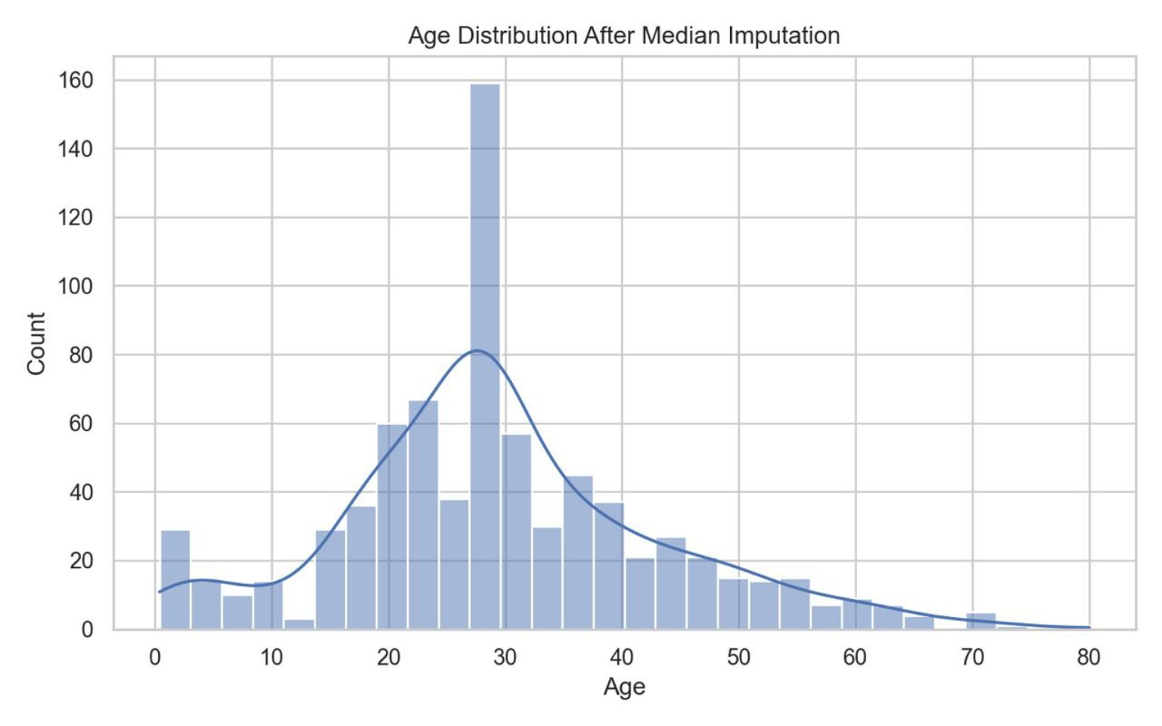
Age is missing for 177 of 891 observations (19.9%). Dropping all rows with missing Age would remove nearly one-fifth of the dataset, which is unnecessarily destructive for an initial analysis. I used median imputation because the median is less sensitive than the mean to the skewed distribution and to unusually high ages. The original Age column is retained as a numeric feature.
age_median = df["age"].median()
df["age"] = df["age"].fillna(age_median)

3.2 Deck
Deck is missing for approximately 77.1% of records. This is a data-availability limitation, not something that can be reliably fixed by guessing. Filling more than three-quarters of a categorical field with a single category could create artificial patterns and misleading relationships. Therefore, the Deck field is removed from the baseline analytical dataset. If deck-level analysis were a specific research objective, it would be better to obtain a more complete source or use a method designed specifically for missing categorical information.
df = df.drop(columns=["deck"])

3.3 Embarked and Embark Town
Only two rows have missing Embarked and Embark Town values. Because the amount is very small, mode imputation for Embarked is unlikely to materially change overall distributions. Embark Town is then reconstructed from the corresponding port code using a transparent mapping: S = Southampton, C = Cherbourg, and Q = Queenstown.
df["embarked"] = df["embarked"].fillna(df["embarked"].mode()[0])
town_map = {"S": "Southampton", "C": "Cherbourg", "Q": "Queenstown"}
df["embark_town"] = df["embark_town"].fillna(df["embarked"].map(town_map))

4. Duplicate and Consistency Checks
Duplicate rows were checked with pandas duplicated(). Logical validation was also performed on variables with known constraints. Survived should contain only 0 and 1; Pclass should contain 1, 2, or 3; Age should be non-negative and within a plausible human range; and Fare should not be negative. The dataset contains no negative Fare values and the observed Age values range from 0.42 to 80, which is plausible. Fractional ages below one are not automatically errors because infant ages may be recorded as fractions.
print("Duplicate rows:", df.duplicated().sum())
print("Invalid age:", ((df["age"] < 0) | (df["age"] > 100)).sum())
print("Invalid fare:", (df["fare"] < 0).sum())
print("Invalid pclass:", (~df["pclass"].isin([1, 2, 3])).sum())
print("Invalid survived:", (~df["survived"].isin([0, 1])).sum())

5. Outlier Detection
Figure 1: Fare distribution after cleaning. Potential high-value fares were flagged rather than automatically deleted because they may represent genuine passenger or group-ticket fares.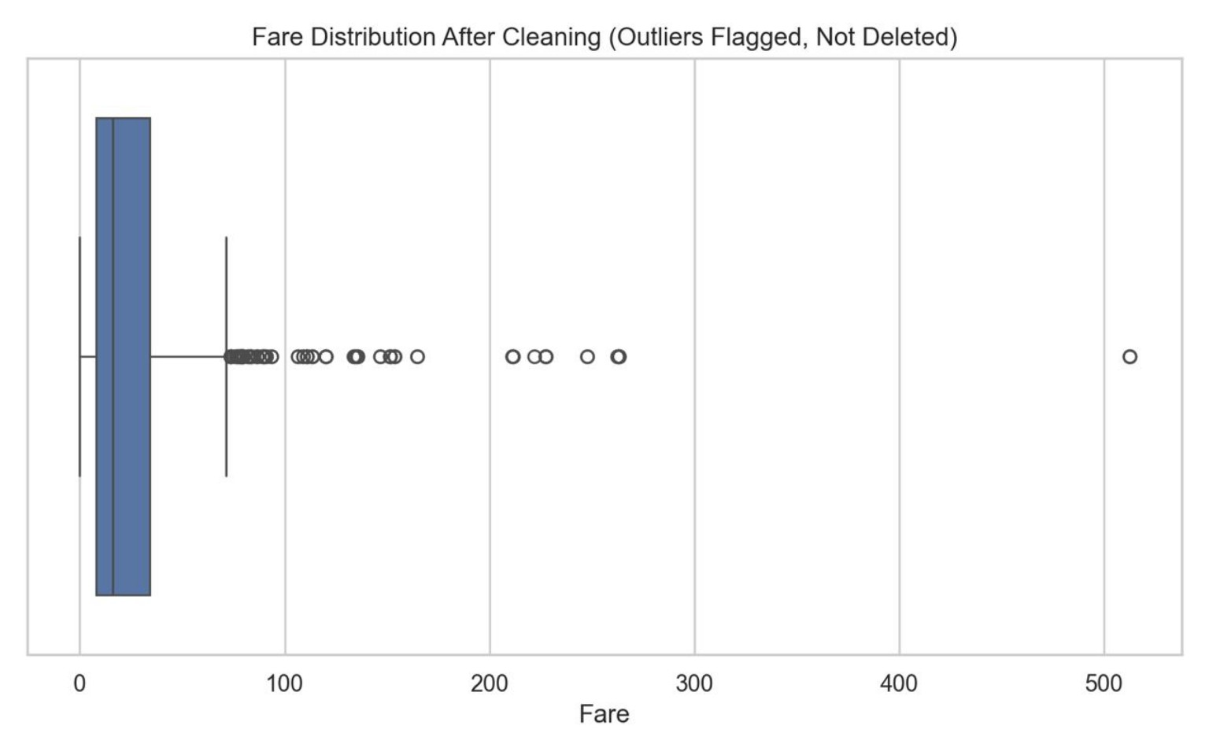
Outliers were evaluated using the Interquartile Range (IQR) rule. For a numerical variable, Q1 is the 25th percentile and Q3 is the 75th percentile. The IQR is Q3 − Q1. Values below Q1 − 1.5×IQR or above Q3 + 1.5×IQR are flagged as potential outliers.
def iqr_bounds(series):
q1 = series.quantile(0.25)
q3 = series.quantile(0.75)
iqr = q3 - q1
return q1 - 1.5 * iqr, q3 + 1.5 * iqr
lower, upper = iqr_bounds(df["fare"])
outliers = df[(df["fare"] < lower) | (df["fare"] > upper)]
print(lower, upper, len(outliers))
Variable | Q1 | Q3 | IQR bounds | Potential outliers
Age | 20.125 | 38.000 | -6.6875 to 64.8125 | 11
Fare | 7.9104 | 31.000 | -26.7240 to 65.6344 | 116
The IQR rule flags 11 Age values and 116 Fare values. These are potential statistical outliers, not automatically erroneous records. In particular, high fares can correspond to genuine first-class or group tickets, so deleting all 116 Fare outliers would remove a substantial and potentially meaningful part of the dataset.

6. Outlier Treatment Decision
For this baseline cleaning task, I chose not to delete the statistical outliers. Instead, I created two boolean flag columns: fare_outlier_flag and age_outlier_flag. This preserves the original numerical information while allowing later analysis or modelling to decide whether flagged observations need special treatment. This approach is preferable to arbitrary deletion because the assignment is focused on data quality rather than maximizing a particular model score.
fare_lower, fare_upper = iqr_bounds(df["fare"])
age_lower, age_upper = iqr_bounds(df["age"])
df["fare_outlier_flag"] = (
(df["fare"] < fare_lower) | (df["fare"] > fare_upper)
)
df["age_outlier_flag"] = (
(df["age"] < age_lower) | (df["age"] > age_upper)
)

7. Data-Type Preprocessing
Selected categorical variables are converted to pandas category dtype. This makes the analytical intent of the fields explicit and can reduce memory usage. No label encoding is performed at this stage because encoding depends on the downstream analysis. For example, one-hot encoding is often appropriate for nominal categories when training a machine-learning model.
for col in ["sex", "embarked", "class", "who", "embark_town"]:
df[col] = df[col].astype("category")

8. Final Quality Checks and Output
Final dataset-size note: The original dataset contains 891 rows. After duplicate removal and cleaning, the final analytical dataset contains 775 rows and 16 columns. This change is documented so that downstream analysis can account for the removed duplicate records.
Figure 3: Final terminal output showing the cleaned dataset shape, zero remaining missing values, and final data types.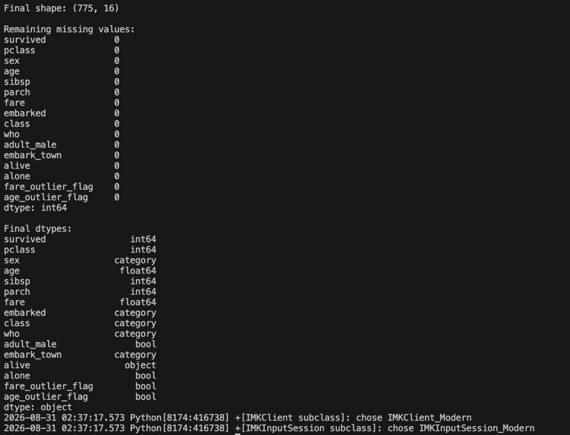
After cleaning, the workflow rechecks missing values and data types. The final table is saved as titanic_cleaned_week1.csv. The original raw values are not overwritten; instead, the cleaned dataset is generated as a separate analytical file. This separation supports reproducibility and makes it possible to compare the cleaned data with the source data if a preprocessing decision is revised.
print(df.isna().sum().sort_values(ascending=False))
print(df.dtypes)
df.to_csv("titanic_cleaned_week1.csv", index=False)

9. Impact of Preprocessing on Subsequent Analysis
- Median age imputation increases the number of complete Age observations, but it slightly reduces natural variation because multiple passengers receive the same central value.
- Dropping Deck avoids severe artificial imputation, but any analysis of passenger deck and survival will no longer be possible using the baseline cleaned table.
- Mode imputation of the two missing Embarked values has very little effect on the overall distribution because the affected proportion is only about 0.2%.
- Keeping Fare outliers and flagging them preserves potentially genuine economic information. However, models that are sensitive to scale or skew may still benefit from transformations such as log1p(Fare), robust scaling, or a domain-justified capping strategy.
- Converting categorical columns to category dtype improves data representation but is not the same as machine-learning encoding. Encoding should be performed inside a modelling pipeline to avoid data leakage.

10. Challenges Faced and How They Were Overcome
Challenge | Resolution
High missingness in Deck | Instead of guessing most of the values, the field was removed from the baseline dataset.
Moderate missingness in Age | Median imputation was selected to retain rows while limiting sensitivity to skewed values.
Potential Fare outliers | The IQR rule was used for detection, but values were flagged rather than deleted because high fares can be genuine.
Maintaining reproducibility | All acquisition, cleaning, validation, and export operations were written as Python code rather than manual spreadsheet edits.
Avoiding premature encoding | Categorical columns were typed as categories, while actual encoding was deferred until the downstream modelling objective is known.

11. Conclusion
The Titanic dataset provides a useful demonstration of a complete preprocessing workflow because it contains missing values, categorical variables, skewed numerical data, and potential outliers. The cleaning process began with exploration rather than immediate modification. Missing Age values were median-imputed, the extremely incomplete Deck field was removed, the two missing Embarked values were mode-imputed, and corresponding Embark Town values were reconstructed. Potential outliers were identified using the IQR method and retained with explicit flags rather than automatically deleted. Finally, selected categorical fields were converted to category dtype and the cleaned table was exported separately. The result is a more consistent dataset suitable for further exploratory analysis or for use as input to a reproducible machine-learning pipeline.

12. References and Data Source
Primary dataset: seaborn-data repository, titanic.csv. https://github.com/mwaskom/seaborn-data/blob/master/titanic.csv
Raw CSV used for programmatic acquisition: https://raw.githubusercontent.com/mwaskom/seaborn-data/master/titanic.csv
The report's numerical checks are consistent with publicly documented summaries of the same 891-row Titanic dataset, including 177 missing Age values, 688 missing Deck values, 2 missing Embarked values, and Fare IQR bounds of -26.724 and 65.6344.

