USER MANUAL
Smart Placement Management & Interview Tracking System
Web Application • Python Flask • Jinja2 • SQLAlchemy • PostgreSQL

1. Introduction
The Smart Placement Management & Interview Tracking System is a web application designed to manage student placement activities. It provides separate portals for Students, Recruiters and Placement Officers. The application supports student profiles, resume verification, job drives, applications, interview rounds, company management, analytics and placement reports.

2. User Roles
Role | Main functions available in the application
Student | Dashboard, profile management, resume/certification upload, job drives, application management and interviews.
Recruiter | Dashboard, job drives management, applications/applicants, candidate profiles, interview scheduling and interview feedback.
Placement Officer | Dashboard, companies, job drives, interviews, student management, resume verification, analytics and reports.

3. Getting Started
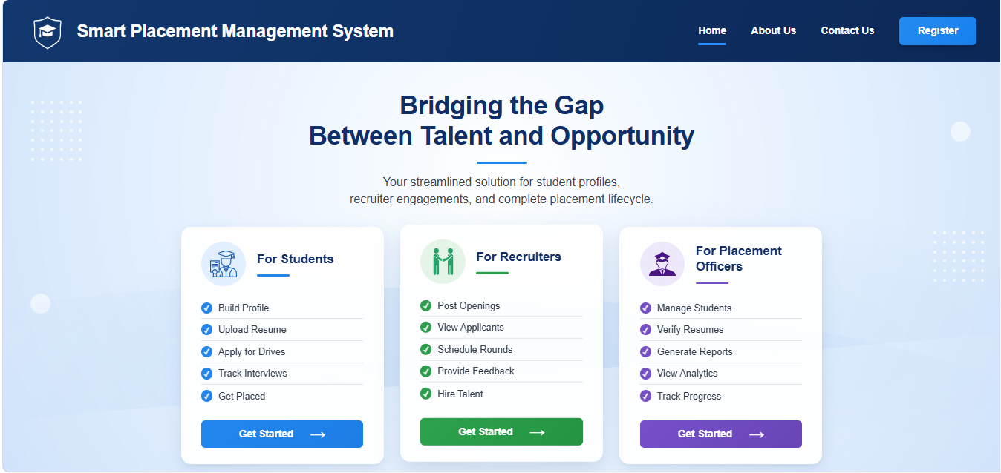
- Open the application URL. It will automatically open home page.
- The home page provides access to the placement system.
- Click on Register button to create an account if account for your role does not exist.
- Click on appropriate ‘Get started’ button to login to Student, Recruiter or Placement Officer role.
- After successful login, the system redirects the user to the corresponding dashboard.
The application check the role of user before giving access. Attempting to access a page outside the permitted role results in a forbidden-access response.

4. Registration
The registration page contains Username, Email, Role, Password and Confirm Password fields.
- Once you click on register button on home page or create account option on login page you will be redirected to registration page.
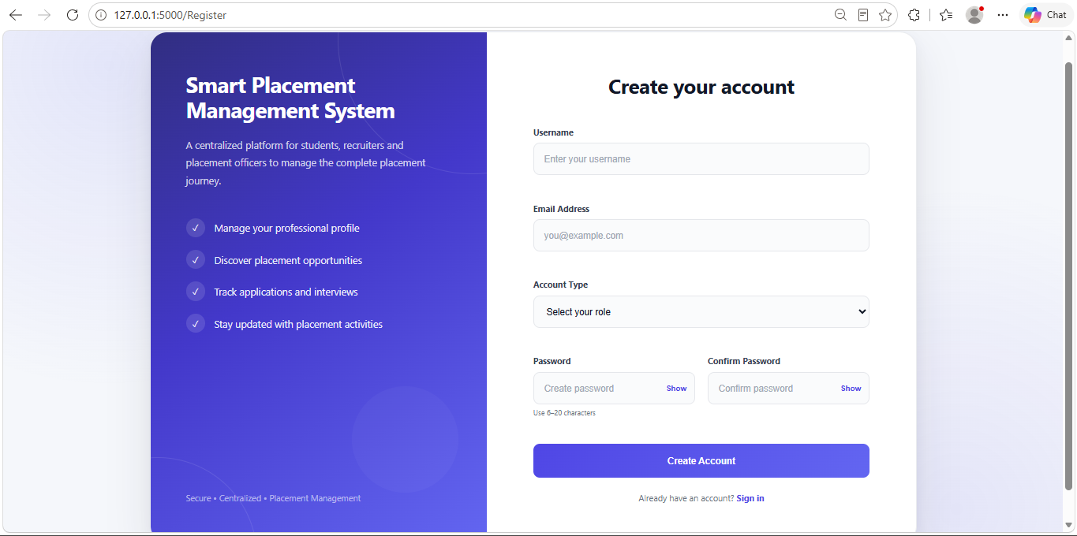
- Enter your full name in Username field.
- Enter a valid email address.
- Select the required role.
- Enter a password and enter it again in Confirm Password.
- Submit the registration form.
- After registration, user will be automatically redirected to home page for login.

- The application checks whether the email is already registered. If email is already present in database then it will flash a message which says “User already exists”
- The password and confirmation password must match. If they are not matching then it will flash a message which says “Passwords do not match”.
- The password length to be between 6 and 20 characters. If it is outside this limit then it will flash a message which says “Passwords length must be between 6 to 20 characters.”
- The password is stored as a generated password hash rather than plain text.

5. Login and Logout

5.1 Student Login
- In home page, click on Get Started button in student card. After that it will redirect you to student login page.
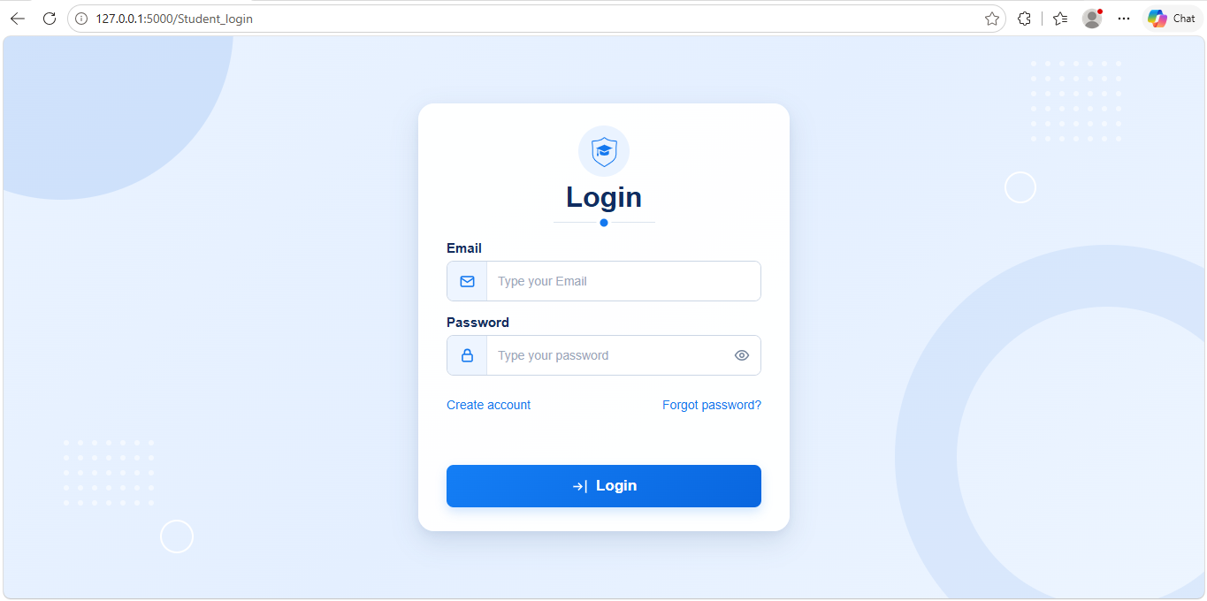
- Enter Email.
- Enter Password.
- Click on login button.
- On successful authentication, the Student Dashboard opens.

- If the entered email is not present in database then it will show error message which says “User does not exist”.
- If entered email is present in database but password given is incorrect then it will show error message which says “Wrong username or password”.

5.2 Recruiter Login
- In home page, click on Get Started button in Recruiters card. After that it will redirect you to Recruiters login page.
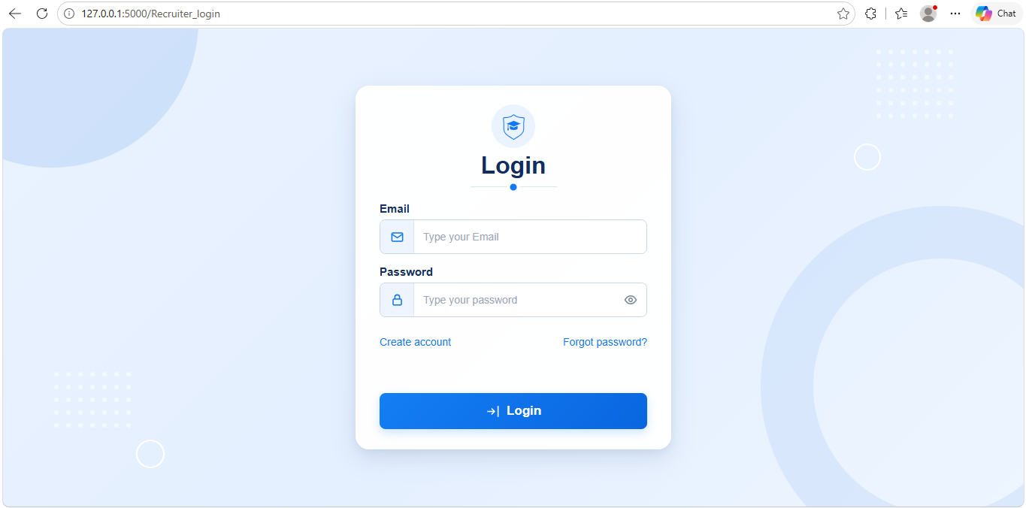
- Enter Email.
- Enter Password.
- Click on login button.
- On successful authentication, the Recruiter Dashboard opens.

- If the entered email is not present in database then it will show error message which says “User does not exist”.
- If entered email is present in database but password given is incorrect then it will show error message which says “Wrong username or password”.

5.3 Placement Officer Login
- In home page, click on Get Started button in Placement Officer card. After that it will redirect you to Placement Officer login page.
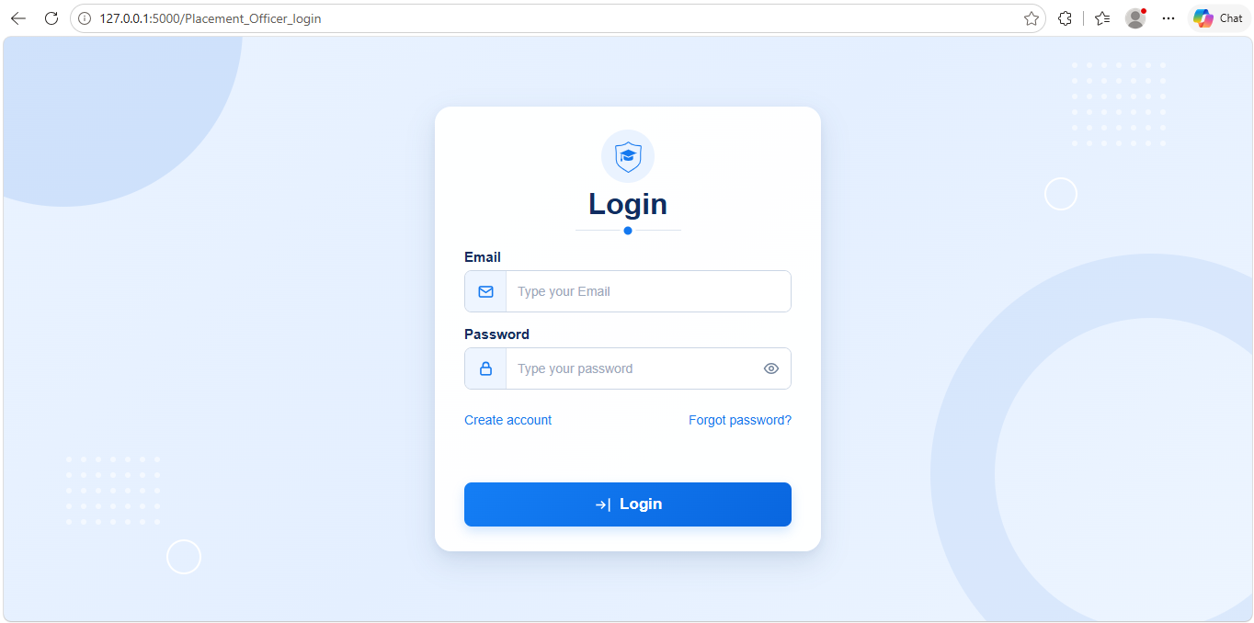
- Enter Email.
- Enter Password.
- Click on login button.
- On successful authentication, the Placement Officer Dashboard opens.

- If the entered email is not present in database then it will show error message which says “User does not exist”.
- If entered email is present in database but password given is incorrect then it will show error message which says “Wrong username or password”.
5.4 Reset Password
- If user forget the password and wants to reset the password and click on Forgot password option on login page.
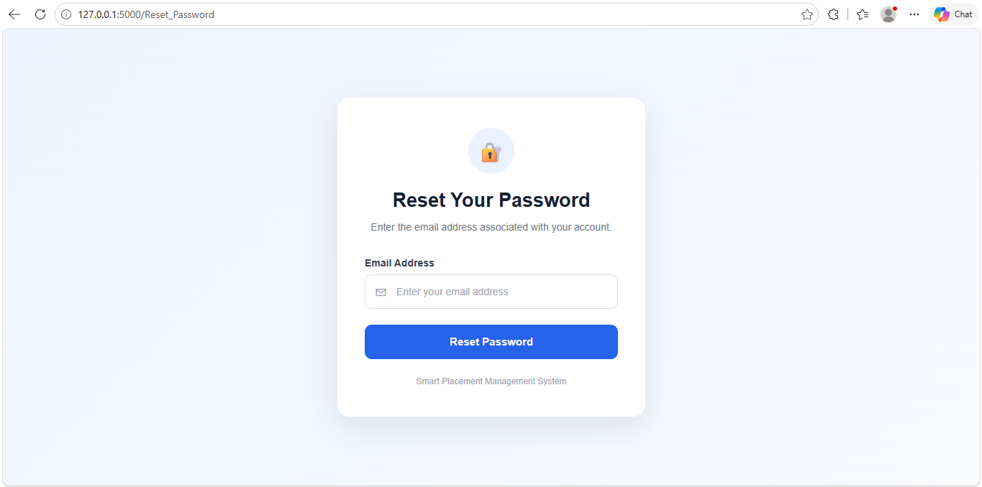
- Enter the email id.
- Click on reset password.
- If user with entered email is present in database, then it will send email with link to reset password.
- Click on that link in email and it will redirect you page where you have to enter new password.

- If that user with entered email is not present in database then it will show error message which says “User does not exist”.

6. Student User Manual

Student Dashboard
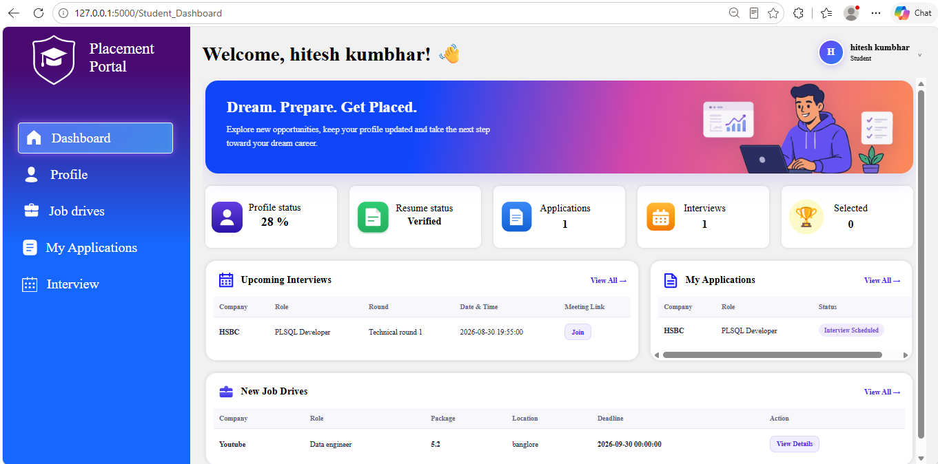
The Student Dashboard is the starting page after student login. It provides access to the main student functions and summarizes placement activity.
On the top right side of this page, there is profile menu which has student photo, student name and role (Student). It has two options. First is Profile option by clicking which user will be redirected to profile section in navigation bar. Second is Logout option by clicking which application ends the logged-in session and redirects the user to the home page.
- 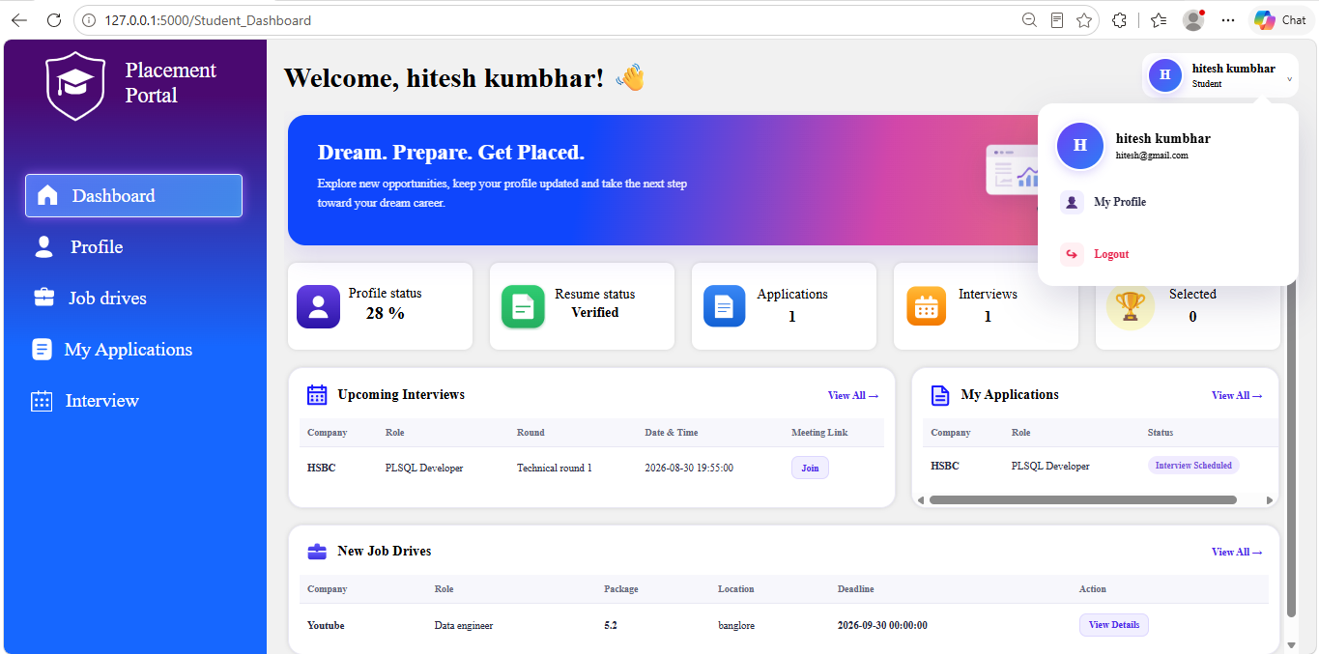
Student dashboard contain following information
- Profile status card indicate percentage of profile completed by user.
- Resume status card indicate resume verification status.
- Applications card indicate number of active applications which belong to those job drive which are not closed by recruiter and where status is not rejected or seletced.
- Interviews card indicate count of upcoming interviews including todays interview.
- Selected card indicate count of job drive in which current user is selected.
- Upcoming Interviews table include details about maximum 3 upcoming interviews including today’s interview. Details include company name, Role, Round name, date and time and meeting link. On top right side of this table there is view all option which will redirect the user to interview section in navigation bar.
- My Applications table include details about maximum 3 applications of current user. Details include company name, Role and status.
- New job drive table include details about maximum 3 new job drives. Details included Company name, Role, Package, Location, Deadline and action. Once user click on View Details button in action column then he/she will be redirected to Job Drives section in navigation bar.

6.2 Student Profile
After clicking on Profile section from the student navigation bar student will be redirected to this page. The profile page shows personal, academic and professional information of current user and allow the user to update them.
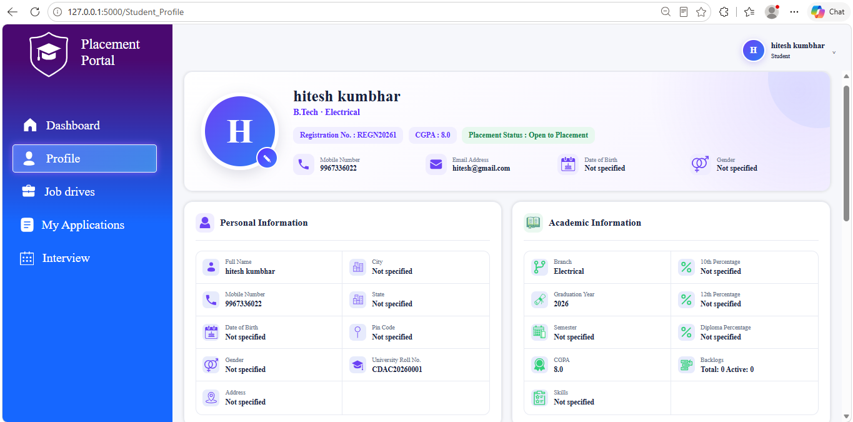
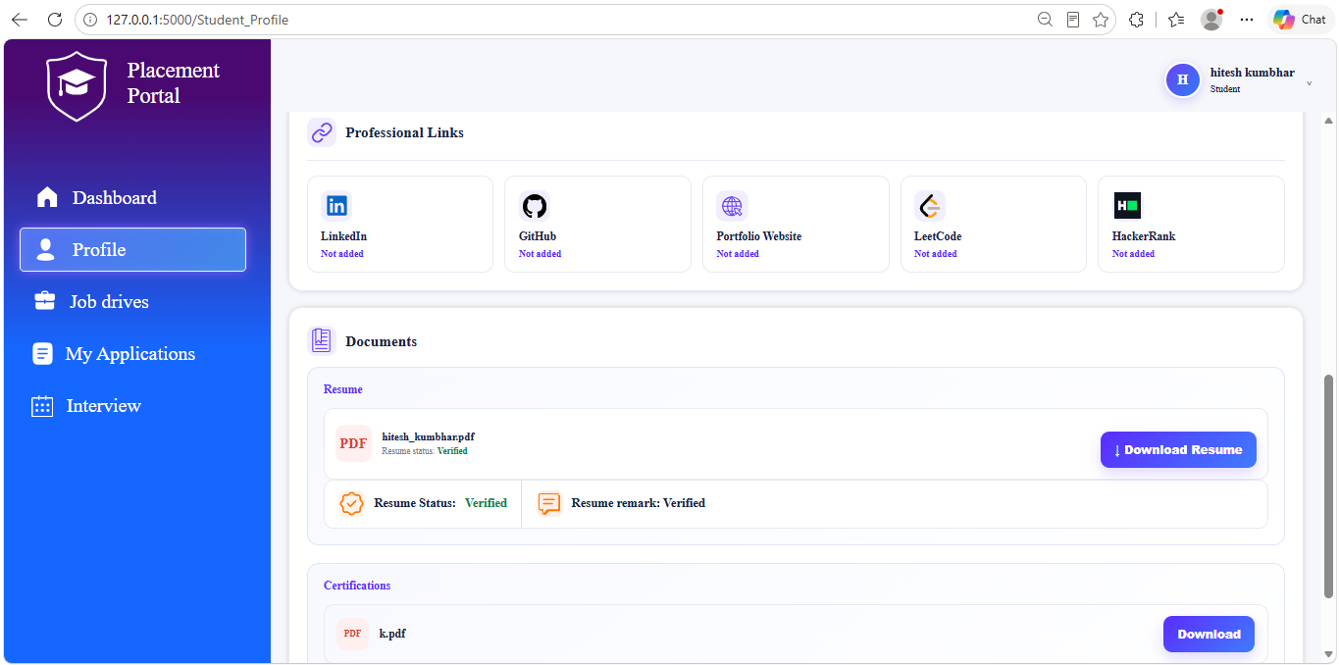

Section | Contents
Personal | Name, mobile number, gender, date of birth, address, city, state, PIN code
Academic | University roll number, branch, graduation year, CGPA, semester, 10th/12th/diploma percentage, Total backlogs and active backlogs, Skills
Professional links | LinkedIn, GitHub, portfolio website, LeetCode, HackerRank
Documents | Profile photo, resume and certifications

To update the profile:
- Select the update profile option at the end of the page.
- Change the required fields.
- Upload documents when required.
- Select Save Changes.
To change the profile photo, click on edit icon on the profile photo and upload the file.
Conditions for uploading files:
- Profile photo must be in JPG/JPEG/PNG format and a maximum size allowed is 5 MB.
- Resumes and certifications are accepted as PDF files with a maximum size of 5 MB.
The student can download the stored resume from the profile page when a resume is available. Also they can download the certification they have uploaded.
After a resume is uploaded, the Placement Officer will review this resume and verify it. The student can see status of verification (such as Pending, Verified, Rejected or Reuploaded) on this page below resume file.
- Pending: Placement officer has not approved uploaded resume yet.
- Verified: the resume has been approved.
- Rejected: the resume has been rejected.
- Reuploaded: a new resume has been uploaded after previous submission and is not verified by placement officer yet.
A student must have a verified resume before applying for a job drive in the current implementation.

6.3 Job Drives
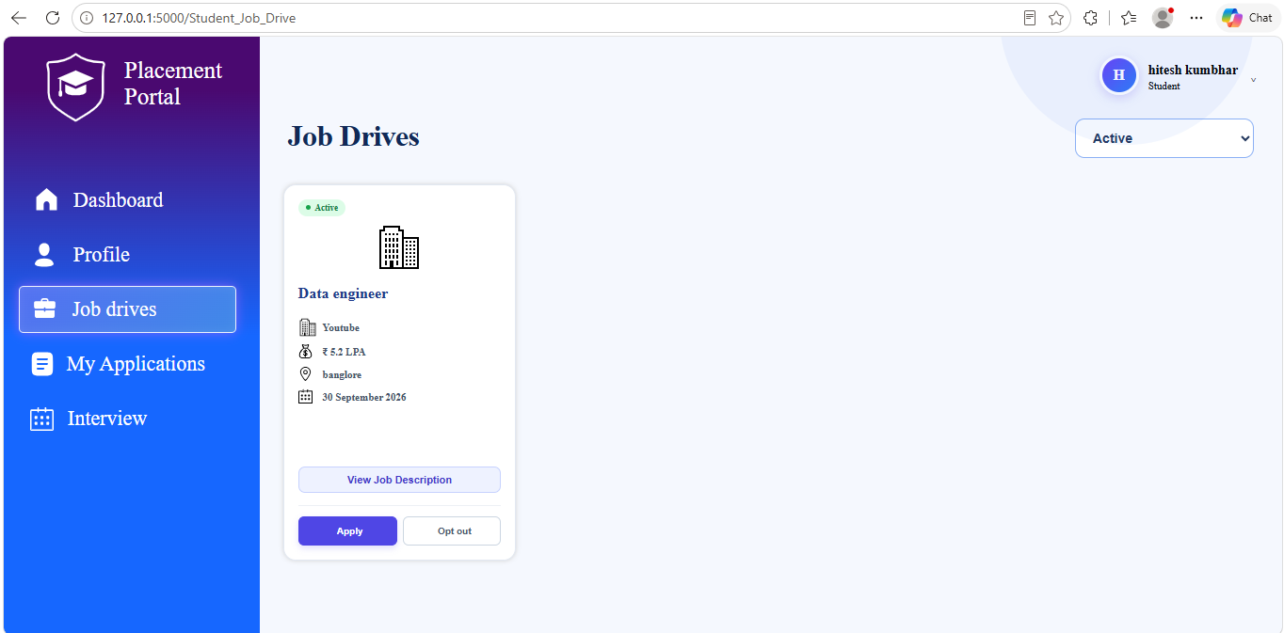
This section contain information about new job drive posted by placement officer. By default, filter is applied to Active job drives. Active job drives are those job drive which has not passed the deadline yet. To see expired job drive, change the filter to expired. Expired job drive are those job drive which has passed the deadline.
Each Job drive card contain information which includes company logo, company name, job role, package, location, deadline and description. Each Job drive contain two options which are Apply and Opt out.
Apply:
- In order to apply for any job drive, student’s resume must be verified by placement officer. If it is not verified then when user click on Apply, error message will be shown which says “Please wait until your resume is verified.” If the resume is verified then when user click on Apply, application for that job drive is created and shown in My Applications section in navigation bar. At the same time this job drive will be disappeared from Job drive section in navigation bar.
- Student cannot apply to same job drive more than once. If application of any job drive already exist in database then error message will be shown which says “Already applied for this role” when user try to apply for that job drive.
- Once student successfully applies for job drive, email will be sent to placement officer and recruiter. For recruiter email will be sent once 5 student apply for the same job drive.
- The initial application status is Applied.
Opt out:
- If application for this job drive already exist then when user try to opt out, error message will be shown which says “Application is already in process”.
- If application for this job drive does not exist then when user try to opt out, it will disappear from job drives section in navigation bar. After this notification email will be send to placement officer.
Student will be able to apply or opt out from job drive only when deadline of job drive has not passed i.e. when job drive is active. Once the deadline is passed then that job drive will become expired automatically and student will not be able to apply or opt-out.

6.7 My Applications
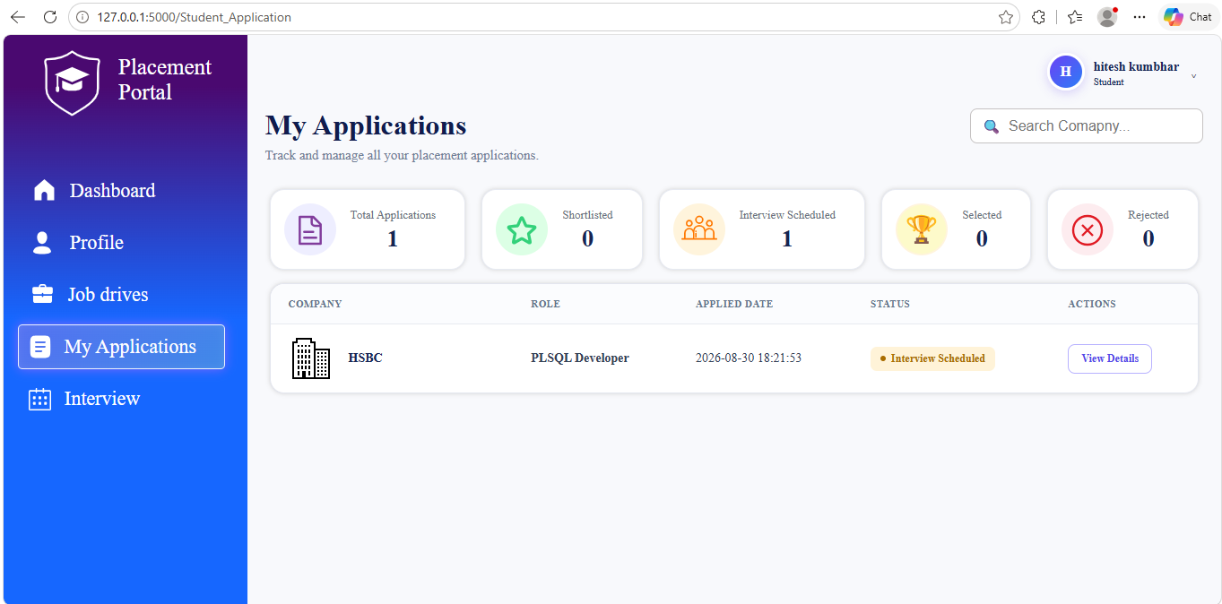
My Applications section contain information about applications of applied job drive. Table contain company logo, name, role, applied date, status and actions.
In this section, Total applications card shows the number of total applications, which belong to those job drives to which student has applied. Once user click on this card then all filters will be removed and it will show all applications.
Shortlisted card shows the number of applications whose status is Shortlisted. Once user click on this card then it will show only those applications in below table which has status as Shortlisted.
Interview Scheduled card shows number of applications whose status is Interview Scheduled. Once user click on this card then it will show only those applications in below table which has status as Interview Scheduled.
Selected card shows number of applications whose status is Selected. Once user click on this card then it will show only those applications in below table which has status as Selected.
Rejected card shows number of applications whose status is Rejected. Once user click on this card then it will show only those applications in below table which has status as Rejected.

Use the search field to search by company.

In actions column, once the user click on view Details button it will redirect the user to another page which contain information about job drive (such as Company Name, Role, Package, Location, Description, Applied Date, Status of application). Along with this it contains information about all interview rounds (such as Round Name, Date and Time, Result, Feedback) which are related to this applications.
- 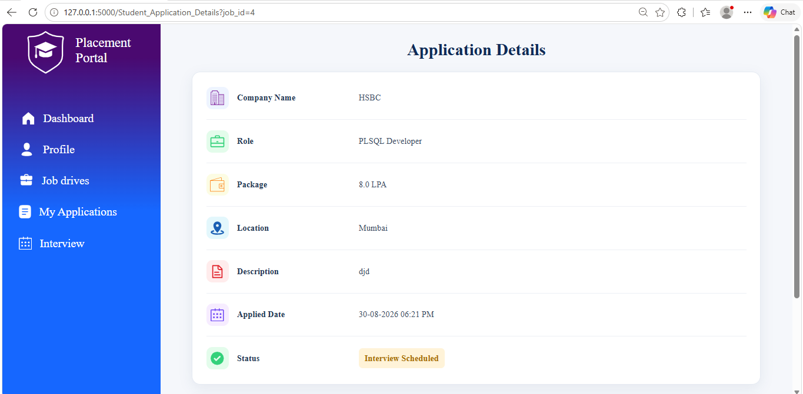
- 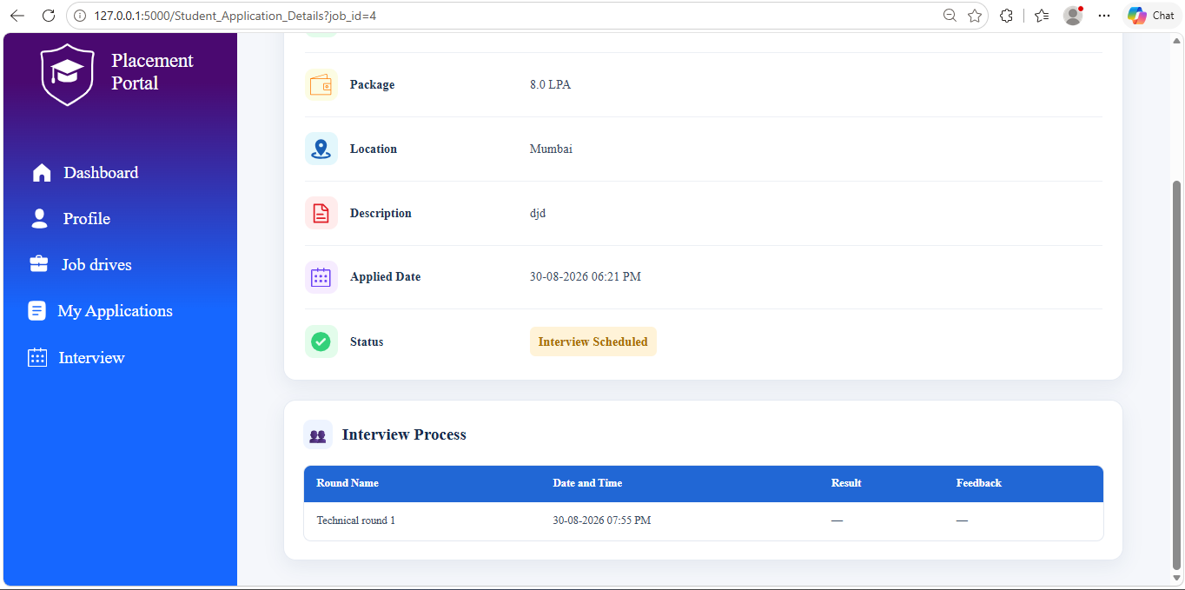

6.8 My Interviews
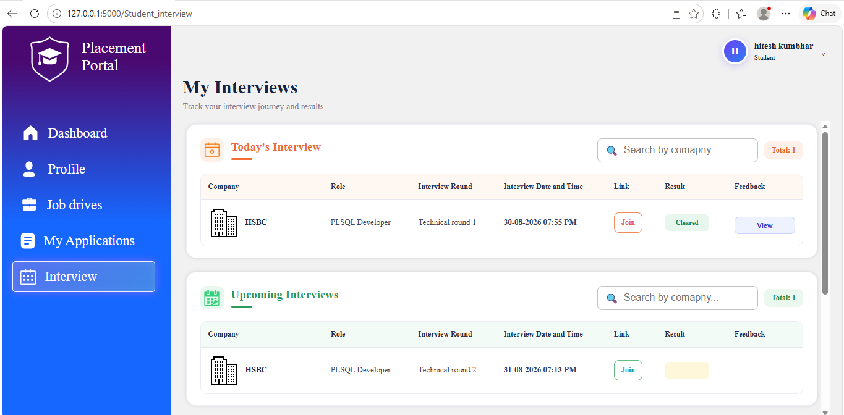
Interview sections contains information about all past interviews, today’s interview and upcoming interview in their respective tables.
Each tables contain information such as company name, job title, round name, interview date and time, meeting link, result and feedback when available.
Click on Join button to join the interview.
Use the search field in the relevant table to search interview by company. Press enter to search.

7. Recruiter User Manual

7.1 Recruiter Dashboard
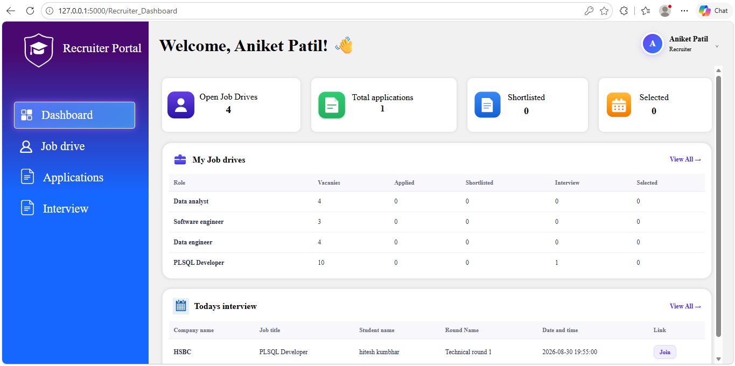
The Recruiter Dashboard summarizes the recruiter's placement activity.
On the top right side of this page, there is profile menu which has recruiter photo, recruiter name and role (recruiter). It has Logout option by clicking which application ends the logged-in session and redirects the user to the home page.
- 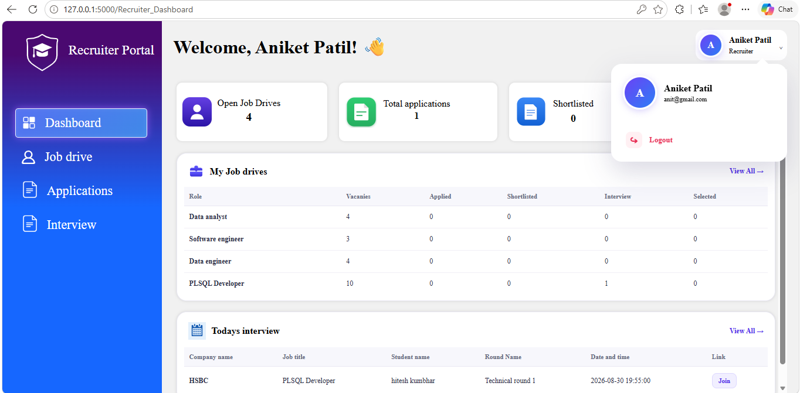
Open job drives card indicate number of job drives which are either active or expired.
Total applications card indicate number of applications which belong to job drives which are created by current user and which are either active or expired.
Shortlisted card indicate number of applications which belong to job drives which are created by current user and which are either active or expired and whose status is shortlisted.
Selected card indicate number of applications which belong to job drives which are created by current user and which are either active or expired and whose status is Selected.
My Job drives table contain information (such as Job title, Vacanies, Applied students count, Shortlisted students count, Interview count, Selected students count) about job drives created by current users. On top right side of same table when user click on view all option it will redirect the recruiter to application section in navigation bar.
- Applied column contains count of application whose current status is applied. i.e. those students which are not shortlisted yet.
- Shortlisted column contain count of application whose current status is Shortlisted.
- Interview column contain count of application whose current status is Interview Scheduled.
- Selected column contain count of application whose current status is Selected.
Today’s interview table contain information (such as Company name, Job title, Student name, Round Name, Date and time, Interview Link) about maximum 4 today’s interview. On top right side of same table when user click on view all option it will redirect the recruiter to Interview section in navigation bar.

7.2 Job Drives
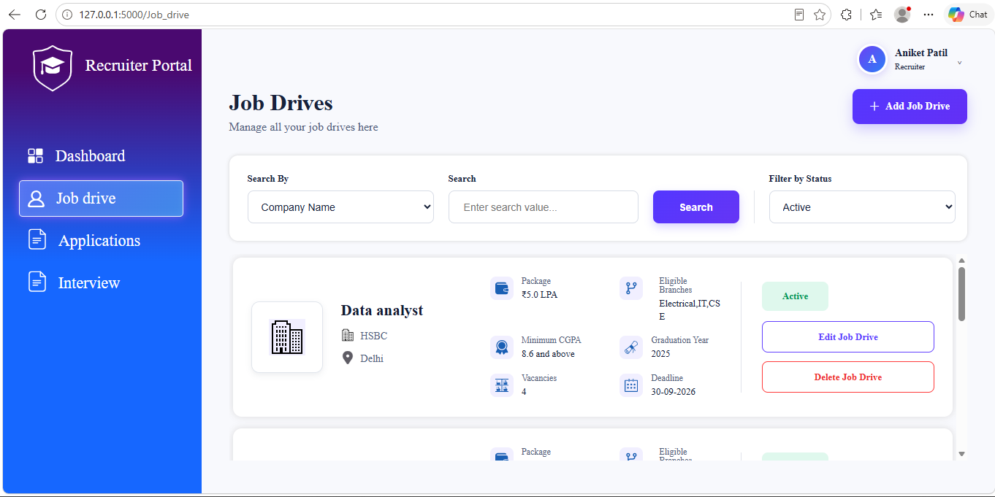
Job drive Section from the navigation bar contain information about job drives which are created by the recruiter.
To add new job drive click on “+ Add Job Drive” button. It will redirect user to create job drive page.
- Select the company from dropdown menu.
- Enter the job title.
- Enter the Package.
- Enter the Location.
- Enter the Minimum CGPA.
- Enter the Graduation Year. To enter multiple years, mention years separated by comma. For example 2025,2026,2027.
- Select eligible branches from dropdown menu.
- Enter vacancies and deadline. Deadline must be future date or current date. The application does not allow a deadline earlier than the current date when creating or editing a job drive.
- Enter the job description.
- Click on Create job drive button.
- Once recruiter click on Create job drive button, it will create job drive and send email to placement officer about this job drive.
A recruiter can edit a job drive created by that recruiter by clicking on edit job drive button.
Deleting a recruiter job drive in the current implementation changes its status to Closed.
The recruiter can search job drives by company name, title or location.
By default active job drives are shown on the page. User can filter by status to see expired job drives. Active job drives are those job drives whose deadline isn’t passed yet. Expired job drives are those job drives whose deadline is passed.

7.3 Applications
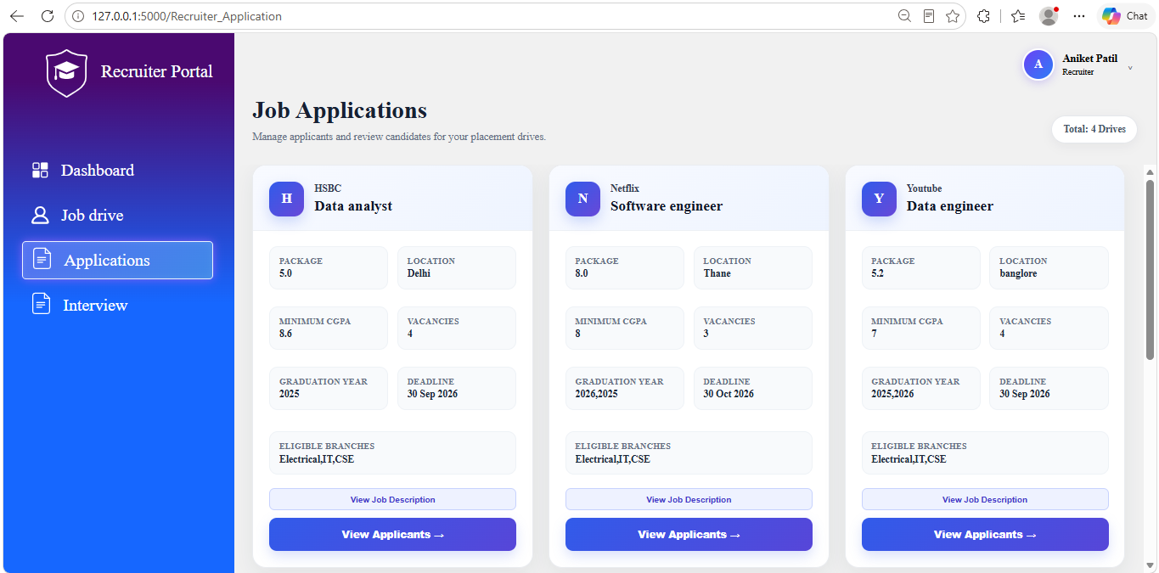
Applications Section from the navigation bar contain information about all applicants which are related to job drives created by current user.
Click on View Applicants button in job drive card to see all applicants who applied for that job drive.
It will redirect the user to applicants page.
- 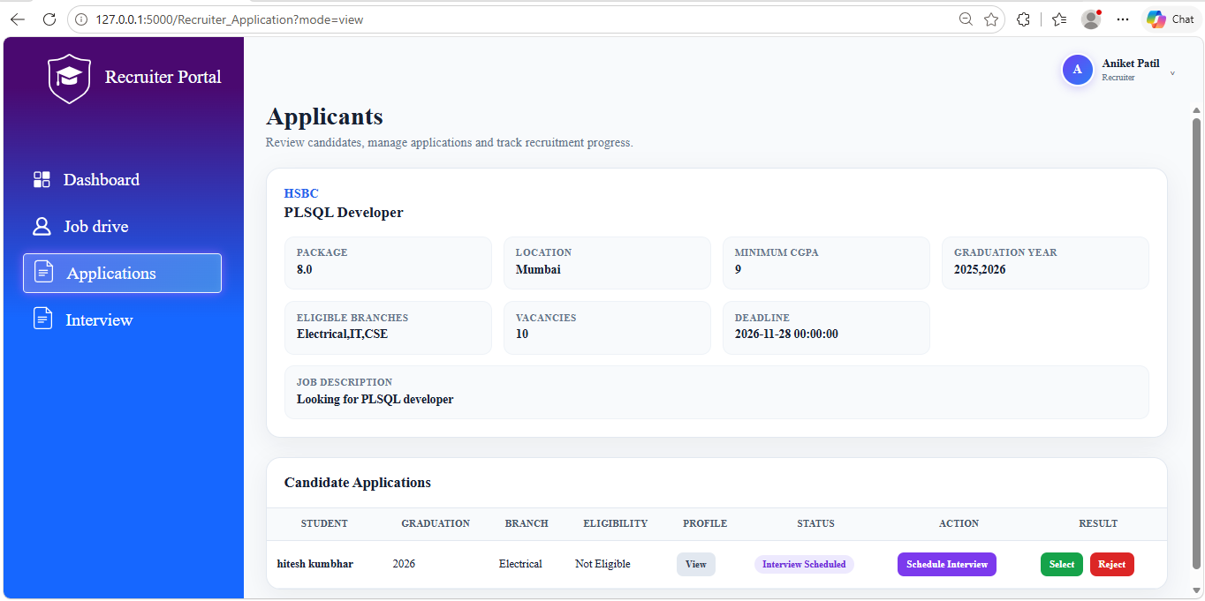
- Applicants page first shows information about job drive (such as company name, Job title, Package, Location, Minimum CGPA, Graduation Year, Eligible Branches, Vacancies, Deadline, Job Description) and then information about applicants (such as Name, Graduation year, Branch, Eligibility, Profile, Status, Action, Result).
- Eligibility column shows whether student is eligible according to criteria of job profile.
- When recruiter click on view button in profile column it will open another page and show information about student (such as Personal Information, Academic Information, Skills & Professional Links, Certifications, Resume and Interview Progress so far). In Interview progress section it shows information (such as Round Name, Date & Time, Feedback, Result) about interview rounds done so far. Recruiter can view student profile before shortlisting him/her for interview.
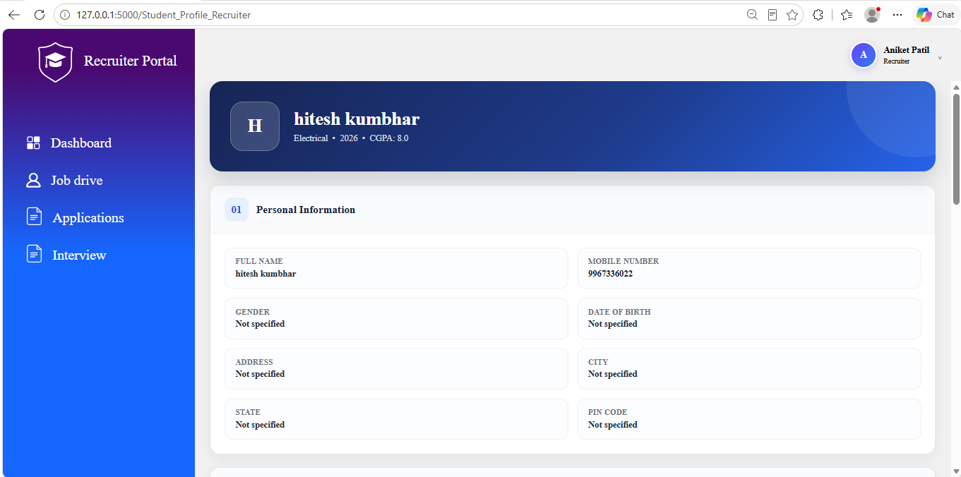
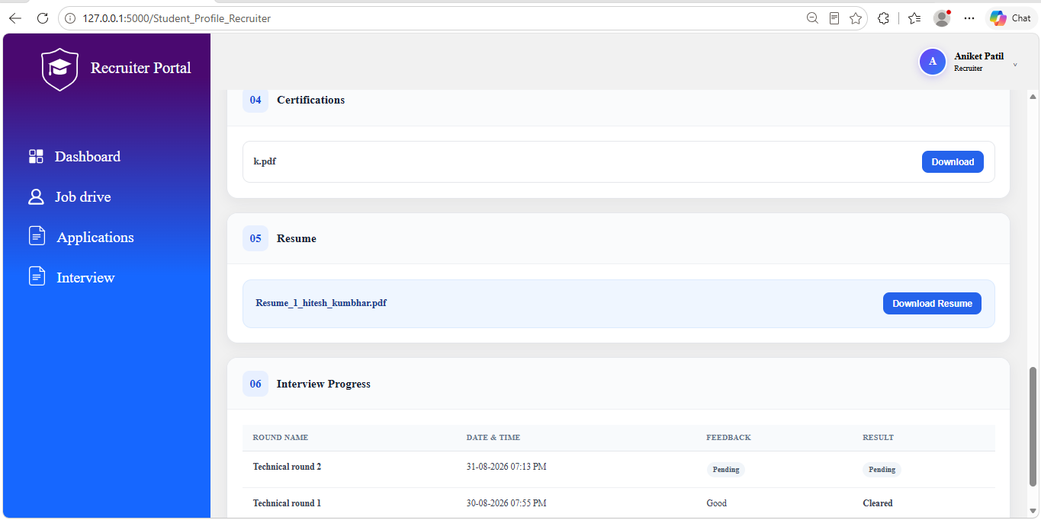
- Status column shows status of the application (such as Applied, Shortlisted, Interview Scheduled, Selected, Rejected).
- Action column will show next action to take.
- If status is Applied then it will show shortlist button. Once recruiter click on shortlist button it will change the status of application as Shortlisted. It will also send email to student and placement officer regarding this shortlisting.
- If status is Shortlisted then it will show Schedule Interview button to schedule interview. Once recruiter click on Schedule Interview button it will open another page which will ask the recruiter to enter round name, Interview Date & Time and Interview Link. Click on schedule interview to schedule the interview. Once recruiter click on schedule interview then it will change the status to Interview Scheduled and it will show interview round in Interview section in navigation bar. It will also send an email to student and placement officer regarding this interview.
- If status is Interview Scheduled then also it will show schedule interview button so that recruiter can schedule as many round as they want for particular student.
- If status is Selected then Action will be Selected. If status is Rejected then Action will be Rejected.
- Result column will show default value “Pending” as long as student is neither selected nor rejected.
- When status is Interview Scheduled then it will show two buttons which are “Select” or “Reject”.
- Click on Select button only if student is finally selected and no further rounds of interview are required. Once student is selected from here then value in this column, Status column and Action column will be shown Selected. It will also send email to student and placement officer regarding this selection.
- Click on “Reject” only if student is finally rejected and no further rounds of interview are required. Once student is rejected from here then value in this column, Status column and Action column will be shown Rejected. It will also send email to student and placement officer regarding this rejection.

7.7 Interview
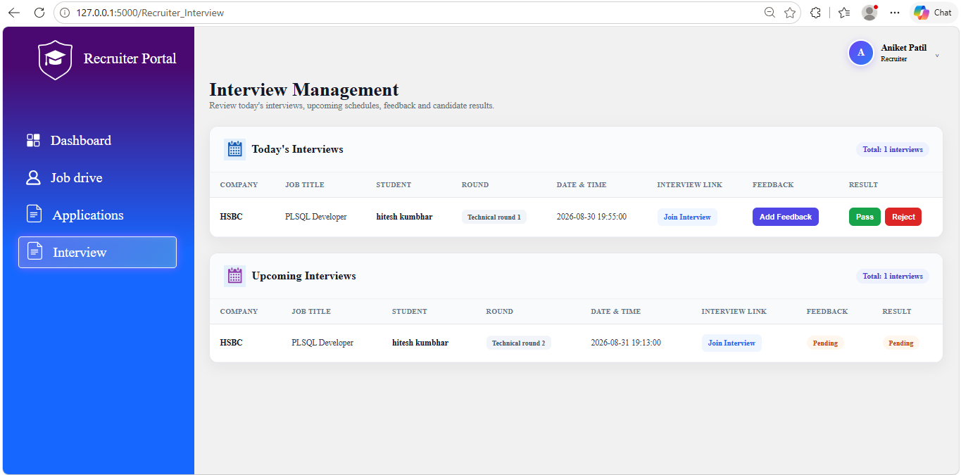
Interview Section from the navigation bar contain information about all today's and upcoming interviews.
Today’s interview table show details about today’s interview such as company name, Job Title, Student name, Round name, Date & Time, Interview Link, Feedback, Result.
- In Interview Link column, click on Join Interview to open the meeting link.
- In Feedback column, click on Add feedback button to give feedback of that particular round.
- Result column there will two buttons which are “Pass” and “Reject”.
- Click on “Pass” button to if student has cleared the current interview round. Once recruiter click on “Pass” button it will send email to student and placement officer regarding this selection. However this does not indicate final selection of student and status of application will still remain interview scheduled as long as recruiter doesn’t select or reject the candidate from Applications section in navigation bar.
- Click on “Reject” button to if student has not cleared the current interview round. Once recruiter click on “Reject” button it will send email to student and placement officer regarding this rejection. This rejection will be final rejection and status of application of this student will be permanently changed to Rejected. There is no need for recruiter to reject the candidate from Applications section in navigation bar.
Upcoming interview table show details about Upcoming interview in future such as company name, Job Title, Student name, Round name, Date & Time, Interview Link, Feedback, Result.

8. Placement Officer User Manual

8.1 Placement Officer Dashboard
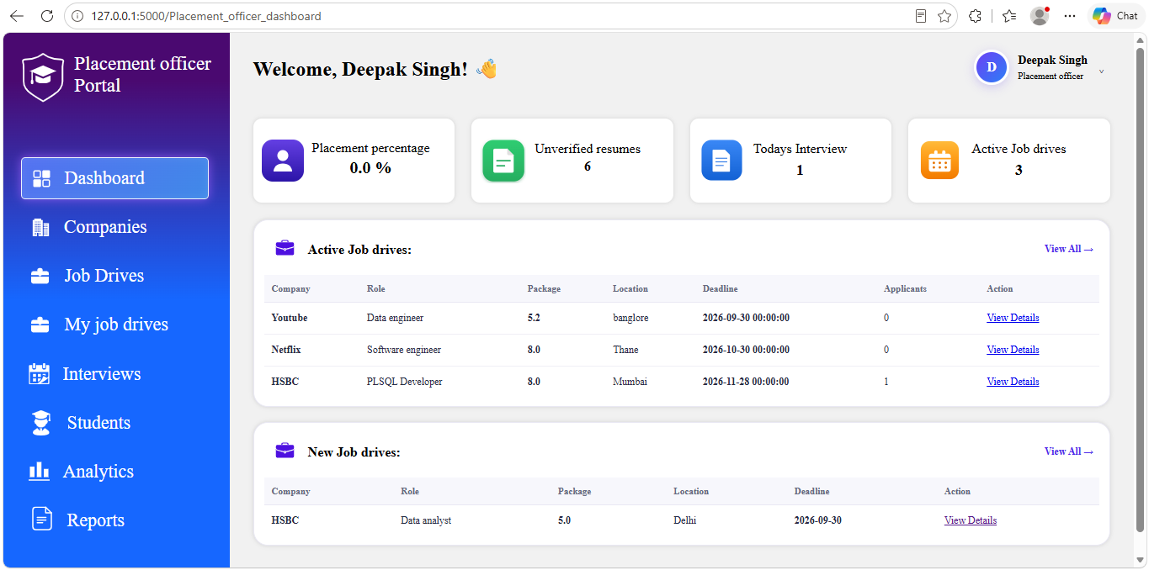
The Placement Officer Dashboard shows information about current year placement activity such as Placement percentage, Unverified resumes, Today’s Interview, Active Job drives, New Job drives.
On the top right side of this page, there is profile menu which has placement officer logo, placement officer name and role (placement officer). It has Logout option by clicking which application ends the logged-in session and redirects the user to the home page.
- 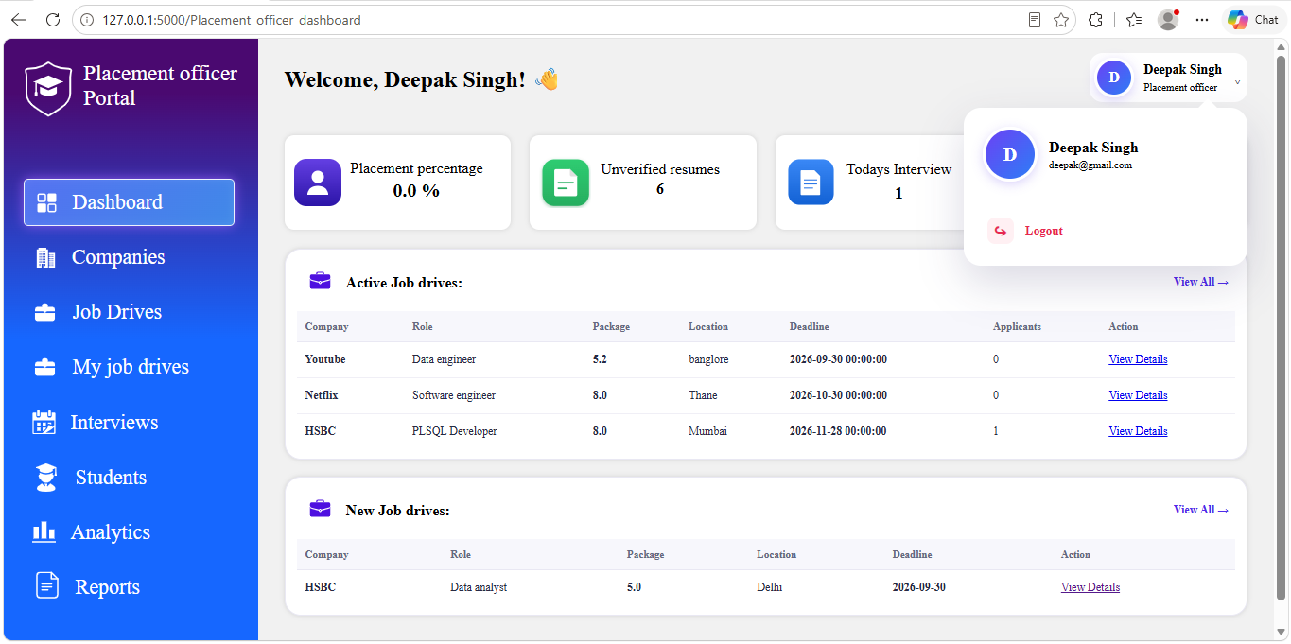
Placement percentage card show percentage of students placed in current year.
Unverified resumes card shows the total number students whose graduation year is current year and whose resume is not verified yet.
Today’s Interview card shows total number of interviews which are scheduled today.
Active Job drives card shows the total number of job drives which are posted by placement officer and which are not closed by recruiter yet.
Active Job drives table shows information about maximum 5 job drives which are posted by placement officer and not closed by recruiter yet. Information include Company name, Job title, Package, Location, Deadline, total number of students who has applied for that job drive and option to view details. Once the user click on view details it will redirect the user to My Job Drives section in navigation bar. On top right side of this table there is view all option which will redirect the user to My Job Drives section in navigation bar.
New Job drives table shows information about maximum 5 job drives which are posted by recruiter not posted by placement officer yet. It contains the information such Company name, Job title, Package, Location, Deadline, view details option. Once user click on view details option it will redirect the user to Job Drives section in navigation bar. On top right side of this table there is view all option which will redirect the user to My Job Drives section in navigation bar.

8.2 Company
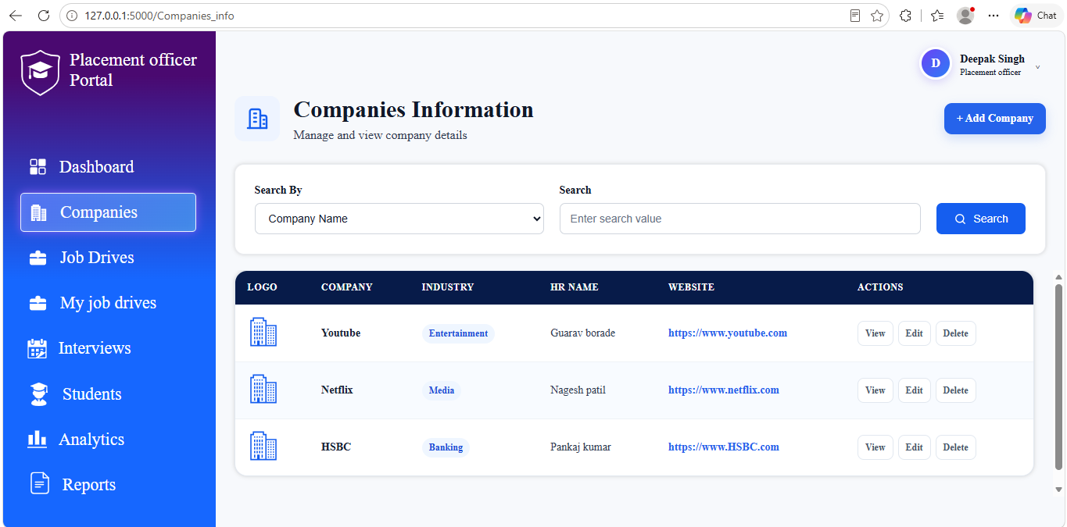
Companies section in navigation bar show information companies.
On top right side there is Add company button to add new company. Once user click on this button it will redirect the user on new web page. On this web page follow the below steps to add a company.
- Enter company name.
- Enter industry.
- Enter Company website.
- Enter HR name, HR email and HR phone number.
- Enter company address.
- Upload Company Logo. Logo size must be less than 5 mb and Uploaded file must be in JPG/JPEG/PNG format.
- Submit the form.
On Companies section in navigation bar there is option to search companies by Company name, Industry and HR name.
Below this search option there is table which shows the information about companies such as Company Logo, Company name, Industry name, HR Name, Company Website and option to view more details, edit company and delete company in Actions Table.
- To view more details about company click on view button. It show more information about the company on right side of this table. Information include Company Name , Industry, Website, HR Name , HR Email , Contact Number , Address, Number of Job Drives which as either active or expired but not closed by recruiter, edit button and delete button.
- To edit a company, click on edit button. In will open new page. Edit the information. Click on update company.
- To delete a company, click on delete button.

8.3 Job Drives
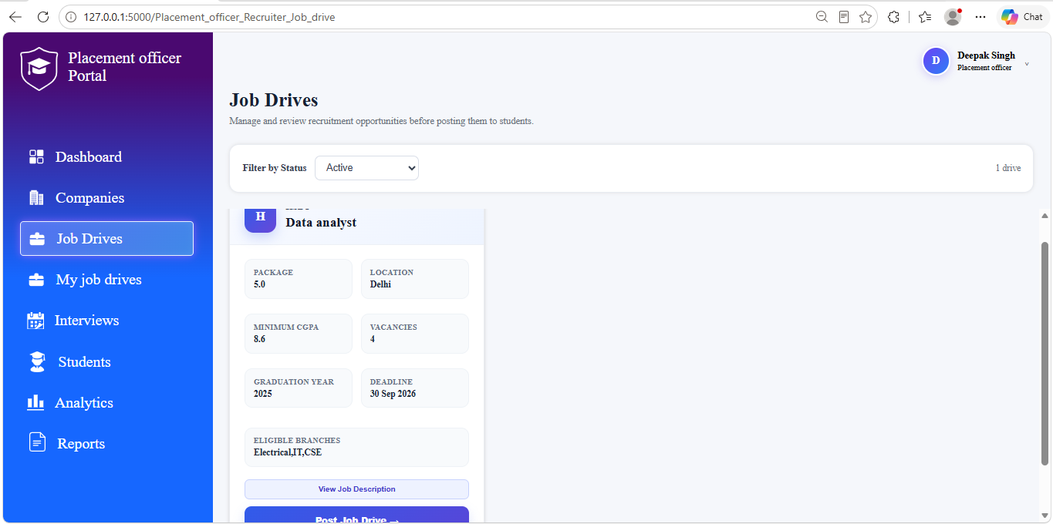
Job Drives section in navigation bar shows new job drives which are posted by recruiter.
By default, filter is applied to active job drives. Active job drives are those job drives whose deadline is not passed. To see expired job drives change the filter to expired.
When filter is set to active, each job drive card contain information about job drive such as Company logo, Company name, Job Title, Package, Location, Minimum CGPA, Vacancies, Graduation year, Deadline, Eligible branches, job description and Post job drive button.
Once the user click on Post job drive button, it will redirect the user to new page. On new page, there will be information about job drive such as Company name, Job title, Package, Location, Deadline, Eligible branches, Job description. Below this there will be two drop down. First drop down shows list of eligible students according to criteria of job drive. If placement officer wants to select more students which are not meeting criteria of job drive then there is second drop down which shows list of all students. Once user post job drives then it will send email to all those students who recommended by placement officer.
- 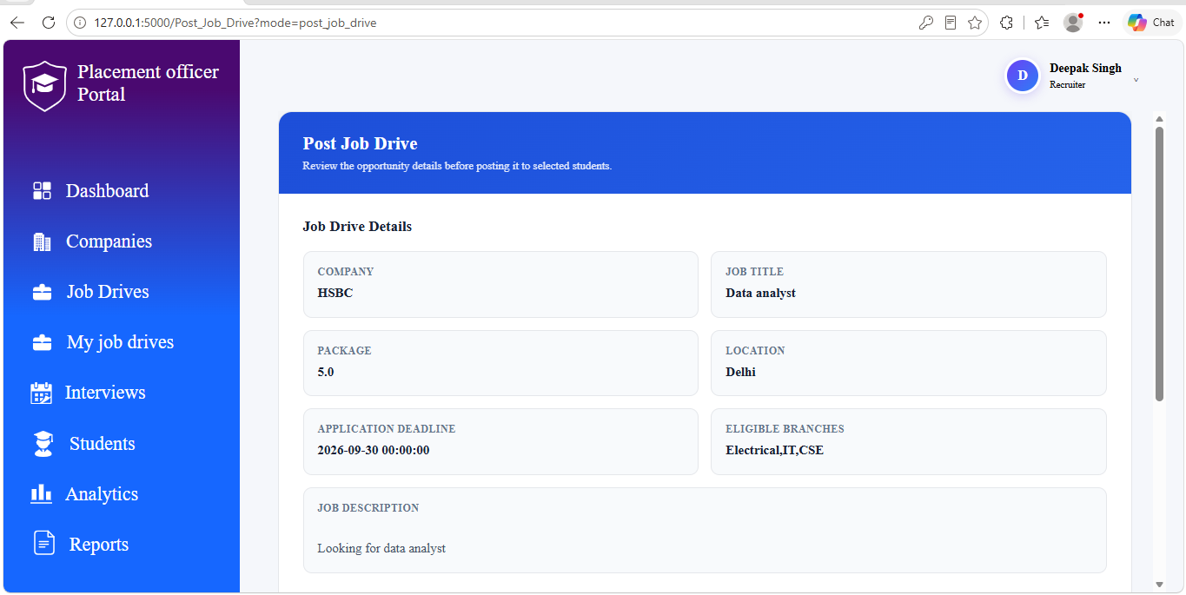
- 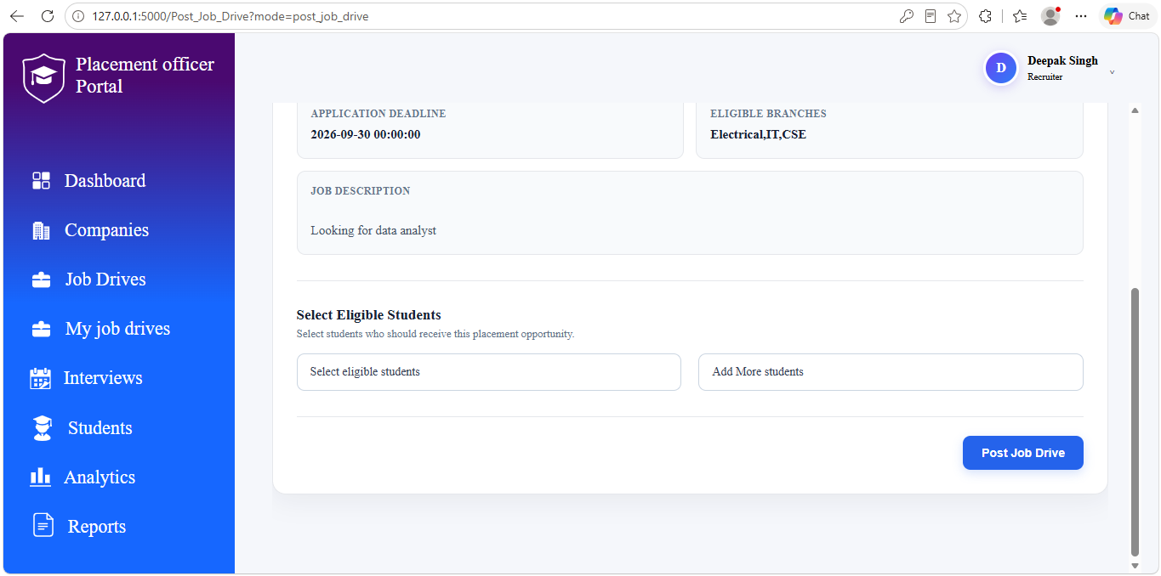
Once the deadline is passed, user wont be able post job drive.

8.4 My Job Drives
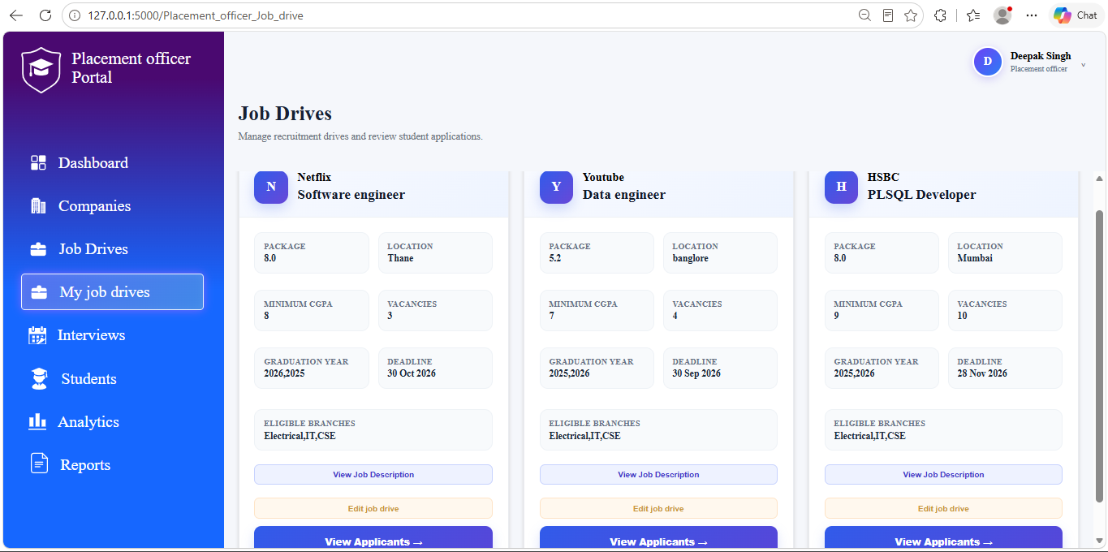
My Job Drives section in navigation bar shows information about those job drives which are posted by placement officer.
On each card there is edit job drive button and View applicants button.
When user click on edit job drive, it will allow the user to recommend more students. If any student opt out by mistake then user can recommend him/her again through this option. Once user click on Post Job Drives then it will send email to all those students who are recommended by placement officer in this page.
To view Applicants related to job drive click on View Applicants button. Once user click on View Applicants button it will take user to Job Drive Details page. This page contains information about job drive such as company name, job title, package, location, minimum CGPA, Graduation Year, Eligible Branches, Vacancies, Deadline, Job Description. Below this there is information about applicant in table. This table contain following Information:
- 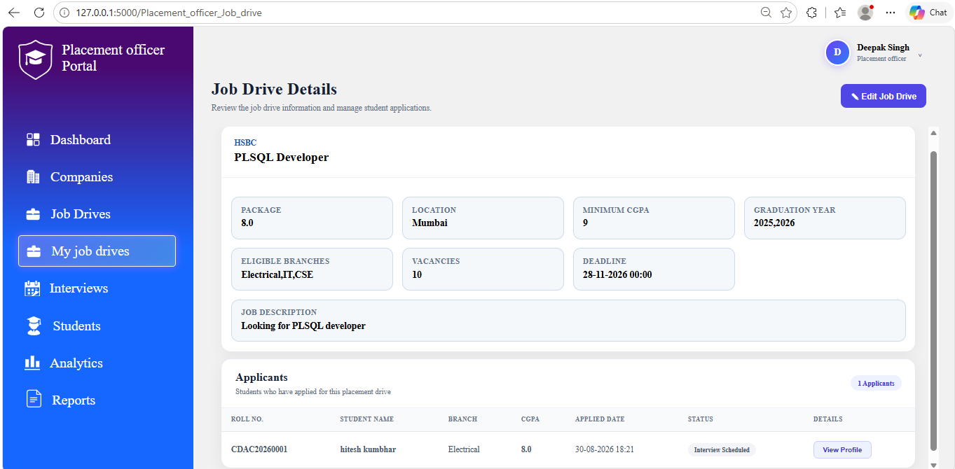
- Roll No: roll number of student
- Student Name: name of student
- Branch: name of branch
- CGPA: CGPA of student
- Applied Date: Date and time when student applied for that particular job drive
- Status: This column indicate status of application.
- If student is recommended by placement officer but not applied to job drive then it will show “Recommended”.
- If student is recommended by placement officer but opted out from job drive then it will show “Opted out”.
- If student has applied for job drive but not shortlisted by recruiter then it will show the status as Applied.
- If student is shortlisted by recruiter then it will show the status as Shortlisted.
- If interview is scheduled by recruiter then it will show the status as Interview Scheduled.
- If student is finally “Selected” or “Rejected”, then it will show the status as “Selected” or “Rejected”.
- Details: To see details of interview round done so far for particular student click on View Profile button in this column.
- 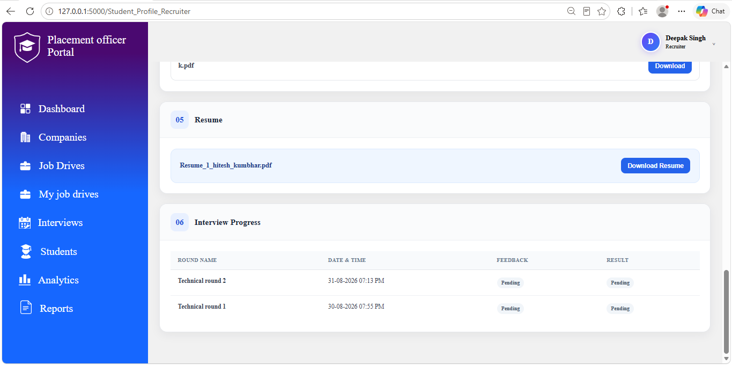

8.5 Interviews
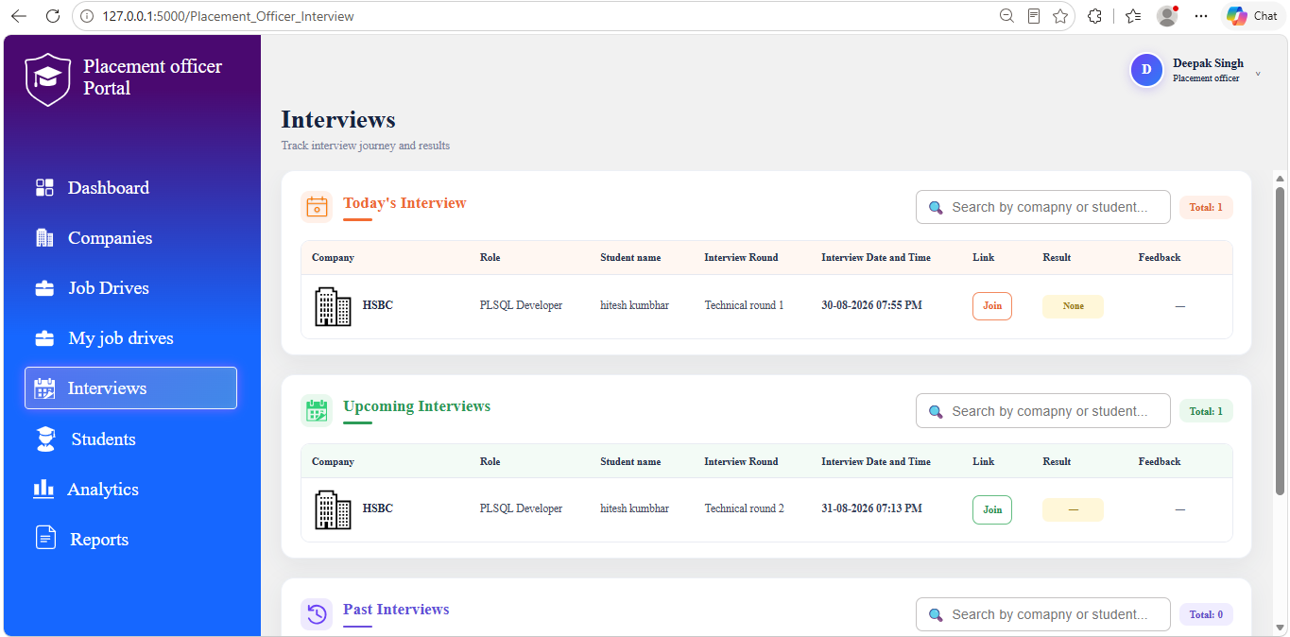
Interviews section in navigation bar shows information about today’s interview, past interview and future interviews.
Today’s interview table shows the information about today’s interview. Information include Company name, job title, Student name, Interview Round, Interview Date and Time, Interview link, Result and Feedback.
Upcoming interview table shows the information about upcoming interview. Information include Company name, job title, Student name, Interview Round, Interview Date and Time, Interview link, Result and Feedback.
Past interview table shows the information about past interview. Information include Company name, job title, Student name, Interview Round, Interview Date and Time, Interview link, Result and Feedback.
On top right side of each table, there is search bar to search interview round by company or student.

8.6 Students
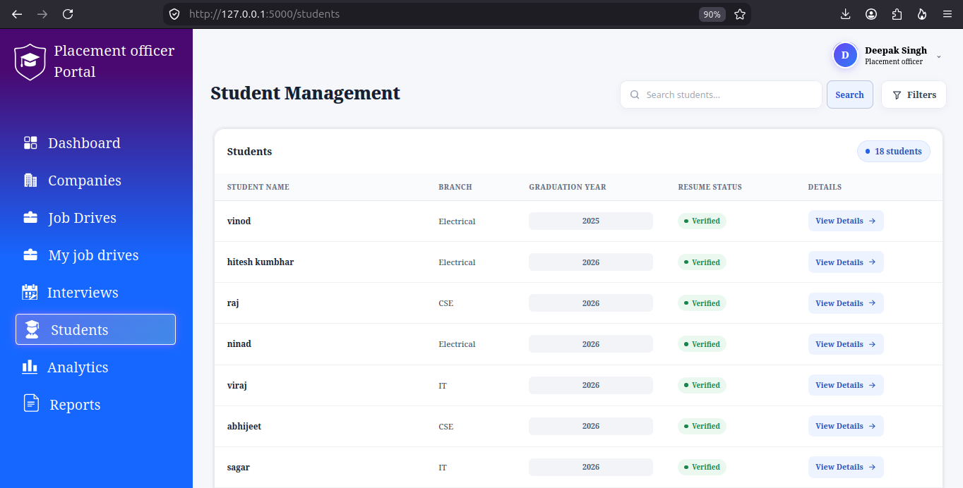
Students section in navigation bar shows information about all students in database.
User can search for particular student by its name in search bar.
Beside search bar there is filter which can be used to filter students based on their resume status, Graduation Year, Branch etc.
Table below filter and search bar shows information about student. Information include Student name, Branch, Graduation Year, Resume Status, Details.
To see all information about student and verify resume, click on view details buttom in details column. It will take the user to new page where user can see following information
- Personal Information
- 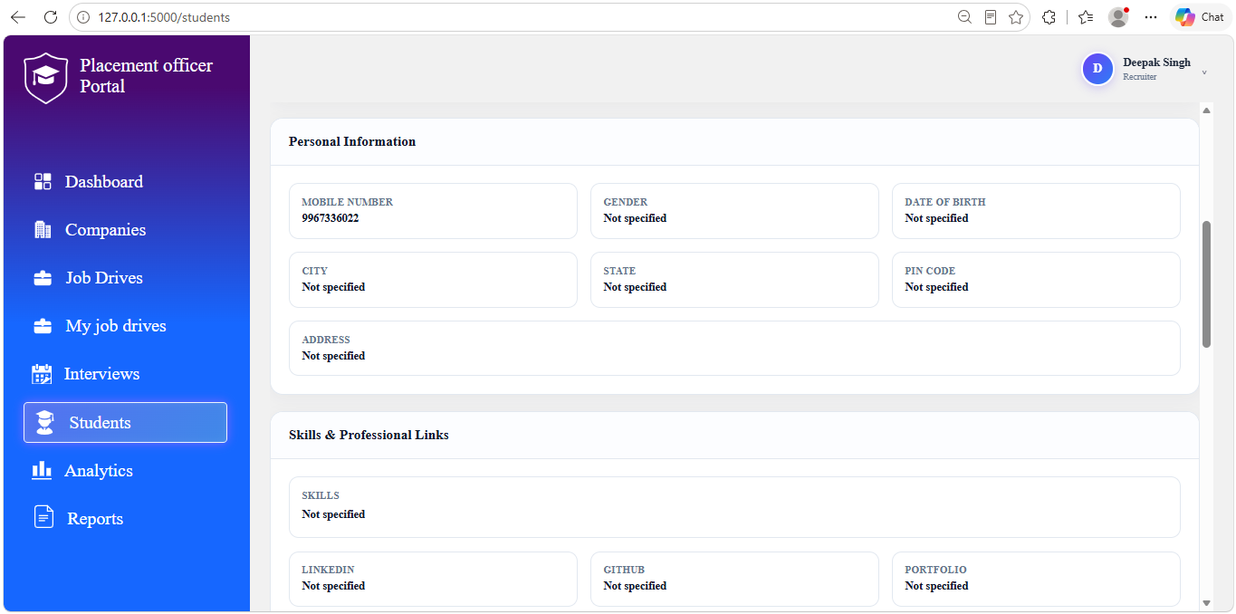
- Academic information
- 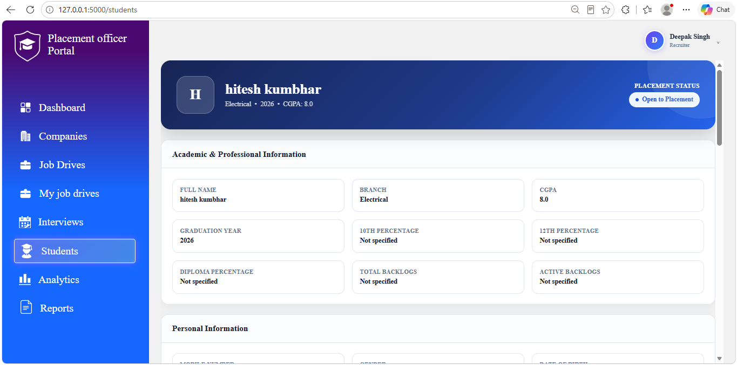
- Skills & Professional Links,
- Certifications,
- 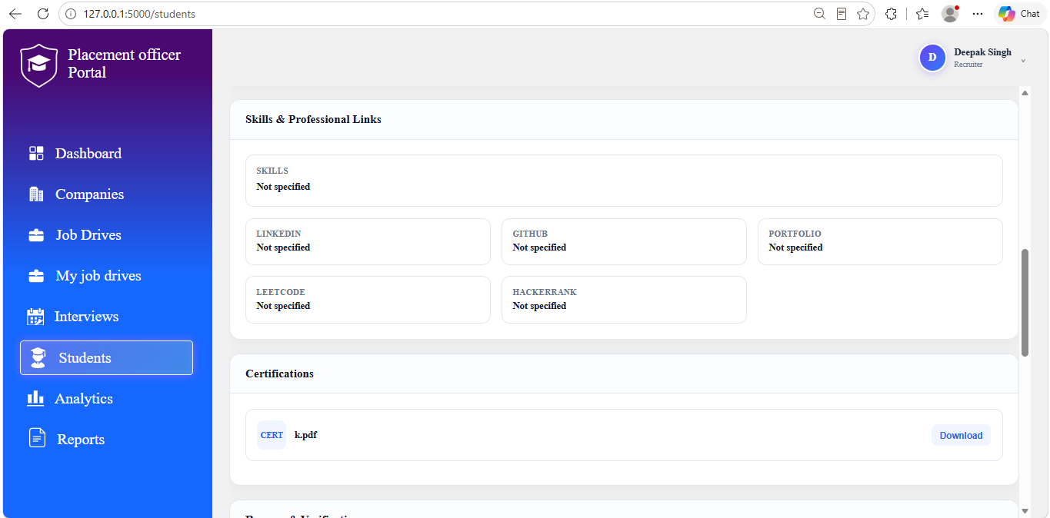
- Resume & Verification: In this user can verify resume, reject resume and give remark for resume.
- Placement Action: In this user can mark student as placed.
- 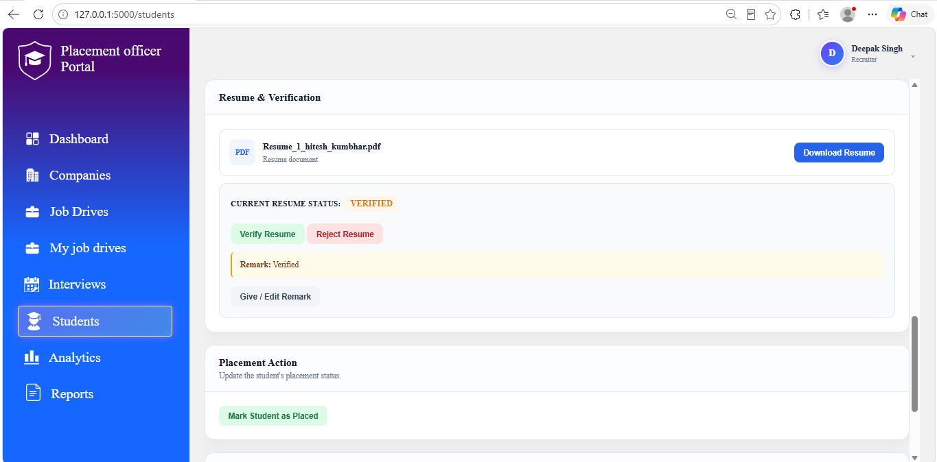
- Placement Applications: This will show list of all application where students has applied so far. User can also see details of interview round by clicking on view details button in Details column.
- 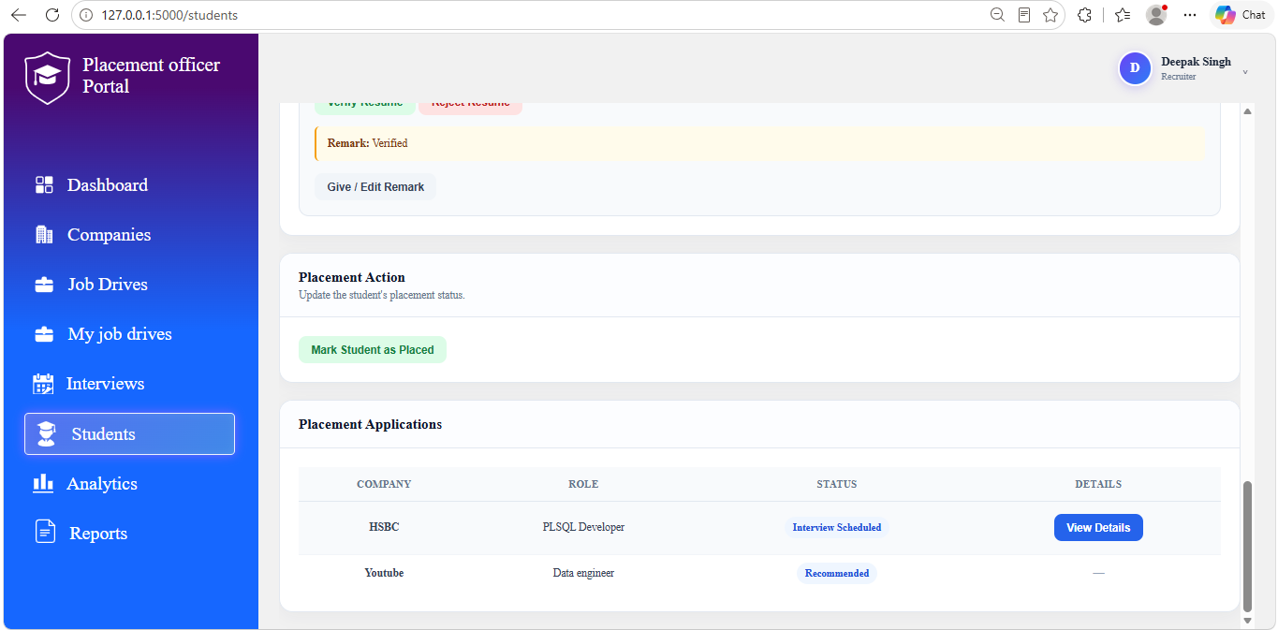

8.7 Analytics
Analytics section in navigation bar shows information about placement statistics, resume verification status etc according to year selected.
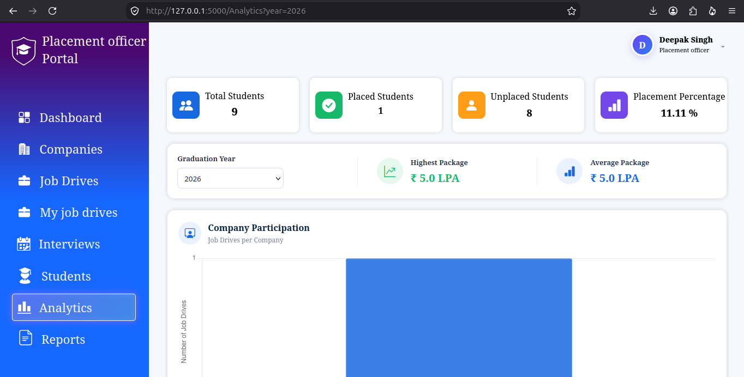
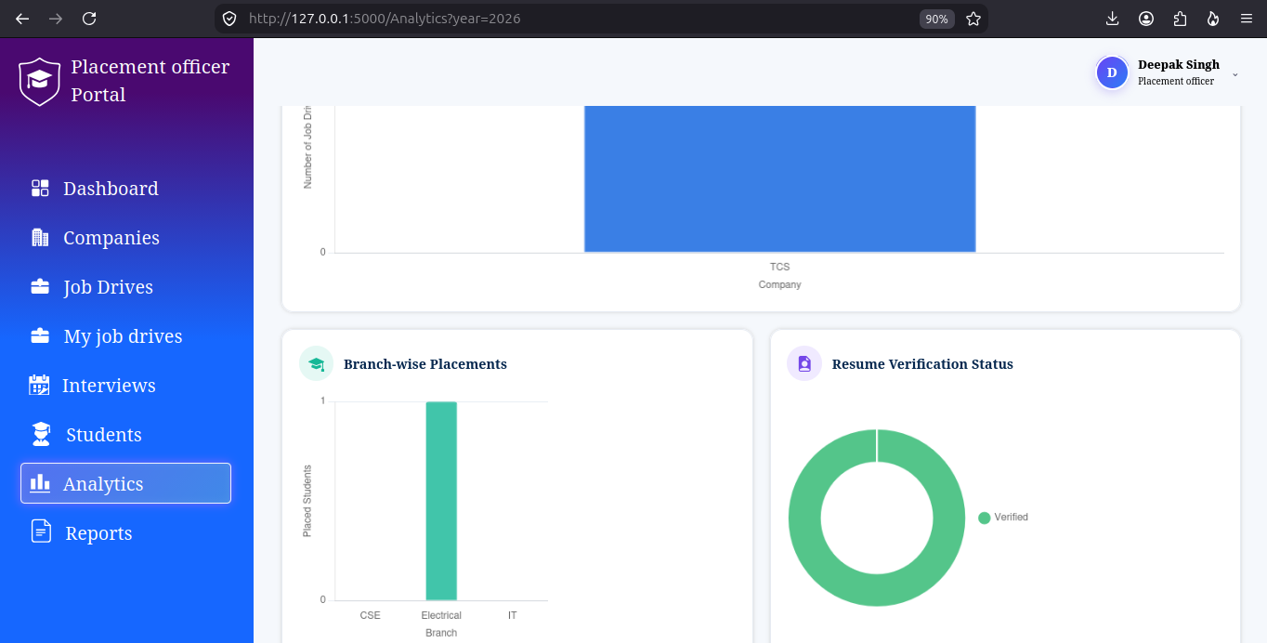
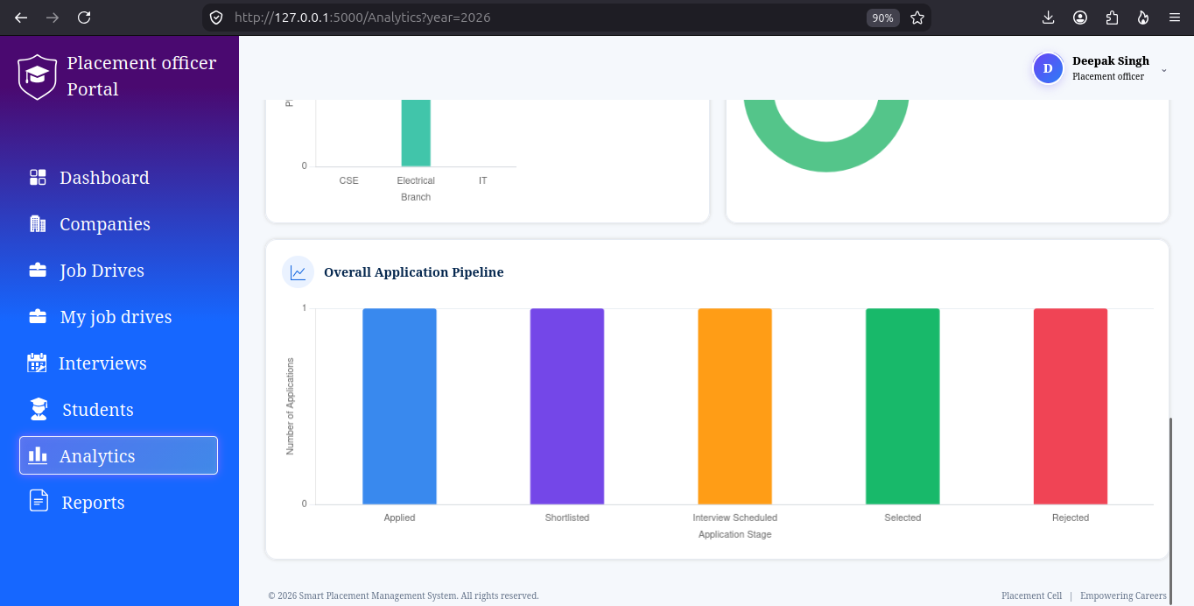
User can filter all analytics according to graduation year selected.
Total students card shows total number of students for that particular year.
Placed Students card shows total number of placed students for that particular year.
Unplaced Students card shows total number of unplaced students for that particular year.
Placement Percentage card shows placement percentage for that particular year.
Highest Package card shows highest package offered in that particular year.
Average Package card shows Average package offered in that particular year.
Company participation chart shows number of job drives per company.
Branch-wise Placements chart shows number of placed students per branch.
Resume Verification Status donut chart shows total number of students whose resume is verified, unverified, pending, reuploaded etc.
Overall Application chart shows number of applications according to their status.

8.8 Reports
The Reports section in navigation bar provides option to download student report, company report and placement report.

Student Report
For student report, user can apply four filters which are Resume status, Graduation year, Branch, Placement status.
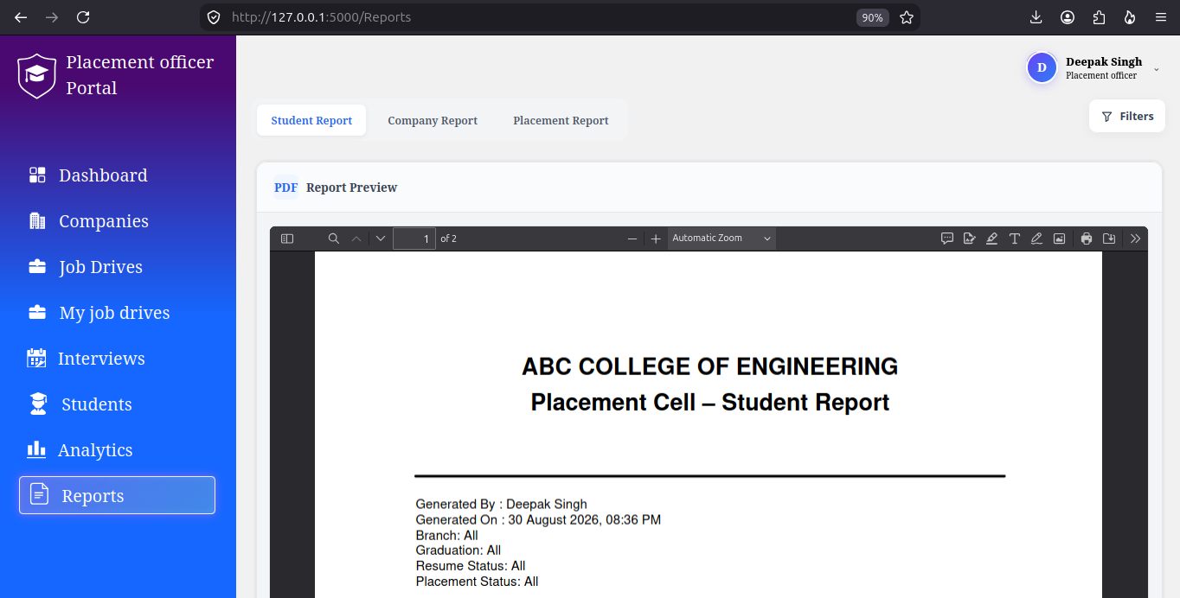
In student report, following details are covered:
- Name of person who generated it
- Date and time of report generation
- If filter is applied to branch then name of that branch
- If filter is applied to graduation year then year of graduation
- If filter is applied to resume status then status of resume
- If filter is applied to placement status then status of placement
- Student details table which include roll no, student name, Branch, CGPA, Resume status, Placement status, Company in which it he/she is selected.
- All information in summary will vary based on filter applied. Summary which include following information:
- Total number of students.
- Total number of students for each branch.
- Total number of students whose resume is verified.
- Total number of students whose resume is rejected.
- Total number of students whose resume verification is pending.
- Total number of students whose have reuploaded their resume.
- Total number of unplaced students.
- Total number of placed students.
- Placement percentage according to filter applied.

Company Report
For company report, user can apply three filters which are Company name, industry, graduation year.
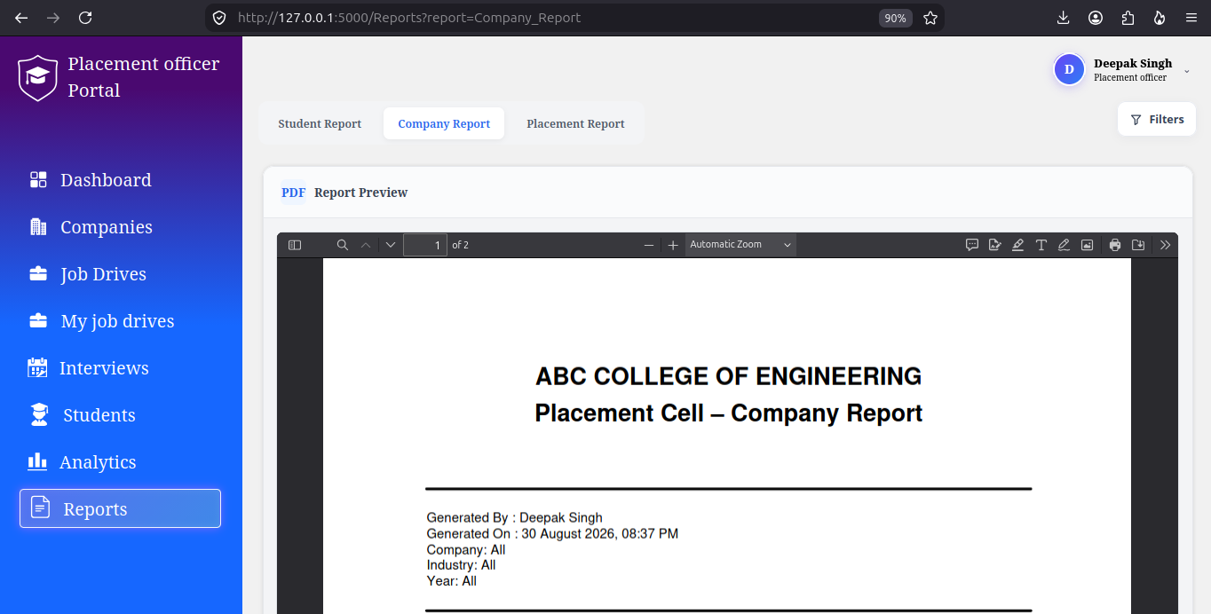
In company report, following details are covered:
- Name of person who generated it,
- Date and time of report generation
- If filter is applied to company then name of that company.
- If filter is applied to industry then name of that industry.
- If filter is applied to year then that year.
- Next table include details of company according to filter applied. If the filter is applied to year then it will show information about those companies who has created job drive in that year.
- Company name
- Industry
- HR Name
- Email
- Website
- Next table include details of Recruitment Statistics. If the filter is applied to year then it will show information about those companies who has created job drive in that year.
- Company: Name of company
- Drives: total number of job drive according to filter applied.
- Applications: Total number of applications for all job drives.
- Shortlisted: Total number of applications whose current application status is shortlisted.
- Interviewed: Total number of applications whose current application status is Interview Scheduled.
- Selected: Total number of applications whose current application status is Selected
- Next table include Company-wise Package Details according to filter applied.
- Company name
- Highest CTC
- Lowest CTC
- Average CTC
- All information in summary will vary based on filter applied. Summary include following information:
- Total Companies
- Total Job Drives of all those total companies.
- Total Applications of all those job drives
- Total Applications whose status selected

Placement report
For Placement report, user can apply three filters which are Company name, Branch, Year.
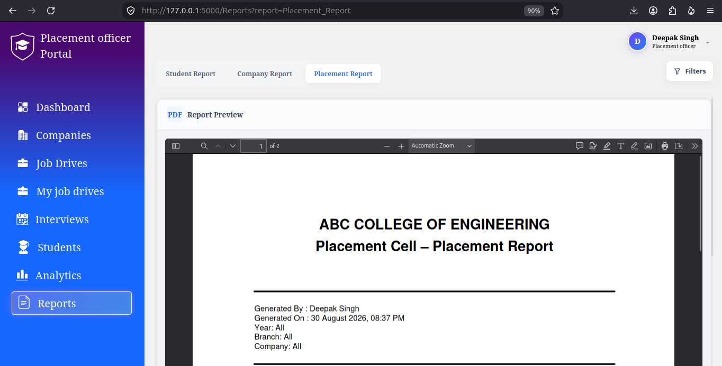
In placement report, following details are covered:
- Name of person who generated it,
- Date and time of report generation
- If filter is applied to company then name of that company.
- If filter is applied to branch then name of that branch.
- If filter is applied to year then that year.
- Next table include details of Branch-wise placement. This table include following details
- Branch: Branch name
- Total Students: Total number of students in that branch.
- Applied: Total number of students who applied for any job drive.
- Placed: Total number of students who are placed.
- Percentage: Placement percentage for that branch
- Highest CTC: Highest CTC offered for that branch.
- Next table include details of Company-wise Placement Summary. This table include following details
- Company: name of company
- Drives: total number of job drives
- Selected: total number of selected students
- Highest CTC: Highest CTC offered by that company-wise
- Next table include details of Selected Students. This table include following details:
- Roll No.
- Student Name
- Branch
- Company
- Job Role
- Package
- All information in summary will vary based on filter applied. Summary include following information:
- Placement Percentage
- Total number of participating Companies
- Total number of Job Drives of all those participating companies
- Total Applications of all those job drives
- Total number of selected students
- Highest Package offered
- Lowest Package offered
- Average Package offered

9. Application Status Lifecycle
Status | Meaning
Applied | Student has submitted an application.
Shortlisted | Recruiter has shortlisted the applicant.
Interview Scheduled | An interview round has been scheduled.
Selected | Applicant has been selected.
Rejected | Applicant has been rejected.

10. Recommended User Practices
- Keep the student profile information up to date.
- Upload a current resume in PDF format.
- Wait for resume verification before applying.
- Review job-drive deadlines carefully.
- Check the Applications page regularly for status changes.
- Check the Interviews page for scheduled and upcoming rounds.
- Recruiters should verify candidate eligibility before proceeding with recruitment actions.
- Placement Officers should verify resumes and maintain accurate student/company information.
- Do not share login credentials with other users.

