METHODOLOGY VEHICLE DAMAGE DETECTION

DATASET :-
https://universe.roboflow.com/damagedlocation/locationset

ABOUT DATASET: -
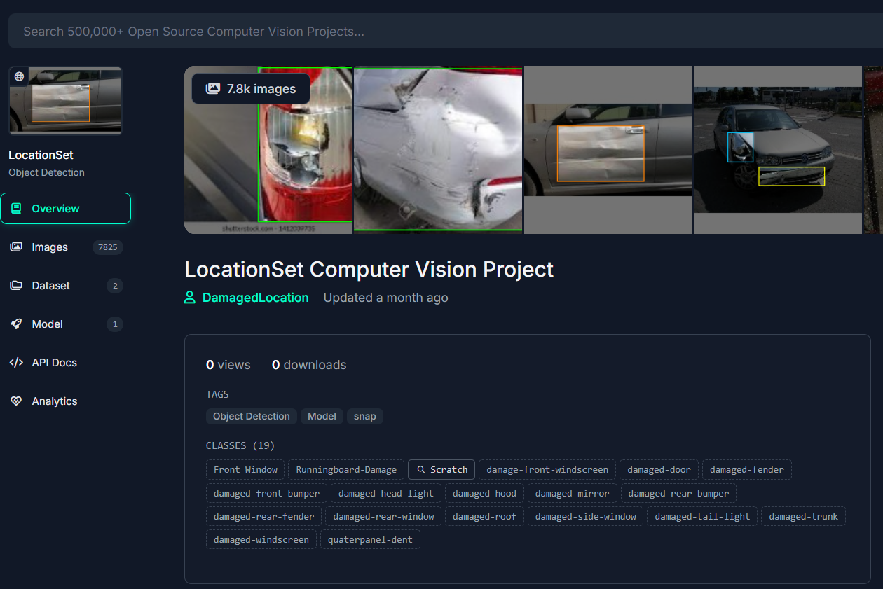

PROJECT FLOW:-
- Importing All Libraries
- Configuring cuDNN on Colab
- Installing Darknet for YOLO on Colab
- Change path to darknet folder
- Set up Custom Dataset for YOLO
- Clone the official yolo version git repo
- Install all requirements
- Write Custom Training Config for YOLO
- Train Custom YOLO Detector
- Evaluation
- Infer Custom Objects with Saved YOLO Weights
- GUI using Flask (best model)

LIST OF MODEL -
- YOLO – V7
- YOLO – V8

