**CONFIGURE A BUDGET AND SETTING A THRESHOLD VALUE**

**Visit** **aws.amazon.com** **and Sign in**

**Click on “Hitesh Periwal”**

**1.….**.

**2.**

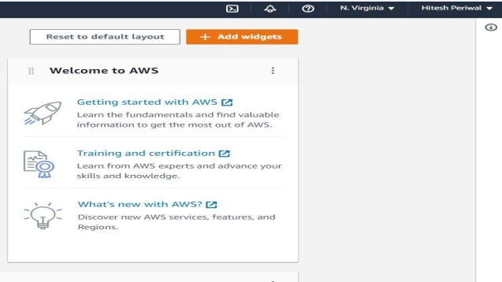

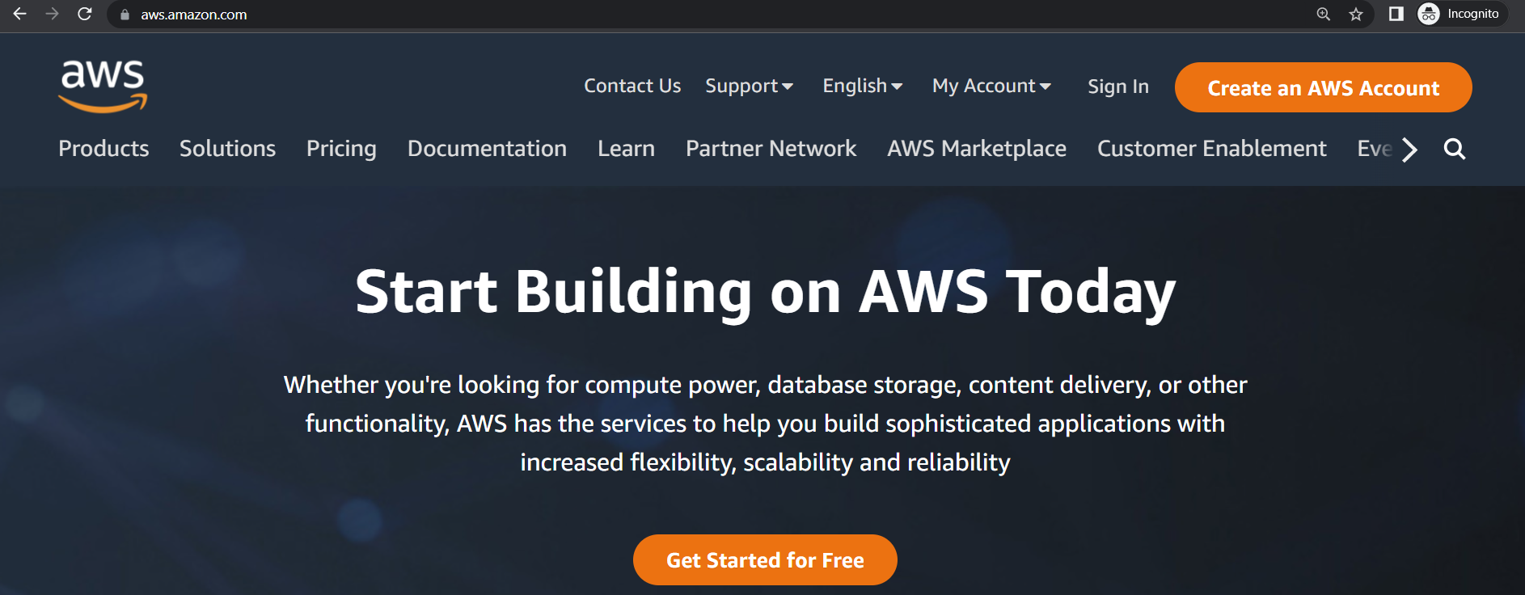

**Click on “Budgets”**

**Click on “Billing Dashboard”**

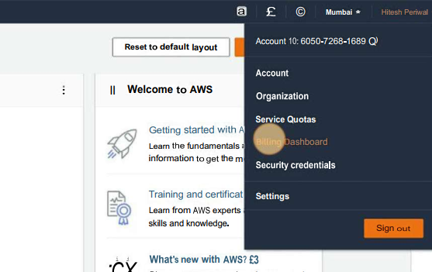

**s**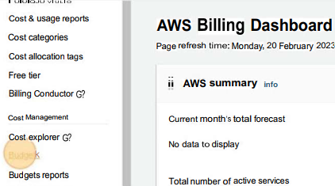

**3.**

**4.….**.

**Click on “Create Budget”**

**Select “Customize (advanced)**

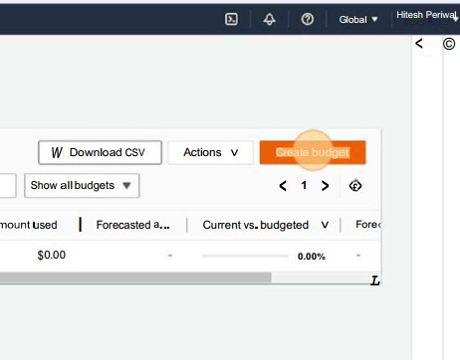

**5.….**.

**6.….**.

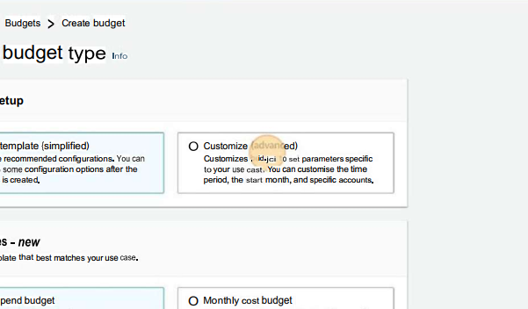

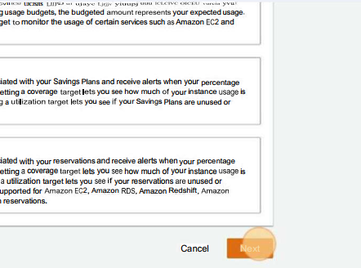

**Click on “Next”**

**Give your budget a name**

**8.….**.

**7.….**.

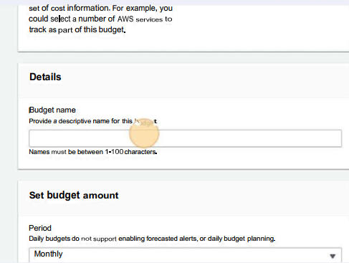

**Click on “Next”**



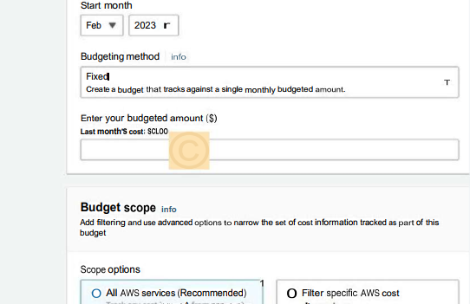

**10.….**.

**Enter the budgeted amount in $**

**9.….**.

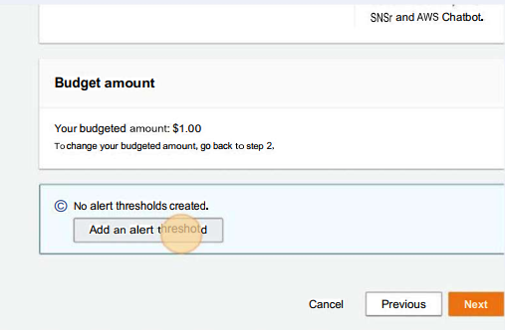

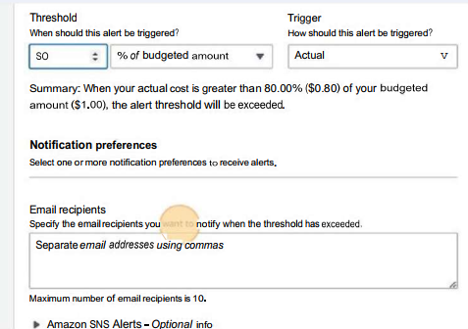

**Set the threshold and then specify the email recipients you want to notify when threshold has exceeded**

**Click on “Add an alert threshold”**

**12.….**.

**11.….**.

**14.….**.

**13.….**.

**Click on “Create Budget”**

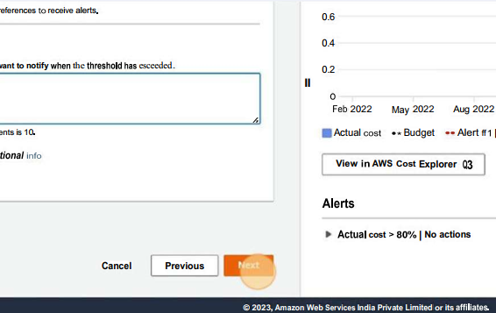

**Select “Customize (advanced)**

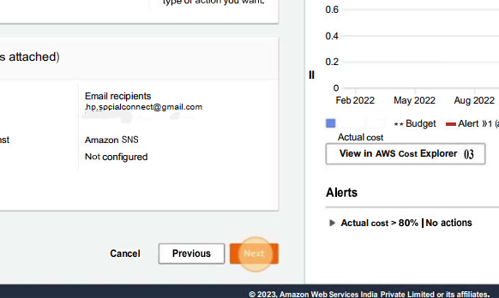

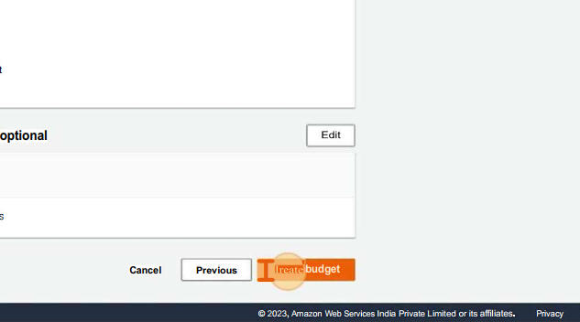

**15**.

**Click on “Create budget ” and hence the budget is created**