**UPLOAD A STATIC WEBSITE ON EC2 SERVER**

**Visit** **aws.amazon.com** **and Sign in.Click on the search field and type “EC2” in the search field and select EC2**

**Select “Launch instance” option**

**1.….**.

**2.**

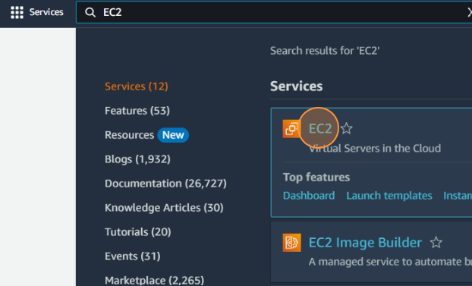

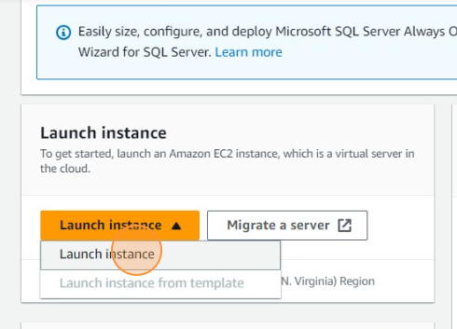

**Select instance type as “t2.micro” and and then “Click on create new key pair”**

**Select Ubuntu**

**s**

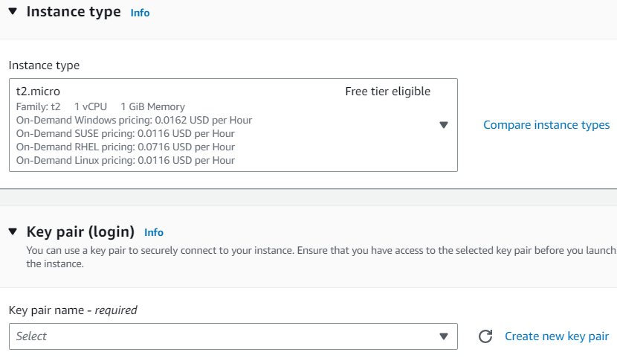

**3.**

**4.….**.

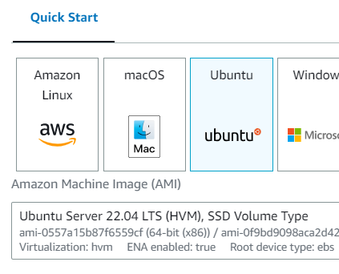

**Type the key pair name,Select “RSA” as key type and “.pem” as key file format.Then click on “Create key pair” and download the .pem file**

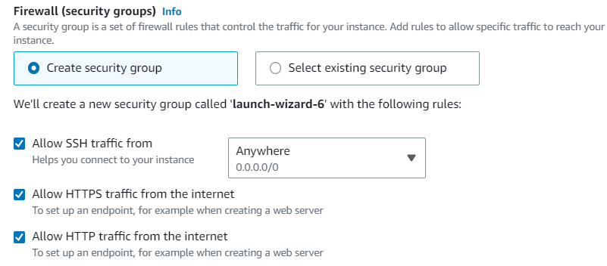

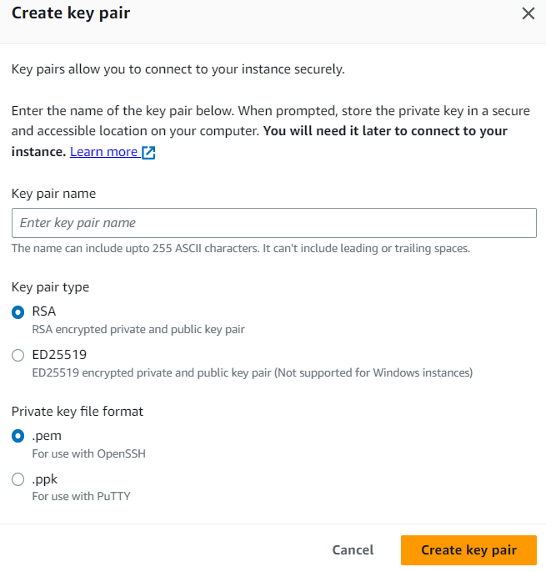

**Allow all the following three traffics and click on “Launch instance”**

**5.….**.

**6.**

**Open Bitwise SSH client,paste the copied public IPv4 address in the host box.Select username as Ubuntu,initial method as none and elevation as default.Then click on client key manager**

**On the instances page click on the instance id and then copy the public IPv4 address**

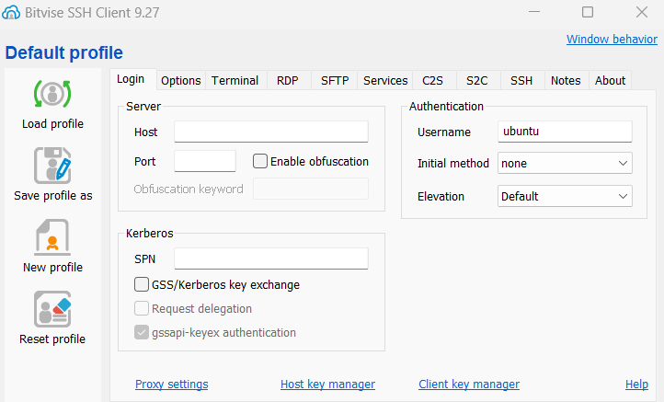

**7.….**.

**8.**

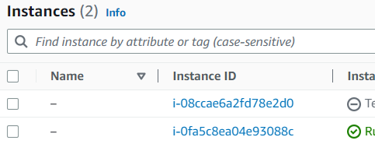

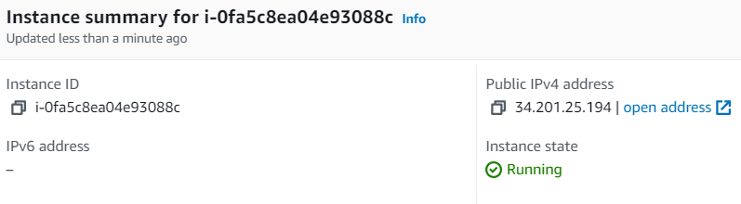

**Select accept and continue and then type the username as Ubuntu,method as public key and client key as Global 1.Then click on “OK”.**

**Import the download .pem file and then click on login on the SSH client.**

**10.**

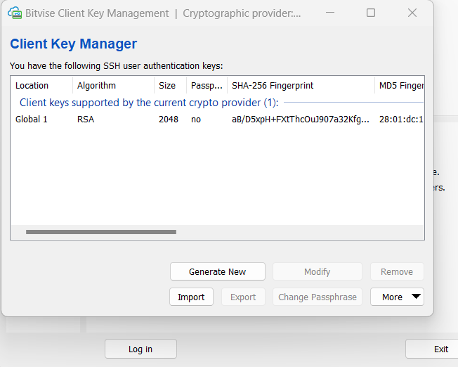

**S**

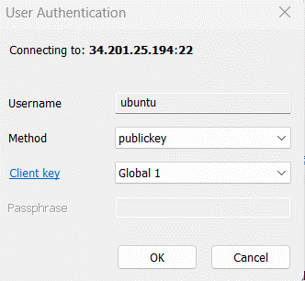

**9.**

**11.**

**Open the terminal console in the SSH client and type and run the following commands individually.If asked for confirmation click on yes and ok depending on the options available.**

 





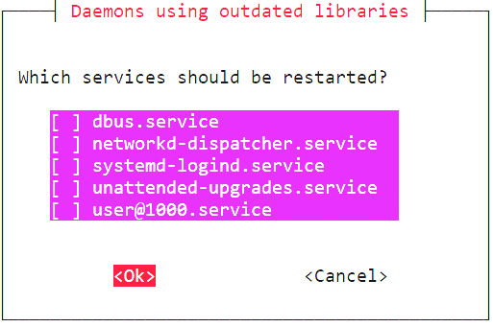



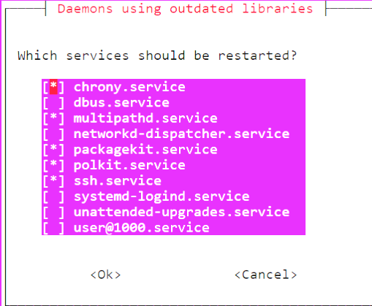

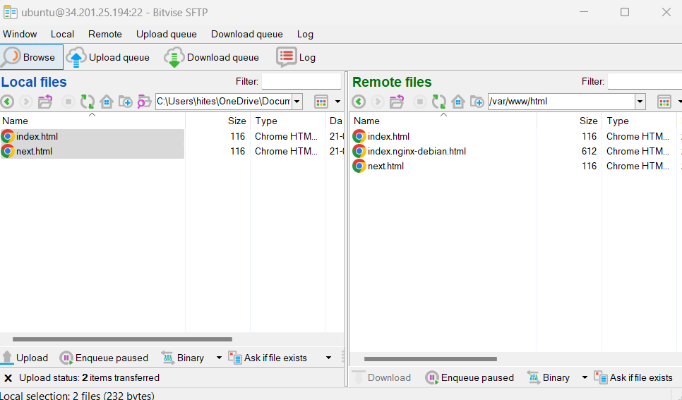

**Type the following commands in the terminal to change the working directory to the root and then move to var/www/ to give the permission add files to that folder.**

**12.**

**13.**

**Open new SFTP window and move to the var/www/html directory in the server machine.Now drag and drop the required html files from the local machine to the server machine.**

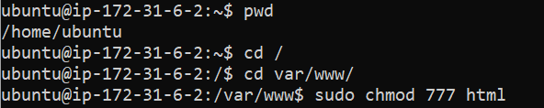

**Open the site using the public IPv4 address and it will be accessible**

**14.**

