SNIFFING
What is Sniffing?
Sniffing (or packet sniffing) in cybersecurity is the process of monitoring and capturing data packets passing through a computer network.
How Sniffing Works
When data is sent over a network, it is broken down into smaller pieces called packets. Normally, a device only looks at packets addressed specifically to it. However, a network card can be placed into promiscuous mode, which forces it to examine and log every single packet passing through the network, regardless of its destination.
Types of Sniffing
- Passive Sniffing: The attacker simply sits back and logs data passing through a hub or a shared network segment. It is completely invisible because the attacker doesn't inject any data into the network.
- Active Sniffing: Used on switched networks where data is strictly routed to specific ports. The attacker must actively flood or manipulate the network (using techniques like ARP spoofing or MAC flooding) to force the switch to send other people's data to the attacker's device.

Tools used for Sniffing
1. Wireshark
It acts as a digital magnifying glass for network traffic. It captures live packets moving through network cards and breaks down complex binary protocols into human-readable text. It is used worldwide for network troubleshooting, software development, and security analysis.
2. Tcpdump
A command-line network utility that captures and parses network packets. It uses very little memory and CPU, making it the preferred tool for system administrators to diagnose remote, headless servers using simple terminal commands.

3. Tshark
This is the command-line equivalent of Wireshark. It uses the exact same packet analysis engine but drops the heavy graphical user interface. It is heavily utilized for automation scripts, cron jobs, and extracting specific data points from packet capture files over a terminal.

4. Snort
An automated network security tool that sniffs traffic and instantly compares it against a library of known attack patterns (rules). It can be deployed to simply log suspicious data, alert administrators to an intrusion, or actively block malicious traffic as a firewall extension.
5. BetterCAP
A modern, modular platform designed for security auditing and penetration testing. It specializes in active sniffing—forcing traffic from other computers on a local network to route through it so the tester can manipulate web traffic, spoof credentials, or test Wi-Fi vulnerabilities in real time.

6. Kismet
A dedicated sniffer for wireless technologies, including Wi-Fi, Bluetooth, Zigbee, and RF (Radio Frequency). Unlike Wireshark, it puts wireless cards into "monitor mode" to actively map out nearby access points, hidden networks, and connected devices without ever making its presence known.

7. NetworkMiner
An artifact-centric forensic analysis tool. Instead of showing rows of packet numbers, it parses pre-captured traffic files (.pcap) and instantly reconstructs them back into their original forms—extracting files, images, emails, and credentials transferred over the network for digital investigators.

Wireshark
Wireshark is the world’s most widely used network protocol analyzer. It allows you to intercept and interactively browse the traffic running on a computer network in real time, or analyze pre-saved capture files.

Wireshark Functions
- Capture Filters (BPF Syntax): Restricts the packet recorder to log only specified traffic types before saving data to memory or disk.
Example: host 192.168.1.1 or port 443

- Display Filters (Wireshark Syntax): Hides specific packets from the on-screen view during or after a live capture session without deleting the underlying data.
Example: ip.addr == 10.0.0.1 or http.request.method == "POST"

- Generates a breakdown chart showing the specific percentage of total data occupied by every protocol layer.
- Lists every unique machine talking on the network along with precise packet counts and transmission volumes between specific pairs.
- Reassembles fragmented network packets into a chronological, readable text transcript of the complete application exchange.
- Stores recorded traffic using universal network file types including .pcapng and .pcap.
- Extracts unencrypted files like images, documents, or scripts directly out of standard application protocols.

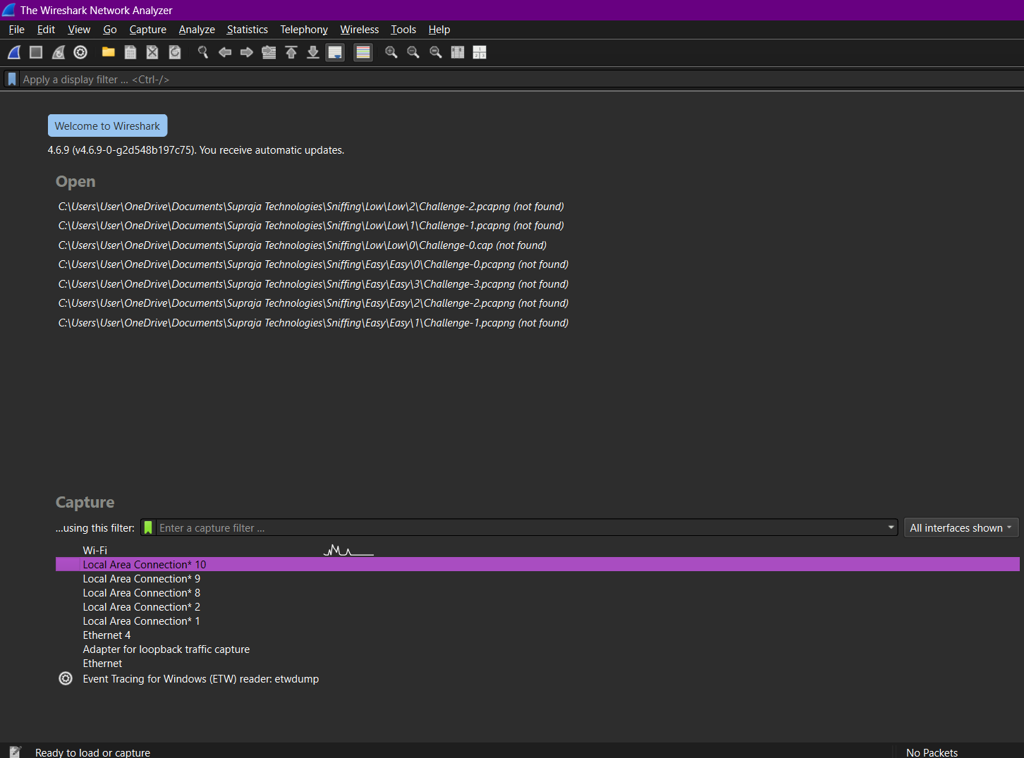

Loopback Address
A loopback address is a special, reserved IP address that allows a computer or network device to send data packets to itself.
127.0.0.1 is the standard and most commonly used address, though the entire 127.0.0.0/8 range (from 127.0.0.0 to 127.255.255.255) is reserved for loopback operations.
Use Cases
- TCP/IP Stack Testing: Running a quick ping 127.0.0.1 command tests whether your computer's internal networking software is functioning properly without needing a live network connection.
- Local Software & Web Development: Developers host and test web apps, APIs, and microservices locally on their machine (e.g., accessing http://localhost:3000 or http://127.0.0.1:8080) before pushing them to public servers.
- Internal Database & Service Binding: Applications can talk to local databases (like MySQL or PostgreSQL) running on the same computer safely, as traffic bound strictly to loopback cannot be reached from the outside internet.

Challenges
Easy :

Challenge 0 Problem Statement : Analyse and Filter the packets, find out the correct login details.
Answer : 5182(uname:"user", pass:"password")

5494(uname:"admin", pass:"admin")

5922(uname:"supraja", pass:"Technologies")

6163(uname:"cyberace", pass:"helloworld")
6275(uname:"test", pass:"test")
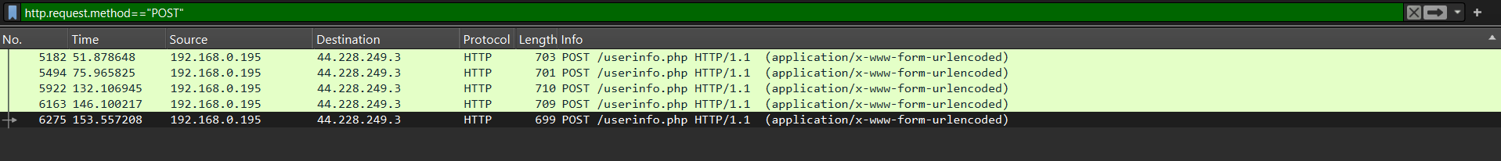
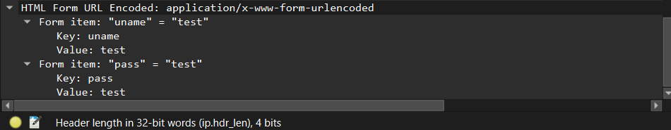
Challenge 1 Problem Statement : Analyse and Filter the packets, find out the updated details of Supraja@Hackers.
Answer : (37209)
urname = "Anonymous@hackers"
ucc = "0000000000000"
uemail = "anonymous@email.com"
uphone = "555555555555"
uaddress = "Dark World"
update = "update"
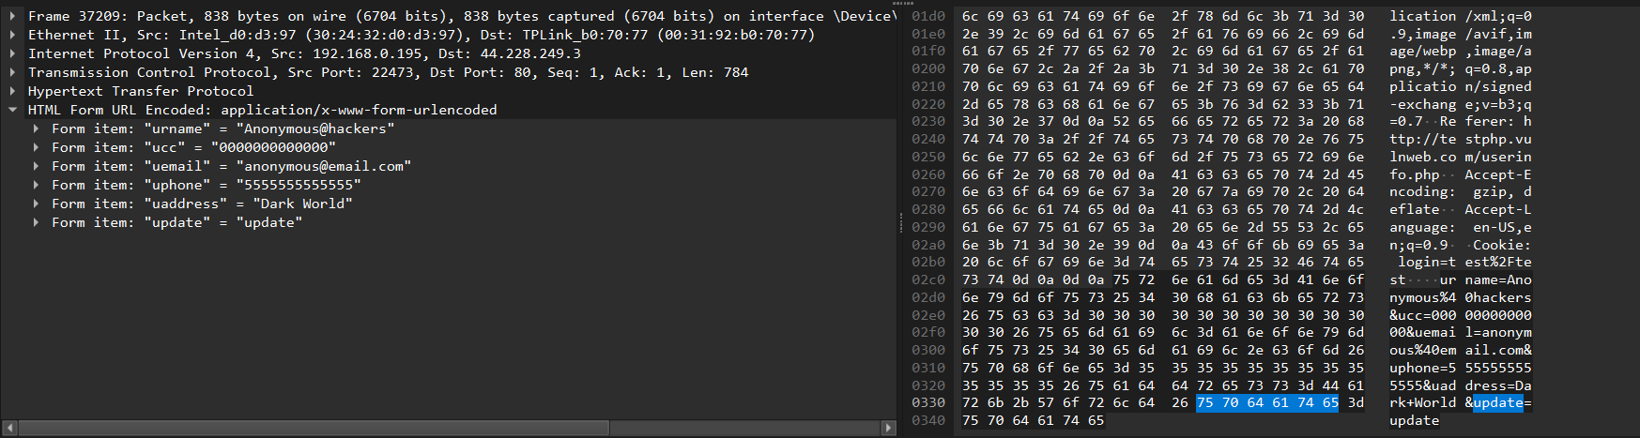
Challenge 2 Problem Statement : Find the newly created user details and report those details.
Answer : (18426)
"uuname" = "Supraja Technologies"
"upass" = "suprajatechnologies.com"
"upass2" = "suprajatechnologies.com"
"urname" = "CHSMRLSS Technologies Pvt. Ltd"
"ucc" = "999999999999"
"uemail" = "contact@suprajatechnologies.com"
"uphone" = "+91 9550055338"
"uaddress" = "Digital World\r\n|\r\n|\r\n|\r\n\r\nL>D3s1n3dBy CYB3R AC3"
"signup" = "signup"
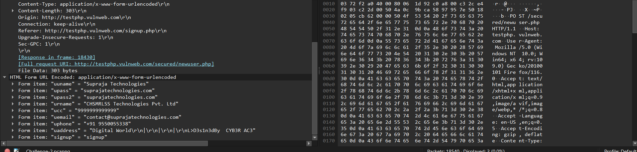
Challenge 3 Problem Statement : Your goal is to find different users authentication activities who are in the same network.
Answer : 1559(192.168.0.195 to 5.180.151.73)
2334(192.168.0.195 to 43.255.154.57)
2836(192.168.0.195 to 35.154.134.64)
3588(192.168.0.195 to 52.2.84.116)
Four user activities
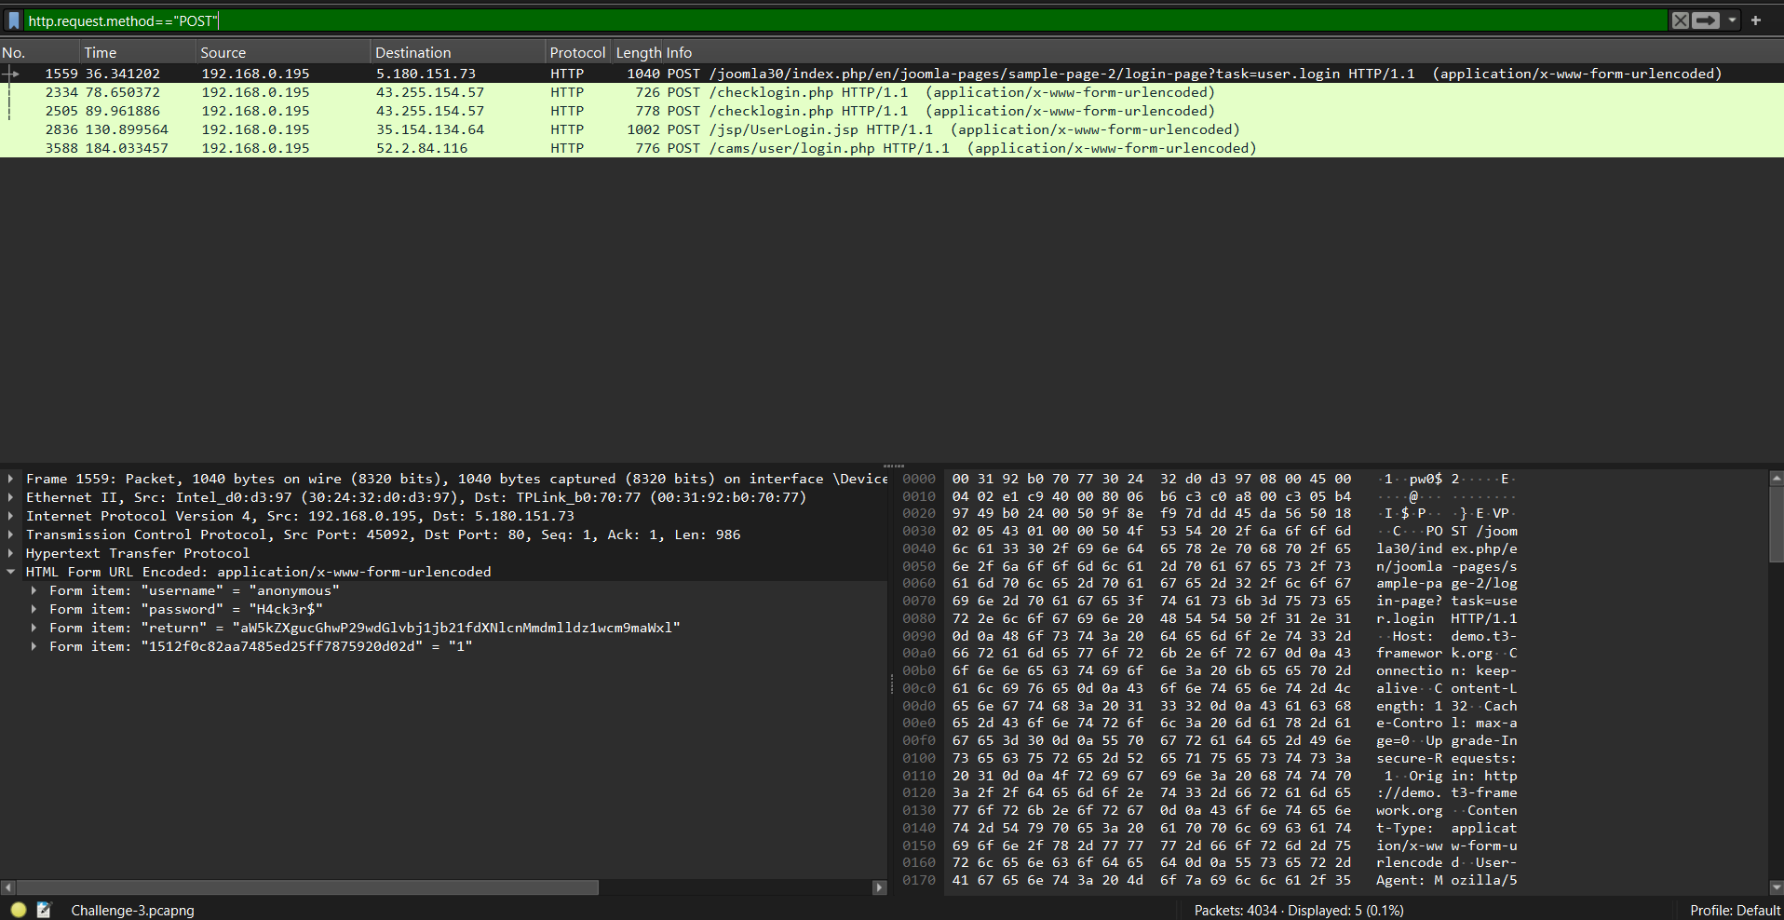

Low :
Challenge 0 Problem Statement : I think you know the difference between HTTP and HTTPS.
Remember one thing, while transferring the data will not always in the PLAIN TEXT
Find the Login credentials of natas0.
Answer : (natas0:natas0)
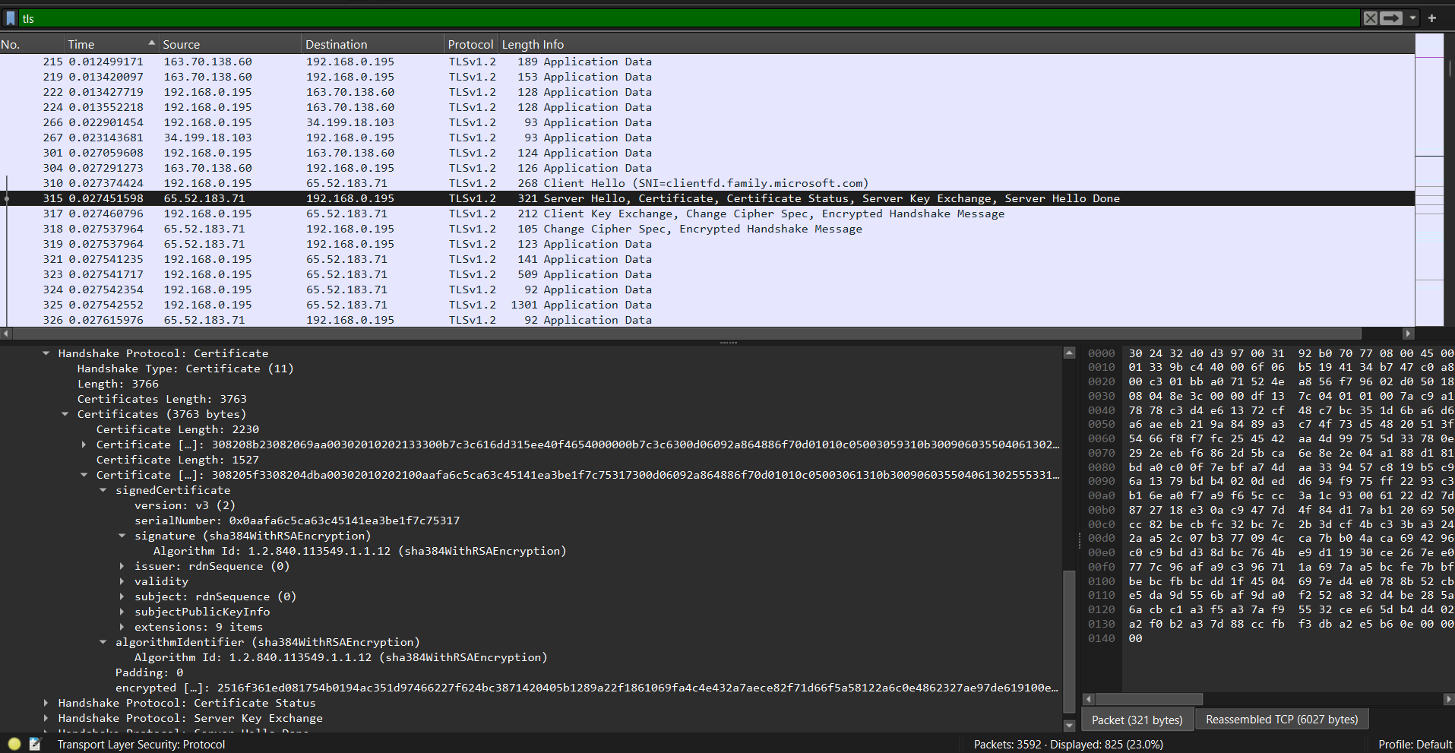

Challenge 1 Problem Statement : In network, Hackers not sniff only passwords, Files also too be sniffed. Analyse the packets and Retrieve the file passing through the network.
Answer : Supraja%20R%20Logo%20-%20Social%20Media.jpg
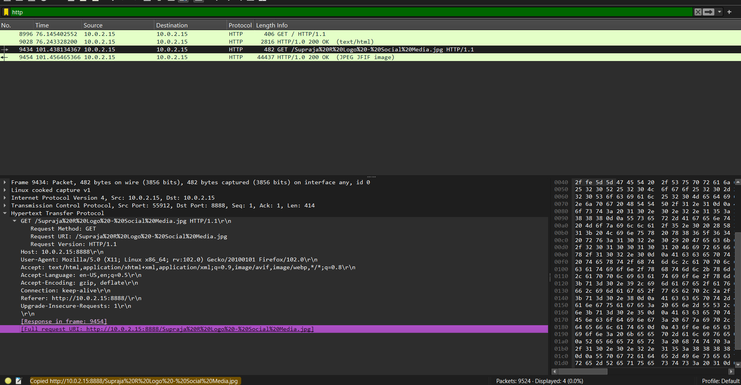

Challenge 2 Problem Statement : A group of Hackers are planning to attack a Company in your Country, as a Nation sponsored hacker you have to find out the company details and intimate them. Those details are communicated in a secured channel, so you got a encrypted information. Decrypt the encrypted info and report to that company.

Answer : Supraja Technologies



