Steganography
What is Steganography?
Steganography is the practice of hiding a secret message, file, or image within an ordinary, non-secret carrier medium (such as a photo, audio file, or text) so that its very existence goes unnoticed.
Common Types of Steganography
- Image Steganography: Hides data inside the digital code of an image (most commonly by altering the Least Significant Bits [LSB] of pixel color values).
- Audio Steganography: Embeds data into sound files by making tiny changes to frequency, amplitude, or phase that human ears cannot detect.
- Video Steganography: Conceals information across individual frames and audio tracks of a video file.
- Text Steganography: Hides secret text using specific word choices, spacing, punctuation, or the first letters of sentences.
- Network (Protocol) Steganography: Hides data inside network traffic layers, packet headers, or timing intervals.

Tools Learnt:
DeepSound:
DeepSound is a widely popular, free steganography desktop application used to hide secret files inside regular audio tracks.
DeepSound uses a modified version of LSB steganography. Audio files are made up of millions of binary bits (1s and 0s). DeepSound modifies the very last bits of the audio data stream to inject the secret file. Because these bits control sound variances too microscopic for the human ear to perceive, the audio quality remains unaffected. hhhhhhhhhhhhhhhhhhhhhhhh
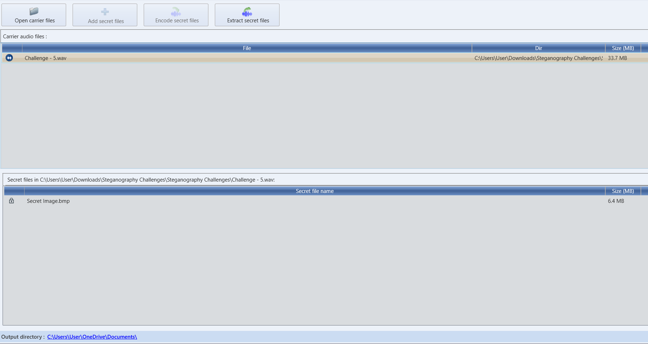
After hiding the data, the files are configured to .wav extension files.
QuickStego:
QuickStego is a lightweight, free Windows software designed to hide secret text messages inside image files.
Unlike DeepSound, which focuses on audio files, QuickStego specializes strictly in image steganography and is widely known for having an incredibly simple, beginner-friendly user interface.
QuickStego uses Image Least Significant Bit (LSB) Modification to achieve its concealment.
- The Binary Trick: Every digital image is made up of pixels, and each pixel's color is determined by a string of binary code (1s and 0s).
- The Invisible Edit: QuickStego takes the text message you type and swaps out the very last bit (the least significant bit) of the image's color data with the bits of your text.
- The Result: Because changing the final bit only alters a pixel's color by a microscopic fraction, the human eye cannot perceive any visual change. The original image and the steganographic image look completely identical.

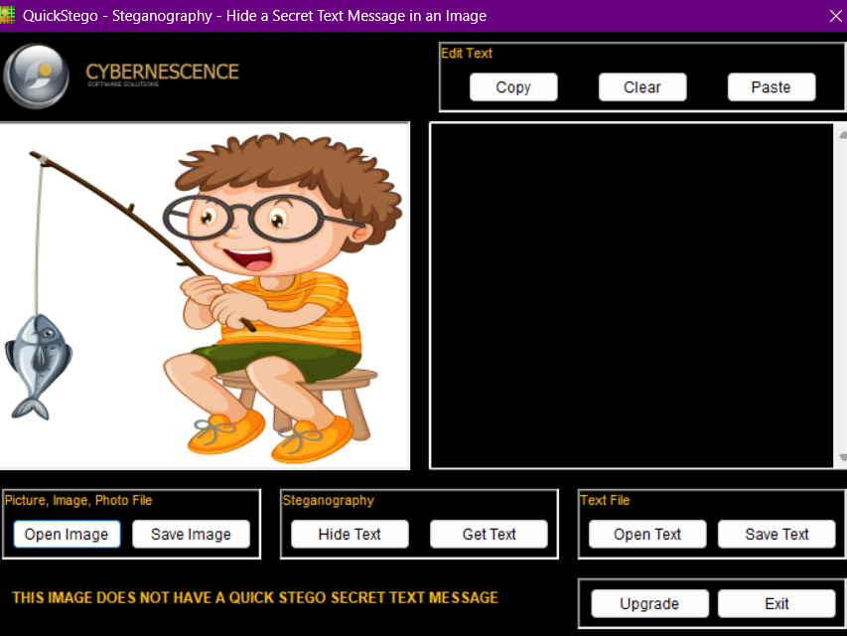

Snow:
SNOW (Steganographic Nature of Whitespace) is a command-line steganography tool that conceals secret messages within plain text files by appending invisible sequences of spaces and tabs to the ends of lines. The carrier file appears entirely normal in standard text editors because human readers and programs naturally ignore trailing whitespace. SNOW also features built-in ICE encryption and data compression to secure and maximize the hidden payload, though the concealed message is brittle and can be permanently erased if the file is pasted into a platform that strips trailing spaces.

Without password
To hide : snow -C -l 25 -m "Hidden text" input file output file
To retrieve : snow -C output file
With password
To hide : snow -C -l 25 -m "Hidden text" -p "password" input file output file
To retrieve : snow -C -p "password" output file
Challenges
Challenge 0
Retrieved {D0n't_B3_A_v1ct1m_of_Ph1$h1ng} using https://futureboy.us/stegano/decinput.html
Chanllenge 1
Used QuickStego tool to retrieve data in binary form as below :
01111011 11100010 10001101 10011001 00110011 11100010 10001100 10110000 11100010 10011000 10001010 00110000 11100010 10001011 10010100 11100010 10011111 10010010 01011111 11100010 10001111 10000001 00110000 01011111 11100010 10001011 10010100 11100010 10001010 10101100 01011111 11100010 10001101 10011001 00110000 11100010 10001101 10000000 11100010 10001100 10110000 11100010 10001110 10000101 01111101
Using https://cryptii.com/pipes/binary-decoder/ I got the alien text cipher below :
{⍙3⌰☊0⋔⟒_⏁0_⋔⊬_⍙0⍀⌰⎅} using https://alienlanguagetranslator.online/alien-language-dcode, I got {w3lc0me_t0_my_w0rld}

Challenge 2
Used QuickStego on the .bmp file to get this 32 character hexadecimal string
a930375c1e05824ff7d3cfed346df656, which matches the format of an MD5 cryptographic hash. Using https://md5hashing.net/hash/md5/ and got Supraja Technologies.
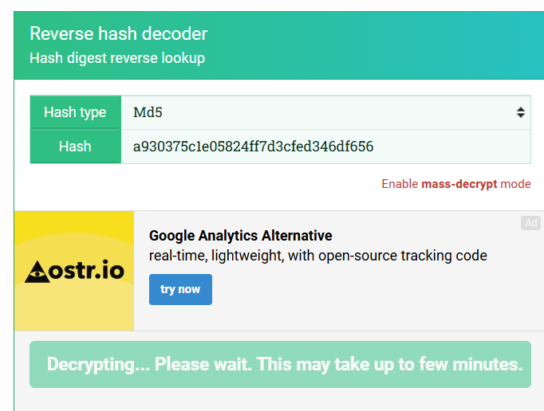
Challenge 4
Decoded morse code in the file using https://www.morsedecode.xyz/ and got the below text :
T I M E I S W H A T D E T E R M I N E S S E C U R I T Y . W I T H E N O U G H T I M E N O T H I N G I S U N H A C K A B L E .
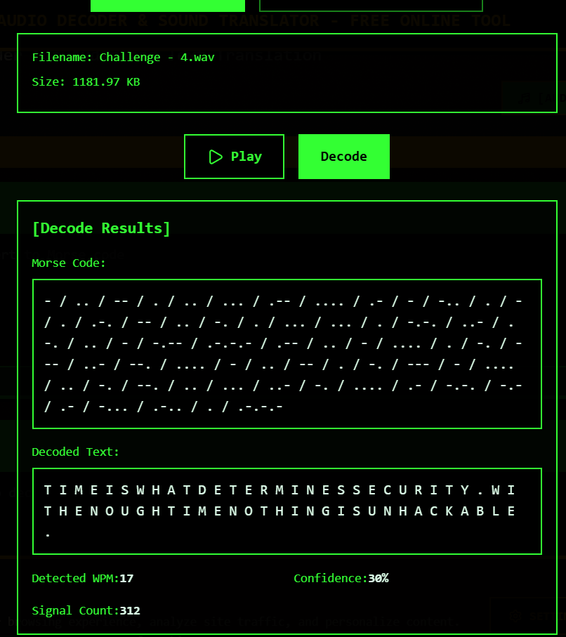

Challenge 5
Used DeepSound to retrieve the hidden .png file.
The hidden file :


Challenge 6
File name contained a text remember. So I used that text as password in DeepSound to retrieve remember.docx and it contains the following :
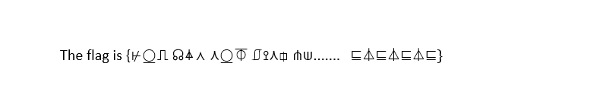
Decoded it to get :
{YOU CAN NOT FIND ME....... HAHAHAH}

Challenge 7
Used command “snow -C Challenge.txt” in command prompt inside folder containing snow.exe file.
{You_re_not_looking_hard_enough}
Challenge 8
Changed the file type to .txt from .jpg and studied the file to get this flag : "{haha_YOU_FOUND_ME!}"
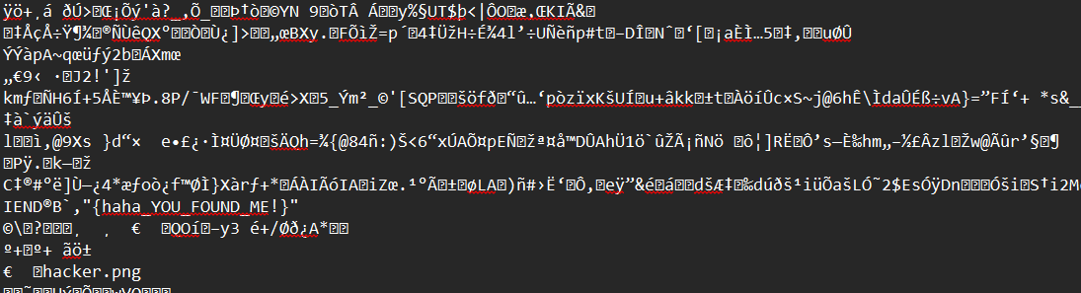
Challenge 9
Used the command “snow -C -p "Lorem ipsum" Challenge.txt” in snow CLI to get the following :
{This_is_Not_The_End........} Mundundhi musalla panduga - { Worse is yet to come. picture abhi baaki hai}

