Standard Operating Procedure (SOP) for deploying Special Consideration Moodle Plugin for the School of Science
Objective:
Setting up a Moodle instance using Docker with a MySQL database and integrating the locally developed Special Consideration plugin on a Windows system setup can be carried out as per the admin setup.

Step 1: Prerequisites
Before starting, ensure the following are installed and configured on your Windows machine:
- Docker Desktop: Make sure Docker is installed and running. Docker Desktop should be configured to use WSL 2 (Windows Subsystem for Linux).
- Docker Compose: This is included with Docker Desktop, so no separate installation is required.
- Git: Optional for version control of your plugin and Moodle.
- Terminal: Use PowerShell, Command Prompt, VS Code or Git Bash to execute the commands. We have used the VS Code terminal to carry out the activity.

Step 2: Set Up Moodle with Docker and create a Docker file for Plugin Development
2.1 Create a Moodle Directory from VS Code
- Open your terminal and create a working directory for the Moodle instance:
mkdir moodle-docker
cd moodle-docker
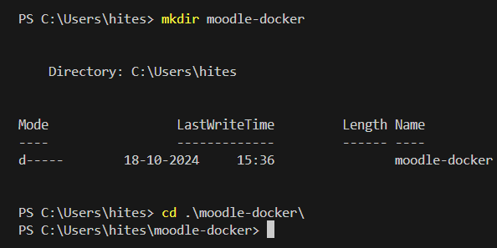
2.2 Create a Docker Compose YAML File
In the moodle-docker directory, create a Dockerfile to extend the Moodle image for local development:
- Inside the moodle-docker directory, create a “Dockerfile” and “docker-compose.yml”
The above files have the configuration for deploying a docker container with PHP 7.4-apache and MySQL database directory setup.
2.3 Build and Start the Containers
Build the Docker Image
Run: docker-compose build
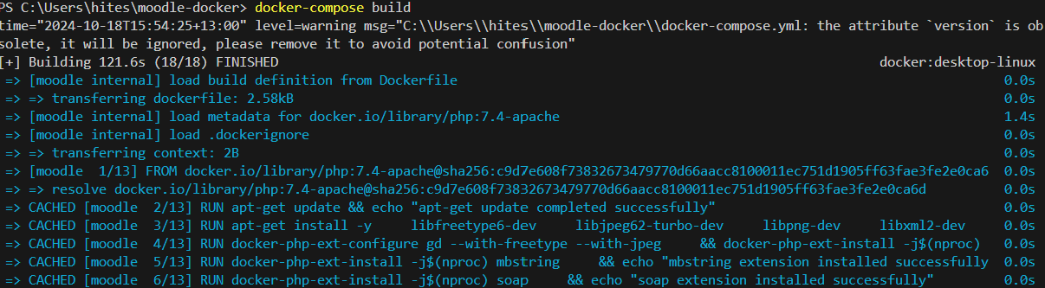
Start the Containers
Run: docker-compose up -d
This starts the Moodle and MySQL containers in detached mode.
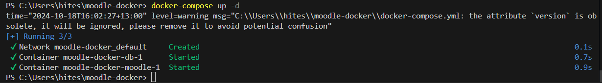
Run: docker ps
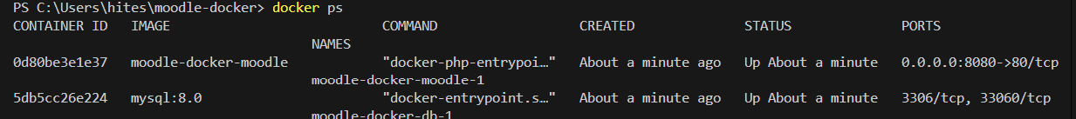

2.3 Access Moodle
Open a web browser and go to http://localhost:8080
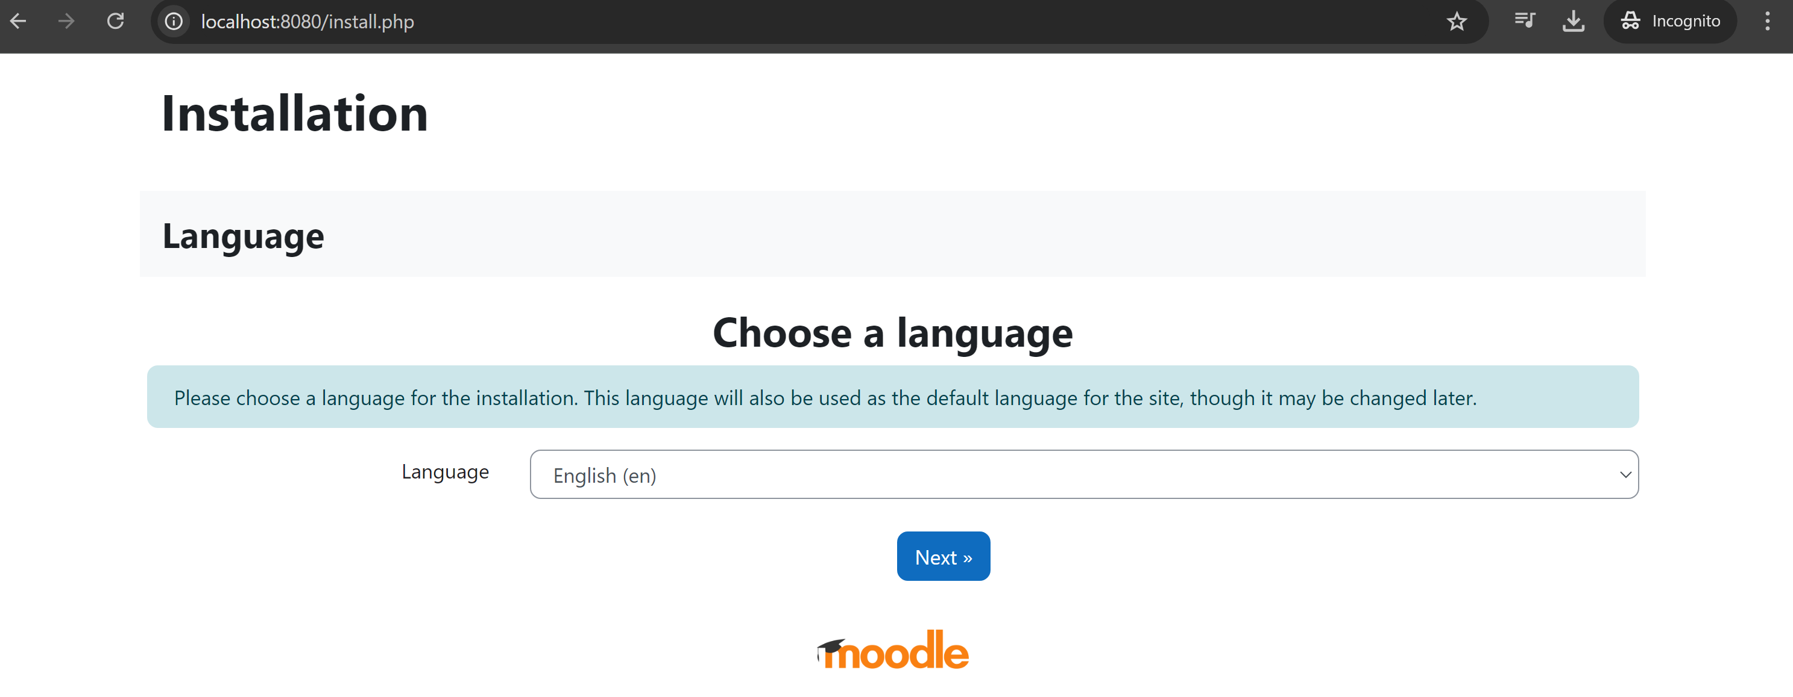

2.4 Follow the Moodle installation wizard.
Confirm Path
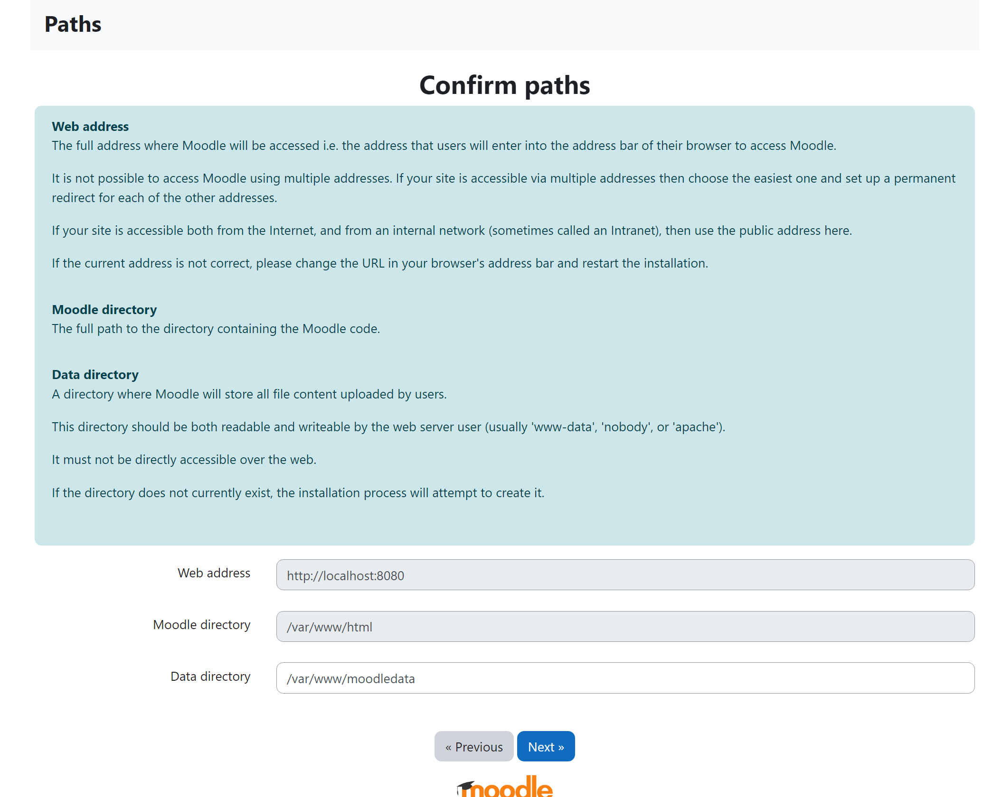
2.5 Choose database driver here we selected default as we are using mysql.
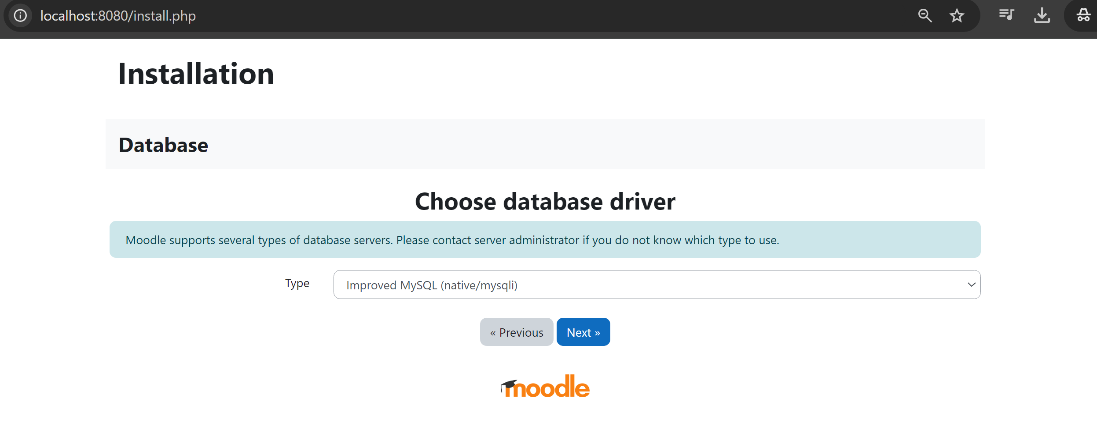
Use these database settings:
- Database Type: MySQL
- Database Host: db
- Database Name: moodle
- Database User: moodle
- Database Password: moodle_password
- Port: 3306
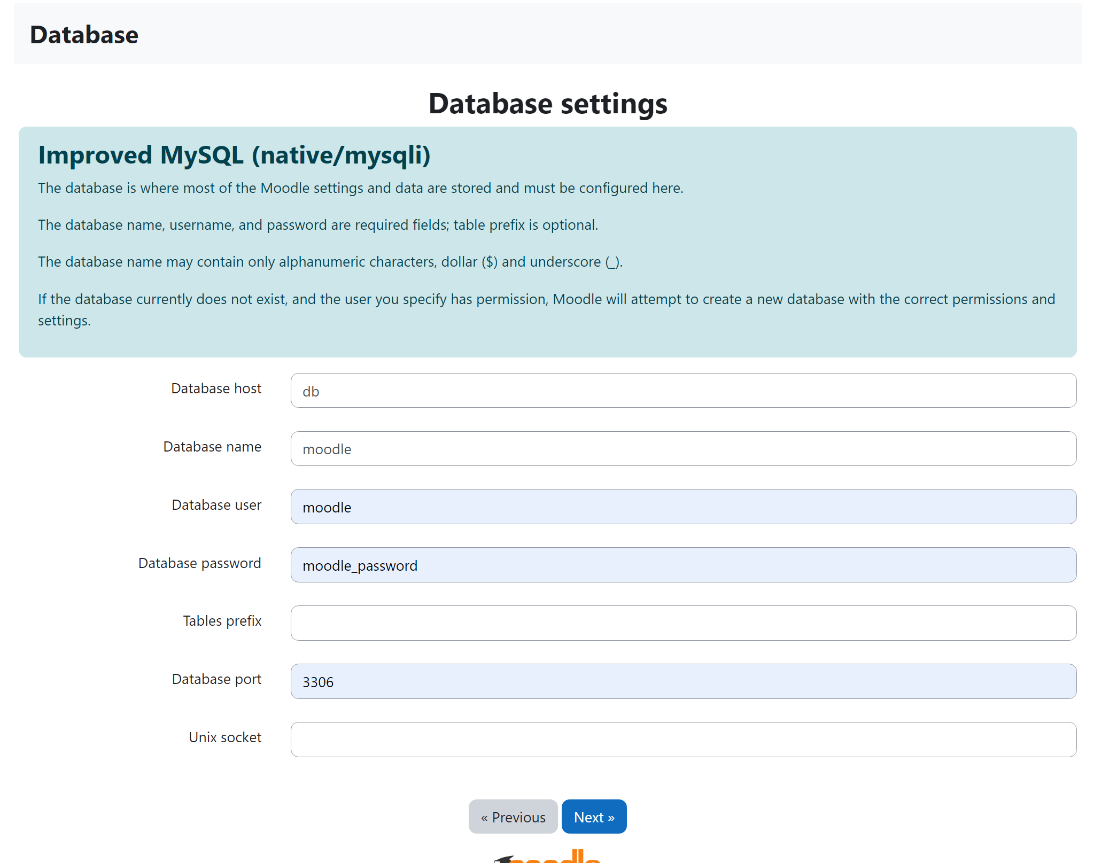
Step 3: Develop and Integrate the Special Consideration Plugin
3.1 Set Up Local Plugin Directory
- Ensure the plugin directory is available locally. Place your plugin files in the moodle/local/special_consideration directory.
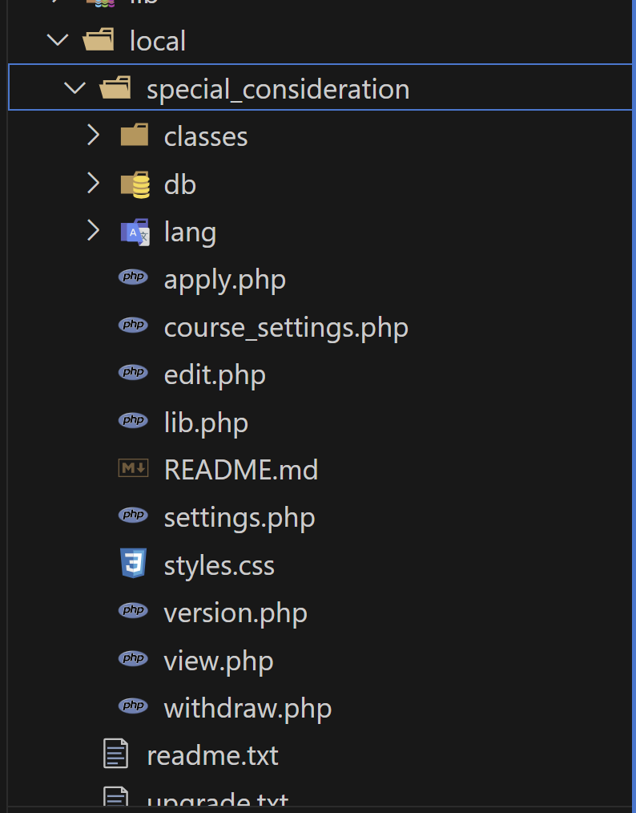
- Copy your local plugin files (such as version.php, settings.php, db/install.xml, etc.) to this directory.
- The validated version file of the plugin should contain information on Moodle and plugin versions. Note: Update the Moodle version to this file as per the main Moodle version.php.

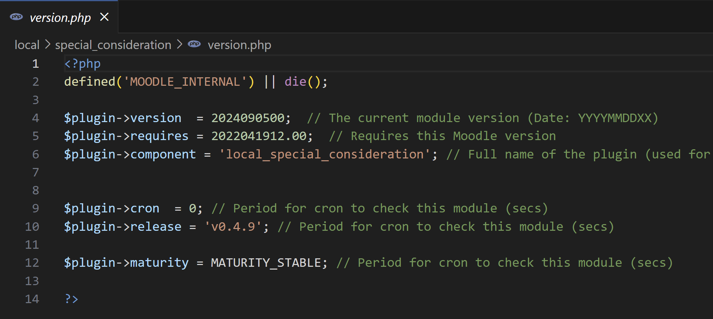
3.2 Modify Moodle’s Configuration
- Update the config.php file to enable the plugin path:
php
Copy code
$CFG->localplugins = 'local/special_consideration';
5.3 Install the Plugin via Moodle Admin
- After adding the plugin files to the directory, navigate to the Moodle admin panel:
bash
Copy code
http://localhost:8080/admin
- Moodle will automatically detect the new plugin and prompt you to install it. Follow the installation process.

Step 4: Verify Plugin Functionality
- Testing Plugin Features:
  - Log in as a student and raise a Special Consideration request from a course page.
  - Log in as a teacher and review, approve, or decline the request.
- Database Integration:
  - Check the MySQL database to ensure requests are being stored properly.
  - Run queries to verify that data for student requests is being recorded and updated as expected.

Step 5: Backup and Maintenance
- Backup Database: Regularly back up the MySQL database using the following command:
bash
Copy code
docker exec moodle-db /usr/bin/mysqldump -u root --password=rootpassword moodle > backup.sql
- Backup Moodle Data: Backup Moodle’s data directory to preserve file uploads and configurations:
bash
Copy code
tar -czvf moodledata-backup.tar.gz ./moodledata

Step 6: Stopping and Removing Containers
- To stop the Docker containers, run:
bash
Copy code
docker-compose down
- To remove all data (optional):
bash
Copy code
docker-compose down -v

Conclusion:
Following these steps, you will set up a Moodle instance using Docker, configure a MySQL database, and successfully integrate the locally developed Special Consideration plugin.

